SUPPLEMENTAL MATERIALS

FIGURE CAPTIONS

Figure S1 (a) Trench I, Chamber 2. Place of the sample Lyon-12523(GrA) [4537–4456 BC], depth 0.99 m (arrow). (b) Final Neolithic red-on-white and burnished bowl found in Trench I (layer 20).
Figure S2 (a) Final Neolithic coarse ware deep bowl with relief and impressed decoration, found in Trench I (layer 20). (b) Final Neolithic small spouted bowl found in Trench I (layer 20).
Figure S3 (a) Trench II, Chamber 3. Place of the samples Lyon-12517(GrA) [4936–4810 BC] and Lyon-12518(GrA) [4977–4789 BC], depth 0.415 m (bottom arrow) and sample Lyon-12519(GrA) [4906–4792 BC], depth 0.26 m (top arrow). (b) Late Neolithic burnished assymetrical open vessel with horned lugs found in Trench II (layer 4).

Figure S4 (a) Late Neolithic matt-painted carinated bowl found in Trench II (layer 7). (b) Late Neolithic coarse ware open vessel found in Trench II (layers 4–6).

Figure S5 (a) Trench III, Chamber 4. Place of the sample Lyon-12520(GrA) [429–536 AD], depth 0.02 m (arrow). (b) Part of a Late Classical–Hellenistic chytra from Trench III (layers 1–5).
Figure S6 (a) Trench III, Chamber IV. Place of the sample Lyon-12521(GrA) [5207–5058 BC], depth 0.16 m (arrow). (b) Late Neolithic matt-painted fragment found in Trench III (layers 2 and 4).
Figure S7 Late Neolithic fragment from a closed unpainted pot with horizontal, pierced, double lug (layer 1).
Figure S8 (a) Trench IV, Chamber 3. Place of the sample Lyon-12522(GrA) [5508–5381 BC], depth 0.30 m (arrow). (b) Late Neolithic matt-painted “mug” found in Trench IV (layer 4).
Figure S9 (a) Trench IV, Chamber 3, layer 11. Place of the sample Lyon-12524(GrA) [5707–5641 BC], depth 0.50 m (arrow). (b) Ceramic fragment from a thin walled Middle Neolithic monochrome Urfirnis bowl or basin found in Trench IV (layer 11).
Figure S10 Calculation of the marine reservoir effect in the Marathon bay during the 5th millennium BC, which yields a sea surface marine reservoir age R(t) = 775 ± 57 yr.
Figure S11 Probability distribution plot for the cave of Pan pair [samples Lyon-12517(GrA) and Lyon-12518(GrA)] ΔR value = 402 ± 63 ¹⁴C yr (1σ).

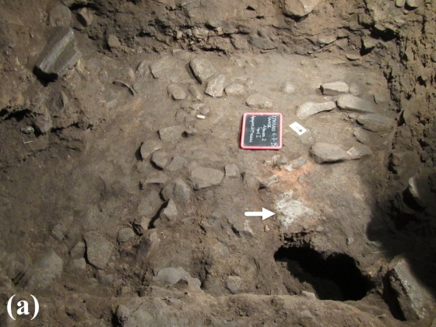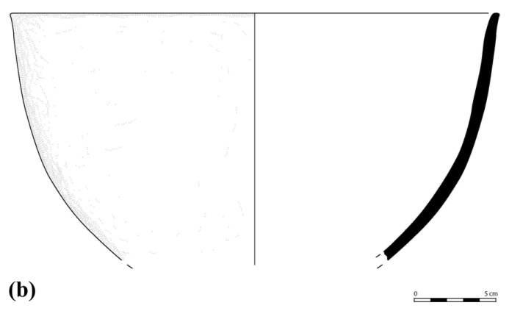

Figure S1

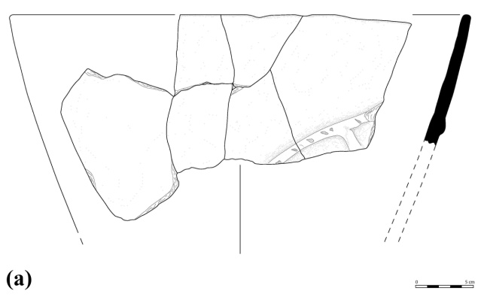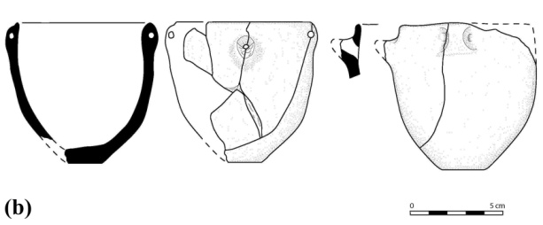

Figure S2

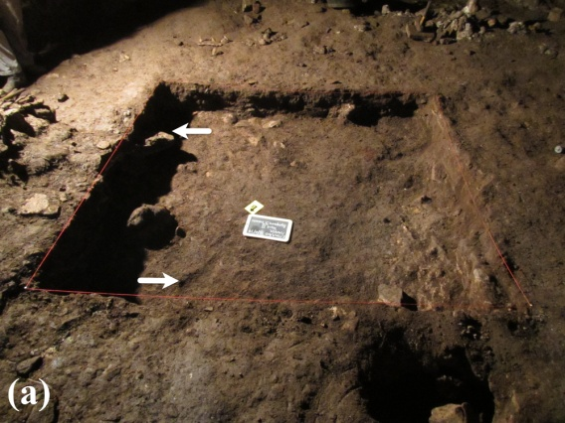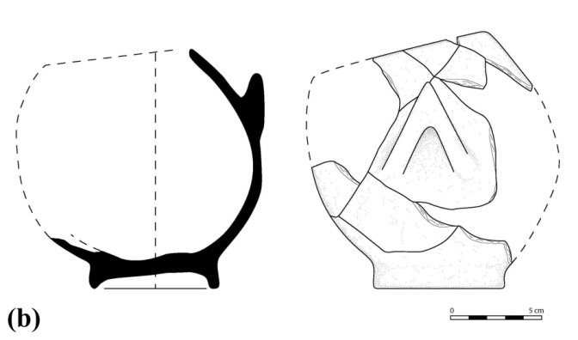

Figure S3

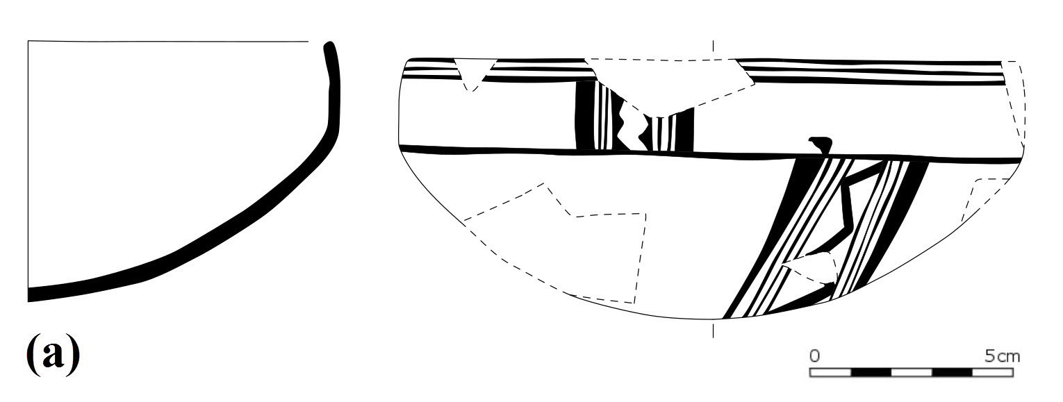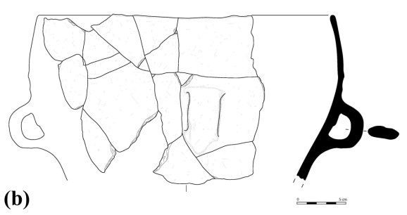

Figure S4

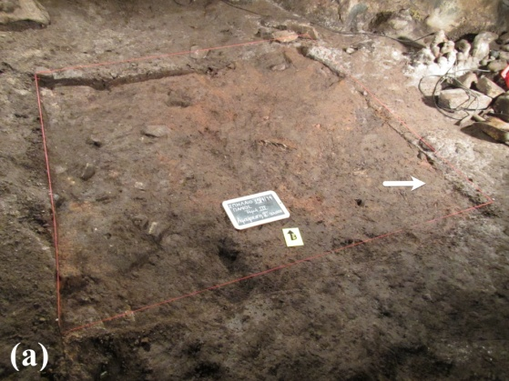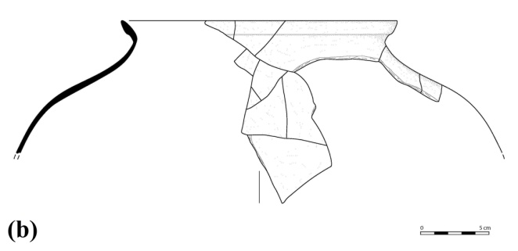

Figure S5

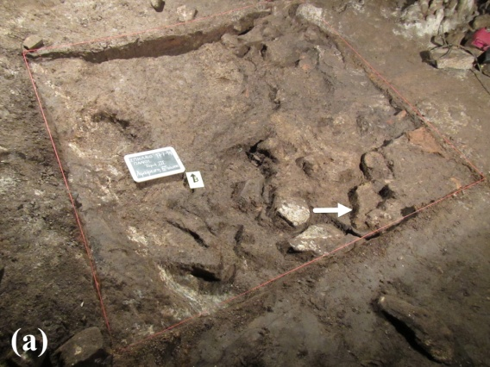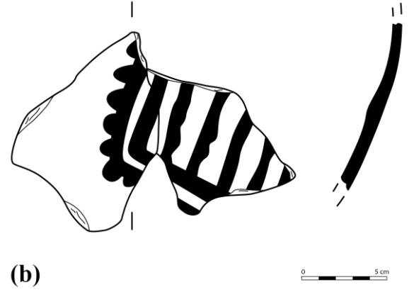

Figure S6

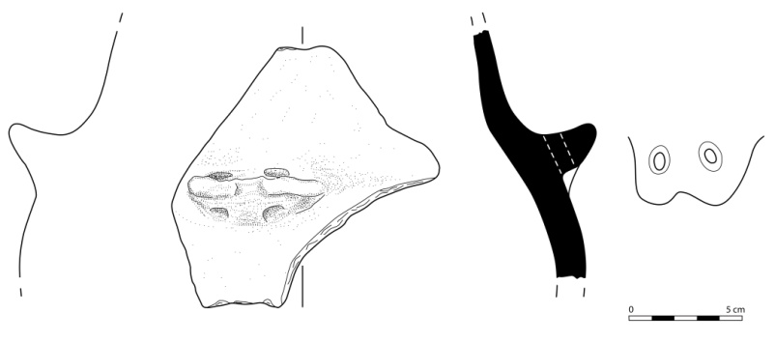

Figure S7

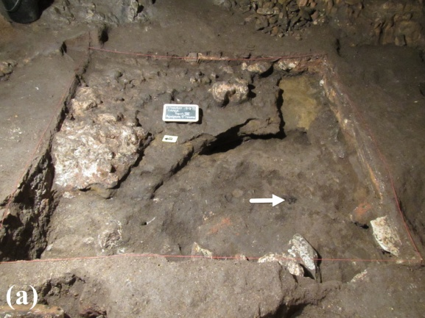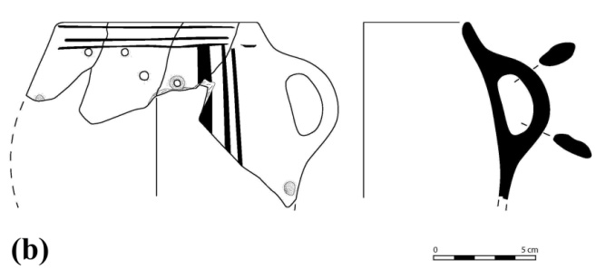

Figure S8
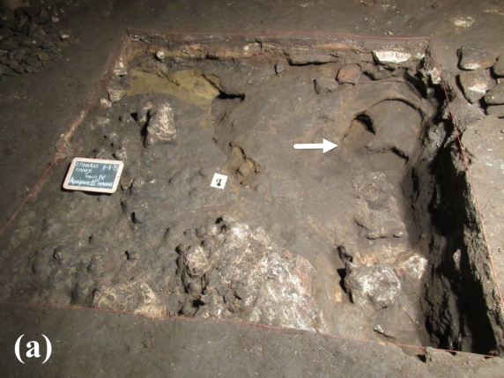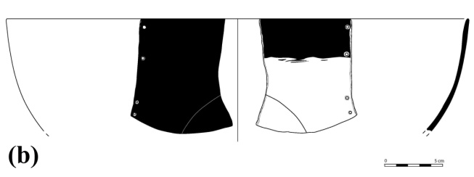

Figure S9
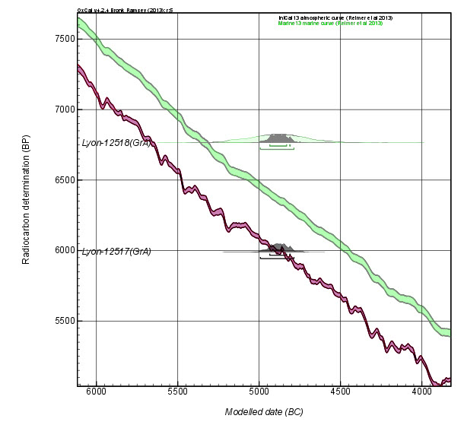

Figure S10

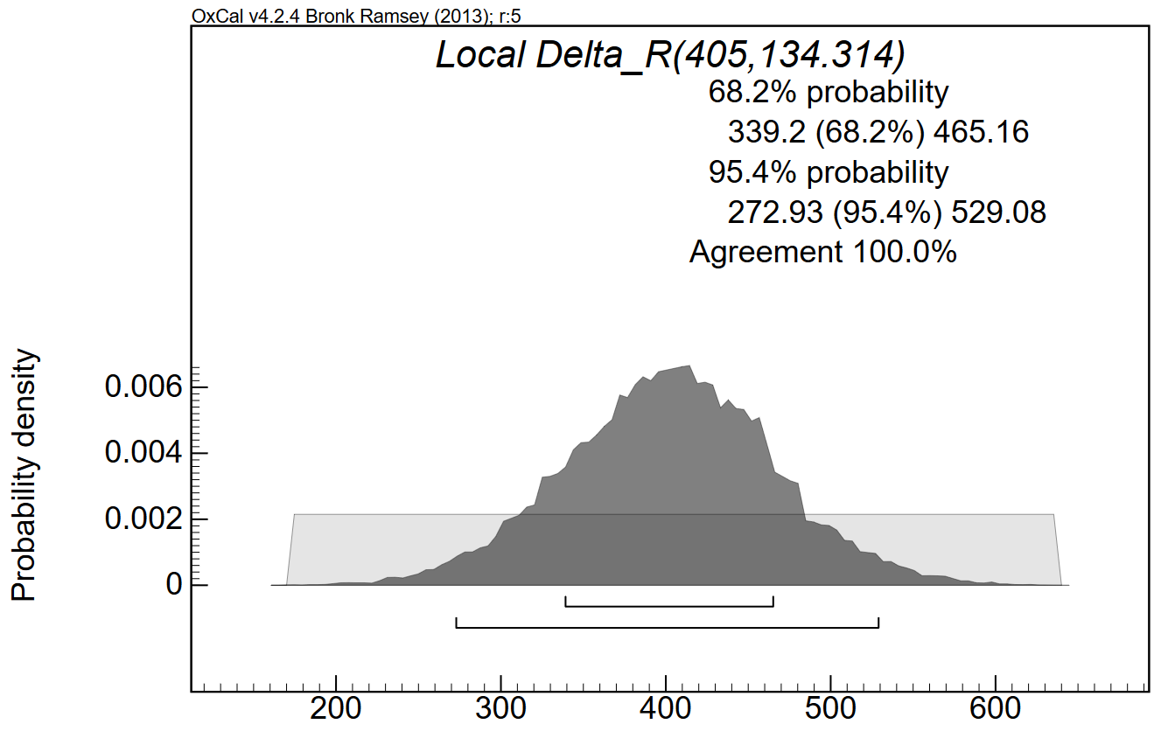

Figure S11

