Supplementary material
A conceptual model of multi-scale formation processes of open-air Middle Paleolithic sites in the arid Negev desert, Israel
Supplementary 1. Stratigraphy and sedimentology
Nahal Yitnan:
Fig. S1.1: The studied slope and trench locations

Three trenches were excavated at the site (Fig. S1.1), the sections were described using routine sedimentological parameters (Tables S1.1-4), and five samples were collected for sedimentological analyses and OSL dating (Tables S1.4 and S2.1). All trenches display similar stratigraphic sequence with distinct catenary changes. Calcrete is more developed in the upper part of the slope as found in the nearby site Nahal Yatir 1 (Roskin, 2019b), while loess thickness increases downslope.
The sediments are highly calcic (46-64%) and resemble incipient calcrete that can rapidly precipitate during intervals of deceased dust (loess) deposition. The values are slightly higher for the calcic Bk horizons. This may be due to contribution from the underlying weathered and eroded chalk deposits (Roskin et al., 2018) (Table S1.5). Sample KUR-3 has values (33.6%) that are typical of primary (Crouvi, 2009) and locally reworked loess (Oron et al., 2019).
Unit | Depth (cm) | Description | OSL age (ka)
4 | 0-10 | A-horizon: Tilled loess that thins out and disappears at top of slope by edge of trench
3 | 10-60/70 | Bk horizon: 70% powdery calcic loess. Its middle part supports rounded clasts 2-12 cm. Its upper part is lined with clasts of angular chert and rectangular -rounded smoothed chalk. Mousterian artifacts at upper part of unit. Wavy boundary. | KUR-1 56±4
2 | 60/70-90 | C-R horizon: Calcrete, fractured, wavy gradual boundary, dip parallel to slope angle
1 | 90+ | R - Chalk bedrock
Table S1.1. Description of the section at Trench East A.
Fig. S1.2. Trench East A. a- Northeast view of trench and hosting slope. The rectangle marks the location of stratigraphic section in the lower photo(b). b- The section and location of OSL sample.

Unit | Depth (cm) | Description | OSL  Age (ka) | Comments
4 | 35-0 | A-horizon: Brown tilled/plowed loess in small depression, dispersed lithics
3b | 55-35 | Bk1 horizon: Calcic loess and clasts. Artifacts dispersed within central part of unit! | KUR-5  30±2 | Mixed sample (see Table S2.1)
3a | 70-55 | Bk2 horizon: Highly calcic loess. | KUR-4  53±6 | Calcrete not observed
1 | 70+ | Fractured, horizontally-bedded chalk
Table S1.2. Description of the section Trench East B (lower slope parallel to trench East A).
Fig S1.3. Trench East B Section. A- The trench and section location. b- The section. Note lack of calcrete.

Unit | Depth (cm) | Description | OSL  Age (ka) | Comments
4 | 0-12 | A-horizon Tilled loess loam; tilled surface
3c | 12-25 | Bk3 horizon: Calcic loess loam– few clasts
3b | 25-40 | Bk2 horizon: Calcic loess loam – with clasts and artifacts, some in vertical reposition | KUR-3  63±5 | Mixed unit possible due to plowing or (only 12%) clay swelling?
3a | 40-55 | Bk1 horizon: Calcic loess-matrix supports clasts | KUR-2  40±2 | Mixed bimodal OSL age (see Table S2.1)
2 | 55+ | Calcrete (nari) surface
Table S1.3. Description of the section of Trench West
Fig. S1.4. Trench West. a- Southwest view of trench within 1st-order wadi. The rectangle marks the location of stratigraphic section in the lower photo(b). b- The section and location of OSL samples. Unit 2 correlates to the calcrete of unit 2 in Trench East A.
KUR1 | KUR2 | KUR3 | KUR4 | KUR5 | Data
6.12 | 5.52 | 4.03 | 7.66 | 6.70 | TIC (%)
51.0 | 46.0 | 33.6 | 63.9 | 55.9 | Calcium carbonate (%)
10YR7/3 | 10YR7/3 | 10YR6/4 | 10YR7/3 | 10YR7/4 | Munsell color
Very pale brown | Very pale brown | Light yellowish brown | Very pale brown | Very pale brown | Munsell color (dry)
33.69 | 18.08 | 24.28 | 27.14 | 27.43 | Sand (%)
53.23 | 66.22 | 63.71 | 57.30 | 51.91 | Silt (%)
13.08 | 15.71 | 12.01 | 15.56 | 20.66 | Clay (%)
100.00 | 100.00 | 100.00 | 100.00 | 100.00 | SUM
6.65 | 5.37 | 7.33 | 5.43 | 3.84 | Coarse-fine ratio
4.07 | 4.22 | 5.30 | 3.68 | 2.51 | Silt-clay ratio
0.6 | 0.46 | 0.24 | 0.77 | 0.55 | Depth (m)

Table S1.4. Summary of sedimentological data.

Giv’at Barne’a
Artifacts were collected from two areas- on top of the geomorphologically stable, flat-topped hill and at the northern colluvial slope of the hill. The limestone ledge separating the two areas was used as a flint quarry, where clasts were removed to expose the natural flint (Fig. S1.5). Sedimentological data was retrieved from two pits excavated on the slope at the upper edge of the lower area (pit West and Sal 851, Fig. S1.6 c,d) and from the sediments within the flint quarry (Fig. S1.7).
The A and B horizon of the Reg soil in the colluvial slope were dated by OSL to determine the age of penetration of pedogenic dust buildup beneath the artifacts (Table S2.2). The A horizon at only ~ 9 cm depth was dated to 21±2 ka while the B horizon was dated to 32±5 ka (Fig. S1.6d). These ages have high over-dispersion values (43 and 49 %, respectively) indicating significant mixture. Nonetheless, the stratigraphic order of the ages appear to represent the gradual accumulation of dust during the late Pleistocene.

Fig. S1.5: Map of the studied area in Giv’at Barne’a.
Fig. S1.6: Pits excavated at upper edge of the lower area of Giv’at Barne’a. a- The site surface, covered with flint fragments and worked pieces. b- Soil profile in one pit (Rock fragments around A-B contact. Chorizon was observed in pit west. c- Soil profile in a second pit (Non-saline B horizon and surface pavement fragment cover indicates moderate soil maturity and stability). Rocks at A-B contact may indicate later A sedimentation. Soil is hypothesized to predate Palaeolithic flint fragments on surface). d. Location of samples collected for OSL dating with ages.

The clay fraction of the dust likely originated from distal sources but the bulk has a proximal source, similar to upslope loess and in situ loess deposits in nearby hills (Lucke et al., 2019). Similar OSL ages in an open fracture loess-like fill in the southeastern Judean desert (Roskin et al., 2018) and in Negev colluvial deposits (Avni et al., 2006; Faershtein et al, 2016) indicate that during this period loess deposition and erosion was prevalent. The soil forming process post-dates the overlying and inversely-dated lithics. It may not point directly to post occupation times but to times when the secondary loess infiltrated down-profile, probably during periods of relatively higher precipitation. The OSL age range of the soil profile to ~37-19 ka dates to pre-LGM times, when there was significant loess deposition in the region (Crouvi et al., 2009) and fixation (Kidron et al., 2014; Lucke and Bäumler, 2021). It seems that the rate of the pedogenic development of the soil decreased in the Holocen, when primary and secondary loess availability decreased and the climate became more arid.
Fig. S1.7: The flint quarry with OSL ages: a- within the “negative” considered a result of a quarrying activity b- Under a detached bolder.
Loess-like dust in cracks and underneath the displaced limestone blocks of the proposed flint quarry along the hilltop ledge were also dated by OSL in order to identify the date of the knapping activities (Fig. S1.7). A similar dating approach in a comparable loess-carbonate environment in the central Negev Highlands was found to be reliable for a Neolithic quarry (Oron et al., 2019). However, at Givat Barnea, the reworked loess in the rock cracks was dated to only 1.6-0.4 ka. The ages have lower OD values than for the older samples (OD = 22-37), indicating less mixture, probably due to the position near the flat hilltop. These ages indicate cycles of erosion and refill of the loess and exemplify the dynamic erosive character of the late Holocene that inhibits loess fixation upon hilltops (Lucke et al., 2019). The location of the quarry on a western slope, facing the incoming cyclonic rain fronts (Enzel et al., 2008) may have generated relatively intensive processes of erosion.
Lab code | Description | Depth  (cm)
Pit in lower low-angle slope base of the site.
GVB-1 | A horizon beneath immature desert pavement and Palaeolithic finds. Powdery light-grey slightly consolidated silt. | 8-10
GVB-2 | Lower low-angle slope base of the site.  B horizon. Blocky, massive, uniform light-colored slightly consolidated silt. Loose silt in cracks between blocks. Small roots. | 20
Ancient quarry in site hill-top edge in limestone strata
GVB-3 | Pile of rock slabs inferred to have been quarried from adjacent layer.  Amidst the slabs was a silty deposit overlaying the bedrock and capped by rock fragments of 1- 10 cm. | 10
GVB-4 | Base of silty infill of crack between a partially unlodged rock slab and bedrock | 20
GVB-5 | Upper part of silty infill of crack between a partially unlodged rock slab and bedrock | 10
Table S1.5: Sedimentological description of the sections at Giv’at Barne’a
Supplementary 2. Optically stimulated luminescence (OSL)
Samples for luminescence dating were collected at each site from newly excavated sections under suitable dark conditions. The external 2-3 cm were removed and the deeper sediments were scraped using a trowel and placed immediately in light-tight bags, to prevent any exposure light and loss of the OSL signal. An additional sample was collected from the same location for dose rate evaluations. Detailed laboratory data and measurement protocols for Nahal Aqev unit 7 are given in Barzilai et al. (2022).
For Nahal Yitnan 7 and Givat Barnea sites, quartz in the range of 90-125 µm was extracted and purified using routine procedures developed for the Negev loess (Faershtein et al. 2016). After wet sieving to the desired grain size, carbonates were dissolved by soaking overnight in 8% HCl, followed by rinsing and drying. The sample was then passed through a Frantz magnetic separator with a current of 1.4 A on the magnet. About 3 gr from the non-magnetic fraction was further etched with 40% HF for 40 min to dissolve feldspars and remove the outer rim of the quartz grains affected by alpha particles. This was followed by an overnight soak in 16% HCl to remove any fluorides which may have precipitated, rinsing and drying.
The equivalent dose (De) values of the purified quartz were measured on 13-34 2-mm aliquots (~ 200 grains per aliquot) using single aliquot regenerative dose (SAR) protocol (Murray and Wintle, 2000) on TL/OSL Risø readers equipped with calibrated beta sources. Three to four dose points were used to construct the dose response curve (DRC), with an additional zero dose point and a recycling point. Average De values were calculated using the central age model (Galbraith and Roberts, 2012), which assumes that the grains are distributed around a central value.
Dose rates were evaluated from the additional sediment samples. The samples were dried and crushed, and a 50 gr split was powdered. The concentrations of the radioactive elements U, Th and K were measured by inductively coupled plasma (ICP) mass spectrometry (MS) or ICP optical emission spectrometry (OES). Alpha, beta and gamma dose rates were calculated from these concentrations using conversion factors of Aitken (1985). Cosmic dose rates were evaluated from current burial depths and time averaged moisture content was estimated at 5±3%, reflecting aridity and seasonal variations.
Dose recovery tests over a range of preheats for a sample from Nahal Yitnan 7 showed that a dose of 78 Gy can be recovered to within 5% of unity using a preheat of 260°C, a test dose of 7.8 Gy and a test dose preheat of 200°C. These measurement parameters were used throughout.
Tables S2.1 and S2.2 give the data used for age calculations. The OSL signal of all samples is bright and decays to background level within 2-3 s. Recycling ratios are typically within 5% of unity, and recuperation is universally low, <2%.
The scatter within the samples (OD – overdispersion in Tables) is mainly above the threshold of 25% associated with well-bleached samples (for 2-mm aliquots), indicating partial bleaching or post burial mixing of the grains.
Field  name | Lab  code | Depth  (m) | K  (%) | U  (ppm) | Th  (ppm) | Ext. α  (Gy/ka) | Ext. β (Gy/ka) | Ext. γ  (Gy/ka) | Cosmic  (Gy/ka) | Dose rate  (Gy/ka) | N | OD  (%) | De  (Gy)⁽¹⁾ | Age  (ka)
KUR - 1 | MAO - 9 | 0.6 | 0.53 | 1.3 | 3.6 | 0.006 | 0.598 | 0.423 | 0.203 | 1.23±0.06 | 21/22 | 24 | 69±3 | 56±4
KUR - 2 | MAO - 10 | 0.46 | 0.63 | 1.6 | 4.0 | 0.007 | 0.707 | 0.495 | 0.214 | 1.42±0.06 | 27/34 | 43 | 57±2 | 40±2⁽²⁾
KUR - 4 | MAO - 11 | 0.77 | 0.28 | 1.6 | 1.9 | 0.006 | 0.426 | 0.318 | 0.192 | 0.94±0.05 | 21/22 | 36 | 56±4 | 60±6
KUR - 5 | MAO - 12 | 0.55 | 0.38 | 1.2 | 2.6 | 0.005 | 0.465 | 0.335 | 0.207 | 1.01±0.05 | 18/23 | 44 | 30±2 | 30±2⁽³⁾
KUR - 3 | MAO - 14 | 0.24 | 0.28 | 6.4 | 2.0 | 0.018 | 1.029 | 0.840 | 0.237 | 2.13±0.09 | 18/19 | 31 | 134±9 | 63±5
Table S2.1: Nahal Yitnan 7 OSL data and ages: N – number of aliquots used for De calculations out of those measured. OD – overdispersion, a measure of the scatter in the sample beyond that expected from instrumental noise.
(1) using the central age model; (2) 12% of aliquots give an age of 75±5 ka; (3) 22% of aliquots give an age of 77±9 ka.
Lab  code | Depth  (cm) | K  (%) | U  (ppm) | Th  (ppm) | Ext. α  (μGy/a) | Ext. β  (μGy/a) | Ext. γ  (μGy/a) | Cosmic  (μGy/a) | Dose rate  (μGy/a) | N | OD  (%) | De  (Gy) | Age  (ka)
GVB-1 | 8-10 | 0.66 | 1.9 | 4.6 | 8 | 782 | 562 | 264 | 1616±35 | 17/17 | 43 | 33±3 | 21±2
GVB-2 | 20 | 0.42 | 3.1 | 2.8 | 10 | 729 | 554 | 243 | 1537±35 | 13/13 | 49 | 49±7 | 32±5
GVB-3 | 10 | 0.47 | 1.7 | 4.0 | 7 | 617 | 470 | 264 | 1358±36 | 24/25 | 37 | 2.2±0.2 | 1.6±0.1
GVB-4 | 20 | 0.71 | 1.9 | 5.4 | 9 | 833 | 610 | 243 | 1695±36 | 17/17 | 22 | 1.0±0.06 | 0.6±0.04
GVB-5 | 10 | 0.75 | 2.0 | 6.0 | 10 | 886 | 656 | 264 | 1817±42 | 22/22 | 23 | 0.6±0.04 | 0.4±0.02

Table S2.2: Givat Barnea field and OSL data and ages: De average and errors were calculated using the central age model. N – number of aliquots used for De calculations out of those measured. OD – overdispersion, a measure of the scatter in the sample beyond that expected from instrumental noise.
Supplementary 3. Particle size distribution
Particle-size distribution (PSD) is a reliable and resourceful tool to analyze sand and loess deposits of the Negev (Crouvi et al., 2009). Five samples < 2mm were analyzed for PSD with a Beckman-Coulter LS grain-size analyzer (Fraunhofer.rf780d diffraction). A representative aliquot of ~2 ml was subsampled from each sample. 35% scientific grade HCl was added to dissolve carbonates and small limestone fragments, until all samples stopped reacting. Five drops of calgon and two minutes of sonification were used to disperse fines. Bin sizes (=116) in 0.4-2000 um range were captured.
Particle-size distribution (Fig. S3.1) shows a pattern generally characteristic of primary loess in the region (Crouvi, 2009), with peaks at clay, fine silt and coarse silt to very fine sand fractions. The ~10 micron "trough" in the PSD curve of the Kur-5 sample is characteristic of loess, whereas the lack of such trough in the other of the samples suggests a greater contribution of other deposits most likely due to slope wash.
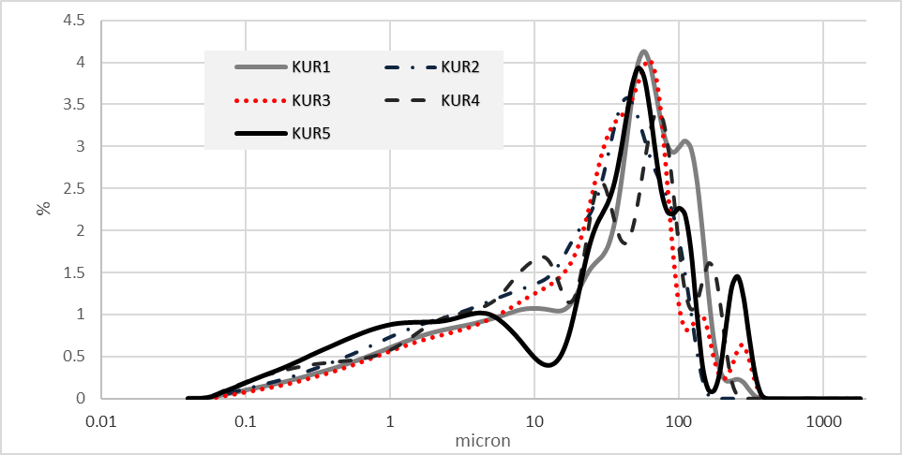 Figure S3.1: Particle-size distribution (PSD) of the sediments from the three trenches at Yitnan. Sample number corresponds to samples collected for OSL and in Table S1.4. The PSD signature resembles primary loess but has two coarser peaks that that could be a contribution of sand from the Miocene Hazeva formation.

Supplementary 4. Taphonomic attributes
The surface alterations that were studied in this research are caused by natural factors such as sediment chemistry, fluvial processes, and compaction. As stated by Burroni et al. (2002), there appears to be no clear linear timeline for formation of the damages impacting flint items. While the intensity of alteration cannot be used as a relative chronological marker, types of impact can serve as indicators of site history and accumulation processes. By contextualizing lithic taphonomic attribute states (e.g., states of breakage, surface alteration), we explored their use as meaningful tools for back-tracking natural processes that affected a site.
A sample from each site was subjected to an attribute analysis focusing on taphonomic variables. The analysis was carried out by simple naked eye observations.
In this section we elaborate on the variables chosen for the analysis and their accumulation according to existing knowledge:
- Item breakage
Unintentional artifact brakeage may occur due to rolling in streams, trampling by both anthropogenic and non-anthropogenic agents, and sediment compaction after coverage (Burroni et al. 2002; Eren et al. 2010, 2011; Herzlinger et al. 2015; Hovers 2003; Jennings 2012; McBrearty et al 1998). According to experimental work, breakage is affected by sediment particle size and is more prominent when sediments include large particles (Burroni et al. 2002; Eren et al. 2011). Breakage can also be a result of burning in direct fire, usually recognized by typical breakage and other fire alternation on the item (Fiers et al. 2021; Halbrucker et al. 2021). For the present research analysis, items were categorized as broken or complete.

- Edge damage and General surface abrasion
Small fractures and the general roughness of artifact's lateral edges and the ridges on its flaked surfaces are related to mechanical movement in fluvial processes (Burroni et al. 2002; Dibble et al. 2007; Grosman et al 2011; Hovers et al. 2014). As shown experimentally, ridge erosion and general roughness of flint surfaces can also be caused by chemical processes, sometimes leading to changes in color and surface gloss (Caux et al. 2018; Honea 1964; Thiry et al. 2014). The degree of surface abrasion (fresh, partly abraded and highly abraded) was categorized based on visual inspection of each item (Fig S4.1) Item’s edge damage (none, minimal, significant, and high) was categorized based on visual inspection assessing how significant is the edge damage on each item from isolated brakes to more intrusive brakes on larger parts of item circumference.
Fig. S4.1. examples for ridge abrasion a- No abrasion, b- partly abraded, c- highly abraded.
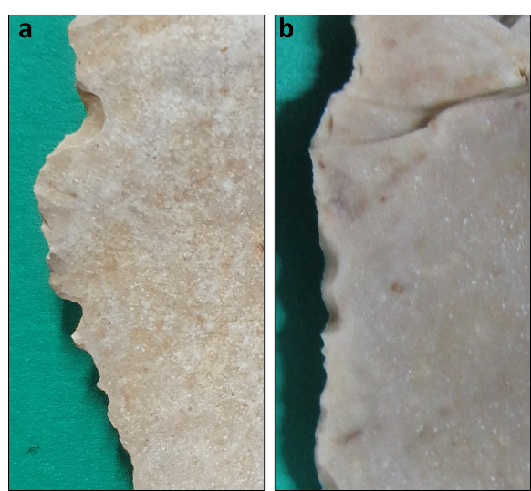
Fig. S4.2. Examples for edge damage
- Coloring (patination)
The term ‘patination’ as used in published studies refers to changes in the color of flint, related to surface alterations caused by the effects of sediment chemistry, flint microscopic structure, humidity, and exposure to sun/light (Burroni et al. 2002; Caux et al. 2018; Friedman et al. 1995; Honea 1964; Howard 1999,2002; Hurst and Kelly 1961; Rottländer 1975). Our choice to refer to it as ‘coloring’ is due to differences in terminology between archaeological and geomorphological studies (see also Coux et al. 2018). In the latter, the term patina encompasses a more varied group of surface alternations including for example surface gloss, which we discuss separately.
Items were categorized into three conditions related to patination: existence of patina (patinated, not patinated, double patinated), type of coloring identified (Desert varnish, White patina, White stains, Black-grey coloring; see below) and the patinated face of the artifact (one or both surfaces of the item).
The coloring identified in the assemblages analyzed here are desert varnish, white patina and black and grey coloring (Fig. S4.3).
Desert varnish presents a color range between brown to orange. It accumulates on flint surfaces when they are exposed on the landscape for long periods. The coloring is a result of clay minerals originating from dust, mostly containing chemical elements such as manganese (Mn) and iron (Fe) oxides that accumulate as laminae on the artifact surface. These processes can be related to paleoclimate and dust regimes. Desert varnish can accumulate on flint artifacts exposed at the surface for several decades, but its accumulation rate is not linear, hence it cannot be used as indication for artifact age (Dorn 2013; Goldsmith et al. 2012, 2014; Honea 1964).
White patina, sometimes referred to as bleaching, occurs as full cover (when the whole item turns white) or as partial cover (white spots and stains). In many cases patination tends to be thicker (thickness refers to the coloring penetrating the flint and can only be observed when looking at a section of a broken item). Several experiments show that white patina is created in alkaline carbonate-rich sediments (Coux et al. 2018; Galland et al. 2019; Honea 1964; Hurst and Kelly 1961; Rottländer 1975). Both forms of white patina are seen in many Negev sites characterized by sediments rich in fluvial or aeolian loess with high carbonate content (circa 30 %; Crouvi et al. 2008), especially on artifacts that were recently exposed on the surface, but also on items excavated from stratified sites. Previous observations suggest that in the Negev sites full cover white patina affects artifacts that are found deeper in the sediments (Oron et al. 2019). In some cases, artifacts from loess-rich sites with almost no patination turned white after being exposed to light in the lab for only a few days (M.O. personal observation). These observation show that the presence and intensity of white patina in the Negev region should not be assigned to surface exposure as a rule.
Black and grey coloring is reported as typical to burnt flint in all prehistoric sites (Fiers et al. 2021; Halbrucker et al. 2021).
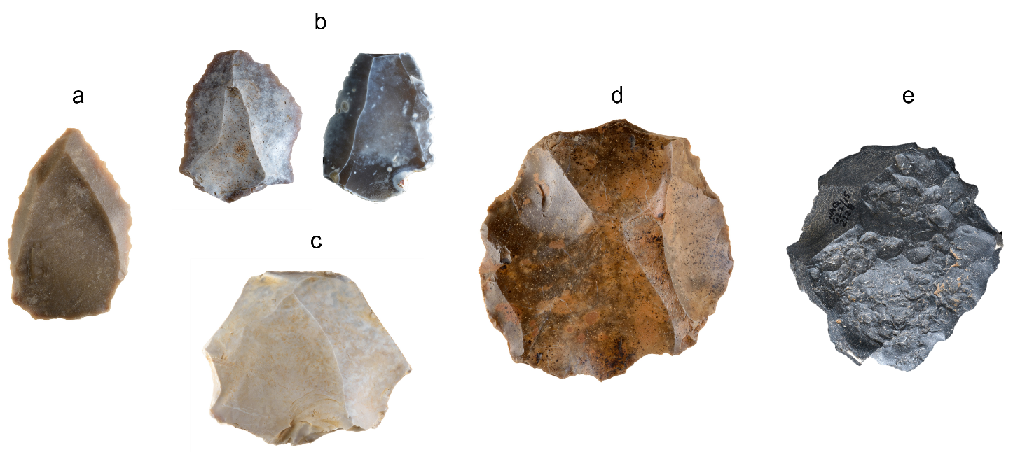
Fig. S4.3. Types of coloring on Flint artifacts from the Negev: a- No coloring, b- white stains, c- white, d- desert varnish, e- black/grey
- Gloss
Glossy surfaces on flint artifacts (Fig. S4.4), smooth to the touch, are a result of chemical processes and, to a lesser degree, of mechanical weathering (Burroni et al. 2002; Howard 1999, 2002). The main process creating the gloss is the absorption of dissolved silica onto the artifact surface. The origin of the absorbed silica can be in soil solutions or from dissolution from the artifact itself. Hence, the process requires high water content in the depositional environment and can happen when artifacts are deposited under the surface as well as due to exposure to high energy stream environments (Howard 1999, 2002; Galland et al. 2019). In some cases, the gloss develops with desert varnish, but will not be as prominent as in wet sediment contexts (Dorn 2013; Howard 2002). Items were categorized into three groups according to the degree of gloss apparent on the item surface (none, some, significant)
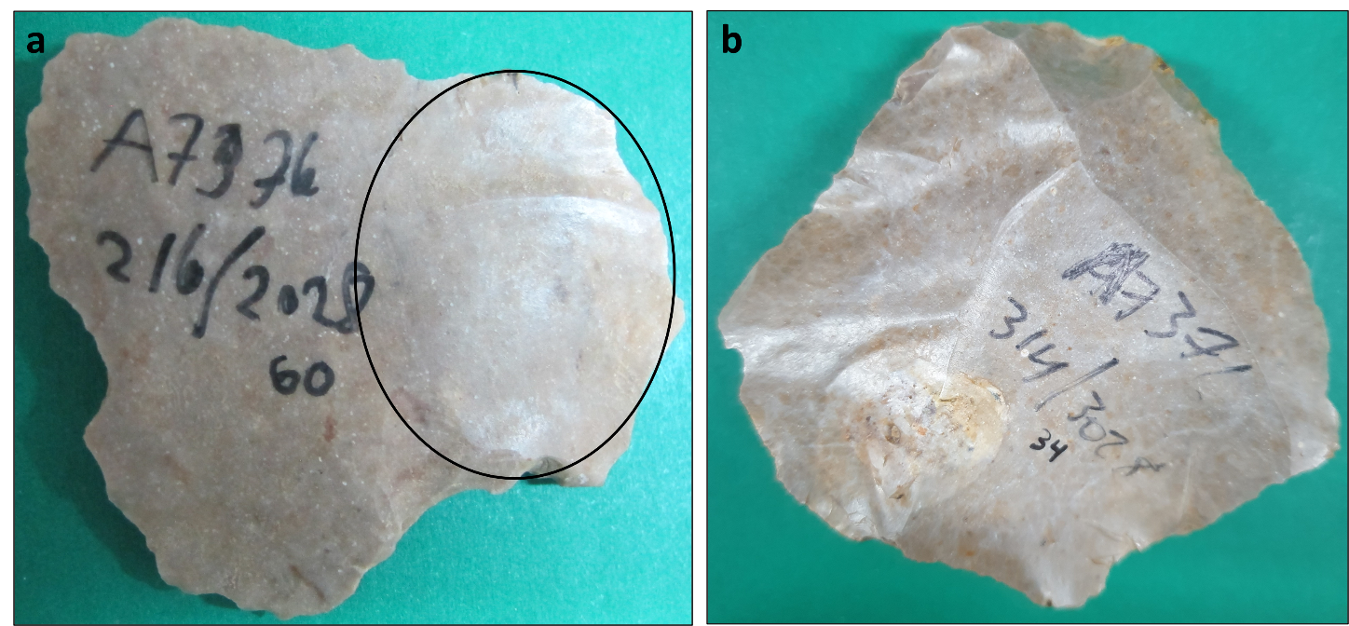
Figure S4.4. Flint artifact showing surface gloss: a- an item showing some gloss on a restricted area (encircled), b- an item showing significant gloss cover.
- Pitting
This term refers to visible spherical pits created on artifact surfaces (Fig. S4.3). The pits can occur in different sizes - from 2mm to several cm in diameter - and in some cases can cause splitting and breakage of the artifact. In most cases the pits result from the impact of thermal processes such as burning or abrupt temperature changes that occur in some arid environments due to large differences between diurnal and nocturnal temperatures (Fig. S4.5a) or from placing the flint items directly into the fire (Fig5.3c) (Knight and Zerboni 2018, Yegorov et al. 2020). Pitting due to thermal damage is usually referred to as: potlidding, potlid fracture/s, potlid scars, or potlid crater/s. Pits can also result from chemical weathering (Burroni et al. 2002). For this analysis items were categorized to three groups according to the number of pits apparent on the item surface (none, some, significant).
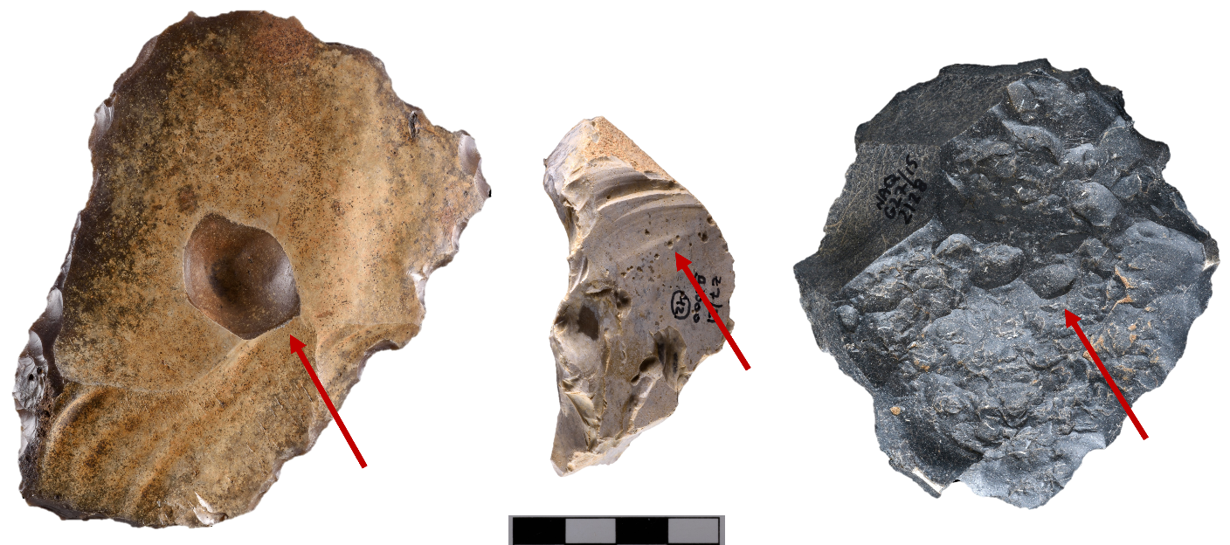
Figure S4.5. examples for Pitting on flint artifacts from the Negev.

Supplementary 5. Statistical tests
χ² tests were used to test meaningful patterning of taphonomy-related conditions within each assemblage (goodness of fit test) and for the comparison between the sites (test of independence). This section details the chosen variables and results for each test. Correlation test was used to test the relationship between every two assemblages for every attribute.
Chi-square goodness of fit test for each taphonomic attribute in each site:
These tests are used to determine whether a categorical variable follows a hypothesized distribution (null hypothesis). In the present study the distribution of the different possible conditions for each taphonomic attribute in each site was tested against the null hypothesis of even distribution. Since we assume each taphonomic condition is the result of specific environmental effects, we suggest they cannot even-up unless the environment causes all the conditions at once. For example, if we have three types of patination on artifacts and they are distributed evenly (each color on third of the artifacts) it is not a meaningful pattern for determining which environmental effect causes which patination. On the other hand, if one or two patina types are significantly more frequent, it may be related to the known environmental conditions at the site. Therefore, the null hypothesis for the test suggests even distribution of taphonomic conditions while the alternative hypothesis is a meaningful pattern created by the environmental effects.
Since the core sample in Nahal Aqev was too small, the core and knapping products assemblages were combined and tested as one assemblage.
The expected values for the null hypothesis were calculated by dividing the number of artifacts in the number of possible conditions and compered with the observed values from the taphonomic lithic analysis. The test was calculated using the formula χ² = Σ(O-E)² / E. The results were checked against the p-value table according to the specific degree of freedom and for α=0.05 in order to reject or except the null hypothesis.
Results
- Breakage
Expected for Null hypothesis- 0.5N, Df=1, Reject H0 if χ2 > 3.84
Valid sample- expected value > 5
- Nahal Aqev
 | Not broken | Broken | total
Observed | 635 | 844 | 1479
Expected | 739.5 | 739.5 | 1479
χ²= 29.53414469, p-value: 0.000000
Null hypothesis rejected – suggesting a meaningful pattern for item breakage.
- Nahal Yitnan
 | Not broken | Broken | total
Observed | 85 | 64 | 149
Expected | 74.5 | 74.5 | 149
χ²= 2.95973154, p-value: 0.085362
Null hypothesis not rejected- the breakage condition distribution is not significantly different from even distribution.
- Giv’at Barne’a
 | Not broken | Broken | total
Observed | 93 | 52 | 145
Expected | 72.5 | 72.5 | 67
χ²= 11.5931034, p-value 0.000662
Null hypothesis rejected- suggesting a meaningful pattern for item breakage.
- Preservation
Expected for Null hypothesis=0.33N, Df=2, Reject H0 if χ2 > 5.99
Valid sample- expected value > 5
- Nahal Aqev
 | Fresh | Partly abraded | Highly abraded | total
Observed | 1449 | 29 | 1 | 1479
Expected | 493 | 493 | 493 | 1479
χ²= 2781.53347, p-value: 0.000000
Null hypothesis rejected- suggesting a meaningful pattern for preservation conditions.
- Nahal Yitnan
 | Fresh | Partly abraded | Highly abraded | total
Observed | 79 | 68 | 2 | 149
Expected | 49.66666667 | 49.66666667 | 49.66666667 | 149
χ²= 69.8389262, p-value: 0.000000
Null hypothesis not rejected- suggesting a meaningful pattern for preservation conditions.
- Giv’at Barne’a
 | Fresh | Partly abraded | Highly abraded | total
Observed | 49 | 83 | 12 | 144
Expected | 48 | 48 | 48 | 144
χ²= 52.5416667, p-value 0.000000
Null hypothesis rejected- suggesting a meaningful pattern for preservation conditions.
- Edge damage
Expected for Null hypothesis=0.25N, Df=3, Reject H0 if χ2 > 7.82
Valid sample- expected value > 5
- Nahal Aqev
 | No breakage | Minimal breakage | Significant breakage | High breakage | total
Observed | 734 | 530 | 51 | 1 | 1316
Expected | 329 | 329 | 329 | 329 | 1316
χ²= 1183.26444, p-value: 0.000000
Null hypothesis rejected- suggesting a meaningful pattern for the level of edge breakage.
- Nahal Yitnan
 | No breakage | Minimal breakage | Significant breakage | High breakage | total
Observed | 6 | 34 | 78 | 31 | 149
Expected | 37.25 | 37.25 | 37.25 | 37.25 | 149
χ²= 72.1275168, p-value: 0.000000
Null hypothesis rejected- suggesting a meaningful pattern for the level of edge breakage.
- Giv’at Barne’a
 | No breakage | Minimal breakage | Significant breakage | High breakage | total
Observed | 7 | 43 | 66 | 28 | 144
Expected | 36 | 36 | 36 | 36 | 144
χ²= 51.5, p-value 0.000000
Null hypothesis rejected- suggesting a meaningful pattern for the level of edge breakage.
- Patina
Expected for Null hypothesis=0.33N, Df=2, Reject H0 if χ2 > 5.99
Valid sample- expected value > 5
- Nahal Aqev
 | Not Patinated | Patinated | Double Patina | total
Observed | 1227 | 250 | 2 | 1479
Expected | 493 | 493 | 493 | 1479
χ²= 1701.59432, p-value: 0.000000
Null hypothesis rejected - suggesting a meaningful pattern for patination
- Nahal Yitnan
 | Not Patinated | Patinated | Double Patina | total
Observed | 34 | 114 | 1 | 149
Expected | 49.66666667 | 49.66666667 | 49.66666667 | 149
χ²= 135.959732, p-value: 0.000000
Null hypothesis rejected - suggesting a meaningful pattern for patination
- Giv’at Barne’a
 | Not Patinated | Patinated | Double Patina | total
Observed | 2 | 141 | 1 | 144
Expected | 48 | 48 | 48 | 144
χ²= 270.291667, p-value 0.000000
Null hypothesis rejected - suggesting a meaningful pattern for patination
- Patina type
Expected for Null hypothesis=0.25N, Df=3, Reject H0 if χ2 > 7.82
Valid sample- expected value > 5
- Nahal Aqev
 | White | White stains | Desert varnish | Black/Grey | total
Observed | 55 | 98 | 3 | 96 | 252
Expected | 63 | 63 | 63 | 63 | 252
χ²= 94.8888889, p-value: 0.000000
Null hypothesis rejected - suggesting a meaningful pattern for patina types
- Nahal Yitnan
 | White | White stains | Desert varnish | Black/Grey | total
Observed | 72 | 35 | 6 | 2 | 115
Expected | 28.75 | 28.75 | 28.75 | 28.75 | 115
χ²= 109.313043, p-value: 0.000000
Null hypothesis rejected - suggesting a meaningful pattern for patina types
- Giv’at Barne’a
 | White | White stains | Desert varnish | Black/Grey | total
Observed | 33 | 6 | 1.3 | 0 | 142
Expected | 35.5 | 35.5 | 35.5 | 35.5 | 142
χ²= 188.535211, p-value 0.000000
Null hypothesis rejected - suggesting a meaningful pattern for patina types
- Patina side
Expected for Null hypothesis=0.33N, Df=2, Reject H0 if χ2 > 5.99
Valid sample- expected value > 5
- Nahal Aqev
 | Flaking /Dorsal | Preparation /Ventral | Both | total
Observed | 4 | 11 | 237 | 252
Expected | 84 | 84 | 84 | 252
χ²= 418.309524, p-value: 0.000000
Valid sample- expected >
Null hypothesis rejected - suggesting a meaningful pattern for patination side
- Nahal Yitnan
 | Flaking /Dorsal | Preparation /Ventral | Both | total
Observed | 10 | 1 | 104 | 115
Expected | 38.33333333 | 38.33333333 | 38.33333333 | 115
χ²= 169.791304, p-value: 0.000000
Null hypothesis rejected - suggesting a meaningful pattern for patination side
- Giv’at Barne’a
 | Flaking /Dorsal | Preparation /Ventral | Both | total
Observed | 8 | 0 | 133 | 141
Expected | 47 | 47 | 47 | 141
χ²= 236.723404, p-value 0.000000
Null hypothesis rejected - suggesting a meaningful pattern for patination side
- Gloss
Expected for Null hypothesis=0.33N, Df=2, Reject H0 if χ2 > 5.99
Valid sample- expected value > 5
- Nahal Aqev
 | No gloss | Some gloss | Significant gloss | total
Observed | 158 | 60 | 6 | 224
Expected | 74.66666667 | 74.66666667 | 74.66666667 | 224
χ²= 159.035714, p-value: 0.000000
Null hypothesis rejected - suggesting a meaningful pattern for the level of gloss
- Nahal Yitnan
 | No gloss | Some gloss | Significant gloss | total
Observed | 13 | 28 | 108 | 149
Expected | 49.66666667 | 49.66666667 | 49.66666667 | 149
χ²= 105.033557, p-value: 0.000000
Null hypothesis rejected - suggesting a meaningful pattern for the level of gloss
- Giv’at Barne’a
 | No gloss | Some gloss | Significant gloss | total
Observed | 55 | 59 | 30 | 144
Expected | 48 | 48 | 48 | 144
χ²= 10.2916667, p-value 0.005824
Null hypothesis rejected - suggesting a meaningful pattern for the level of gloss
- Pitting
Expected for Null hypothesis=0.33N, Df=2, Reject H0 if χ2 > 5.99
Valid sample- expected value > 5
- Nahal Aqev
 | No pitting | Some pitting | Significant pitting | total
Observed | 224 | 0 | 0 | 224
Expected | 74.66666667 | 74.66666667 | 74.66666667 | 224
χ²= 448, p-value: 0.000000
Null hypothesis rejected - suggesting a meaningful pattern for pitting frequencies
- Nahal Yitnan
 | No pitting | Some pitting | Significant pitting | total
Observed | 146 | 3 | 0 | 149
Expected | 49.66666667 | 49.66666667 | 49.66666667 | 149
χ²= 280.362416, p-value: 0.000000
Null hypothesis rejected - suggesting a meaningful pattern for pitting frequencies
- Giv’at Barne’a
 | No pitting | Some pitting | Significant pitting | total
Observed | 106 | 30 | 8 | 144
Expected | 48 | 48 | 48 | 144
χ²= 110.166667, p-value 0.000000
Null hypothesis rejected - suggesting a meaningful pattern for pitting frequencies
In summary, the χ² tests showed that the distribution is significantly different from the even distribution hypothesis (Null Hypothesis) for all attributes in all sites apart from item breakage in Nahal Yitnan 7, where the observed distribution is not significantly different from even distribution. This may support the alternative hypothesis of meaningful distribution of taphonomic conditions due to different environmental effects.

Chi-square (χ²) tests of independence for the comparison between the sites:
Chi-Square test of independence can be used to determine if there is an association between two categorical variables in a many different settings. In our case we used them to examine the differences between the three sites in the distribution of taphonomic conditions. Null hypothesis is that the two variables (taphonomic condition and site) are independent, and the alternative hypothesis is they are associated- meaning each site shows its own patterning that is significantly different from the others.
For some of the taphonomic conditions sample size was not sufficient for valid results. In these cases, few of the categories for each condition were combined in order to test some differences between sites that can still be considered as meaningful when associated with environmental effects. The categories combined were: partly and highly abraded artifacts (against fresh artifacts) patinated and double patinated items (against non-patinated), artifacts sowing patination on one side only were combined (as opposed to two sides) and artifacts with any amount of pitting (as opposed to no pitting).
The expected values for the tests were calculated for each taphonomic condition: the sum of all items in showing specific taphonomic condition multiplied by the sum of items for a specific site and divided by the total sample [Expected value = (row sum * column sum) / table sum]. This calculation supports the null hypothesis by giving proportional frequencies of taphonomic conditions for the three sites.
Then the expected values were compared with the observed values from the lithic analysis and the significance was tested using χ² test. The test results were calculated using the formula χ² = Σ(O-E)² / E . The results were checked against the p-value table according to the specific degree of freedom and for α=0.05 in order to reject or except the null hypothesis.
Results
- Breakage
Df=2, Reject H0 if χ2 > 5.99
Valid sample- expected value > 5
 | Not broken | Broken | total
Nahal Aqev observed | 635 | 844 | 1479
Nahal Aqev expected | 678.19 | 800.819
Nahal Yitnan observed | 85 | 64 | 149
Nahal Yitnan expected | 68.329 | 80.68
Giv’at Barne’a observed | 93 | 52 | 145
Giv’at Barne’a expected | 66.49 | 78.51
total | 813 | 960 | 1773
χ²= 32.11995892, p-value: 0.000000
Null hypothesis rejected
- Preservation
Df=4, Reject H0 if χ2 > 9.49
Valid sample- expected value > 5
 | Fresh | Partly abraded | Highly abraded | total
Nahal Aqev observed | 1449 | 29 | 1 | 1479
Nahal Aqev expected | 1316.24 | 150.24 | 12.52
Nahal Yitnan observed | 79 | 68 | 2 | 149
Nahal Yitnan expected | 132.60 | 15.13 | 1.26
Giv’at Barne’a observed | 49 | 83 | 12 | 144
Giv’at Barne’a expected | 128.15 | 14.62 | 1.21
total | 1577 | 180 | 15 | 1772
The values in some cells are too small. Test is invalid
χ²= 792.3986948, p-value: 0.000000
combined attributes:
Df=2, Reject H0 if χ2 > 5.99
 | Fresh | abraded | total
Nahal Aqev observed | 1449 | 30 | 1479
Nahal Aqev expected | 1316.24 | 162.76
Nahal Yitnan observed | 79 | 70 | 149
Nahal Yitnan expected | 132.60 | 16.40
Giv’at Barne’a observed | 49 | 95 | 144
Giv’at Barne’a expected | 128.15 | 15.85
total | 1577 | 195 | 1772
χ²= 762.8434, p-value: 0.000000
Null hypothesis rejected
- Edge Damage
Df=6, Reject H0 if χ2 > 12.6
Valid sample- expected value > 5
 | No brakage | Minimal breakage | Significant breakage | High breakage | total
Nahal Aqev observed | 734 | 530 | 51 | 1 | 1316
Nahal Aqev expected | 610.97 | 496.46 | 159.49 | 49.07
Nahal Yitnan observed | 6 | 34 | 78 | 31 | 149
Nahal Yitnan expected | 69.17 | 56.21 | 18.06 | 5.56
Giv’at Barne’a observed | 7 | 43 | 66 | 28 | 144
Giv’at Barne’a expected | 66.85 | 54.32 | 17.45 | 5.37
total | 747 | 607 | 195 | 60 | 1609
χ²= 816.2669682, p-value: 0.000000
Null hypothesis rejected
- Patina
Df=4, Reject H0 if χ2 > 9.49
Valid sample- expected value > 5
 | Not patinated | Patinated | Double patina | total
Nahal Aqev observed | 1227 | 250 | 2 | 1479
Nahal Aqev expected | 1054.16 | 421.50 | 3.34
Nahal Yitnan observed | 34 | 114 | 1 | 149
Nahal Yitnan expected | 106.204 | 42.464 | 0.34
Giv’at Barne’a observed | 2 | 141 | 1 | 144
Giv’at Barne’a expected | 102.64 | 41.04 | 0.33
total | 1263 | 505 | 4 | 1772
The values in some cells are too small. Test is invalid
χ²= 613.1283017, p-value: 0.000000
combined attributes:
Df=2, Reject H0 if χ2 > 5.99
 | Not patinated | Patinated | total
Nahal Aqev observed | 1227 | 252 | 1479
Nahal Aqev expected | 1054.16 | 424.84
Nahal Yitnan observed | 34 | 115 | 149
Nahal Yitnan expected | 106.20 | 42.80
Giv’at Barne’a observed | 2 | 142 | 144
Giv’at Barne’a expected | 102.64 | 41.36
total | 1263 | 509 | 1772
χ²= 613.0588, p-value: 0.000000
Null hypothesis rejected
- Patina Type
Df=6, Reject H0 if χ2 > 12.6
Valid sample- expected value > 5
 | White | White spots | Desert brown | Black/grey | total
Nahal Aqev observed | 55 | 98 | 3 | 96 | 252
Nahal Aqev expected | 79.21 | 68.82 | 55.45 | 48.52
Nahal Yitnan observed | 72 | 35 | 6 | 2 | 115
Nahal Yitnan expected | 36.1 | 31.40 | 25.30 | 22.14
Giv’at Barne’a observed | 33 | 6 | 103 | 0 | 142
Giv’at Barne’a expected | 4 | 38.78 | 31.25 | 27.34
total | 160 | 139 | 112 | 98 | 509
χ²= 407.7322757, p-value: 0.000000
Null hypothesis rejected
- Patina side
Df=4, Reject H0 if χ2 > 9.49
Valid sample- expected value > 5
 | Flaking /Dorsal | Preparation /Ventral | Both | total
Nahal Aqev observed | 4 | 11 | 237 | 252
Nahal Aqev expected | 10.91 | 5.95 | 235.13
Nahal Yitnan observed | 10 | 1 | 104 | 115
Nahal Yitnan expected | 4.98 | 2.72 | 107.30
Giv’at Barne’a observed | 8 | 0 | 133 | 141
Giv’at Barne’a expected | 6.11 | 3.33 | 131.56
total | 22 | 12 | 474 | 508
The values in some cells are too small. Test is invalid
χ²= 18.85314486, p-value: 0.000840
combined attributes:
Df=2, Reject H0 if χ2 > 5.99
 | one side | two sides | total
Nahal Aqev observed | 15 | 237 | 252
Nahal Aqev expected | 16.87 | 235.13
Nahal Yitnan observed | 11 | 104 | 115
Nahal Yitnan expected | 7.70 | 107.30
Giv’at Barne’a observed | 8 | 133 | 141
Giv’at Barne’a expected | 9.44 | 131.56
total | 34 | 474 | 508
χ²= 1.975051, p-value: 0.372497
Null hypothesis not rejected
- Gloss
Df=4, Reject H0 if χ2 > 9.49
Valid sample- expected value > 5
 | Non | Some | Significant | total
Nahal Aqev observed | 158 | 60 | 6 | 224
Nahal Aqev expected | 97.92 | 63.69 | 62.39
Nahal Yitnan observed | 13 | 28 | 108 | 149
Nahal Yitnan expected | 65.13 | 42.37 | 41.50
Giv’at Barne’a observed | 55 | 59 | 30 | 144
Giv’at Barne’a expected | 62.95 | 40.94 | 40.11
total | 226 | 147 | 144 | 517
χ²= 252.7140226, p-value: 0.000000
Null hypothesis rejected
- Pitting
Df=4, Reject H0 if χ2 > 9.49
Valid sample- expected value > 5
 | Non | Some | Significant | total
Nahal Aqev observed | 224 | 0 | 0 | 224
Nahal Aqev expected | 206.24 | 14.30 | 3.47
Nahal Yitnan observed | 146 | 3 | 0 | 149
Nahal Yitnan expected | 137.18 | 9.51 | 2.31
Giv’at Barne’a observed | 106 | 30 | 8 | 144
Giv’at Barne’a expected | 132.58 | 9.19 | 2.23
total | 476 | 33 | 8 | 517
The values in some cells are too small. Test is invalid
χ²= 94.01080538, p-value: 0.000000
combined attributes:
Df=2, Reject H0 if χ2 > 5.99
 | No pitting | pitting | total
Nahal Aqev observed | 224 | 0 | 224
Nahal Aqev expected | 206.24 | 17.76
Nahal Yitnan observed | 146 | 3 | 149
Nahal Yitnan expected | 137.18 | 11.82
Giv’at Barne’a observed | 106 | 38 | 144
Giv’at Barne’a expected | 132.58 | 11.42
total | 476 | 41 | 517
χ²= 93.6351, p-value: 0.000000
Null hypothesis rejected
In summary, the χ² tests showed that the sites differ from each other for all taphonomic conditions except patina side, where the null hypothesis was not rejected. Therefore, most of the results support the alternative hypothesis, suggesting different patterns of taphonomic conditions for each site.
Correlation tests between sites:
The correlation between each site to the others was checked further using an ordinal correlation test, expressing the similarities or dissimilarities between the attribute distribution of each pair of sites in numeric values between -1 and 1. Test results by attribute are presented in the following tables.
- Breakage
 | N.Aqev | N.Yitnan | G.Barne'a
N.Aqev | 1
N.Yitnan | 0.887238744 | 1
G.Barne'a | 0.767761713 | 0.976765965 | 1

- Surface Abrasion
 | N.Aqev | N.Yitnan | G.Barne'a
N.Aqev | 1
N.Yitnan | 0.623304629 | 1
G.Barne'a | 0.041286735 | 0.807046567 | 1

- Edge Damage
 | N.Aqev | N.Yitnan | G.Barne'a
N.Aqev | 1
N.Yitnan | -0.698433875 | 1
G.Barne'a | -0.597571035 | 0.966006976 | 1

- Patina
 | N.Aqev | N.Yitnan | G.Barne'a
N.Aqev | 1
N.Yitnan | -0.043008428 | 1
G.Barne'a | -0.319060608 | 0.960579679 | 1

- Patina Type
 | N.Aqev | N.Yitnan | G.Barne'a
N.Aqev | 1
N.Yitnan | 0.081902184 | 1
G.Barne'a | -0.985549473 | -0.191547477 | 1

- Patina side
 | N.Aqev | N.Yitnan | G.Barne'a
N.Aqev | 1
N.Yitnan | 0.994453373 | 1
G.Barne'a | 0.996796587 | 0.999679738 | 1

- Gloss
 | N.Aqev | N.Yitnan | G.Barne'a
N.Aqev | 1
N.Yitnan | -0.856776154 | 1
G.Barne'a | 0.684558139 | -0.962428479 | 1

- Pitting
 | N.Aqev | N.Yitnan | G.Barne'a
N.Aqev | 1
N.Yitnan | 0.999838403 | 1
G.Barne'a | 0.976850043 | 0.980537891 | 1

References
Aitken, M.J., 1985. Thermoluminescence Dating. Academic Press, London.
Barzilai, O., Oron, M., Porat, N., White, D., Timms, R., Blockley, S., Zular, A., Avni, Y., Faershtein, G., Weiner, S., 2022. Expansion of eastern Mediterranean Middle Paleolithic into the desert region in early marine isotopic stage 5. Scientific reports 12, 4466. doi:10.1038/s41598-022-08296-9
Burroni, D., Donahue, R.E., Pollard, A.M., Mussi, M., 2002. The surface alteration features of flint artefacts as a record of environmental processes. Journal of Archaeological Science 29, 1277–1287. doi:10.1006/jasc.2001.0771
Caux, S., Galland, A., Queffelec, A., Bordes, J. G., 2018. Aspects and characterization of chert alteration in an archaeological context: a qualitative to quantitative pilot study. Journal of Archaeological Science: Reports 20, 210–219. doi:10.1016/j.jasrep.2018.04.027
Crouvi, O., Amit, R., Enzel, Y., Porat, N., Sandler, A., 2008. Sand dunes as a major proximal dust source for late Pleistocene loess in the Negev Desert, Israel. Quaternary Research 70, 275–282. doi:10.1016/j.yqres.2008.04.011
Crouvi, O., Amit, R., Porat, N., Gillespie, A.R., McDonald, E.V., Enzel, Y., 2009. Significance of primary hilltop loess in reconstructing dust chronology, accretion rates, and sources: An example from the Negev Desert, Israel. Journal of Geophysical Research: Earth Surface 114. doi:10.1029/2008JF001083
Dibble, H.L., Chase, P.G., McPherron, S.P., Tuffreau, A., 1997. Testing the reality of a “living floor” with archaeological data. American Antiquity 62, 629–651. doi:10.2307/281882
Dorn, R.I., 2013. Rock coatings. In: Pope, G.A. (Ed.), Treatise on Geomorphology. Academic Press, San Diego, pp. 70–97.
Enzel, Y., Amit, R., Dayan, U., Crouvi, O., Kahana, R., Ziv, B., Sharon, D., 2008. The climatic and physiographic controls of the eastern Mediterranean over the late Pleistocene climates in the southern Levant and its neighboring deserts. Global and Planetary Change 60, 165–192. doi:10.1016/j.gloplacha.2007.02.003
Eren, M.I., Durant, A., Neudorf, C., Haslam, M., Shipton, C., Bora, J., Korisettar, R., Petraglia, M., 2010. Experimental examination of animal trampling effects on artifact movement in dry and water saturated substrates: a test case from South India. Journal of Archaeological Science 37, 3010–3021. doi:10.1016/j.jas.2010.06.024
Eren, M.I., Boehm, A.R., Morgan, B.M., Anderson, R., Andrews, B., 2011. Flaked stone taphonomy: a controlled experimental study of the effects of sediment consolidation on flake edge morphology. Journal of Taphonomy 9, 201–217.
Faershtein, G., Porat, N., Avni, Y., Matmon, A., 2016. Aggradation–incision transition in arid environments at the end of the Pleistocene: an example from the Negev Highlands, southern Israel.. Geomorphology 253, 289–304. doi:10.1016/j.geomorph.2015.10.017
Fiers, G., Halbrucker, É., De Kock, T., Vandendriessche, H., Crombé, P., Cnudde, V., 2021. Thermal Alteration of Flint: An Experimental Approach to Investigate the Effect on Material Properties. Lithic Technology 46, 27–44. doi:10.1080/01977261.2020.1805215
Friedmann, E., Goren-Inbar, N., Rosenfeld, A., Marder, O., Burian, F., 1995. Hafting during Mousterian times-further indication. Journal of the Israel Prehistoric Society 26, 8–31.
Galbraith, R.F., Roberts, R.G., 2012. Statistical aspects of equivalent dose and error calculation and display in OSL dating: an overview and some recommendations. Quaternary Geochronology 11, 1–27. doi:10.1016/j.quageo.2012.04.020
Galland, A., Queffelec, A., Caux, S., Bordes, J.-G., 2019. Quantifying lithic surface alterations using confocal microscopy and its relevance for exploring the Châtelperronian at La Roche-à-Pierrot (Saint-Césaire, France). Journal of Archaeological Science 104, 45–55.
Goldsmith, Y., Enzel, Y., Stein, M., 2012. Systematic Mn fluctuations in laminated rock varnish developed on coeval early Holocene flint artifacts along a climatic transect, Negev desert, Israel. Quaternary Research 78, 474–485. doi:10.1016/j.yqres.2012.07.009
Goldsmith, Y., Stein, M., Enzel, Y., 2014. From dust to varnish: Geochemical constraints on rock varnish formation in the Negev Desert, Israel. Geochimica et cosmochimica acta 126, 97–111. doi:10.1016/j.gca.2013.10.040
Grosman, L., Sharon, G., Goldman-Neuman, T., Smikt, O., Smilansky, U., 2011. Studying post depositional damage on Acheulian bifaces using 3-D scanning. Journal of human evolution 60, 398–406. doi:10.1016/j.jhevol.2010.02.004
Halbrucker, É., Fiers, G., Vandendriessche, H., De Kock, T., Cnudde, V., Crombé, P., 2021. Burning flint: An experimental approach to study the effect of fire on flint tools. Journal of Archaeological Science: Reports 36, 102854.
Herzlinger, G., Pinsky, S., Goren-Inbar, N., 2015. A note on handaxe knapping products and their breakage taphonomy: An experimental view. Journal of Lithic Studies 2, 65–82.
Honea, K.H., 1964. The patination of stone artifacts. Plains Anthropologist 9, 14–17. doi:10.1080/2052546.1964.11908372
Hovers, E., 2003. Treading Carefully: Site Formation Processes and Pliocene Lithic Technology. In: Martínez-Moreno, J., Torcal, R.M., Torre, I. de la (Eds.), Oldowan: Rather More than Smashing Stones: First Hominid Technology Workshop. Universitat Autònoma de Barcelona, Centre d’Estudis del Patrimoni Arqueològic de la Prehistòria, Barcelona, pp. 145–164.
Hovers, E., Ekshtain, R., Greenbaum, N., Malinsky-Buller, A., Nir, N., Yeshurun, R., 2014. Islands in a stream? Reconstructing site formation processes in the late Middle Paleolithic site of ‘Ein Qashish, northern Israel. Quaternary International, Opportunities, problems and future directions in the study of open-air Middle Paleolithic sites 331, 216–233. doi:10.1016/j.quaint.2014.01.028
Howard, C.D., 1999. River patina on flint artifacts: Features and genesis. Plains Anthropologist 44, 293–295. doi:10.1080/2052546.1999.11931922
Howard, C.D., 2002. The gloss patination of flint artifacts. Plains anthropologist 47, 283–287. doi:10.1080/2052546.2002.11932098
Hurst, V.J., Kelly, A.R., 1961. Patination of Cultural Flints: Flint artifacts can be dated by cortical changes in mineralogy and texture. Science 134, 251–256. doi:10.1126/science.134.3474.251
Jennings, T.A., 2011. Experimental production of bending and radial flake fractures and implications for lithic technologies. Journal of Archaeological Science 38, 3644–3651. doi:10.1016/j.jas.2011.08.035
Kidron, G.J., Zohar, M., Starinsky, A., 2014. Spatial distribution of dust deposition within a small drainage basin: Implications for loess deposits in the Negev Desert. Sedimentology 61, 1908–1922. doi:10.1111/sed.12121
Knight, J., Zerboni, A., 2018. Formation of desert pavements and the interpretation of lithic-strewn landscapes of the central Sahara. Journal of Arid Environments 153, 39–51. doi:10.1016/j.jaridenv.2018.01.007
Lucke, B., Bäumler, R., 2021. Holocene dust dynamics archives in archaeological ruins in arid and semi-arid environments in the Southern Levant. Arabian Journal of Geosciences 14, 1–15. doi:10.1007/s12517-021-08884-5
Lucke, B., Roskin, J., Vanselow, K.A., Bruins, H.J., Abu-Jaber, N., Deckers, K., Lindauer, S., Porat, N., Reimer, P.J., Bäumler, R., 2019. Character, rates, and environmental significance of Holocene Dust accumulation in archaeological Hilltop Ruins in the southern Levant. Geosciences 9, 190. doi:10.3390/geosciences9040190
McBrearty, S., Bishop, L., Plummer, T., Dewar, R., Conard, N., 1998. Tools underfoot: human trampling as an agent of lithic artifact edge modification. American Antiquity 63, 108–129. doi:10.2307/2694779
Murray, A.S., Wintle, A.G., 2000. Luminescence dating of quartz using an improved single-aliquot regenerative-dose protocol. Radiation measurements 32, 57–73. doi:10.1016/S1350-4487(99)00253-X
Nadel, D., Gordon, D., 1993. Patination of Flint Artefacts: Evidence from Bikta, A Submerged Prehistoric Occurrence in the Sea of Galilee, Israel. Mitekufat Haeven: Journal of the Israel Prehistoric Society 25, 145–162.
Oron, M., Groman-Yaroslavski, I., Lavi, R., Porat, N., Roskin, J., 2019. Mitzpe Ramon: A Flint Quarry and Blade Production Workshop Dated to the Early Late Neolithic in the Central Negev Highlands, Israel. Mitekufat Haeven: Journal of the Israel Prehistoric Society 49, 100–118.
Roskin, J., 2018. The Yatir 1 site: 2014 excavation - geoarchaeological report and geomorphological analysis of the site and its environs (Internal report for the IAA).
Roskin, J., Bowman, D., Eyal, Y., Porat, N., 2018. Opening stages of tension fractures upon the western margin of the Dead Sea Rift based on OSL age estimates of their sediment fill [Conference presentation]. In: EGU General Assembly Conference Abstracts. p. 3846.
Rottländer, R., 1975. The Formation of Patina on Flint. Archaeometry 17, 106–110. doi:10.1111/j.1475-4754.1975.tb00120.x
Thiry, M., Fernandes, P., Milnes, A., Raynal, J.-P., 2014. Driving forces for the weathering and alteration of silica in the regolith: Implications for studies of prehistoric flint tools. Earth-Science Reviews 136, 141–154.
Yegorov, D., Marder, O., Khalaily, H., Milevski, I., Rosen, S.A., 2020. Heat treated or not heat treated: Archaeological and experimental interpretation of flint assemblage from the Middle Pre-Pottery Neolithic B site of Yiftahel. Journal of Archaeological Science: Reports 29, 102090.

