Table S1: Details of the luminescence dating measurements. A burial mean water content of 3 ± 3 % was applied following Helm et al. (2022). The Central Age Model (CAM) weighted mean equivalent dose (Galbraith et al., 1999) was used to calculate sample ages. *outliers removed prior to averaging (see Figure S1)
Lab code | Field code | Burial depth (m) | Measured water content (%) | Applied water content (%) | Grain size (µm) | Aliquots accepted / measured | CAM D_{e} (Gy) | OD (%) | Total dose rate  (Gy ka⁻¹) | Age (ka)
Leic20033 | Horse | 70 | 0.5 | 3 ± 3 | 150-250 | 20/20 | 40.6 ± 1.9 | 13 ± 3 | 0.25 ± 0.02 | 161 ± 12
Leic21005 | Mole | 70 | 5.2 | 5 ± 3 | 180-250 | 18/20 | 68.2 ± 3.1 | 11 ± 4 | 0.54 ± 0.03 | 126 ± 9
Leic21003 | Robberg 1 | 10 | 0.4 | 3 ± 3 | 180-250 | 20/22 | 69.0 ± 3.7 | 17 ± 4 | 1.23 ± 0.07 | 56 ± 5
Leic21004 | Robberg 2 | 10 | nd. | 3 ± 3 | 150-250 | 23/24 | 83.9 ± 4.4* | 16 ± 3 | 1.96 ± 0.15 | 43 ± 4
Leic20028 | Robberg 3 | 10 | 0.5 | 3 ± 3 | 150-250 | 23/30 | 60.9 ± 3.5* | 18 ± 4 | 1.39 ± 0.09 | 44 ± 4

Table S2: Details of the measured elemental concentrations and dose rate calculations. ªan internal alpha dose rate was included following Jacobs et al. (2003). Relative uncertainties of 10% (U and Th) and 5% (K) were applied to the elemental concentrations and were propagated to the final dose rate uncertainties. External gamma and beta doses were corrected for water content (Aitken, 1985), external beta doses were also corrected for grain size (Mejdahl, 1979) and HF etching (Bell, 1979). The external beta dose rates were evaluated using GM beta counting on a dried and powdered sub-sample (Bøtter-Jensen and Mejdahl, 1988; Jacobs and Roberts, 2015). Cosmic dose rates were calculated using the Luminescence R package (Kreutzer et al., 2012, 2022), a calculation itself based on Prescott and Hutton (1994).
Lab code |  | U  (ppm) | Th  (ppm) | K  (%) | Internal alpha dose rate  (Gy ka⁻¹)ª | External beta dose rate (ICP-MS)  (Gy ka⁻¹) | External gamma dose rate  (Gy ka⁻¹) | Cosmic dose rate  (Gy ka⁻¹) | Total Dose rate  (Gy ka⁻¹)
Leic20033 | Horse | 0.6 | 0.6 | 0.05 | 0.036 ± 0.01 | 0.109 ± 0.008 | 0.102 ± 0.008 | 0.005 ± 0.001 | 0.25 ± 0.02
Leic21005 | Mole | 1.4 | 1.4 | 0.11 | 0.036 ± 0.01 | 0.257 ± 0.020 | 0.242 ± 0.018 | 0.005 ± 0.001 | 0.54 ± 0.03
Leic21003 | Robberg 1 | 4.0 | 1.3 | 0.19 | 0.036 ± 0.01 | 0.588 ± 0.054 | 0.533 ± 0.049 | 0.074 ± 0.007 | 1.23 ± 0.07
Leic21004 | Robberg 2 | 7.9 | 0.4 | 0.09 | 0.036 ± 0.01 | 0.955 ± 0.108 | 0.891 ± 0.096 | 0.074 ± 0.007 | 1.96 ± 0.15
Leic20028 | Robberg 3 | 4.8 | 0.7 | 0.18 | 0.036 ± 0.01 | 0.677 ± 0.067 | 0.601 ± 0.060 | 0.074 ± 0.007 | 1.39 ± 0.09
 |  |  |  |  |  | External beta dose rate beta counting (Gy ka⁻¹)
Leic20033 | Horse |  |  |  |  | 0.10 ± 0.06
Leic21005 | Mole |  |  |  |  | 0.31 ± 0.07
Leic21003 | Robberg 1 |  |  |  |  | 0.59 ± 0.07
Leic21004 | Robberg 2 |  |  |  |  | 0.93 ± 0.08
Leic20028 | Robberg 3 |  |  |  |  | Nd.

EQUIVALENT DOSE DISTRIBUTIONS
Figure S1: Radial plots showing the measured equivalent dose distributions, created with the Radial Plotter software (Vermeesch, 2009). Filled circles represent aliquots identified as outliers using the Normalised Median Absolute Deviation (nMAD e.g. Clarkson et al. 2017)

SAMPLE PREPARATION

Block samples were shipped to the University of Leicester (UK), were spray painted black and broken up under red light conditions. Analyses were undertaken on coarse-grained quartz (usually in the range 180-250 µm). Samples were treated with dilute HCl to remove carbonates and 30% H₂O₂ to remove organic matter. The fraction > 2.58 g cm⁻³ and < 2.7 g cm⁻³ was etched in 48% HF for 45 minutes and then treated with HCl for one hour. The remaining material was repeatedly rinsed in deionised water and re-sieved to the selected grain size range.

INSTRUMENTATION AND EQUIVALENT DOSE MEASUREMENT

Measurements were undertaken using a Risoe DA20 TL/OSL reader using small (2 mm) multi-grain aliquots of quartz. Optical stimulation was provided by blue LEDS (wavelength 470 nm, 40 seconds at 125°C), detected via a Hoya U-340 detection filter. Laboratory irradiations were delivered by a calibrated ⁹⁰Sr beta source. Equivalent doses (D_{e}) were determined using the Single Aliquot Regeneration (SAR) protocol (Murray and Wintle, 2000, 2003; Wintle and Murray, 2006). This comprised 6 or 7 regeneration points, a repeat (recycling) regeneration dose point, an IR depletion ratio regeneration point (Duller, 2003) and a zero-dose point. Aliquots were rejected from the analyses, prior to calculation of the sample equivalent dose if: 1) recycling ratios were outside of 10% of unity, 2) recuperation (zero dose) L_{x}/T_{x} values were greater than 5% of the natural sensitivity-corrected OSL signal, 3) a significant reduction in the sensitivity-corrected OSL signal after infra-red stimulation (Duller, 2003). All analyses were undertaken in the Risoe Analyst software (Duller, 2007). OSL signal integration windows comprised the first 0.8 seconds of stimulation and a background” subtraction from the last 3.2 seconds of measurement. The dose-response curves were fitted with saturating exponential plus linear fits. D_{e} uncertainties were all calculated using Monte Carlo methods (1000 iterations, following Duller 2007) (Table S1).

DOSE RATE DETERMINATION

Dose rates were determined from U, Th and K concentrations (Table S2). These were estimated using several tens of grams of block sample material via inductively coupled plasma mass spectrometry (ICP-MS; U and Th) and ICP-OES (K). These were converted to annual dose rates following the conversion factors provided by Guerin et al. (2011).

REFERENCES

Aitken, M.J., 1985. Thermoluminescence Dating. Academic Press, London, 370 pp.

Bell, W.T., 1979. Thermoluminescence dating: radiation dose rate data. Archaeometry 21,243–246.

Bøtter-Jensen, L., Mejdahl, V., 1988. Assessment of beta dose-rate using a GM multicounter system. Nuclear Tracks and Radiation Measurements 14, 187–191.

Clarkson, C., Jacobs, Z., Marwick, B., Fullagar, R., Wallis, L., Smith, M., Roberts, R. G., Hayes, E., Lowe, K., Carah, X., Florin, S.A. 2017. Human occupation of northern Australia by 65,000 years ago. Nature 547, 306–310.

Duller, G.A.T., 2003. Distinguishing quartz and feldspar in single grain luminescence measurements. Radiation Measurements 37, 161–165.

Duller, G.A.T., 2007. Assessing the error on equivalent dose estimates derived from single aliquot regenerative dose measurements. Ancient TL 25, 15–24.

Galbraith, R.F., Roberts, R.G., Laslett, G.M., Yoshida H., Olley, J.M., 1999. Optical dating of single and multiple grains of quartz from Jinmium rock shelter, northern Australia, part 1, Experimental design and statistical models. Archaeometry 41, 339–364.

Guérin, G., Mercier, N., Adamiec, G., 2011. Dose-rate conversion factors: update. Ancient TL 29, 5–8.

Jacobs, Z. Wintle, A.G., Duller, G.A.T., 2003. Optical dating of dune sand from Blombos Cave, South Africa: I—multiple grain data. Journal of Human Evolution 44, 599–612.

Kreutzer, S., Burow, C., Dietze, M., Fuchs, M., Schmidt, C., Fischer, M., Friedrich, J., Mercier, N., Philippe, A., Riedesel, S., Autzen, M., Mittelstrass, D., Gray, H., Galharret, J., 2022. Luminescence: Comprehensive Luminescence Dating Data Analysis. R package version 0.9.19, https://CRAN.R-project.org/package=Luminescence

Kreutzer, S., Schmidt, C., Fuchs, M.C., Dietze, M., Fischer, M., Fuchs, M., 2012. Introducing an R package for luminescence dating analysis. Ancient TL 30, 1-8.

Mejdahl, V., 1979. Thermoluminescence dating - Beta-dose attenuation in quartz grains. Archaeometry 21, 61–72.

Mauz, B., Hoffmann, D., 2014. What to do when carbonate replaced water: Carb, the model for estimating the dose rate of carbonate-rich samples. Ancient TL 32, 24–32.

Murray, A.S., Wintle, A.G., 2000. Luminescence dating of quartz using an improved single-aliquot regenerative-dose protocol. Radiation Measurements 32, 57–73.

Murray, A.S., Wintle, A.G., 2003. The single-aliquot regenerative-dose protocol: potential for improvements in reliability. Radiation Measurements 37, 377–381.

Prescott, J.R., Hutton, J.T., 1994. Cosmic ray contributions to dose rates for luminescence and ESR dating: large depths and long-term variations. Radiation Measurements 23, 497–500.

Vermeesch, P., 2009. RadialPlotter: a Java application for fission track, luminescence and other radial plots. Radiation Measurements 44, 409–41.

Wintle, A.G., Murray, A.S., 2006. A review of quartz optically stimulated luminescence characteristics and their relevance in single-aliquot regeneration dating protocols. Radiation Measurements 41, 369–391.

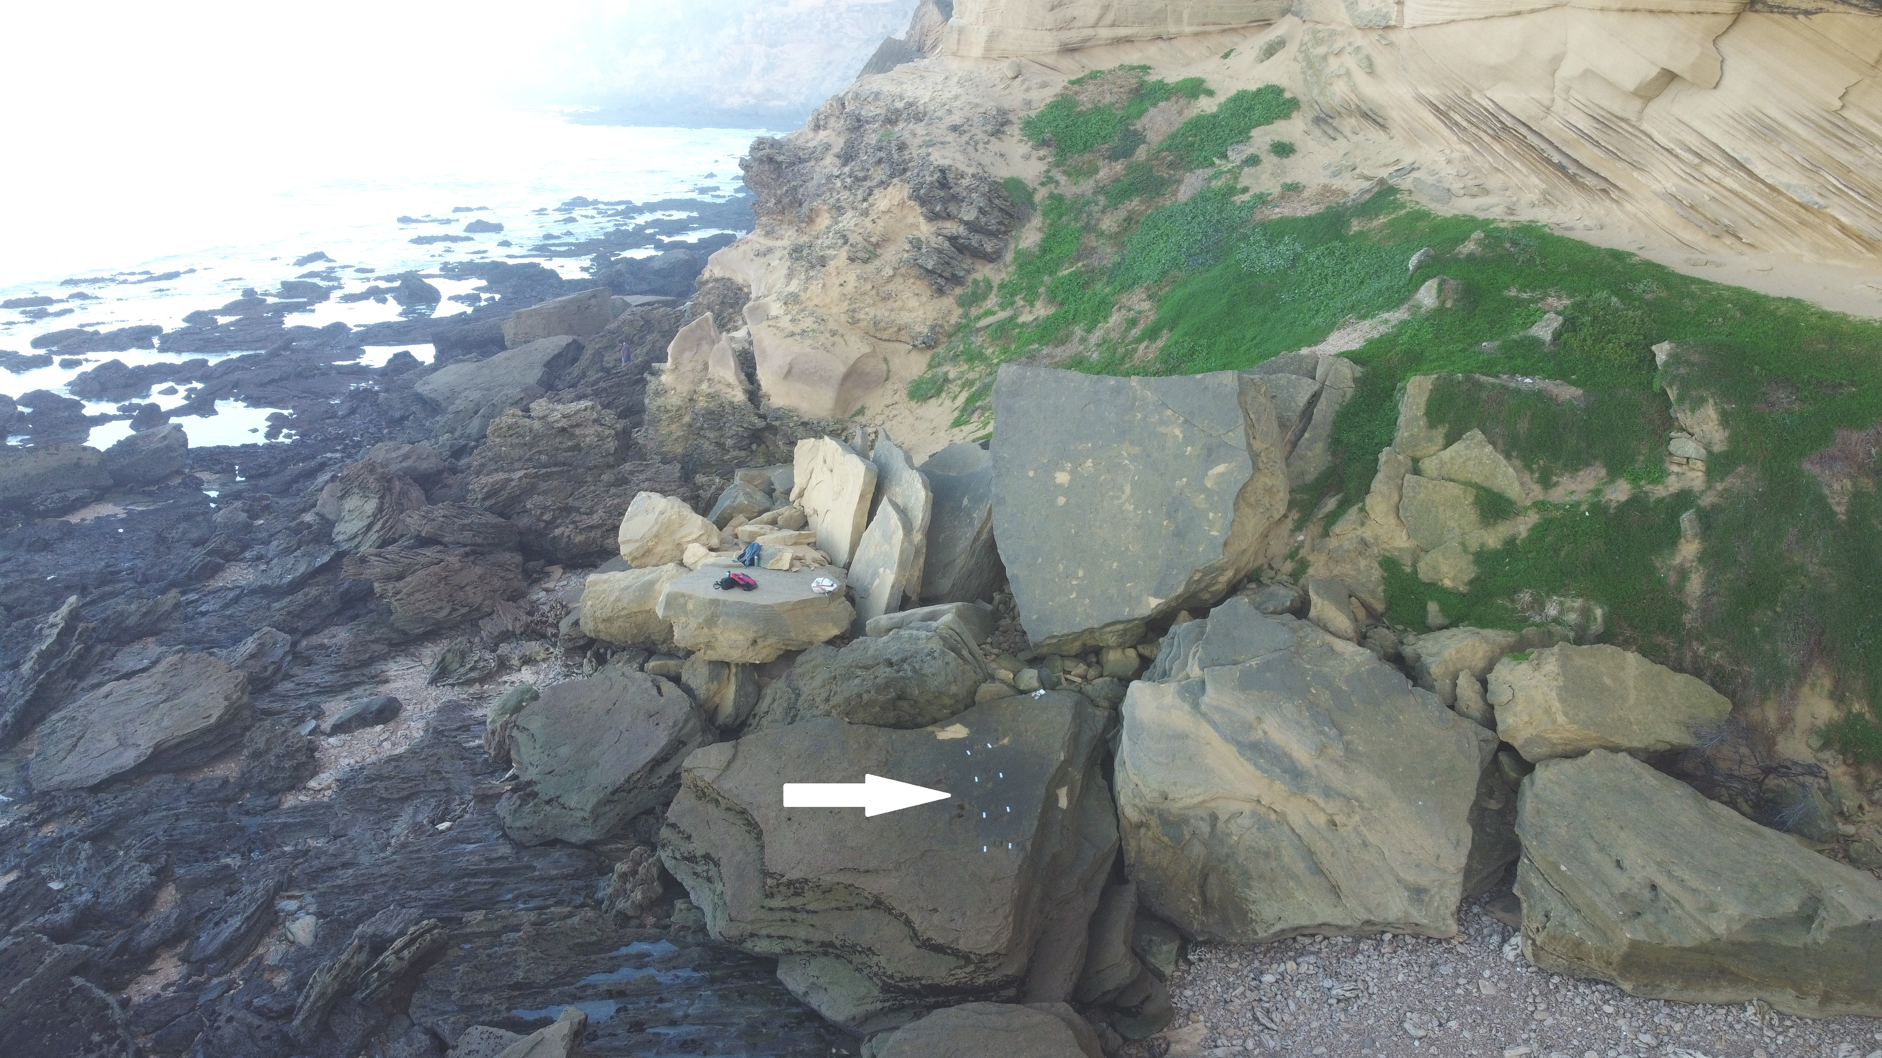
Figure S2: Drone image of the long large-equid trackway (indicated by white arrow) at Driefontein, and surrounding coastline.

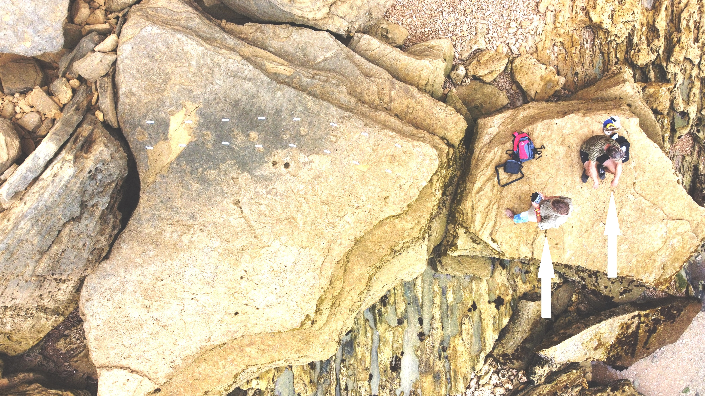
Figure S3: Drone image of the long large-equid trackway at Driefontein, taken from directly above the trackway; all scale bars = 10 cm, and white arrows indicate two adult humans for scale.

