Supplementary material
The sediment profiles in the supplementary material were taken from the Tekkedere valley infill (Tek-1 and Tek-3) and the Tekkedere alluvial fan (Tek-4, Tek-4-2, and Tek-5-2) (Fig. 1). The detailed description of the sediment profiles and the analyzed measurements are shown in the text and the corresponding illustrations. Raw data of the measurements and the calculation results of the proxies according to different units can be found in Yang et al. (2022).
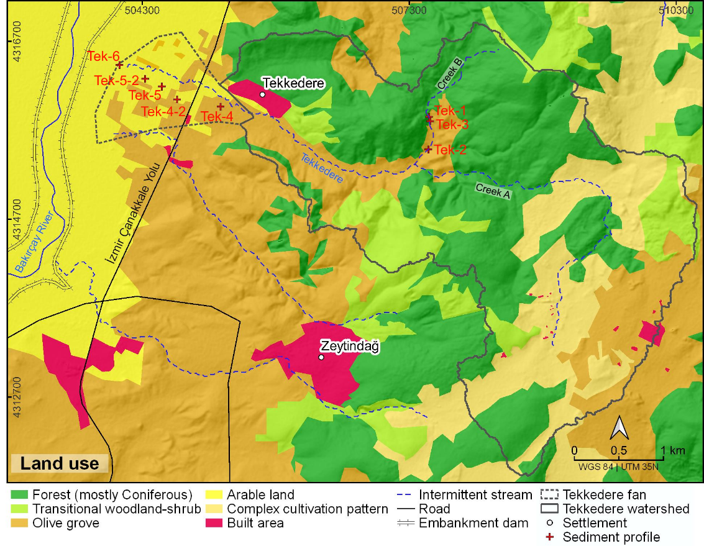
Figure 1. The location of the sediment profiles and the land use (data based on Corine Land Cover data (Cole et al., 2018)) in the surroundings of the Tekkedere catchment.

Tekkedere valley infill: Sediment profile Tek-1
Sediment profile Tek-1 is located close to the headwater area of Tekkedere creek B (Fig. 1). The profile has a total thickness of 176 cm and shows 6 macroscopically distinguishable units of silty/sandy and pebbly layers (Fig. 2). Roots are present in most units. The sediments are mostly strongly calcareous and they are slightly alkaline (pH: 7.7 (0), n = 14) throughout the profile. Electrical conductivity values (EC: 172 (6) μS/cm, class 1, n = 14) are very low and show a slightly increasing trend with decreasing depth. Magnetic susceptibility values (X_{LF}: 11 (2) 10⁻⁸ m³/kg, class 1, n = 14) are very low and a slight peak (16 10⁻⁸ m³/kg) occurs in the middle part of the profile (ca. 120–100 cm below surface [bs]). LOI₅₅₀ values (3.5 (0.4) mass%, class 3, n = 14) show a small increase at 120–100 cm bs and continue to increase in the upper part of the profile.
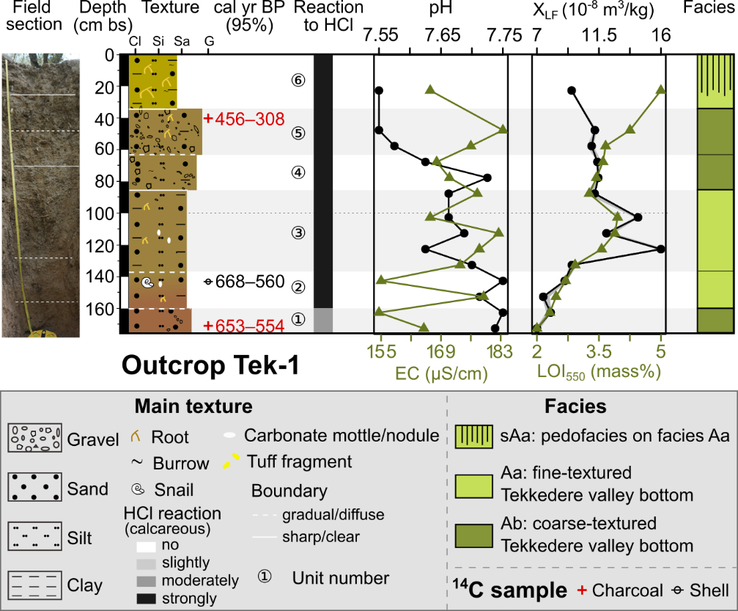
Figure 2. The lithostratigraphy, radiocarbon dates, and sediment analyses of outcrop Tek-1. The color of the sediment texture column represents the color observed in the field. The shaded band represents the different units and the dashed line refers to the depth in every meter.
Unit 1 (176–160 cm bs) consists of reddish brown, moderate compacted silty sand and contains a lens (length is 20–30 cm) of subangular, highly spherical pebbles (Ø < 1.5–3 cm; abundance 50%). X_{LF} (7 (1) 10⁻⁸ m³/kg, class 1, n = 2) and LOI₅₅₀ (2.4 (0.1) mass%, class 2, n = 2) values are low. A charcoal sample at 172 cm bs dates to 653–554 cal yr BP. The boundary to the overlying unit 2 is gradual.
Unit 2 (160–136 cm bs) consists of reddish to light brown, moderate compacted silty sand with slightly subangular fine pebbles (Ø < 1 cm). Very few fine roots occur in this unit. Carbonate precipitations and a shell (radiocarbon dating: 668–560 cal yr BP at 144 cm bs) occur in the upper part of the unit. X_{LF} (8 (1) 10⁻⁸ m³/kg, class 1, n = 2) and LOI₅₅₀ (2.8 (0.1) mass%, class 2, n = 2) values are low and slightly increased compared to unit 1. The boundary between units 2 and 3 is diffuse.
Unit 3 (136–85 cm bs) consists of brown, slightly moist, strongly compacted slightly pebbly silty sand. The unit has very few coarse roots (Ø < 8 mm) and burrows. Carbonate precipitations occur around 110 cm bs This unit shows peaks in X_{LF} (12 (2) 10⁻⁸ m³/kg, class 1, n = 5) and LOI₅₅₀ (3.5 (0.3) mass%, class 3, n = 5). The boundary to unit 4 is clear.
Unit 4 (85–63 cm bs) consists of brown, slightly moist, strongly compacted, and poorly sorted pebbly sand. The coarse material consists of few subangular medium pebbles (Ø < 2 cm) and very few angular very coarse pebbles (Ø < 5 cm). The pebbles include strong weathered Molasse-conglomerate. Few fine roots occur throughout the unit. X_{LF} (11 (0) 10⁻⁸ m³/kg, class 1, n = 2) values slightly decrease compared to unit 3 and remain low to the top of the profile. The boundary between units 4 and 5 is diffuse.
Unit 5 (63–34 cm bs) consists of brown, slightly moist, moderately compacted, and poorly sorted sandy pebbles. The coarse material includes common subangular fine pebbles (Ø < 1 cm) and very few angular very coarse pebbles (Ø < 6 cm). Strongly weathered Molasse-conglomerate are included. Few fine to medium roots and very few burrows occur. A charcoal sample at 40 cm bs dates to 456–308 cal yr BP. The boundary to the overlying unit is clear.
Unit 6 (34–0 cm bs) represents the Ap soil horizon. It consists of light brown, slightly moist, moderately compacted, and poorly sorted sandy silt with few angular to subangular medium pebbles (Ø < 2 cm). The unit is strongly rooted (Ø < 3 cm) and presents very few burrows. LOI₅₅₀ values increase from 3.4 mass% (class 2) at the bottom of unit 4 to 4.7 mass% (class 3) at the top of the profile.

Tekkedere valley infill: Sediment profile Tek-3
Profile Tek-3 is located adjacent to Tek-1 (Fig. 1) and the 220-cm-thick profile shows 8 macroscopically distinguishable units (Fig. 3). Unit 1 at the base consists of silty sand and is nearly free of gravel. The sediments above (units 2–7) are characterized by fine to medium pebbles. Animal burrows and fine roots occur commonly. The sediments slightly change from moderately to slightly alkaline (pH: 8.1 to 7.6, n = 19) from the base to the top of the profile. Electrical conductivity (EC) values fluctuate around 143 (11) μS/cm (class 1, n = 19). Magnetic susceptibility values are generally very low (X_{LF}: 9 (3) 10⁻⁸ m³/kg, class 1, n = 19) and slightly increase at 145–120 cm bs LOI₅₅₀ values also alternate in the low class (3.2 (0.2) mass%, class 2, n = 19).
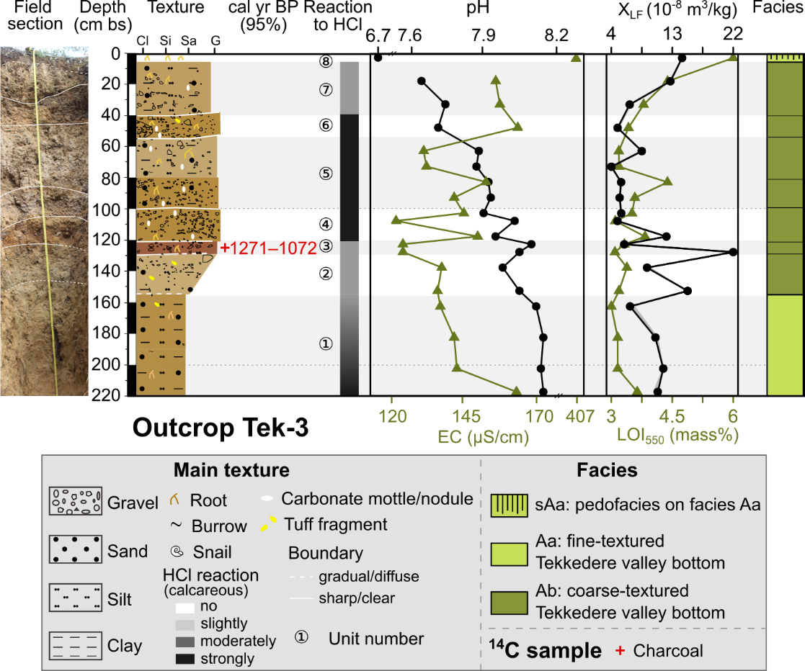
Figure 3. The lithostratigraphy, radiocarbon date, and sediment analyses of outcrop Tek-3.
Unit 1 (220–155 cm bs) consists of light brown, strongly compacted, and slightly moist sandy silt with few tuff pieces in the upper part. The sediments are strongly to moderately calcareous with decreasing depth. A small lens of strongly weathered and reddish blackish ("rusty") fine pebbles occurs in the lower part. The unit has few fine roots and burrows. Two coarse roots (size ca. 2.5 cm) occur at 155–145 cm and 210–180 cm bs Electrical conductivity values average 143 (3) μS/cm (class 1, n = 4) and change from 165 μS/cm at the bottom to 136 μS/cm at the top. Both X_{LF} (11 (1) 10⁻⁸ m³/kg, class 1, n = 4) and LOI₅₅₀ (3.0 (0.1) mass%, class 2, n = 4) values remain constantly low. The boundary to the overlying unit 2 is diffuse.
Unit 2 (155–130 cm bs) consists of light brown, strongly compacted, slightly moist, and inversely graded sediments with few fine roots. Sediment texture changes from sandy silt to silty sandy pebbles with decreasing depth. The medium pebbles (Ø < 2 cm) are mainly subangular and few rounded pebbles and tuff pieces (Ø < 5 cm) occur. The sediments are moderately calcareous but lack secondary carbonate precipitations. The EC (137 (1) μS/cm, class 1, n = 2), X_{LF} (12 (3) 10⁻⁸ m³/kg, class 1, n = 2) and LOI₅₅₀ (3.1 (0.1) mass%, class 2, n = 2) values are in the same range in comparison with the underlying unit. The boundary from unit 2 to unit 3 is clear.
Unit 3 (130–120 cm bs) consists of reddish brown, slightly moist sandy medium pebbles (Ø < 2 cm). The sediments are moderately calcareous, lack secondary carbonate precipitations, and contain few fine roots. Compared to unit 2, the EC values drop to 124 (0) μS/cm (class 1, n = 2). The X_{LF} value (22 10⁻⁸ m³/kg, class 1) is the highest in this profile. The LOI₅₅₀ shows no change compared to unit 2. A charcoal sample at 125 cm bs dates to 1271–1072 cal yr BP. The boundary between unit 3 and unit 4 is clear.
Unit 4 (120–100 cm bs) consists of light brown, moderately sorted, sub-angular to rounded, slightly organized, spherical to platy medium pebbles (Ø < 2 cm) with few angular very coarse pebbles (Ø < 5 cm). The sediment matrix consists of silty sand and is strongly calcareous with secondary carbonate precipitations. Few fine roots (Ø < 1 mm) and an olive core occur in this unit. EC (146 (5) μS/cm, class=1, n = 3), X_{LF} (6 (1) 10⁻⁸ m³/kg, class=1, n = 3) and LOI₅₅₀ (3.3 (0.3) mass%, class=2, n = 3) remain generally low. The boundary from unit 4 to unit 5 is clear to slightly irregular.
Unit 5 (100–55 cm bs) consists of grayish to light brown, compacted, fine pebbly (Ø < 1 cm) silty sand at the bottom to spherical medium pebbly (Ø < 2 cm) sandy silt at the top. The sediments are strongly calcareous with few secondary carbonate precipitations. Few fine roots (Ø < 1 mm) occur at the bottom and common coarse roots (Ø < 2 cm) at the top. Burrows are generally fine (Ø < 1 cm). The sediments in units 1–5 are moderately alkaline and generally decrease with decreasing depth. EC (138 (6) μS/cm, class 1, n = 4) and LOI₅₅₀ (3.2 (0.2) mass%, class 2, n = 4) show similar trends with a small peak at ca. 80 cm bs The values of X_{LF} (6 (1) 10⁻⁸ m³/kg) remain very low (class 1, n = 4). The boundary to the overlying unit 6 is sharp and irregular.
Unit 6 (55–40 cm bs) consists of light brown, slightly to moderately compacted, silty sandy, coarse pebbles (Ø < 3 cm). The clasts are spherical, sub-angular to rounded, and contain angular tuff pieces (Ø < 7 cm). A lens of olive cores occurs in the strongly calcareous sediment matrix. Medium roots (Ø < 5 mm) and fine burrows (Ø < 1 cm) occur abundantly. The EC value increases to 166 μS/cm (class 1, n = 1). The boundary to unit 7 is sharp.
Unit 7 (40–5 cm bs) consists of light brown, moderately compacted, fine pebbly (Ø < 1 cm) silty sand. The unit contains moderately calcareous sediment and commonly fine roots and burrows. A single olive core occurs at ca. 25 cm bs Sediments in units 6–7 are slightly alkaline (pH: 7.7 (0.1), n = 3). The EC values are in a comparable range to unit 6. X_{LF} and LOI₅₅₀ increase from unit 6 to unit 7. The boundary to the overlying unit is sharp.
Unit 8 (5–0 cm bs) represents the Ah soil horizon. It consists of dark brown, slightly to moderately compacted, and slightly moist, slightly sandy silt. The unit shows non-calcareous sediments and contains abundant fine roots and macro plant remains. The pH rapidly decreases to 6.7 (sediments are neutral, n = 1). Electrical conductivity increases to 408 μS/cm (class 3, n = 1). X_{LF} (15 10⁻⁸ m³/kg, class 1, n = 1) and LOI₅₅₀ (6 mass%, class 4, n = 1) continue to increase, too.

Tekkedere fan apex: Sediment profile Tek-4
Sediment profile Tek-4 is located at the Tekkedere fan apex (Fig. 1) and has a total thickness of 200 cm. Two macroscopically distinguishable units are characterized by normally graded deposits (Fig. 4).
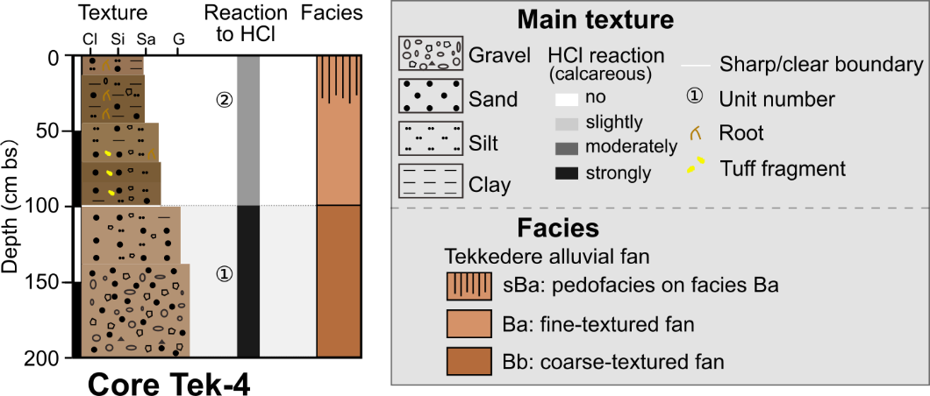
Figure 4. The lithostratigraphy of core Tek-4.
Unit 1 (200–100 cm bs) consists of light brown (7.5YR 6/4), heavily compacted, poorly sorted matrix-supported sediments. The unit gradually changes from medium pebbles at the base to fine pebbly sand at the top. The sediment matrix is strongly calcareous silty sand. The boundary between unit 1 and unit 2 is sharp.
Unit 2 (100–0 cm bs) shows normally graded sediments with distinct changes in color and compaction. The sediments at the base are (dark yellowish) brown (10YR 4/4, 10YR 4/3) silty sand with few angular fine to coarse pebbles (Ø < 3 cm). The coarse white clasts likely consist of tuff fragments. The middle part is yellowish brown (10YR 5/4) silty sand with few angular fine and medium pebbles (Ø < 2 cm). The sediments at the top are brown (10YR 4/3), sandy silt with very few angular fine pebbles (Ø < 1 cm). The moderately calcareous sediments contain abundant vegetation remains and few fine roots. The top of this unit represents the modern soil horizon.

Tekkedere mid-fan: Sediment profile Tek-4-2
Profile Tek-4-2 is located in the middle part of the Tekkedere alluvial fan (Fig. 1), has a total thickness of 700 cm, and shows 7 units (Fig. 5). This profile is generally characterized by alternating units of fine (silty) and coarse (sandy to fine pebbly) deposits. The sediments are slightly calcareous below 463 cm bs and moderately calcareous above. The average pH value is 7.9 (0.1, moderately alkaline, n = 32) and the sediments gradually change from moderately alkaline at the bottom to slightly alkaline at the top. Electricity conductivity (EC: 273 (28) μS/cm, class 2, n = 32) is generally low and the LOI₅₅₀ alternates between low (2.2–3.5 mass%, class 2) and medium values (3.7–4.8 mass%, class 3) in the coarse and fine units.
Unit 1 (700–600 cm bs) consists of strong brown (7.5YR 4/6), moderately compacted sandy silt. This unit contains common fine manganese mottles and nodules, and few fine secondary precipitated carbonate concretions. The values (n = 4) of pH (8 (0), moderately alkaline), EC (290 (5) μS/cm, class 2), and LOI₅₅₀ (4 (0.1) mass%, class 3) in this unit remain roughly constant. The boundary to the overlying unit is diffuse.
Unit 2 (600–463 cm bs) consists of brown (7.5YR 4/3) moderately compacted sandy silt with very few subangular fine pebbles occurring at 600–560 cm bs Common blackish fine manganese mottles and nodules and few fine secondary precipitated carbonates occur. The values (n = 7) of EC (from 224 to 367 μS/cm, class 2) and LOI₅₅₀ (from 3.6 to 4.1 mass%, class 3) similarly increase with decreasing depth. A sample with a mixture of charcoal and sediment in the upper part of this unit (469 cm bs) dates to 4971–4653 cal yr BP. The boundary from unit 2 to unit 3 is sharp.
Unit 3 (463–404 cm bs) consists of strong brown (7.5YR 4/6), loose to moderately compacted silty sand with subangular, fine to coarse pebbles (Ø < 3 cm). Some of the clasts are weathered. Fine manganese mottles and nodules occur at 445–422 cm bs EC (227 (50) μS/cm, class 2, n = 3) and LOI₅₅₀ (2.8 (0.1) mass%, class 2, n = 3) values are lower than in unit 2. Unit 3 has a sharp boundary with unit 4.
Unit 4 (404–253 cm bs) consists of strong brown (7.5YR 4/6), loose silty sand with common subangular, fine to medium pebbles (Ø < 2 cm). Two fine pieces of shell occur at 258–255 cm and 360–357 cm bs The average electrical conductivity values slightly increase to 267 (25) μS/cm (class 2, n = 7) and LOI₅₅₀ values remain low (2.9 (0.2) mass%, class 2, n = 7). The boundary to the overlying unit is sharp.
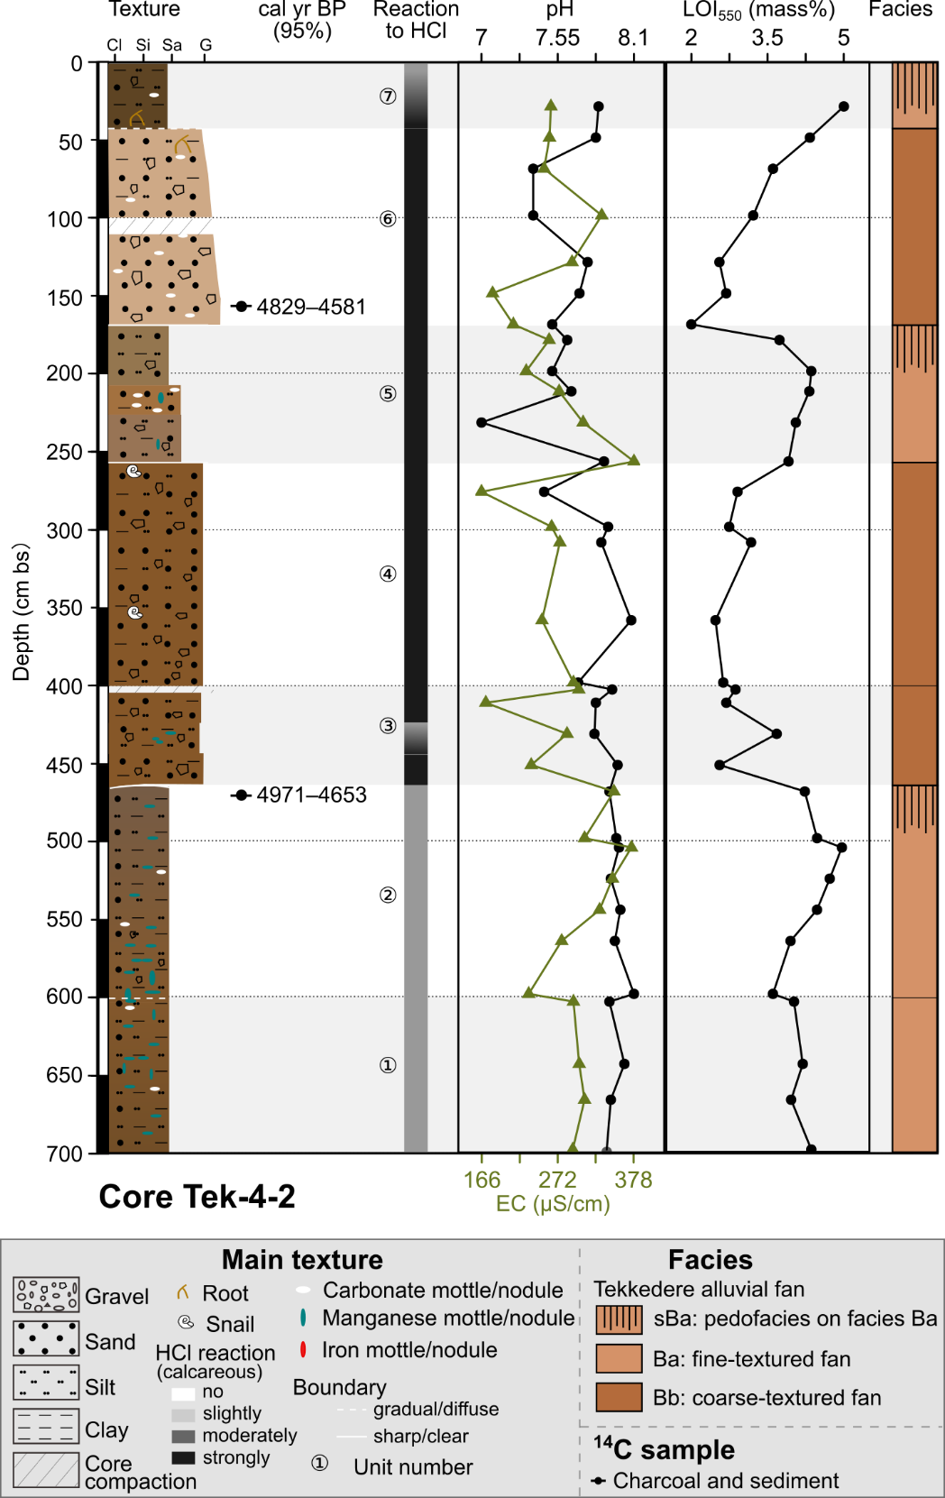
Figure 5. The lithostratigraphy, radiocarbon dates, and sediment analyses of core Tek-4-2.
Unit 5 (234–174 cm) consists of brown (7.5YR 5/4), loose to moderately compacted sandy silt at the top, and yellowish brown (10YR 5/4) silty sand at the bottom. Carbonate mottles occur commonly in the middle part and few fine manganese mottles occur in the middle to lower part. From the bottom to the top, the pH values (pH: 7.6 (0.1), slightly alkaline, n = 4) slightly decrease and EC values decrease from 300 μS/cm (class 2) to 220 μS/cm (class 1). LOI₅₅₀ values increase (4.1 (0.1) mass%, class 3, n = 4) compared to unit 4. The boundary from unit 5 to unit 6 is sharp.
Unit 6 (174–45 cm bs) consists of pink (7.5YR 7/4), loose normal graded sediments. The texture changes from sandy (sub)angular coarse pebbles (Ø < 3 cm) at the base to silty sand with few fine pebbles (Ø < 1 cm) at the top. The sediments contain common carbonate nodules and few fresh fine roots at ca. 54 cm bs The pH (7.6 (0.2), slightly alkaline, n = 6) and EC (249 (41) μS/cm, class 2, n = 6) values show minor fluctuations. LOI₅₅₀ values drop to 2.2 mass% (class 2) at the bottom and gradually increase to 4.2 mass% (class 3) to its top. A sample with a mixture of charcoal and sediments at 161 cm bs dates to 4829–4581 cal yr BP. Unit 6 has a gradual boundary with the overlying unit 7.
Unit 7 (45–0 cm bs) represents the present-day plow horizon. The dark yellowish brown (10YR 3/4) loose sediments are characterized by slightly gravely silts and contain few carbonate nodules and fresh fine roots. The sediment sample is moderately alkaline (pH: 7.9) and has an EC value of 255 μS/cm (class 2) and a LOI₅₅₀ value of 4.8 mass% (class 3).

Tekkedere mid-fan: Sediment profile Tek-5-2
Profile Tek-5-2 is located in the middle-lower part of the alluvial fan (Fig. 1), has a total thickness of 400 cm, and shows 6 units (Fig. 6). The sediments are mainly composed of sandy silt with common manganese mottles and show abundant secondary precipitated carbonate concentrations in the lower part. The boundaries between all units are gradual. The sediments are moderately to strongly calcareous and moderately to strongly alkaline (pH: 8.6 (0.2), n = 17). EC values (608 (58) μS/cm) are high (class 4, n = 17) and vary between 242 and 803 μS/cm. Generally, LOI₅₅₀ values (4.3 (0.7) mass%, class 3, n = 17) display a decreasing trend from the bottom to the top. Geochemical ratios of Ca/Ti (17.07 (4.3)) and Zr/Rb (1.39 (0.2)) present a parallel pattern with values roughly increasing from the bottom to the top.
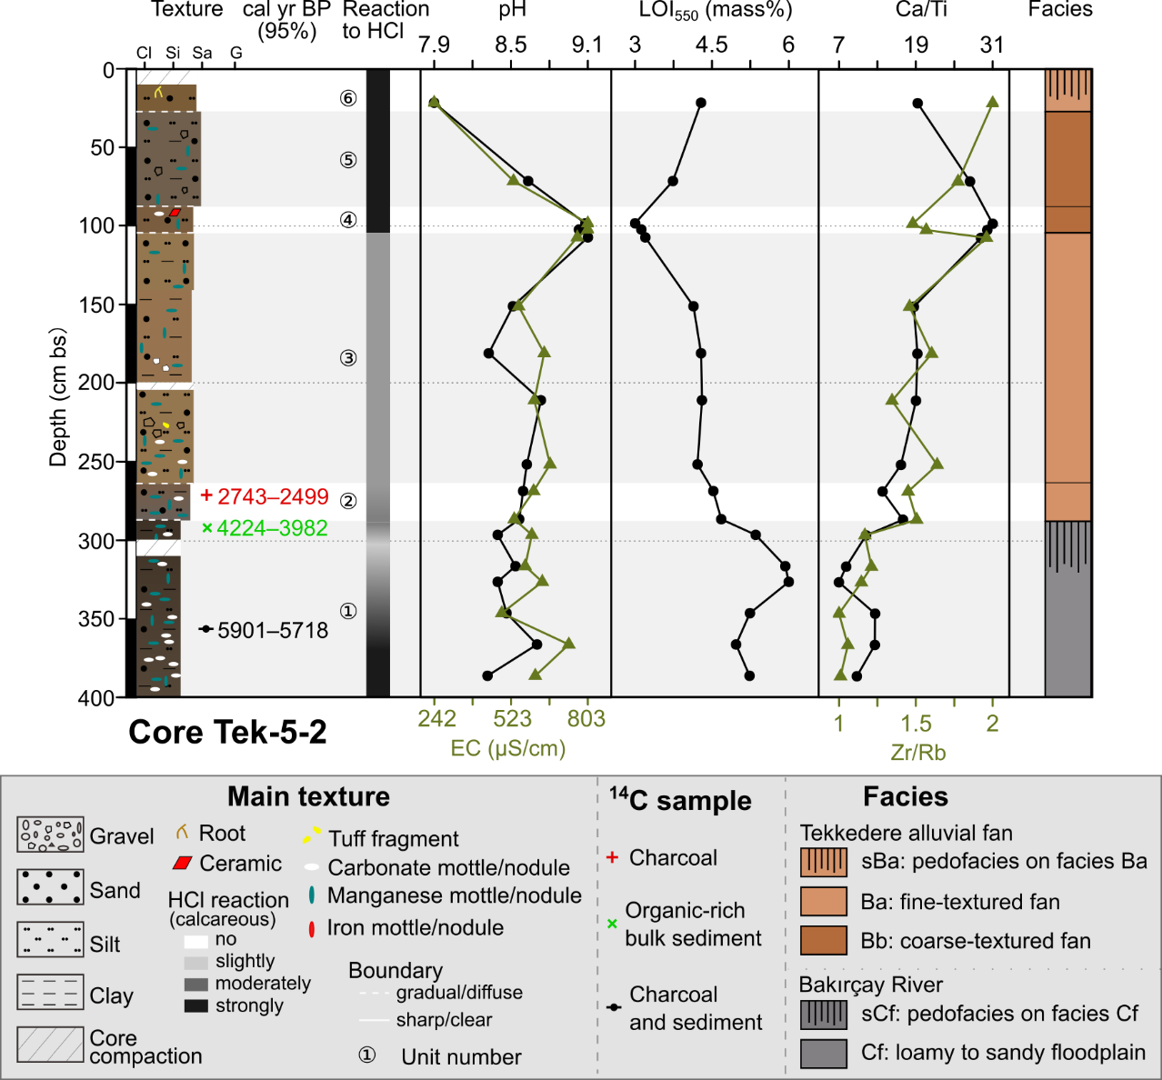
Figure 6. The lithostratigraphy, radiocarbon dates, and sediment analyses of core Tek-5-2.
Unit 1 (400–284 cm bs) consists of very dark brown (10YR 2/2) clayey silt. The sediments change from strongly calcareous at the base to moderately calcareous at the top. Secondary precipitated carbonate nodules and manganese mottles occur commonly throughout the unit. The pH (8.5 (0.1), strongly alkaline, n = 7) and EC values (599 (38) μS/cm, class 4, n = 7) show minor fluctuations. LOI₅₅₀ values (5.2 (0.3) mass%, class 4, n = 7) are high and peak (6 mass%, class=4) at ca. 330 cm bs The Ca/Ti ratio shows a minor drop at the same depth (ca. 330 cm bs) and increases towards the top. The Zr/Rb ratio gradually increases with decreasing depth. A sample with a mixture of charcoal and sediments at 354 cm bs dates to 5901–5718 cal yr BP and a bulk sample containing organic matter from 285–286 cm bs dates to 4224–3982 cal yr BP.
Unit 2 (284–265 cm bs) consists of moderately calcareous sandy silt. The color gradually changes from dark gray (7.5YR 4/1) at the bottom to brown (7.5YR 4/3) at the top. The amount of blackish manganese mottles decreases. The LOI₅₅₀ value decreases to 4.5 (0) mass% (class 3, n = 1). A charcoal sample from 273 cm bs dates to 2743–2499 cal yr BP.
Unit 3 (265–104 cm bs) consists of yellowish brown (10YR 5/4), very soft, and moderately calcareous sandy silt. Few fine to medium pebbles (including rounded tuff) occur at 235–225 cm bs and few coarse, weathered carbonate fragments at 186–178 cm bs The sediments from 200 to 140 cm bs contain more reddish clay. Manganese mottles and fine nodules commonly occur in this unit, particularly at 265–247 cm bs where secondary precipitated carbonate concentrations occur, too. The values (n = 5) of pH (8.7 (0.1), strongly alkaline) and EC values (644 (36) μS/cm, class 4) are in the same range as the underlying two units. The LOI₅₅₀ values (4.2 (0.1) mass%, class 3, n = 5) continue to decrease to the top of unit 3 and the ratios of Ca/Ti (19.08 (0.3)) and Zr/Rb (1.50 (0.1)) generally increase with decreasing depth.
Unit 4 (104–85 cm bs) consists of dark yellowish brown (10YR 4/4) slightly sandy silt. The sediments are strongly calcareous and contain few carbonate nodules and manganese mottles. A broken brick fragment occurs at 82 cm bs The pH (9.1 (0), very strongly alkaline, n = 2) and EC (803 (0) μS/cm, class 5, n = 2) values markedly increase compared to the units below and above, whereas LOI₅₅₀ (3 (0.1) mass%, class 2, n = 2) markedly drops to its lowest values. The Zr/Rb ratio slightly decreases to 1.44 (0) and the Ca/Ti ratio slightly increases to 30.47 (0.4).
Unit 5 (85–30 cm bs) consists of dark grayish brown (10YR 4/2) fine pebbly sandy silt. The sediments are strongly calcareous and contain few manganese mottles.
Unit 6 (30–0 cm bs) is the present-day plow horizon. The brown (10YR 4/3) loose sediments consist of strongly calcareous, slightly sandy silt with few fine roots. From unit 5 to unit 6, the sediments change from strongly alkaline (pH: 8.7) to moderately alkaline (pH: 7.9), EC values (from 532 to 242 μS/cm) and Ca/Ti ratio (from 27.4 to 19.3) decrease, whereas LOI₅₅₀ (from 3.7 to 4.2 mass%) and Zr/Rb ratio (from 1.64 to 1.82) increase.

Reference
Cole, B., Smith, G., Balzter, H., 2018. Acceleration and fragmentation of CORINE land cover changes in the United Kingdom from 2006–2012 detected by Copernicus IMAGE2012 satellite data. International Journal of Applied Earth Observation and Geoinformation 73, 107–122.
Yang, X., Becker, F., Nykamp, M., Schütt, B., 2022. Dataset of sediment analyses (pH, electrical conductivity, magnetic susceptibility, loss on ignition, and X-ray fluorescence) from the Tekkedere catchment in the Pergamon Micro-Region, western Turkey, in: Yang, X. (Ed.), Pangaea.

