Supplementary Figure 1. All identifiable fungal spore morphotypes recovered from the Monquentiva record. Due to its size, morphotype 4 (Chaetomium) is photographed at 1000-x magnification. Sporormiella (morphotype 15) is photographed at both magnifications. 1, Arnium imitans; 2, Achaetomium; 3, Cercophora; 4, Chaetomium; 5, Coniochaeta; 6, Delitschia; 7, Endophragmiella; 8, Gelasinospora-types; 9, 0U-5; 10, 0U-18 AFF; 11, OU-100 AFF; 12, OU-108; 13, Podospora; 14, Sordaria. 15, Sporormiella; 16, Trichodelitschia; 17, UAB-1; 18, UAB-2; 19, UAB-7; 20, UAB-15; 21, UAB-30A; 22, UAB-32; 23, UAB-40; 24, UAB-48; 25, UAB-50. Morphotypes OU- and UAB- identified using keys from Loughlin et al. (2018) and Revelles et al. (2016).

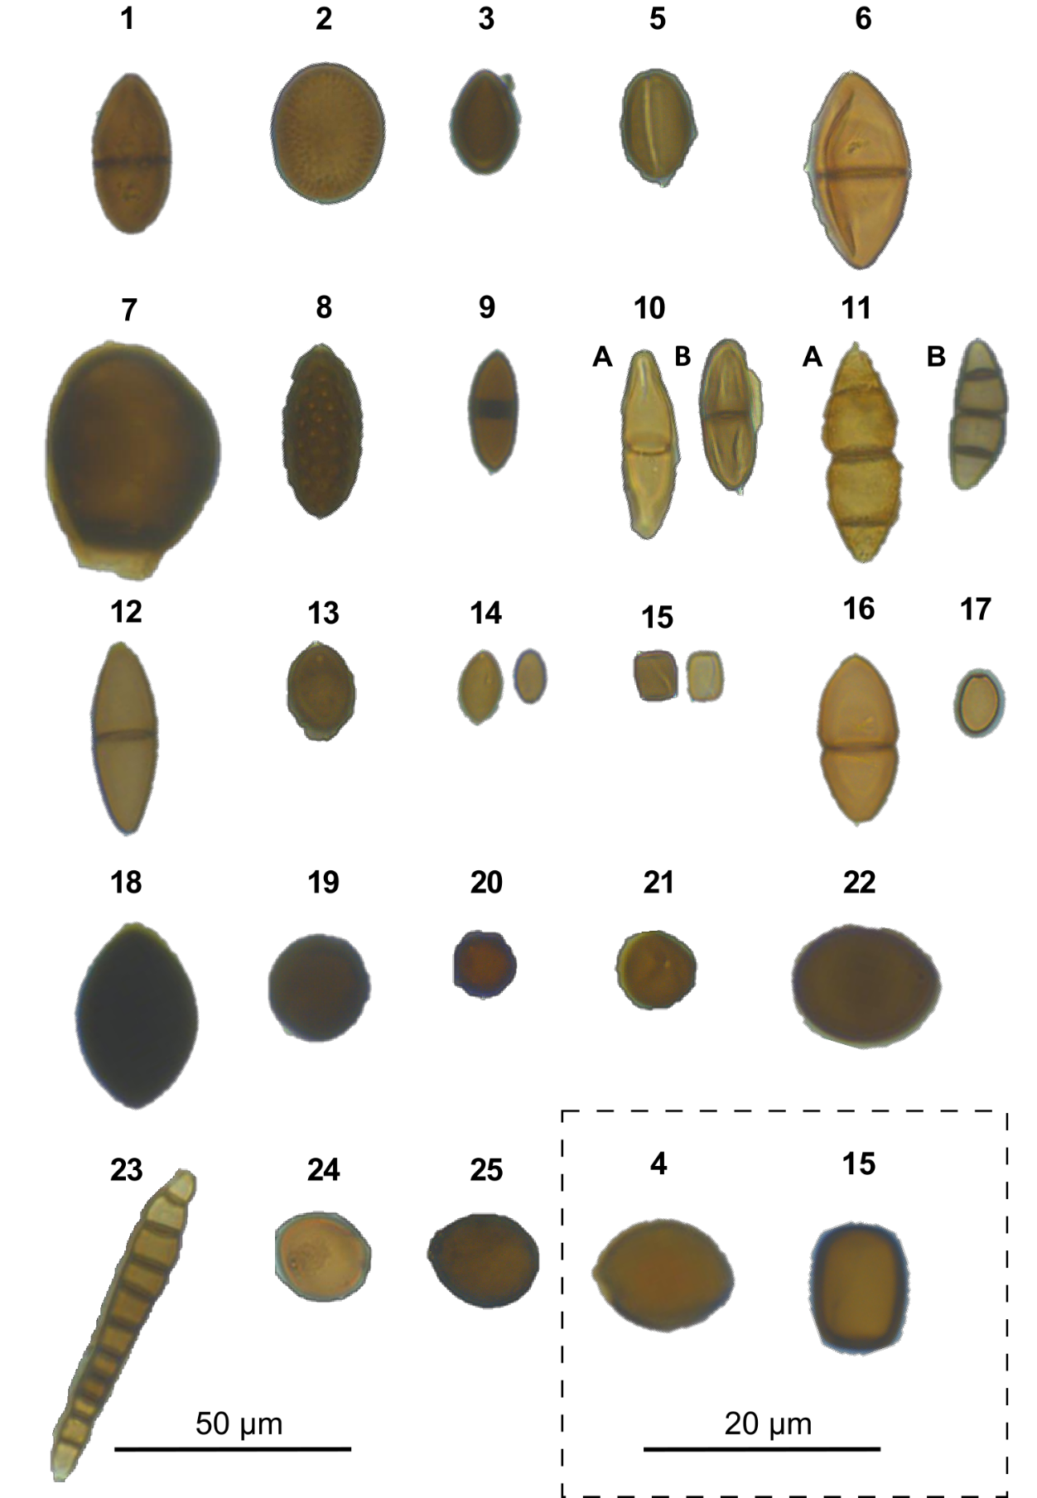
Supplementary Figure 2: Complete fossil pollen and charcoal diagram for all pollen taxa and charcoal particles recorded from the sediments of Monquentiva.
The pollen taxa are split into their growth forms, colour codes: Grasses and herbs (Browny green); Trees and shrubs (Green). Malvaceae, Salvia and Vicia grouped at the end of the diagram as they can be found as trees, shrubs and herbs (Marchant et al., 2002). Species are expressed as a percentage of the pollen sum (%TPA). Pollen unidentifiable at species level are grouped in their family and include the number of different species.
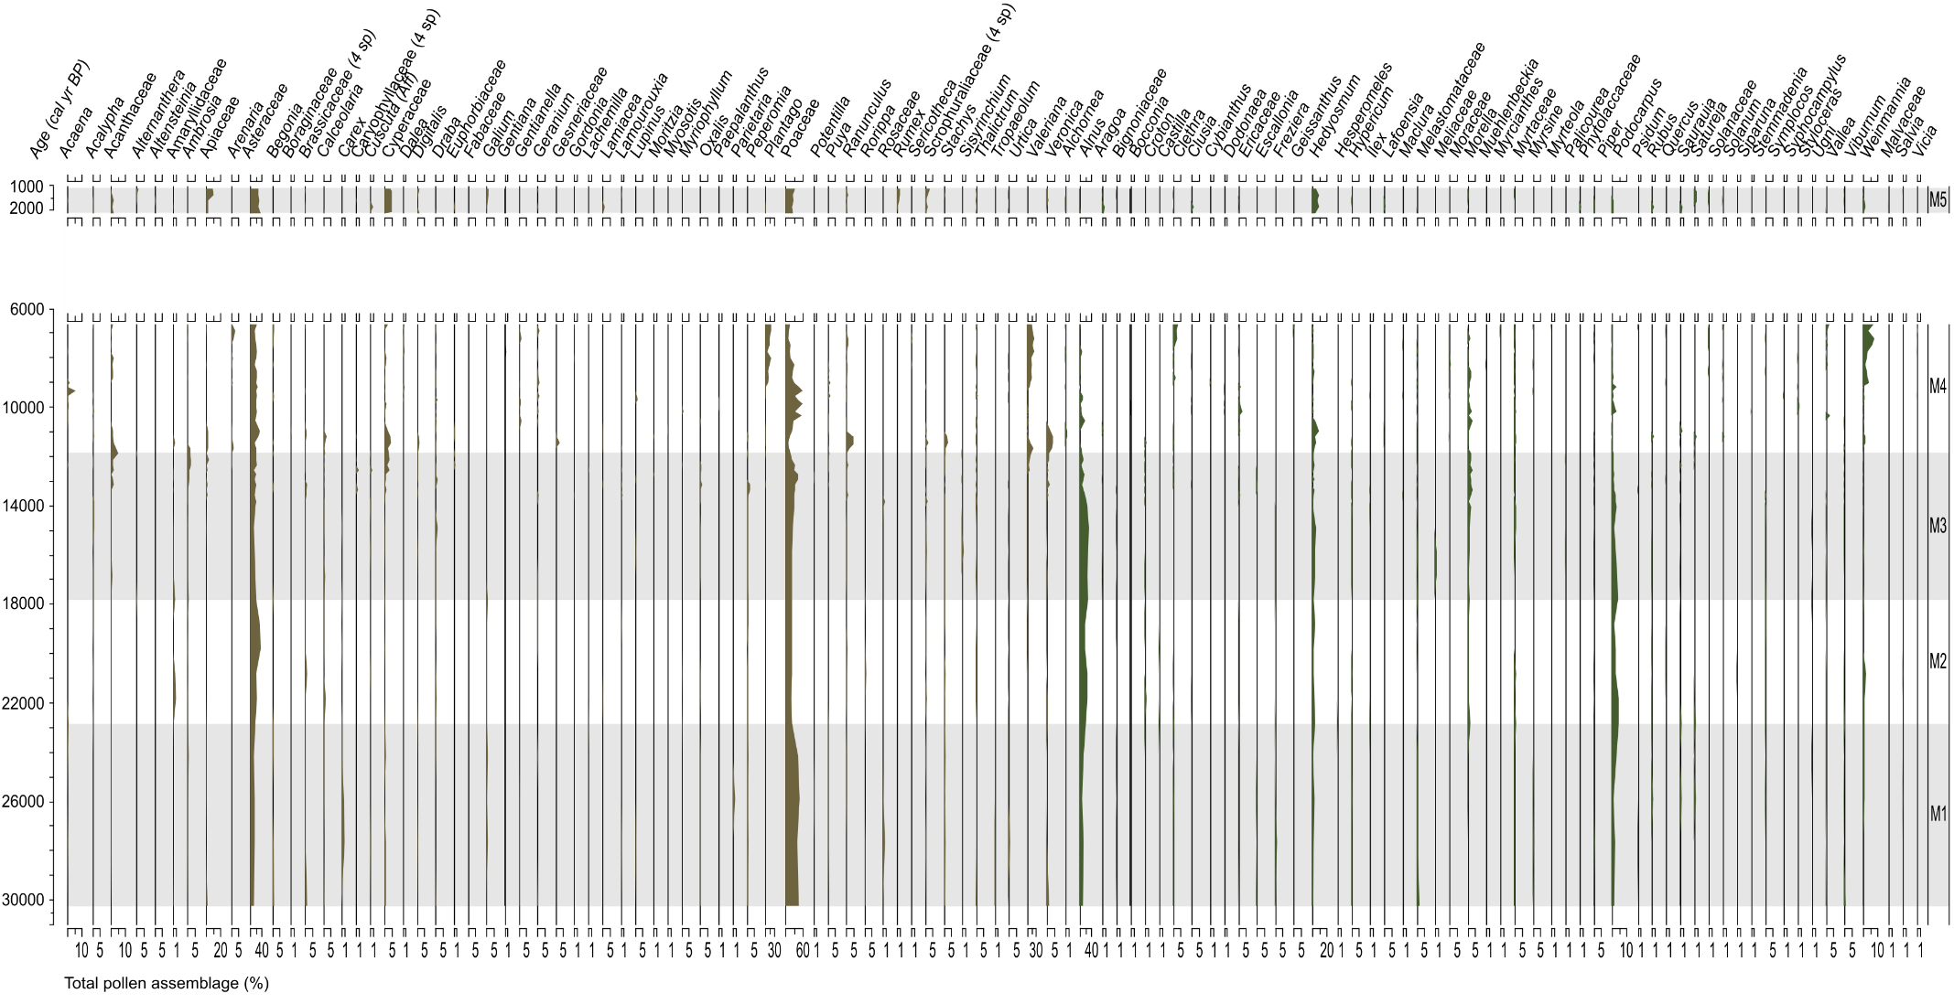
Supplementary Figure 3: Macroscopic (local; black) and microscopic (regional; red) charcoal fractions. Both fractions are expressed as counts per cubic centimetre (cm³) and area (cm²/cm³). Charcoal counts in the floating Holocene samples use different x-axis limits to the Pleistocene samples.
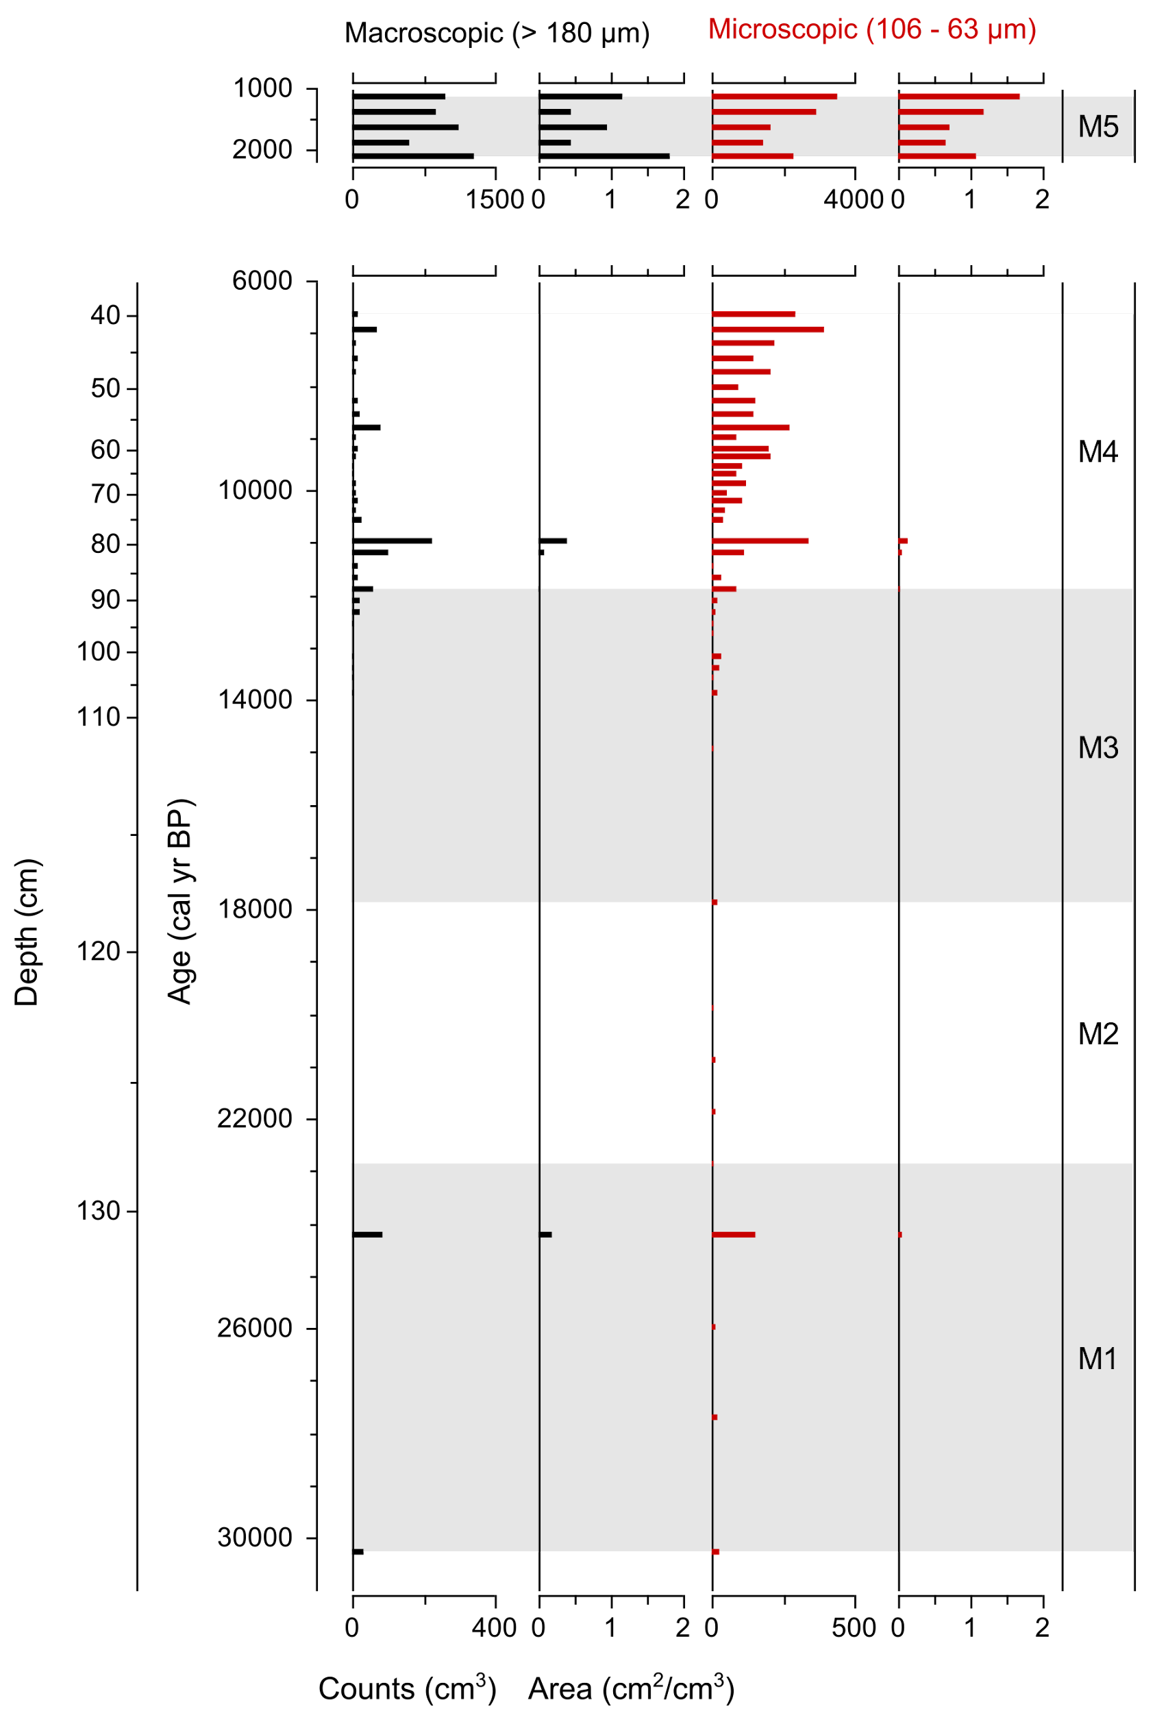
Supplementary Figure 4: Complete fossil spore diagram for all identifiable fungal spore morphotypes recovered from the sediments of Monquentiva.
All fungal spores are expressed as a percentage of the total pollen assemblage (%TPA) and as concentration of counts per cubic centimetre (cm³). Colour codes: key SCF (light orange) other identified fungi spores (dark orange). AFF refers to the affinity of spore morphotypes and indicates when they were assigned to their most akin morphotype.
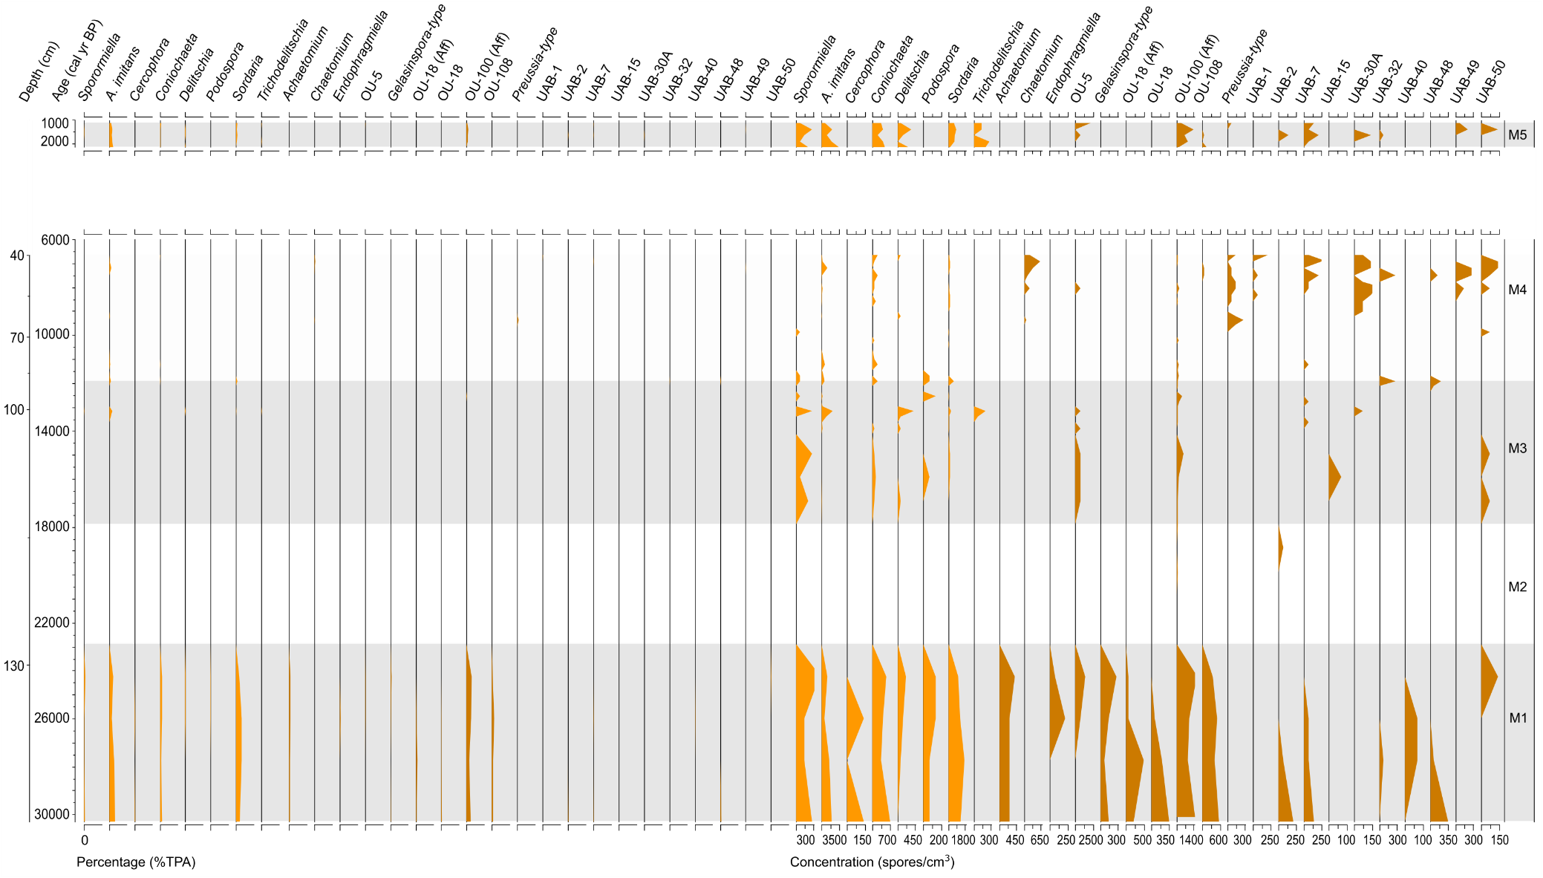
Supplementary Table 1: Adapted outputs of a general outlier model run on the Monquentiva ¹⁴C radiocarbon ages, created using Oxcal v.4.4 (Ramsey, 2009a; Ramsey, 2009b).
The prior probability for each measurement being an outlier was set to 0.05. The posterior column provides the probability for each measurement being an outlier.
Colour codes: Accepted age (Blue); Likely outlier (Red).
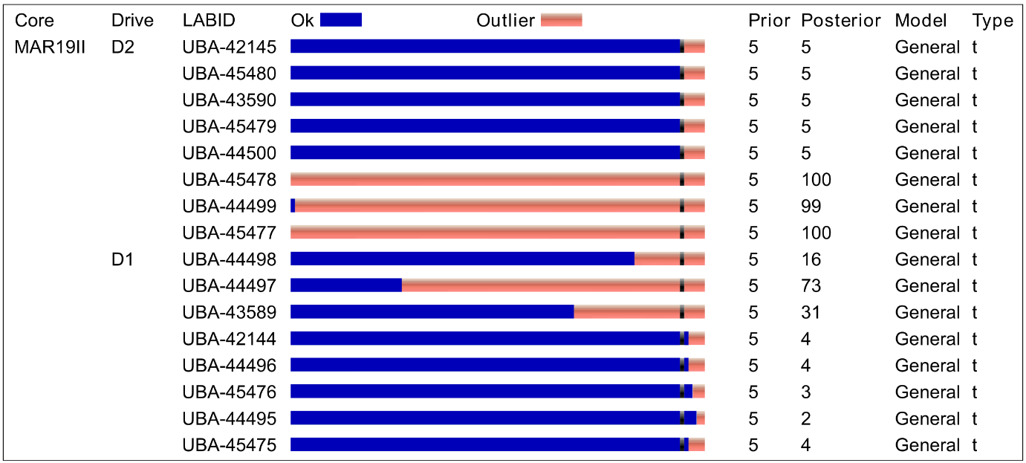

Supplementary Table 2: Coefficient correlation outputs between all identifiable fungal spores recorded from the sediments of Monquentiva.
Correlations are calculated using Pearson correlation coefficients using the concentration of fungal spore counts per cubic centimetre (cm³), at both the 0.01 (**) and 0.05 (*) level of significance.
Sporormiella A.imitans Cercophora Coniochaeta Delitschia Podospora Sordaria-type Trichodelitschia Achaetomium Chaetomium Endophragmiella Gelasinospora OU-5 OU-18 type OU-100 type OU108 Preussia-type UAB1 UAB2 UAB7 UAB15 UAB30A UAB32 UAB40 UAB48 UAB49 UAB50
Sporormiella Pearson Correlation 1 .644** .312* .672** .691** .468** .633** .364** .596** -0.163 .278* .507** .624** .351* .770** .549** -0.246 -0.119 .325* 0.093 0.021 -0.105 0.002 0.171 0.249 0.018 .412**
Sig. (2-tailed) 0.000 0.024 0.000 0.000 0.000 0.000 0.008 0.000 0.249 0.046 0.000 0.000 0.011 0.000 0.000 0.078 0.402 0.019 0.513 0.883 0.460 0.989 0.226 0.075 0.902 0.002
N 52 52 52 52 52 52 52 52 52 52 52 52 52 52 52 52 52 52 52 52 52 52 52 52 52 52 52
A.imitans Pearson Correlation .644** 1 0.225 .714** .722** 0.176 .574** .749** .334* -0.020 0.069 0.152 .290* .362** .562** .453** -0.180 -0.090 .327* 0.195 -0.083 0.020 0.035 0.168 0.251 0.174 0.181
Sig. (2-tailed) 0.000 0.108 0.000 0.000 0.213 0.000 0.000 0.016 0.888 0.627 0.282 0.037 0.008 0.000 0.001 0.201 0.528 0.018 0.165 0.560 0.887 0.804 0.234 0.073 0.216 0.200
N 52 52 52 52 52 52 52 52 52 52 52 52 52 52 52 52 52 52 52 52 52 52 52 52 52 52 52
Cercophora Pearson Correlation .312* 0.225 1 .530** 0.069 .485** .562** -0.067 .598** -0.059 .659** 0.094 .544** .523** .527** .781** -0.095 -0.043 .525** 0.234 -0.028 -0.093 -0.049 .480** .536** -0.064 -0.086
Sig. (2-tailed) 0.024 0.108 0.000 0.626 0.000 0.000 0.637 0.000 0.680 0.000 0.510 0.000 0.000 0.000 0.000 0.504 0.763 0.000 0.095 0.844 0.510 0.730 0.000 0.000 0.654 0.546
N 52 52 52 52 52 52 52 52 52 52 52 52 52 52 52 52 52 52 52 52 52 52 52 52 52 52 52
Coniochaeta Pearson Correlation .672** .714** .530** 1 .435** .462** .797** .402** .673** -0.044 .363** .364** .648** .529** .829** .733** -0.105 0.076 .459** .410** 0.027 -0.103 0.167 .325* .481** 0.121 0.216
Sig. (2-tailed) 0.000 0.000 0.000 0.001 0.001 0.000 0.003 0.000 0.758 0.008 0.008 0.000 0.000 0.000 0.000 0.460 0.594 0.001 0.003 0.852 0.466 0.237 0.019 0.000 0.392 0.124
N 52 52 52 52 52 52 52 52 52 52 52 52 52 52 52 52 52 52 52 52 52 52 52 52 52 52 52
Delitschia Pearson Correlation .691** .722** 0.069 .435** 1 0.138 .392** .605** 0.246 -0.098 0.236 .374** 0.269 0.045 .423** 0.236 -0.114 0.007 0.032 0.061 -0.061 0.033 -0.049 0.148 -0.101 0.127 0.251
Sig. (2-tailed) 0.000 0.000 0.626 0.001 0.330 0.004 0.000 0.079 0.490 0.092 0.006 0.054 0.750 0.002 0.092 0.421 0.960 0.823 0.666 0.667 0.818 0.728 0.297 0.475 0.370 0.072
N 52 52 52 52 52 52 52 52 52 52 52 52 52 52 52 52 52 52 52 52 52 52 52 52 52 52 52
Podospora Pearson Correlation .468** 0.176 .485** .462** 0.138 1 .586** -0.133 .716** -0.117 .600** .281* .706** .403** .593** .644** -0.189 -0.085 0.175 -0.003 0.208 -0.186 0.133 .485** .276* -0.127 0.077
Sig. (2-tailed) 0.000 0.213 0.000 0.001 0.330 0.000 0.347 0.000 0.411 0.000 0.044 0.000 0.003 0.000 0.000 0.181 0.548 0.214 0.982 0.139 0.186 0.347 0.000 0.047 0.370 0.585
N 52 52 52 52 52 52 52 52 52 52 52 52 52 52 52 52 52 52 52 52 52 52 52 52 52 52 52
Sordaria-type Pearson Correlation .633** .574** .562** .797** .392** .586** 1 0.206 .809** -0.076 .460** .337* .685** .773** .853** .840** -0.173 -0.074 .544** .347* -0.023 -0.028 0.167 .670** .446** 0.047 0.166
Sig. (2-tailed) 0.000 0.000 0.000 0.000 0.004 0.000 0.144 0.000 0.591 0.001 0.015 0.000 0.000 0.000 0.000 0.221 0.602 0.000 0.012 0.870 0.843 0.237 0.000 0.001 0.743 0.239
N 52 52 52 52 52 52 52 52 52 52 52 52 52 52 52 52 52 52 52 52 52 52 52 52 52 52 52
Trichodelitschia Pearson Correlation .364** .749** -0.067 .402** .605** -0.133 0.206 1 -0.095 -0.098 -0.060 0.215 -0.086 -0.077 0.248 -0.037 -0.103 -0.072 -0.087 0.077 -0.047 -0.061 -0.082 -0.067 -0.091 0.090 0.010
Sig. (2-tailed) 0.008 0.000 0.637 0.003 0.000 0.347 0.144 0.504 0.490 0.675 0.127 0.543 0.588 0.077 0.794 0.465 0.614 0.542 0.586 0.742 0.669 0.564 0.637 0.520 0.524 0.946
N 52 52 52 52 52 52 52 52 52 52 52 52 52 52 52 52 52 52 52 52 52 52 52 52 52 52 52
Achaetomium Pearson Correlation .596** .334* .598** .673** 0.246 .716** .809** -0.095 1 -0.083 .605** .324* .958** .705** .776** .919** -0.134 -0.061 .411** 0.136 -0.040 -0.132 0.011 .598** .369** -0.090 0.202
Sig. (2-tailed) 0.000 0.016 0.000 0.000 0.079 0.000 0.000 0.504 0.559 0.000 0.019 0.000 0.000 0.000 0.000 0.343 0.670 0.002 0.335 0.780 0.350 0.940 0.000 0.007 0.525 0.151
N 52 52 52 52 52 52 52 52 52 52 52 52 52 52 52 52 52 52 52 52 52 52 52 52 52 52 52
Chaetomium Pearson Correlation -0.163 -0.020 -0.059 -0.044 -0.098 -0.117 -0.076 -0.098 -0.083 1 -0.052 -0.117 -0.075 -0.067 -0.113 -0.048 0.222 0.249 -0.076 .536** -0.041 .591** 0.058 -0.059 -0.020 .384** .593**
Sig. (2-tailed) 0.249 0.888 0.680 0.758 0.490 0.411 0.591 0.490 0.559 0.714 0.408 0.595 0.636 0.427 0.734 0.114 0.076 0.594 0.000 0.773 0.000 0.683 0.680 0.890 0.005 0.000
N 52 52 52 52 52 52 52 52 52 52 52 52 52 52 52 52 52 52 52 52 52 52 52 52 52 52 52
Endophragmiella Pearson Correlation .278* 0.069 .659** .363** 0.236 .600** .460** -0.060 .605** -0.052 1 .315* .617** 0.137 .431** .595** -0.084 -0.038 -0.046 0.058 -0.025 -0.083 -0.044 .659** -0.049 -0.057 0.076
Sig. (2-tailed) 0.046 0.627 0.000 0.008 0.092 0.000 0.001 0.675 0.000 0.714 0.023 0.000 0.335 0.001 0.000 0.552 0.789 0.745 0.683 0.861 0.557 0.759 0.000 0.732 0.690 0.591
N 52 52 52 52 52 52 52 52 52 52 52 52 52 52 52 52 52 52 52 52 52 52 52 52 52 52 52
Gelasinospora Pearson Correlation .507** 0.152 0.094 .364** .374** .281* .337* 0.215 .324* -0.117 .315* 1 .394** -0.016 .351* 0.205 -0.066 -0.086 0.025 0.168 0.187 -0.044 -0.056 0.094 -0.109 -0.017 0.172
Sig. (2-tailed) 0.000 0.282 0.510 0.008 0.006 0.044 0.015 0.127 0.019 0.408 0.023 0.004 0.910 0.011 0.145 0.640 0.546 0.862 0.234 0.184 0.757 0.695 0.510 0.440 0.905 0.224
N 52 52 52 52 52 52 52 52 52 52 52 52 52 52 52 52 52 52 52 52 52 52 52 52 52 52 52
OU-5 Pearson Correlation .624** .290* .544** .648** 0.269 .706** .685** -0.086 .958** -0.075 .617** .394** 1 .495** .761** .820** -0.122 -0.055 .319* 0.092 -0.036 -0.120 -0.027 .395** .302* -0.082 .282*
Sig. (2-tailed) 0.000 0.037 0.000 0.000 0.054 0.000 0.000 0.543 0.000 0.595 0.000 0.004 0.000 0.000 0.000 0.389 0.698 0.021 0.517 0.799 0.395 0.851 0.004 0.030 0.563 0.043
N 52 52 52 52 52 52 52 52 52 52 52 52 52 52 52 52 52 52 52 52 52 52 52 52 52 52 52
OU-18 type Pearson Correlation .351* .362** .523** .529** 0.045 .403** .773** -0.077 .705** -0.067 0.137 -0.016 .495** 1 .552** .808** -0.109 -0.049 .656** 0.226 -0.032 -0.107 0.083 .637** .584** -0.073 -0.061
Sig. (2-tailed) 0.011 0.008 0.000 0.000 0.750 0.003 0.000 0.588 0.000 0.636 0.335 0.910 0.000 0.000 0.000 0.442 0.729 0.000 0.107 0.821 0.448 0.558 0.000 0.000 0.606 0.668
N 52 52 52 52 52 52 52 52 52 52 52 52 52 52 52 52 52 52 52 52 52 52 52 52 52 52 52
OU-100 type Pearson Correlation .770** .562** .527** .829** .423** .593** .853** 0.248 .776** -0.113 .431** .351* .761** .552** 1 .737** -0.200 -0.094 .476** .299* -0.028 -0.102 -0.023 .373** .348* 0.086 .345*
Sig. (2-tailed) 0.000 0.000 0.000 0.000 0.002 0.000 0.000 0.077 0.000 0.427 0.001 0.011 0.000 0.000 0.000 0.156 0.508 0.000 0.031 0.845 0.472 0.870 0.007 0.011 0.543 0.012
N 52 52 52 52 52 52 52 52 52 52 52 52 52 52 52 52 52 52 52 52 52 52 52 52 52 52 52
OU108 Pearson Correlation .549** .453** .781** .733** 0.236 .644** .840** -0.037 .919** -0.048 .595** 0.205 .820** .808** .737** 1 -0.133 -0.048 .582** 0.254 -0.047 -0.095 0.070 .668** .525** -0.011 0.098
Sig. (2-tailed) 0.000 0.001 0.000 0.000 0.092 0.000 0.000 0.794 0.000 0.734 0.000 0.145 0.000 0.000 0.000 0.348 0.736 0.000 0.070 0.740 0.501 0.623 0.000 0.000 0.937 0.491
N 52 52 52 52 52 52 52 52 52 52 52 52 52 52 52 52 52 52 52 52 52 52 52 52 52 52 52
Preussia-type Pearson Correlation -0.246 -0.180 -0.095 -0.105 -0.114 -0.189 -0.173 -0.103 -0.134 0.222 -0.084 -0.066 -0.122 -0.109 -0.200 -0.133 1 .320* -0.123 0.047 -0.066 .286* 0.005 -0.095 -0.073 0.215 0.000
Sig. (2-tailed) 0.078 0.201 0.504 0.460 0.421 0.181 0.221 0.465 0.343 0.114 0.552 0.640 0.389 0.442 0.156 0.348 0.021 0.387 0.740 0.640 0.040 0.974 0.504 0.606 0.126 1.000
N 52 52 52 52 52 52 52 52 52 52 52 52 52 52 52 52 52 52 52 52 52 52 52 52 52 52 52
UAB1 Pearson Correlation -0.119 -0.090 -0.043 0.076 0.007 -0.085 -0.074 -0.072 -0.061 0.249 -0.038 -0.086 -0.055 -0.049 -0.094 -0.048 .320* 1 -0.055 0.178 -0.030 0.206 0.165 -0.043 0.043 0.168 -0.018
Sig. (2-tailed) 0.402 0.528 0.763 0.594 0.960 0.548 0.602 0.614 0.670 0.076 0.789 0.546 0.698 0.729 0.508 0.736 0.021 0.697 0.207 0.833 0.143 0.241 0.763 0.763 0.234 0.898
N 52 52 52 52 52 52 52 52 52 52 52 52 52 52 52 52 52 52 52 52 52 52 52 52 52 52 52
UAB2 Pearson Correlation .325* .327* .525** .459** 0.032 0.175 .544** -0.087 .411** -0.076 -0.046 0.025 .319* .656** .476** .582** -0.123 -0.055 1 .407** -0.036 0.091 0.078 0.141 .629** -0.082 -0.111
Sig. (2-tailed) 0.019 0.018 0.000 0.001 0.823 0.214 0.000 0.542 0.002 0.594 0.745 0.862 0.021 0.000 0.000 0.000 0.387 0.697 0.003 0.799 0.523 0.583 0.320 0.000 0.561 0.434
N 52 52 52 52 52 52 52 52 52 52 52 52 52 52 52 52 52 52 52 52 52 52 52 52 52 52 52
UAB7 Pearson Correlation 0.093 0.195 0.234 .410** 0.061 -0.003 .347* 0.077 0.136 .536** 0.058 0.168 0.092 0.226 .299* 0.254 0.047 0.178 .407** 1 -0.073 .346* .314* 0.121 .294* .289* .297*
Sig. (2-tailed) 0.513 0.165 0.095 0.003 0.666 0.982 0.012 0.586 0.335 0.000 0.683 0.234 0.517 0.107 0.031 0.070 0.740 0.207 0.003 0.608 0.012 0.023 0.391 0.035 0.038 0.033
N 52 52 52 52 52 52 52 52 52 52 52 52 52 52 52 52 52 52 52 52 52 52 52 52 52 52 52
UAB15 Pearson Correlation 0.021 -0.083 -0.028 0.027 -0.061 0.208 -0.023 -0.047 -0.040 -0.041 -0.025 0.187 -0.036 -0.032 -0.028 -0.047 -0.066 -0.030 -0.036 -0.073 1 -0.065 -0.034 -0.028 -0.038 -0.045 -0.060
Sig. (2-tailed) 0.883 0.560 0.844 0.852 0.667 0.139 0.870 0.742 0.780 0.773 0.861 0.184 0.799 0.821 0.845 0.740 0.640 0.833 0.799 0.608 0.645 0.809 0.844 0.788 0.754 0.673
N 52 52 52 52 52 52 52 52 52 52 52 52 52 52 52 52 52 52 52 52 52 52 52 52 52 52 52
UAB30A Pearson Correlation -0.105 0.020 -0.093 -0.103 0.033 -0.186 -0.028 -0.061 -0.132 .591** -0.083 -0.044 -0.120 -0.107 -0.102 -0.095 .286* 0.206 0.091 .346* -0.065 1 -0.044 -0.093 -0.127 .337* .318*
Sig. (2-tailed) 0.460 0.887 0.510 0.466 0.818 0.186 0.843 0.669 0.350 0.000 0.557 0.757 0.395 0.448 0.472 0.501 0.040 0.143 0.523 0.012 0.645 0.754 0.510 0.368 0.015 0.022
N 52 52 52 52 52 52 52 52 52 52 52 52 52 52 52 52 52 52 52 52 52 52 52 52 52 52 52
UAB32 Pearson Correlation 0.002 0.035 -0.049 0.167 -0.049 0.133 0.167 -0.082 0.011 0.058 -0.044 -0.056 -0.027 0.083 -0.023 0.070 0.005 0.165 0.078 .314* -0.034 -0.044 1 0.078 .541** .354** 0.063
Sig. (2-tailed) 0.989 0.804 0.730 0.237 0.728 0.347 0.237 0.564 0.940 0.683 0.759 0.695 0.851 0.558 0.870 0.623 0.974 0.241 0.583 0.023 0.809 0.754 0.581 0.000 0.010 0.658
N 52 52 52 52 52 52 52 52 52 52 52 52 52 52 52 52 52 52 52 52 52 52 52 52 52 52 52
UAB40 Pearson Correlation 0.171 0.168 .480** .325* 0.148 .485** .670** -0.067 .598** -0.059 .659** 0.094 .395** .637** .373** .668** -0.095 -0.043 0.141 0.121 -0.028 -0.093 0.078 1 0.064 -0.064 -0.086
Sig. (2-tailed) 0.226 0.234 0.000 0.019 0.297 0.000 0.000 0.637 0.000 0.680 0.000 0.510 0.004 0.000 0.007 0.000 0.504 0.763 0.320 0.391 0.844 0.510 0.581 0.654 0.654 0.546
N 52 52 52 52 52 52 52 52 52 52 52 52 52 52 52 52 52 52 52 52 52 52 52 52 52 52 52
UAB48 Pearson Correlation 0.249 0.251 .536** .481** -0.101 .276* .446** -0.091 .369** -0.020 -0.049 -0.109 .302* .584** .348* .525** -0.073 0.043 .629** .294* -0.038 -0.127 .541** 0.064 1 0.114 -0.039
Sig. (2-tailed) 0.075 0.073 0.000 0.000 0.475 0.047 0.001 0.520 0.007 0.890 0.732 0.440 0.030 0.000 0.011 0.000 0.606 0.763 0.000 0.035 0.788 0.368 0.000 0.654 0.422 0.784
N 52 52 52 52 52 52 52 52 52 52 52 52 52 52 52 52 52 52 52 52 52 52 52 52 52 52 52
UAB49 Pearson Correlation 0.018 0.174 -0.064 0.121 0.127 -0.127 0.047 0.090 -0.090 .384** -0.057 -0.017 -0.082 -0.073 0.086 -0.011 0.215 0.168 -0.082 .289* -0.045 .337* .354** -0.064 0.114 1 .590**
Sig. (2-tailed) 0.902 0.216 0.654 0.392 0.370 0.370 0.743 0.524 0.525 0.005 0.690 0.905 0.563 0.606 0.543 0.937 0.126 0.234 0.561 0.038 0.754 0.015 0.010 0.654 0.422 0.000
N 52 52 52 52 52 52 52 52 52 52 52 52 52 52 52 52 52 52 52 52 52 52 52 52 52 52 52
UAB50 Pearson Correlation .412** 0.181 -0.086 0.216 0.251 0.077 0.166 0.010 0.202 .593** 0.076 0.172 .282* -0.061 .345* 0.098 0.000 -0.018 -0.111 .297* -0.060 .318* 0.063 -0.086 -0.039 .590** 1
Sig. (2-tailed) 0.002 0.200 0.546 0.124 0.072 0.585 0.239 0.946 0.151 0.000 0.591 0.224 0.043 0.668 0.012 0.491 1.000 0.898 0.434 0.033 0.673 0.022 0.658 0.546 0.784 0.000
N 52 52 52 52 52 52 52 52 52 52 52 52 52 52 52 52 52 52 52 52 52 52 52 52 52 52 52
**. Correlation is significant at the 0.01 level (2-tailed).
*. Correlation is significant at the 0.05 level (2-tailed).

