Supplementary information

SAMPLE PREPARATION

The samples were shipped to the University of Leicester (UK) luminescence laboratory, where they were spray painted and broken up under subdued red light conditions to obtain unexposed sand-sized sediments. The samples were then prepared for the analysis of coarse-grained (usually in the range 150-250 µm) quartz. Briefly, this comprised treatment with dilute HCl to remove carbonates, treatment with 30% H₂O₂ to remove organic matter, sieving and then density separation using LST Fastfloat. The latter was used to isolate a fraction > 2.58 g cm⁻³ and < 2.72 g cm⁻³. This material was etched in 48% HF for 45 minutes, treated with HCl for a further one hour, (repeatedly) rinsed in deionised water and re-sieved to the selected grain size range.

INSTRUMENTATION AND EQUIVALENT DOSE MEASUREMENT

Luminescence measurements were undertaken using a Risoe DA20 TL/OSL reader. Simulation of small (2 mm) aliquots of quartz was for 40 seconds at 125°C and was provided by blue LEDS (wavelength 470 nm). The resulting OSL was detected via a Hoya U-340 detection filter. Laboratory irradiations were delivered by a ⁹⁰Sr beta source with a dose rate at the time of measurement of 7.25 Gy min⁻¹. This beta source was calibrated using the Risoe calibration quartz. Equivalent doses (D_{e}) were determined for 2 mm aliquots using the Single Aliquot Regeneration (SAR) protocol (Murray and Wintle, 2000, 2003; Wintle and Murray, 2006). The SAR analyses comprised 6 or 7 regeneration point sequences, including a repeat (recycling) regeneration dose point, an IR depletion ratio regeneration point (Duller, 2003) and a zero-dose point.

Extensive application of this protocol along the Cape south coast has shown that quartz in this region generally responds well to this approach and can produce reliable equivalent dose estimates (e.g. Jacobs et al., 2003, 2006; Cawthra et al., 2018; Carr et al., 2019). In this instance, protocol performance (via dose recovery experiments) and sensitivity to the choice of preheating were assessed (see below). Aliquots were rejected from the analyses, prior to calculation of the sample equivalent dose, using standard rejection criteria, including recycling ratios outside of 10% of unity, recuperation (zero dose) values greater than 5% of the natural sensitivity-corrected OSL signal and a significant reduction in the sensitivity-corrected OSL signal after infra-red stimulation (Duller, 2003).

DOSE RATE DETERMINATION

Dose rates were calculated based on the U, Th and K concentrations determined from several tens of grams of remaining block sample material using inductively coupled plasma mass spectrometry (ICP-MS; U and Th) and ICP-OES (K). The U, Th and K concentrations were converted to annual dose rates following Guerin et al. (2011) and corrected for grain size (Mejdhal, 1979), water content (Aitken, 1985) and HF etching (Bell, 1979). The external beta dose rates were further validated using GM beta counting on a powdered subset of the material used for the ICP-MS analysis (Bøtter-Jensen and Mejdahl, 1988, calculations following Jacobs and Roberts, 2015). Cosmic dose rates were calculated using the Luminescence R package (Kreutzer et al., 2012, 2022), itself based on Prescott and Hutton (1994), with the average burial depths inferred from field observations and consideration of the likely typical sample burial depth. Final age uncertainties include 3% relative uncertainties for the dose rate conversion factors, grain-size attenuation factors, water attenuation and HF etching.

The measured water contents were typically very low (Tables 1 and 3), which to some extent is likely to be the result of exposure at the surface on the sampled outcrops, and then drying during shipping and laboratory storage (the latter was extended due to the Covid-19 outbreak). On the basis of the measured water contents (mean and standard deviations) for South African aeolianites reported in Roberts et al. (2008) and Bateman et al. (2011) – aeolianite samples either taken in quickly-sealed tubes or promptly prepared block samples – a mean water content of 3 ± 3 % was applied in initial age calculations. However, in this study we also assessed the sensitivity of the age estimates to changes in the amount of calcium carbonate cementand the associated progressive reduction in sample water content during burial. This was achieved using the RCarb R Package (Nathan and Mauz, 2008; Mauz and Hoffman, 2014; Kreutzer et al., 2022). This models the sample dose rate through time for specified changes in the starting and finishing water contents and the progressive replacement of water/pore space with calcium carbonate cement. This makes small, but in some instances potentially significant, changes to the resulting sample ages (Table 2).

ANALYSES

Dose-response curves were fitted with saturating exponential plus linear fits, although in all circumstances the dose-response curves were also reasonably well fitted with single saturating exponential equations. D_{e} uncertainties were all calculated within the Risoe Analyst software, obtained using Monte Carlo methods (1000 iterations, following Duller 2007). The D_{e} uncertainties also include a 1 % systematic instrument uncertainty. The integration windows used to construct the dose-response curves comprised the first 0.8 seconds of stimulation and a “late background” subtraction spanning the last 3.2 seconds of measurement. The samples were also checked using an “early background subtraction” method (Cunningham and Wallinga, 2010) that utilised the first 0.3 seconds of stimulation and a background subtraction from the subsequent 0.8 seconds. Equivalent doses obtained using the early and late background subtraction approaches were indistinguishable. As is typical of quartz from this region, the samples produced bright, rapidly decaying OSL signals (Figure 1) and the dose response curves continued to grow over the measured equivalent dose ranges, as is typical of quartz.
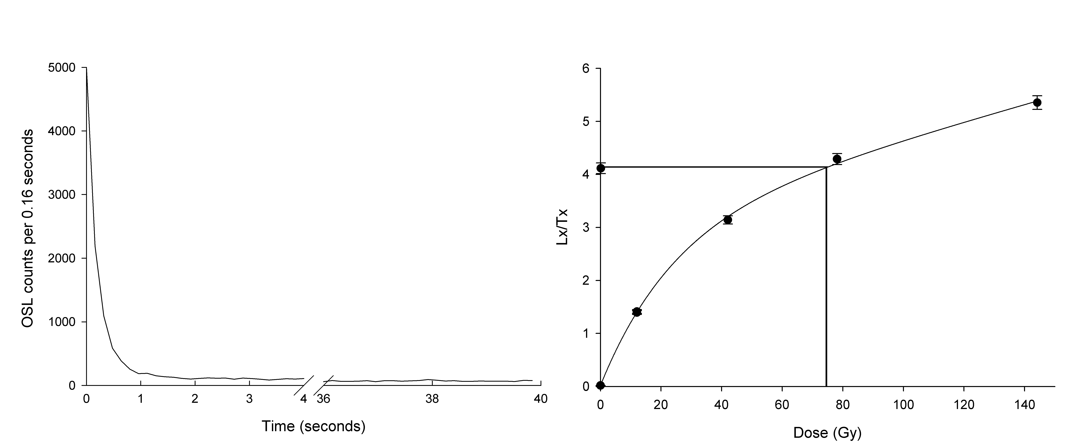
Figure 1. Left: OSL shine down in response to a 9.6 Gy test dose for sample Leic21008. Right: A typical dose response curve for the same sample.

Dose recovery experiments, with varied preheating temperature combinations, were undertaken for two samples (Figure 2). Preheats for the natural or regenerated OSL signals (L_{n} and L_{x}) were held for 10 seconds. The test dose preheats (T_{n} and T_{x}) were in all cases a “cut heat” (held for zero seconds). The results indicate limited sensitivity to the choice of preheating temperature and acceptable performance of the SAR protocol, with the possible exception of the lowest (180/160°C) preheat temperature combination. An additional dose recovery experiment undertaken on Leic20024 using the 220/160°C preheating combination selected for the SAR analysis also indicated acceptable performance of the SAR protocol (dose recovery ratio 0.96 ± 0.02; n=4). These results are consistent with findings from other luminescence studies of quartz along this coastline (e.g., Jacobs et al., 2003; Carr et al., 2019).
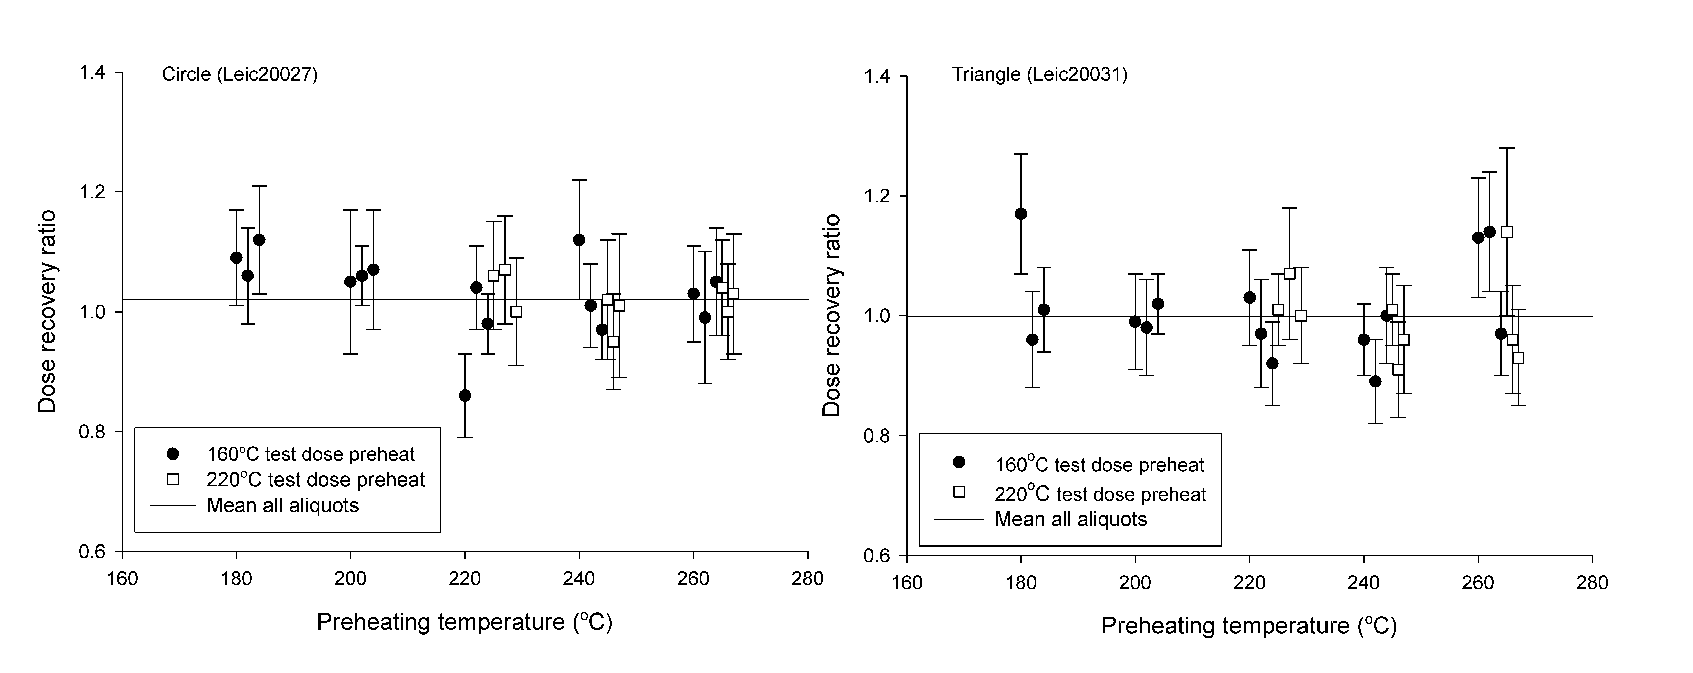
Figure 2. Results of dose recovery preheating experiments for samples Leic20027 and Leic20031 following 55 Gy beta doses. The mean dose recovery ratios for all measured aliquots are (respectively) 1.00 ± 0.07 (n=24) and 1.03 ± 0.06 (n=24). The selected preheats for the SAR measurements were 220/160°C (Leic20027) and 240/160°C (Leic20027).

The equivalent dose distributions exhibited low inter-aliquot scatter, with over-dispersion (OD) values in the range of 10-15%, typical of results from small multi-grain aliquots for well-bleached aeolian sediments along this coastline (Jacobs et al., 2003; Carr et al., 2019). For some samples occasional outlier aliquots, identified using nMAD (e.g. Clarkson et al., 2017), were removed prior to averaging (Figure 3), but given the limited inter-aliquot scatter, final equivalent doses were derived using Central Age Model (CAM; Galbraith et al., 1999) weighted mean.

Figure 3. Radial plots showing the equivalent dose distributions and overdispersion (OD) estimates for all reported samples. The filled circles indicate aliquots identified as statistical outliers. All data were obtained using 2 mm aliquots. The radial plots were created using the RadialPlotter software (Vermeesch, 2009).
The ages obtained using “standard” dose rate calculations (3 ± 3% water content) are shown in Table 1 and span MIS 6 to MIS 4, which places them within the age range often reported for aeolianite along this coastline (Bateman et al., 2011), and specifically the Still Bay region (Roberts et al., 2008). The sample dose rates for these quartz-carbonate dominated materials are quite low (Table 3) and the Th:U ratios are also, as is typical of the region, low (e.g., Carr et al., 2019). To explore the effects of, and age-sensitivity to, changing water contents through time and specifically the associated replacement of pore waters with calcium carbonate cement (Nathan and Mauz 2008), several dose rate modelling experiments were run using the RCarb model (Mauz and Hoffman, 2014; Kreutzer et al., 2022). Initial OSL ages (dose rates) were reassessed for several scenarios. All assumed starting water contents in the upper range measured for coastal dunes along this coastline (i.e. 4 ± 1 %, e.g., Bateman et al., 2008, Table 1), with final water contents in the lower range measured for cemented aeolianite sediments (2 ± 1 %). Associated with this was the ingrowth of 20 ± 5% calcium carbonate cement (see Bateman et al., 2011 for thin section data from the study region). Scenarios were then modelled for rapid (within the initial ~33% of the burial history) cementation and for slow (over 90% of the burial history) cementation histories. The suitability of such scenarios may well be quite context- and site-specific; for instance, one of us (ASC) has observed incipient cementation of early Holocene coastal dunes in the Wilderness embayment, but this is not necessarily widespread.

As noted by Mauz and Hoffman (2014), the results (Table 2) are relatively insensitive to cementation history scenario, and consistent with Nathan and Mauz (2008), the general tendency is for this model to render the final ages somewhat younger than those derived using standard dose rate calculations. This difference reflects the different energy absorption properties of water and calcium carbonate, and the progressive replacement of the former with the latter (Nathan and Mauz, 2008). For samples Leic20003 and Leic20024 the modelled ages, given the measurement uncertainties, do not differ greatly from the initial age calculations, with the samples dating to MIS 5/4 and MIS 5d/5c respectively. For samples Leic21008, Leic20031 and Leic20027 the initial ages fall into late MIS 6, a time of relatively low sea level, but the modelled ages place all three samples more firmly into MIS 5e. Given the likely need for a proximal sediment source to form the extensive MIS 5e coastal dune systems on this coastline, the modelled MIS 5e ages are perhaps more geomorphologically plausible. It should be noted that the model addresses the specific case of calcium carbonate cement replacing pore water. Other changes in dose rate due, for example, to U-Series disequilibrium are not addressed in these scenarios.

REFERENCES

Aitken, M.J., 1985. Thermoluminescence Dating. Academic Press, London, 370 pp.
Bateman, M.D., Carr, A.S., Dunajko, A.C., Holmes, P.J., Roberts, D.L., McLaren, S.J., Bryant, R.G., Marker, M.E., Murray-Wallace, C.V., 2011. The evolution of coastal barrier systems: a case study of the Middle-Late Pleistocene Wilderness barriers, South Africa. Quaternary Science Reviews 30, 63–81.

Bell, W.T., 1979. Thermoluminescence dating: radiation dose rate data. Archaeometry 21,243–246.
Bøtter-Jensen, L., Mejdahl, V., 1988. Assessment of beta dose-rate using a GM multicounter system. Nuclear Tracks and Radiation Measurements 14, 187–191.

Carr, A.S., Bateman, M.D., Cawthra, H., Sealy, J., 2019. First evidence for on-shore Marine Isotope Stage 3 aeolianite formation on the southern Cape coastline of South Africa. Marine Geology 407, 1–15.

Cawthra, H.C.; Jacobs, Z.; Compton, J.S.; Fisher, E.C.; Karkanas, P., Marean, C.W., 2018. Depositional and sea-level history from MIS 6 (termination II) to MIS3 on the southern continental shelf of South Africa. Quaternary Science Reviews 181, 156–172.

Clarkson, C., Jacobs, Z., Marwick, B., Fullagar, R., Wallis, L., Smith, M., Roberts, R.G., Hayes, E., Lowe, K., Carah, X. Florin, S.A., 2017. Human occupation of northern Australia by 65,000 years ago. Nature 547, 306–310.

Cunningham, A.C., Wallinga, J., 2010. Selection of integration time intervals for quartz OSL decay curves. Quaternary Geochronology 5, 657–666.

Duller, G.A.T., 2003. Distinguishing quartz and feldspar in single grain luminescence measurements. Radiation Measurements 37, 161–165.

Duller, G.A.T., 2007. Assessing the error on equivalent dose estimates derived from single aliquot regenerative dose measurements. Ancient TL 25, 15–24.

Galbraith, R.F.; Roberts, R.G.; Laslett, G.M.; Yoshida H., Olley, J.M., 1999. Optical dating of single and multiple grains of quartz from Jinmium rock shelter, northern Australia, part 1, Experimental design and statistical models. Archaeometry 41, 339–364.

Guérin, G., Mercier, N., Adamiec, G., 2011 Dose-rate conversion factors: update. Ancient TL 29, 5–8.

Helm, C.W., Carr, A.S., Cawthra, H.C., De Vynck, J.C., Dixon, M., Stear, W., Stuart, C., Stuart, M., Venter, J.A., 2022 in press. Possible Pleistocene pinniped ichnofossils on South Africa’s Cape south coast. Journal of Coastal Research.

Jacobs, Z., Duller, G.A.T., Wintle, A.G., 2006. Interpretation of single grain D_{e} distributions and calculation of D_{e}. Radiation Measurements 41, 264–277.

Jacobs, Z., Roberts, R.G., 2015. An improved single grain OSL chronology for the sedimentary deposits from Diepkloof Rockshelter, Western Cape, South Africa. Journal of Archaeological Science 63, 175–192.

Jacobs, Z., Wintle, A.G., Duller, G.A.T. 2003. Optical dating of dune sand from Blombos Cave, South Africa: I - multiple grain data. Journal of Human Evolution 44, 599–612.

Kreutzer, S., Burow, C., Dietze, M., Fuchs, M., Schmidt, C., Fischer, M., Friedrich, J., Mercier, N., Philippe, A., Riedesel, S., Autzen, M., Mittelstrass, D., Gray, H., Galharret, J., 2022. Luminescence: Comprehensive Luminescence Dating Data Analysis. R package version 0.9.19, https://CRAN.R-project.org/package=Luminescence

Kreutzer, S., Nathan ,R., Mauz, B. 2022. RCarb: Dose Rate Modelling of Carbonate-Rich Samples. R package version 0.1.5, https://CRAN.R-project.org/package=RCarb

Kreutzer, S., Schmidt, C., Fuchs, M.C., Dietze, M., Fischer, M., Fuchs, M. 2012. Introducing an R package for luminescence dating analysis. Ancient TL 30, 1-8.

Mauz, B., Hoffmann, D., 2014. What to do when carbonate replaced water: Carb, the model for estimating the dose rate of carbonate-rich samples. Ancient TL 32, 24–32.

Mejdahl, V., 1979. Thermoluminescence dating - Beta-dose attenuation in quartz grains. Archaeometry 21, 61–72.

Murray, A.S., Wintle, A.G., 2000. Luminescence dating of quartz using an improved single-aliquot regenerative-dose protocol. Radiation Measurements 32, 57–73.

Murray, A.S., Wintle, A.G., 2003. The single-aliquot regenerative-dose protocol: potential for improvements in reliability. Radiation Measurements 37, 377–381.

Nathan, R.P., Mauz, B., 2008. On the dose-rate estimate of carbonate-rich sediments for trapped charge dating. Radiation Measurements 43, 14–25.

Prescott, J.R., Hutton, J.T., 1994. Cosmic ray contributions to dose rates for luminescence and ESR dating: large depths and long-term variations. Radiation Measurements 23, 497–500.

Roberts, D.L, Bateman, M.D. Murray-Wallace, C.V. Carr, A.S. Holmes, P.J., 2008. Last interglacial fossil elephant trackways dated by OSL/AAR in coastal aeolianites, Still Bay, South Africa.
Palaeogeography, Palaeoclimatology, Palaeoecology 257, 261–279.

Vermeesch, P., 2009. RadialPlotter: a Java application for fission track, luminescence and other radial plots. Radiation Measurements 44, 409–41.

Wintle, A.G., Murray, A.S., 2006. A review of quartz optically stimulated luminescence characteristics and their relevance in single-aliquot regeneration dating protocols. Radiation Measurements 41, 369–391.

Table 1. Details of the equivalent dose determinations and the sample ages. The measured water contents were obtained in the laboratory after sampling, shipping and prolonged storage (due to Covid 19) and are not considered representative of the likely average water content during burial (a value of 3 ± 3 % was applied for dose rate calculation; see also Helm et al., 2022 in press).
Lab code | Burial depth (m) | Measured water content (%) | Applied water content (%) | Grain size (µm) | Aliquots accepted / measured | CAM D_{e} (Gy) | OD (%) | Total dose rate  (Gy ka⁻¹) | Age (ka)
Leic21008 | 70 | 0.4 | 3 ± 3 | 180-212 | 24/24 | 71.7 ± 3.0 | 10 ± 3 | 0.54 ± 0.03 | 134 ± 9
Leic20031 | 70 | nd | 3 ± 3 | 180-250 | 23/24 | 46.0 ± 1.8* | 9 ± 2 | 0.33 ± 0.02 | 139 ± 10
Leic20024 | 70 | nd | 3 ± 3 | 180-250 | 18/20 | 31.4 ± 1.3* | 11 ± 2 | 0.29 ± 0.02 | 109 ± 9
Leic20027 | 80 | 2.5 | 3 ± 3 | 180-212 | 22/24 | 63.8 ± 2.8* | 12 ± 3 | 0.47 ± 0.02 | 136 ± 8
Leic20003 | 10 | nd | 3 ± 3 | 180-250 | 23/24 | 50.6 ± 2.2* | 12 ± 3 | 0.73 ± 0.03 | 70 ± 4
*The stated CAM D_{e} and OD is that following the removal of individual outlier aliquots. The radial plots and D_{e}/OD values for all otherwise acceptable aliquots shown in figure 3.

Table 2. Dose rate modelling and age estimations using the RCarb package (Nathan and Mauz, 2008; Mauz and Hoffman, 2014; Kreutzer et al., 2022), showing dose rate and age adjustment scenarios for a moderate reductions in water content (4 to 2%) and the progressive formation of ~20% cement. The water contents are in the measured range of aeolianites from the southern Cape coastline, while the cementation estimate is based on observations presented in Bateman et al. (2011). Scenarios are presented for cement formation relatively early (with the ~first one third of the burial period) and gradual cement formation (over the majority of the burial period).
 | Early cementation (first third of burial period) |  |  | Gradual cementation (over 90% of burial period)
Lab code | Stating dose rate  (Gy ka⁻¹) | Final dose rate  (Gy ka⁻¹) | Modelled age  (ka) | Stating dose rate  (Gy ka⁻¹) | Final dose rate  (Gy ka⁻¹) | Modelled age  (ka)
Leic21008 | 0.62 ± 0.03 | 0.53 ± 0.03 | 130 ± 10 | 0.62 ± 0.04 | 0.53 ± 0.03 | 126 ± 9
Leic20031 | 0.38 ± 0.03 | 0.33 ± 0.02 | 137 ± 9 | 0.37 ± 0.03 | 0.33 ± 0.02 | 131 ± 10
Leic20024 | 0.32 ± 0.02 | 0.28 ± 0.02 | 109 ± 7 | 0.32 ± 0.03 | 0.28 ± 0.08 | 104 ± 8
Leic20027 | 0.55 ± 0.04 | 0.47 ± 0.02 | 130 ± 7 | 0.55 ± 0.03 | 0.47 ± 0.02 | 125 ± 7
Leic20003 | 0.84 ± 0.05 | 0.73 ± 0.04 | 68 ± 4 | 0.83 ± 0.05 | 0.73 ± 0.04 | 66 ± 5

Table 3. Details of the “standard” dose rate calculations for the samples in this paper (cf. Table 2). Elemental concentrations were determined via ICP-MS and ICP-OES. An internal alpha dose rate was included following Jacobs et al. (2003) and Smith et al. (2018), consistent with other publications in the study region (e.g. Cawthra et al., 2018; Carr et al., 2019). Relative uncertainties of 10% (U and Th) and 5% (K) were propagated from the elemental concentrations. Dose rates were adjusted for grain size, HF etching and sample water contents (values here for 3 ± 3% for the duration of burial). Cosmic dose rates were based on the estimated burial overburdens (as derived with field observation).

Lab code | U (ppm) | Th (ppm) | K (%) | Internal alpha dose rate  (Gy ka⁻¹)ª | External beta dose rate (ICP-MS)  (Gy ka⁻¹) | External gamma dose rate  (Gy ka⁻¹) | Cosmic dose rate  (Gy ka⁻¹) | Total Dose rate  (Gy ka⁻¹)
Leic21008 | 1.43 | 1.32 | 0.11 | 0.036 ± 0.01 | 0.254 ± 0.021 | 0.241 ± 0.019 | 0.005 ± 0.0005 | 0.54 ± 0.03
Leic20031 | 0.65 | 1.24 | 0.08 | 0.036 ± 0.01 | 0.144 ± 0.010 | 0.146 ± 0.010 | 0.005 ± 0.0005 | 0.33 ± 0.02
Leic20024 | 0.56 | 0.96 | 0.07 | 0.036 ± 0.01 | 0.124 ± 0.009 | 0.122 ± 0.009 | 0.005 ± 0.0005 | 0.29 ± 0.02
Leic20027 | 0.63 | 1.22 | 0.24 | 0.036 ± 0.01 | 0.248 ± 0.016 | 0.182 ± 0.011 | 0.004 ± 0.0004 | 0.47 ± 0.02
Leic20003 | 1.22 | 1.54 | 0.29 | 0.036 ± 0.01 | 0.346 ± 0.023 | 0.273 ± 0.018 | 0.07 ± 0.007 | 0.73 ± 0.03
External beta dose rate
via GM beta counting (Gy ka⁻¹)
Leic21008 |  |  |  |  | nd.
Leic20031 |  |  |  |  | 0.16 ± 0.02
Leic20024 |  |  |  |  | 0.12 ± 0.02
Leic20027 |  |  |  |  | 0.22 ± 0.02
Leic20003 |  |  |  |  | 0.32 ± 0.03

