Bayesian modelling and tables of the duration of the phases

This file contains a brief summary of the method and the robustness tests of the model and Markow chains, as well the values of temporal ranges for each LTC of each archaeological sites.

Testing the Bayesian model : checking the Markov chains 2
Abri Bordes-Fitte 3
Les Cottés 3
La Quina aval 4
La Ferrassie 4
Isturitz 5
Gatzarria 5
Labeko-Koba 6
Covalejos 7
Cobrante 7
El Castillo 7
Morín 8
El Cuco 8
Esquicho-Grapaou 9

In this study, the origin of pollen grains conditions the selection of archaeological sites to compare with our environmental record. The pollen preserved in the deep-sea core comes from the Loire to Adour river basins but also from the small rivers to the northern margin of Cantabria. For this reason, our study would focus on archaeological sites from western France and the northern Spain. We propose to compare our environmental and climatic records with three LTC of the Middle to Upper Paleolithic transition in Western Europe: Châtelperronian, Proto-Aurignacian and Early Aurignacian.
A Bayesian modelling approach has been made to model the temporal range of each LTC in each archaeological site. This chronological database is based on published works and available in a .xls file in the supplementary information. The Bayesian modelling has been made using only the quality indices n°3 and stratigraphic order between sample (Fig S1). We have represented below the high probability of density (HPD) values at 68.2% and 95.5% for each LTCs temporal ranges of the different archaeological sites.
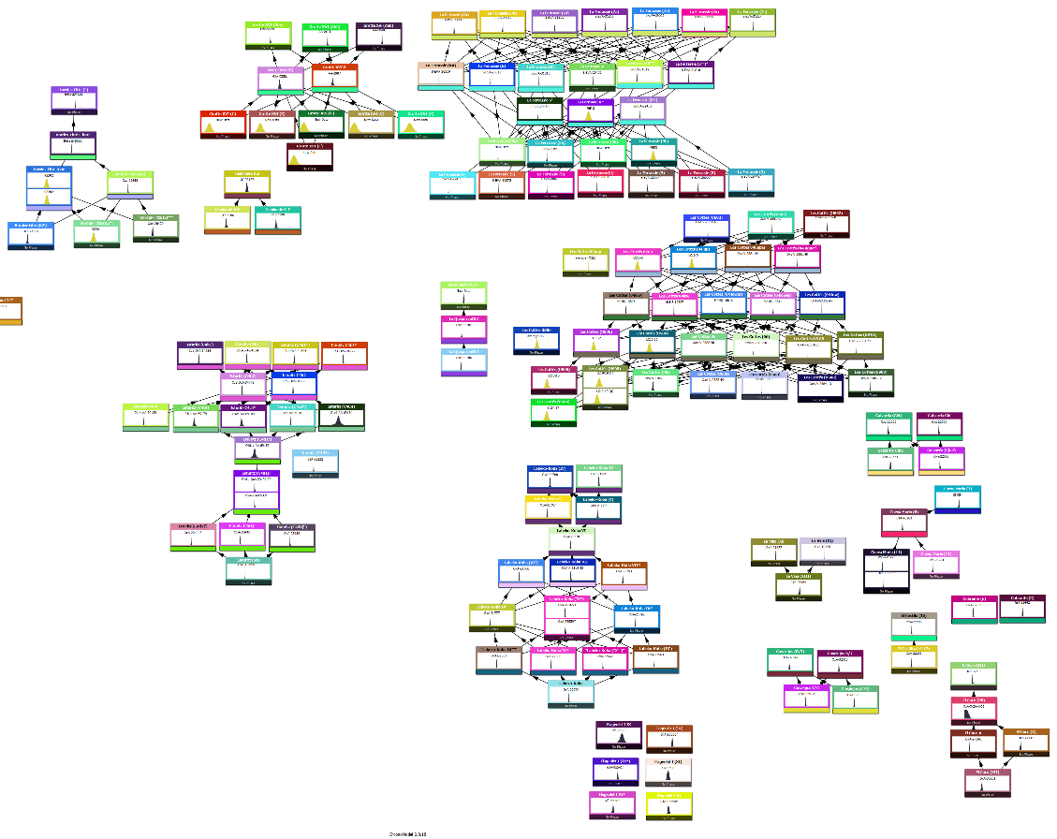
Fig. S1. Event model for each sites. Each event corresponds to an age and arrows correspond to a stratigraphical prior between samples in a site.

Testing the Bayesian model : checking the Markov chains

To verify of the robustness of the Bayesian model, we test the convergence of the chain and the absence of correlation between successive values. The first step is to check if the Markov chain has reach its equilibrium to estimate an appropriate estimate if the posterior distribution. For that, we check the history plot of the chains (dates and variances) and inspect it for signs of convergence.
For all modelled sample, all chains have converged.
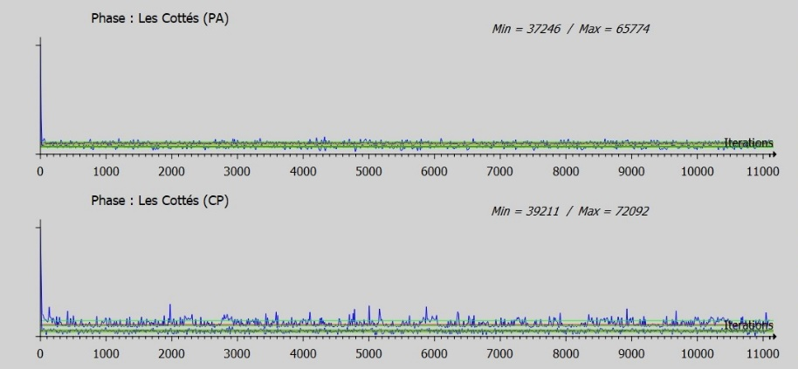
Fig. S2. Example of History plot and chains convergence for the Châtelperronian (CP) and Proto-Aurignacian (PA) at Les Cottés site.

Second step is to check the autocorrelation plot to verify whether the chain is correlated. The autocorrelations of all events have an exponential decrease, indicating that that the autocorrelation functions have a good behaviour.
Another step is to look at the acceptance rates. The Metropolis Hasting algorithm generates a candidate value from a proposal density, which is accepted with a probability. The rate gives an idea of the adequation of the MCMC methods used. There is no theoretical criterion except for the adaptive Metropolis Hastings Gaussian random walk and the theoretical optimal rate for it, is 43%.

Fig. S3. Example of autocorrelation of Markov chain for a sample/event from Châtelperronian level at Les Cottés site.

North Aquitaine basin

Abri Bordes-Fitte

The Bordes-Fitte rockshelter is located in Roche-d’Abilly village in Central France not far from Les Cottés site. This site contains Middle Paleolithic, Châtelperronian, an Aurignacian and Solutrean levels. We build a Bayesian model based on the Châtelperronian and Aurignacian ages (Aubry et al., 2012, 2014 ; Thomsen et al., 2016), available in the chronological database .xls.
Results of the 68.2% and 95.5% HPD range of the duration of Châtelperronian and Aurignacian and temporal range of the beginning and ending phases.
Phases | Modelled range (cal BP)
 | from | to | from | to
 | 68.2% |  | 95.5%
End Early Aurignacian | 41254 | 40154 | 41840 | 39090
Early Aurignacian | 41245 | 40167 | 41842 | 39120
Start Early Aurignacian | 41254 | 40154 | 41840 | 39090
End Châtelperronien | 42191 | 40977 | 42807 | 40189
Châtelperronian | 42939 | 40852 | 44038 | 40142
Start Châtelperronian | 42941 | 41568 | 43944 | 40968

Les Cottés

Les Cottés is a cave located on the border of Vienne department, in Central France. The site presents Mousterian, Châtelperronian, Proto-Aurignacian and Early Aurignacian levels, each separated by sterile levels. The Bayesian model has been made using 14C and OSL ages (Talamo et al., 2012; Jacobs et al., 2015), referenced in the database.

Results of the 68.2% and 95.5% HPD range of the duration of Châtelperronian, Proto-Aurignacian and Early Aurignacian and temporal range of the beginning and ending phases.
Phases | Modelled cal BP
 | from | to | from | to
 | 68.2% |  | 95.5%
End Early Aurignacian | 38335 | 37037 | 38874 | 36511
Early Aurignacian | 39460 | 37296 | 39572 | 36566
Start Early Aurignacian | 39413 | 38807 | 39598 | 38261
End Proto-Aurignacian | 39537 | 38963 | 39766 | 38491
Proto-Aurignacian | 40567 | 38878 | 41119 | 38435
Start Proto-Aurignacian | 40495 | 39662 | 41066 | 39429
End Châtelperronian | 41464 | 40555 | 41735 | 39887
Châtelperronian | 42735 | 40274 | 44441 | 39815
Start Châtelperronian | 42608 | 41976 | 44433 | 41802

La Quina aval

La Quina-Aval rockshelter also called “Station Aval” is located in Charente. The site is near the Quina-Amont, containing Middle Paleolithic industries. The La Quina-Aval presents Châtelperronian and Upper Paleolithic’s Aurignacian industry.
Results of the 68.2% and 95.5% HPD range of the duration of Châtelperronian and temporal range of the beginning and ending phase.
Phases | Modelled cal BP
 | from | to | from | to
 | 68.2% |  | 95.5%
End Châtelperronien | 42805 | 41412 | 43568 | 40121
Châtelperronian | 44268 | 41297 | 46029 | 39683
Start Châtelperronian | 44172 | 42424 | 45751 | 41551

La Ferrassie

La Ferrassie is a rockshelter located in Dordogne, southwest France. The site presents Mousterian to Aurignacian archaeological levels, including Châtelperonnian.
Results of the 68.2% and 95.5% HPD range of the duration of Châtelperronian and temporal range of the beginning and ending phase.

Phases | Modelled cal BP
 | from | to | from | to
 | 68.2% |  | 95.5%
End Châtelperronien | 41626 | 40098 | 41836 | 38527
Châtelperronian | 44537 | 40070 | 44899 | 38496
Start Châtelperronian | 44352 | 43463 | 44785 | 42938

French basque country

Isturitz

Isturitz is a cave located in western Pyrenees, in southwestern France. The site contains Aurignacian sequences: Proto-Aurignacian and Early Aurignacian, which have been dated (Barshay-Szmidt et al., 2018). Some issues have been made concerning the ages of Isturitz level C4d in particular the dating sample with label AA, which have large uncertainties. We have made two models: one with all the age including the –AA sample and another one without these ages.
Model 1: Results of the 68.2% and 95.5% HPD range of the duration of Proto-Aurignacian and Early Aurignacian and temporal range of the beginning and ending phases.
Phases | Modelled range cal BP
 | from | to | from | to
 | 68.2% |  | 95.5%
End Early Aurignacian | 39623 | 37357 | 40378 | 33454
Early Aurignacian | 41046 | 37606 | 41539 | 33628
Start Early Aurignacian | 40830 | 40083 | 41179 | 39668
End Proto-Aurignacian | 42116 | 41520 | 42424 | 41184
Proto-Aurignacian | 43546 | 41374 | 44911 | 41062
Start Proto-Aurignacian | 43559 | 42232 | 44943 | 41931

The results of model 1 shows a time range for the Proto-Aurignacian spanning 43.5 to 41.4 ka. The starting time is the oldest all of our sites in Western Europe.
Model 2: Results of the 68.2% and 95.5% HPD range of the duration of Proto-Aurignacian and Early Aurignacian and temporal range of the beginning and ending phases.
Phases | Modelled range cal BP
 | from | to | from | to
 | 68.2% |  | 95.5%
End Early Aurignacian | 40162 | 36749 | 41307 | 39770
Early Aurignacian | 41069 | 37578 | 41671 | 33627
Start Early Aurignacian | 40948 | 40186 | 41798 | 32945
End Proto-Aurignacian | 42146 | 41583 | 42403 | 41304
Proto-Aurignacian | 43399 | 41425 | 46317 | 41188
Start Proto-Aurignacian | 44214 | 41601 | 47223 | 40173

The results of the two models are relatively similar. The ages of the C4dj1j’ level were not constrained by other ages of an earlier level. There is therefore a need for further work on the modelling of these Proto-Aurignacian levels.

Gatzarria

Gatzarria is a cave is located in the Ossas-Suhare region in the Basque area of France. The site presents Mousterian, Châtelperronian, Proto-Aurignacian and Early Aurignacian sequences. 6 ages are available (Barshay-Szmidt et al., 2012) for the Mousterian (n=2), Proto-Aurignacian (n=2) and Early Aurignacian (n=2).
Results of the 68.2% and 95.5% HPD range of the duration of Proto-Aurignacian and Early Aurignacian and temporal range of the beginning and ending phases.
Phases | Modelled cal BP
 | from | to | from | to
 | 68.2% |  | 95.5%
End Early Aurignacian | 39415 | 37110 | 41249 | 34055
Early Aurignacian | 40143 | 37202 | 42155 | 34161
Start Early Aurignacian | 39981 | 38321 | 41861 | 37651
End Proto-Aurignacian | 41829 | 38942 | 42700 | 38443
Proto-Aurignacian | 42228 | 38900 | 47736 | 37557
Start Proto-Aurignacian | 42352 | 40404 | 47945 | 39200

The ages obtained for the Mousterian Cjr level are beyond the 14C limit and are only indicative. This ages are not take into account ion our study, which focuses on Châtelperronian, Proto-Aurignacian and Early Aurignacian. The beginning of the Proto-Aurignacian is older because any “boundary” are used in the model due to the no-selection of the Mousterian level. Our model for the Proto-Aurignacian thus the site of Gatzarria could be not sufficiently robust.

Spanish Basque country

Labeko-Koba

Labeko-Koba is a cave situated in the upper basin of the Deba river in the west Spanish Basque country in the province de Gipuzkoa. The site is located 28km from the current coastline. It contains archaeological units: Chatelperonnian (IX lower), Proto-Aurignacian (VII) separated by units with low level of human activity (IX upper, VIII). It also presents Early Aurignacian levels (VI, IV) in a separate unit to the Proto-Aurignacian level VII (Bon, 2006).
Results of the 68.2% and 95.5% HPD range of the duration of Châtelperronian, Proto-Aurignacian and Early Aurignacian and temporal range of the beginning and ending phases.
Phases | Modelled ranges cal BP
 | from | to | from | to
 | 68.2% |  | 95.5%
End Early Aurignacian | 38439 | 36460 | 39332 | 33782
Early Aurignacian | 40698 | 36733 | 41212 | 34004
Start Early Aurignacian | 40545 | 39709 | 40917 | 39258
End Proto-Aurignacian | 40914 | 40134 | 41242 | 39693
Proto-Aurignacian | 41443 | 40171 | 41717 | 39706
Start Proto-Aurignacian | 41436 | 40799 | 41724 | 40423
End Châtelperronian | 42268 | 41716 | 42557 | 41416
Châtelperronian | 43049 | 41626 | 43884 | 41291
Start Châtelperronian | 43082 | 42259 | 43905 | 41935

Cantabrian region

Covalejos

Covalejos is a cave located in Velo de Piélagos, Cantabria (Spain). The site is approximately 3km from de current coastline and situated near the mouth of the Pas River. The site contains sequences dating from the Early Middle Paleolithic or Late Acheulean, several levels to the Mousterian. Two level are considered to be Archaic Aurignacian/Proto-Aurignacian and Early Aurignacian (B/2 and C/3). We built the Bayesian model based on Marín-Arroyo et al. (2018) ages.
Results of the 68.2% and 95.5% HPD range of the duration of Proto-Aurignacian and Early Aurignacian and temporal range of the beginning and ending phases.
Phases | Modelled range cal BP
 | from | to | from | to
 | 68.2% |  | 95.5%
End Early Aurignacian | 39834 | 37564 | 40717 | 34748
Early Aurignacian | 40493 | 37667 | 41356 | 34791
Start Early Aurignacian | 40388 | 39011 | 41050 | 37890
End Proto-Aurignacian | 40923 | 39666 | 41778 | 38946
Proto-Aurignacian | 41863 | 39511 | 44595 | 38503
Start Proto-Aurignacian | 41910 | 40092 | 44617 | 39241

Cobrante

Cobrante cave is situated in Valle de Aras, Cantabria (Spain). The site opens to an endorheic valley in the Asón basin and it is near the coastal marshes of East Cantabria. The site presents archaeological levels of Mousterian, Aurignacian, Solutrean (Uzquiano, 2014). Levels 6 and 7 has been attributed to the Proto-Aurignacian (Archaic Aurignacian), but only level 6 has been dated. The Aurignacian has been attributed to level 5. However, these attributions (i.e Proto-Aurignacian and Aurignacian) are based on few lithic materials. We built the model using 2 ages for the Proto-Aurignacian level 6.
Results of the 68.2% and 95.5% HPD range of the duration of Proto-Aurignacian and temporal of the beginning and ending phase.
Phases | Modelled cal BP
 | from | to | from | to
 | 68.2% |  | 95.5%
End Proto-Aurignacian | 39049 | 37140 | 40118 | 35999
Proto-Aurignacian | 41275 | 37184 | 43016 | 35533
Start Proto-Aurignacian | 41280 | 39151 | 43076 | 37749

El Castillo

The site of El Castillo is situated near Puente Viesgo, Cantabria (northern Iberia). This site was excavated in the early 1900’s (1910 to 1914). This site contains archaeological levels from early Middle Paleolithic to the Azilian, each separated by sterile units (Cabrera Valdés, 1984, Cabrera Valdés et al., 2006). We have built the Bayesian model from Marín-Arroyo et al. (2018). This site is extremely important to the emergence of Aurignacian in the Cantabria region. According to Marín-Arroyo et al. (2018), the Bayesian model of the Proto-Aurignacian level 16 appear to be older that Labeko-Koba level VIII. In addition, in the Cantabria region, an overlap between Châtelperronian and Proto-Aurignacian appear. In removing the single age of this level 16, the Bayesian model significantly changes: the start of the Proto-Aurignacian in the region is pushed forward of 1,200 years and the overlap with the Châtelperronian is reduced.
Results of the 68.2% and 95.5% HPD range of the duration of Proto-Aurignacian and temporal range of the beginning and ending phase.
Phases | Modelled range (cal BP)
 | from | to | from | to
 | 68.2% |  | 95.5%
End Proto-Aurignacian | 43020 | 41361 | 44095 | 39523
Proto-Aurignacian | 43055 | 41466 | 44143 | 39685
Start Proto-Aurignacian | 43020 | 41361 | 44095 | 39523

From our model, the Proto-Aurignacian in El Castillo would begin around 43 ka and be older than the Proto-Aurignacian of Labeko-Koba, dated at 41.4 ka (68,2%). However, our model used a single date for level 16. There is need for an in-depth study. We will not use the modelling of this site in the following discussion.

Morín

The cave of Morín (also called Cueva Morín) is located in Villaescusa, Cantabria. The site contains an archaeological sequence from Mousterian to the Azilian, including Châtelperronian, Proto-Aurignacian and Early Aurignacian levels. We have constructed the Bayesian model for the Proto-Aurignacian and Early Aurignacian time ranges, using 1 age each for the Proto-Aurignacian level 8 and Early Aurignacian level 7.
Results of the 68.2% and 95.5% HPD range of the duration of Proto-Aurignacian, Early Aurignacian and temporal range of the beginning and ending phases.
Phases | Modelled range (cal BP)
 | from | to | from | to
 | 68.2% |  | 95.5%
End Early Aurignacian | 37031 | 35058 | 38785 | 33435
Early Aurignacian | 37004 | 35092 | 38831 | 33532
Start Early Aurignacian | 37031 | 35058 | 38785 | 33435
End Proto-Aurignacian | 42267 | 40540 | 43419 | 39022
Proto-Aurignacian | 42240 | 40550 | 43357 | 38999
Start Proto-Aurignacian | 42267 | 40540 | 43419 | 39022

The temporal ranges of Proto-Aurignacian and Early Aurignacian seem realistic but the model for these two phases is not sufficiently robust (1 age). For this reason, we will not use the temporal ranges on this site. In addition, dated samples conserved in collections, have been frequent moved and have caused provenience and preservation problems with the material (Marín-Arroyo et al., 2018).

El Cuco

El Cuco is a rock-shelther located in Castro Urdiales, Cantabria. This site presents problems with bone collagen preservation, which led to problems in the dated samples. Shells of Patella vulgate species, found in the levels X, XII and XIII have been dated (Gutiérrez-Zugasti et al., 2018). For this levels initially attributed to Aurignacian, the ages are older than expected. In addition, a technological revision of these levels allowed to attribute these level to the Late Middle Paleolithic. Initially attributed to the Gravettian on the basis on a single date, the levels III and Vb have been dated (Marín-Arroyo et al., 2018). The ages used to construct the Bayesian model are available in the database xls.
Results of the 68.2% and 95.5% HPD range of the duration of Proto-Aurignacian and the temporal range of the beginning and ending phase.
Phases | Modelled range cal BP
 | from | to | from | to
 | 68.2% |  | 95%
End Proto-Aurignacian | 41133 | 39007 | 42608 | 36924
Proto-Aurignacian | 41108 | 39067 | 42670 | 37064
Start Proto-Aurignacian | 41133 | 39007 | 42608 | 36924

For the El Cuco site, only one age was used in our Bayesian model. Although only age has been used to date the Proto-Aurignacian level, the temporal range is consistent with other site yielding Proto-Aurignacian in the region i.e. Cobrante and Covalejos.

Southestern France

Esquicho-Grapaou

The southestern France and Mediterranean region are represented only by a site, Esquicho-Grapaou. It is located in Russan-Ste-Anastasie, Gard. ¹⁴C dating has been made but recently, the first AMS ¹⁴C dates for the site allowed to date Proto-Aurignacian levels (Barshay-Szmidt et al., 2020). We have construct the model based on these new dates.
Results of the 68.2% and 95.5% HPD range of the duration of Proto-Aurignacian and the temporal range of the beginning and ending phase.
Phases | Modelled range cal BP
 | from | to | from | to
 | 68.2% |  | 95%
End Proto-Aurignacian | 41051 | 38891 | 41709 | 37231
Proto-Aurignacian | 42024 | 39338 | 48017 | 36473
Start Proto-Aurignacian | 42835 | 40483 | 47876 | 39501

The ending age of Esquicho-Grapaou is the youngest among all sites. It due to few ages were integrated in the model: two ages for the Proto-Aurignacian and there is any other ages to “boundary” the level.

