Online Supplementary Information for “Environmental changes in SW France during the Middle-to-Upper Palaeolithic transition from the pollen analysis of an eastern North Atlantic deep-sea core”

This file includes:
Fig. S1. Contributions of each variable on dimension 1 and dimension
Fig. S2: IRD curve and location of samples for luminescence dating
Fig. S3: Radial plot of pIR-IR₂₉₀ measurements
Fig. S4: Dates of HS 4 from six North Atlantic deep-sea cores between 62°-42°N
Fig. S5: Comparison of calibrated ages of HS 4 in North Atlantic

Table S1: pIR-IR₂₉₀ measurements using SAR protocol.
Table S2: Bibliographic comparisons of previous study using luminescence dating on deep-sea core. The locations, depths of the cores, methods and granulometric fractions used, water contents and cosmic doses are shown.
Table S3: ¹⁴C ages delimiting the HS4 in several North Atlantic cores

List of references

Pollen analysis
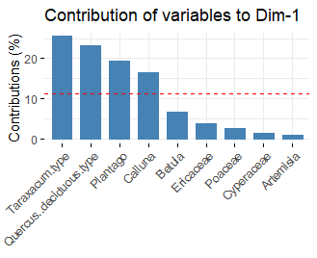
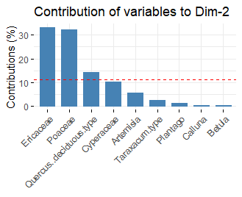

Fig. S1. Contributions of each variable on dimension 1 and dimension 2.

MD04-2845 chronology

Luminescence: methods and sampling

Luminescence dating methods determine the time elapsed since the minerals were last exposed to sunlight or heat. The method of the OSL (optically stimulated luminescence) requires the determination of two elements: the determination, based on luminescence measurements, of the equivalent dose (D_{e}) corresponding to the total irradiation dose absorbed by minerals since their last zeroing. This resetting can occur when sediments bleached by sunlight, by pressure (Bateman et al., 2012, 2018) or heat independents of the time of the deposition. The dose rate (D_{r}) corresponds to the dose absorbed per unit time. In general, it is determined by radioelements contents in the sediment itself (usually a CRP2A laboratory thanks to High purity and low background gamma-spectrometry, (Guibert and Schvoerer, 1991) combined with in situ dosimetric measurements (dosimeters or in situ gamma spectrometry), the latter being impossible in the case of deep-sea cores. Dating feldspars by IRSL (Infrared stimulated luminescence) with commonly used protocols (IR at 50°C for example) requires, contrary to quartz OSL dating, to consider a loss of charge from stable traps called anomalous fading (Huntley and Lamothe, 2001), or to use protocols to overcome it. The post-IR-IR signal (pIR-IR), measured at high temperature (e.g 290°C) can be used to avoid anomalous fading and determine an age (Thiel et al., 2011a, 2011b; Thomsen et al., 2011; Buylaert et al., 2012).
Sampling
The samples were collected according to the protocols described by Armitage and Pinder (2017) and Nelson et al., (2019). The first few external centimetres of sediment (exposed to light after sampling) were sampled for D_{r} determination. Below these first few centimetres, internal sediment was sampled for D_{e} measurements. Approximately 50 g of material was required for both D_{e} and D_{r} measurements.
Each measured aliquot contained approximately 1 mg of material (polymineral extract averaging 250 grains, estimated with the function “calc_AliquotSize” in the Luminescence package (v. 0.9.10, Kreutzer et al., 2020) in RStudio environment).

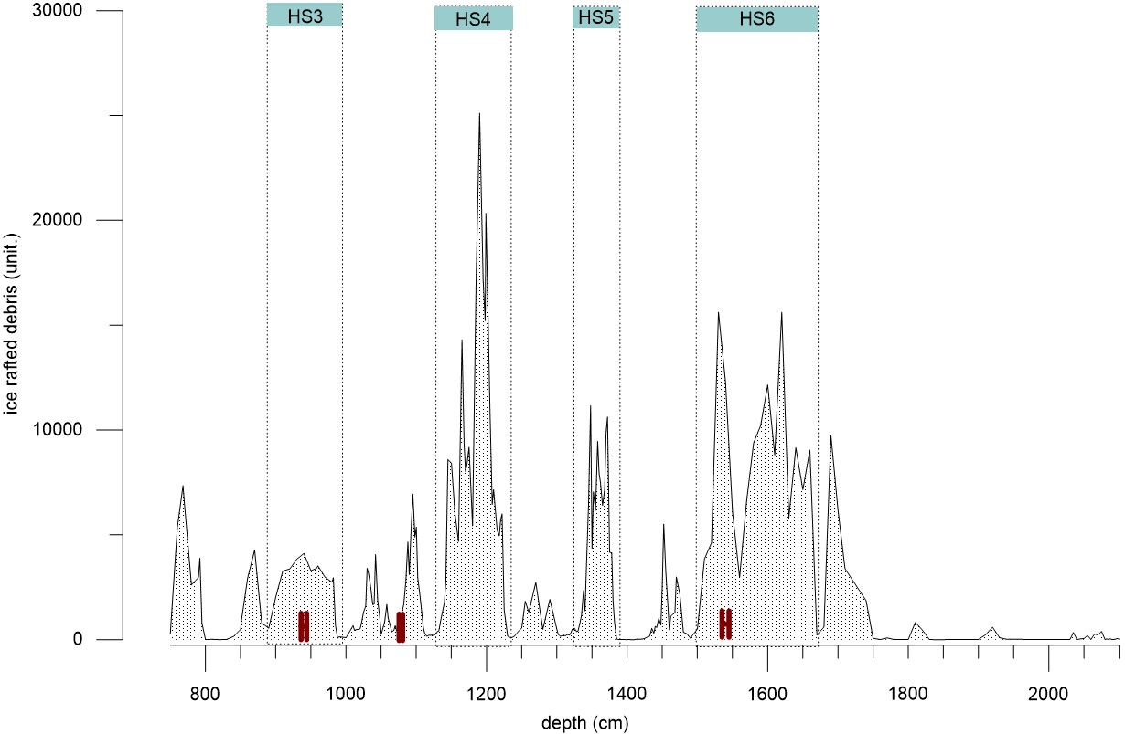
Fig. S2: Ice Rafted Debris curve (unit) according to depth (centimeters) from MD04-2845 deep-sea core. The quantity of IRD are used to identify the HEs. The Heinrich Stadials (HS) are delimited by both the IRD and the Sea Surface Temperatures. Vertical dashed lines represent the depth limits of the four HSs (HS3 to HS6) in MD04-2845 deep-sea core. The red dots represent the three sampling between 936-944, 1076-1081 and 1535-1545 cm depth for the luminescence dating. The grains were sampled over a width of ~10 cm.
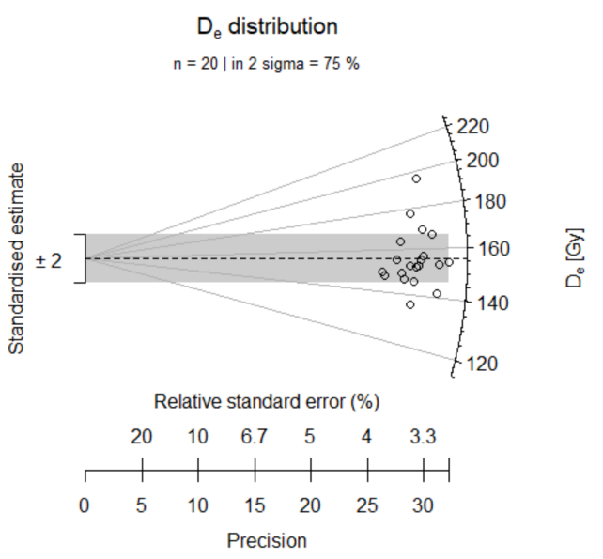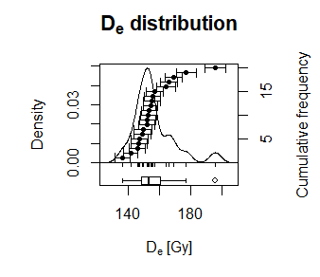Fig. S3: Radial and Kernel plots of pIR-IR290 measurements on BDX24931 sample (n=20), using the Luminesncence package V. 0.9.10 in RStudio environment

Step | pIR-IR290
1  2  3  4  5  6  7  8  9  10 | Irradiation  Preheat, 60s at320°C  IRSL, 280s at 50°C  IRSL, 280s at 290°C  Dose test  Preheat (TL) 60s at 320°C  IRSL, 280s at 50°C  IRSL, 280s at 290°C  IRSL, 280s at 325°C  Return step 1
Table S1: Single-aliquot regenerative-dose (SAR) protocols used for feldspars D_{e} determinations (pIR-IR₂₉₀)(Murray and Wintle, 2003)

Chronologies of HS 4

- Chronological comparison of several deep-sea cores: HS 4 and calibration curves
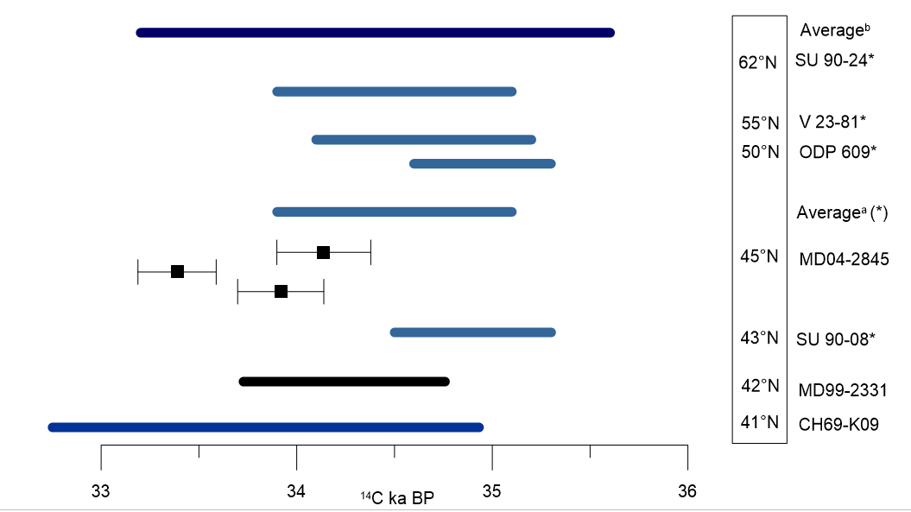
Fig. S4: Dates of HS 4 from six North Atlantic deep-sea cores between 62°-42°N.
The duration of HS 4 in each deep-sea core (at the right) is given by the ¹⁴C dating of the interval containing high abundance of coarse grains (IRD). The three new ¹⁴C age of core MD04-2845 within the HS 4, are represented with the age and its uncertainties. Furthermore, for the other ages of HS 4, the duration of this same event are estimated from different cores. Are represented HS 4 in MD99-2331 (Naughton et al., 2009). “Averageª” (light blue) represents the HS 4 temporal lapse,calculated from the correlation of several cores: SU-90-08 (3 ages), ODP 609 (1 age), V 23-81 (1 sample), SU 90-24 (7 ages) (Elliot et al., 1998). “Average^{b}” (dark blue, Eliott et al.,2001; 2002) was estimated using SU90-24, V23-81 and ODP 609, Na 87-22 (2 ages from Cortijo et al., 1997) , CH69-K09 (from correlation with NA 87-22), SU 90-08 (light blue) and cores.

Area | Core names and localisation | Depth (m) | Method | Grain size  (µm) | Water content  (%) | Cosmic rate | References
North Pacific | TT28-14  (33°26’N 173°38’E) | 5079 | TL | 4-11 | 57 ± 5 | negligible (> 4km) | Wintle and Huntley, (1980, 1979)
Antarctic | RC8-39  (42°53’S 42°21’E) | 4330 | TL | 4-11 | 59 ± 2 | negligible (> 4km) | Wintle and Huntley, (1980, 1979)
Gulf of Carpentaria (Australia) | MD32  (12°S32’, 139°98’)  MD-33  (12°39’, 140°34’) | 60 | TL-OSL | 106–150  63–106 | 20 ±5 |  | Chivas et al., (2001), Reeves et al., (2008)
Arabian Sea | 70KL  (17°52’N 61°71’E)  74KL  (14°32’N 57°36’E) | 3810  3212 | OSL | 4-11 | 65 à 135 | n.d. | Stokes et al., (2003)
Arctic Ocean | 96/24-1sel (87°183’N,144°60’E) | 980 | OSL (MG) | >63 | 28 - 46 | negligible | Jacobson,(2003)
East Indian Ocean | FR10/95-GC17 (22°05’ S 113°50 E) | 1093 | OSL | 60-70 | 80 à 105± 10 | (Prescott et Hutton, 1994) | Olley et al., (2004)
Arctic Ocean | LLF03(-SM1A,  8 cores | 449 (min)  960 (max) | TL – IRSL  (polyminieral) | 4-11 ; 62-105 ; 105-185 | 28± 4 to 100±2 | Négligeable (=0) | (Berger, 2009) + Berger, (2006)
Baltic Sea, Arkona basin | 242790  (54°951’N 13°780’E) | n.d. | OSL | 63-106 | 27-237 | n.d. | Kortekaas et al., (2007)
Mediterrannean Sea, Peloponese | 36°37.5’N 21°34.6’E | 5200 | TL - OSL | 30-60  (polymineral) | 52-57 ratio w/mineral | negligeable | Polymeris et al., (2009)
North Sea | 21VC  26VC  14VC  35VC  06VC  41VC  49VC |  | OSL - IRSL | 100-150  150-200 | 40 ± 10 | 0.3 mGy/a | Alappat et al., (2010)
Okhotsk Sea | MR0604-PC07A (51°16.54’ N, 149°12.54’ E) | 1249 | OSL (quartz) | 4 - 11 | n.d. | negligible | Sugisaki et al., (2010)
Shiretoko Peninsula | MR0604-PC04A (44°31.65′N, 145°00.25′E) | 1215 | OSL | 4 - 11 | 61-114 | negligible | Sugisaki et al., (2012)
Baltic Sea | C06 (55°3'02"N, 13°7’47"E)  D03 (55°2'39"N, 13°9'31"E)  E02 (55°2'44"N, 13°1'01"E) |  |  |  | 30±5 |  | Anjar et al., (2012)
China East Sea | ECS-DZ1 (30°29'N, 112°03'E) | 1200 | OSL | 4-11100-200 | 20 ± 5  40± 10 | Prescott & Hutton, 1994  <0.04 ± 0.004 mGy/a ± 10% | Yi et al., (2014)  Wang et al., (2015)
Atlantic Ocean, Cap Blanc | ODP 658 (20°45’N, 18°35’W) | 2263 | OSL | 4-11  40-63 | 48±5.0 | negligible | Armitage, (2015); Armitage and Pinder, (2017)
Japonese Sea | LV53-18-2 (42°56'N, 134°44'E) | 551 | pIR-IRSL  MET-pIRIR  OSL | 4-11 | 40-50±10 | negligible | Yang et al., (2015)
Monterey Canyon (California) | DR 584 VC 328 (36°59’N, 122°44’W)  DR 584 VC 329 (36°59’N, 122°43’W)  DR 584 VC330 (36°59’N, 122°44’W)  DR 39 – VC3  DR 39 – VC9  DR 38 – VC1 | 2920  3612  3555  3456 | IRSL  OSL (SA) | 200-250  150-250  74-250 | Saturated  0.04±0.04 à 0.57±0.06 | Prescott & Hutton, 1994  0 | Heerema, (2016)  Steven et al., (2014)
East Mediterranean Sea (Israel coast) | K20  (34°49’N, 31°62’E)  K38  (34°51’N, 31°63’E) | 2540  950 | OSL – IRSL  KF et Q | 150-200  105-250 | 20±10 | 35±5 µGy/a | Porat et al., (2003)
Table S2: Deep-sea cores dated by luminescence dating (OSL, IRSL, TL). The locations, depths of the cores, granulometric fractions, water contents and cosmic doses rates are shown, associated with bibliographic references.
 | Top  ¹⁴C ka BP | Bottom  ¹⁴C ka BP | ¹⁴Cages  (average or date) | Calibrate ages (ka Cal BP)  Marine13 | Calibrate ages  (ka Cal BP)  Marine20
Cortijo et al., 1998 | 33.2 ±0.3 | 35.1 ± 1.1 |  | 33.6-35.2  34.2-39.2 | 33.8-35.2  34.3-38.8
(Elliot et al., 1998) | 33.9 | 35.1 | 35.2±0.13 | 38.4-39.1 | 36.8-37.4
(Elliot et al., 2001, 2002) | 33.9 ± 0.7 | 34.9 ± 1.1 |  | 33.7-36 .9  33.9-38.9 | 33.9-37.2 (top)  34.1-38.7 (bottom)
Naughton et al., 2009 | 33.73 | 34.74
This study |  |  | 33.92±0.22 | 34.6-36.2- | 34.7-36.2-
This study |  |  | 33.39±0.20 | 34.1-35.3- | 34.2-35.2-
This study |  |  | 34.14±0.24 | 35.0-36.5- | 35.0-36.6-
Table S3: ¹⁴C and calibrated ages of estimated HS4 in several North Atlantic cores (see Figure S2 above). The ¹⁴C ages and their uncertainties were calibrated with Marine13 with Calib 7.0.4 and with Marine20 (Calib. 8.20).

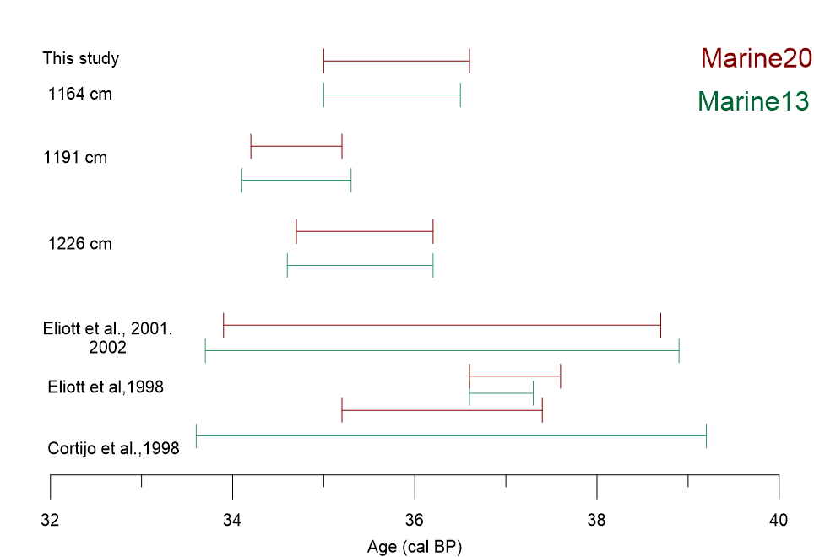
Fig. S5: Comparison of calibrated ages of HS 4 (Table 3 above) using Marine13 (Calib v.7.0.4) and Marine20 (Calib v.8.20).

References
Alappat, L., Vink, A., Tsukamoto, S., Frechen, M., 2010. Establishing the Late Pleistocene–Holocene sedimentation boundary in the southern North Sea using OSL dating of shallow continental shelf sediments. Proc. Geol. Assoc. 121, 43–54. https://doi.org/10.1016/j.pgeola.2009.12.006
Anjar, J., Adrielsson, L., Bennike, O., Björck, S., Filipsson, H.L., Groeneveld, J., Knudsen, K.L., Larsen, N.K., Möller, P., 2012. Palaeoenvironments in the southern Baltic Sea Basin during Marine Isotope Stage 3: a multi-proxy reconstruction. Quat. Sci. Rev. 34, 81–92. https://doi.org/10.1016/j.quascirev.2011.12.009
Armitage, S.J., 2015. Optically stimulated luminescence dating of Ocean Drilling Program core 658B: Complications arising from authigenic uranium uptake and lateral sediment movement. Quat. Geochronol., LED14 Proceedings 30, 270–274. https://doi.org/10.1016/j.quageo.2015.03.002
Armitage, S.J., Pinder, R.C., 2017. Testing the applicability of optically stimulated luminescence dating to Ocean Drilling Program cores. Quat. Geochronol. 39, 124–130. https://doi.org/10.1016/j.quageo.2017.02.008
Bateman, M.D., Swift, D.A., Piotrowski, J.A., Rhodes, E.J., Damsgaard, A., 2018. Can glacial shearing of sediment reset the signal used for luminescence dating? Geomorphology 306, 90–101. https://doi.org/10.1016/j.geomorph.2018.01.017
Bateman, M.D., Swift, D.A., Piotrowski, J.A., Sanderson, D.C.W., 2012. Investigating the effects of glacial shearing of sediment on luminescence. Quat. Geochronol., 13th International Conference on Luminescence and Electron Spin Resonance Dating - LED 2011 Dedicated to J. Prescott and G. Berger 10, 230–236. https://doi.org/10.1016/j.quageo.2011.11.012
Berger, G.W., 2009. Zeroing tests of luminescence sediment dating in the Arctic Ocean: Review and new results from Alaska-margin core tops and central-ocean dirty sea ice. Glob. Planet. Change, The 2005 HOTRAX Expedition to the Arctic Ocean 68, 48–57. https://doi.org/10.1016/j.gloplacha.2009.03.019
Buylaert, J.-P., Jain, M., Murray, A.S., Thomsen, K.J., Thiel, C., Sohbati, R., 2012. A robust feldspar luminescence dating method for Middle and Late Pleistocene sediments. Boreas 41, 435–451. https://doi.org/10.1111/j.1502-3885.2012.00248.x
Chivas, A.R., Garcı́a, A., van der Kaars, S., Couapel, M.J.J., Holt, S., Reeves, J.M., Wheeler, D.J., Switzer, A.D., Murray-Wallace, C.V., Banerjee, D., Price, D.M., Wang, S.X., Pearson, G., Edgar, N.T., Beaufort, L., De Deckker, P., Lawson, E., Cecil, C.B., 2001. Sea-level and environmental changes since the last interglacial in the Gulf of Carpentaria, Australia: an overview. Quat. Int., Australian Quaternary Studies: A Tribute to Jim Bowler 83–85, 19–46. https://doi.org/10.1016/S1040-6182(01)00029-5
Cortijo, E., Labeyrie, L., Vidal, L., Vautravers, M., Chapman, M., Duplessy, J.-C., Elliot, M., Arnold, M., Turon, J.-L., Auffret, G., 1997. Changes in sea surface hydrology associated with Heinrich event 4 in the North Atlantic Ocean between 40° and 60°N. Earth Planet. Sci. Lett. 146, 29–45. https://doi.org/10.1016/S0012-821X(96)00217-8
Guibert, P., Schvoerer, M., 1991. TL dating: Low background gamma spectrometry as a tool for the determination of the annual dose. Int. J. Radiat. Appl. Instrum. Part Nucl. Tracks Radiat. Meas. 18, 231–238. https://doi.org/10.1016/1359-0189(91)90117-Z
Heerema, C., 2016. Luminescence Dating of Submarine Canyons: Application to the Monterey Canyon, California.
Huntley, D.J., Lamothe, M., 2001. Ubiquity of anomalous fading in K-feldspars and the measurement and correction for it in optical dating. Ubiquity Anomalous Fading K-Feldspars Meas. Correct. It Opt. Dating 38, 1093–1106.
Jacobson, n.d. Optically stimulated luminescence dating supports central Arctic Ocean cm-scale sedimentation rates - Research - Aarhus University.
Kortekaas, M., Murray, A.S., Sandgren, P., Björck, S., 2007. OSL chronology for a sediment core from the southern Baltic Sea: A continuous sedimentation record since deglaciation. Quat. Geochronol., LED 2005 2, 95–101. https://doi.org/10.1016/j.quageo.2006.05.036
Kreutzer, S., Burow, C., Dietze, M., Fuchs, M.C., Schmidt, C., Fischer, M., Friedrich, J., Mercier, N., Smedley, R.K., Christophe, C., Zink, A., Durcan, J., King, G.E., Philippe, A., Guerin, G., Riedesel, S., Autzen, M., Guibert, P., Mittelstrass, D., Fuchs, M., 2020. Luminescence: Comprehensive Luminescence Dating Data Analysis.
Murray, A.S., Wintle, A.G., 2003. The single aliquot regenerative dose protocol: potential for improvements in reliability. Radiat. Meas., Proceedings of the 10th international Conference on Luminescence and Electron-Spin Resonance Dating (LED 2002) 37, 377–381. https://doi.org/10.1016/S1350-4487(03)00053-2
Nelson, M., Rittenour, T., Cornachione, H., 2019. Sampling Methods for Luminescence Dating of Subsurface Deposits from Cores. Methods Protoc. 2, 88. https://doi.org/10.3390/mps2040088
Olley, J.M., De Deckker, P., Roberts, R.G., Fifield, L.K., Yoshida, H., Hancock, G., 2004. Optical dating of deep-sea sediments using single grains of quartz: a comparison with radiocarbon. Sediment. Geol. 169, 175–189. https://doi.org/10.1016/j.sedgeo.2004.05.005
Polymeris, G.S., Kitis, G., Liolios, A.K., Sakalis, A., Zioutas, K., Anassontzis, E.G., Tsirliganis, N.C., 2009. Luminescence dating of the top of a deep water core from the NESTOR site near the Hellenic Trench, east Mediterranean Sea. Quat. Geochronol. 4, 68–81. https://doi.org/10.1016/j.quageo.2008.05.001
Porat, N., Avital, A., Frechen, M., Almogi-Labin, A., 2003. Chronology of upper Quaternary offshore successions from the southeastern Mediterranean Sea, Israel. Quat. Sci. Rev., LED 2002 22, 1191–1199. https://doi.org/10.1016/S0277-3791(03)00016-7
Reeves, J.M., Chivas, A.R., García, A., Holt, S., Couapel, M.J.J., Jones, B.G., Cendón, D.I., Fink, D., 2008. The sedimentary record of palaeoenvironments and sea-level change in the Gulf of Carpentaria, Australia, through the last glacial cycle. Quat. Int., Subaerially exposed continental shelves: contributions from INQUA Project 0419 183, 3–22. https://doi.org/10.1016/j.quaint.2007.11.019
Stokes, S., Ingram, S., Aitken, M.J., Sirocko, F., Anderson, R., Leuschner, D., 2003. Alternative chronologies for Late Quaternary (Last Interglacial–Holocene) deep sea sediments via optical dating of silt-sized quartz. Quat. Sci. Rev. 22, 925–941. https://doi.org/10.1016/S0277-3791(02)00243-3
Sugisaki, S., Buylaert, J.-P., Murray, A., Tsukamoto, S., Nogi, Y., Miura, H., Sakai, S., Iijima, K., Sakamoto, T., 2010. High resolution OSL dating back to MIS 5e in the central Sea of Okhotsk. Quat. Geochronol., 12th International Conference on Luminescence and Electron Spin Resonance Dating (LED 2008) 5, 293–298. https://doi.org/10.1016/j.quageo.2009.01.008
Sugisaki, S., Buylaert, J.P., Murray, A.S., Harada, N., Kimoto, K., Okazaki, Y., Sakamoto, T., Iijima, K., Tsukamoto, S., Miura, H., Nogi, Y., 2012. High resolution optically stimulated luminescence dating of a sediment core from the southwestern Sea of Okhotsk. Geochem. Geophys. Geosystems 13, Q0AA22. https://doi.org/10.1029/2011GC004029
Thiel, C., Buylaert, J.-P., Murray, A., Terhorst, B., Hofer, I., Tsukamoto, S., Frechen, M., 2011a. Luminescence dating of the Stratzing loess profile (Austria) – Testing the potential of an elevated temperature post-IR IRSL protocol. Quat. Int., Loess in Eurasia 234, 23–31. https://doi.org/10.1016/j.quaint.2010.05.018
Thiel, C., Buylaert, J.-P., Murray, A., Tsukamoto, S., 2011b. On the applicability of post-IR IRSL dating to Japanese loess. Geochronometria 38, 369–378. https://doi.org/10.2478/s13386-011-0043-4
Thomsen, K., Murray, A., Jain, M., 2011. Stability of IRSL signals from sedimentary K-feldspar samples. Geochronometria 38, 1–13. https://doi.org/10.2478/s13386-011-0003-z
Wang, Y., Long, H., Yi, L., Yang, L., Ye, X., Shen, J., 2015. OSL chronology of a sedimentary sequence from the inner-shelf of the East China Sea and its implication on post-glacial deposition history. Quat. Geochronol., LED14 Proceedings 30, 282–287. https://doi.org/10.1016/j.quageo.2015.06.005
Wintle, A.-G., Huntley, D.-J., 1980. Thermoluminescence dating of ocean sediments. Can. J. Earth Sci. 17, 348-.
Wintle, A.G., Huntley, D.J., 1979. Thermoluminescence dating of a deep-sea sediment core. Nature 279, 710–712. https://doi.org/10.1038/279710a0
Yang, L., Long, H., Yi, L., Li, P., Wang, Y., Gao, L., Shen, J., 2015. Luminescence dating of marine sediments from the Sea of Japan using quartz OSL and polymineral pIRIR signals of fine grains. Quat. Geochronol., LED14 Proceedings 30, 257–263. https://doi.org/10.1016/j.quageo.2015.05.003
Yi, L., Ye, X., Chen, J., Li, Y., Long, H., Wang, X., Du, J., Zhao, S., Deng, C., 2014. Magnetostratigraphy and luminescence dating on a sedimentary sequence from northern East China Sea: Constraints on evolutionary history of eastern marginal seas of China since the Early Pleistocene. Quat. Int., Quaternary of East Asia and the Western Pacific: Part 2 349, 316–326. https://doi.org/10.1016/j.quaint.2014.07.038

