Supplementary Information

Methods

Optically stimulated luminescence dating
OSL sampling was undertaken in 2007 and processed in 2008-2009 at the Research School of Earth Sciences, Australian National University. OSL samples were collected by driving 4 cm diameter (±2.5 cm error), 10 cm long stainless-steel tubes horizontally into cleaned, vertical surfaces. Additional sediment surrounding the samples was collected in a sealed plastic bag for moisture content and laboratory measurements of radionuclide concentrations. Processing was guided by pilot samples collected from site S3 (Fig 2) in 1995, but these were prepared with an obsolete OSL method and are not presented here.
Samples were prepared under dim red light and sodium vapour lamps with the aim of extracting sand-sized, purified quartz grains. Quartz extraction was undertaken using published methods (e.g., Fitzsimmons and Barrows (2010) by digestion in hydrogen peroxide and hydrochloric acid to remove organic and calcium carbonate content respectively, rinsed repeatedly with distilled water between digestions. Heavy minerals were removed by separation using sodium polytungstate prepared to a density of 2.68 g.cm⁻³. The remaining grains were dry sieved to extract the desired size fractions of 125-180 μm. These grains were then etched in 40% hydrofluoric acid for 45 minutes to dissolve any remaining feldspars and to remove the outer alpha-dosed outer rinds from each of the quartz sand grains and were subsequently rinsed in hydrochloric acid to dissolve any precipitated fluorides and sieved again to ensure removal of finer grained flakes.
High-resolution gamma-ray spectrometry (HRGS) measurements were conducted at site S3 to evaluate the equilibrium status of the ²³⁸U and ²³²Th decay chains in the pilot samples. The ²³²Th and ²³⁸U decay chains are presently in a state of secular equilibrium, with the exception of ²¹⁰Pb/²²⁶Ra ratios of 0.69 ± 0.06 (BM-01) and 0.81 ± 0.11 (BM-02) in the ²³⁸U chain (Suppl. Table 1). We attribute the latter to loss of radon gas to the atmosphere and assume that the measured ratios have prevailed throughout the period of sample burial. The gamma dose rate determined from HRGS is within 1% of that estimated from in situ gamma spectrometry measured in the same holes, indicating that spatial variation in the gamma dose rate is not a significant problem in this sediment. In light of this, sediment dose rates were calculated using chemical analyses. Concentrations of radionuclides were analysed using inductively-coupled plasma (ICP) mass spectrometry (ICP-MS; for U and Th) and optical emission spectroscopy (ICP-OES; for K). Analyses were undertaken on milled, homogenised subsamples from the sediments surrounding each sample at Genalysis Laboratories, Perth, Australia. Duplicates of samples K1931-K1934 were also analysed using ICP-MS at the Australian National University (ANU). The similarity of the results (Suppl. Table 2) provides greater (although not absolute) confidence in the accuracy of ICP analyses on small subsamples of sediment in the absence of in situ gamma spectrometry. For consistency the Genalysis results were used for dose rate calculations for all sediments.
A time-averaged water content of 6 % ± 5% was assumed, with a large error included to allow for environmental variability through time (cf. Hesse (2016)). The cosmic-ray dose rate was calculated from the equations of (Prescott and Hutton, 1994), incorporating burial depth, geomagnetic latitude, and altitude of the samples.
Palaeodose measurements were undertaken on automated Risø TL-DA-12 and TL-DA-15 readers, equipped with calibrated 90Sr/90Y beta sources for sample irradiation, and 9235QA photomultiplier tubes fitted with 2.5 mm U-340 and 3 mm UG-11 filters for detection of the OSL signals (Bøtter-Jensen et al., 2000). Single grain measurements were made on the TL-DA-15 using a single-grain attachment equipped with a green laser. Both small aliquot and single grain measurements were made on the samples, with the exceptions of K2036 and K2037, for which only single aliquots were measured. The single-aliquot regenerative-dose (SAR) protocol was applied to all samples (Aitken, 1998; Galbraith et al., 1999; Murray and Wintle, 2003). Single aliquot measurements using the SAR protocol were made on 18 aliquots of each sample, using blue (470 ± 30 nm) light for optical stimulation (100 s at 125°C), following preheating to 240ºC based on preheat plateau tests. Regenerative doses were applied based on initial abbreviated SAR tests on three additional aliquots. Dose recovery tests on small aliquots yielded doses within 3 Gy of the applied dose. Internal checks on the performance of the regenerative-dose protocol also provide confidence in the single-aliquot palaeodoses. Data obtained from the zero-dose regeneration cycle showed that the extent of recuperation and thermal transfer was negligible, and recycling ratios of close to unity were obtained. Palaeodoses include a ± 2% uncertainty associated with laboratory beta-source calibrations.
The single grain analyses were undertaken on 600 grains from each sample (K1931-K1934, K2033-K2035), using the 125-180 μm size fraction. Single grain measurements yielded generally bright grains, a characteristic which has been argued to reflect long sedimentary histories, potentially inherited from the Black Mountain Sandstone from which the sediments are derived (Fitzsimmons, 2011; Fitzsimmons et al., 2010). However, only a small proportion (<5%) of luminescent grains passed acceptance criteria for palaeodose analysis based on inherent characteristics and response to the SAR protocol (e.g. (Jacobs et al., 2006)).
Both single aliquot and single age dose distributions yielded wide, often scattered, age populations, with large overdispersion values reflecting these characteristics (Suppl. Table 3). Dose curves are presented in Suppl. Fig. 1-9). Samples K2033, K2035 (single grain only), K2036 and K2037 yielded broadly Gaussian distributions, from which palaeodoses were calculated using the central age model of Galbraith et al. (1999), albeit with correspondingly larger uncertainties. For the remaining samples (K1931-34, K2034, K2035 single aliquot), multiple age populations were identified using the finite mixture model of Galbraith and Green (1990) (Suppl. Table 4). Palaeodoses used for age calculation were interpreted based on likely transport history and the proportion of grains calculated using the model; in some cases, the scatter was sufficiently large to prevent reliable age calculation (Suppl. Table 5).
Ages are expressed as the mean ± total (1σ) uncertainty, calculated as the quadratic sum of the random and systematic uncertainties.

Suppl. Fig. 1 K1931. Alluvial valley fill section 1 (BM1).
Single grain (131 ± 8 Gy)
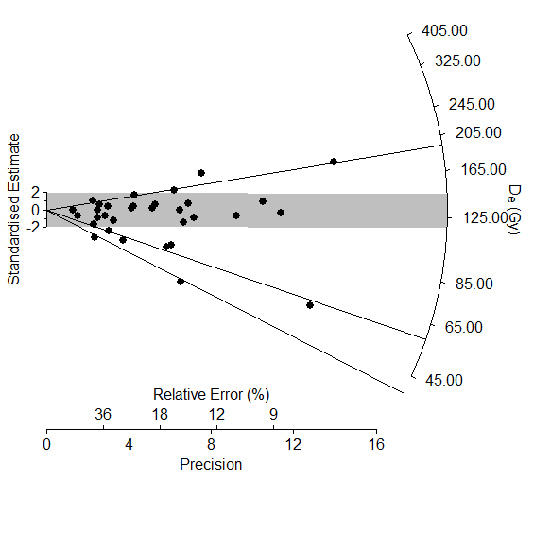
Single aliquot (171 ± 9 Gy)

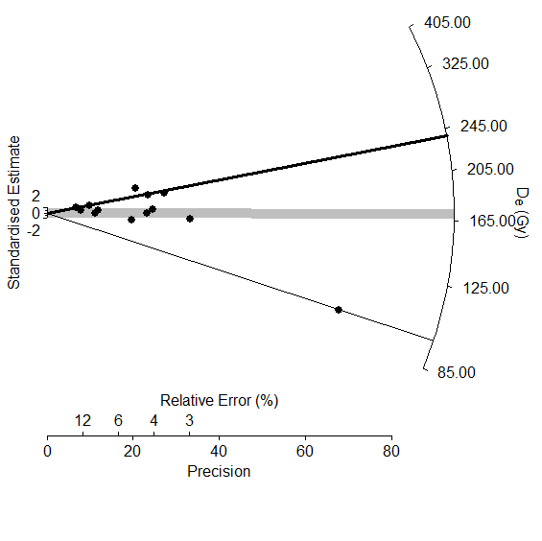

Suppl. Fig. 2. K1932. Alluvial valley fill section 1 (BM2).
Single grain (115 ± 7 Gy)
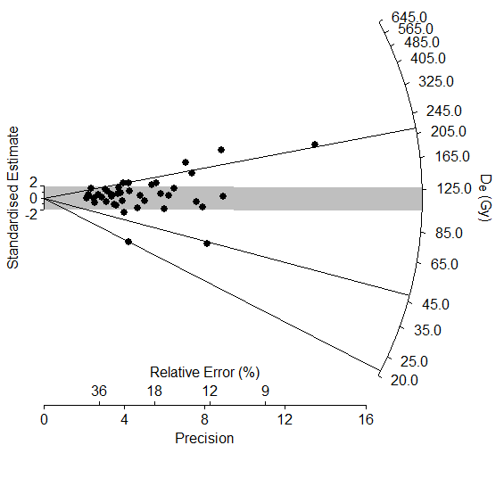
Single aliquot (187 ± 6 Gy)

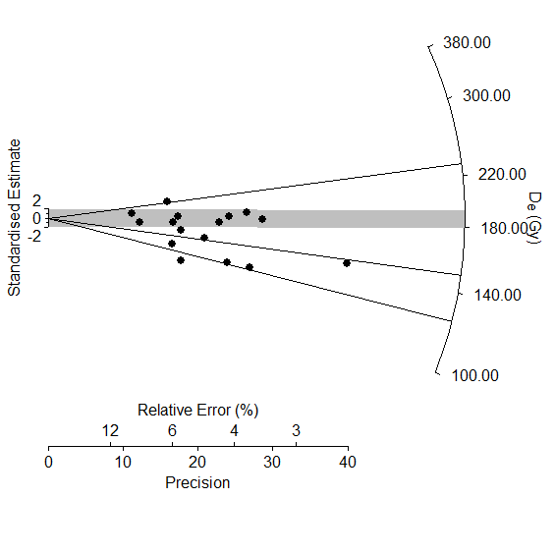

Suppl. Fig. 3. K1933. Alluvial valley fill section 2 (BM3).
Single grain (114 ± 43 Gy, 180 ± 23 Gy)
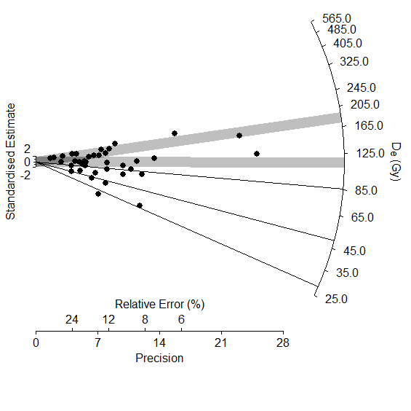
Single aliquot (167 ± 8 Gy)
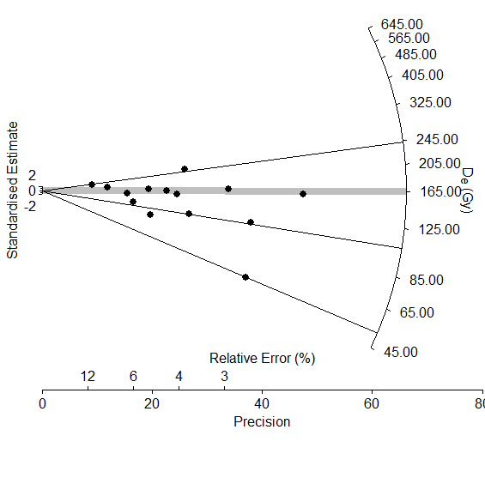

Suppl. Fig. 4. K1934. Alluvial valley fill section 2 (BM4).
Single grain (81.6 ± 6.5 Gy)

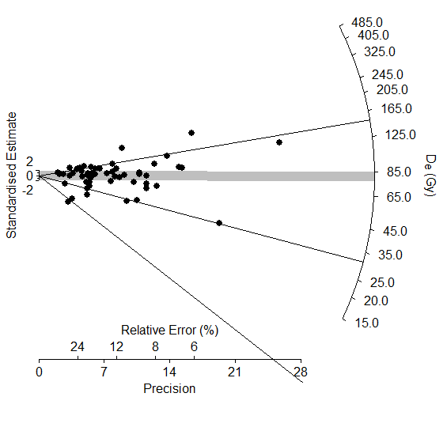
Single aliquot (undateable)
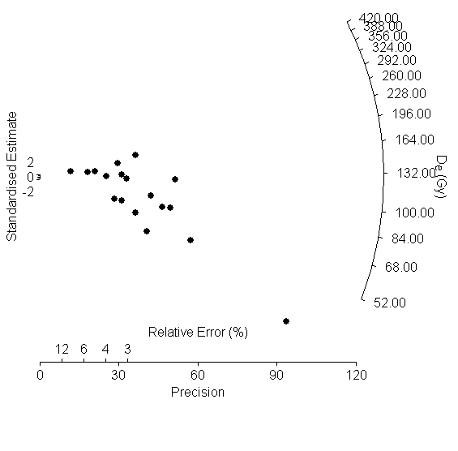

Suppl. Fig. 5. K2033. Alluvial fan section 4 (BM5).
Single grain (27.6 ± 4.6 Gy)
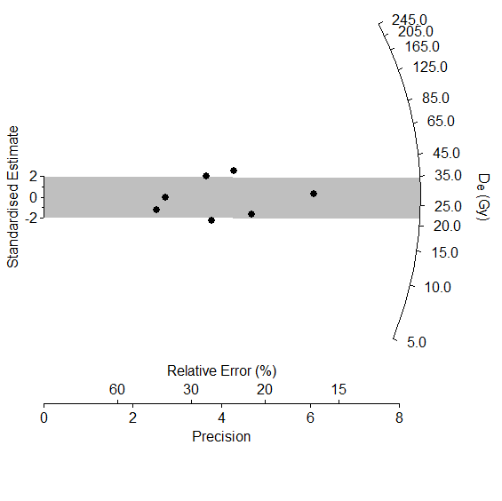
Single aliquot (30.2 ± 1.3 Gy)
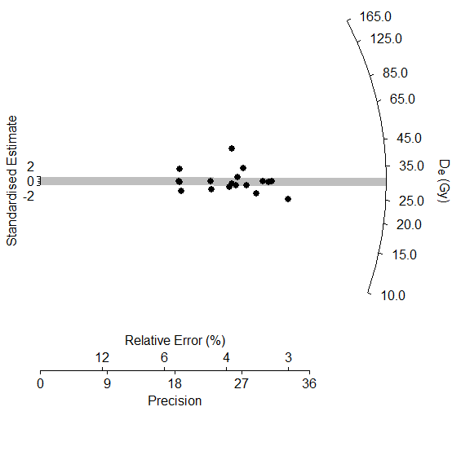

Suppl. Fig. 6. K2034. Alluvial fan section 4 (BM6).
Single grain (too few data points)
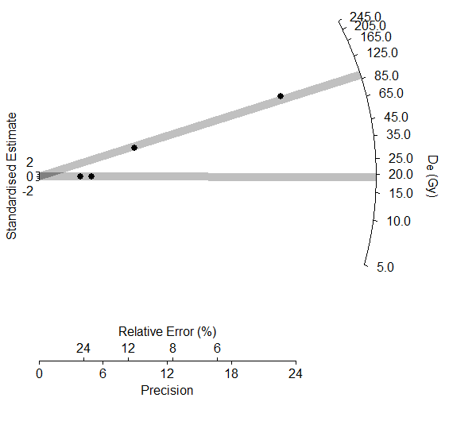
Single aliquot (125 ± 9 Gy)
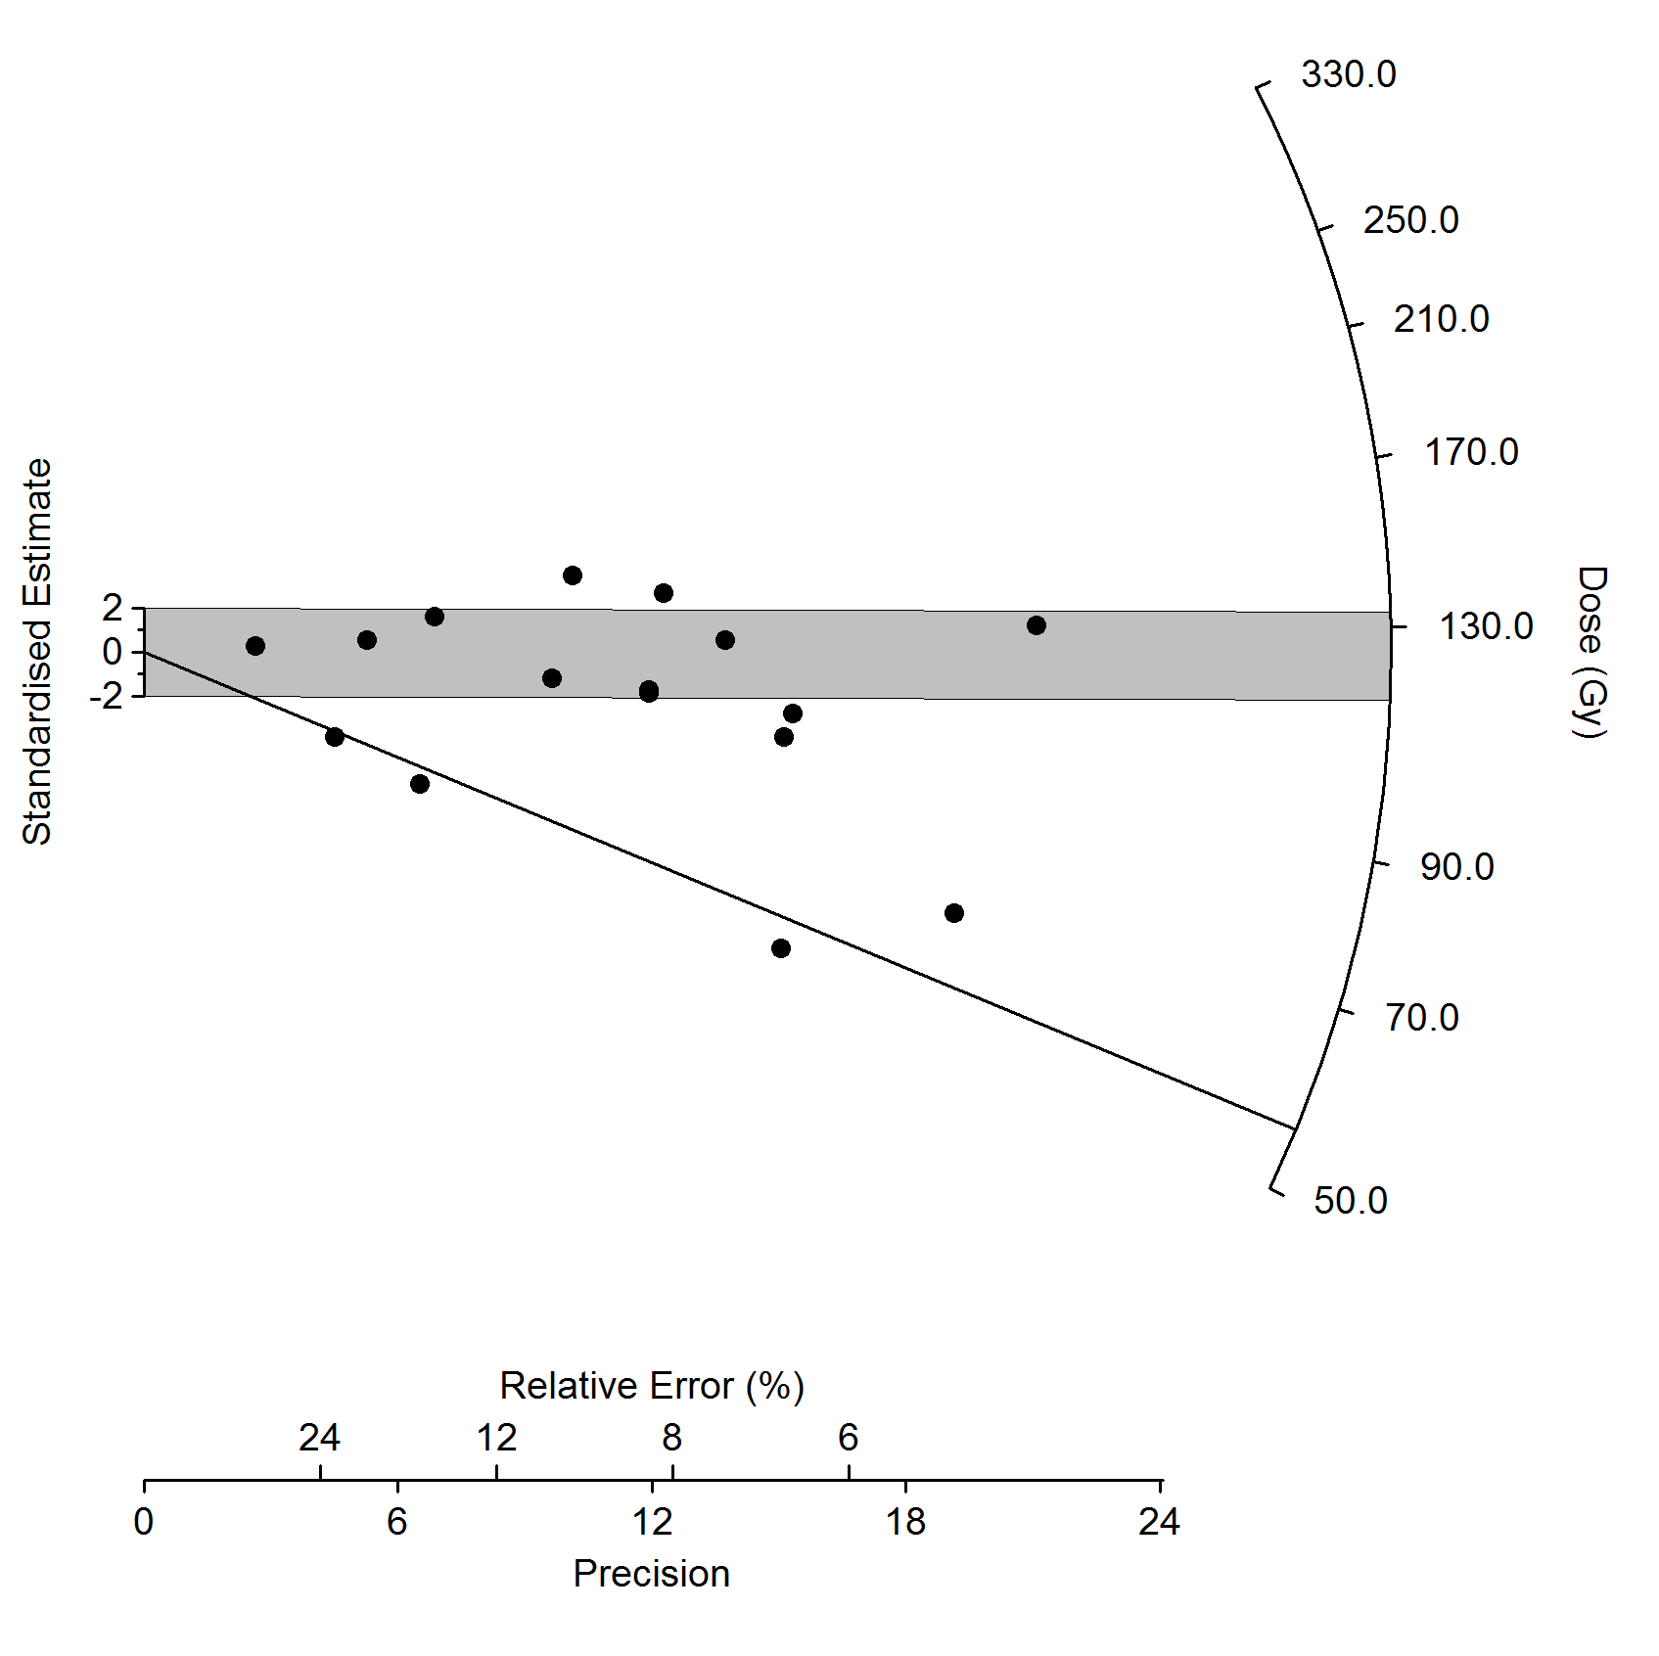

Suppl. Fig. 7. K2035. Alluvial fan section 4 (BM7).
Single grain (30.0 ± 4.0 Gy)
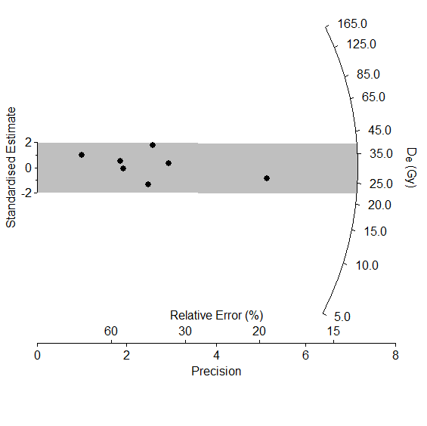
Single aliquot (80.4 ± 10.4 Gy)
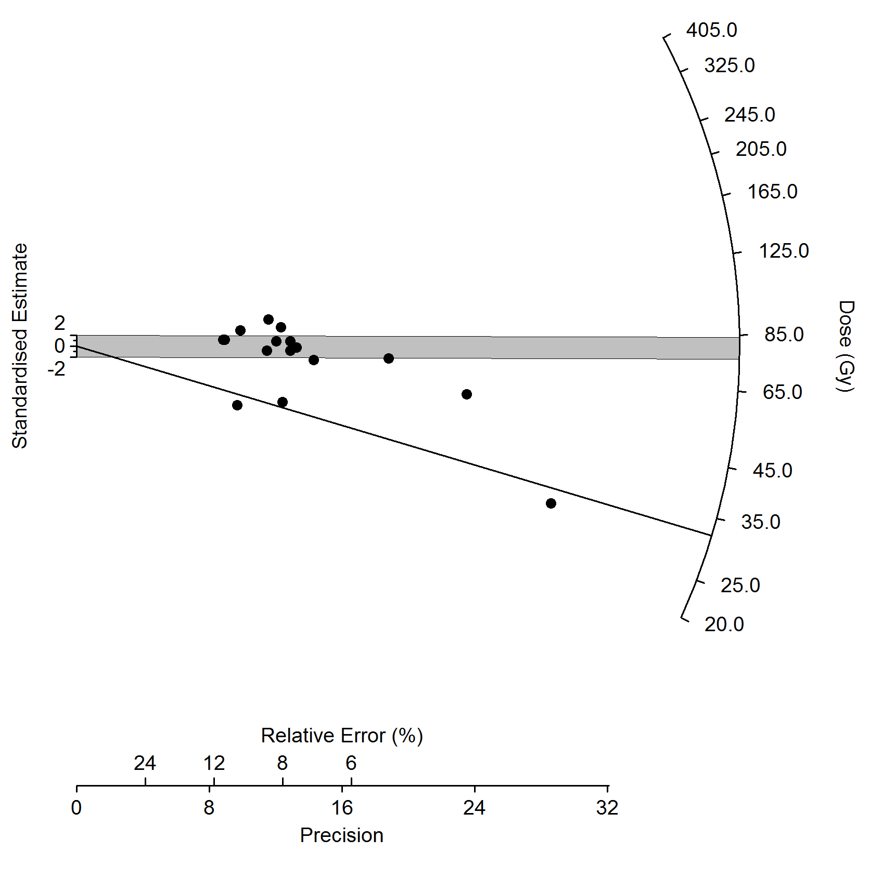

Suppl. Fig. 8. K2036. Alluvial fan section 5 (BM8).
Single aliquot only (304 ± 11 Gy)
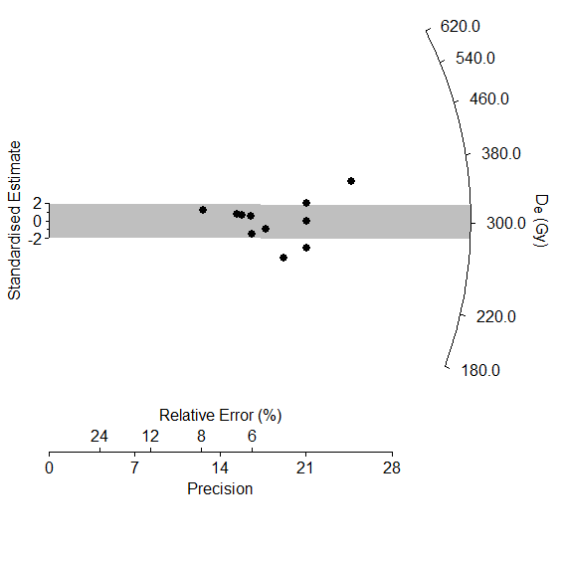

Suppl. Fig. 9. K2037. Alluvial fan section 5 (BM9).
Single aliquot only (314 ± 13 Gy)
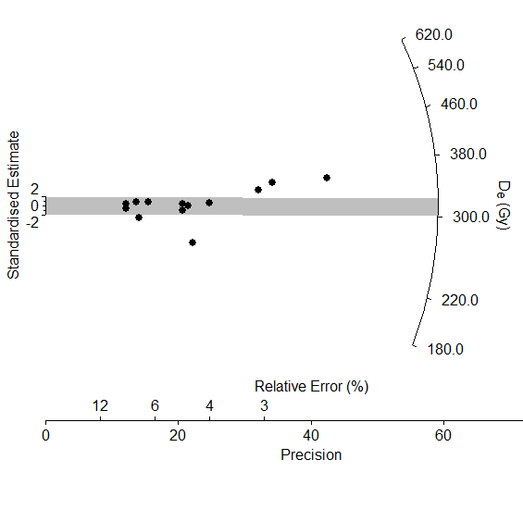

Supplementary Table 1. BM sample Radionuclide activities

 | Radionuclide activities¹ (Bq kg⁻¹)
Sample | ²³⁸U | ²²⁶Ra | ²¹⁰Pb | ²²⁸Ra | ²²⁸Th | ⁴⁰K
BM-001 | 32.0 ± 1.9 | 32.1 ± 0.4 | 22.3 ± 2.0 | 45.8 ± 0.7 | 44.9 ± 0.5 | 253 ± 5
BM-002 | 32.6 ± 2.9 | 31.8 ± 0.5 | 25.6 ± 3.4 | 48.2 ± 1.2 | 48.4 ± 0.7 | 322 ± 9
1. Measured by high-resolution gamma-ray spectrometry using dried and powdered samples. Concentrations of 1 ppm ²³⁸U, 1 ppm ²³²Th and 1% ⁴⁰K correspond to activities of 12.4, 4.1 and 316 Bq kg⁻¹, respectively.

Supplementary Table 2. Chemical analyses.
Comparison between commercially analysed (Genalysis) and ANU-analysed ICPMS results for the Th and U concentrations from OSL samples K1931-K1934. The similarity of the results (generally within 2σ error) provides greater (although not absolute) confidence in the accuracy of ICP analyses on small subsamples of sediment.
Lab code | Element | Genalysis ICPMS (ppm) | ANU ICPMS (ppm)
K1931 | Th | 12.010 ± 0.601 | 11.310 ± 0.566
 | U | 2.610 ± 0.131 | 2.260 ± 0.113
K1932 | Th | 11.760 ± 0.588 | 11.100 ± 0.555
 | U | 2.430 ± 0.122 | 2.240 ± 0.112
K1933 | Th | 16.590 ±0.830 | 14.400 ±0.720
 | U | 2.620 ± 0.131 | 2.220 ± 0.111
K1934 | Th | 13.570 ± 0.679 | 13.330 ± 0.667
 | U | 2.640 ± 0.132 | 2.420 ± 0.121

Supplementary Table 3. Overdispersion values for OSL samples.
Single grain values are given in italics, and single aliquot results are in plain text.
Lab code | Field code | Overdispersion (%)
K1931 | BM1 | 43  26
K1932 | BM2 | 45  19
K1933 | BM3 | 55  39
K1934 | BM4 | 72  58
K2033 | BM5 | 35  18
K2034 | BM6 | 75  38
K2035 | BM7 | 45
K2036 | BM8 | 11
K2037 | BM9 | 13

Supplementary Table 4. Results from finite mixture model analyses, for both single grain and single aliquot measurements.
The age representing the greatest proportion of grains (or aliquots), used for age calculation, is indicated in italics. Note: For samples K2033, K2036 and K2037, and the single grain data of K2035, the central age model was used for age calculation, based on the dose distribution. The single aliquot data of K1934 were too scattered and could not be fitted using the finite mixture model.
Lab code | Number of grains | Number of components | De (Gy) | % population | BIC
Single grain
K1931 | 32 | 4 | 39.5 ± 9.1  58.9 ± 5.9  131 ± 8  193 ± 21 | 4.5  22.5  57  16 | 59.4¹
K1932 | 40 | 4 | 21.3 ± 5.5  47.9 ± 8.1  115 ± 7  214 ± 17 | 2.5  3.5  65  29 | 72.3¹
K1933 | 39 | 5² | 28.4 ± 6.5  49.5 ± 16.8  86.2 ± 34.5  114 ± 43  180 ± 23 | 5.5  8.5  21  28  37 | 94.0¹
K1934 | 40 | 4 | 4.9 ± 1.2  31.4 ±3.5  81.6 ± 6.5  150 ± 17 | 3.5  13.5  52.5  30.5 | 134¹
K2034 | 4³ | 2 | 19.2 ± 4.0  90.6 ± 13.6 | 50  50 | 6.54
Single aliquot
K1931 |  | 3 | 98.0 ± 9.8  171 ± 8.6  237 ± 14 | 8  48.5  43 | 9.0
K1932 |  | 4 | 125 ± 5  150 ± 8  187 ± 6  230 ± 23 | 22.5  20  51.5  6 | 6.6
K1933 |  | 4 | 52.6 ± 5.3  107 ± 6  167 ± 8  243 ± 24 | 7  28  51  14 | 21.2
K2034 |  | 2 | 56.4 ± 7.3  125 ± 9 | 25  75 | 18.9
K2035 |  | 2 | 32.1 ± 10.9⁴  80.4 ± 10.4 | 16  84 | 26.7
¹ This was the lowest value achieved with the model given a reasonable number of components and the small sample size.
² Given the modeling results, the single grain age of this sample must be given as a range of the three oldest populations, which represent 86% of the total number of grains. The two younger populations are interpreted to represent post-depositional bioturbation.
³ The small sample size reflects the low proportion of grains which passed the selection criteria, and the low yield of sample. Consequently the age model results are essentially meaningless for this sample, and a single grain age cannot be calculated.
⁴ The younger population of the single aliquot results of this sample correlates with the central age model results from single grain analyses, and is therefore interpreted as the more likely equivalent dose, despite only representing 16% of the total population.

Supplementary Table 5. Arguments for final equivalent dose interpretation.

Lab code | D_{e} (Gy) used for age calculation |  | Interpretation
 | Single Grain (SG) | Single aliquot (SA)
K1931 | Range:  57.0 ± 8  131 ± 8 | 171 ± 9 | SG D_{e} has two main peaks: older grains incompletely bleached. SA results therefore probably unreliable, with OSL signal dominated by incompletely bleached grains.
K1932 | 115 ± 7 | 125 ± 6 | SG D_{e} represents dominant population; older grains incompletely bleached. Lower SA population correlates with SG D_{e}; OSL signal of older aliquots probably dominated by incompletely bleached grains.
K1933 | Range:  86.2 ± 34.5  180 ± 23 | Lower peak:  52.5 ± 8  Central peak:  167 ± 9 | No clearly dominant SG population. SG D_{e} probably within this range. SA D_{e} represents dominant population and lies within the SG range; lower peak represents most likely age, older grains incompletely bleached.
K1934 | 81.6 ± 6.5 | N/A | No clearly dominant SG population, and SA results undateable. Main SG age peak taken as most likely age.
K2033 | 27.6 ± 4.6 | 30.7 ± 1.4 | Both SG and SA D_{e} calculated using the central age model.
K2034 | N/A | Lower peak  51.5 ± 9  Central peak  125 ± 9 | Too few dateable grains for SG. SA populations indicate probable mixing, dose heterogeneity, or both.
K2035 | 30.0 ± 4.0 | 32.1 ± 10.9 | SG D_{e} calculated using the central age model. Although the older SA D_{e} contains the greatest number of aliquots, the younger D_{e} correlates with the SG results and is more likely.
K2036 | N/A | 304 ± 13 | SG data not available; SA D_{e} calculated using the central age model.
K2037 | N/A | 314 ± 14 | SG data not available; SA D_{e} calculated using the central age model.

Profile dating with ¹⁰Be
Exposure of a sediment package to cosmic rays produces a characteristic cosmogenic nuclide depth profile that is a function of the production rate of the nuclide, sediment density, the accumulation or erosion rate of the sediment, and inherited nuclides in the sediment from previous exposure at the bedrock source. Profile dating produces the most reliable results with rapid sediment deposition (<<than the time of exposure), an absence of post-depositional accumulation or erosion of the surface, no sediment storage in the catchment, and rapid parent bedrock erosion rates delivering a minimal inherited nuclide component. Alluvial fans can satisfy most of these conditions. Alluvial fan deposition is likely to be rapid and the modern setting shows no sediment storage in the catchment. There is no obvious erosion or deposition on the fan surface. However, the bedrock in the catchment is resistant to erosion and this is likely to deliver significant inheritance to the site and a need for profile dating.
An exposure age was calculated from a least squares fit of a curve that is a sum of exponentials representing spallation, slow muon capture and fast muons (see main text). Because the relative errors are similar on each sample, the fit was not weighed. An initial fit to all the data was poor (Χ²/ν=50). The sample at 187.5 cm (BMT-03) has a much higher concentration than the overlying sample (BMT-02) and indicates a break in production (ie a hiatus) where there is a change in clast density in the section. To model this, we arbitrarily chose the mid-point between BMT-02 and 03 (149 cm) as the break. A fit (Χ²/ν=0.0) was then made for the upper two samples (BMT-01-02) and the results were used to correct the concentrations of the samples in the lower section for post-depositional exposure. A fit was then made to the samples in the lower section (Χ²/ν=8.3). The standard error was calculated for both the exposure age (7.0%) and the inheritance (5.9%) before calculating the erosion rate. This was not possible for the upper samples, because there are only two. In this case the average internal error (1.9%) was combined with the error from the production rate (6.3%) in quadrature. The uncertainties of the ages and erosion rates are the external error, including the error from the production rate. External uncertainties in conjunction with the LSDn scheme are 6.3% for ¹⁰Be.
The sediment is highly consolidated and does not vary significantly through the column, so a density of 1.8 g/cm³ was assumed for the whole profile. Variations of 0.1 g/cm³ in density change the exposure age by ~2 %. An attenuation length of Λ = 160 g.cm⁻² was used. The fit was solved for both exposure age and inheritance. The inheritance concentration was corrected for decay since deposition (ie. using the exposure age), so that an estimate could be made of erosion rates in the catchment at that time. Erosion rates were estimated using the mean elevation of the catchment above the site (730 m). This is a minimum estimate only because of shielding in the catchment. The apparent erosion rate incorporates exposure in the soil and any transit time to the fan and the transit time is likely to be short (10³ years).

Core LG4 age model
The dating of LG4 is of low quality and choice of ages for an age model is somewhat arbitrary. Because of the evidence of contamination in the core, only the oldest dates were chosen, similar to the original approach (Singh and Geissler, 1985). The dates were calibrated following the same procedure as the other radiocarbon dates in the paper (see main text). A smoothing spline (degrees of freedom =n-1) was fit the ages to construct the age model (Supplementary Figure 6). The fit has a standard error of 390 years, but the accuracy of the model is likely to be poorer than this given the scatter of ages from LG4.

Supplementary Table 6. LG4 radiocarbon ages
Code | depth (cm) |  | ¹⁴C yr BP | ± | cal yr BP |  | ±
 | 0 |  |  |  | 0
ANU-1637 | 25 | 3430 |  | 80 | 3640 | 3640 +180/-150
ANU-1638 | 41.5 | 5460 |  | 170 | 6200 | 6200 +190/-200
N-1512 | 87 | 7770 |  | 110 | 8530 | 8530 +100/-130
N-1814 | 145 | 18600 |  | 930 | 22410 | 22410 +1310/-1060
N-1815 | 230 | 25600 |  | 445 | 29790 | 29790 +360/-550
N-1817 | 285 | 35700 |  | 3525 | 39600 | 39600 +2990/-2930

Supplementary Fig. 10. LG4 age model
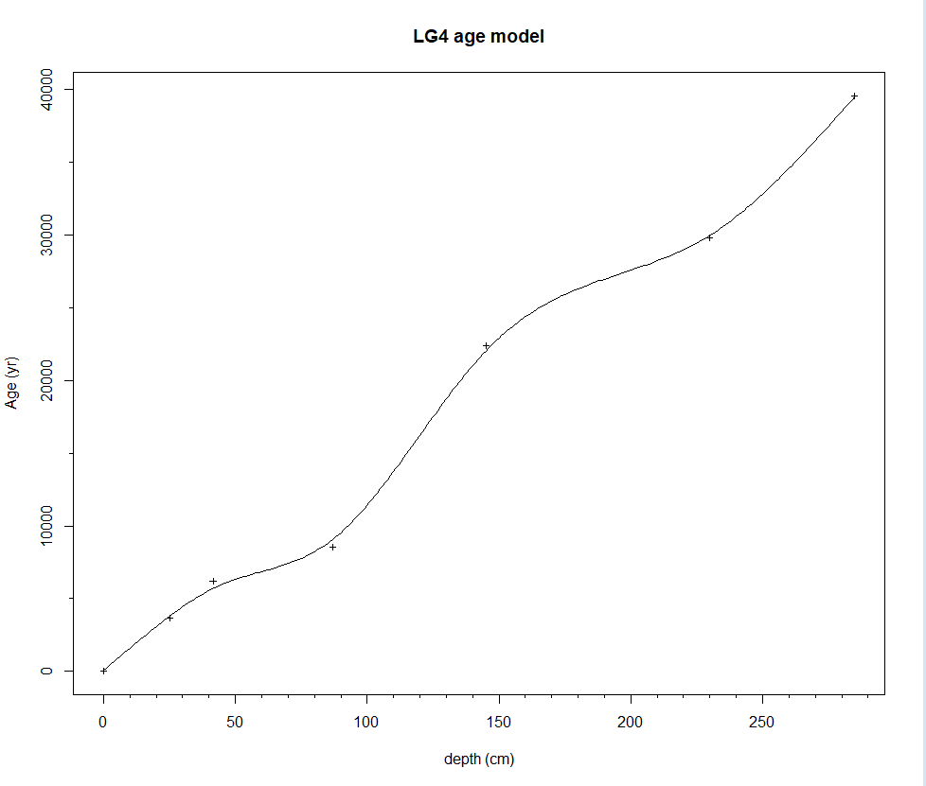

References
References

Aitken, M.J., 1998. An introduction to optical dating: the dating of Quaternary sediments by the use of photon-stimulated luminescence. Oxford University Press, New York.
Bøtter-Jensen, L., Bulur, E., Duller, G.A.T., Murray, A.S., 2000. Advances in luminescence instrument systems. Radiation Measurements, 32(5–6), 523-528.
Fitzsimmons, K.E., 2011. An assessment of the luminescence sensitivity of australian quartz with respect to sediment history. Geochronometria, 38(3), 199-208.
Fitzsimmons, K.E., Barrows, T.T., 2010. Holocene hydrologic variability in temperate southeastern Australia: An example from Lake George, New South Wales. The Holocene, 20(4), 585-597.
Fitzsimmons, K.E., Rhodes, E.J., Barrows, T.T., 2010. OSL dating of southeast Australian quartz: A preliminary assessment of luminescence characteristics and behaviour. Quaternary Geochronology, 5(2-3), 91-95.
Galbraith, R.F., Roberts, R.G., Laslett, G.M., Yoshida, H., Olley, J.M., 1999. Optical dating of single and multiple grains of quartz from Jinmium rock shelter, northern Australia. Part 1, Experimental design and statistical models. Archaeometry, 41(2), 339-364.
Hesse, P.P., 2016. How do longitudinal dunes respond to climate forcing? Insights from 25 years of luminescence dating of the Australian desert dunefields. Quaternary International, 410, 11-29.
Jacobs, Z., Wintle, A.G., Duller, G.A.T., 2006. Evaluation of SAR procedures for De determination using single aliquots of quartz from two archaeological sites in South Africa. Radiation Measurements, 41(5), 520-533.
Murray, A.S., Wintle, A.G., 2003. The single aliquot regenerative dose protocol: potential for improvements in reliability. Radiation Measurements, 37(4–5), 377-381.
Prescott, J.R., Hutton, J.T., 1994. Cosmic ray contributions to dose rates for luminescence and ESR dating: Large depths and long-term time variations. Radiation Measurements, 23(2), 497-500.
Singh, G., Geissler, E.A., 1985. Late Cainozoic history of vegetation, fire, lake levels and climate, at Lake George, New South Wales, Australia. Philosophical Transactions of the Royal Society of London, Series B, 311, 379-447.

