Riedel et al. Supplemental Material 1 - Laboratory Procedures for the Isolation and Identification of Macrofossils from Glacial Lakes Skymo and Concrete
Conifer macrofossils were isolated from one liter bulk sediment samples at the University of Washington in Seattle WA USA. The samples were soaked for a minimum of three days in a warm sodium meta-phosphate solution and agitated daily. The samples were then sieved through a 500-micron screen with warm water. Needles were identified to species on the basis of needle length, tip, and base morphology, and the density, number, and arrangement of rows of stomata (Hitchcock and Cronquist 1973; Dunwiddie 1985).
Another set of samples were examined for all taxa at the Paleotech laboratory in Ottawa. Macrofossils were recovered from 1 litre bulk samples by week-long soaking, swirling, and then sieving with warm tap water. This technique provided relatively intact, identifiable macrofossils. Samples were weighed, and the volume of organic material estimated, by water displacement. The organic concentrate was passed through a set of nested screens (4, 0.85, 0.425, and 0.25 mm). All material greater than 0.425 mm was analyzed under a binocular microscope; only part of the smaller fraction was examined. We attempted an oil flotation technique to isolate fossil insects, but it proved unsuccessful due to the compactness of the samples and adherence of fine silt to the fossils.
Sitka spruce needles, which are abundant in some samples, were differentiated from Engelmann spruce (Picea engelmanni) needles by their straight, relatively blunt tips, flattened cross-section, prominent abaxial midrib, and presence of stomata on only one side (Dunwiddie 1985). White spruce (Picea glauca), Englemann spruce, and Sitka spruce hybridize with one another, and white spruce presently grows at low elevations in southeastern Washington (Daubenmire 1973; Farrar 1995). Although possible, it is unlikely that white spruce needles were misidentified as Sitka spruce and/or Engelmann spruce. Halliday and Brown (1943) suggest that white spruce was extirpated from western North America during the last ice age, and Krajina (1970) notes that it is not well adapted to subalpine conditions.

Riedel et al. Supplemental Material 2 - Sample Descriptions

Radiocarbon ages calibrated with OxCal online program (Bronk Ramsay, 2009) and reported below as median age with 2σ age range.

Glacial Lake Skymo

NOCA-56/28 (27.7 cal ka BP )(27,938-27,522) - UW
Only four needles from the middle of the Rainbow Point section were identified. They include two spruce needle tips that may be either Picea engelmannii or Picea sitchensis, one mountain hemlock needle (Tsuga mertensiana), and one needle that is either Douglas fir (Pseudotsuga menziesii) or western hemlock needle (Tsuga heterophylla).

NOCA 33 and 77 (25.9 cal ka yr BP) (26,024-25,693) Paleotech (33) and UW (77)
This sample, collected from a bed at 476.5 m asl, contains 16% organic matter. Macrofossils are abundant, diverse, and well preserved, although many are flattened and impregnated with silt. Specimens include seven species of conifers, one deciduous shrub, and one evergreen shrub, sedge, and moss (Supplementary Material 3).
Subalpine species dominate the coniferous macrofossil assemblage (Supplementary Material 3). Englemann spruce accounts for most of the 104 needles identified, but mountain hemlock and subalpine fir needles are also present. Whitebark pine (Pinus albicaulis) fascicles, some containing needle bases, and needles are also abundant.
Sedge (Carex) macrofossils include achenes and peryginial fragments, representing lenticular and trigonus types (Supplementary Material 4) Four nutlets of black crowberry heath (Empetrum nigrum) and three nutlets of birch were recovered; two of the nutlets appear to be bog or dwarf birch (Betula glandulosa/nana type) based on size (1 mm) and a narrow seed wing. Several hundred whole and half seeds of aquatic buttercup (Ranunculus aquatilus L.) were counted (Supplementary Material 4).
Five species of beetles (Coleopteran), identified from 49 individual body parts, include terrestrial (rove, bark, and moss beetles) and aquatic (water scavenger and predaceous diving) groups (Supplementary Material 4/4). Other aquatic macrofossils include ephippia of water fleas (Daphnia sp.), caddis fly larva head capsules (Trichoptera), and several hundred lentic midge (Chironomidae) head capsules (SM 4/4).

NOCA 36 (ca. 25.5 ka ) UW
This sample was collected from a bed between samples NOCA 33 and 37 at 479.4 m asl. It was analyzed only for conifer macrofossils (Figures 5 and 7). Of the 419 needle fragments recovered, only 141 tips and bases could be identified to species. One hundred of the needle tips and bases are Engelmann spruce; the remainder could not be identified beyond genus due to poor preservation.

NOCA 37 (25.1 cal ka BP) (25,340-24,649) Paleotech and UW
This sample was collected 0.5 m above sample NOCA 36 to better document changes in species diversity. The organic content is 25%, with about 15% of the sample wood and twigs as long as 7 cm. Preservation of macrofossils is fair to good, but most specimens are flattened and have adhering fine silt.
More than 9000 arboreal macrofossils were recovered from a one-litre sample, including whole needles, twig terminals, seed wing fragments, and one cone scale fragment (Supplementary Material 3). Approximately half of the needles identified to species level are Engelmann spruce; the remainder comprise equal numbers of subalpine fir and Sitka spruce needles and a few grand fir/silver fir (Figure 7). Ninety-four five-needle-type fascicles and nearly 500 needle tips and bases were identified as whitebark pine on the basis of needle stature and presence of stomata on both surfaces.
Other macrofossils include one bog birch nutlet with a partial wing, one heath nutlet, achenes of pond weed (Potamogeton sp.), and lenticular and trigonus-type sedges (Carex). Four of the pondweed achenes were identified as alpine pondweed (Potamogeton alpinus), an emergent aquatic that inhabits shallow waters of cold lakes and ponds (Supplementary Material 3). The sample also yielded whole and half achenes of whitewater buttercup.
Thirty-two beetle body parts represent seven species. They include four articulated specimens (Supplementary Material 4). The assemblage includes the same terrestrial and aquatic groups found in the underlying sample.

NOCA 40 and 40B (24.4 cal ka BP) (24, 590-24,174) Paleotech (40) and UW
This sample was split and examined at two laboratories. Seventeen percent of sample NOCA 40 is organic matter consisting primarily of conifer macrofossils. Other organic material includes flattened wood and twigs and a single unidentified species of moss. With a few exceptions, fossil preservation is fair to poor; aquatic fossils are slightly better preserved than terrestrial ones.
Seven conifer species are present among the more than 8000 conifer macrofossils recovered from sample NOCA 40, including several dozen seeds, seed-wing fragments, and cone-scale fragments of Pinaceae (Supplementary Material 3/4). Conifer macrofossils include 36 whole needles and 49 flattened twig terminals (Abies sp.) and 270 whitebark pine fascicles and needles. Most of the remaining macrofossils are Picea sp., including more than 100 whole needles and twig terminals. Relative to underlying samples, NOCA 40 records a large increase in the abundance of mountain hemlock and a modest increase in Douglas-fir/western hemlock and grand fir/silver fir.
No heath or birch fossils were found in NOCA 40, in contrast to samples lower in the sequence, but one bud of willow (Salix sp.) was recovered. Abundant achenes of white-water buttercup record the continued presence of this species from lower in the section. Sedge, sheathed pond weed (Potamogeton vaginatus Turcz.) (Brayshaw 1985), and aquatic buttercup are present in this sample in proportions similar to those in NOCA 37 (Supplementary Material 3 and 4).
The fossil beetle assemblage in NOCA 40 is similar to that in overlying beds and includes the same five species of forest and riparian beetle groups (Supplementary Material 4). Three of the specimens are articulated.

NOCA-61/98 (21.8 cal ka BP) (22,069-21,518) (UW)
Due to low fossil content, two samples (NOCA 61 and 98) were collected at Rainbow Point at 489 m asl near the full pool level of Ross Lake (Figure 3). The samples yielded only 21 coniferous macrofossils that could be identified to species level (Table 2). The macrofossils are mainly Engelmann spruce, but include mountain hemlock, subalpine fir, and four needles of either western hemlock or Douglas-fir.

Glacial Lake Concrete

NOCA 107 (23.9 cal ka BP) (24,175-23,6630) UW
NOCA 107 was collected at 58 m asl from the base of the section below the water level of Skagit River. It contained only a few identifiable conifer macrofossils, including subalpine fir and grand fir/silver fir needles, but no spruce.

NOCA 100 and 100B (ca. 23.5 cal ka BP) Paleotech and UW (B)
This sample was collected 1 m above NOCA 107, and its age was estimated using a 4.7 mm/yr sedimentation rate (Riedel et al. 2010). The sample consists of 43% organic material, but few identifiable conifer macrofossils (Table 1). About 75 percent of the organic material is roots, horsetail (Equisetum sp.), twigs, and wood fragments. The macrofossil assemblage includes many spores of the soil-borne fungus Cenococcum geophilum, which forms a mycorrhizal relationship with tree roots (Table 1). Other abundant macrofossils include sedge, achenes, woodrush (Luzula sp.) seeds, and more than 40 megaspores of northern spikemoss (Selaginella selaginoides), which were identified on the basis of large spore size (0.48-0.53 mm) and yellow-green color (Supplementary Material 3; Tyron 1949). Northern spikemoss macrofossils have not been previously reported from Pleistocene sediments in the Cascade Range (Heusser and Igarashi 1994). Less abundant macrofossils include Engelmann spruce needle tips and bases, conifer twigs, and two seed capsules and three persistent buds of willow (Supplementary Material 3).
Six families are represented in 32 recovered beetle body parts. Most of the specimens are rove beetles (Staphylinidae; Table 2) and include Olophrum boreale (Payk.), and Tachnius sp. Ground beetles (Carabidae, Elaphrus clairvillei), weevils (Curculionidae, Isochnus rufipes ?), pill beetles (Byrrhidae), and leaf beetles (Chrysomelidae) are also present.

NOCA 101 (22.7 cal ka BP) (22,941-22,441) Paleotech and UW
This sample, collected at 61 m asl, consists almost entirely of organic material. Fossil preservation is fair to poor, and most fossils are likely underrepresented in the inventory due to problems encountered in disaggregating the sample. Half of the organic material is fine plant detritus, including moss, horsetail stem fragments, and bark. The only conifer macrofossils recovered are a spruce seed, needle tip, and needle base. The most common macrofossils are northern spikemoss megaspores and sedge achenes. Willow is represented by persistent buds, four twigs with persistent buds, and a half seed capsule (Supplementary Material 3).
Preservation of insect macrofossils is better than in the underlying sample. Ninety-two beetle body parts include heads, elytra, sternites, coxa, and pronota of terrestrial and riparian beetles (Bembidion sp., Aleocharinae sp., and Olophrum consimilie Gyll.). The sample includes two groups not found in NOCA 100: feather-wing beetles (Ptiliidae) and click beetles (Elateridae; Supplementary Material 4).

NOCA 105 (21.2 cal ka BP) (21,540-20,930) Paleotech and UW
Sample NOCA 105, collected from a dark gray silt bed at 68 m asl, contains 40% organic material, three-quarters of which is moss and most of the remainder is flattened twigs and bark, horsetail fragments, and deciduous bud scales. Fossil preservation is good, but most macrofossils were coated with fine silt, making identification difficult.
Identified coniferous macrofossils are limited to two subalpine fir needles. The assemblage is dominated by sedge achenes, nearly 70% of which retain partial seed coats. The second most common group of macrofossils is willow seed capsules, twigs, and persistent buds (Table 1). The sample also contains macrofossils of a number of taxa not observed lower in the section, including buckwheat (Polygonumsp.) and silverweed cinquefoil (Argentina anserina L. Rybd.).
The beetle assemblage comprises multiple skeletal parts of 17 terrestrial and aquatic species, with several articulated specimens (Supplementary Material 4). Aquatic genera included members of the Dytiscidae and Hydrophiolidae families. Terrestrial specimens included long-horned leaf beetles (Chrysolmelidae, Plateumaris sp.) and nine genera of rove beetle. Pill beetles, including Curimopsis sp., ground beetles, leafhoppers, and click beetles (Eleteridae), constitute the remainder of the Coleopterans recovered.

NOCA 104 (20.7 cal ka BP) (20,904-2-,533) Paleotech and UW
This sample was collected at 76 m asl, near the top of the glaciolacustrine part of the section. It yielded more abundant and diverse arboreal macrofossils than any other sample from the glacial Lake Concrete sequence. It contains 39% organic matter, most of which are branches as long as 18 cm and twigs, some of which are worn.
Conifer macrofossils include two cone scales, a seed, seed wings, two seed wing fragments, and 878 whole and partial conifer needles. Species-level identification was completed on 127 specimens, with Englemann spruce accounting for 33% of the needles, followed by subalpine fir (15%), Sitka spruce (10%), and Douglas-fir/western hemlock (7%). The floral assemblage contains much greater species diversity than assemblages lower in section (Supplementary Material 3). Taxa observed only in this bed, although in low numbers, include birch (Betulaceae), goosefoot (Chenopodiaceae), pink (Caryophyllaceae), and mustard (Brassicaceae). Willow, sedge, and cinquefoil are also present. Northern spikemoss megaspores, which are so abundant in samples lower in the section, are notably absent.
Twenty-three beetle body parts were recovered from this sample, and most of them are poorly preserved (Supplementary Material 4). Specimens include aquatic and terrestrial taxa, and a dung beetle (Scarabaeidae).

NOCA 89 (19.8 cal ka BP) (20,027-19,565) UW
A complete, flattened Engelmann spruce cone provided the AMS age for this sample and a date for the end of the glacial Lake Concrete fossil record. The cone was identified based on its length and size. Twigs were also recovered, but no needles or other macrofossils were found in the sample.

References
Brayshaw, T.C., 1985. Pondweeds and Bur-reeds, and Their Relatives: Aquatic Families of Monocotyledons in British Columbia. British Columbia Provincial Museum Occasional Paper 26.
Daubenmire, R., 1973. Taxonomic and ecologic relationships between Picea glauca and Picea engelmannii. Canadian Journal of Botany 52: 1545-1560.
Dunwiddie, P.W., 1985. Dichotomous key to conifer foliage in the Pacific Northwest. Northwest Science 59: 185-191.
Farrar, J.L., 1995. Trees in Canada. Fitzhenry and Whiteside Ltd. and Canadian Forest Service, Ottawa, ON.
Halliday, W.E.D., and Brown, A.W.A., 1943. The distribution of some important forest trees in Canada. Ecology 33: 31-41.
Heusser, C.J., and Igarashi, Y., 1994. Quaternary migration pattern of Selaginella selaginoides in the North Pacific. Arctic and Alpine Research 26: 187-192.
Hitchcock, C.L., and Cronquist, A., 1973. Flora of the Pacific Northwest. University of Washington Press, Seattle, WA.
Krajina, V.J., 1970. Ecology of Forest Trees in British Columbia. University of British Columbia, Department of Botany, Ecology of Western North America 2.
Riedel, J.L., Clague, J.J., and Ward, B.C. 2010. Timing and extent of early marine isotope stage 2 alpine glaciation in Skagit valley, Washington. Quaternary Research 73:313-323.
Tyron, A.F., 1949. Spores of the genus Selaginella in North America north of Mexico. Annals of the Missouri Botanical Garden 36: 413-431.
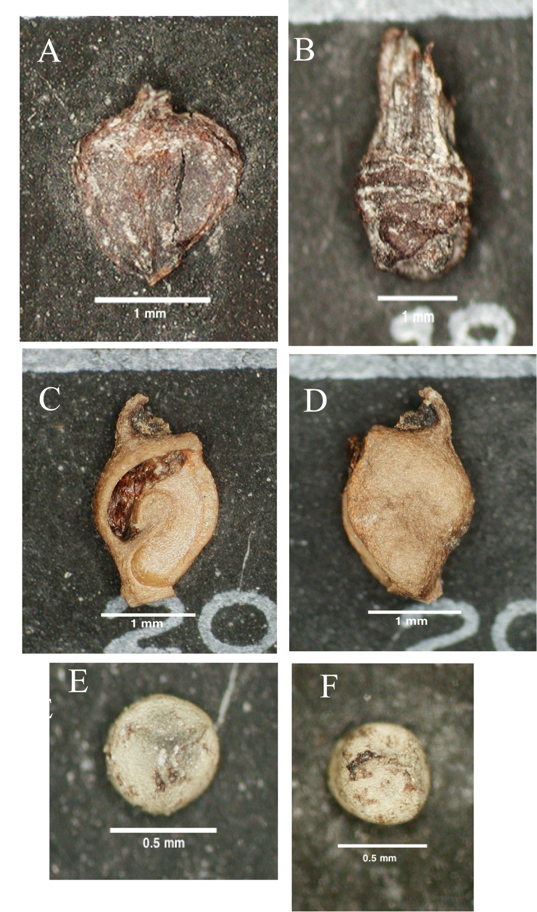
Selected cold-adapted plant macrofossils recovered from glacial lake Skymo and Concrete sediments. A) Bog birch (Betula glandulosa/nana type) nutlet. B) Whitebark pine (Pinus albicaulis) fascicle. C and D) Alpine pondweed (Potamogeton alpinus) seeds. E and F) Northern spikemoss (Selaginella selaginoides) megaspores. Photos by Alice Telka.
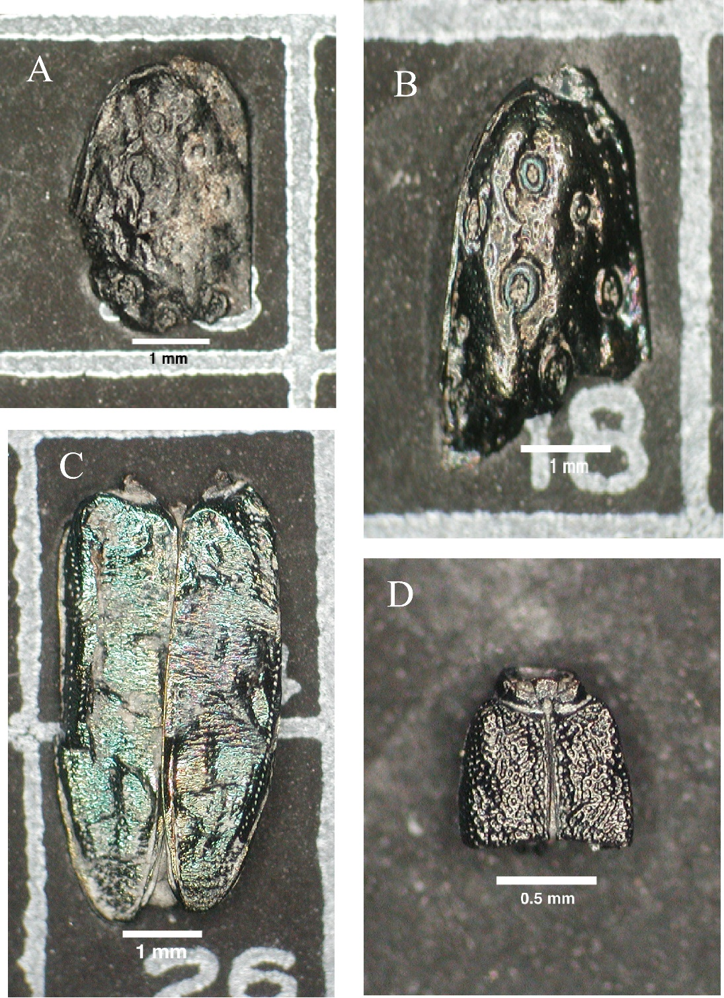

Selected beetle fossils from glacial Lake Concrete sediments. A-B) ground beetle (Elaphrus clairvillei) half elytra, C) leaf beetle (Plateumaris sp.) articulated elytra and prothorax, and D) rove beetle (Stenus sp.) articulated elytra. Photos by Alice Telka.

