The Holocene lake-evaporation history of the afro-alpine Lake Garba Guracha in the Bale Mountains, Ethiopia based on δ¹⁸O records of sugar biomarkers and diatoms

Lucas Bittner^{1,2}, Graciela Gil-Romera^{3,4} David Grady⁵, Henry F. Lamb^{5,6}, Eva Lorenz¹, Mikaela Weiner⁷, Hanno Meyer⁷, Tobias Bromm², Bruno Glaser², Michael Zech¹

Supplementary Data-
__________________________________________________________________________________

Table 1: Measured δ¹⁸O_{diatom} values in the Garba Guracha sediment core: calculated contamination (c_{cont}), δ¹⁸O values corrected for contamination (δ¹⁸O_{Al2O3corr}), and standard deviation SD (δ¹⁸O s.d. N).
Sample ID | Depth  [cm] |  | Age  [cal. BP] |  | Al₂O₃ | SiO₂ | δ¹⁸O | δ¹⁸O  [‰] |  | δ¹⁸O | δ¹⁸O mean  [‰] | δ¹⁸O s.d. S | δ¹⁸O s.d. N | C_{cont} | δ¹⁸O  Al₂O_{3corr}  [‰] | Δ¹⁸O_{corr} [‰]
BAL-01 | 105 |  | 931 |  | 0.91 | 98.46 | 41.59 | 41.54 |  |  | 41.57 | 0.04 | 0.03 | 5.51% | 43.39 | -1.82
BAL-02 | 135 |  | 1442 |  | 1.89 | 96.89 | 40.77 | 40.40 |  |  | 40.58 | 0.26 | 0.18 | 11.43% | 44.49 | -3.91
BAL-03 | 185 |  | 2136 |  | 0.95 | 98.74 | 40.38 | 41.41 |  | 40.98 | 40.93 | 0.51 | 0.42 | 5.76% | 42.80 | -1.87
BAL-04 | 245 |  | 2962 |  | 1.16 | 98.58 | 40.41 | 40.81 |  | 40.48 | 40.57 | 0.21 | 0.17 | 6.97% | 42.83 | -2.27
BAL-05 | 283 |  | 3508 |  | 1.01 | 97.88 | 43.05 | 42.37 |  |  | 42.71 | 0.48 | 0.34 | 6.10% | 44.81 | -2.10
BAL-06 | 343 |  | 4259 |  | 0.60 | 98.59 | 42.11 | 41.51 |  |  | 41.81 | 0.42 | 0.30 | 3.61% | 42.99 | -1.18
BAL-07 | 363 |  | 4540 |  | 0.79 | 99.04 | 40.83 | 40.35 |  |  | 40.59 | 0.34 | 0.24 | 4.79% | 42.11 | -1.52
BAL-08 | 403 |  | 5167 |  | 0.72 | 99.13 | 41.23 |  |  |  | 41.23 |  |  | 4.35% | 42.64 | -1.41
BAL-09 | 503 |  | 6601 |  | 1.51 | 98.07 | 38.22 | 38.16 |  |  | 38.19 | 0.04 | 0.03 | 9.08% | 40.97 | -2.78
BAL-10 | 523 |  | 6875 |  | 0.63 | 98.68 | 37.29 | 37.19 |  |  | 37.24 | 0.07 | 0.05 | 3.80% | 38.31 | -1.06
BAL-11 | 582 |  | 7680 |  | 0.38 | 99.29 | 36.48 | 36.18 |  |  | 36.33 | 0.21 | 0.15 | 2.30% | 36.94 | -0.61
BAL-12 | 632 |  | 8407 |  | 0.66 | 98.71 | 36.39 | 35.63 |  | 36.42 | 36.40 | 0.02 | 0.01 | 4.01% | 37.49 | -1.09
BAL-13 | 680 |  | 9225 |  | 0.62 | 98.95 | 35.90 | 36.27 |  |  | 36.09 | 0.26 | 0.19 | 3.72% | 37.08 | -0.99
BAL-14 | 720 |  | 9757 |  | 1.53 | 96.43 | 35.97 | 35.60 |  |  | 35.79 | 0.26 | 0.18 | 9.24% | 38.38 | -2.59
BAL-15 | 784 |  | 10296 |  | 2.28 | 95.74 | 35.61 | 35.70 |  |  | 35.66 | 0.06 | 0.04 | 13.74% | 39.69 | -4.03
BAL-16 | 804 |  | 10457 |  | 0.97 | 98.51 | 37.03 | 37.33 |  |  | 37.18 | 0.21 | 0.15 | 5.86% | 38.85 | -1.67
 |  |  |  |  | EDX | EDX | single measurements |  |  |  | statistics |  |  | final corrected values
Heavy fraction (>2.5g/cm³)  (for Contamination Correction) |  |  |  |  |  | Al₂O₃ | SiO₂ |  | δ¹⁸O
BAL-01 | 105 |  | 931 |  |  | 16.05 | 70.55 |  | 10.38
BAL-05 | 283 |  | 3508 |  |  | 16.04 | 67.82 |  | 10.18
BAL-09 | 503 |  | 6601 |  |  | 17.61 | 66.53 |  | 10.41
 |  |  |  |  | mean: | 16.57 | 68.30 |  | 10.32
 |  |  |  |  |  | 0.1657
 |  |  |  |  |  | for % cont
Table 2: Measured δ¹⁸O_{fuc} values in the Garba Guracha sediment core: δ¹⁸O_{fuc} (δ¹⁸O_{fuc}) and standard error mean SEM (SEM).
Sample ID | Depth min  [cm] | Depth max  [cm] | Depth mean  [cm] | Age  [cal. Yr. BP] | δ¹⁸O_{fuc}  [‰] | SEM  [‰]
26169 | 70 | 79 | 75 | 356 | 33.25 | 0.50
26170 | 80 | 89 | 85 | 531 | 30.02 | 0.02
26171 | 90 | 99 | 95 | 715 | 32.06 | 0.23
26172 | 100 | 109 | 105 | 931 | 33.21 | 0.16
26173 | 110 | 119 | 115 | 1124 | 33.98 | 0.36
26174 | 120 | 129 | 125 | 1296 | 33.81 | 0.34
26175 | 130 | 139 | 135 | 1442 | 33.19 | 0.37
26176 | 140 | 149 | 145 | 1588 | 34.31 | 0.33
26177 | 150 | 159 | 155 | 1716 | 34.17 | 0.07
26178 | 160 | 169 | 165 | 1850 | 33.19 | 0.10
26179 | 170 | 179 | 175 | 1997 | 33.35 | 0.60
26180 | 180 | 189 | 185 | 2136 | 35.37 | 0.76
26181 | 190 | 199 | 195 | 2280 | 34.10 | 0.54
26182 | 200 | 209 | 205 | 2411 | 34.21 | 0.35
26183 | 210 | 219 | 215 | 2550 | 32.30 | 0.38
26184 | 220 | 229 | 225 | 2694 | 33.41 | 0.55
26185 | 230 | 239 | 235 | 2824 | 32.99 | 0.18
26186 | 240 | 249 | 245 | 2962 | 33.53 | 0.32
26187 | 250 | 259 | 255 | 3121 | 31.42 | 0.42
26188 | 260 | 267 | 264 | 3251 | 33.77 | 0.62
26189 | 268 | 277 | 273 | 3391 | 34.34 | 0.58
26190 | 278 | 287 | 283 | 3508 | 33.62 | 0.48
26191 | 288 | 297 | 293 | 3631 | 34.80 | 0.18
26192 | 298 | 307 | 303 | 3764 | 34.30 | 0.19
26193 | 308 | 317 | 313 | 3887 | 32.99 | 0.10
26194 | 318 | 327 | 323 | 3993 | 33.65 | 0.29
26195 | 328 | 337 | 333 | 4111 | 30.66 | 0.68
26196 | 338 | 347 | 343 | 4259 | 32.87 | 0.32
26197 | 348 | 357 | 353 | 4402 | 31.38 | 0.40
26198 | 358 | 367 | 363 | 4540 | 29.68 | 0.66
26302 | 378 | 387 | 383 | 4862 | 34.51 | 0.56
26303 | 388 | 397 | 393 | 5006 | 32.20 | 1.36
26304 | 398 | 407 | 403 | 5167 | 27.94 | 0.41
26305 | 408 | 417 | 413 | 5326 | 32.17 | 0.87
26306 | 418 | 427 | 423 | 5472 | 34.98 | 0.57
26307 | 428 | 437 | 433 | 5616 | 30.80 | 0.85
26308 | 438 | 447 | 443 | 5761 | 29.25 | 0.84
26309 | 448 | 457 | 453 | 5897 | 29.47 | 0.42
26310 | 458 | 467 | 463 | 6028 | 30.61 | 0.69
26199 | 468 | 477 | 473 | 6174 | 29.85 | 0.26
26200 | 478 | 487 | 483 | 6311 | 29.71 | 0.84
26201 | 488 | 497 | 493 | 6449 | 30.87 | 0.43
26202 | 498 | 507 | 503 | 6601 | 30.50 | 0.61
26203 | 508 | 517 | 513 | 6748 | 30.33 | 0.45
26204 | 518 | 527 | 523 | 6875 | 31.04 | 0.33
26205 | 528 | 537 | 533 | 6987 | 31.67 | 0.10
26206 | 538 | 547 | 543 | 7109 | 30.75 | 0.23
26207 | 548 | 557 | 553 | 7267 | 29.68 | 0.13
26208 | 558 | 566 | 562 | 7413 | 27.83 | 0.11
26209 | 567 | 576 | 572 | 7557 | 30.41 | 0.30
26210 | 577 | 586 | 582 | 7680 | 26.92 | 0.21
26211 | 587 | 596 | 592 | 7806 | 26.63 | 0.39
26212 | 597 | 606 | 602 | 7945 | 27.26 | 0.06
26213 | 607 | 616 | 612 | 8107 | 27.19 | 0.38
26214 | 617 | 626 | 622 | 8258 | 26.82 | 0.07
26215 | 627 | 636 | 632 | 8407 | 28.88 | 0.71
26216 | 637 | 646 | 642 | 8595 | 24.73 | 0.17
26217 | 647 | 656 | 652 | 8791 | 26.31 | 0.26
26218 | 657 | 664 | 661 | 8952 | 26.98 | 0.14
26219 | 665 | 674 | 670 | 9077 | 28.09 | 0.27
26220 | 675 | 684 | 680 | 9225 | 30.20 | 0.17
26221 | 685 | 694 | 690 | 9392 | 29.23 | 0.23
26222 | 695 | 704 | 700 | 9512 | 30.16 | 0.54
26223 | 705 | 714 | 710 | 9642 | 31.75 | 0.68
26225 | 725 | 734 | 730 | 9838 | 28.65 | 0.81
26226 | 735 | 744 | 740 | 9923 | 29.81 | 0.37
26227 | 745 | 754 | 750 | 9995 | 30.25 | 1.40
26228 | 755 | 758 | 757 | 10060 | 33.21 | 0.75
26229 | 759 | 768 | 764 | 10124 | 34.47 | 0.96
26231 | 779 | 788 | 784 | 10296 | 35.85 | 0.19
26232 | 789 | 798 | 794 | 10377 | 36.20 | 0.42
26233 | 799 | 808 | 804 | 10457 | 33.71 | 0.79
26234 | 809 | 818 | 814 | 10537 | 33.28 | 0.74
26235 | 819 | 828 | 824 | 10613 | 31.50 | 0.93
26236 | 829 | 838 | 834 | 10693 | 31.65 | 1.32
26237 | 839 | 842 | 841 | 10749 | 27.12 | 0.71
26238 | 863 | 872 | 868 | 10967 | 29.87 | 0.68
26239 | 873 | 882 | 878 | 11040 | 32.15 | 0.24
26241 | 893 | 902 | 898 | 11186 | 34.05 | 0.71

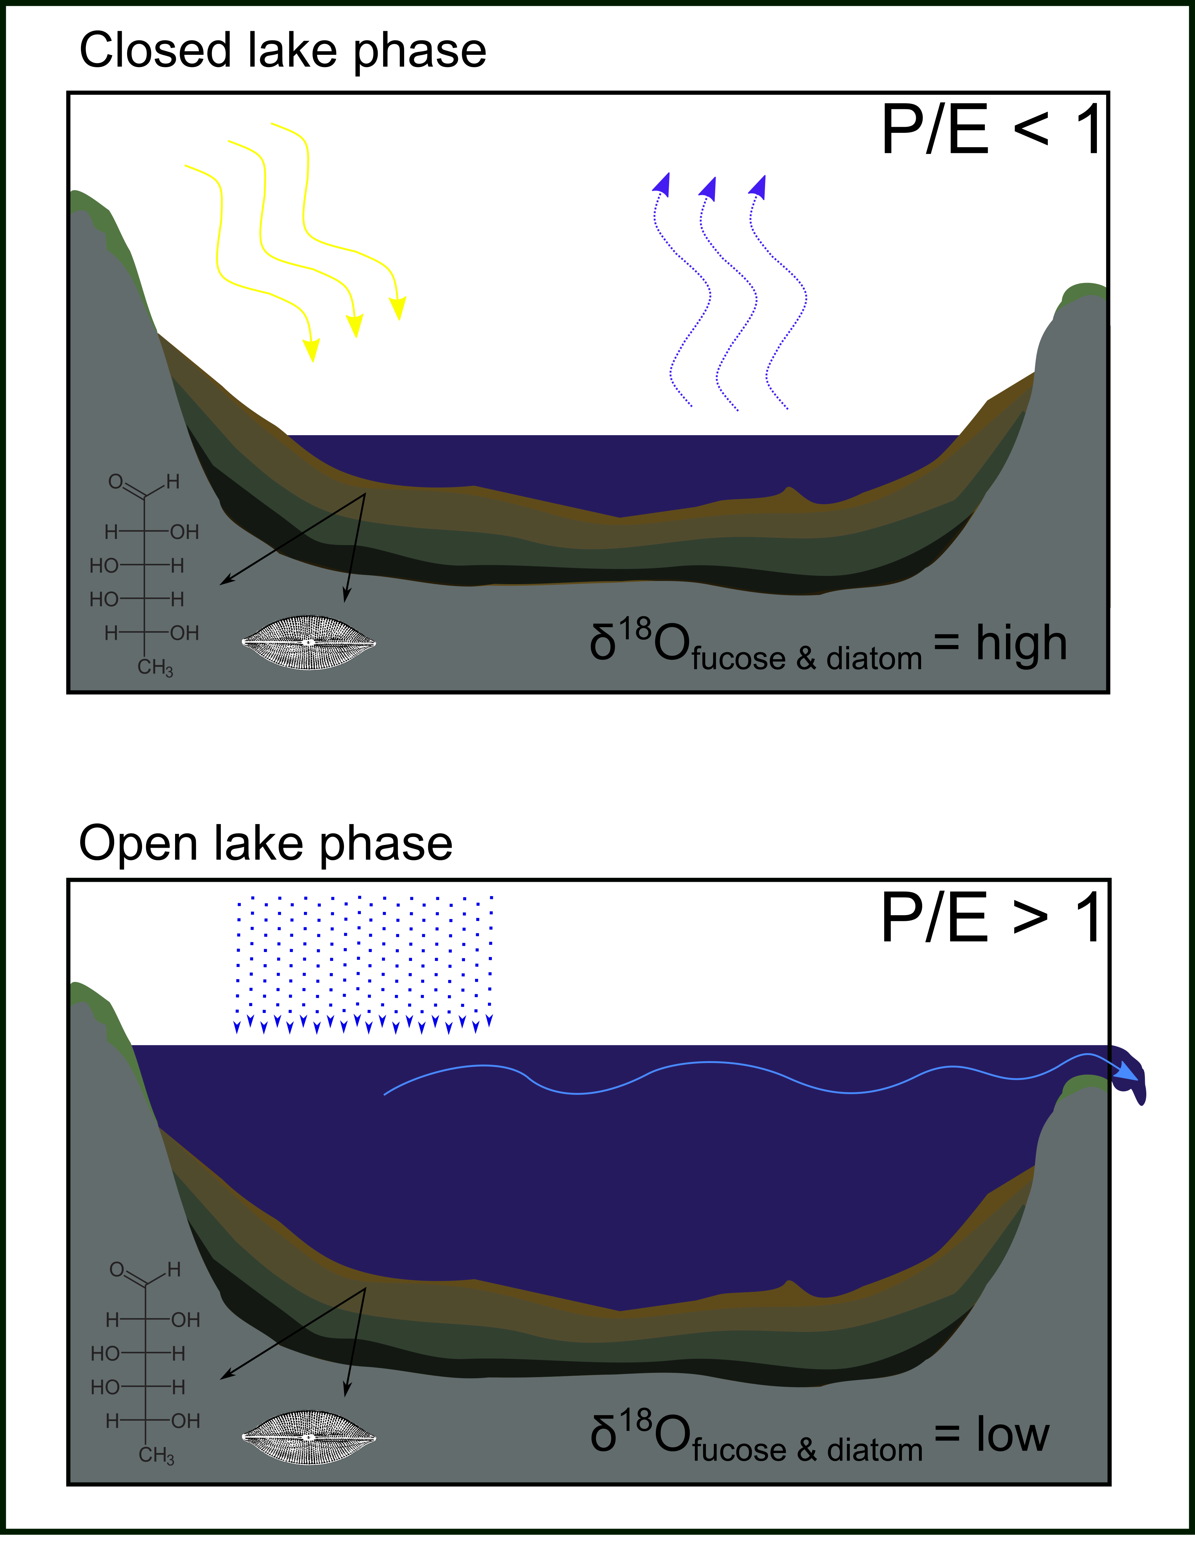
Fig. 5: A schematic figure of evaporative enrichment of lake water in open and closed lake systems.
Fig. 6: Scanning Electron Microscope picture of the diatom sample 26186 (245 cm depth)

