Supplementary Material for Davies et al. “Eco-hydrological controls on apparent rates of peat carbon accumulation in a boreal bog record from the Hudson Bay Lowlands, Canada”

1. PRINCIPAL COMPONENTS AND PROCRUSTES ANALYSIS
The sample scores of a principles component analysis (PCA) for samples common to the pollen and testate amoeba datasets (N= 28; Fig. S1) were tested for congruence using Procrustes analysis in the ‘vegan’ package in R (Figure S1; Oksanen et al., 2018). The datasets were converted to proportions and square root transformed prior to PCA analysis to minimize variance. Procrustes analysis rescales and rotates the sample scores of one of the ordination datasets to minimize the sum of squares of the Euclidean distances between the two configurations. A sum of squares value of zero represents perfect alignment (Peres-Neto and Jackson, 2001). This technique has been used to compare multivariate ecological and environmental datasets in both modern (Bunbury et al., 2020) and paleoecological settings (Forcino et al., 2015). We selected the target ordination in the Procrustes analysis to be the testate amoeba dataset, as we wanted to test whether the vegetation (pollen dataset) was responding to local environmental conditions (testate amoeba dataset). We scaled the configurations to equal dispersion (i.e. unit variance; symmetric = TRUE in the ‘procrustes’ function in vegan) before rotation. The Procrustes sum of squares (m₁₂) significance was tested with 999 permutations on a symmetric rotation (Peres-Neto and Jackson, 2001). For the testate amoeba dataset, the PC1 (λ=0.1468) and PC2 (λ=0.08726) axes explained 41% and 24% of the variance, respectively. For the pollen dataset, the PC1 (λ=0.02139) and PC2 (λ=0.00862) axes explained 45% and 18% of the variance, respectively.
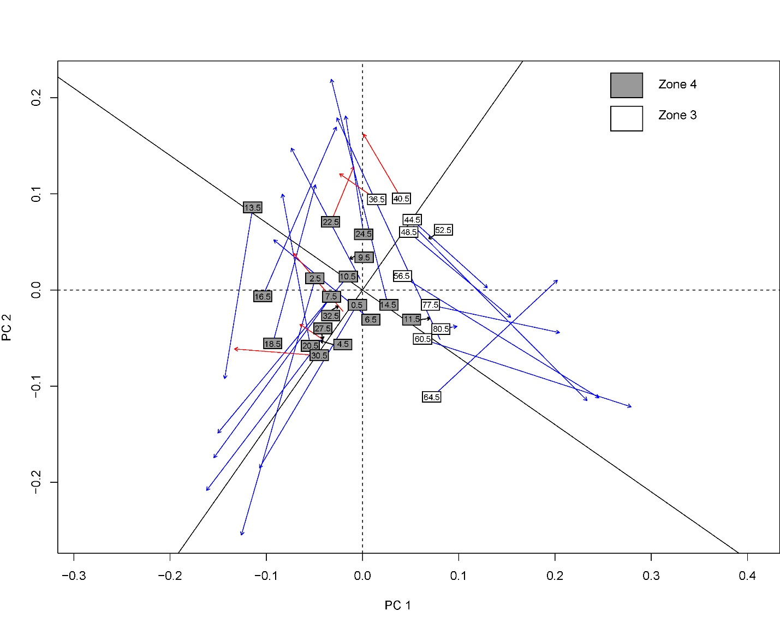
Figure S1. Procrustes analysis of the PCA axis scores for the testate amoeba and pollen datasets (N=28). Labels indicate the position of the samples in the pollen ordination and the arrows indicate the sample position in the testate amoeba ordination. The red arrows indicate the samples that had residuals that were less than the first quartile of the dataset (sample residual <0.1), which was used in this study to indicate samples that were highly congruent. The solid axes lines (black) indicate the rotation of the pollen dataset needed to minimize the sum of squared difference between the two ordinations.

2. POLLEN AND TESTATE AMOEBA RECORDS
A total of 40 testate amoebae and 35 pollen and spore taxa were identified at Site 13-01. Rare and infrequent taxa not included in Figure 4 of the main text are found in Figure S2 (<10% of the assemblage). Figure S2 also shows the absolute water table depth reconstruction and the reconstruction error. Images of Pyxidicula sp. A are found in Figure S3.

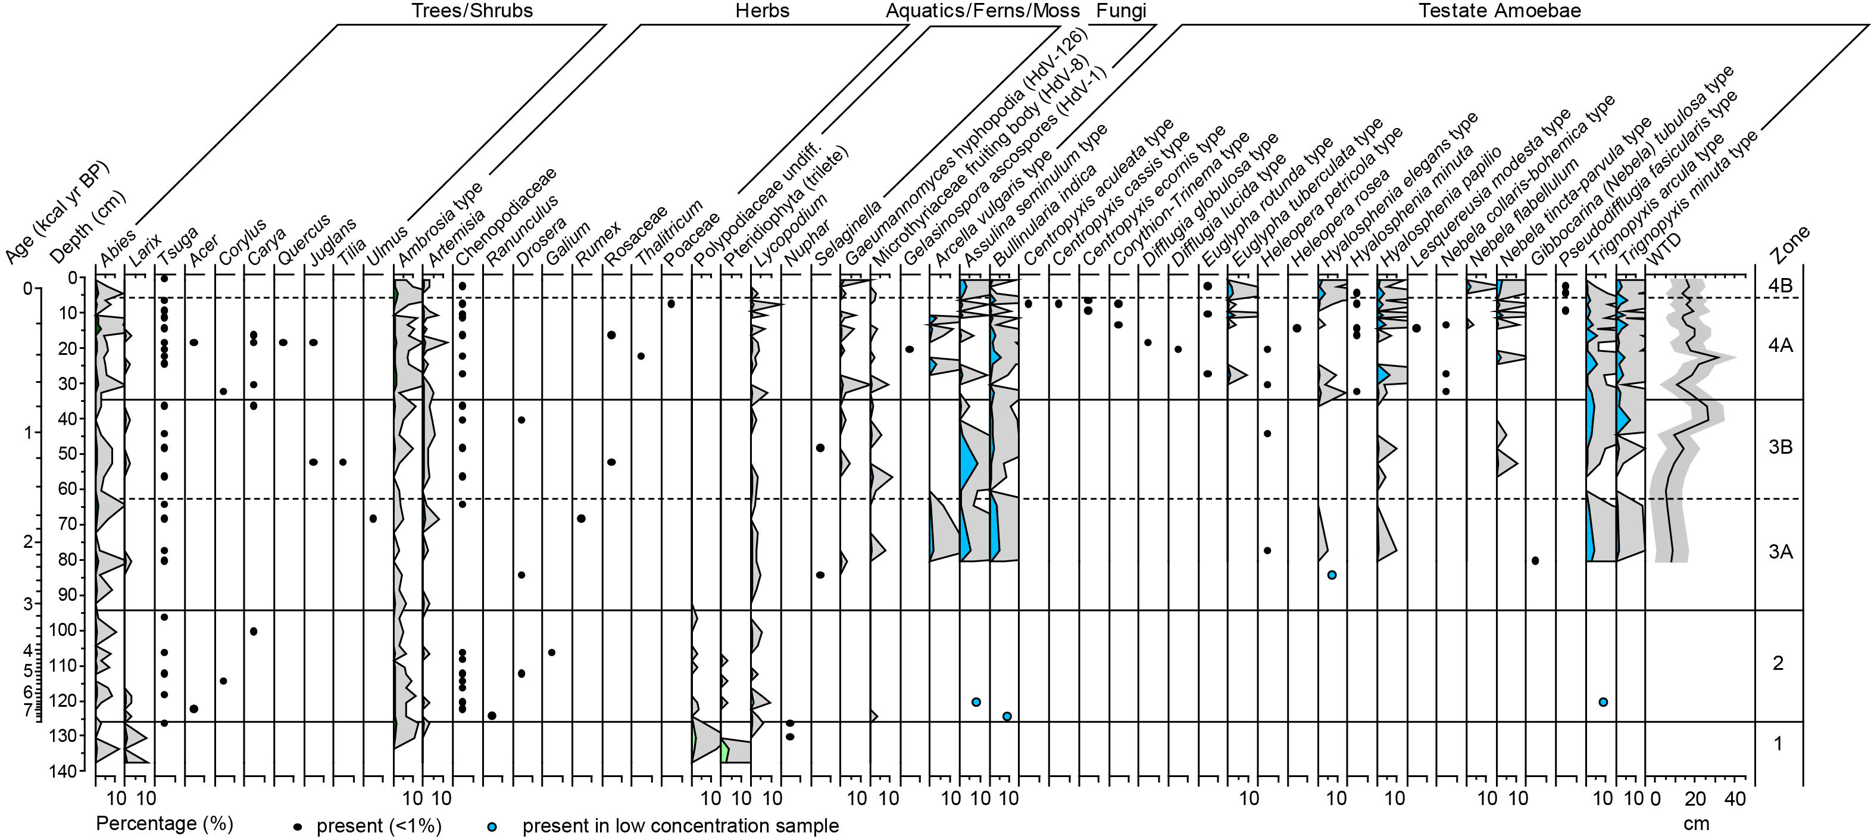
Figure S2. Pollen and spore, non-pollen palynomorph (NPP; fungi and algae), and testate amoeba assemblages of HRST 13-01, Hudson Bay Lowlands region, Canada. Taxa present in this diagram were <10% of their given assemblage. Depth is the primary y-axis for this figure. Grey exaggeration is 10x. WTD: water table depth (larger numbers indicate drier conditions). The pollen sum used to calculate the percentages included all pollen and spore taxa, minus Sphagnum spores. Sphagnum spore and NPP sums were the pollen sum plus the respective taxa included in each category. The testate amoeba (TA) sum included all taxa minus the rotifer taxon. The rotifer sum was calculated like the Sphagnum and NPP sums, using the TA sum as the base. Numbers listed after the NPPs are the type numbers after Miola (2012). The shaded grey region of the water table depth curve is the reconstruction standard error of prediction (SEP).

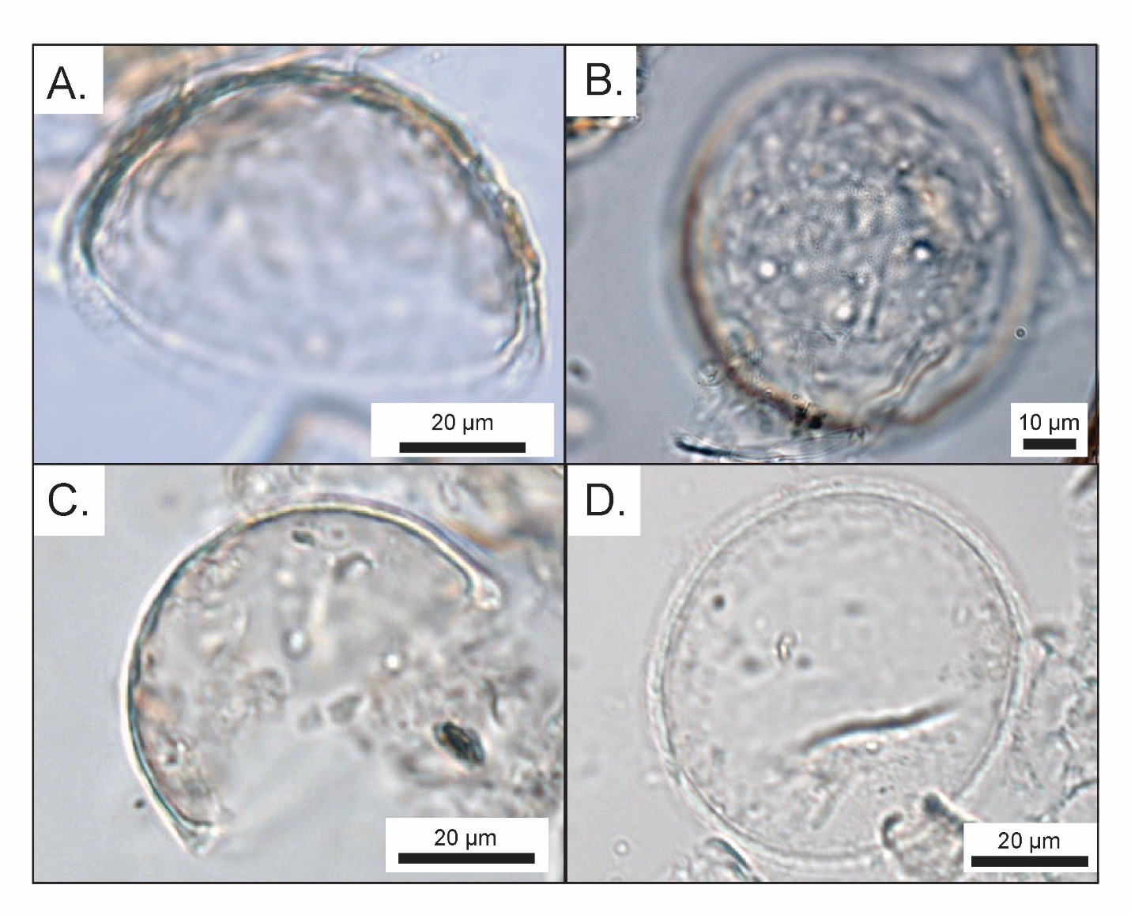
Figure S3. Pyxidicula sp. A of HRST 13-01. A. Oblique view showing the extension of the test wall or lip seen in some specimens (sample from depth 4-5 cm; 400x magnification). B. Aboral view showing the areolar surface texture (sample from depth 18-19 cm, 1000x magnification in oil immersion) C. Lateral view showing the test thickening towards the aperture (sample from depth 30-31 cm, 400x magnification) D. Aboral view showing the extension of the test wall or lip seen in some specimens (sample from depth 11-12 cm, 400x magnification).

3. WATER TABLE DEPTH RECONSTRUCTION MODEL SELECTION
The wa.inv.tol model of Amesbury et al. (2018) was selected as it included samples from the Hudson Bay Lowlands and the range of percentages for each taxon were suitable analogues for the site samples (i.e. the maximum percentages in the modern dataset were higher than the recalculated fossil percentages, tested using the ‘coverage.plot’ function in the ‘palaeoSig’ package in R; (Telford, 2015)). Sample standard errors and model performance statistics were generated using bootstrap simulations (1000 iterations; Amesbury et al. (2018)). The model was run in the ‘rioja’ package in R (Juggins, 2017). The WTD reconstruction values were converted to a Z score using ‘R.basic’ package in R (Bengtsson, 2013) to demonstrate the relative shifts in species assemblages related to hydrology without assigning an absolute value to the data, as although shown to represent directional changes in water table well, absolute values from transfer functions should be interpreted with caution (Swindles et al., 2015).

4.. TAXONOMIC AUTHORITIES FOR THE TESTATE AMOEBA TAXA
A total of 40 testate amoebae and one rotifer were found at site HRST 13-01. Taxonomic authorities and summary data (minimum, maximum, total number of samples, average abundance) for each taxon are shown in Table S1.
Table S1. Taxonomic authorities for the testate amoeba taxa found at Site HRST 13-01. Summary values are based on the 28 samples with counts of > 150 tests. N = number of occurrences. Percentages calculated for minimum (min), mean, and maximum (max) relative abundances are based on all 28 samples.

Taxon | Authority | N | %
 |  |  | Min | Mean | Max
Alabasta militaris type | (Penard, 1890) | 20 | 0 | 3.7 | 16.5
Amphitrema wrightianum type | Archer, 1869 | 11 | 0 | 4.8 | 30.7
Arcella artocrea | Leidy, 1876 | 20 | 0 | 1.9 | 8.7
Arcella catinus type | Penard, 1890 | 23 | 0 | 1.7 | 10.6
Arcella discoides type | Ehrenberg, 1843 | 28 | 1.1 | 5.6 | 16.2
Arcella vulgaris type | Ehrenberg, 1830 | 6 | 0 | 0.4 | 3.3
Archerella flavum | (Archer, 1877) | 18 | 0 | 8.8 | 65.9
Assulina muscorum | Greef, 1888 | 17 | 0 | 2.2 | 10.3
Assulina seminulum type | (Ehrenberg, 1848) | 16 | 0 | 1.5 | 8.6
Bullinularia indica | (Penard, 1907) | 23 | 0 | 1.5 | 5.8
Centropyxis aculeata type | (Ehrenberg, 1830) | 1 | 0 | 0.0 | 0.4
Centropyxis cassis type | (Wallich, 1864) | 1 | 0 | 0.0 | 0.4
Centropyxis ecornis type | (Ehrenberg, 1841) | 2 | 0 | 0.0 | 0.5
Corythion-Trinema type | Tarànek, 1881; Dujardin, 1841 | 2 | 0 | 0.0 | 0.4
Cyclopyxis arcelloides type | (Penard, 1902) | 20 | 0 | 2.3 | 15.6
Difflugia globulosa type | Dujardin, 1837 | 1 | 0 | 0.0 | 0.7
Difflugia lucida type | Penard, 1890 | 1 | 0 | 0.0 | 0.6
Difflugia pristis type | Penard, 1902 | 19 | 0 | 5.6 | 27.7
Difflugia pulex type | Penard, 1902 | 26 | 0 | 14.9 | 47.5
Euglypha rotunda type | Wailes, 1911 | 3 | 0 | 0.1 | 1.0
Euglypha tuberculata type | Dujardin, 1841 | 6 | 0 | 0.3 | 2.9
Gibbocarina (Nebela) tubulosa type | (Penard, 1890) | 1 | 0 | 0.0 | 0.7
Heleopera petricola | Leidy, 1879 | 4 | 0 | 0.1 | 1.0
Heleopera rosea | Penard, 1890 | 1 | 0 | 0.0 | 1.1
Heleopera sphagni | (Leidy, 1874) | 21 | 0 | 4.5 | 13.2
Heleopera sylvatica | Penard, 1890 | 28 | 1.3 | 10.6 | 33.2
Hyalosphenia elegans type | Leidy, 1874 | 10 | 0 | 0.5 | 4.0
Hyalosphenia minuta | Cash, 1892 | 5 | 0 | 0.1 | 1.0
Hyalosphenia papilio | Leidy, 1875 | 14 | 0 | 0.9 | 6.0
Hyalosphenia subflava | Cash and Hopkinson, 1909 | 27 | 0 | 13.3 | 46.8
Lesquereusia modesta type | Rhumbler, 1895 | 1 | 0 | 0.0 | 0.6
Nebela collaris-bohemica type | (Ehrenberg, 1848); (Tarànek, 1882) | 3 | 0 | 0.0 | 0.5
Nebela flabellulum | Leidy, 1874 | 2 | 0 | 0.1 | 2.0
Nebela tincta-parvula type | (Leidy, 1879); Cash & Hopkinson, 1909 | 9 | 0 | 0.6 | 3.2
Phryganella acropodia type | (Hertwig and Lesser, 1874) | 13 | 0 | 0.9 | 10.6
Pseudodifflugia fasicularis type | Penard, 1902 | 3 | 0 | 0.0 | 0.5
Pseudodifflugia fulva type | (Archer, 1870) | 18 | 0 | 2.2 | 13.6
Pyxidicula sp. A | Ehrenberg, 1838 | 20 | 0 | 6.7 | 29.0
Trigonopyxis arcula type | (Leidy, 1879) | 25 | 0 | 2.0 | 5.9
Trigonopyxis minuta type | Schönborn & Peschke, 1988 | 24 | 0 | 2.1 | 7.1

REFERENCES CITED

Amesbury, M.J., et al., 2018. Towards a Holarctic synthesis of peatland testate amoeba ecology: Development of a new continental-scale palaeohydrological transfer function for North America and comparison to European data. Quaternary Science Reviews 201, 483-500, doi: 10.1016/j.quascirev.2018.10.034.
Bengtsson, H., 2013. R.basic: [R] Class Library - Stand-alone basic functions, R Package version 0.53.0., http://www.braju.com/R/
Bunbury, J., Fisher, R.G., Blumenstein, T., 2020. Anthropogenic and climate change impacts on lake-water chemistry over the past 20 years, Upper Midwest, United States. Physical Geography 41, 433-450, doi: 10.1080/02723646.2019.1674556.
Forcino, F.L., Ritterbush, K.A., Stafford, E.S., 2015. Evaluating the effectiveness of the Mantel test and Procrustes randomization test for exploratory ecological similarity among paleocommunities. Palaeogeography, Palaeoclimatology, Palaeoecology 426, 199-208, doi: 10.1016/j/palaeo.2015.03.023.
Juggins, S., 2017. rioja: Analysis of Quaternary Science Data, R Package Version 0.9-15.1, http://cran.r-project.org/package=rioja
Miola, A., 2012. Tools for non-pollen palynomorphs (NPPs) analysis: A list of Quaternary NPP types and reference literature in English language (1972-2011). Review of Palaeobotany and Palynology 186, 142-161, doi: 10.1016/j.revpalbo.2012.06.010.
Oksanen, P., et al., 2018. vegan: Community Ecology Package, R Package version 2.5-2., https://CRAN.R-project.org/package=vegan
Peres-Neto, P.R., Jackson, D.A., 2001. How well do multivariate data sets match? The advantages of a Procrustean superimposition approach over the Mantel test. Oecologia 129, 169-178, doi: 10.1007/s004420100720.
Swindles, G.T., Holden, J., Raby, C.L., Turner, T.E., Blundell, A., Charman, D.J., Menberu, M.W., Kløve, B., 2015. Testing peatland water-table depth transfer functions using high-resolution hydrological monitoring data. Quaternary Science Reviews 120, 107-117, doi: j.quascirev.2015.04.019.
Telford, R.J., 2015. palaeoSig: Signficance tests of quantitative palaeoenvironmental reconstructions, R package version 1.1-3, http://cran.r-project.org/package=palaeoSig

