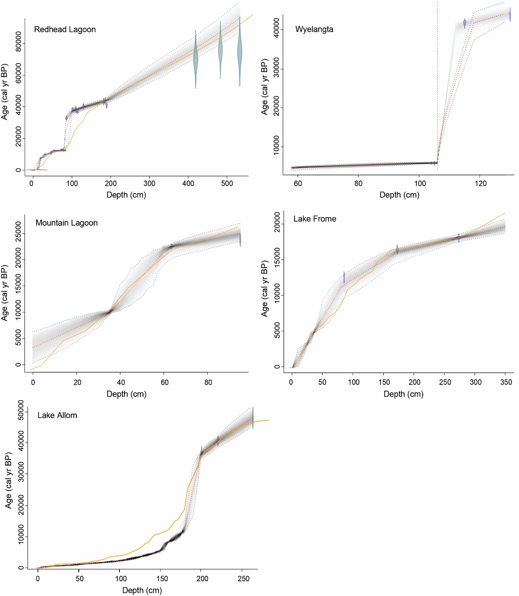
Figure S1. Bayesian age-depth models developed in Bacon in R of records excluded from further analysis during the age modelling process due to sedimentary hiatuses (Redhead Lagoon, Wyelangta and Lake Allom) or not extending to 25 ka (Mountain Lagoon and Lake Frome). Previously published age-depth relationships (retrieved from original publications listed in Table 1) are shown in orange line.
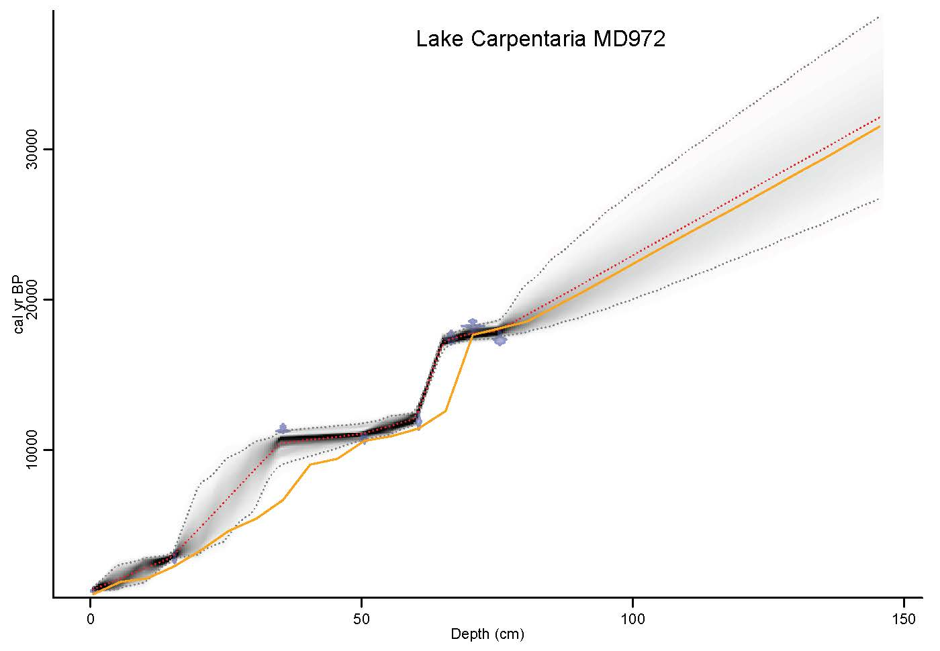
Figure S2a. Bayesian age-depth models developed in Bacon in R for Lake Carpentaria MD972128. Previously published age-depth relationships (retrieved from original publication) are shown in orange line.
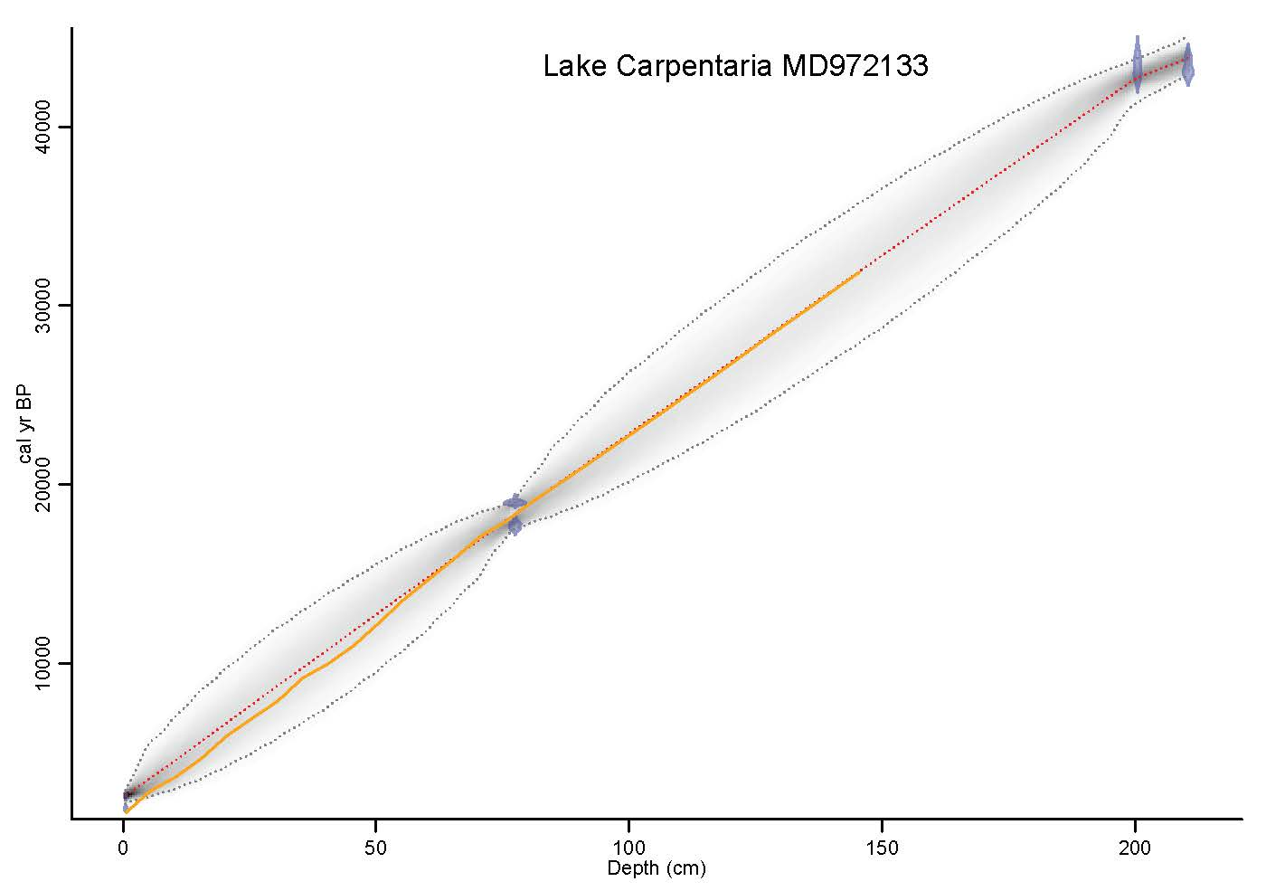
Figure S2a. Bayesian age-depth models developed in Bacon in R for Lake Carpentaria MD972133. Previously published age-depth relationships (retrieved from original publication) are shown in orange line.
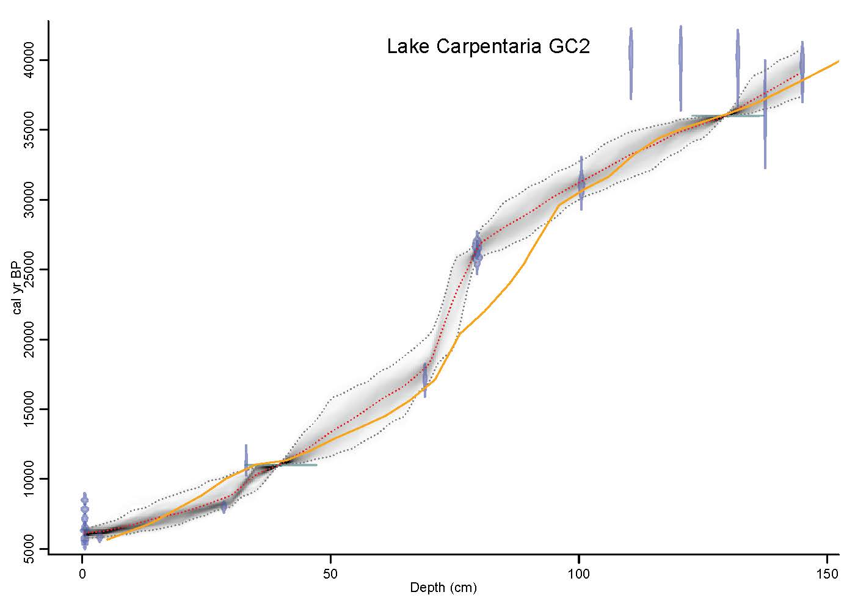
Figure S2c. Bayesian age-depth models developed in Bacon in R for Lake Carpentaria GC2. Previously published age-depth relationships (retrieved from original publication) are shown in orange line.
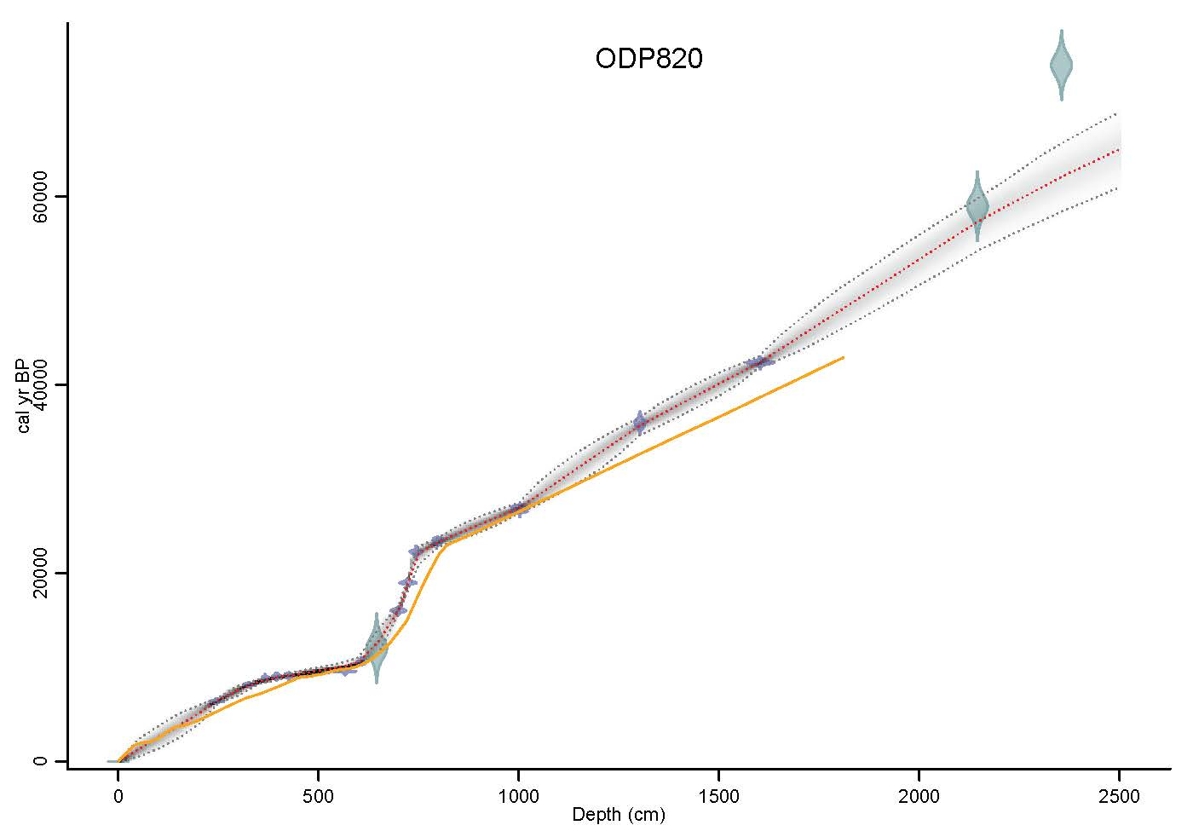
Figure S2d. Bayesian age-depth models developed in Bacon in R for ODP820. Previously published age-depth relationships (retrieved from original publication) are shown in orange line.

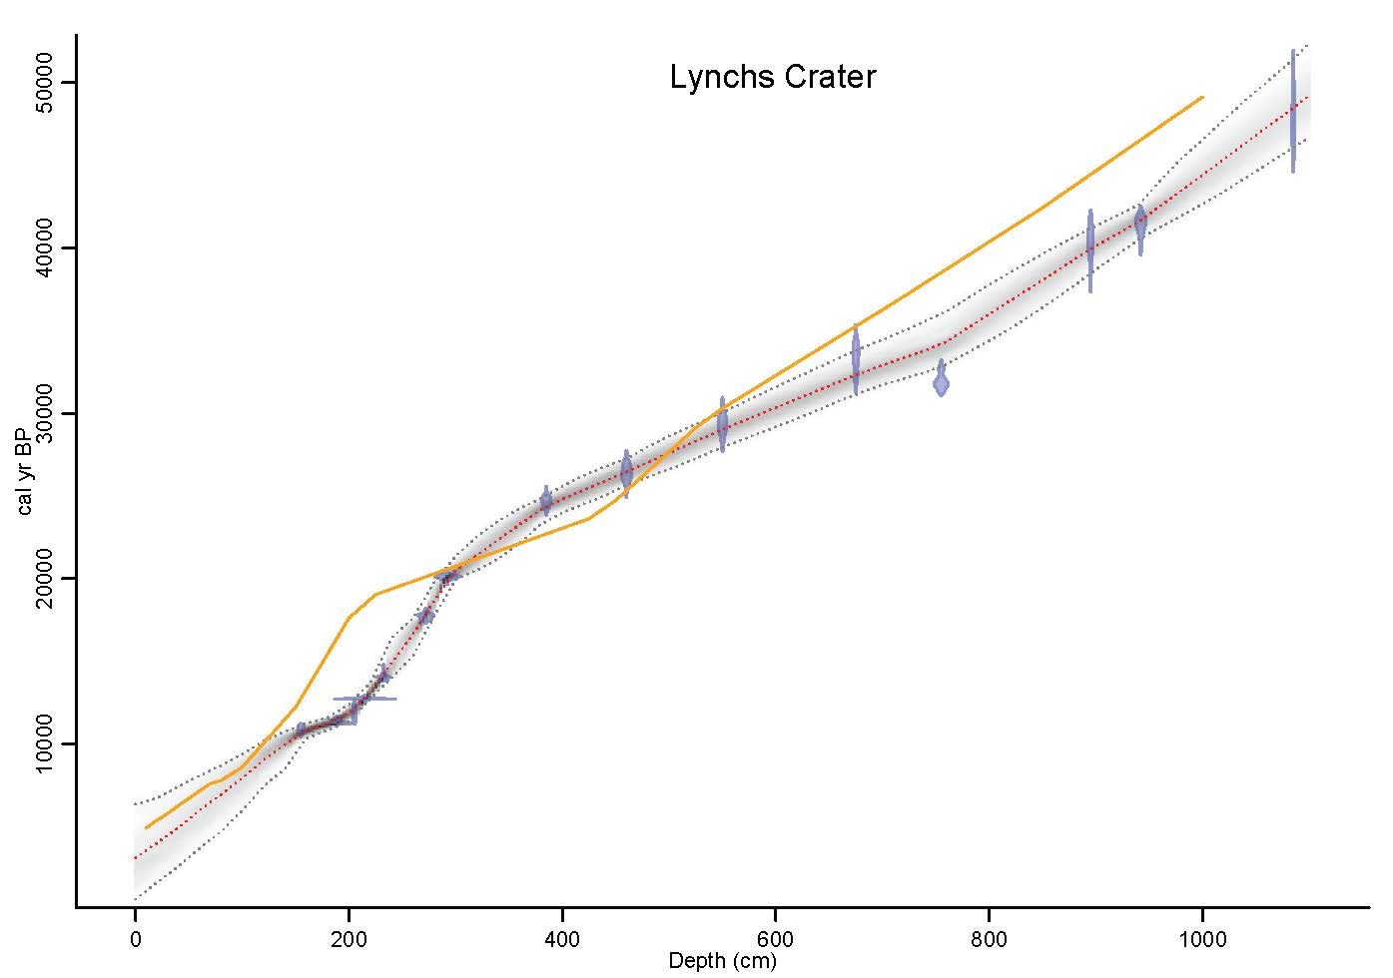
Figure S2e. Bayesian age-depth models developed in Bacon in R for Lynchs Crater. Previously published age-depth relationships (retrieved from original publication) are shown in orange line.
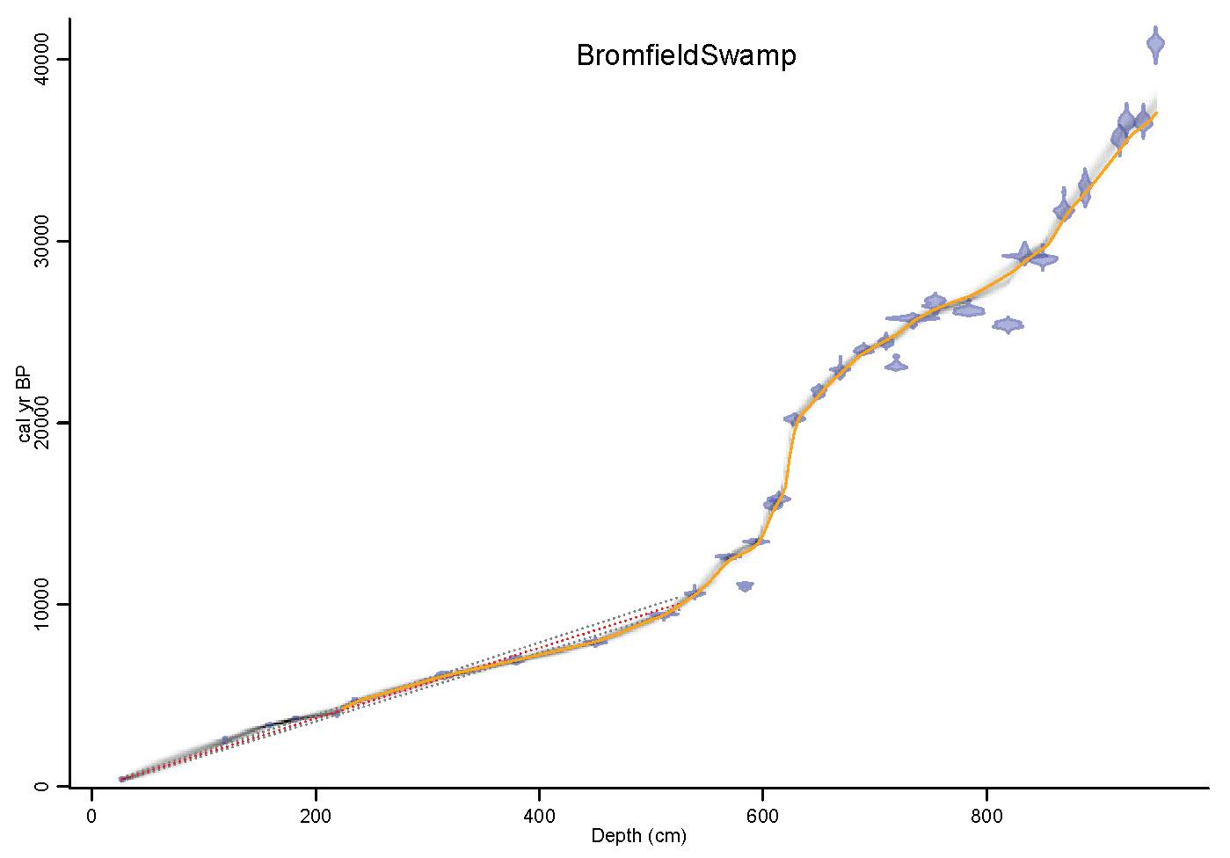
Figure S2f. Bayesian age-depth models developed in Bacon in R for Bromfield Swamp. Previously published age-depth relationships (retrieved from original publication) are shown in orange line.
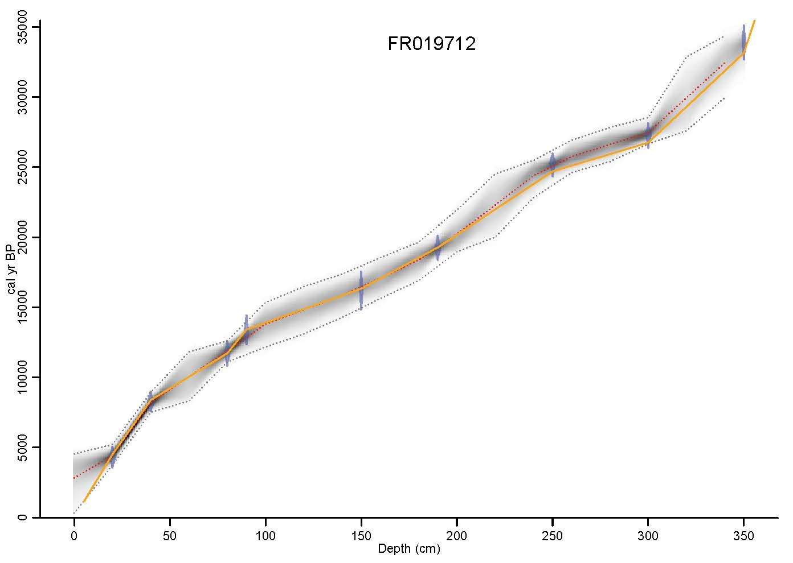
Figure S2g. Bayesian age-depth models developed in Bacon in R for FR019712. Previously published age-depth relationships (retrieved from original publication) are shown in orange line.
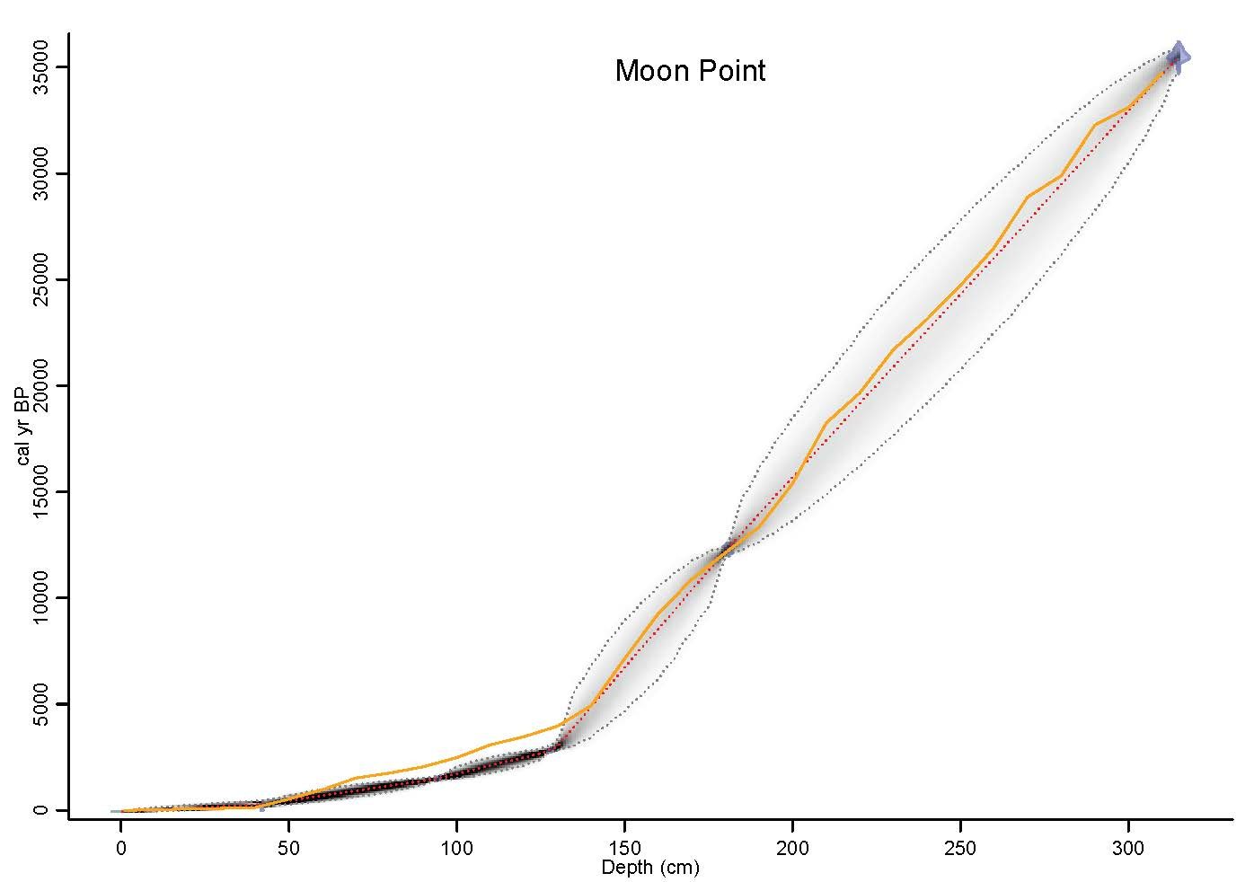
Figure S2h. Bayesian age-depth models developed in Bacon in R for Moon Point. Previously published age-depth relationships (retrieved from original publication) are shown in orange line.
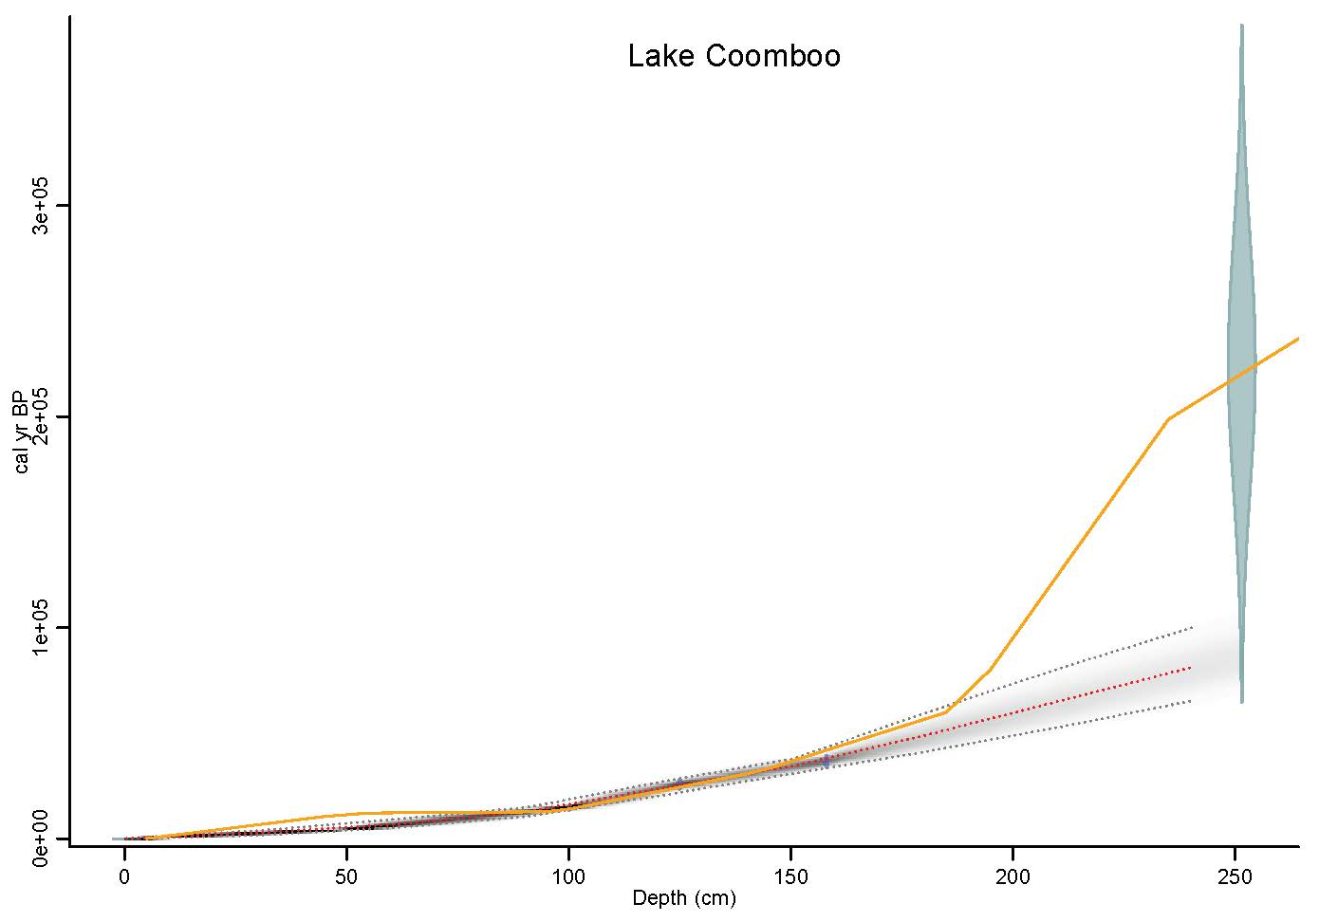
Figure S2i. Bayesian age-depth models developed in Bacon in R for Lake Coomboo. Previously published age-depth relationships (retrieved from original publication) are shown in orange line.
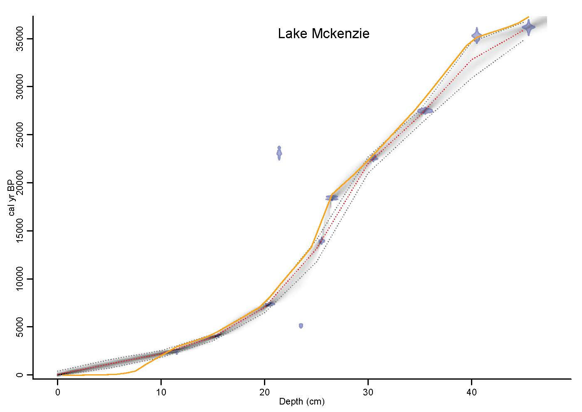
Figure S2j. Bayesian age-depth models developed in Bacon in R for Lake McKenzie. Previously published age-depth relationships (retrieved from original publication) are shown in orange line.
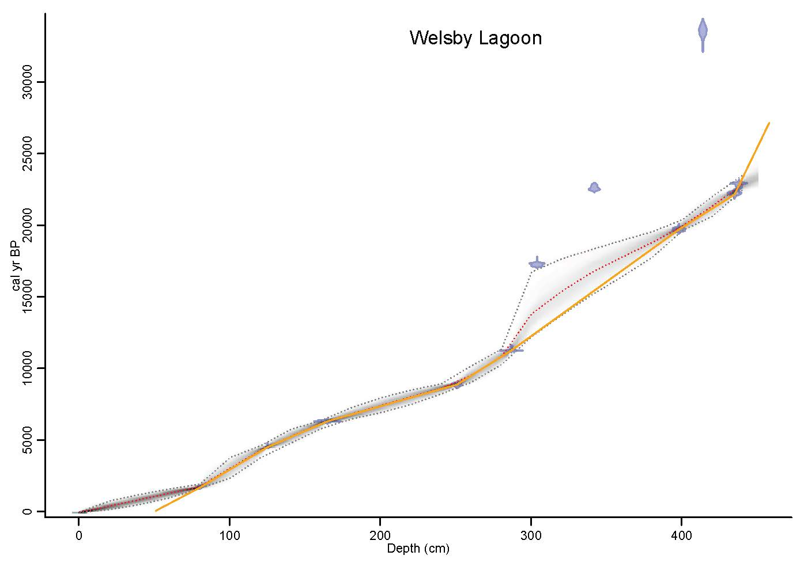
Figure S2k. Bayesian age-depth models developed in Bacon in R for Welsby Lagoon. Previously published age-depth relationships (retrieved from original publication) are shown in orange line.
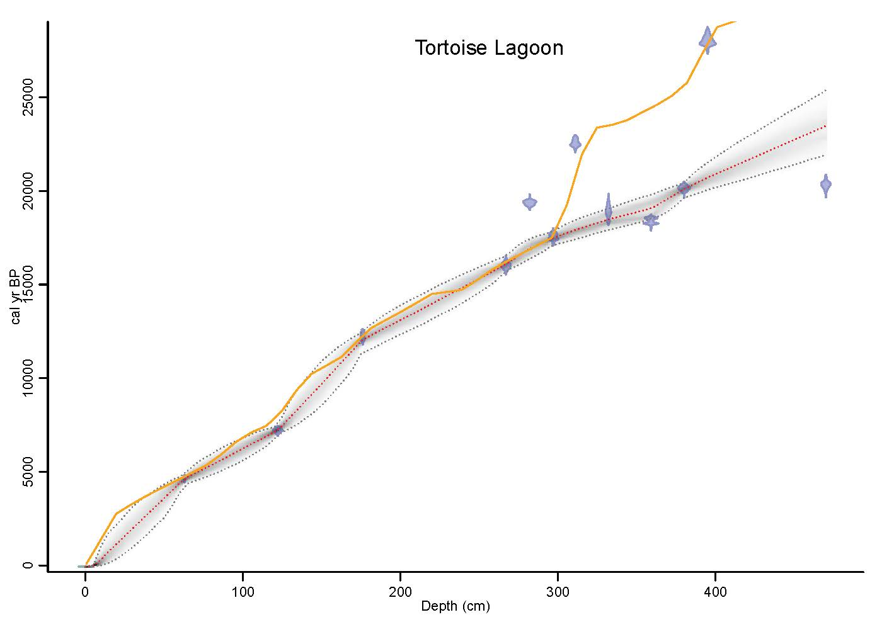
Figure S2l. Bayesian age-depth models developed in Bacon in R for Tortoise Lagoon. Previously published age-depth relationships (retrieved from original publication) are shown in orange line.
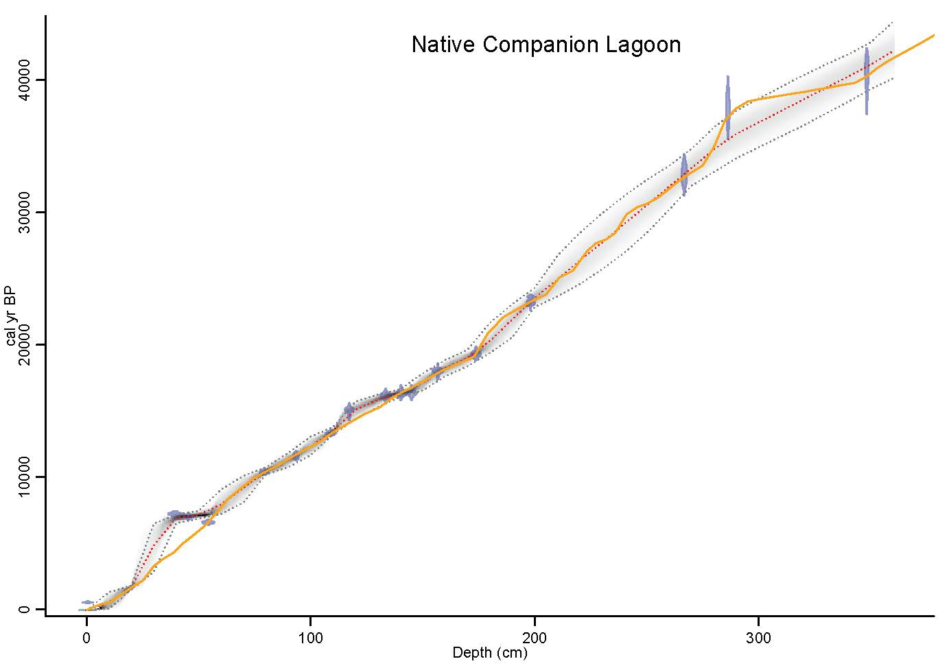
Figure S2m. Bayesian age-depth models developed in Bacon in R for Native Companion Lagoon. Previously published age-depth relationships (retrieved from original publication) are shown in orange line.
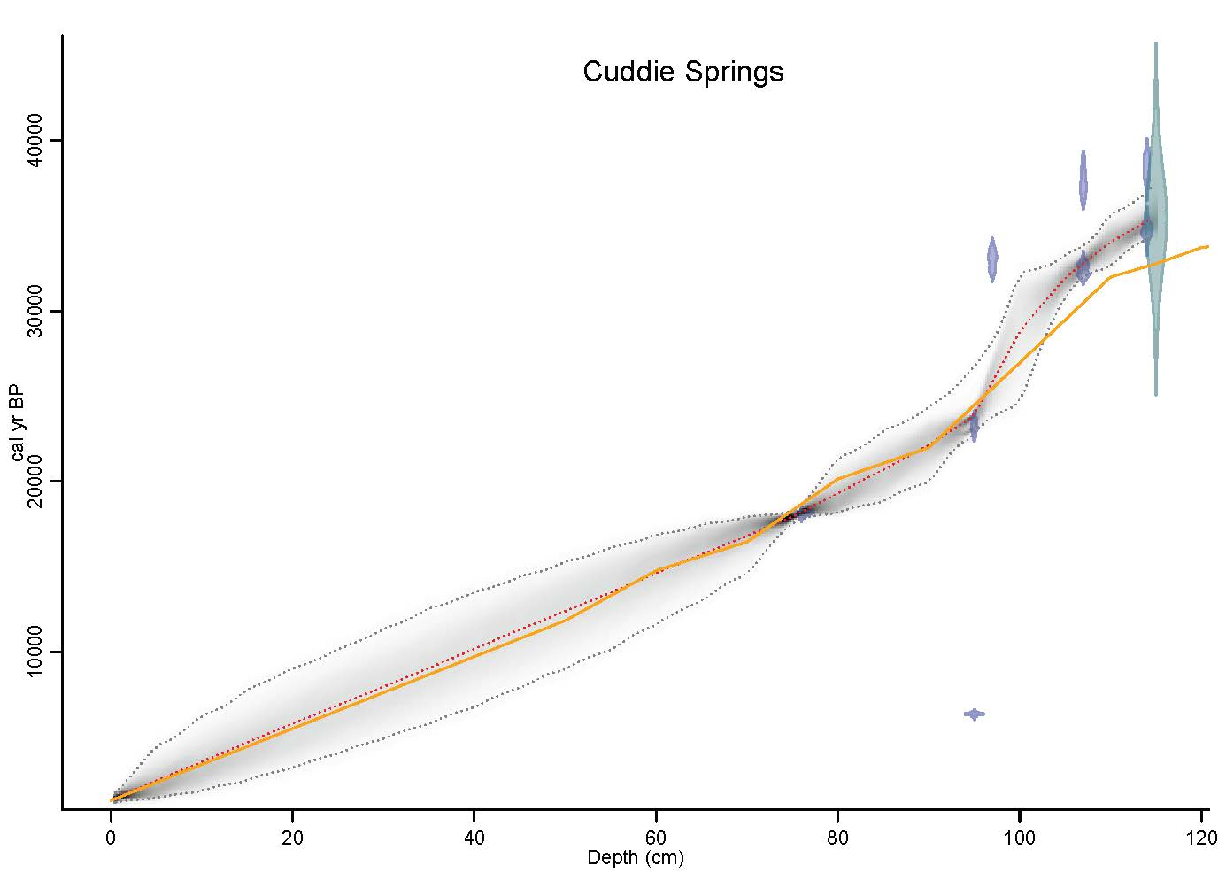
Figure S2n. Bayesian age-depth models developed in Bacon in R for Cuddie Springs. Previously published age-depth relationships (retrieved from original publication) are shown in orange line.
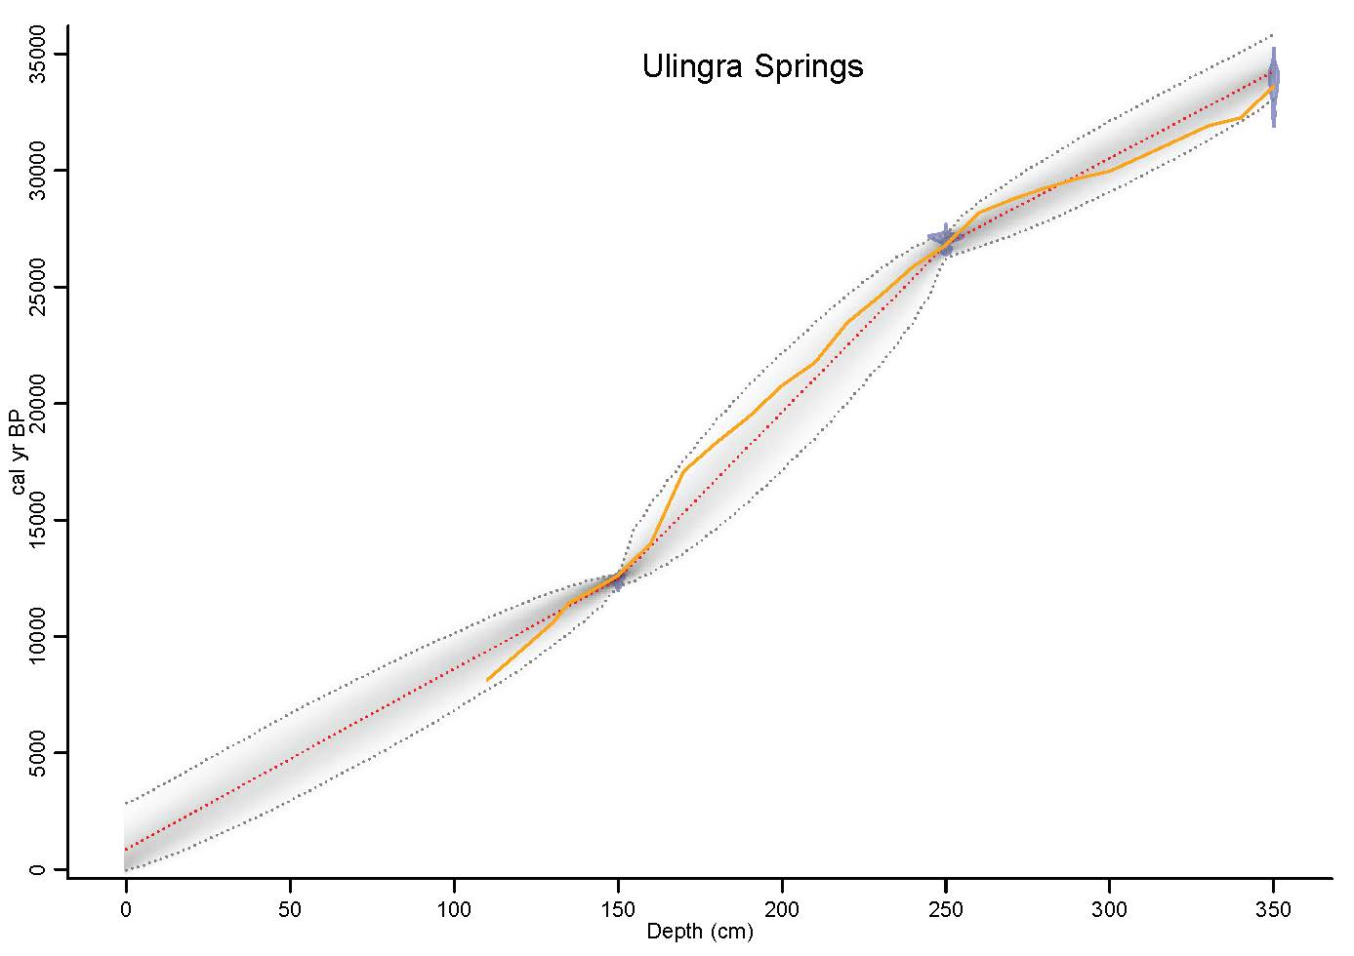
Figure S2o. Bayesian age-depth models developed in Bacon in R for Ulingra Springs. Previously published age-depth relationships (retrieved from original publication) are shown in orange line.
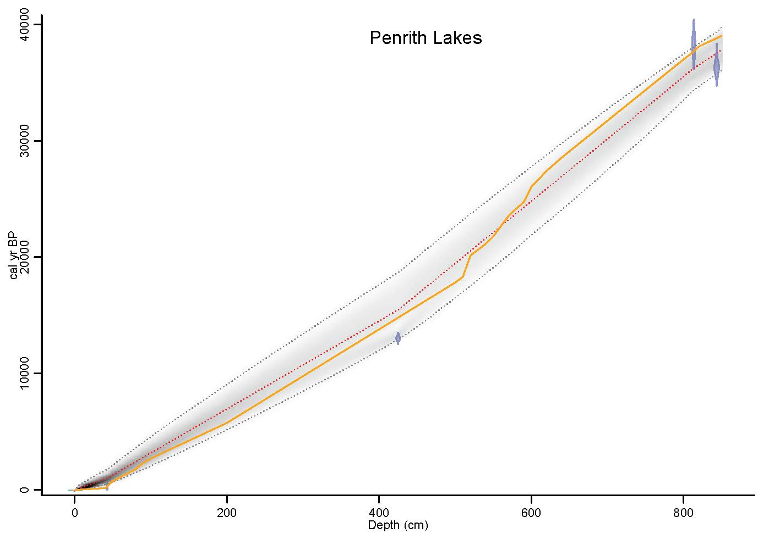
Figure S2p. Bayesian age-depth models developed in Bacon in R for Penrith Lakes. Previously published age-depth relationships (retrieved from original publication) are shown in orange line.
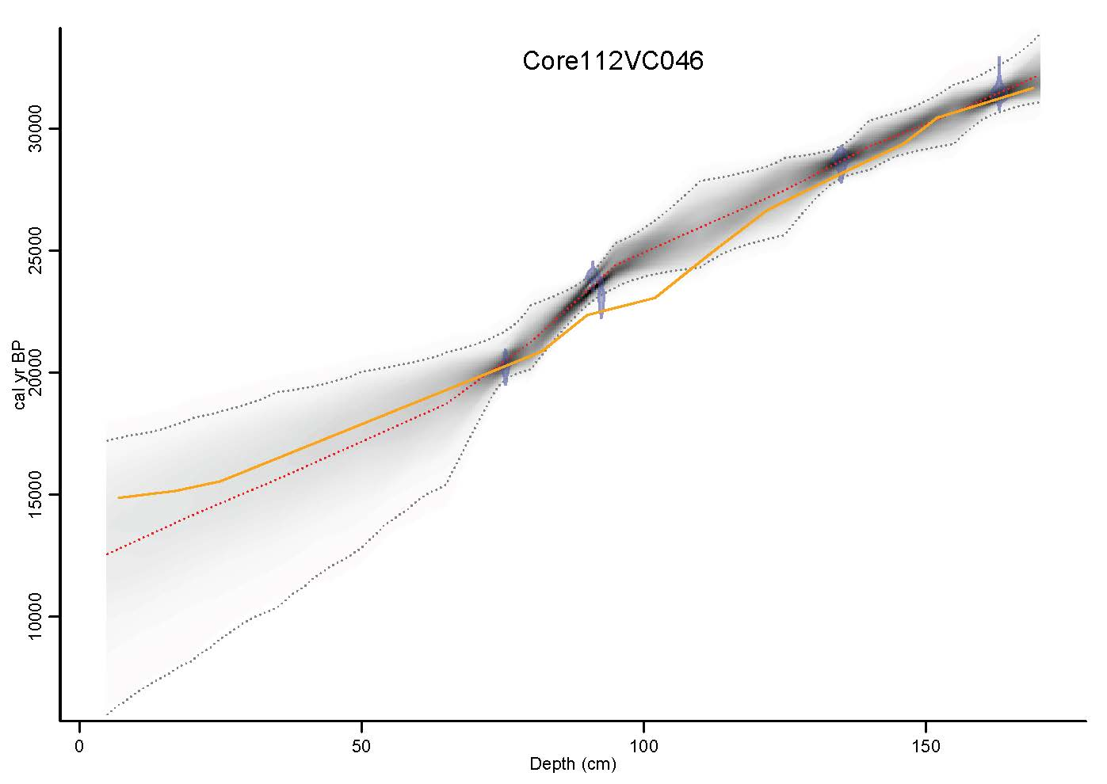
Figure S2q. Bayesian age-depth models developed in Bacon in R for Core 112VC046. Previously published age-depth relationships (retrieved from original publication) are shown in orange line.
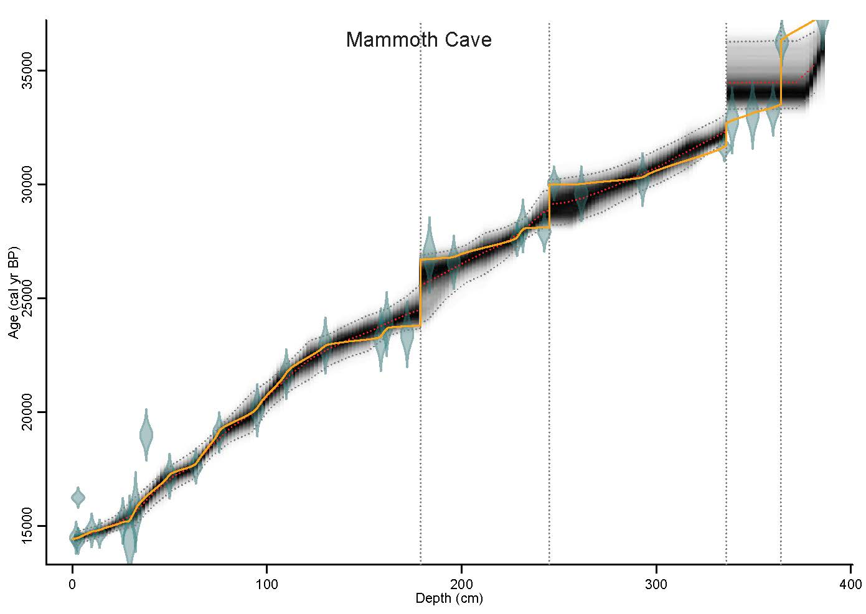
Figure S2r. Bayesian age-depth models developed in Bacon in R for Mammoth Cave. Previously published age-depth relationships (retrieved from original publication) are shown in orange line.
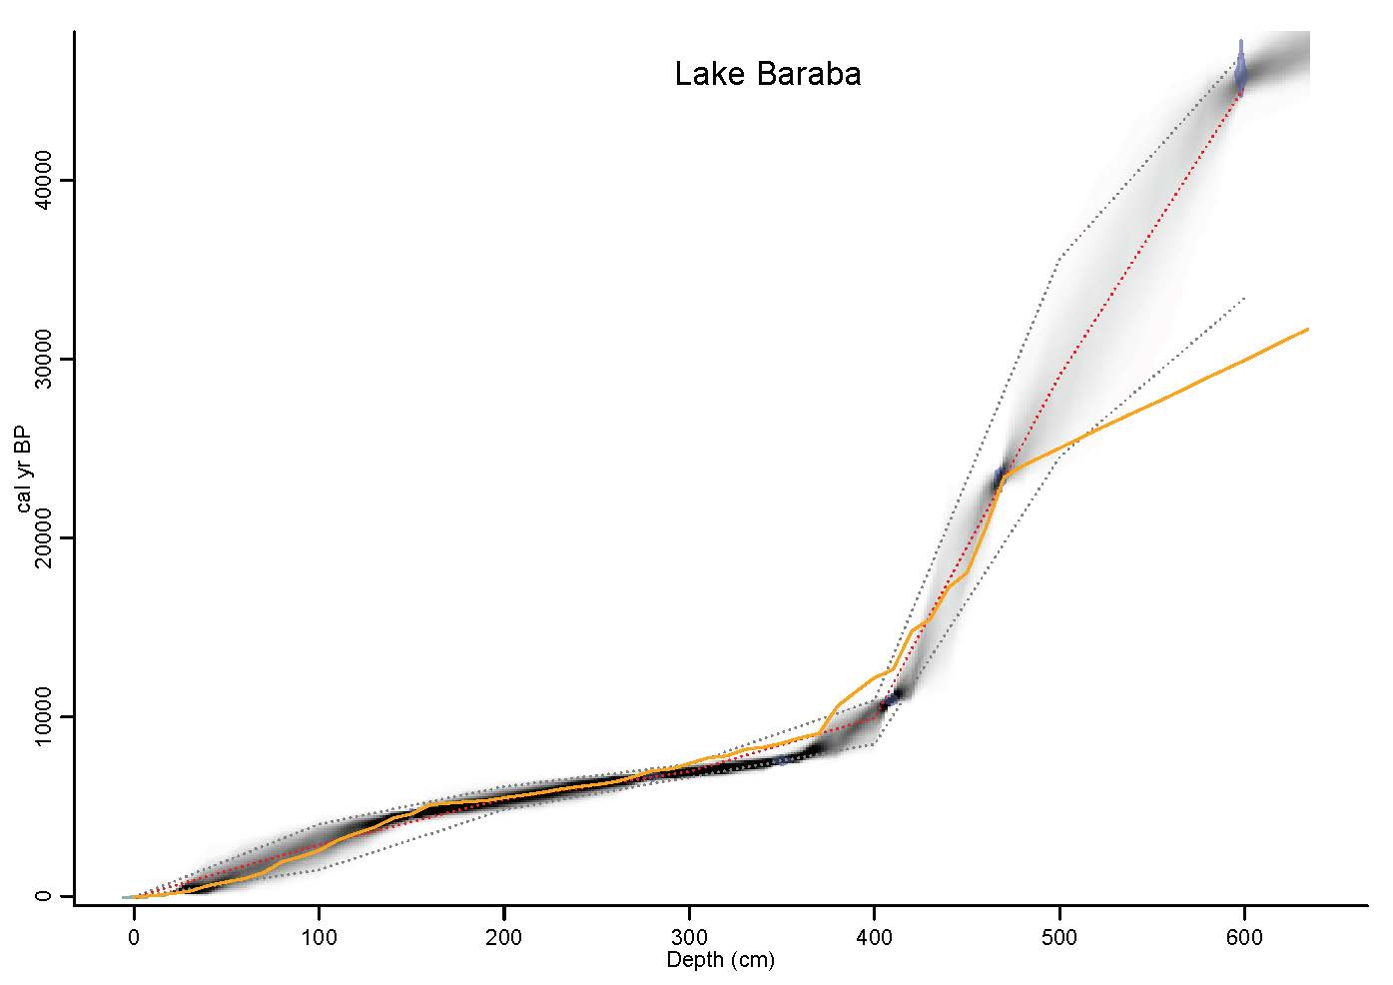
Figure S2s. Bayesian age-depth models developed in Bacon in R for Lake Baraba. Previously published age-depth relationships (retrieved from original publication) are shown in orange line.
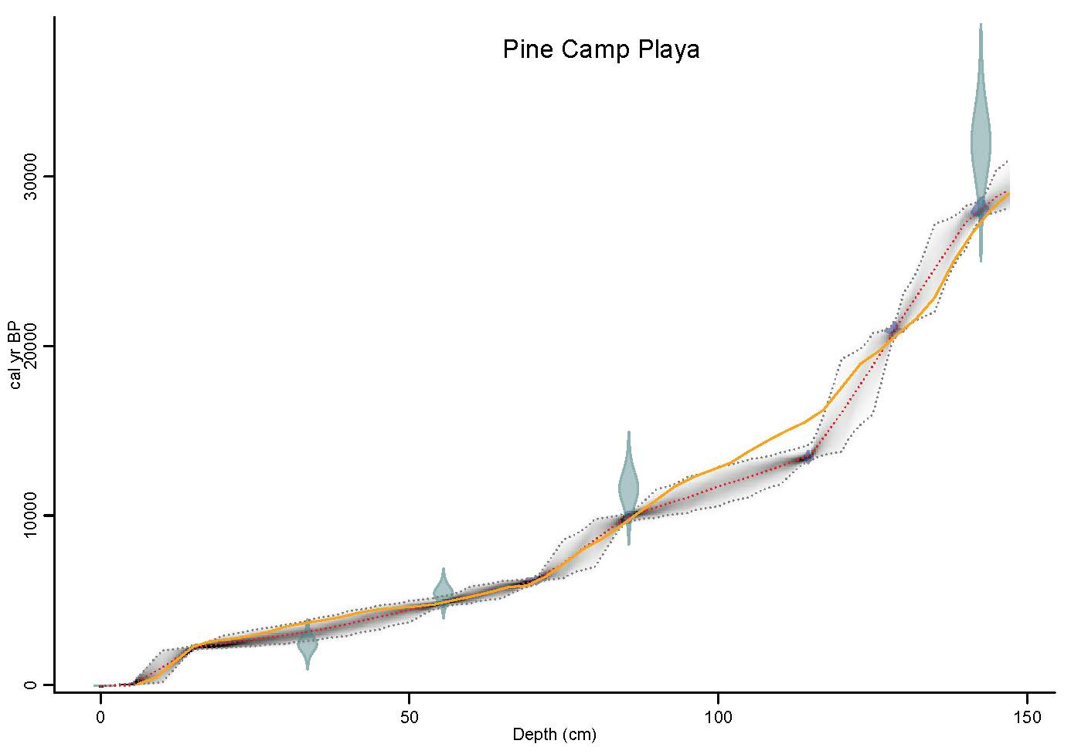
Figure S2t. Bayesian age-depth models developed in Bacon in R for Pine Camp Playa. Previously published age-depth relationships (retrieved from original publication) are shown in orange line.
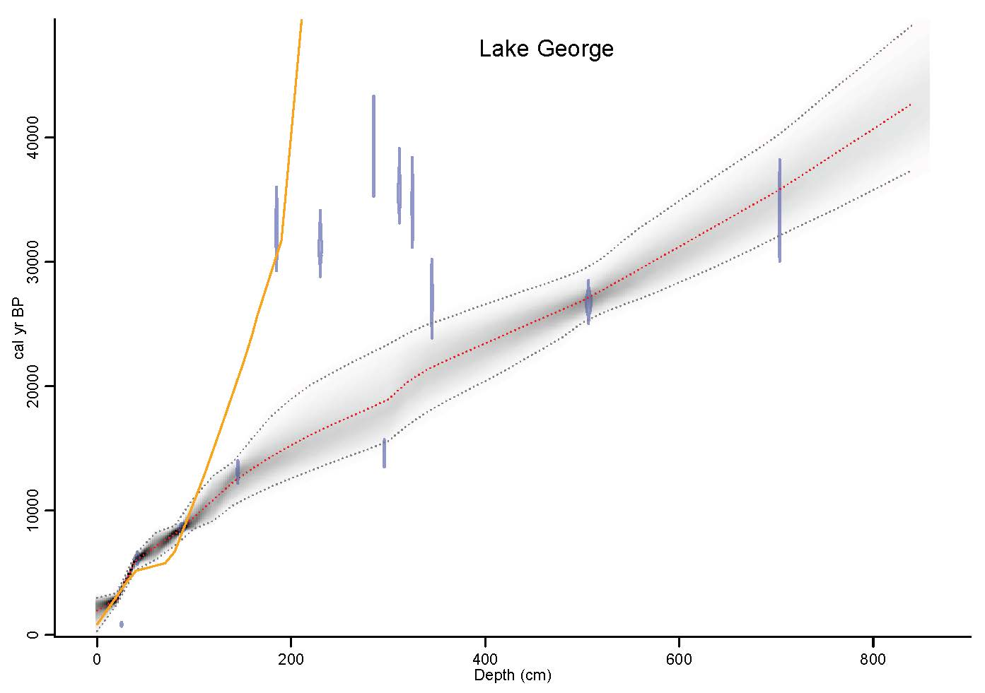
Figure S2u. Bayesian age-depth models developed in Bacon in R for Lake George. Previously published age-depth relationships (retrieved from original publication) are shown in orange line.
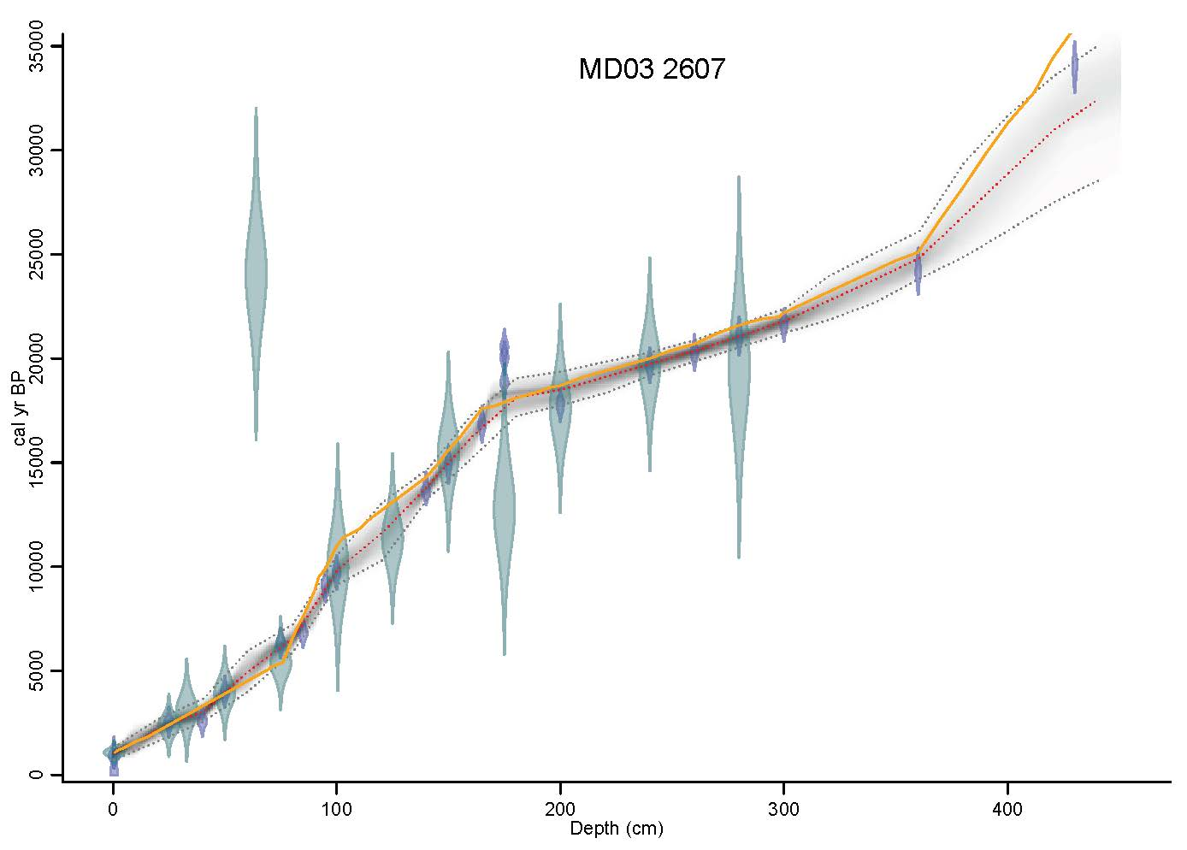
Figure S2v. Bayesian age-depth models developed in Bacon in R for MD03 2607. Previously published age-depth relationships (retrieved from original publication) are shown in orange line.
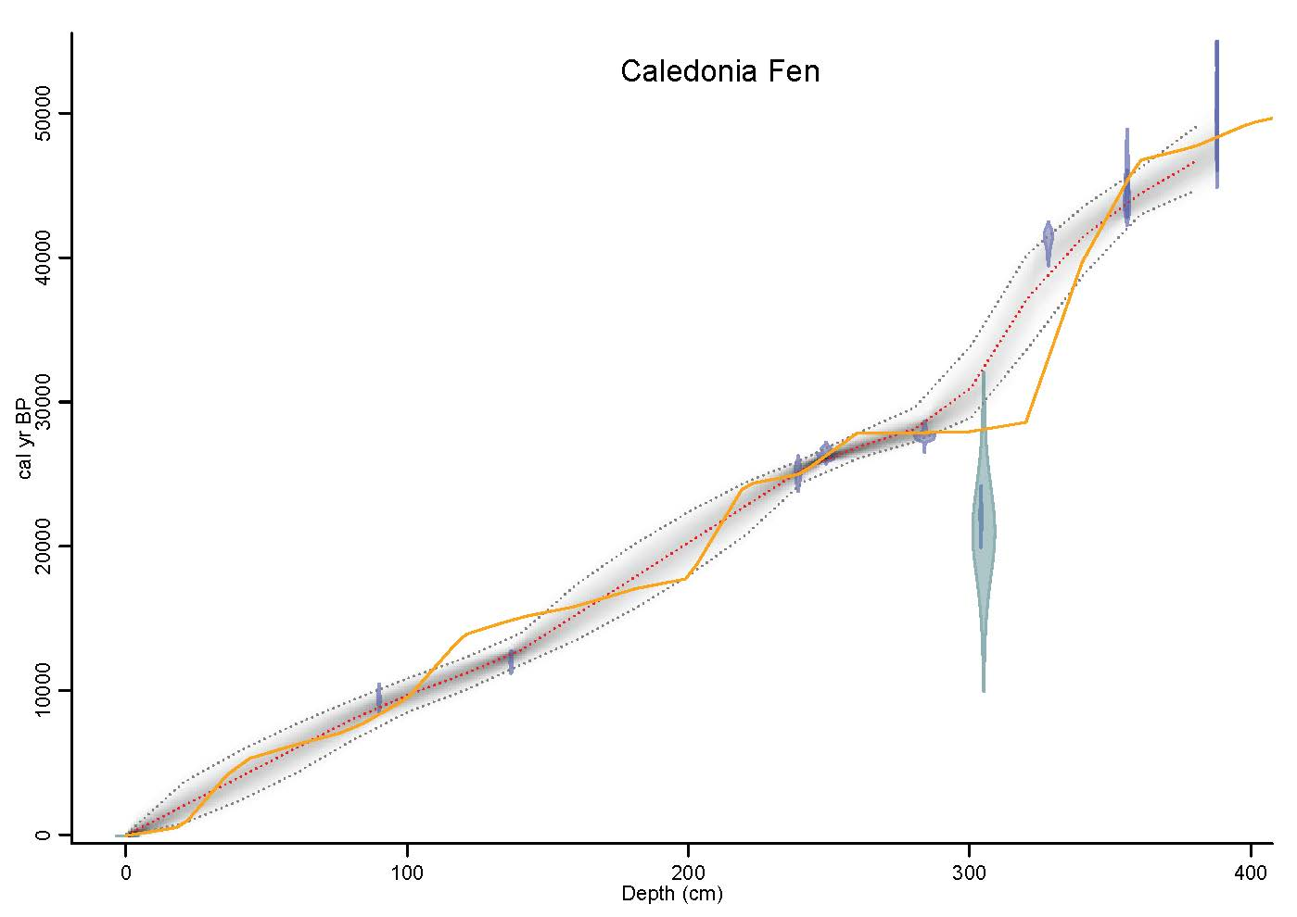
Figure S2w. Bayesian age-depth models developed in Bacon in R for Caledonia Fen. Previously published age-depth relationships (retrieved from original publication) are shown in orange line.
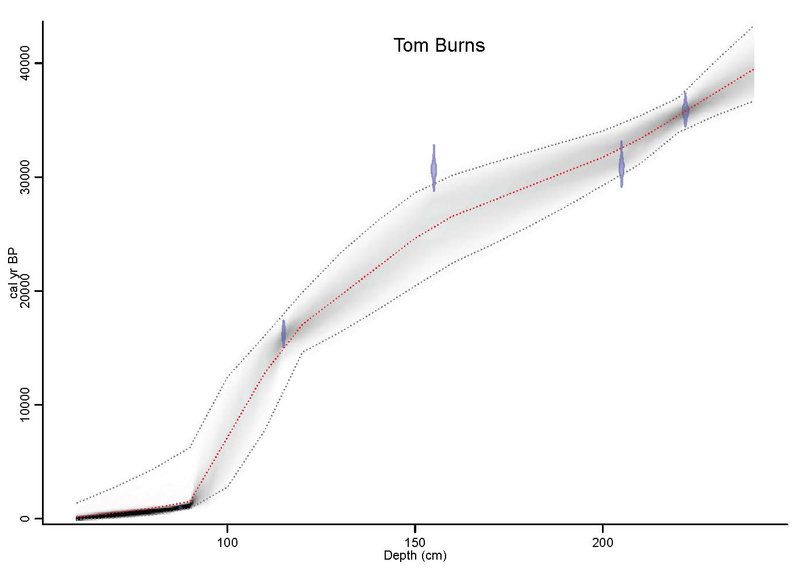
Figure S2x. Bayesian age-depth models developed in Bacon in R for Tom Burns. No previous age model has been published for Tom Burns.
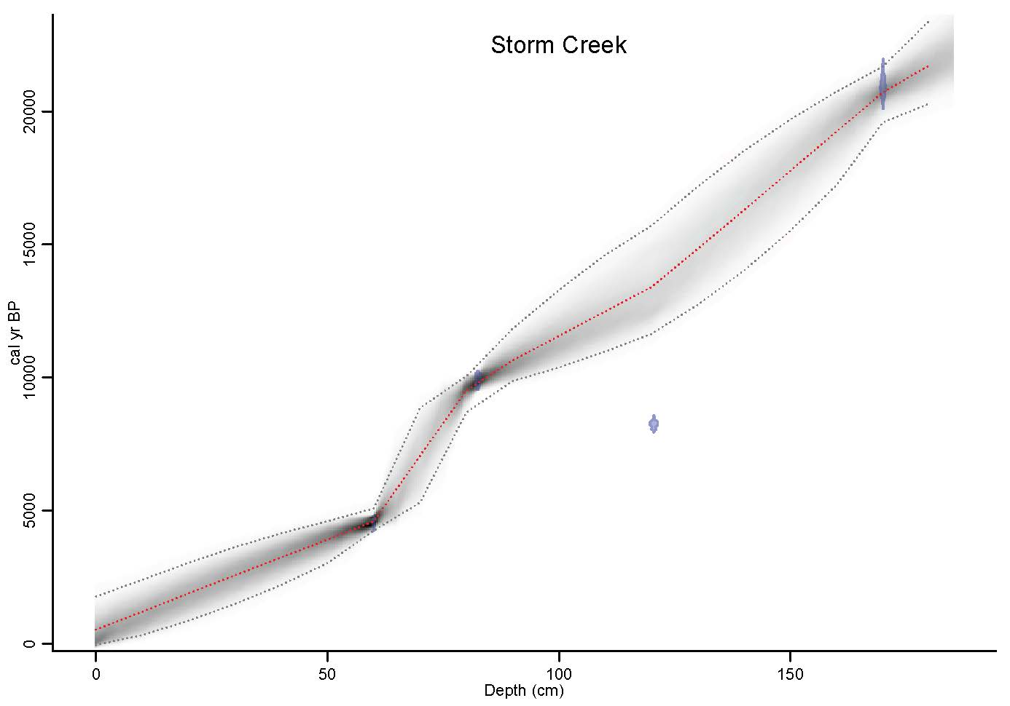
Figure S2y. Bayesian age-depth models developed in Bacon in R for Strom Creek. No previous age model has been published for Storm Creek.
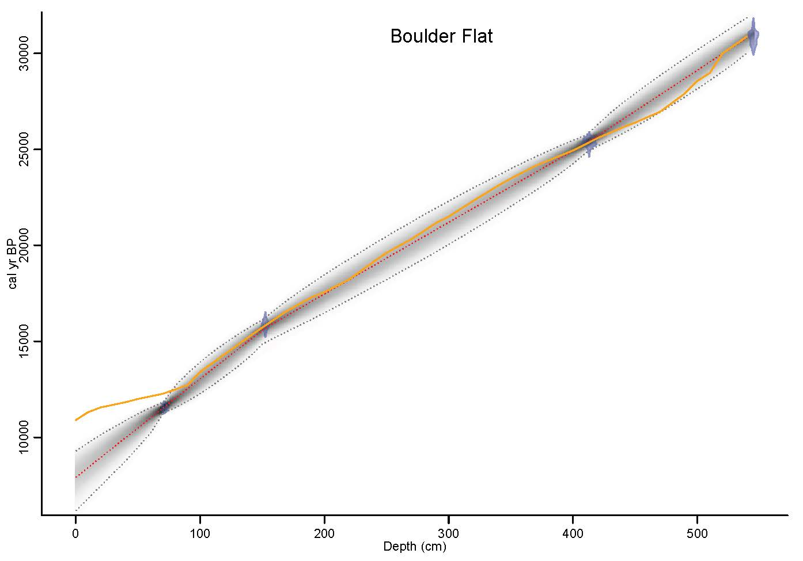
Figure S2z. Bayesian age-depth models developed in Bacon in R for Boulder Flat. Previously published age-depth relationships (retrieved from original publication) are shown in orange line.
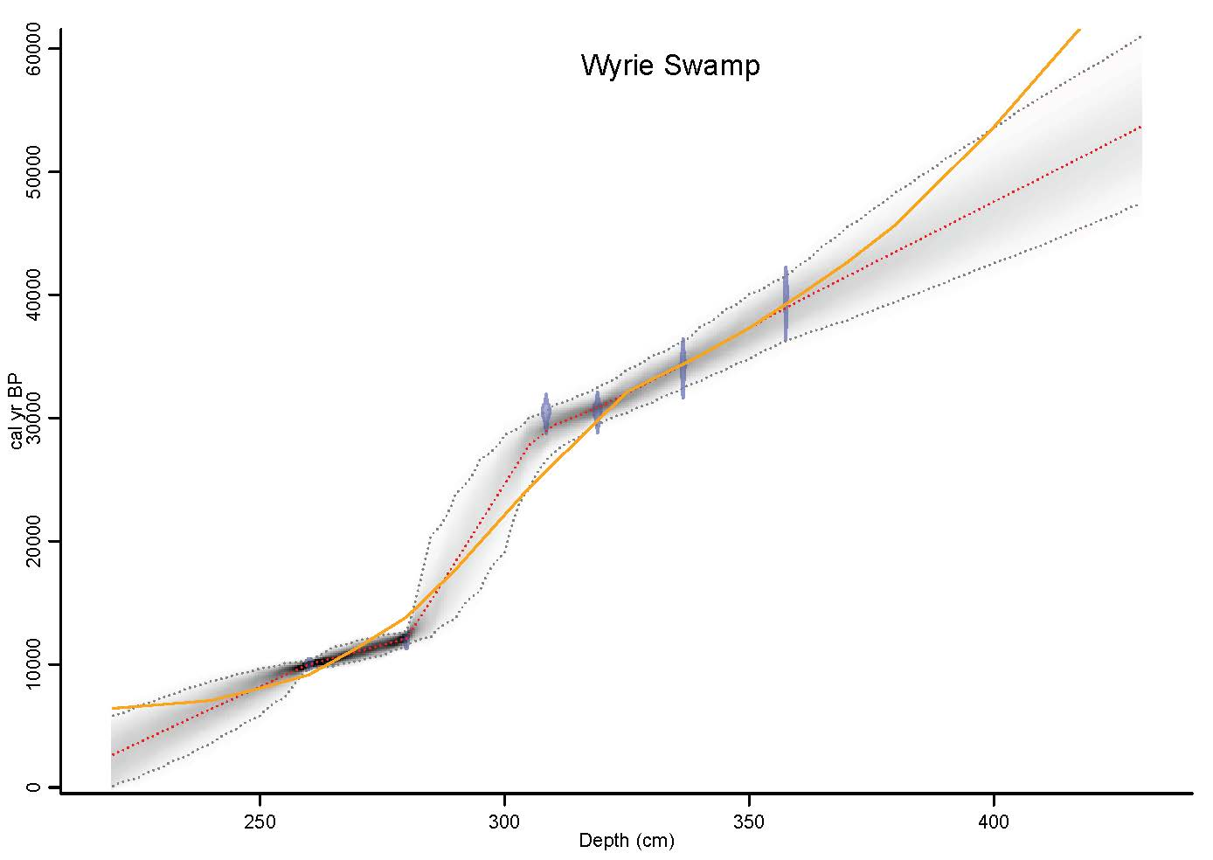
Figure S2aa. Bayesian age-depth models developed in Bacon in R for Wyrie Swamp. Previously published age-depth relationships (retrieved from original publication) are shown in orange line.
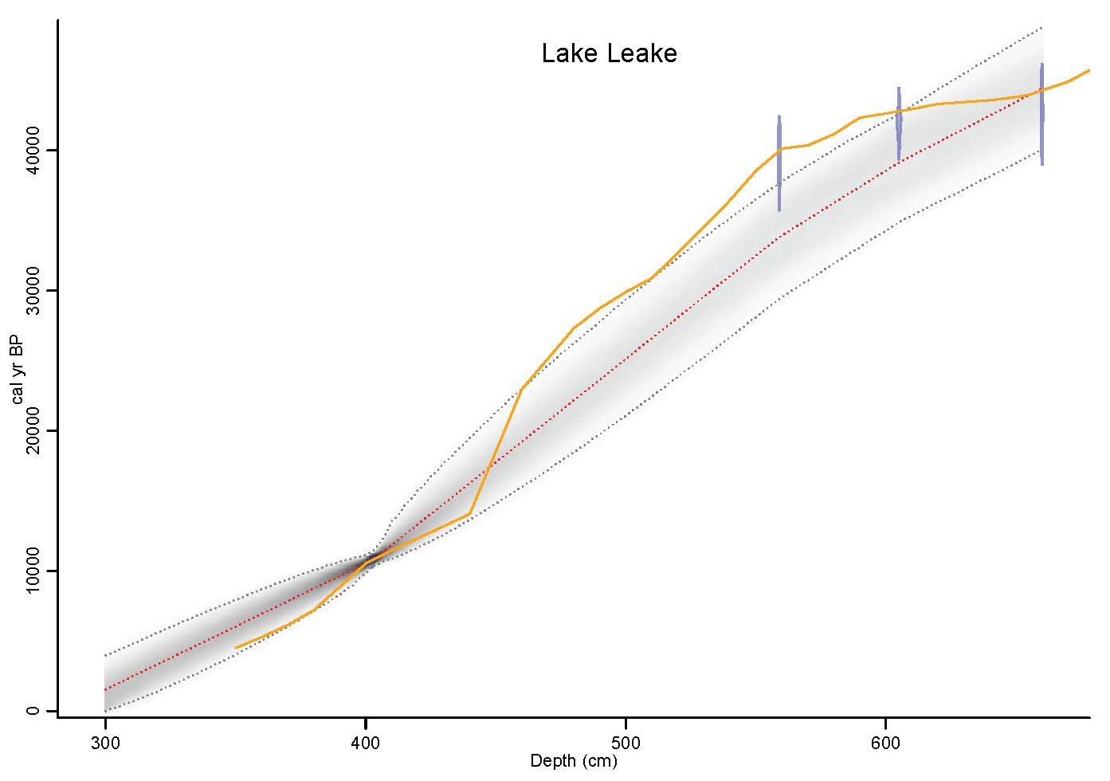
Figure S2ab. Bayesian age-depth models developed in Bacon in R for Lake Leake. Previously published age-depth relationships (retrieved from original publication) are shown in orange line.
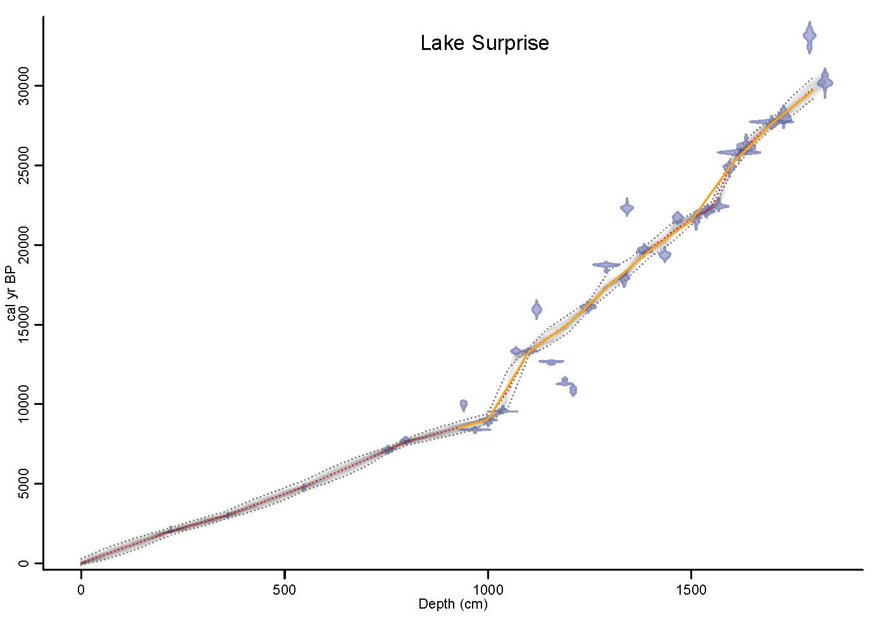
Figure S2ac. Bayesian age-depth models developed in Bacon in R for Lake Surprise. Previously published age-depth relationships (retrieved from original publication) are shown in orange line.
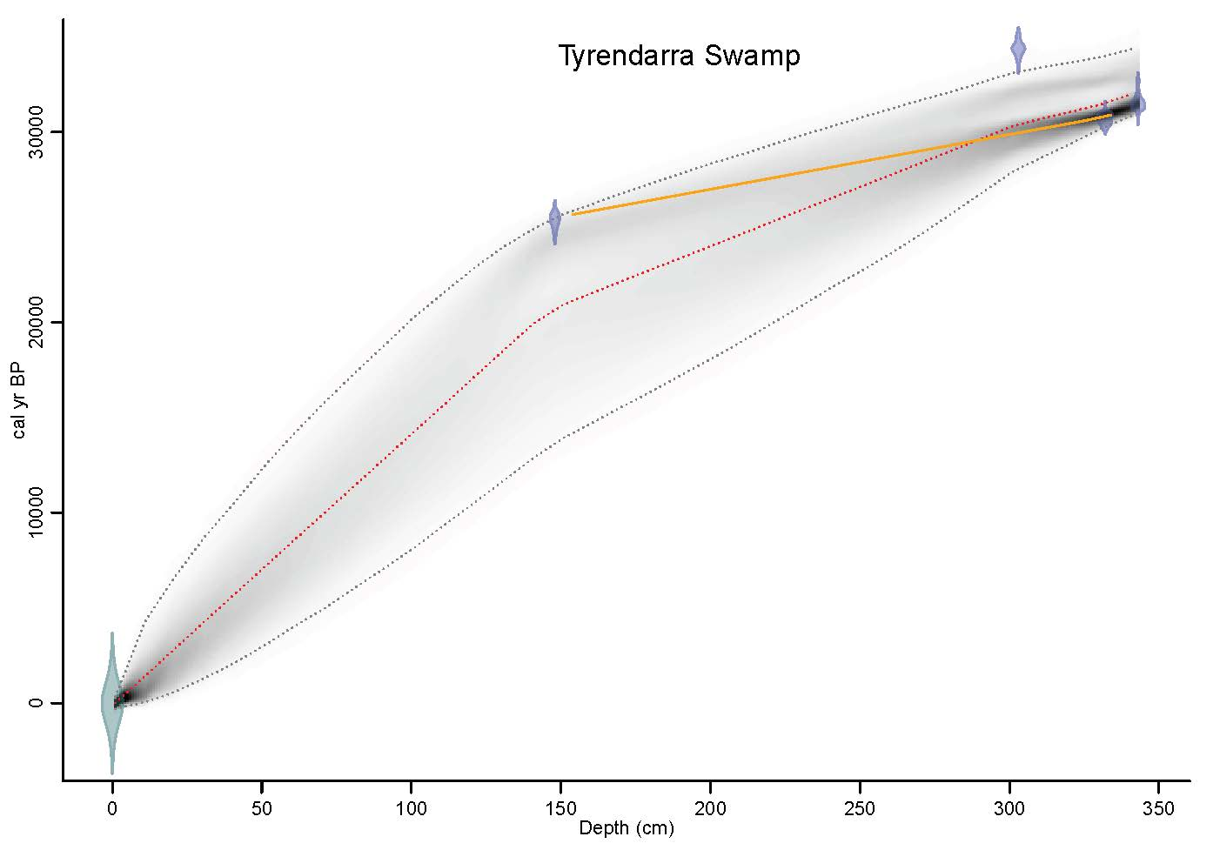
Figure S2ad. Bayesian age-depth models developed in Bacon in R for Tyrendarra Swamp. Previously published age-depth relationships (retrieved from original publication) are shown in orange line.
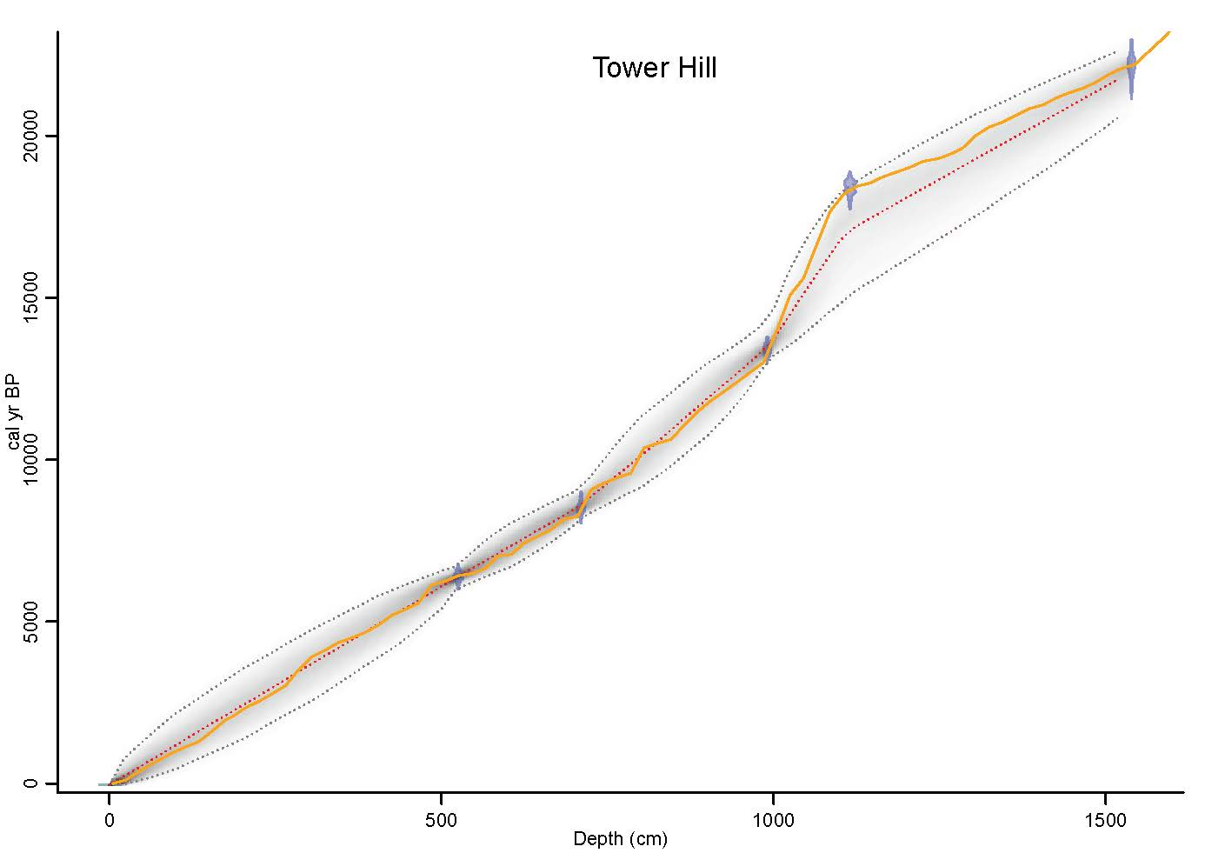
Figure S2ae. Bayesian age-depth models developed in Bacon in R for Tower Hill. Previously published age-depth relationships (retrieved from original publication) are shown in orange line.
Figure S2af. Bayesian age-depth models developed in Bacon in R for Welsby Lagoon. Previously published age-depth relationships (retrieved from original publication) are shown in orange line.
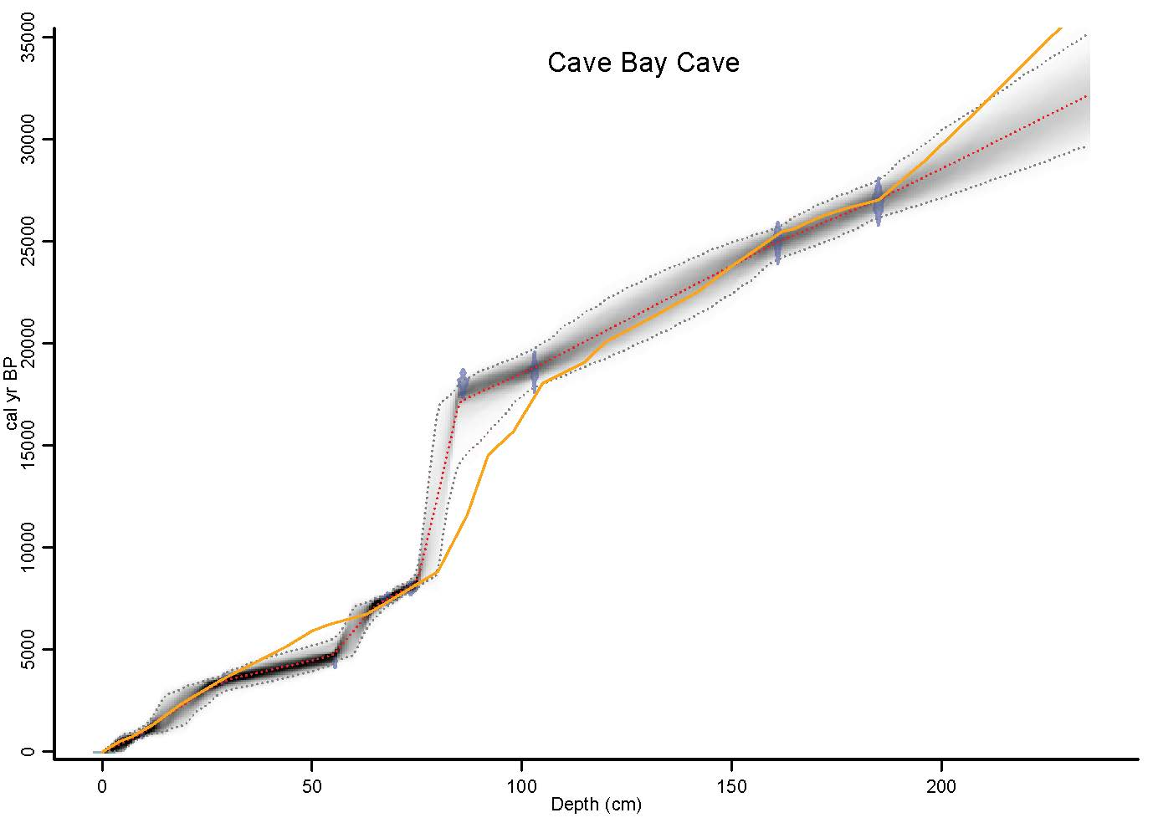
Figure S2ag. Bayesian age-depth models developed in Bacon in R for Cave Bay Cave. Previously published age-depth relationships (retrieved from original publication) are shown in orange line.

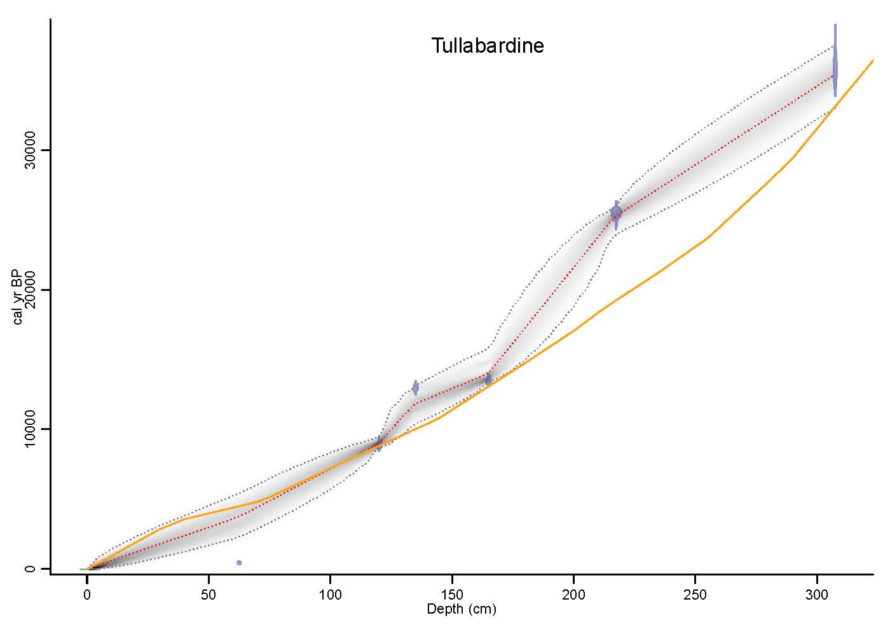
Figure S2ah. Bayesian age-depth models developed in Bacon in R for Tullabardine Dam. Previously published age-depth relationships (retrieved from original publication) are shown in orange line.
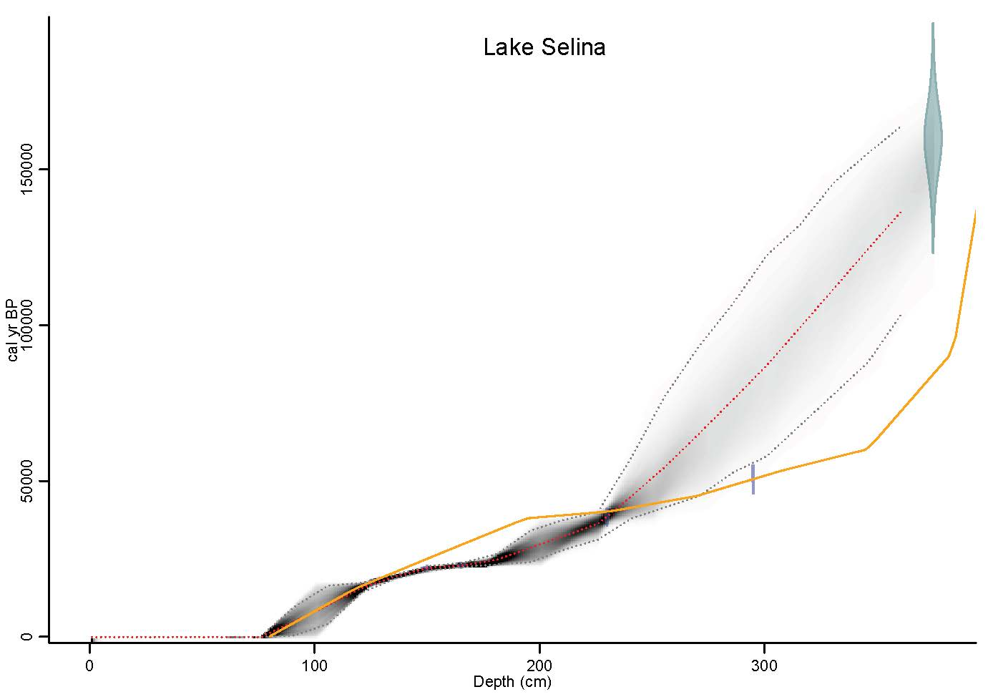
Figure S2ai. Bayesian age-depth models developed in Bacon in R for Lake Selina. Previously published age-depth relationships (retrieved from original publication) are shown in orange line.
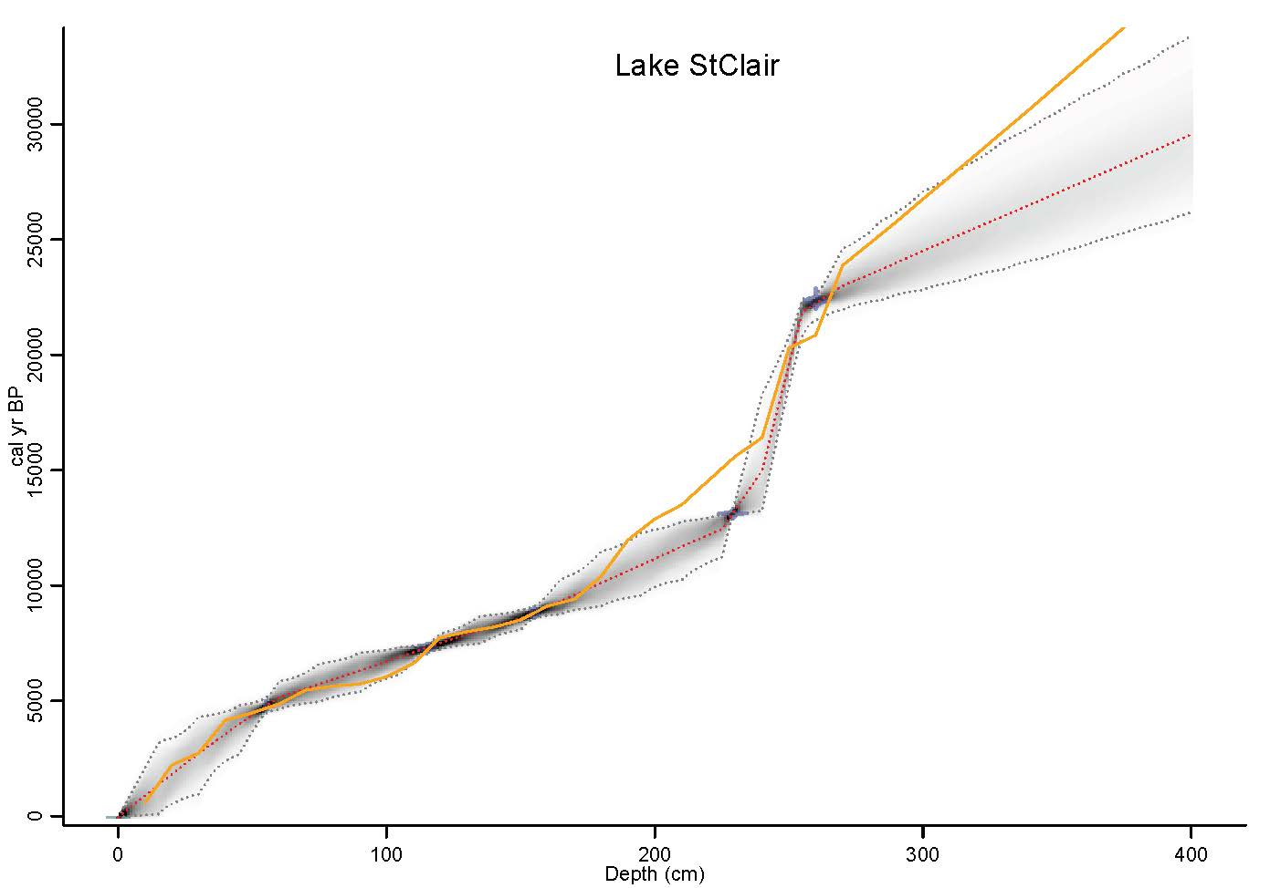
Figure S2aj. Bayesian age-depth models developed in Bacon in R for Lake St Clair. Previously published age-depth relationships (retrieved from original publication) are shown in orange line.

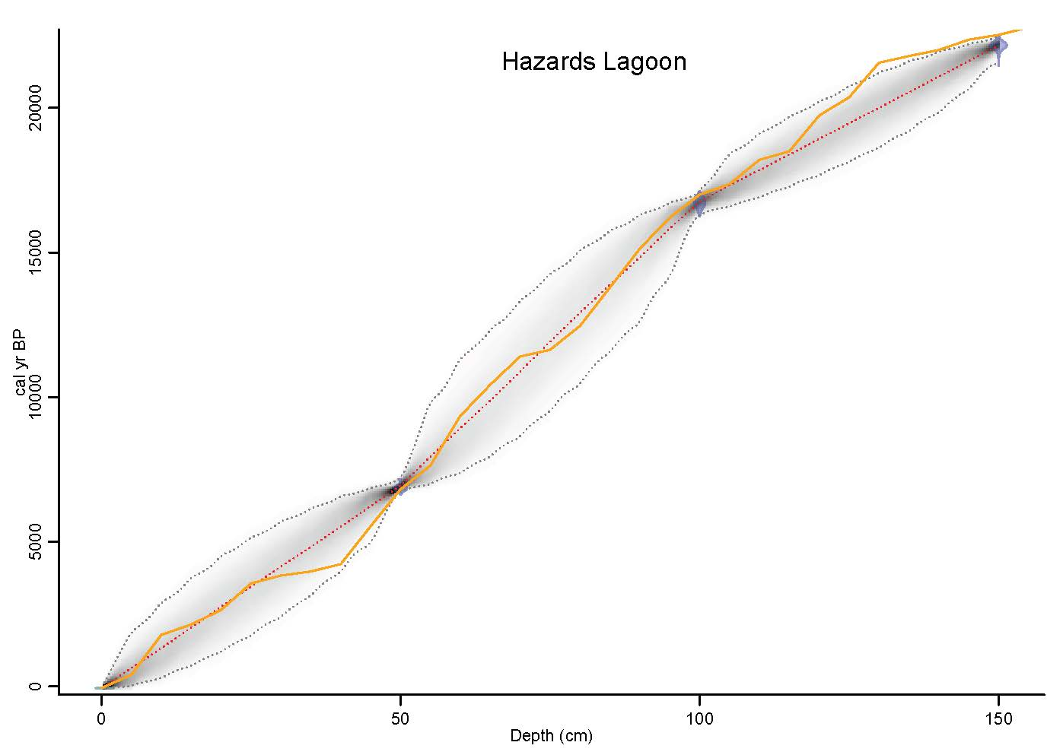
Figure S2ak. Bayesian age-depth models developed in Bacon in R for Hazards Lagoon. Previously published age-depth relationships (retrieved from original publication) are shown in orange line.

Figure S3a. Lake Carpentaria MD972128 pollen Principal Curve (PrC) and probability density functions. Low PrC values are driven by increased values of Eucalyptus and Casuarinaceae. High PrC values are driven by increased values of Poaceae (Chivas et al., 2001). (Note inverse PrC y-axis).
Figure S3b. Lake Carpentaria MD972133 pollen Principal Curve (PrC) and probability density functions. Low PrC values are driven by increased values of Calitris and Poaceae. High PrC values are driven by increased values of Casuarinaceae (Chivas et al., 2001). (Note inverse PrC y-axis).

Figure S3c. Lake Carpentaria pollen GC2 Principal Curve (PrC) and probability density functions. Low PrC values are driven by increased values of Myrtaceae and Calitris. High PrC values are driven by increased values of Poaceae (Torgersen et al., 1988). (Note inverse PrC y-axis).
Figure S3d. ODP820 pollen Principal Curve (PrC) and probability density functions. High PrC values are driven by increased values of Agathis, Araucaria and Bruguiera/Ceriops. Low PrC values are driven by increased values of Poaceae and Cunoniaceae (Moss et al., 2017; Moss and Kershaw, 2000).
Figure S3e. Lynch’s Crater pollen Principal Curve (PrC) and probability density functions. High PrC values are driven by increased values of Podocarpus and Eucalyptus. Low PrC values are driven by increased values of Casuarinaceae (Kershaw et al., 2007a).
Figure S3f. Bromfield Swamp pollen Principal Curve (PrC) and probability density functions. Low PrC values are driven by increased values of Podocarpus and Eucalyptus. High PrC values are driven by increased values of Casuarinaceae (Burrows et al., 2016; Kershaw, 1975). (Note inverse PrC y-axis).
Figure S3g. FR0197 Globigerinoides ruber δ¹⁸O and probability density functions. Low δ¹⁸O values indicate higher sea level and warmer sea surface temperatures. High δ¹⁸O values indicate lower seal level and cooler sea surface temperatures (Bostock et al., 2006). (Note inverse δ¹⁸O y-axis).
Figure S3h. Moon Point pollen Principal Curve (PrC) and probability density functions. Low PrC values are driven by higher values of rainforest and arboreal taxa. High PrC values are driven by increased values of Casuarinaceae and Poaceae (Moss et al., 2016). (Note inverse PrC y-axis).

Figure S3i. Lake Coomboo pollen Principal Curve and probability density function. Low PrC values are driven by increased values of Araucariaceae and Calitris. High PrC values are driven by increased values of Casuarinaceae, Poaceae and Eucalyptus taxa (Longmore, 1997). (Note inverse PrC y-axis).
Figure S3j. Lake McKenzie Branched glycerol dialkyl glycerol tetraether (GDGT) and probability density function. Low values indicate lower MAAT estimates. High values indicate higher MAAT estimates (Woltering et al., 2014).

Figure S3k. Welsby Lagoon pollen Principal Curve (PrC) and probability density function. High PrC values are driven by increased values of Eucalyptus and Asteraceae. Low PrC values are driven by increased values of Casuarinaceae and Poaceae (Barr et al., 2017). (Note inverse PrC y-axis)
Figure S3l. Tortoise Lagoon pollen Principal Curve (PrC) and probability density function. Low PrC values are driven by increased values of Melaleuca and Eucalyptus. High PrC values are driven by increased values of Casuarinaceae and Poaceae (Moss et al., 2013; Petherick et al., 2017). (Note inverse PrC y-axis)

Figure S3m. Native Companion Lagoon pollen Principal Curve (PrC) and probability density function. Low PrC values are driven by increased values of Araucariaceae and Eucalyptus. High PrC values are driven by increased values of Casuarinaceae and Poaceae (Petherick et al., 2008). (Note inverse PrC y-axis)
Figure S3n. Cuddie Springs pollen Principal Curve (PrC) and probability density function. High PrC values are driven by increased values of Casuarinaceae and Asteraceae. Low PrC values are driven by increased values of Chenopodiaceae and Acacia (Field et al., 2002).

Figure S3o. Ulungra Springs pollen Principal Curve (PrC) and probability density function. Low PrC values are driven by increased values of Chenopodiaceae and Asteraceae. High PrC values are driven by increased values of Eucalyptus, Lomandra and Plantago (Dodson and Wright, 1989).
Figure S3p. Penrith Lakes pollen Principal Curve (PrC) and probability density function. Low PrC values are driven by increased values of Eucalyptus. High PrC values are driven by increased values of Asteraceae (Chalson and Martin, 2008). (Note inverse PrC y-axis)

Figure S3q. Core 112/VC/046 pollen Principal Curve (PrC) and probability density function. High PrC values are driven by increased values of Asteraceae, Casuarinaceae and Chenopodiaceae. Low PrC values are driven by increased values of Eucalyptus and Myrtaceae (Ferland and Roy, 1997). (Note inverse PrC y-axis).
Figure S3r. Mammoth Cave pollen Principal Curve (PrC) and probability density function. High PrC values are driven by increased values of Eucalyptus, Myrtaceae and Banksia. Low PrC values are driven by increased values of Asteraceae, Casuarinaceae and Poaceae (Sniderman et al., 2019).

Figure S3s. Lake Baraba pollen Principal Curve (PrC). No Change points were identified. High PrC values are driven by increased values of Casuarinaceae. Low PrC values are driven by increased values of Myrtaceae (Black et al., 2006). (Note inverse PrC y-axis).
Figure S3t. Pine Camp Playa pollen Principal Curve (PrC) and probability density function (PDF). High PrC values are driven by increased values of Chenopodiaceae, Sapindaceae and Eucalyptus. Low PrC values are driven by increased values of Casuarinaceae and Asteraceae (Cupper, 2006, 2005).
Figure S3u. Lake George pollen Principal Curve (PrC) and probability density function (PDF). High PrC values are driven by increased values of Liliaceae and Huperzia selago. Low PrC values are driven by increased values of Asteraceae, Poaceae and Eucalyptus (Singh et al., 1981; Singh and Geissler, 1985).
Figure S3v. Murray Canyons core MD03-2607 weighted average stable carbon isotopic composition of C₂₇–C₃₃ n-alkanes (δ¹³C). High (less negative) δ¹³C values indicate a greater contribution of C₄ plants to the n-alkane pool, interpreted as an increase in temperature and summer rainfall. Low (more negative) δ¹³C values indicate a greater contribution of C₃ plants, interpreted as a decrease in temperature and summer rainfall (Lopes dos Santos et al., 2013).
Figure S3w. Caledonia Fen pollen Principal Curve (PrC) and probability density function (PDF). High PrC values are driven by increased values of Asteraceae and Poaceae. Low PrC values are driven by increased values of Casuarinaceae (Kershaw et al., 2007b).
Figure S3x. Tom Burns pollen Principal Curve (PrC) and probability density function (PDF). High PrC values are driven by increased values of Asteraceae, Chenopodiaceae and Eucalyptus. Low PrC values are driven by increased values of Astelia, Epacridaceae and Ranunculaceae (McKenzie, 2002).
Figure S3y. Storm Creek pollen Principal Curve (PrC) and probability density function (PDF). High PrC values are driven by increased values of Asteraceae and Poaceae. Low PrC values are driven by increased values of Eucalyptus and Astelia (McKenzie, 2002). (Note inverse PrC y-axis)
Figure S3z. Boulder Flat pollen Principal Curve (PrC) and probability density function (PDF). High PrC values are driven by increased values of Asteraceae and Chenopodiaceae. Low PrC values are driven by increased values of Dicksonia and Eucalyptus. (Kenyon, 1989) (Note inverse PrC y-axis).

Figure S3aa. Wyrie Swamp pollen Principal Curve (PrC) and probability density function (PDF). High PrC values are driven by increased values of Asteraceae. Low PrC values are driven by increased values of Casuarinaceae (Dodson, 1977). (Note inverse PrC y-axis).
Figure S3ab. Lake Leake pollen Principal Curve (PrC) and probability density function (PDF). High PrC values are driven by increased values of Casuarinaceae and Chenopodiaceae. Low PrC values are driven by increased values of Asteraceae and Poaceae. (Dodson, 1975)(Note inverse PrC y-axis).

Figure Sac. Lake Surprise δ¹³C of bulk organic material. Less negative δ¹³C values interpreted to reflect increased C₄ plant types and plant moisture stress. More negative δ¹³C values interpreted to reflect increased C₃ plant types and plant moisture stress (Falster et al., 2018). (Note the inverse y-axis).
Figure S3ad. Tyrendarra Swamp pollen Principal Curve (PrC) and probability density function (PDF). High PrC values are driven by increased values of Asteraceae and Acacia. Low PrC values are driven by increased values of Callitris and Poaceae (Builth et al., 2008). (Note inverse PrC y-axis).
Figure S3ae. Tower Hill pollen Principal Curve (PrC) and probability density function (PDF). High PrC values are driven by increased values of Asteraceae and Poaceae. Low PrC values are driven by increased values of Casuarinaceae and Chenopodiaceae. (D’Costa et al., 1989)
Figure S3af. Lake Wangoom pollen Principal Curve (PrC) and probability density function (PDF). High PrC values are driven by increased values of Eucalyptus and Plantago. Low PrC values are driven by increased values of Asteraceae and Poaceae. (Note inverse PrC y-axis) (Harle et al., 2002).

Figure S3ag. Lake Wangoom pollen Principal Curve (PrC) and probability density function (PDF). High PrC values are driven by increased values of Asteraceae and Poaceae. Low PrC values are driven by increased values of Pteridophytes and Microsorum (Note inverse PrC y-axis) (Hope, 1978).
Figure S3ah. Tullabardine Dam pollen Principal Curve (PrC) and probability density function (PDF). High PrC values are driven by increased values of Asteraceae, Poaceae and Eucalyptus. Low PrC values are driven by increased values of Nothofagus cunninghamii and Lagarostrobos franklinii (Colhoun and van de Geer, 1986). (Note inverse PrC y-axis).

Figure S3ai. Lake Selina pollen Principal Curve (PrC) and probability density function (PDF). High PrC values are driven by increased values of Poaceae. Low PrC values are driven by increased values of Leptospermum and Nothofagus cunninghamii (Colhoun, 2000). (Note inverse PrC y-axis).
Figure S3aj. Lake St Clair pollen Principal Curve (PrC) and probability density function (PDF). High PrC values are driven by increased values of Asteraceae and Poaceae. Low PrC values are driven by increased values of Eucalyptus and Nothofagus cunninghamii (Hopf et al., 2000). (Note inverse PrC y-axis).

Figure S3ak. Hazards Lagoon pollen Principal Curve (PrC) and probability density function (PDF). High PrC values are driven by increased values of Eucalyptus and Casuarinaceae. Low PrC values are driven by increased values of Poaceae, Asteraceae and Epacridaceae (Mackenzie and Moss, 2017).

