Supporting Information for
Causes and climatic influence of centennial scale denitrification variability in the southeastern Arabian Sea since the last glacial period

Sidhesh Nagojiª and Manish Tiwari^{a*}

ªNational Centre for Polar and Ocean Research, Ministry of Earth Sciences, Vasco-da-Gama, Goa 403804, India.

*Corresponding author e-mail address: manish@ncpor.res.in (M. Tiwari)

This supplementary file contains Figure 1a, 1b, 1c, and 1d and the text evaluating the effect of diagenetic alteration and terrestrial organic matter input on nitrogen isotopic composition with the help of supporting Fig. 2.

Figure 1a. Dissolved oxygen (DO) transect for the upper 2000 m (data from World Ocean Atlas 09).

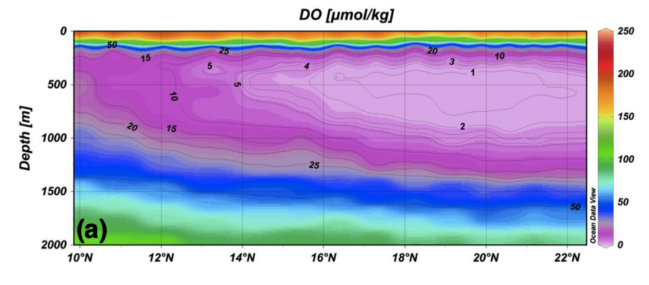

Figure 1b. Nitrate transect for the upper 2000 m (data from World Ocean Atlas 09).
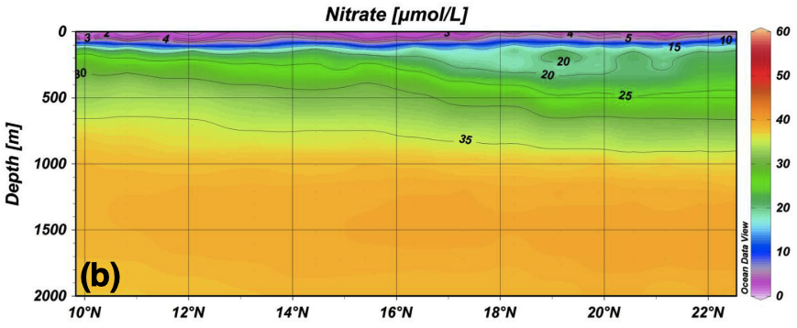

Figure 1c. Nitrate deficit (N*) transect for the upper 300 m (data from World Ocean Atlas 09); arrows show the flow direction.
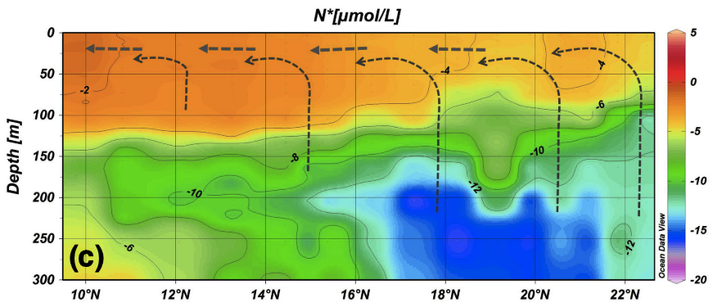

Figure 1d. Nitrate deficit (N*) transect for the upper 2000 m (data from World Ocean Atlas 09); arrows show the flow direction.
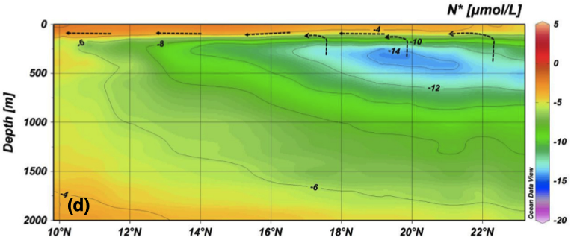

Figure 1e. Yellow dashed line indicates the transect for the data shown above (Fig. 1a to 1d); colour contours represent dissolved oxygen concentration at 300 m depth in μmol/kg.

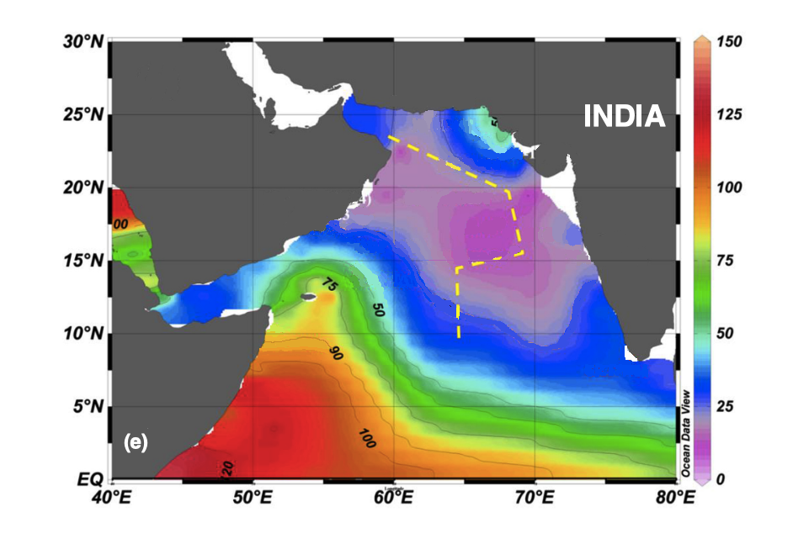

(1) No Effect of Terrestrial Organic Input on Nitrogen Isotopic Composition
As the organic matter in the present study contains a small amount terrestrial organic matter, the possibility of it affecting the δ¹⁵N values was further examined using the relationship between δ¹³C_{org} and δ¹⁵N. It has been shown than terrestrial organic material is characterized by relatively low δ¹⁵N values (2-4 ‰) (Sweeney and Kaplan, 1980, Sigman et al., 2001) and therefore different admixtures of material could influence the δ¹⁵N values. A positive correlation is expected between δ¹³C_{org} and δ¹⁵N (Peters et al., 1978) if the terrestrial organic matter had any influence on δ¹⁵N values thereby producing a mixing line in the δ¹³C_{org}–δ¹⁵N plot, with lower δ¹³C_{org} corresponding to lower δ¹⁵N values (Sweeney and Kaplan, 1980). However, in the present study, scatter found in the δ¹⁵N versus δ¹³C_{org} plot (r = -0.17, n= 256; Fig. 2a) rules out the possibility that mixing of terrestrial and marine organic matter had any influence on δ¹⁵N values in the SEAS.

(2) No Effect of Diagenetic Alteration on Nitrogen Isotopic Composition
The early diagenetic effects on the δ¹⁵N values of the present study were examined through relationships among δ¹⁵N and TOC, TN and C/N ratios. δ¹⁵N values will increase if early diagenetic degradation affects it (Agnihotri et al., 2003). It would result in an anti-covariance trend with TOC and TN contents and covariance with atomic C/N ratios. However, no such trends were observed in the case of the present study. We do not find any relationship between δ¹⁵N and TOC (r = 0.21, n = 256, Fig. 2b), TN (r= 0.22, n= 256, Fig. 2c), and atomic C/N ratio (r = -0.14, n =256, Fig. 2d) suggesting that diagenesis affecting δ¹⁵N is not a significant factor. Further, the rate of diagenetic alteration of the δ¹⁵N at the near-surface is ascribed to the particle downward sinking rate and its preservation in the marine environment (Altabet, 1988). Interestingly, δ¹⁵N of sinking particles reported by Gaye-Haake et al. (2005), using five sedimentation traps deployed from 500 m throughout a depth of 3200 m from the Arabian Sea (ranged from 5.1 to 8.5‰), overlaps largely with δ¹⁵N_{NO3-} values at 100–150 m (ranged from 7 to 9 ‰) reported by several workers at different stations in the Arabian Sea (Altabet et al., 1999; Naqvi et al., 2006). It indicates that not much alteration had occurred in δ¹⁵N of sinking particles during sinking in the water column in the Arabian Sea, which was also suggested by Altabet (2006).

Figure 2. Panel (a) shows cross plot of δ¹⁵N with δ¹³C_{org}. Panel (b), (c), & (d) shows the cross plot of δ¹⁵N with TOC, TN, and atomic C/N respectively. The r (correlation coefficient) and n (number of data points) values are given in the text. Different colours show data points belonging to four different time periods viz. the Holocene, deglaciation, the last glacial period, and those near the MIS2/3 boundary

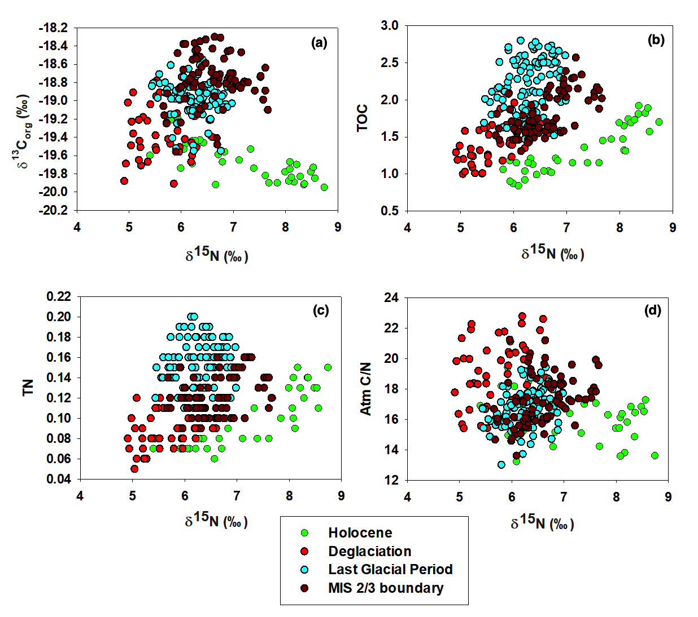

REFRENCES:
Agnihotri, R., Bhattacharya, S. K., Sarin, M. M., and Somayajulu, B. L. K., 2003. Changes in surface productivity and subsurface denitrification during the Holocene: a multiproxy study from the eastern Arabian Sea. The Holocene 13, 701-713.

Altabet, M., 1988. Variations in nitrogen isotopic composition between sinking and suspended particles: Implications for nitrogen cycling and particle transformation in the open ocean. Deep-Sea Research 35, 535–554.

Altabet, M. A., Murray, D. W., and Prell, W. L., 1999. Climatically linked oscillations in Arabian Sea denitrification over the past 1 m.y.. Implications for the marine N cycle. Paleoceanography 14, 732-743.

Altabet, M., 2006. Isotopic tracers of the marine nitrogen cycle: Present and past. in: Marine organic matter: biomarkers, isotopes and DNA: edited by: Volkman, J. K., Springer-Verlag Berlin Heidel- berg, 251–293.

Gaye-Haake, B., Lahajnar, N., Emeis, K.-C., Unger, D., Rixen, T., Suthhof, A., Ramaswamy, V., Schulz, H., Paropkari, A. L., Guptha, M. V. S., and Ittekkot, V., 2005. Stable nitrogen isotopic ratios of sinking particles and sediments from the northern Indian Ocean. Marine Chemistry 96, 243-255.

Naqvi, S., Naik, H., Pratihary, A., D’Souza, W., Narvekar, P., Jayakumar, D., Devol, A., Yoshinari, T., and Saino, T., 2006. Coastal versus open-ocean denitrification in the Arabian Sea. Biogeoscience 3, 621–633.

Peters, K. E., Sweeney, R. E., and Kaplan, I. R., 1978. Correlation of carbon and nitrogen stable isotope ratios in sedimentary organic matter. Limnology Oceanography 23, 598-604.

Sweeney, R. E., and Kaplan, I. R., 1980. Natural abundance of ¹⁵N as source indicator of near- shore marine sedimentary and dissolved nitrogen. Marine Chemistry 9, 81-94.

Sigman, D. M., Casciotti, K. L., Andreani, M., Barford, C., Galanter, M. and Bohlke, J. K., 2001. A bacterial method for the nitrogen isotopic analysis of nitrate in seawater and freshwater. Analytical Chemistry 73, 4145-4153.

