Supplementary Information:

Patterns of aeolian deposition in subtropical Australia through the last glacial and deglacial periods

OSL dating equivalent dose (D_{e}) determination

Preparation

Purified quartz fractions were extracted from the wetland (BL18) and dune (NSI18) cores under “safe light conditions” (subdued red lighting), to prevent any bleaching of the natural burial dose signal. The organic-rich BL18 sample was treated with 10% NaOH to disperse particles before being wet sieved to isolate the material with Ø 180-212 μm. Meanwhile, the coarse NSI18 samples were mechanically sieved to obtain mineral fractions of Ø 212-250 μm. The mineral fractions were then treated with 30% HCl and 30% H₂O₂, including a rinse cycle between each treatment, to dissolve carbonates and organic material, respectively (Aitken, 1998). Quartz was isolated from other minerals through heavy liquid separation, using LST prepared at densities 2.72 g/cm³ and 2.62 g/cm³. The alpha-irradiated outer rind of the isolated quartz grains was then etched using 48% HF for 40 mins, followed up by a treatment with 30% HCl to dissolve any fluoride precipitates.

Instrumentation

A Risø TL-DA-20 reader equipped with blue LEDs, an array of infrared LEDs, and a 10 mW Nd:YVO4 single-grain laser attachment emitting at 532 nm was used to measure the OSL signals. Ultraviolet OSL signals were detected using an EMI 9235QA photomultiplier tube, fitted with 7.5 mm thick Hoya U-340 filters. Samples were irradiated with a ⁹⁰Sr/⁹⁰Y β source that had been calibrated for individual grain-hole positions to account for spatial variations in beta dose rate across each disk.

D_{e} measurement conditions

Individual D_{e} values were determined using the single-aliquot regenerative-dose (SAR) procedure shown in Supplementary Table S2. The suitability of the chosen SAR measurement conditions was evaluated using a dose-recovery test on samples NSI18-4. For this purpose, the natural signals of four multigrain disks (each containing ~1,000 quartz grains) were bleached using two cycles of 1,000 s blue LED exposure, separated by a 10,000 s pause. The disks were then administered a dose of 65 Gy before a multi-grain version of the SAR procedure was undertaken (replacing single-grain laser stimulations in steps 4 and 7 of Supplementary Table S2 with blue LED stimulations) using different test dose preheat (PH2) conditions (Supplementary Figure S4). A preheat of 260°C for 10 s prior to measurement of the natural (L_{n}) or regenerative dose (L_{x}), and a preheat of 220°C for 10 s prior to the test-dose (T_{n} or T_{x}) provided accurate dose recovery ratios (Supplementary Figure S4). These conditions were then validated by subsequent single-grain dose recovery measurements repeated on samples NSI18-4, NSI18-7 and BL18-A; yielding measured to given dose recovery ratios of 0.98±0.02, 1.02±0.02 and 0.99±0.01, respectively (Supplementary Figure S5). These single-grain dose recoveries produced low overdispersion values ranging from 5±2% to 8±2%.
OSL signals from individual grains were assessed against a series of quality assurance criteria (see Arnold et al., 2016; Demuro et al., 2019) prior to inclusion in the final age calculation. Grains were considered inappropriate and excluded from D_{e} analysis if: (i) their net T_{n} signals were <3σ above the late-light background; (ii) recycling ratios (sensitivity-corrected luminescence responses (L_{x}/T_{x}) for two identical regenerative doses) were not consistent with unity at 2σ. For the single-grain OSL measurements, the recycling ratio test was performed using both a low-dose and high-dose regenerative dose cycle; (iii) the OSL-IR depletion ratio (Duller, 2003) was less than unity at 2σ; (iv) the recuperation ratio, calculated as the ratio of the sensitivity-corrected 0 Gy dose point (L₀/T_{x}) to the sensitivity-corrected natural (L_{n}/T_{n}), was >5%; (v) the L_{n}/T_{n} value intercepted the saturated part of the dose-response curve (L_{n}/T_{n} values were equal to I_{max} saturation limit of the dose-response curve at 2σ); (vi) the dose-response curve displayed anomalous properties (i.e., zero or negative response with increasing dose) or very scattered L_{x}/T_{x} values that could not be successfully fitted with the Monte Carlo procedure; (vii) the sensitivity-corrected natural signal (L_{n}/T_{n}) did not intercept the sensitivity-corrected dose-response curve; (viii) the net D_{e} uncertainty was >50%. The rejection statistics from the evaluation of single-grain OSL responses are presented in Supplementary Table S3, with an example of an accepted grain’s dose response and OSL characteristics presented in Supplementary Figure S6.
D_{e} values for individual grains were derived from the integration of the first 0.2 s of emission counts, minus a background count from the last 0.25 s of stimulation. Dose response curves were fitted using a single saturating exponential function, with curve fitting uncertainty determined from 1,000 iteration of the Monte Carlo method (Duller, 2007). Single-grain D_{e} uncertainties additionally incorporate an empirically determined instrument reproducibility uncertainty of 2.5% for each OSL measurement (calculated for the Risø reader used in this study, following the approach outlined in Jacobs et al. (2006)).

DOSE RATE RESULTS
Supplementary Tables S1, S7 and S8 summarise the environmental dose rate results for the OSL samples. The high-resolution gamma spectrometry results confirm that the dune sediments dated in this study are in present-day secular equilibrium (daughter-parent isotopic ratios for ²³⁸U and ²³²Th series are consistent with unity at either 1σ or 2σ; Supplementary Table S8). For all six samples, the final beta dose rates derived using high-resolution gamma spectrometry are in agreement at either 1 or 2σ with those obtained using beta counting (Supplementary Table S1), supporting the suitability of the dose rate evaluation procedures. Supplementary Figure S11 confirms that the dune OSL ages are relatively insensitive to our choice of long-term water content. Use of the present-day (as measured) water content, our preferred long-term estimate (7±3% dry weight), and the measured saturated water content of these samples all produce final ages that are in agreement at 1σ (Supplementary Figure S11).

Radiocarbon (¹⁴C) dating
The samples were dried, milled into powder and prepared using standard ABA treatments (Brock et al., 2010). This included repeating the steps (for up to 8 cycles) of reacting with 5% HCl to remove contaminant carbonates, a hot ultrasonic wash and dissolution of fulvic acids using up to 2M of NaOH. After pre-treatment, the samples were dried, combusted and loaded into a Pyrex tube with suitable amounts of copper granules and silver. The tubes were then placed under vacuumed, sealed and placed in a furnace overnight at a temperature of 580°C. The released CO₂, following combustion of the samples, was transferred through vacuum lines into an additional Pyrex tube prior to graphitization. Measurements were then undertaken at the respective AMS facilities.

Lake sequence age modelling

Method

The preliminary version of the BL18 age-depth model was produced, incorporating the replicate OZX94a and OZX94b ¹⁴C ages. However, the modelled likelihood estimates failed to converge, with these two samples identified as statistical outliers (79%) owing to their incompatibility with the surrounding OSL (BL18-A) and 14C ages (OZX793 and OXZ792). As such, these two major outliers were not included in the final Bayesian age-depth model for BL18 (Figure 6).
Differences in bottom lake sediment topography through time, inferred from modern bathymetry (Figure 2), were considered when developing the age models for the two cores and rather than assuming uniform sediment deposition, individual age models were produced for the separate cores. The sequences were modelled using a Poisson depositional framework (P_Sequence) with the base rigidity perimeter (k₀) set to a single event per 1 cm of sedimentation, and allowed to vary between 0.01 to 100 events per cm to account for randomly variable deposition rates (Bronk Ramsey, 2008, 2009; Bronk Ramsey and Lee, 2013). Posterior dated events have been interpolated at 1 cm intervals throughout the sequence. A general outlier function has been included in the model, with an assigned prior outlier probability of 5% used to identify potentially significant statistical outliers (Bronk Ramsey, 2009). Likelihood estimates that yielded posterior outlier probabilities >5% were not excluded from the final model but were proportionally down-weighted in the iterative Monte Carlo runs.
Each depositional unit is represented by a separate P_Sequence with delineating start and end boundaries, nested within a master Sequence according to stratigraphic priors. This type of modelling framework is considered advantageous for lacustrine sequences that exhibit notable sedimentological changes, as it does not presume continuous wetland deposition over time, and is able to accommodate potential hiatuses or erosional discontinuities (or both) between the various sedimentary units (e.g., Fu et al., 2017).

Results
The models selected to best represent the BL18 and BL09 sediment records include three units (represented by separate nested P_Sequences), each of which includes a starting and ending boundary to account for intervening depositional hiatuses or erosion events. In the BL18 model, the starting and ending P_Sequence unit boundaries were specified at depths of 3.57 – 2.29 m (Unit 1), 2.29 – 1.65 m (Unit 2) and 1.65 – 0.00 m (Unit 3) (Figure 2). These modelling priors were chosen based on the sedimentology results, as well as preliminary palynology analyses of the cores; in particular, that of BL18 where the white sand of sub-unit 2.1 overlies highly organic lake muds of sub-unit 1.2 (Figure 3) and fossil pollen assemblages vary abruptly. A first qualitative assessment of the pollen samples at 230 cm shows a sudden shift from an Araucaria- to a Eucalyptus/Allocasuarina-dominated assemblage. The overlying sedimentary section, sub-unit 2.2 (which grades from light brown into dark brown organic rich lake muds) is interpreted as forming during fluctuating lake levels. This is supported by what is inferred to be coatings of clay minerals and iron oxyhydroxides, perhaps ferrihydrite, which, if so, would indicate fluctuation of the water table and provide a means to provenance aeolian material. As noted earlier, the sedimentological units from BL09 can be linked to those defined in the BL18 core, allowing direct comparison of the age model results for the two cores, and consideration of a conceptual theory of sediment deposition across the basin through time (Figure 7).
According to the OxCal Difference query, the Bayesian model does not support a statistically significant depositional hiatus in BL18 (or BL09) between Unit 2 (Unit B) and Unit 1 (Unit A). However, this interpretation may simply reflect the low dating resolution of BL18 Unit 2, which contains only one likelihood, and the absence of direct age constraint for BL09 Unit B, which likely limits the precision of the model at this boundary contact. The youngest units in both cores (BL09 – Unit C; BL18 – Unit 3) began to develop at 8.5±1.8 ka and 8.0±0.2 ka, with accumulation continuing up to the present. While there is no evidence of a statistically significant break in deposition between the upper two units of the BL09 model, the OxCal Difference query does identify a statistically significant hiatus in the BL18 model between Unit 3 and Unit 2 spaning ~2.0 – 12.2 ka (95% confidence interval). This disparity between the two records may be a result of heterogeneous accumulation or erosion of sediment across the basin, or the lower dating resolution of the BL09 core between the Unit 2 boundaries (Figure 6).

µXRF core scanning
An Itrax µXRF was used to measure the elemental abundance down the sediment profile of the overlapping and vertically offset BL18-3 and BL18-4 cores, in addition to the single BL09 core. Prior to measurement, the surface of the sediment to be scanned was prepared to minimise the effect of changes in surface topography. Photon emissions were measured every millimetre following stimulation with a molybdenum (Mo) tube (30 kV, 55 mA and dwell time of 10 s), with 35 elements used during the integration of the total count signal (Al, Si, P, S, Cl, Ar, K, Ca, Ti, V, Cr, Mn, Fe, Ni, Cu, Zn, Br, Rb, Sr, Y, Zr, Sn, Sb, Cs, Ba, La, Nd, Eu, Gd, Tb, Dy, Tm, Hf, Pb, Bi).

Table S1. Environmental dose rates for the Brown Lake and North Stradbroke Island dune samples.
 |  |  | Water Content (% dry mass) ª |  |  |  | Environmental dose rate (Gy/ka) ^{b-g}
Sample ID | Depth (cm) | Grain size (μm) | Beta | Gamma | Cosmic |  | Beta | Gamma | Internal | Cosmic | Total
BL18-A | 351 | 180-212 | 253±13 | 242±12 | 340±17 |  | 0.22±0.028 | 0.39±0.009 | 0.02±0.007 | 0.04±0.004 | 0.67±0.04
NSI18-1 | 160 | 212-250 | 7±3 | 7±3 | 7±3 |  | 0.06±0.005 | 0.08±0.004 | 0.02±0.007 | 0.16±0.016 | 0.33±0.02
NSI18-2 | 150 | 212-250 | 7±3 | 7±3 | 7±3 |  | 0.10±0.007 | 0.12±0.006 | 0.02±0.007 | 0.17±0.017 | 0.41±0.03
NSI18-3 | 183 | 212-250 | 7±3 | 7±3 | 7±3 |  | 0.19±0.016 | 0.21±0.009 | 0.02±0.007 | 0.16±0.016 | 0.58±0.04
NSI18-4 | 170 | 212-250 | 7±3 | 7±3 | 7±3 |  | 0.05±0.005 | 0.06±0.003 | 0.02±0.007 | 0.16±0.015 | 0.30±0.02
NSI18-5 | 70 | 212-250 | 7±3 | 7±3 | 7±3 |  | 0.35±0.019 | 0.71±0.029 | 0.02±0.007 | 0.18±0.018 | 1.26±0.07
NSI18-6 | 170 | 212-250 | 7±3 | 7±3 | 7±3 |  | 0.08±0.006 | 0.08±0.004 | 0.02±0.007 | 0.16±0.016 | 0.35±0.02
NSI18-7 | 130 | 212-250 | 7±3 | 7±3 | 7±3 |  | 0.12±0.008 | 0.09±0.004 | 0.02±0.007 | 0.17±0.017 | 0.40±0.03
ª Long-term water contents used for beta / gamma / cosmic-ray dose rate attenuation, respectively, expressed as % of dry mass of mineral fraction, with an assigned relative uncertainty of ±5%. For sample BL18-A, the final beta dose rate has been adjusted for moisture attenuation using the measured water contents determined from the midpoint of the OSL sample depth. The final gamma dose rate has been adjusted using the average water content measured from the OSL sample midpoint, as well as from 1 cm³ bulk sediment samples collected for the overlying and underlying 10 cm depth. The final cosmic-ray dose rate has been adjusted using the average water content measured from 1 cm³ bulk sediment samples collected at 1 cm intervals throughout the overlying core sequence. For the NSI18 samples, beta, gamma and cosmic dose rates have been corrected using a fixed long-term water content of 7±3%, following approaches used in comparable OSL dating studies of dune deposits in the region (e.g., Ellerton et al., 2020).
^{b} Beta dose rates were calculated on dried, powdered sediment samples using a combination of ICP-MS and ICP-OES (sample BL18-A) or a Risø GM-25-5 low level beta counting (all other samples), after making allowance for beta dose attenuation due to grain-size effects and HF etching (Mejdahl, 1979; Brennan, 2003).
^{c} Dose rate value represent mean ± total uncertainty (68% confidence interval), calculated as the quadratic sum of the random and systematic uncertainties.
^{d} Gamma dose rates were calculated using a combination of ICP-MS and ICP-OES measurements performed on dried, powdered sediment samples (sample BL18-A) or from in situ gamma-ray spectrometry measurements made at each sample position with a NaI:Tl detector, using the ‘energy windows’ approach (Arnold et al., 2012) (all other samples).
^{e} Specific activities and radionuclide concentrations have been converted to dose rates using the conversion factors given in Guérin et al. (2011).
^{f} An internal dose rate of 0.02±0.01 Gy / ka has been included in the final dose rate calculations, based on measurements made on etched quartz grains from North Stradbroke Island (Lewis et al., 2020).
^{g} Cosmic-ray dose rates were calculated using the approach of Prescott and Hutton (1994), and assigned a relative uncertainty of ±10%.

Table S2. Single-aliquot regenerative-dose (SAR) procedure used for single-grain D_{e} determination. The SAR measurement cycle shown here was repeated for the natural dose, different-sized regenerative doses - including a 0 Gy regenerative dose (to measure OSL signal recuperation). Both the smallest and largest non-zero Gy regenerative dose cycles were repeated at the end of the SAR procedure to assess the suitability of the test dose sensitivity correction. The smallest regenerative dose cycle was then repeated a second time with the inclusion of step 2 to check for the presence of feldspar contaminants using the OSL IR depletion ratio of Duller (2003). L_{x} = regenerative dose signal response; L_{n} = natural dose signal response; T_{x} = test dose signal response for a laboratory dose cycle T_{n} = test dose signal response for the natural dose cycle.
Step | Treatment | Symbol
1 | Dose (natural or laboratory) | N or D
2ª | IRSL stimulation (50°C for 60 s)
3 | Preheat 1 (260°C for 10 s) | PH1
4 | Single-grain OSL stimulation (125°C for 2 s) | L_{n} or L_{x}
5 | Test dose (10 Gy) | T_{d}
6 | Preheat 2 (220°C for 10 s) | PH2
7 | Single-grain OSL stimulation (125°C for 2 s) | T_{n} or T_{x}
8 | Repeat measurement cycle for different sized regenerative doses
ª Step 2 is only included in the single-grain OSL SAR procedure when measuring the OSL IR depletion ratio (Duller, 2003).

Table S3. Single-grain OSL grain classification statistics, showing proportion of rejected and accepted grains after applying the SAR quality assurance criteria. Data are also shown for the single-grain OSL dose recovery test (DRT) measurements made on samples BL18-A, NSI18-4 and NSI18-7.
 |  |  | Rejected grains (%)
 |  |  |  | Poor recycling ratio
Sample | Depth (cm) | Grains measured (n) | Tn <3σ BG | low | high | IR depletion ratio | Recuperation >5% | Saturated | Anomalous DRC | Ln/Tn not intersecting DRC | Relative error of De >50% | Accepted grains (%)
BL18-A (DRT) | 353 | 600 | 41 | 18 | 0 | 12 | 6 | 1 | 1 | 8 | 0 | 13
NSI18-4 (DRT) | 170 | 1100 | 60 | 16 | 1 | 6 | 3 | 2 | 5 | 1 | 0 | 7
NSI18-7 (DRT) | 130 | 900 | 52 | 20 | 0 | 8 | 5 | 0 | 6 | 0 | 0 | 9
BL18-A | 353 | 600 | 45 | 22 | 11 | 7 | 1 | 1 | 2 | 5 | 0 | 8
NSI18-1 | 160 | 900 | 63 | 17 | 3 | 6 | 3 | 0 | 4 | 0 | 0 | 3
NSI18-2 | 150 | 900 | 58 | 17 | 5 | 9 | 2 | 1 | 5 | 0 | 0 | 4
NSI18-3 | 183 | 900 | 63 | 14 | 3 | 7 | 3 | 1 | 5 | 0 | 0 | 4
NSI18-4 | 170 | 1100 | 61 | 15 | 5 | 6 | 2 | 2 | 5 | 1 | 0 | 3
NSI18-5 | 70 | 1600 | 58 | 17 | 4 | 7 | 2 | 5 | 5 | 1 | 0 | 2
NSI18-6 | 170 | 600 | 54 | 18 | 4 | 6 | 4 | 1 | 7 | 1 | 0 | 6
NSI18-7 | 130 | 1100 | 53 | 17 | 5 | 8 | 6 | 0 | 5 | 0 | 0 | 5

Table S4. Finite mixture model fitting results for sample NSI18-4, which exhibits a D_{e} distribution with multiple dose components. The FMM was fitted by varying the common overdispersion (OD) parameter between 20% and 30% (to adequately cover the range of overdispersion observed in ‘ideal’ (well-bleached and unmixed) sedimentary samples from this study (BL18-A, NSI18-1, NSI18-2, NSI18-3 and NSI18-6) and from global overdispersion datasets (Arnold and Roberts, 2009)) and incrementally increasing the specified number of dose components until the FMM fits would no longer converge. The Bayes Information Criteria (BIC) and log-likelihood (llik) scores are shown for each of the different FMM parameterisation scenarios tested with sample NSI18-4. The BIC score has been used to assess the suitability of the FMM fits, with the lowest BIC score taken to represent the optimum parameterisation of the FMM (shown in bold).
NSI18-4
OD | # comps | llik | BIC | comp 1 (Gy) | proportion of grains | comp 2 (Gy) | proportion of grains | comp 3 (Gy) | proportion of grains
20 | 1 | -45.10 | 93.67 | 49.40
20 | 2 | -26.82 | 64.03 | 32.33±3.04 | 0.39±0.11 | 67.17±4.89 | 0.61±0.11
20 | 3 | -21.51 | 60.35 | 13.38±3.36 | 0.03±0.03 | 43.29±2.51 | 0.72±0.1 | 95.83±13.34 | 0.25±0.10
25 | 1 | -34.33 | 72.13 | 50.01
25 | 2 | -24.59 | 59.57 | 34.05±5.18 | 0.43±0.18 | 68.30±8.18 | 0.57±0.18
25 | 3 | -21.15 | 59.64 | 13.47±4.07 | 0.03±0.03 | 43.72±3.34 | 0.71±0.12 | 92.08±17.02 | 0.25±0.12
30 | 1 | -28.25 | 59.97 | 50.37
30 | 2 | -23.48 | 57.36 | 37.00±9.26 | 0.51±0.38 | 70.54±19.01 | 0.49±0.38
30 | 3 | -21.58 | 60.49 | 13.70±5.08 | 0.03±0.03 | 44.45±4.60 | 0.71±0.17 | 86.99±21.26 | 0.26±0.17

Table S5. Finite mixture model fitting results for sample NSI18-5, which exhibits a D_{e} distribution with multiple dose components. The FMM was fitted by varying the common overdispersion (OD) parameter between 20 and 30% (to adequately cover the range of overdispersion observed in ‘ideal’ (well-bleached and unmixed) sedimentary samples from this study (BL18-A, NSI18-1, NSI18-2, NSI18-3 and NSI18-6) and from global overdispersion datasets (Arnold and Roberts, 2009)) and incrementally increasing the specified number of dose components until the FMM fits would no longer converge. The Bayes Information Criteria (BIC) and log-likelihood (llik) scores are shown for each of the different FMM parameterisation scenarios tested with sample NSI18-5. The BIC score has been used to assess the suitability of the FMM fits, with the lowest BIC score taken to represent the optimum parameterisation of the FMM (shown in bold).
NSI18-5
OD | # comps | llik | BIC | comp 1 (Gy) | proportion of grains | comp 2 (Gy) | proportion of grains | comp 3 (Gy) | proportion of grains
20 | 1 | -35.35 | 74.16 | 117.2
20 | 2 | -19.20 | 48.80 | 77.4±7.7 | 0.49±0.12 | 166.6±14.5 | 0.51±0.12
20 | 3 | FAIL | - | - | - | - | - | - | -
25 | 1 | -27.99 | 59.44 | 116.5
25 | 2 | -19.42 | 49.23 | 79.0±9.5 | 0.49±0.14 | 163.7±17.8 | 0.51±0.14
25 | 3 | FAIL | - | - | - | - | - | - | -
30 | 1 | -23.81 | 51.09 | 116.0
30 | 2 | -19.94 | 50.28 | 81.7±12.5 | 0.49±0.19 | 158.6±22.4 | 0.51±0.19
30 | 3 | FAIL | - | - | - | - | - | - | -

Table S6. Finite mixture model fitting results for sample NSI18-7, which exhibits a D_{e} distribution with multiple dose components. The FMM was fitted by varying the common overdispersion (OD) parameter between 20 and 30% (to adequately cover the range of overdispersion observed in ‘ideal’ (well-bleached and unmixed) sedimentary samples from this study (BL18-A, NSI18-1, NSI18-2, NSI18-3 and NSI18-6) and from global overdispersion datasets (Arnold and Roberts, 2009)) and incrementally increasing the specified number of dose components until the FMM fits would no longer converge. The Bayes Information Criteria (BIC) and log-likelihood (llik) scores are shown for each of the different FMM parameterisation scenarios tested with sample NSI18-7. The BIC score has been used to assess the suitability of the FMM fits, with the lowest BIC score taken to represent the optimum parameterisation of the FMM (shown in bold).
NSI18-7
OD | # comps | llik | BIC | comp 1 (Gy) | proportion of grains | comp 2 (Gy) | proportion of grains | comp 3 (Gy) | proportion of grains
20 | 1 | -216.88 | 437.78 | 10.0
20 | 2 | -69.32 | 150.66 | 5.3±0.3 | 0.51±0.07 | 20.4±1.4 | 0.49±0.07
20 | 3 | -55.39 | 130.82 | 4.5±0.3 | 0.36±0.07 | 10.8±1.0 | 0.29±0.08 | 24.2±1.8 | 0.35±0.07
25 | 1 | -161.13 | 326.27 | 10.0
25 | 2 | -62.66 | 137.34 | 5.3±0.4 | 0.50±0.08 | 20.2±1.6 | 0.50±0.08
25 | 3 | -56.25 | 132.53 | 4.5±0.4 | 0.37±0.08 | 10.8±1.4 | 0.27±0.09 | 23.8±2.2 | 0.36±0.08
30 | 1 | -126.34 | 256.70 | 10.1
30 | 2 | -59.67 | 131.35 | 5.3±0.4 | 0.50±0.08 | 19.9±1.8 | 0.50±0.08
30 | 3 | -57.38 | 134.80 | 4.7±0.5 | 0.39±0.09 | 10.8±2.3 | 0.24±0.11 | 23.0±2.7 | 0.37±0.10

Table S7. Elemental concentrations for OSL dating samples, measured on dry sediment subsamples using ICP-OES and ICP-MS (BL18-A), or using in situ FGS and the energy windows approach detailed in Arnold et al. (2012) (all other samples). The as measured (i.e., in situ moisture-attenuated) FGS concentrations have been converted to dry equivalent values (0% water content) for direct comparisons with the ICP-MS/ICP-OES data for BL18-A.
Sample | Method | Depth (cm) | K(%) | Th (ppm) | U (ppm)
BL18-A | ICP-MS/ICP-OES | 353 | 0.08±0.002 | 23.8±0.7 | 2.72±0.08
NSI18-1 | FGS (dry calc) | 160 | 0.01±0.003 | 0.88±0.06 | 0.37±0.03
NSI18-2 | FGS(dry calc) | 150 | 0.01±0.003 | 1.04±0.07 | 0.73±0.05
NSI18-3 | FGS(dry calc) | 183 | 0.03±0.004 | 2.81±0.16 | 0.69±0.05
NSI18-4 | FGS(dry calc) | 170 | 0.02±0.002 | 0.62±0.05 | 0.31±0.03
NSI18-5 | FGS(dry calc) | 70 | 0.05±0.007 | 8.08±0.43 | 1.38±0.09
NSI18-6 | FGS(dry calc) | 170 | 0.01±0.003 | 0.65±0.05 | 0.50±0.03
NSI18-7 | FGS(dry calc) | 130 | 0.02±0.003 | 0.71±0.05 | 0.49±0.03

Table S8. High-resolution gamma spectrometry results for the NSI18 dune sand samples. The beta dose rates shown in the final column have been calculated using the long-term water content corrections, beta attenuation factors and dose rate conversation factors detailed for each sample in Supplementary Table S1.
 |  | Radionuclide specific activities (Bq/kg) ^{a, b} |  |  |  |  |  |  | Daughter: parent isotopic ratio |  |  | HRGS beta dose rate (Gy/ka) ^{b}
Sample | depth (cm) | ²³⁸U | ²²⁶Ra | ²¹⁰Pb | ²²⁸Ra | ²²⁸Th | ⁴⁰K |  | ²²⁶Ra:²³⁸U | ²¹⁰Pb:²²⁶Ra | ²²⁸Th:²²⁸Ra
NSI18-1 | 160 | 5.3±1.2 | 4.3±0.2 | 4.5±1.4 | 2.7±0.4 | 2.5±0.3 | 0.4±1.7 |  | 0.98±0.53 | 1.05±0.33 | 0.92±0.17 | 0.05±0.012
NSI18-2 | 183 | 10.2±1.3 | 9.3±0.3 | 9.6±1.5 | 6.6±0.5 | 6.1±0.4 | 1.0±2.0 |  | 0.91±0.12 | 1.04±0.16 | 0.93±0.09 | 0.13±0.013
NSI18-3 | 150 | 8.1±1.5 | 7.0±0.3 | 6.3±2.2 | 12.3±0.6 | 13.8±0.5 | 11.0±2.7 |  | 0.87±0.17 | 0.90±0.32 | 1.12±0.07 | 0.12±0.013
NSI18-4 | 170 | 3.4±1.0 | 4.1±0.3 | 3.9±1.2 | 2.7±0.7 | 3.2±0.3 | 0.7±2.1 |  | 1.21±0.36 | 0.95±0.30 | 1.17±0.30 | 0.05±0.011
NSI18-5 | 70 | 15.9±1.9 | 15.6±0.4 | 15.7±2.6 | 23.1±0.8 | 20.5±0.6 | 15.5±2.6 |  | 0.99±0.12 | 1.00±0.17 | 0.89±0.04 | 0.27±0.023
NSI18-6 | 170 | 6.4±1.4 | 6.6±0.3 | 5.7±1.3 | 2.6±0.6 | 2.8±0.4 | 0.1±2.5 |  | 1.03±0.22 | 0.86±0.20 | 1.06±0.29 | 0.06±0.013
NSI18-7 | 130 | 9.0±0.8 | 8.5±0.2 | 9.8±1.4 | 3.7±0.4 | 3.1±0.3 | 2.2±2.1 |  | 1.02±0.22 | 1.15±0.17 | 0.84±0.12 | 0.10±0.012
ª Measurements made on dried and powdered samples. The specific activities of ²³⁸U (determined from ²³⁵U emissions after correcting for ²²⁶Ra interference, and ²³⁴Th emissions after correcting for ²²⁸Ra interference), ²²⁶Ra (derived from ²¹⁴Pb and ²¹⁴Bi emissions), ²¹⁰Pb, ²²⁸Ra (derived from ²²⁸Ac emissions), ²²⁸Th (derived from ²¹²Pb and ²⁰⁸Tl emissions) and ⁴⁰K were measured for each sediment sample, and used to derive the daughter-to-parent isotope ratios for ²²⁶Ra:²³⁸U, ²¹⁰Pb:²²⁶Ra and ²²⁸Th:²²⁸Ra.
^{b} Mean ± total uncertainty (68% confidence interval), calculated as the quadratic sum of the random and systematic uncertainties.

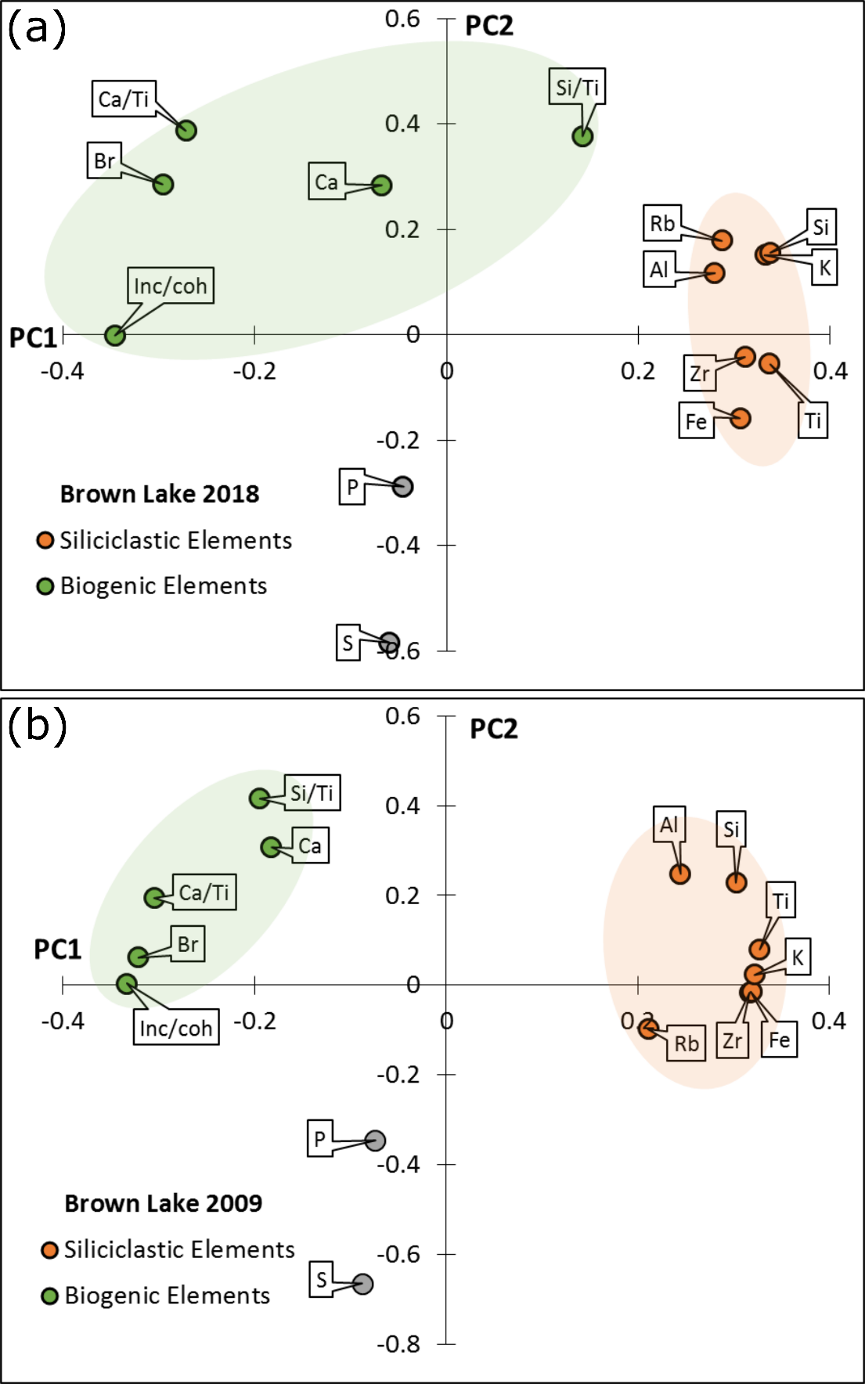
Figure S1. Ordination diagram of the first two principal components of the scanning XRF data for (a) BL18-3 and BL18-4 composite core and, (b) the BL09 core. Elements associated with siliciclastic sediments and high loadings for PC1 are displayed as orange circles, while elemental ratios associated with biogenic sediments and high loadings for PC2 are displayed as green circles.

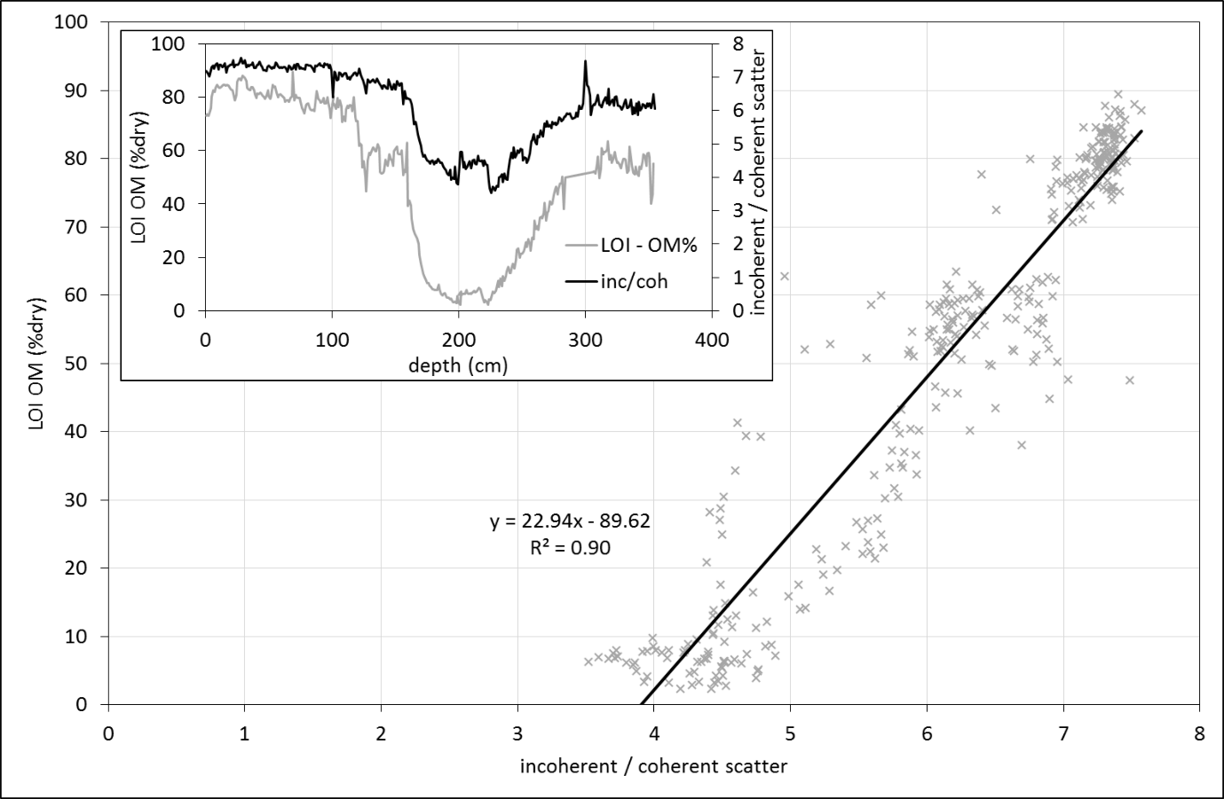
Figure S2. Calibration of organic matter (OM) from Itrax data (incoherent scatter / coherent scatter) plotted against empirically derived OM content from LOI analysis for core BL18-3.

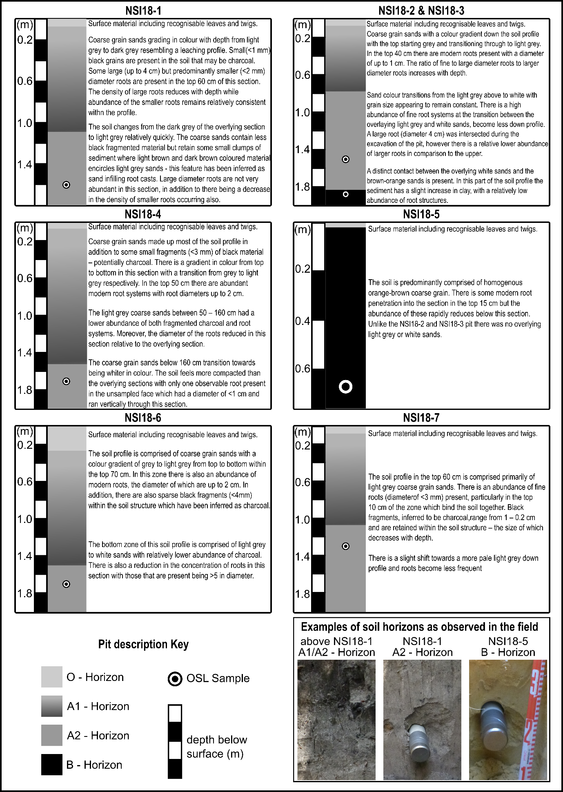
Figure S3. Pit photos and descriptions for the NSI18 OSL dune core samples reported in this paper. The black and white circles represent the position of the OSL core(s) extracted from a given pit. Note the change in scale between individual photos.

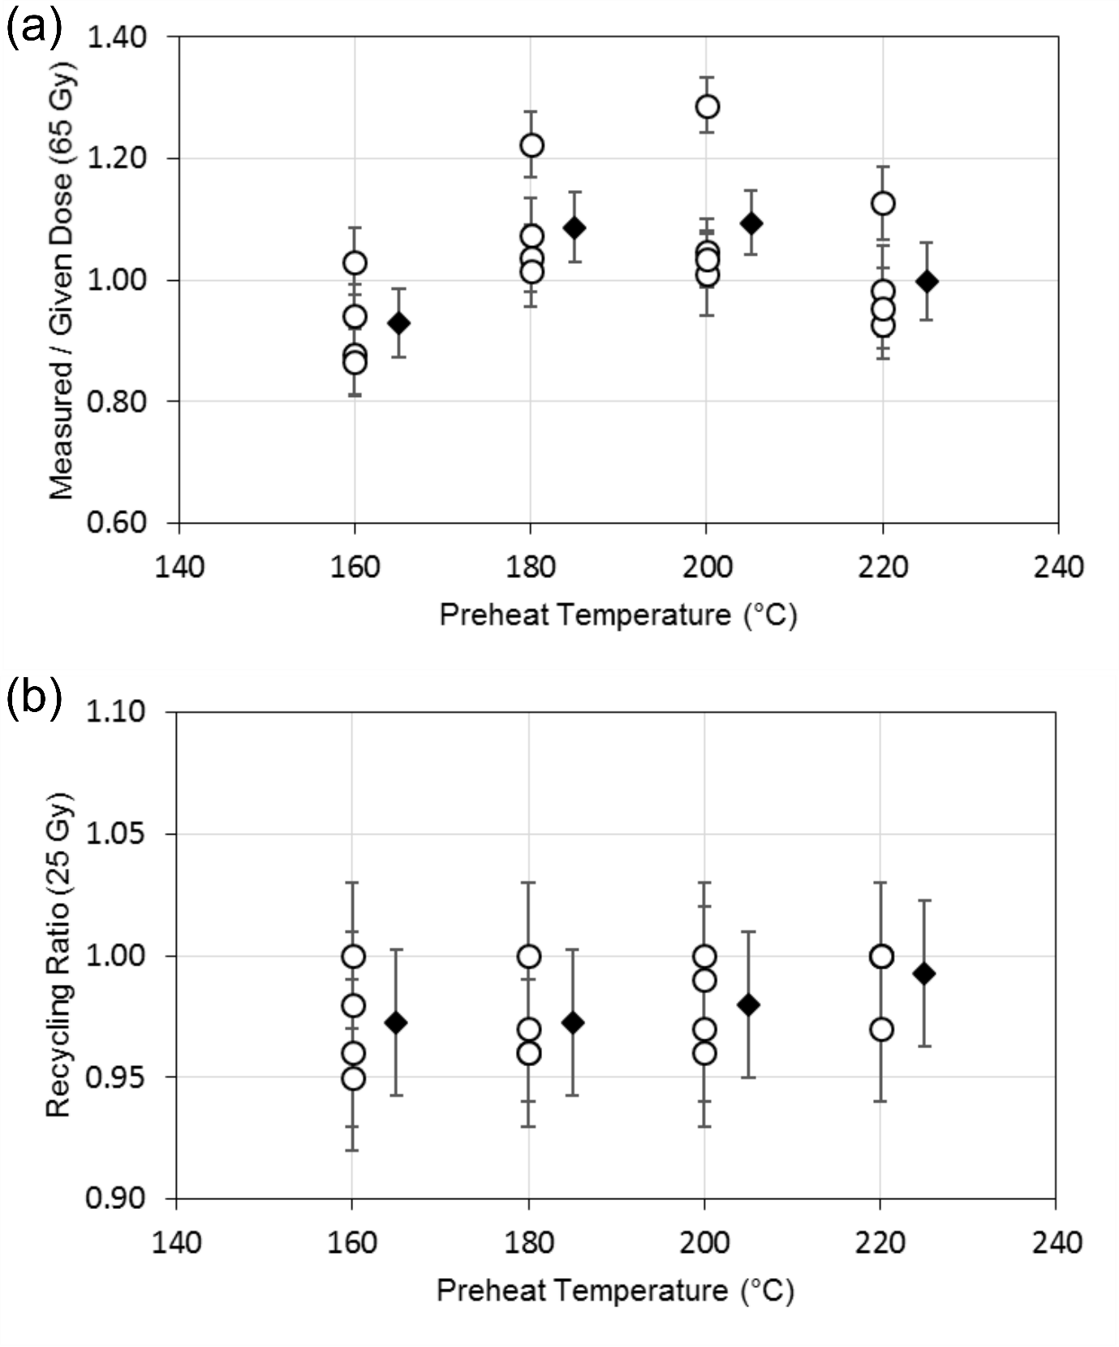
Figure S4. Multi-grain dose recovery test results obtained for sample NSI18-4 after administering a dose of 65 Gy (uncertainties are shown at 1σ). For each test, a fixed natural and regenerative dose preheat (PH1) of 260°C for 10 s was applied, and the test dose preheat (PH2) temperature was varied, as indicated in the plots (in all cases a PH2 duration of 10 s was used). (a) the recovered doses (open circles = individual aliquot D_{e} values; black diamonds = weighted mean D_{e} values). (b) the recycling ratios obtained for different preheat conditions. D_{e} measurements were made with a modified version of SAR protocol (replacing single-grain laser stimulations in steps 4 and 7 of Supplementary Table S2 with blue LED OSL stimulations performed at 125°C for 60 s) using various test dose preheat (PH2) conditions. D_{e} measurements were made on multi-grain aliquots containing ~1000 quartz grains.

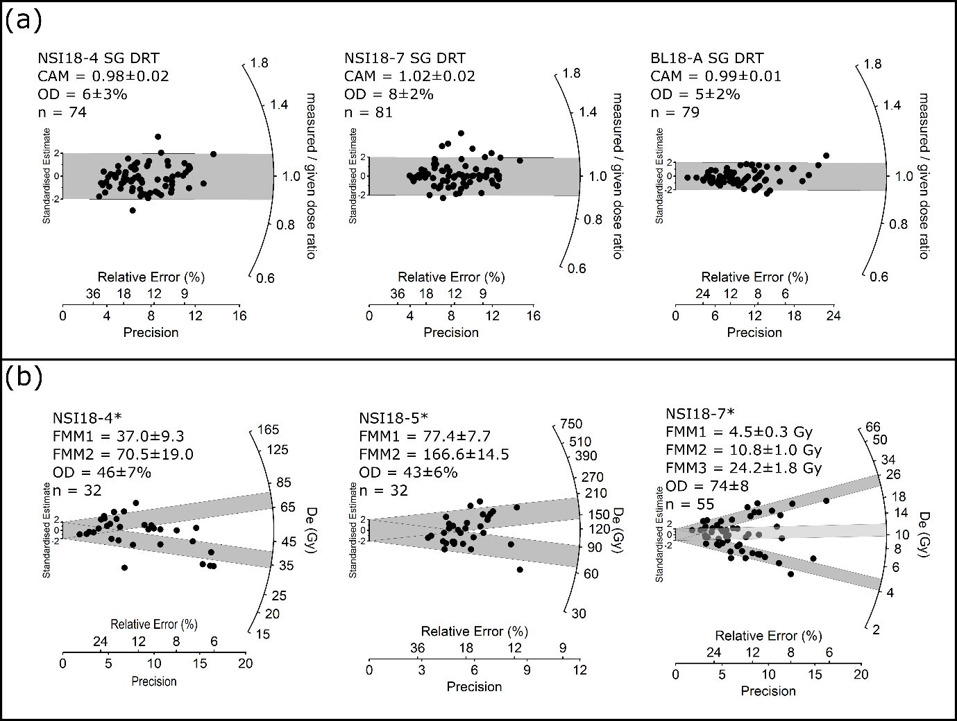
Figure S5. Radial plots showing single-grain OSL dose recovery test results and alternate age model fits obtained for 212-250 μm quartz grains. (a) Dose recovery test results from samples NSI18-4, NSI18-7 and BL18-A respectively, using the SAR protocol in Supplementary Table S2 (D_{e} uncertainties are shown at 1σ). Grains were bleached within the Risø reader chamber using blue LEDs prior to administering a dose of 65 Gy. The central age model (CAM) measured-to-given dose ratio and the overdispersion (OD) is shown next to each sample. (b) alternate age model fits for samples identified with (*) in Figure 5 with final D_{e} values calculated using the finite mixture model (FMM; Galbraith and Green, 1990) for comparative purposes.

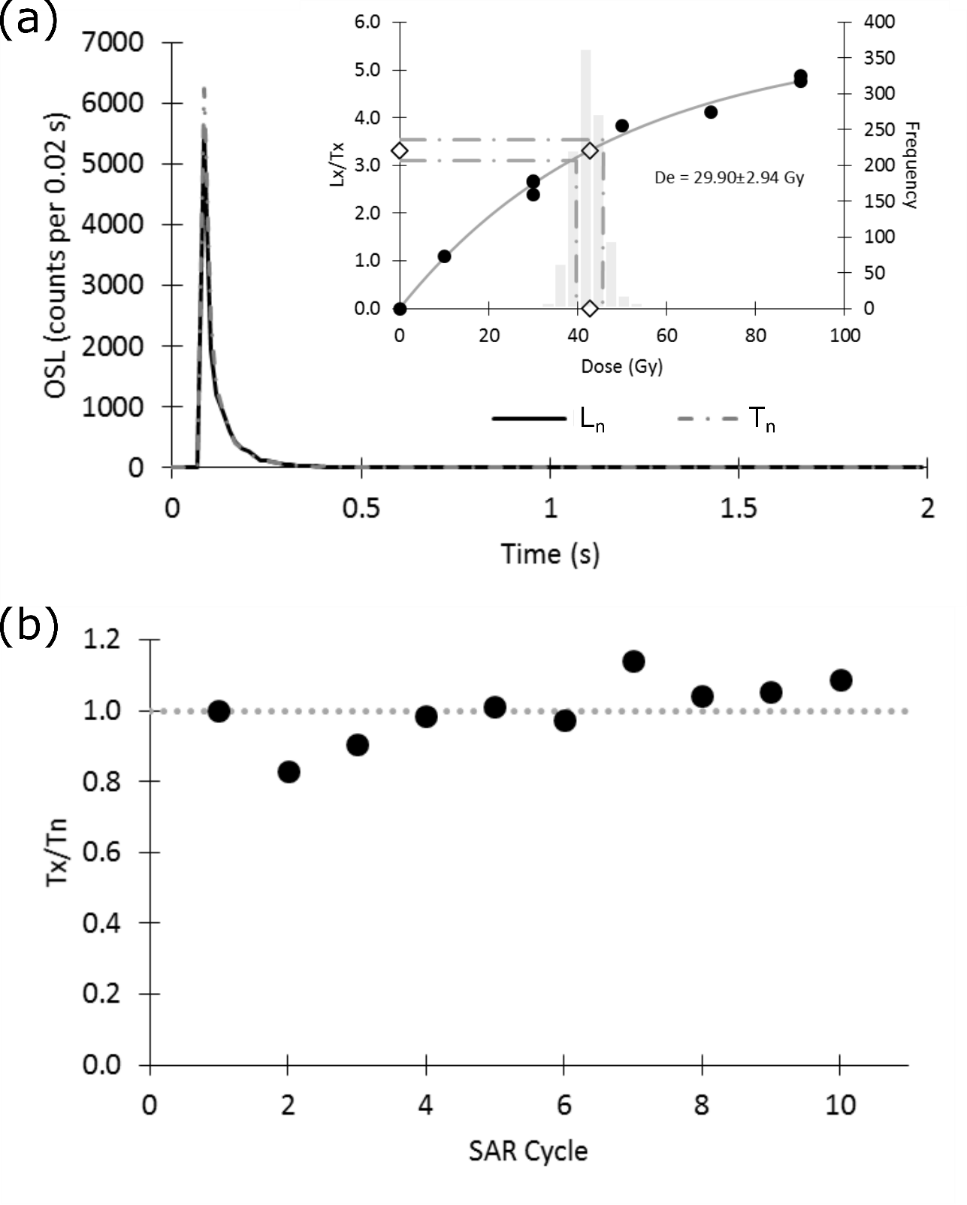
Figure S6. Example of the OSL and dose-response characteristics of an accepted grain from sample BL18-A. (a) OSL decay curve showing the OSL counts measured for the natural signal (L_{n;}; black line) and 10 Gy test-dose signal (T_{n}; grey dashed line). The inset of (a) shows the sensitivity-corrected OSL dose response curve solid grey line) reconstructed using different regenerative dose cycles (black filled circles). The grey columns represent the frequency of intercepts following 1,000 Monte Carlo repeats; open diamonds and dashed grey line represent the calculation of D_{e} and associated error. (b) The normalised test dose sensitivity (T_{x}/T_{n}) response through the SAR measurement cycles.

Sedimentology

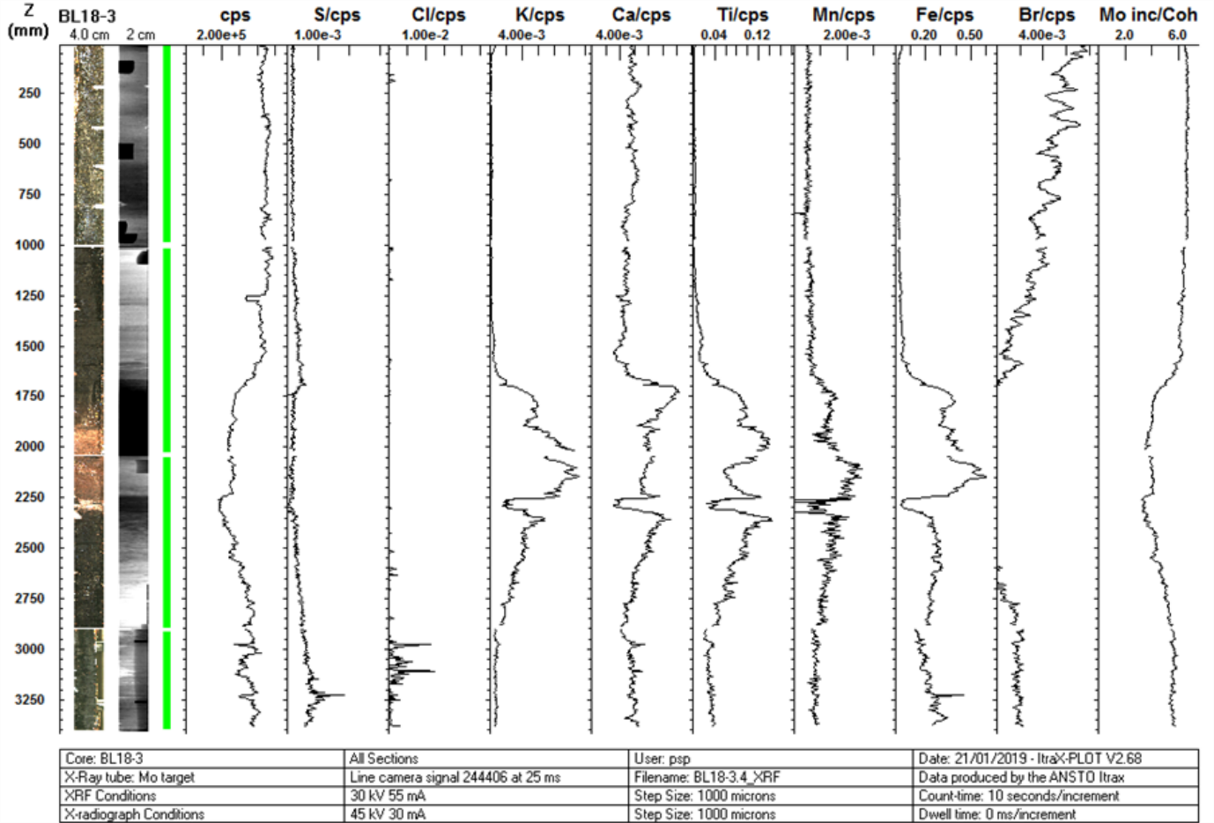
Figure S7. Scanning XRF output data for core BL18-3. (Left to right) Cumulative scan length relative to top of core, optical image capture of scanned sediment surface, radiographic image, element, elemental ratio and scattering counts.

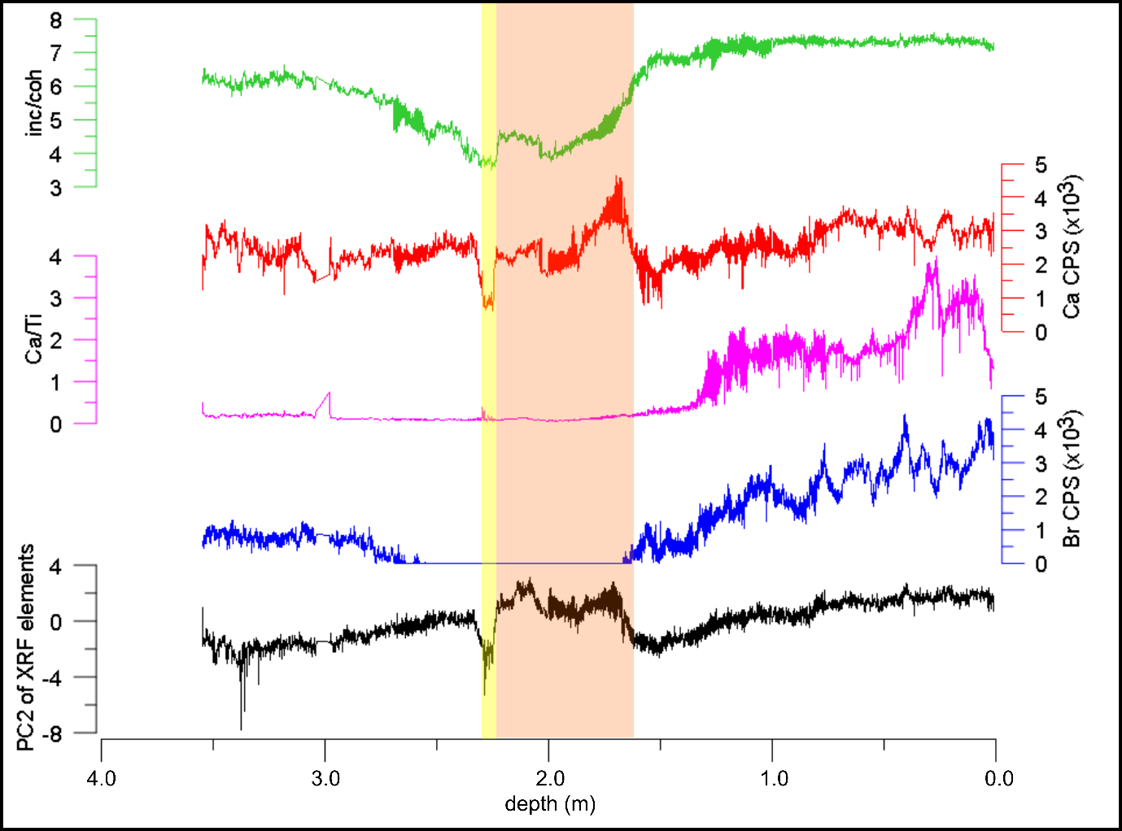
Figure S8. XRF elemental counts per second (CPS) of selected biogenic elements (as identified using Principal Component Analysis). (a) ratio of incoherent and coherent scatter (green line), proportional to change in organic matter (see SI figure); (b) XRF count data for calcium; (c) scanning XRF count data ratio between elements calcium and titanium; (d) count data for bromine; (e) the second principal component of the scanning XRF cps. Yellow and orange shading represent, the sand (sub-unit 2.2) and transitional (sub-unit 2.1) layers observed in the sedimentary sequence. For terrigenous element correlations the reader is directed to Figure 4.

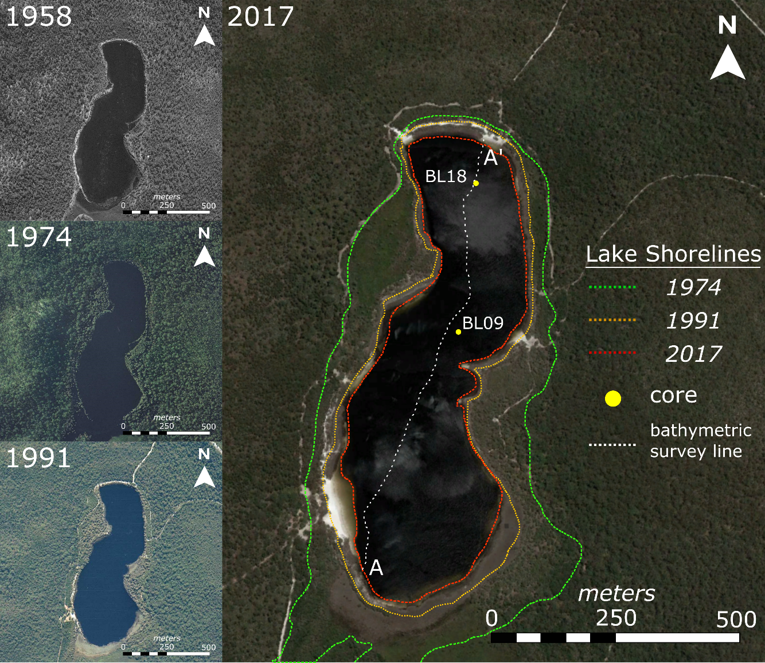
Figure S9. Aerial images of Brown Lake showing water level variation from 1958 to 2017. The imbedded 1958 (QAP768139), 1974 (QAP768139) and 1991 (QAP4951) historic aerial photographs were downloaded from the Queensland Government, QImagery web-database (State of Queensland; 2007). The large 2017 image is a satellite capture that shows fluctuations in lake level relative to 2017 shorelines, in addition to data collection locations in this study.

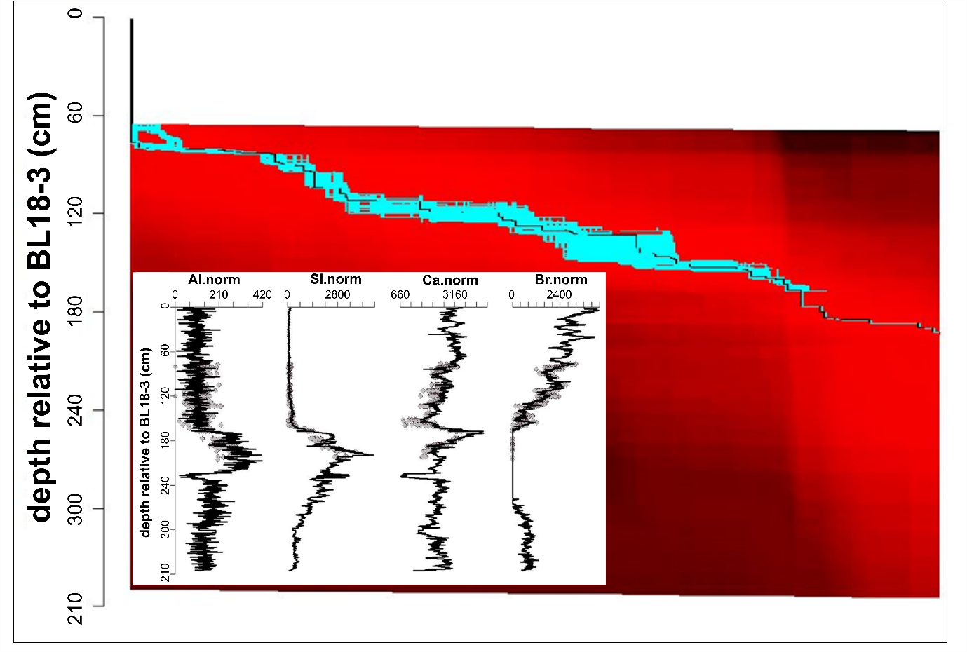
Figure S10. Core correlation H-matrix and data plot (inset) following sequence slotting in CPLSlot (Hounslow and Clark, 2016). The possible slotting positions are shown on the H-matrix as a gradient from blue (more likely), to red (less likely) when BL18-4 is fitted to BL18-3. The inset plot shows the mean slotting positions of BL18-4 (grey diamonds) against BL18-3 (black line) for the selected elements.

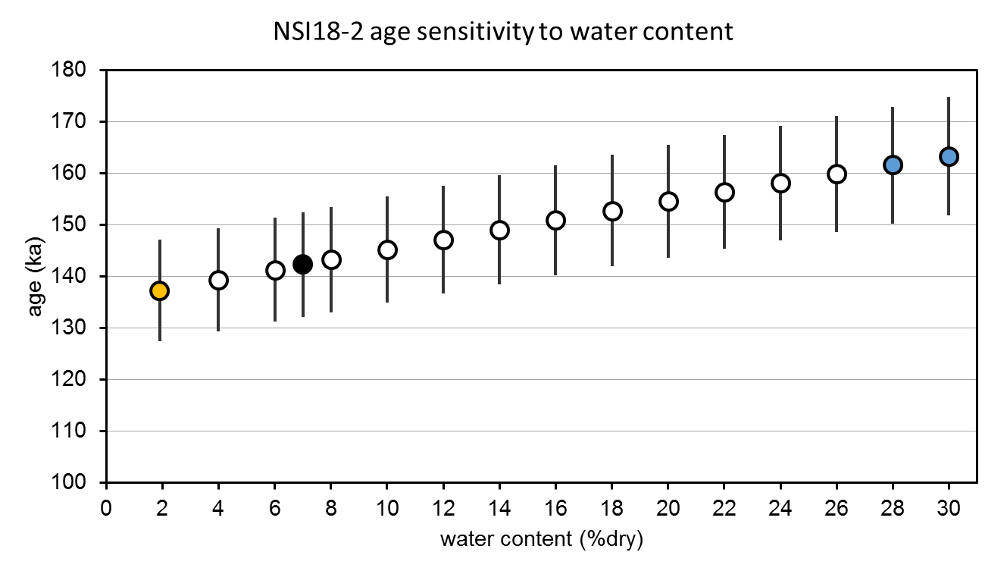
Figure S11. Influence of changing water content on OSL age for NSI18-2. Orange, blue and black points indicate ages associated with present-day (as measured) water content, the measured saturated water content and the long-term assumed value adopted in this study, respectively.

references
Aitken, M.J., 1998. An introduction to optical dating: the dating of Quaternary sediments by the use of photon-stimulated luminescence. Oxford University Press, Oxford.
Arnold, L., Roberts, R., 2009. Stochastic modelling of multi-grain equivalent dose (De) distributions: Implications for OSL dating of sediment mixtures. Quaternary Geochronology 4, 204-230.
Arnold, L.J., Duval, M., Demuro, M., Spooner, N.A., Santonja, M., Pérez-González, A., 2016. OSL dating of individual quartz ‘supergrains’ from the Ancient Middle Palaeolithic site of Cuesta de la Bajada, Spain. Quaternary Geochronology 36, 78-101.
Arnold, L.J., Duval, M., Falguères, C., Bahain, J.J., Demuro, M., 2012. Portable gamma spectrometry with cerium-doped lanthanum bromide scintillators: Suitability assessments for luminescence and electron spin resonance dating applications. Radiation Measurements 47, 6-18.
Brennan, B.J., 2003. Beta doses to spherical grains. Radiation Measurements 37, 299-303.
Brock, F., Higham, T., Ditchfield, P., Ramsey, C.B., 2010. Current pretreatment methods for AMS radiocarbon dating at the Oxford Radiocarbon Accelerator Unit (ORAU). Radiocarbon 52, 103-112.
Bronk Ramsey, C., 2008. Deposition models for chronological records. Quaternary Science Reviews 27, 42-60.
Bronk Ramsey, C., 2009. Dealing with outliers and offsets in radiocarbon dating. Radiocarbon 51, 1023-1045.
Bronk Ramsey, C., Lee, S., 2013. Recent and planned developments of the program OxCal. Radiocarbon 55, 720-730.
Demuro, M., Arnold, L.J., Aranburu, A., Sala, N., Arsuaga, J.-L., 2019. New bracketing luminescence ages constrain the Sima de los Huesos hominin fossils (Atapuerca, Spain) to MIS 12. Journal of Human Evolution 131, 76-95.
Duller, G.A.T., 2003. Distinguishing quartz and feldspar in single grain luminescence measurements. Radiation measurements 37, 161-165.
Duller, G.A.T., 2007. Luminescence Analyst, 3.24 ed. Aberystwyth Luminescence Research Laboratory, University of Wales, Aberystwyth.
Ellerton, D., Rittenour, T., Shulmeister, J., Gontz, A., Welsh, K.J., Patton, N., 2020. An 800 kyr record of dune emplacement in relationship to high sea level forcing, Cooloola Sand Mass, Queensland, Australia. Geomorphology 354, 106999.
Fu, X., Cohen, T.J., Arnold, L.J., 2017. Extending the record of lacustrine phases beyond the last interglacial for Lake Eyre in central Australia using luminescence dating. Quaternary Science Reviews 162, 88-110.
Galbraith, R., Green, P., 1990. Estimating the component ages in a finite mixture. International Journal of Radiation Applications and Instrumentation. Part D. Nuclear Tracks and Radiation Measurements 17, 197-206.
Guérin, G., Mercier, N., Adamiec, G., 2011. Dose-rate conversion factors: update. Ancient TL 29, 5-8.
Hounslow, M.W., Clark, R.M., 2016. CPLSlot a program for objective correlation between successions using sequence slotting.
Jacobs, Z., Duller, G.A., Wintle, A.G., Henshilwood, C.S., 2006. Extending the chronology of deposits at Blombos Cave, South Africa, back to 140 ka using optical dating of single and multiple grains of quartz. Journal of Human Evolution 51, 255-273.
Lewis, R.J., Tibby, J., Arnold, L.J., Barr, C., Marshall, J., McGregor, G., Gadd, P., Yokoyama, Y., 2020. Insights into subtropical Australian aridity from Welsby Lagoon, north Stradbroke Island, over the past 80,000 years. Quaternary Science Reviews 234, 106262.
Mejdahl, V., 1979. Thermoluminescence dating: Beta‐dose attenuation in quartz grains. Archaeometry 21, 61-72.
Prescott, J.R., Hutton, J.T., 1994. Cosmic ray contributions to dose rates for luminescence and ESR dating: large depths and long-term time variations. Radiation measurements 23, 497-500.

