Supplementary Information:
Spatial variation of East Asian winter monsoon evolution between northern and southern China since the Last Glacial Maximum
Qin Li^{1, 2}, Haibin Wu^{2, 3, 4}, Jun Cheng⁵, Shuya Zhu², Chunxia Zhang², Jianyu Wu², Yating Lin², Pei Li², Xiangbin Ren², Deai Zhao², Yan Zhang²
1. School of Geography, Liaoning Normal University, Dalian 116029, China
2. Key Laboratory of Cenozoic Geology and Environment, Institute of Geology and Geophysics, Chinese Academy of Sciences, Beijing 100029, China
3. CAS Center for Excellence in Life and Paleoenvironment, Beijing, 100044, China
4. University of Chinese Academy of Sciences, Beijing 100049, China
5. College of Oceanography, Nanjing University of Information Science and Technology, Nanjing 210044, China

Comparison with the nearby Weinan-1 sections on SR and MAR
The grain size of the loess, i.e the eolian dust, reflects the strength of the wind, whereas the accumulation rate (g/cm².ka) is an approximate of the eolian dust flux, which suggests the strength of wind filed and the aridity of source area as well as the frequency of the dust storm events and dust fall event, so the distribution of the grain size and the dust flux can be approximately used to reconstructed the strength field of the wind and the average climatic condition from source area to deposition area (Liu, 1985; An and Xiao, 1990; An et al., 1991; Ding et al., 2001; Kohfeld and Harrison, 2001; Sun and An, 2005).
The mass accumulation rates (MARs) of eolian deposits on the Chinese Loess Plateau (CLP) are reconstructed from measured bulk sediment densities combined with sedimentation rates (Sun and An, 2005; An and Xaio, 1990). MAR can be calculated according to:
MAR=f_{eolian}×SR×BD
where feolian is the fraction of eolian dust in the deposit, SR (cm/kyr) is the dust accumulation rate, and BD (g/cm3) is the bulk density. As loess and red clay deposits are assumed to be entirely eolian in origin (Pye, 1987; Kohfeld and Harrison, 2001, 2003), feolian = 1 is often assumed when
estimating the MAR of eolian deposits in the CLP.
It should be noted that the bulk densities of loess deposits have rarely been measured in practice, and most previous MAR estimates have been based on the assumption that the average BD value is 1.6 g/cm3 or 1.65 g/cm3 as suggested by Liu (1985) and Pye (1987) in Loess deposits. Considering lack of measured bulk density at Weinan profile in this study, the MAR estimates was calculated based on the bulk density measured in Weinan-1 profile by Kang et al., (2013). The MAR calculated in this study has been compared with that from Kang et al., (2013), which was shown in Fig. S1.
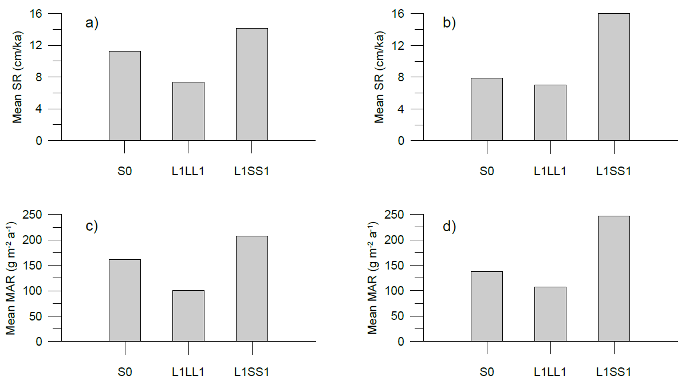
Fig. S1 Mean SR (sediment rate) of S0, L1LL1, and L1SS1 unit at Weinan (a) and Weinan-1 (Kang et al., 2013) (b); Mean MAR of S0, L1LL1, and L1SS1 unit at Weinan (c) and Weinan-1 (Kang et al., 2013) (d)
The comparison of our MAR estimates and SR with those from Kang et al., (2013) do display some similar change. For example, the MAR show a decline first, followed by an increase in both sections. The above comparison further supported the two nearby eolian sequence are under a very similar climatic environment, making it possible to develop a time scale for this sequence by correlating to the Weinan-1 in Kang et al., (2013).

References:
An Z.S, Xian G, Kukla, Palisades S.C. Porter, Seattle, Xiao J.L. 1991. Late Quaternary dust flow on the Chinese loess Plateau. CATENA 18:125-132.
An Z.S, jule X. 1990. Study on the eolian dust flux over the loess plateau: An example. Chinese Science Bulletin 35:1627-1631.
Ding Z, Yu Z, Yang S, Sun J, Xiong S, Liu T. 2001. Coeval changes in grain size and sedimentation rate of eolian loess, the Chinese Loess Plateau. Geophysical Research Letters - GEOPHYS RES LETT 28:2097-2100.
Kang S, Wang X, Lu Y. 2013. Quartz OSL chronology and dust accumulation rate changes since the Last Glacial at Weinan on the southeastern Chinese Loess Plateau. Boreas 42:815-829.
Kohfeld K, Harrison S. 2001. DIRTMAP: the geological record of dust. Earth-Science Reviews 54:81-114.
Kohfeld, K. E., and S. P. Harrison. 2003. Glacial-integlacial changes in dust deposition on the Chinese Loess Plateau. Quaternary Science Reviews 22:1859-1878.
Liu TS. 1985. Loess and the Environment. China Ocean, Beijing.
Pye K. 1987. Aeolian Dust and Dust Deposits. Elsevier, New York.
Sun Y, An Z. 2005. Late Pliocene-Pleistocene changes in mass accumulation rates of eolian deposits on the central Chinese Loess Plateau. Journal of Geophysical Research 110, D23101.

