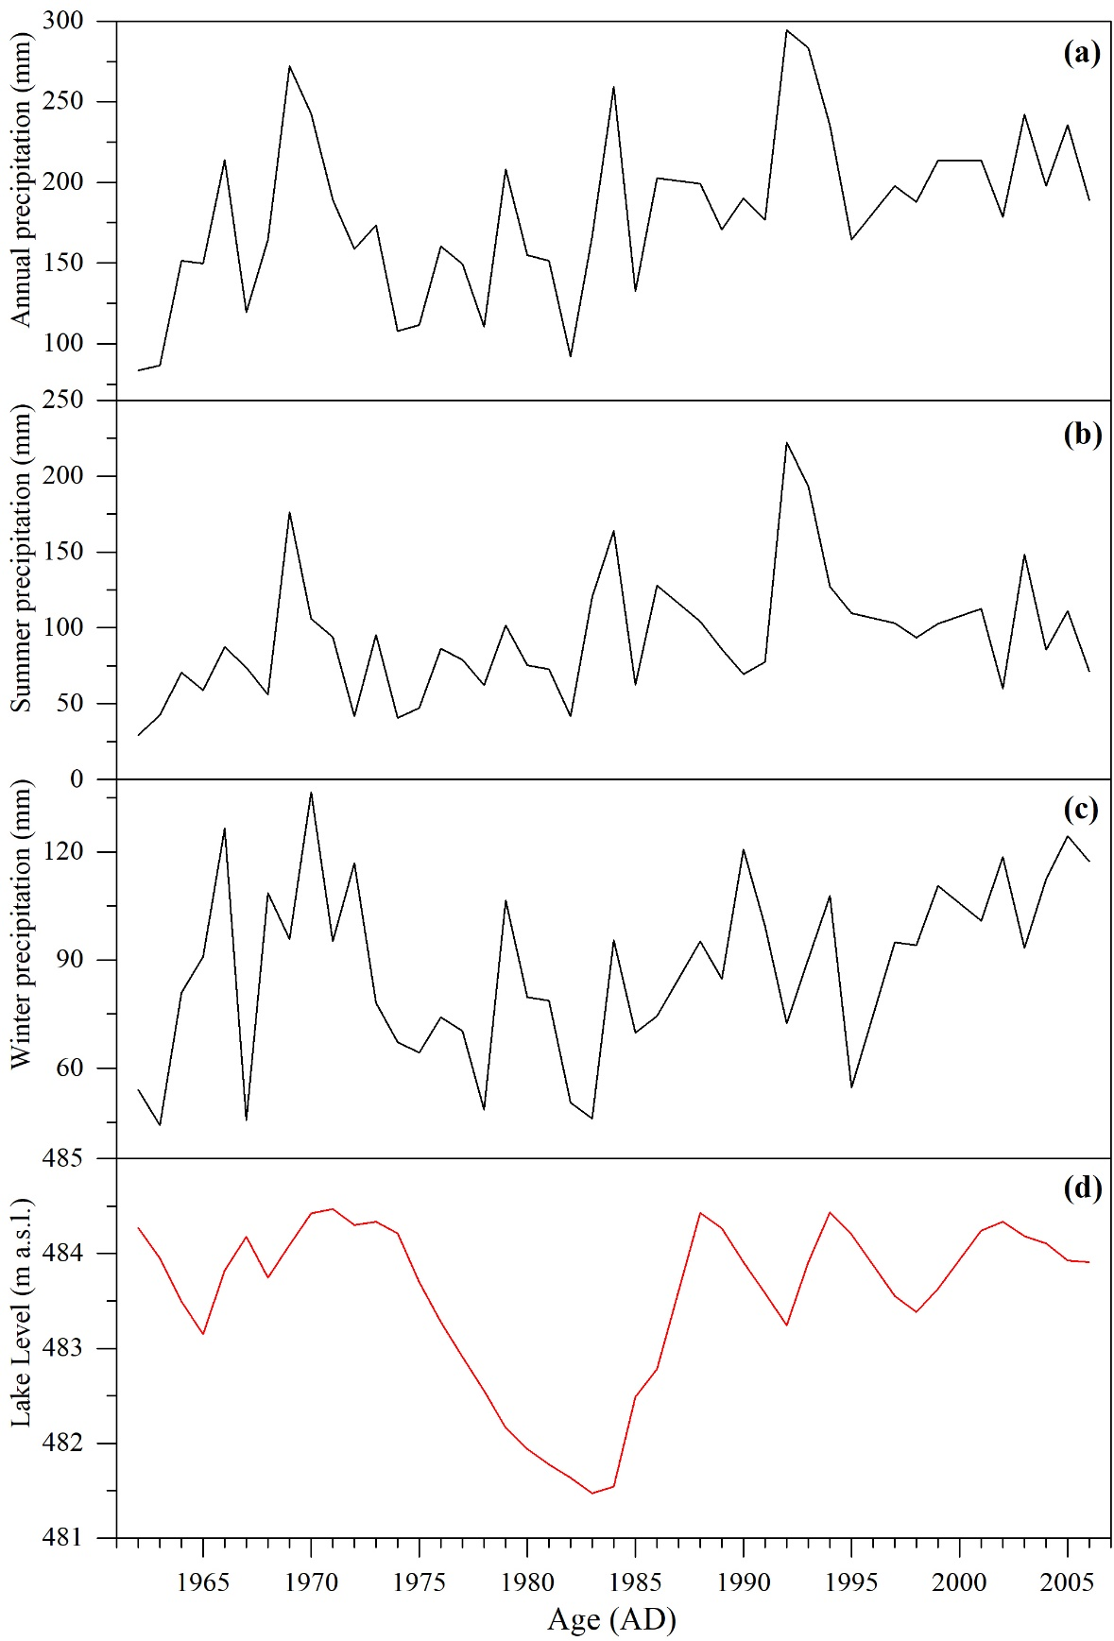
Fig. S1. Comparisons of lake level changes in Wulungu Lake (Liu, 2015) (d) and precipitation records of annual (a), summer half-year (b) and winter half-year (c) from Fuyu meteorological station (in Wulungu River catchment) during 1962-2006 AD.

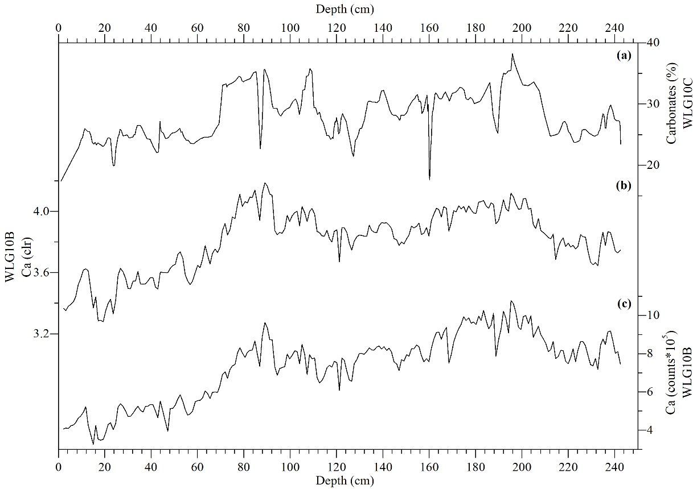
Fig. S2. Comparisons of carbonate content in core WLG10C, XRF-Ca intensity and clr-transformed XRF-Ca in core WLG10B.

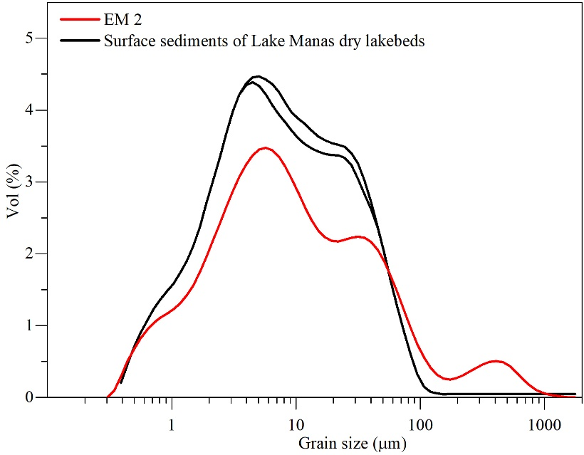
Fig. S3. Distribution of EM 2 and GSDs of surface samples from Lake Manas dry lakebeds (Yang et al., 2008).

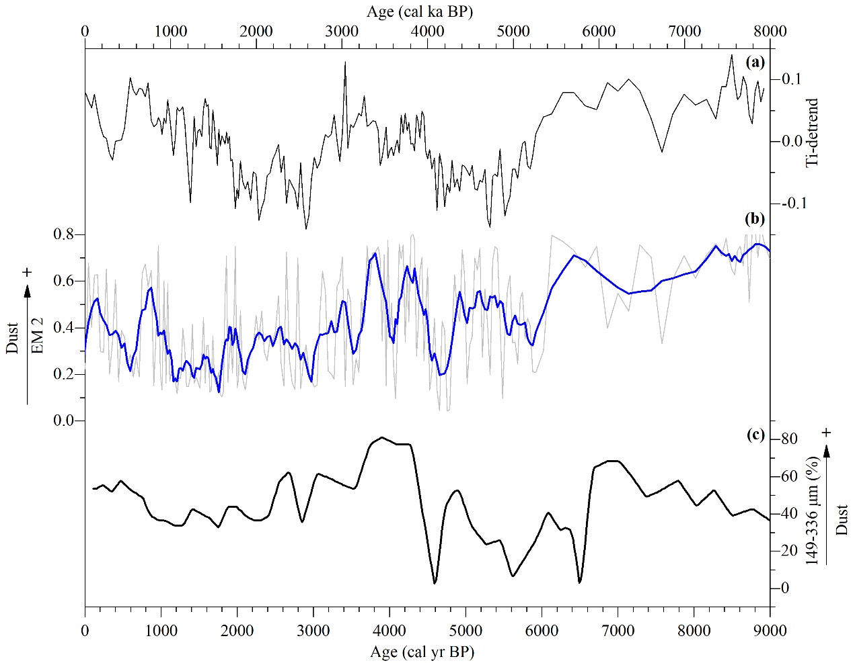
Fig. S4. Comparisons of detrended clr-transformed-Ti (a) and variances of EM 2 (b) from core WLG10B, and dust records from a sand dune in Balikun Basin (Ji et al., 2019) (c).

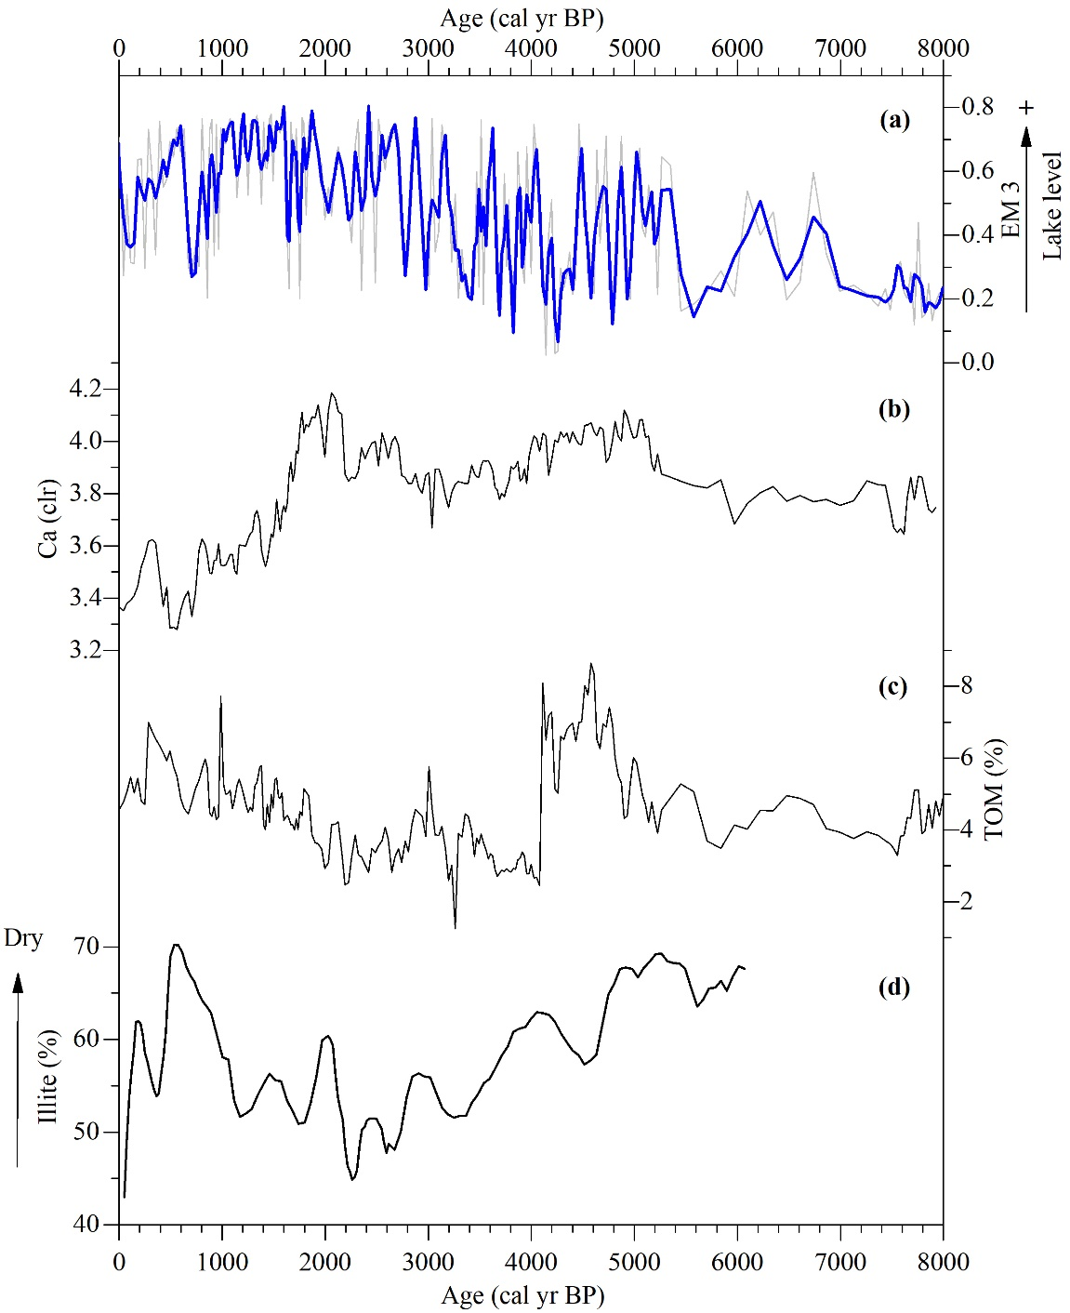
Fig. S5. Comparisons of EM 3 (a), clr-transformed Ca (b) and TOM of WLG10B (c), and illite record of sediments from the center of Wulungu Lake (Qian et al., 2014) (d).

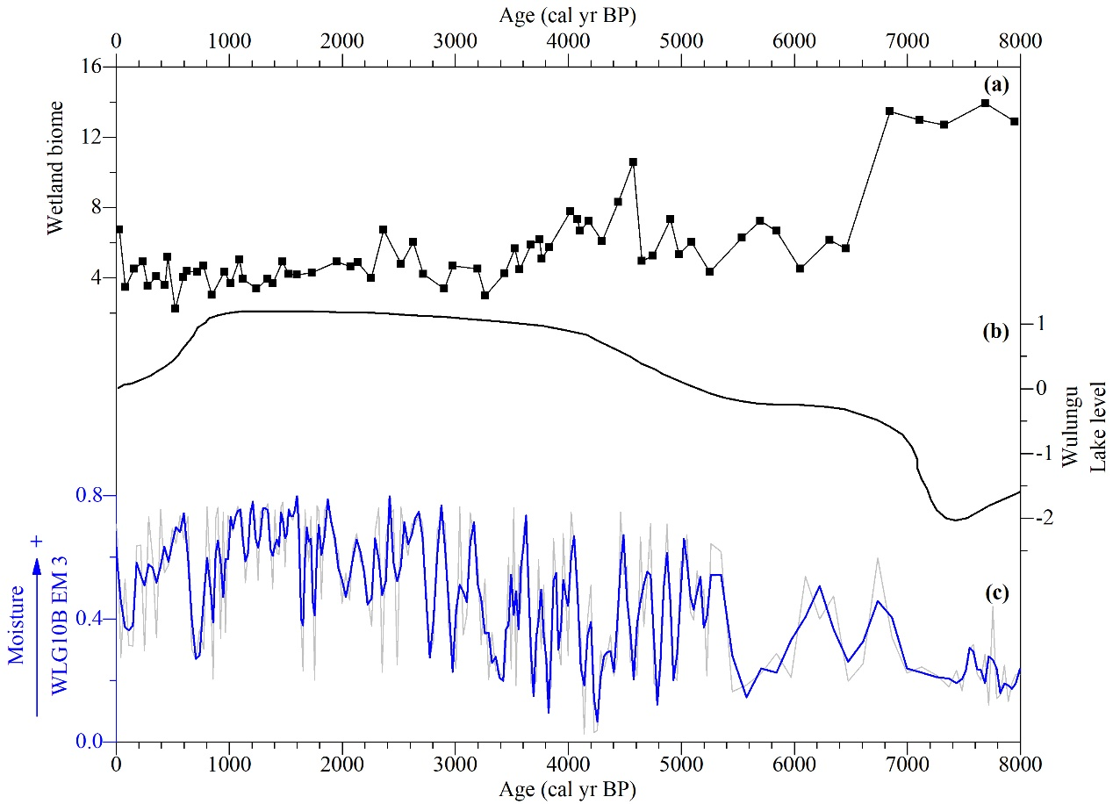
Fig. S6. Variances of WLG10B EM 3 (c), wetland biome reconstruction based on pollen (Liu et al., 2008) (a), and lake-level fluctuation derived from grain-size and pollen data from Wulungu Lake (Liu et al., 2008) (b).

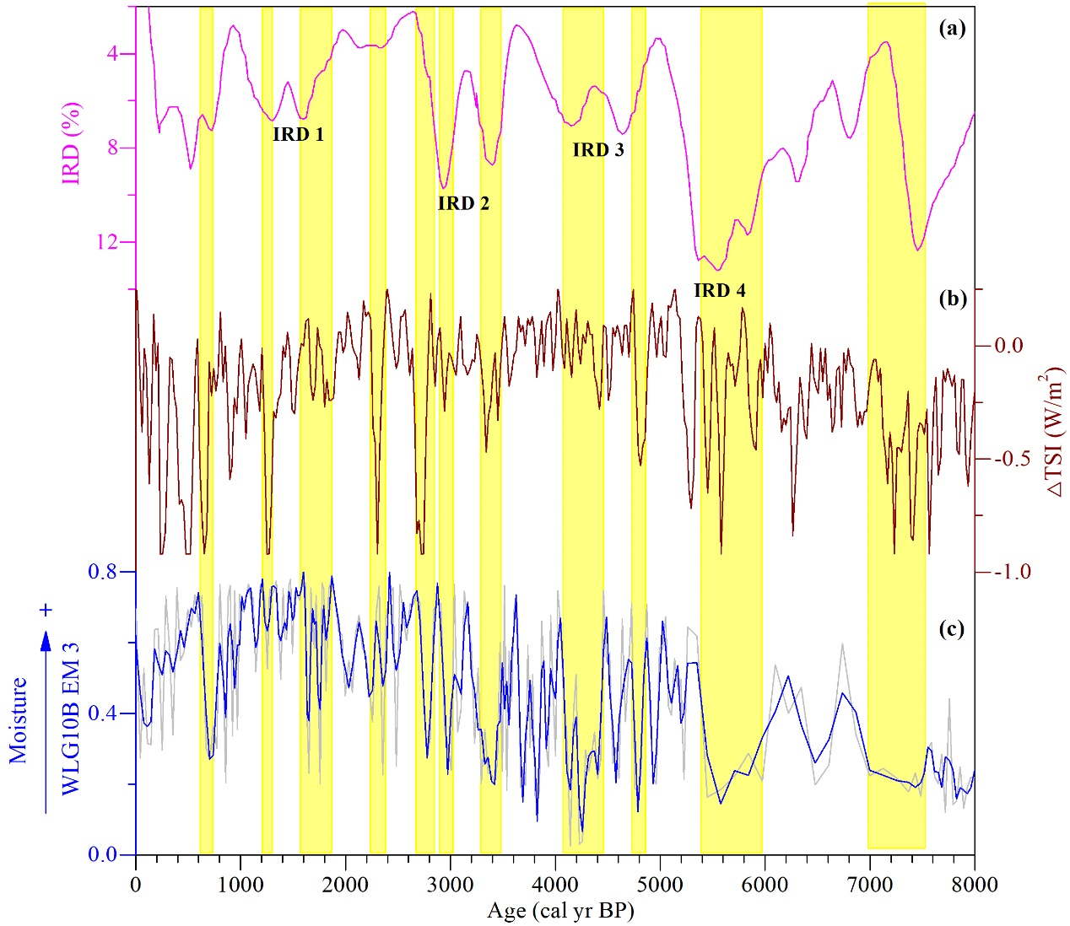
Fig. S7. Comparison of EM 3 of core WLG10B (c), concentration of IRD (ice-rafted debris) in North Atlantic sediments (Bond et al., 2001) (a), and solar activity (averaged total solar irradiance [△TSI]) (Steinhilber et al., 2012) (b). The yellow bars indicate dry events recorded at Wulungu Lake.

References
Liu, J., 2015. Analysis of water inflow in Wulungu Lake. Energy and Energy Conservation 2015, 103-105 (in Chinese).

