Figs. S1-S3: Graphical representation of the luminescence characteristics of each dated sample. The abanico plots show the distribution of the equivalent dose (De) values. The CAM De used for age calculation is written in red.
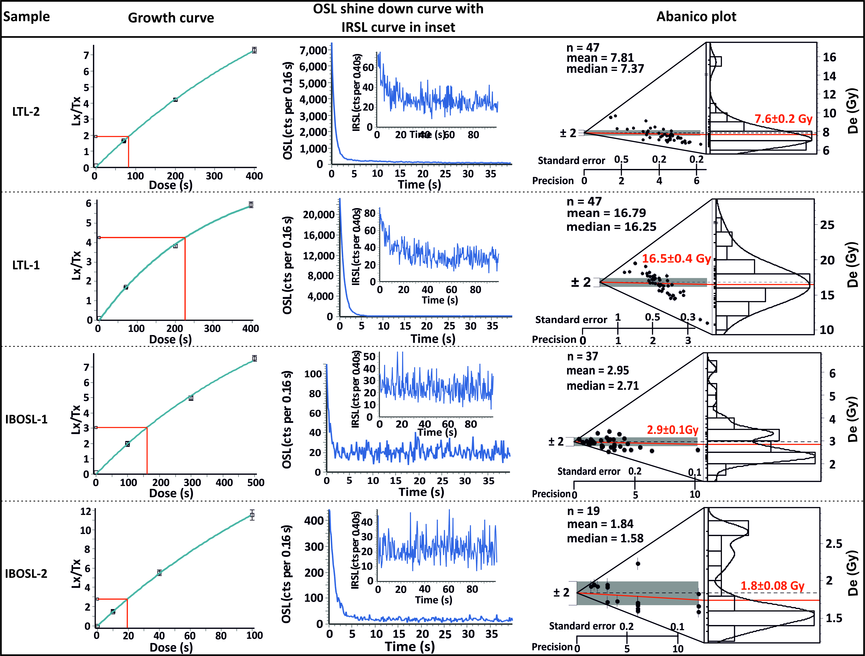
Figure S1:

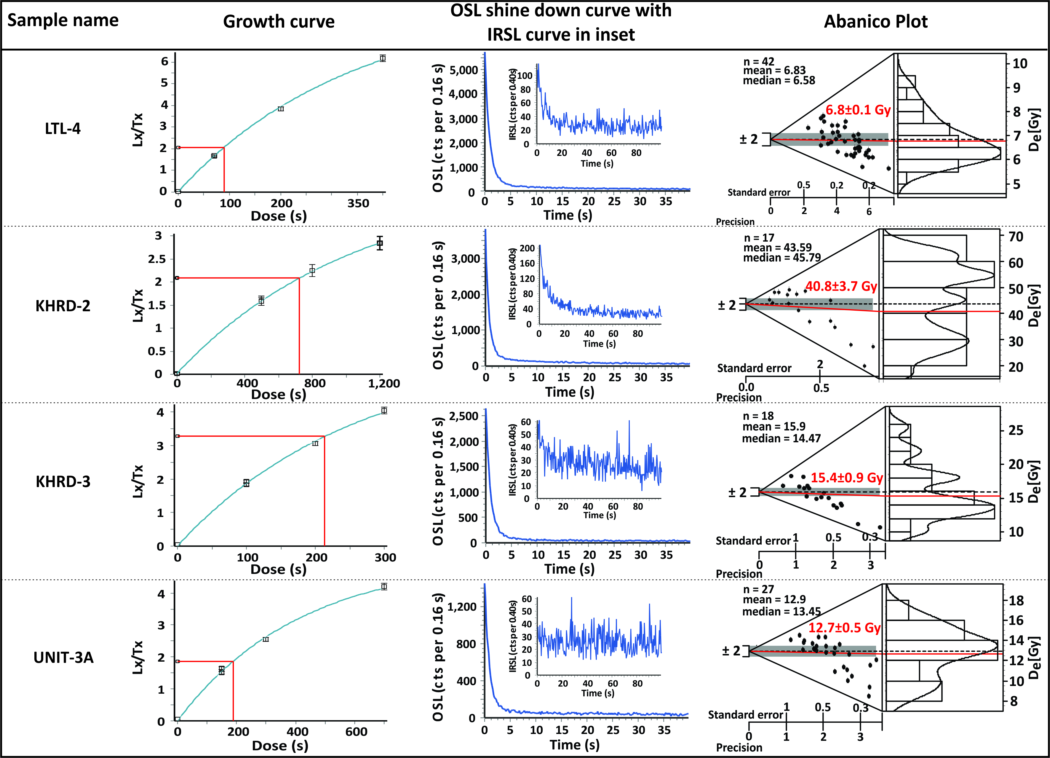

Figure S2:

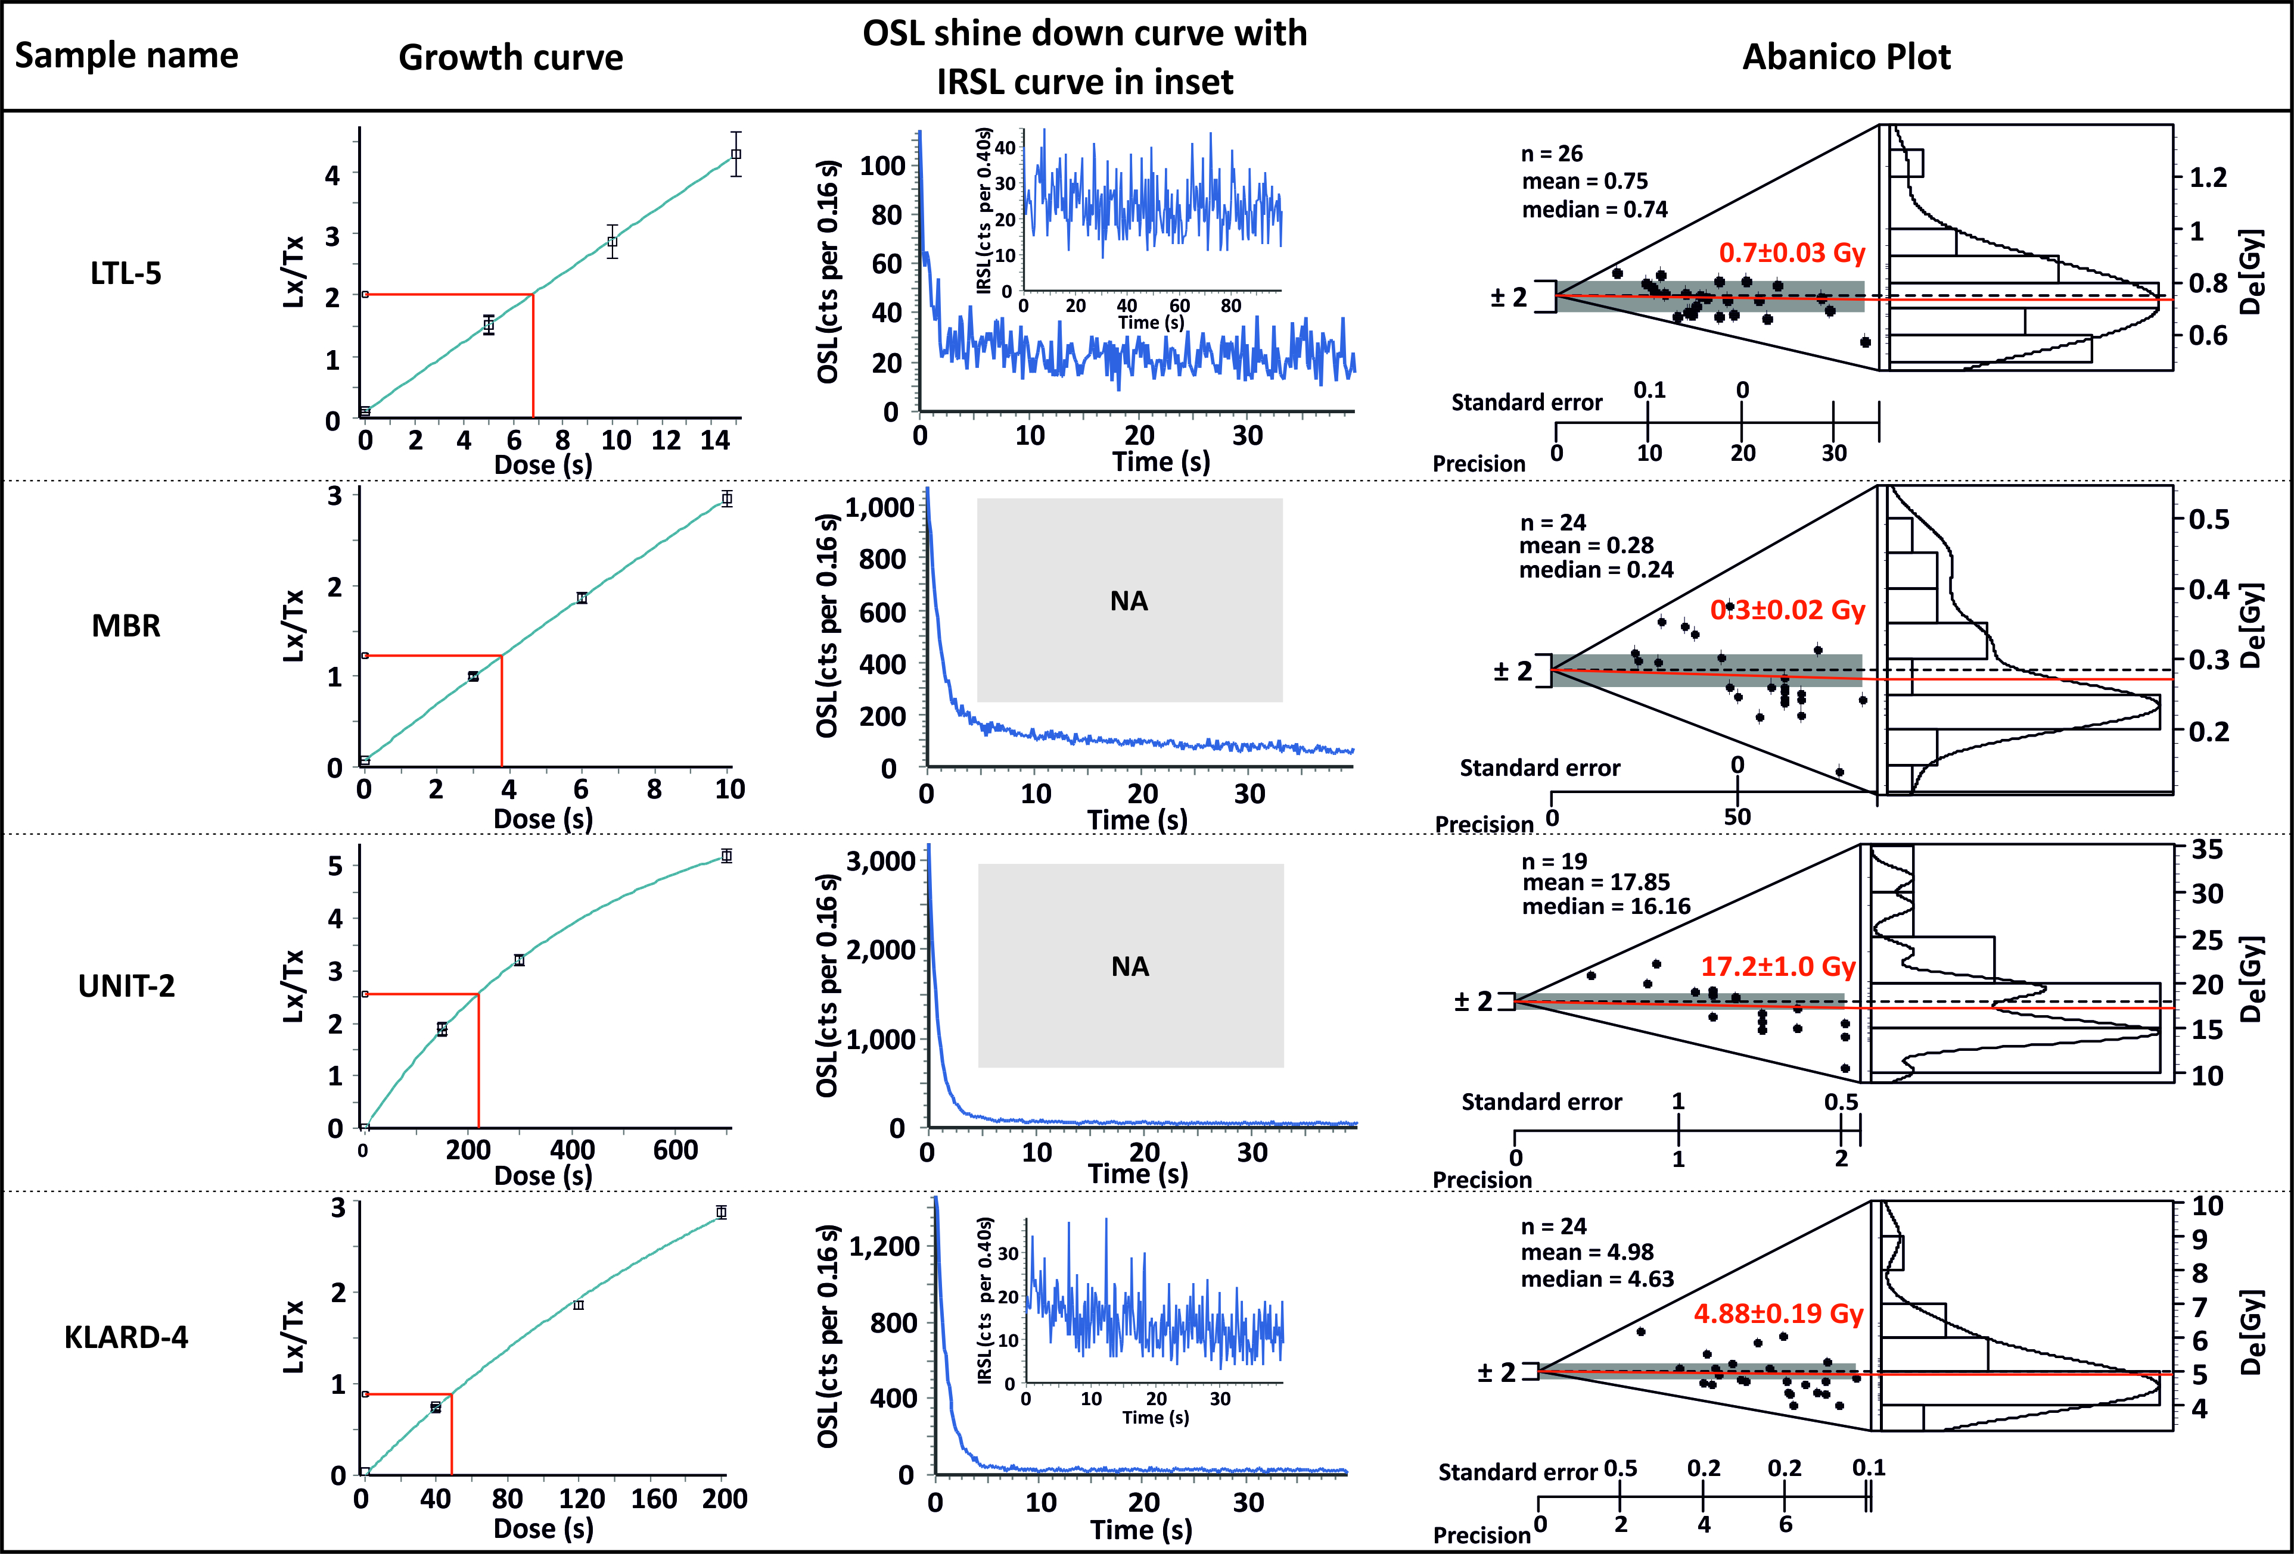

Figure S3:

Table S1: Grain size analysis using GRADISTAT software where statistical parameters derived following the method suggested by Folk and Ward, (1957). Sampling interval is mentioned in the parentheses and it is based on visual differentiation of the sedimentary texture. Only sand dominated horizons are used for grain size analysis.
Site- name | Unit name and sampling interval (cm) | Sample name | Grain size Geometric mean  (µm) | Sorting (s) | Skewness (SK) | Kurtosis (K) | Description
Site-1a  Kharod estuary section | Unit-III  (top of the unit) | LGS-1 | 233.1 | 2.223 | -0.182 | 0.948 | Fine Sand, Poorly Sorted, Fine Skewed, Mesokurtic
 | Unit-IV  (50 cm) | LGS -2 | 231.7 | 1.610 | -0.250 | 0.773 | Fine Sand, Moderately Well Sorted, Fine Skewed, Platykurtic
 |  | LGS -3 | 234.8 | 1.596 | -0.282 | 0.779 | Fine Sand, Moderately Well Sorted, Fine Skewed, Platykurtic
 |  | LGS -4 | 223.4 | 1.680 | -0.283 | 0.931 | Fine Sand, Moderately Sorted, Fine Skewed, Mesokurtic
 |  | LGS -5 | 223.4 | 1.680 | -0.283 | 0.931 | Fine Sand, Moderately Sorted, Fine Skewed, Mesokurtic
 |  | LGS -6 | 230.6 | 1.597 | -0.254 | 0.766 | Fine Sand, Moderately Well Sorted, Fine Skewed, Platykurtic
 | Unit-V  (50 cm) | LGS -7 | 226.6 | 1.550 | -0.291 | 0.703 | Fine Sand, Moderately Well Sorted, Fine Skewed, Platykurtic
 |  | LGS -8 | 180.4 | 1.454 | 0.727 | 0.546 | Fine Sand, Moderately Well Sorted, Very Coarse Skewed, Very Platykurtic
 |  | LGS-9 | 176.5 | 1.437 | 0.764 | 0.589 | Fine Sand, Moderately Well Sorted, Very Coarse Skewed, Very Platykurtic
 |  | LGS-10 | 220.9 | 1.465 | -0.399 | 0.527 | Fine Sand, Moderately Well Sorted, Very Fine Skewed, Very Platykurtic
Site-2  India Bridge | Unit-III Top 30 cm sampled  (10 cm) | IB 21 | 151.4 | 2.033 | 0.288 | 0.766 | Fine Sand, Poorly Sorted, Coarse Skewed, Platykurtic
 |  | IB 22 | 145.5 | 1.966 | 0.270 | 1.480 | Fine Sand, Moderately Sorted, Coarse Skewed, Leptokurtic
 |  | IB23 | 146.2 | 2.025 | 0.269 | 0.757 | Fine Sand, Poorly Sorted, Coarse Skewed, Platykurtic
 | Unit-IV  (20 cm) | IB 24 | 150.1 | 2.002 | 0.276 | 0.767 | Fine Sand, Poorly Sorted, Coarse Skewed, Platykurtic
 |  | IB 25 | 149.8 | 1.884 | 0.283 | 0.810 | Fine Sand, Moderately Sorted, Coarse Skewed, Platykurtic
 |  | IB 26 | 141.5 | 1.677 | 0.161 | 1.236 | Fine Sand, Moderately Sorted, Coarse Skewed, Leptokurtic
 |  | IB 27 | 119.4 | 1.436 | -0.232 | 4.093 | Very Fine Sand, Moderately Well Sorted, Fine Skewed, Extremely Leptokurtic
 |  | IB 28 | 120.5 | 1.429 | -0.227 | 4.305 | Very Fine Sand, Moderately Well Sorted, Fine Skewed, Extremely Leptokurtic
 |  | IB 29 | 141.2 | 1.720 | 0.162 | 1.234 | Fine Sand, Moderately Sorted, Coarse Skewed, Leptokurtic

Table S2: Details of elevations used in RSL estimation for Site-1a (Kharod Estuary section), Site-1b (Kharod River section) and Site-2 (INB section): Indicative Ranges (IR, IR-2), Reference Water Level (RWL), Relative Sea Level (RSL, RSL-2) and Error (Et), and sea level indicator (Es). All the elevations (except uplift rate) are in meters above mean sea level and taken through DGPS with accuracy of ±0.01 m.

 | Site-1a | Site-1b | Site-2
RWL | 0.96 | 1.31 | 2.08
Es | 2.38 | 4.61 | 2.81
Std. Dev. of modern tidal flat elevations | 0.08 | 0.09 | 0.14
IR (Std. Dev.*1.96) | 0.15 | 0.18 | 0.28
IR-2 (See Table S4) | 0.79 | 1.76 | 0.51
RSL | 1.42 | 3.32 | 0.73
Error in RSL (Et)  (Based E1-E7) | 0.38 | 0.53 | 0.43
Error in RSL-2 (Et-2)  (Based E1-E7)* | 0.55 | 1.02 | 0.48
Variance of respective modern tidal flats (Table S3) | 0.01 | 0.01 | 0.02
Variance of respective relict tidal flats  (Table S3) | 0.01 | 0.36 | 0.14
E1 | 0.38 | 0.38 | 0.38
E2 | 0.01 | 0.01 | 0.02
E3 | 0.01 | 0.01 | 0.01
E4 | 0.08 | 0.09 | 0.14
E4-2* | 0.40 | 0.88 | 0.26
E5 | 0.01 | 0.01 | 0.01
E6 | 0.01 | 0.01 | 0.01
E7 | 0.01 | 0.36 | 0.14
Uplift rate considered  (mm/yr) | 0.13 | 0.13 | 0.2
Total tectonic uplift | 0.91 (0.13*7) | 0.91 (0.13*7) | 0.2 (0.2*1)
RSL (tectonically uncorrected) | 1.42 | 3.32 | 0.73
RSL-2 (tectonically uncorrected) | 1.42 | 3.32 | 0.73
RSL (tectonically corrected) | 0.51 | 2.39 | 0.53
RSL-2 (tectonically corrected) | 0.51 | 2.39 | 0.53
RWL: Average values of respective modern tidal flat elevations given in Table S3
Es: Average values of elevation of the respective SLIPs (Sea Level Index Points) given in Table S3
RSL: Es-RWL
E1- The thickness error which is half the thickness of the sample unit, E2-Statistical variance of measured modern tidal flat elevation, E3-DGPS error is based on the instrument accuracy, E4-IR error is taken as half the IR, E5-Sampling error arise from measuring the sample depth within a section (0.01 m), E6-Non-vertical exposure error, E7- Statistical variance of measured relict tidal flat elevation
*Alternate values E4-2 (instead of E4) are used in the calculation which are based on IR-2
Et: Error in RSL estimation based on the equation of (Hijma et al., 2015)
E_{t} = $\sqrt{e_{1}^{2}+e_{2 }^{2}+…+e_{n}^{2}}$
Table-S3: Details of DGPS elevation points (accuracy of ±0.01 m) for modern tidal flats, relict tidal deposits used as SLIP (Es), and the Rann surface. Site-1a- Kharod estuary section, Site-1b-Kharod River, section, Site-2-INB section. All the elevations are in meters above mean sea level.
 | Site-1a |  | Site-1b |  | Site-2
S.no. | Modern tidal flat | Bottom of marine unit-III (Es) | Modern tidal flat | Top of unit-V (Es) | Modern tidal flat (Sunda High) | Elevation of Rann surface (near India Bridge) | Elevation of top of intertidal sediments (unit-II) (based on C/N ratios)  (Es)#
 | 0.87 | 2.40 | 1.41 | 5.19 | 1.84 | 3.69 | 2.81
 | 0.91 | 2.50 | 1.38 | 5.20 | 2.07 | 3.65 | 2.43
 | 0.95 | 2.45 | 1.38 | 5.15 | 1.97 | 3.60 | 3.18
 | 0.91 | 2.41 | 1.36 | 5.08 | 2.18 | 3.52
 | 0.92 | 2.39 | 1.34 | 5.00 | 2.22 | 3.75
 | 0.97 | 2.36 | 1.32 | 4.94 | 2.16 | 3.75
 | 0.97 | 2.37 | 1.3 | 4.90 |  | 3.70
 | 0.99 | 2.41 | 1.32 | 4.80 |  | 3.63
 | 0.99 | 2.37 | 1.3 | 4.70 |  | 3.51
 | 1.03 | 2.38 | 1.33 | 4.50 |  | 3.45
 | 1.04 | 2.37 | 1.37 | 4.30 |  | 3.54
 | 0.98 | 2.35 | 1.36 | 4.10 |  | 3.46
 | 1 | 2.35 | 1.33 | 3.60 |  | 3.66
 | 1.1 | 2.43 | 1.32 | 3.30 |  | 3.55
 | 1.2 | 2.10 | 1.30 |  |  | 3.66
 | 0.98 | 2.45 | 1.32 |  |  | 3.56
 | 0.99 | 2.39 | 1.26 |  |  | 3.67
 | 0.97 | 2.40 | 1.20 |  |  | 3.55
 | 0.8 |  | 1.15 |  |  | 3.34
 | 0.87 |  | 1.02 |  |  | 3.36
 | 0.86 |  |  |  |  | 3.79
 | 0.98 |  |  |  |  | 3.26
 | 0.97 |  |  |  |  | 3.52
 | 0.99 |  |  |  |  | 3.27
 | 0.95 |  |  |  |  | 3.46
 | 0.88
 | 0.94
 | 0.98
Average | 0.96 | 2.38 | 1.30 | 4.62 | 2.08 | 3.56 | 2.81
#Since the intertidal deposits are located below the Rann surface, we sampled the Rann surface at multiple locations. The Es was then calculated by subtracting the depth from the Rann surface. For depth besides measured depth at the actual section (0.75 m), we considered ±100% variation for calculation of the variance (E4 in table S2).

Table-S4: Tidal ranges (meters amsl) for Site-1 a-Kharod Estuary section, Site-1b-Kharod river section, Site-2-INB section (Babu et al., 2005). Indicative Range (IR-2) values are used in table S2.
All elevations are in meters amsl | Site-1 a | Site-1b | Site-2
Mean Low Water Neap (MLWN) | 1.2 | 1.2 | -
Mean Low Water Spring (MLWS) | 0.41 | - | -
Mean High Water Neap (MHWN) | - | 2.96 | 2.96
Mean High Water Spring (MHWS) | - | - | 3.47
Indicative Range (IR-2)  Site-1a: (MLWN- MLWS)  Site-1b: (MHWN- MLWN)  Site-2: (MHWS- MHWN) | 0.79 | 1.76 | 0.51

Table-S5: The Nitrogen (%N), carbon (%C) percentages, and the C/N values for the samples are given along with the respective ranges. The IB samples are from Site-2 (India Bridge-INB); LTOC from Site-1a (Kharod estuary section); and KHRD from Site-1b (Kharod river section).

Sample ID | %N | %C | C/N | Sample ID | %N | %C | C/N | Sample ID | %N | %C | C/N
IB 1 | 0.032 | 0.098 | 3.033 | Modern clay | 0.22 | 0.90 | 4.02 | KHRD 1 | 0.03 | 0.26 | 8.74
IB 2 | 0.026 | 0.074 | 2.918 | Modern algae | 0.46 | 2.56 | 5.61 | KHRD 2 | 0.03 | 0.24 | 8.68
IB 3 | 0.025 | 0.072 | 2.870 | LTOC 1 | 0.03 | 0.13 | 3.81 | KHRD3 | 0.03 | 0.27 | 9.75
IB 4 | 0.031 | 0.096 | 3.080 | LTOC2 | 0.01 | 0.16 | 10.68 | KHRD4 | 0.03 | 0.31 | 10.50
IB 5 | 0.025 | 0.088 | 3.468 | LTOC 3 | 0.04 | 0.18 | 4.92 | KHRD5 | 0.02 | 0.29 | 11.86
IB 6 | 0.008 | 0.041 | 5.092 | LTOC 4 | 0.03 | 0.23 | 7.39 | KHRD6 | 0.02 | 0.26 | 11.07
IB 7 | 0.008 | 0.048 | 6.268 | LTOC 5 | 0.04 | 0.29 | 7.99 | KHRD7 | 0.02 | 0.24 | 11.64
IB 8 | 0.006 | 0.036 | 6.619 | LTOC 6 | 0.04 | 0.23 | 5.47 | %N range | 0.02-0.03%,
IB9 | 0.006 | 0.039 | 6.832 | LTOC7 | 0.01 | 0.25 | 17.71 | %C_{org} range | 0.24-0.31%
IB10 | 0.004 | 0.033 | 7.506 | LTOC 8 | 0.03 | 0.21 | 8.32 | C/N range | 8.68-11.86
IB11 | 0.006 | 0.044 | 7.052 | LTOC 9 | 0.02 | 0.14 | 6.26
IB 12 | 0.006 | 0.041 | 7.006 | LTOC 10 | 0.029 | 0.129 | 4.418
IB13 | 0.006 | 0.050 | 8.977 | LTOC 11 | 0.024 | 0.140 | 5.922
IB14 | 0.013 | 0.085 | 6.334 | LTOC 12 | 0.025 | 0.145 | 5.720
IB 15 | 0.007 | 0.060 | 8.279 | LTOC 13 | 0.012 | 0.141 | 11.746
IB 16 | 0.016 | 0.261 | 15.937 | LTOC14 | 0.011 | 0.120 | 11.072
IB 17 | 0.008 | 0.084 | 10.150 | LTOC15 | 0.010 | 0.120 | 12.391
IB 18 | 0.002 | 0.048 | 21.792 | LTOC16 | 0.011 | 0.131 | 12.294
IB 19 | 0.004 | 0.060 | 16.374 | LTOC17 | 0.007 | 0.094 | 13.079
IB 20 | 0.004 | 0.059 | 13.702 | LTOC18 | 0.006 | 0.080 | 12.452
IB 21 | 0.008 | 0.067 | 8.768 | LTOC19 | 0.007 | 0.087 | 13.196
IB 22 | 0.005 | 0.065 | 12.671 | LTOC20 | 0.008 | 0.087 | 11.433
IB23 | 0.009 | 0.082 | 9.389 | LTOC21 | 0.009 | 0.090 | 10.355
IB 24 | 0.008 | 0.084 | 11.094 | %N range | 0.01- 0.5
IB 25 | 0.003 | 0.050 | 15.790 | %C_{org} range | 0.08-2.56
IB 26 | 0.001 | 0.041 | 41.741 | C/N range | 3.8-13.2
IB 27 | 0.001 | 0.037 | 49.626
IB 28 | 0.003 | 0.094 | 28.103
IB 29 | 0.004 | 0.064 | 16.871
%N range | 0.001-0.03%
%C_{org} range | 0.03-0.26%
C/N range | 2.9-49.6

References:
Babu, M.T., Vethamony, P. and Desa, E., 2005. Modelling tide-driven currents and residual eddies in the Gulf of Kachchh and their seasonal variability: A marine environmental planning perspective. Ecological modelling, 184(2-4), 299–312.
Folk, R.L. and Ward, W.C., 1957. Brazos River bar [Texas]; a study in the significance of grain size parameters. Journal of Sedimentary Research, 27(1), 3-26.
Hijma, M.P., Engelhart, S.E., Törnqvist, T.E., Horton, B.P., Hu, P. and Hill, D.F., 2015. A protocol for a geological sea-level database. Handbook of Sea-Level Research, edited by: Shennan, I., Long, AJ, and Horton, BP, Wiley Blackwell, 536–553.

