Supplementary material

Supplemental Table 1: List of published archaeological finds on Kilimanjaro shown in Figure 6 (corresponding numbers in the first column). Conventional radiocarbon dates (with reported laboratory error) of charcoal found at the archaeological sites are also listed (Odner, 1971; Mturi, 1986). GX laboratory code, Geochron Laboratories, Cambridge, MA, USA; N laboratory code, Nishina Memorial, Japan. The estimated coordinates for the site locations are presented in a spreadsheet along with these Supplementary Materials.

Number | Site name | Reference | Radiocarbon age (¹⁴C years BP, 1σ error) | Laboratory code
1 | Maua farm | Mturi, 1986 | 1545±140 | GX-3348
 |  |  | 2160±190 | GX-3347
 |  |  | 4140±200 | GX-3346
2 | Wasendo Madukani | Mturi, 1986 | 1420±135 | GX-3916
 |  |  | 1885±120 | GX-3910
 |  |  | 1895±120 | GX-3915
 |  |  | 2170±165 | GX-3913
 |  |  | 3145±160 | GX-3912
 |  |  | 3200±180 | GX-3914
 |  |  | 3225±140 | GX-3911
3 | Lemigushira | Mturi, 1986
4 | Simba 1 | Mturi, 1986 | 4930±180 | GX-3917
 |  |  | 5020±165 | GX-3918
5 | Mwika III | Odner, 1971
6 | Lombeta III | Odner, 1971
7 | Farm No.8. 01 Molog | Odner, 1971
8 | Arisi II | Odner, 1971
9 | Old Moshi I | Odner, 1971
10 | Mwika I | Odner, 1971
11 | Mwika IV | Odner, 1971 | 1700±330 | N-883
12 | Lombeta II | Odner, 1971
13 | Kirima Lower Primary School | Odner, 1971
14 | Kirima II | Odner, 1971
15 | Machame Kisiki | Odner, 1971
16 | Marangu Market I | Odner, 1971
17 | Lombeta VI | Odner, 1971
18 | Mwika VI | Odner, 1971
19 | Hamurukana | Odner, 1971
20 | Lombeta I | Odner, 1971
21 | Lombeta IV | Odner, 1971
22 | Lombeta V | Odner, 1971
23 | Rombo | Kiriama, 1990; Shoemaker, 2018
24 | Mwika II | Odner, 1971
25 | Mwika V | Odner, 1971
26 | Marangu East | Odner, 1971
27 | Kirefure | Odner, 1971
28 | Arisi I | Odner, 1971
29 | Marangu Teachers' College | Odner, 1971 | 745±190 | N-882
30 | Sembetti School 3 | Odner, 1971
31 | Sembetti II | Odner, 1971
32 | Sembetti III | Odner, 1971
33 | Lombeta VII | Odner, 1971
34 | Old Moshi II | Odner, 1971 | 2260±430 | N-884
35 | Kibosho Mkorina | Odner, 1971
36 | Matunda | Odner, 1971
37 | Kombo | Odner, 1971
38 | Nkweseko II | Odner, 1971
39 | Nkweseko III | Odner, 1971
40 | Nkweseko IV | Odner, 1971
41 | Narumu Orori | Odner, 1971
42 | Kikafu Cave | Odner, 1971
43 | Sienyi | Odner, 1971
44 | Kalali I | Odner, 1971
45 | Kalali II | Odner, 1971
46 | Nshahara | Odner, 1971
47 | Kihalia | Odner, 1971
48 | Ngare Nairobi north | Odner, 1971
49 | Wasendo Glade | Odner, 1971

Supplemental Table 1 References

Kiriama, H.O., 1990. The iron using communities of southeastern Kenya and northeastern Tanzania c. 0-15th Century, A.D. Unpublished manuscript, cited by permission to Dr Anna Shoemaker.

Mturi, N.A.A., 1986. The pastoral neolithic of West Kilimanjaro. Azania 21, 53-63.

Odner, K., 1971. A preliminary report of an archaeological survey on the slopes of Kilimanjaro. Azania 6, 131-149.

Shoemaker, A. 2018. Pastoral pasts in the Amboseli landscape: An archaeological exploration of the Amboseli ecosystem from the later Holocene to the colonial period. PhD Thesis. Uppsala University, Uppsala, Sweden.

Supplemental Table 2: List of accelerator mass spectrometry (AMS) and one conventional radiocarbon dates associated with iron working archaeological material at Mwanga, North Pare Mountains, Tanzania (Iles et al., 2019), used in Figure 7. AA laboratory code, NSF-Arizona AMS Facility, USA; LTL laboratory code CEDAD - AMS Radiocarbon Dating and IBA Facility, Italy; N laboratory code, Nishina Memorial, Japan (conventional radiocarbon dating).

Site | Reference | ¹⁴C age, 1σ error  (¹⁴C years) | Laboratory code
Mwanga A | Iles et al., 2018 | 862 ± 40 | LTL5138A
Mwanga C | Odner, 1971b | 1020 ± 110 | N-649
Mwanga C | Iles et al., 2018 | 560 ± 50 | LTL5140A
Mwanga G | Iles et al., 2018 | 366 ± 45 | LTL5139A
Mwanga G | Iles et al., 2018 | 873 ± 36 | AA103978
Campi ya Simba | Iles et al., 2018 | 900 ± 36 | AA103979
Campi ya Simba | Iles et al., 2018 | 927 ± 36 | AA103980
Campi ya Simba | Iles et al., 2018 | 945 ± 36 | AA103981
Campi ya Simba | Iles et al., 2018 | 900 ± 36 | AA103982
Ngalanga | Iles et al., 2018 | 194 ± 45 | LTL5136A
Ngalanga | Iles et al., 2018 | 236 ± 41 | AA103983
Ngalanga | Iles et al., 2018 | 278 ± 42 | AA103976
Ngalanga | Iles et al., 2018 | 261 ± 41 | AA103975
Ngalanga | Iles et al., 2018 | 245 ± 41 | AA103974

Supplemental Table 2 References

Iles, L., Stump, D., Heckmann, M., Lang, C., Lane, P.J., 2018. Iron Production in North Pare, Tanzania: Archaeometallurgical and Geoarchaeological Perspectives on Landscape Change. African Archaeological Review, 35(4), 507-530.

Odner, K., 1971b. Usangi hospital and other archaeological sites in the North Pare Mountains, north-eastern Tanzania. Azania 6, 89-130.

Supplemental Figure 1: Biplots of principal components analysis (PCA; Pearson, 1901; Hotelling, 1933) of the relative pollen abundances (square-root transformed) and charcoal accumulation rate (CHAR, charcoal >125 m, log transformed) data from the same sampling level (co-located pollen and CHAR samples), excluding rare taxa with <1% relative abundance. Taxa in bold font are plotted as relative abundances in Figure 6. Data analysis was done using C2 software version 1.7.7 (Juggins, 2007).

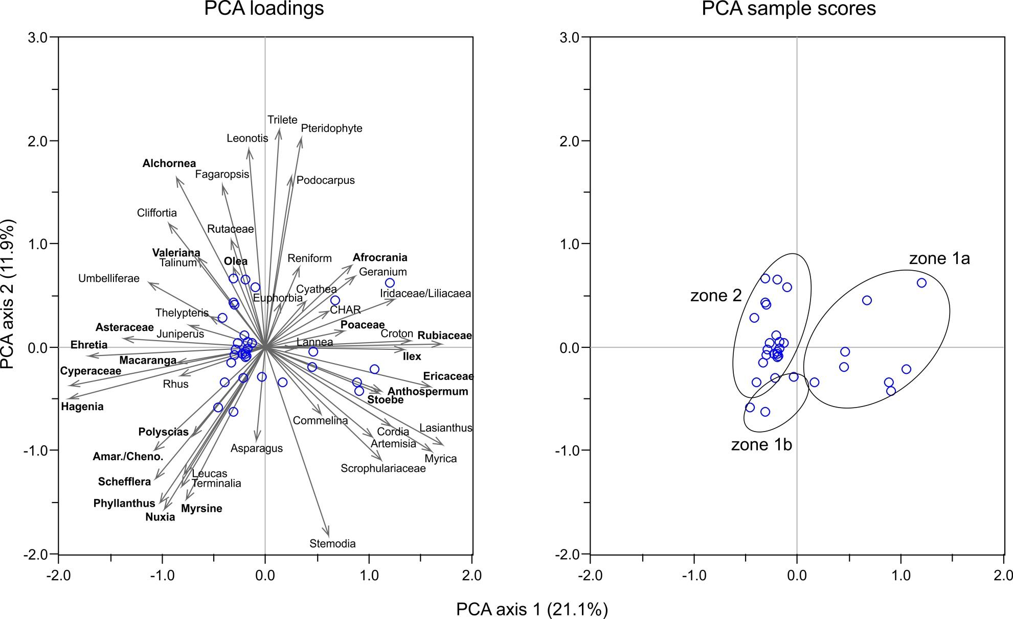

Supplemental Figure 1 References

Hotelling, H. 1933. Analysis of a complex of statistical variables into principal components. Journal of Educational Psychology 24, 417–441 and 498–520.

Juggins, S. 2007. Software for ecological and palaeoecological data analysis and visualisation user guide Version 1.5. [C2 Software user manual]. School of Geography, Politics & Sociology, Newcastle University, UK. 73p.

Pearson, K. 1901. On Lines and Planes of Closest Fit to Systems of Points in Space. Philosophical Magazine, 2(11), 559–572.

