**Supplementary information 1; IRSL dating methodology**

For environmental dose rate measurements, we used the thick-source alpha counting (Aitken, 1988) and beta counting (Bøtter-Jensen and Mejdahl, 1988) techniques to determine the U, Th and K contents of the samples. The measured water contents of the samples range from 10 to 17%, so we have assumed a value of 15 ± 5 % as an estimate of the long-term water content. An internal K concentration of 10 ± 2% (Smedley et al., 2012) and Rb concentration of 400 ± 100 ppm were assumed (Huntley and Hancock, 2001). The equivalent dose (De) was determined using a single-aliquot regenerative-dose (SAR) post-IR IRSL (pIRIR) procedures (Thomsen et al., 2008) to overcome the anomalous fading effect. Due to the dim IRSL signals from the samples from this region, it was used a two-step pIRIR procedure (Glauberman et al., 2020), which involves a prior IR stimulation at 100 °C for 200 and a post-IR IR stimulation at 290 °C for either 200 s, so called pIRIR (100, 290). We used a preheat of 320 °C for 60 s for the natural, regenerative and test doses. An IR bleach at 325 °C for 100 s was applied at the end of each SAR cycle. Example pIRIR decay curves of the natural and regenerative signals from one aliquot of sample Alapars-OSL1 is shown in Fig. SI1a.

The performance of the pIRIR (100, 290) signals was checked using several tests, including residual, dose recovery and anomalous fading tests. For the residual dose test, 3 aliquots from Alapars-OSL1 were bleached for ~4 hr using a UVACUBE 400 solar simulator before being measured using the pIRIR procedure mentioned above. The residual doses obtained for the 290°C pIRIR signal is 9 ± 2 Gy, which is subtracted from the De values for calculating the final ages. Dose recovery tests were performed on 5 aliquots from Alapars-OSL1. The aliquots were bleached for ~4 hr using the solar simulator before giving a beta dose of 200 Gy. The given dose was then measured as surrogate ‘natural’ doses using the same pIRIR procedure. The measured dose for the 290°C pIRIR signals is 216 ± 9 Gy, corresponding to a dose recovery ratio of 1.04 ± 0.05 after correcting for residual dose. This suggests that the given dose can be recovered successfully using the pIRIR (100, 290) procedure.

Anomalous fading tests were conducted on 12 aliquots, including 6 from each of Alapas-OSL1 and -OSL2, using a single-aliquot procedure similar to that described by Auclair et al. (2003), but based on the pIRIR (100, 290) procedure. After being measured for De, these aliquots were given ~200 Gy, and then preheated and stored for various periods of up to 1 week at room temperature. The 290 °C pIRIR signal as a function of delay time was shown in Fig. SIb. There is no detectable loss of IRSL signals, and the g-value obtained for the data from both samples is -1.1 ± 0.9 %/decade, suggesting that the pIRIR signals suffer negligible fading signals for our samples. We, therefore, did not make any fading correction for the ages.

Based on the above performance tests, from 8 to 11 aliquots were measured for each sample to determine their De values. The distribution of De for individual aliquots from each sample are shown in Figs. SI1c–f. The over-dispersion (OD) values range from 12 to 46%, but they are all associated large uncertainties.



Figure SI1: (a) Typical natural and regenerative decay curves of the 290 °C pIRIR signals for one aliquot from sample Alapars-OSL1. (b) Anomalous fading test results of the 290 °C pIRIR signal from sample Alapars-OSL1 and -OSL2. (c–f) Radial plots showing the distribution of the 290 °C pIRIR De for for Alapars-OSL-1, -2, -3 and -4, respectively.

**Supplementary information 2**

**Tephra analysis**

Contiguous 5 cm thick samples through Units 9–6 were assessed for their cryptotephra content following the recommendations of Lane et al., (2014). Sub-samples of approximately 0.5 cm3 were dried overnight at 105°C, before combustion at 550°C to remove organics. Combusted residues were then treated with 10% HCL to remove carbonates, with the remaining material passed thorough nylon sieves with 125 μm and 15 μm diameter apertures. Sieved material in the 15–125 μm size range was processed for tephra following the Blockley et al., (2005) flotation method. Optical examination after floatation revealed high concentrations of volcanic glass shards, thus in order to reliably quantify concentrations, residues were ‘spiked’ with Lycopodium spores following Gehrels et al., (2008), and mounted on glass slides using Canada balsam. Optical characterisation of glass shards was made using high-powered polarizing light microscopy at 200 and 400 x magnification and quantification of the glass shard concentrations were made using the following:

C=(lxa/b)d  
  
Where c = concentration of glass shards, l = number of Lycopodium spores in a tablet, a = glass shard count, b = Lycopodium spore count, d = dry sample weight in grams.  
  
**Tephra results/ analysis**  
  
Aside from the pumice rich unit (Unit 12) at the base of the Alapars-1 sequence, no units with a clear volcanic origin were identified based on macroscale sedimentological observations. Thus, we decided to assess Units 6–8 for their cryptotephra potential, with results from these units determining the viability of further cryptotephra assessment at the site. Throughout Units 8–6 high concentrations of colourless glass shards were identified, with values ranging from c. 50K to c. 2M shards g-1 dry weight (Figure S2). The distribution profile is, however, continuous and lacks any obvious structure indicative of primary input derived from a primary volcanic eruption (see Davies 2015). The high ‘background’ values are instead more suggestive of a supply of volcanic material to the site from antecedent tephra deposits (Lowe and Hunt, 2001). This interpretation of sediment transport to the site is supported by the morphology of the glass shards, which in many instances show a degree of rounding, likely due to aeolian or fluvial transport processes. Due to the overly high background concentrations of tephra in Units 6–8 it was decided that the site was not viable for further cryptotephrostratigraphic investigation.  
  
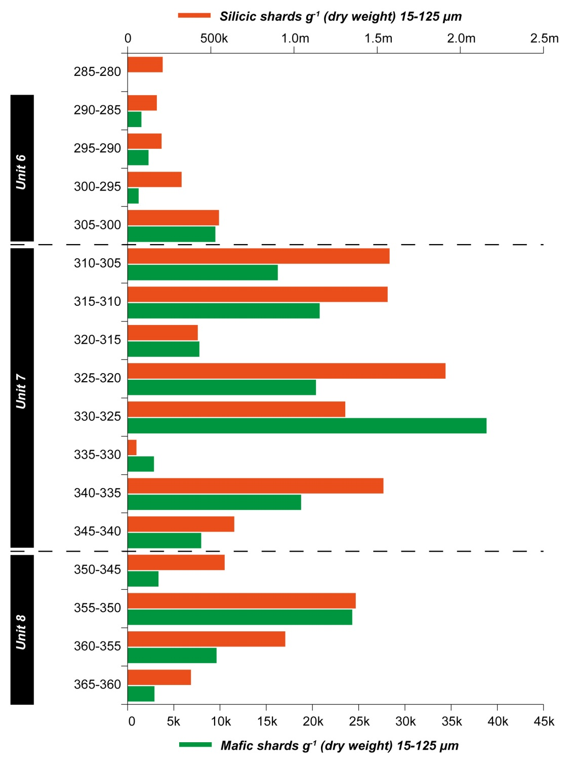

Figure SI2: Volcanic glass shard concentrations from Alapars-1 (Units 8–6). Note the difference in scale between the upper and lower axis.

**References**Aitken, M. J., 1985. *Thermoluminescence dating*. Academic press, London.

Aitken, M. J. 1998. *An introduction to optical dating.* Oxford university press, oxford.

Auclair, M., Lamothe., Huot, S. 2003. Measurement of anomalous fading for feldspar IRSL using Sar. *Radiation Measurements*, 37, 487-492.

Blockley, S.P.E., Pyne-O’Donnell, S.D.F., Lowe, J.J., Matthews, I.P., Stone, A., Pollard, A.M., Turney, C.S.M., Molyneux, E.G., 2005. A new and less destructive laboratory procedure for the physical separation of distal glass tephra shards from sediments. *Quaternary Science Reviews*, 24, 1952-1960.  
Bøtter-Jensen, L., Andersen, C. E., Duller, G. A. T., Murray, A. S. 2003. Developments in radiation, stimulation and observation facilities in luminescence measurements. *Radiation Measurements*, 37, 535-541.

Bøtter-Jensen, L., Mejdahl, V. 1988. Assessment of beta-dose-rate using a gm multicounter system. *Nuclear tracks and radiation measurements*, 14, 187-191.

Davies, S.M., 2015. Cryptotephras: the revolution in correlation and precision dating. *Journal of Quaternary Science*, 30, 114-130.  
Galbraith, R. F., Roberts, R. G., Laslett, G. M., Voshida, H., Olley, J. M. 1999. Optical dating of single and multiple grains of quartz from Jinmium rock shelter, northern Australia, part 1, experimental design and statistical models. *Archaeometry*, 41, 339-364.

Huntley, D. J., Hancock, R. G. V. 2001. The rb contents of the k-feldspars being measured in optical dating. *Ancient TL*, 19, 43-46.

Gehrels, M.J., Newnham, R.M., Lowe, D.J., Wynne, S., Hazell, Z.J., Caseldine, C., 2008. Towards rapid assay of cryptotephra in peat cores: review and evaluation of various methods. *Quaternary International*, 178, pp.68-84.  
Lane, C.S., Cullen, V.L., White, D., Bramham-Law, C.W.F. and Smith, V.C., 2014. Cryptotephra as a dating and correlation tool in archaeology. *Journal of Archaeological Science*, 42, 42-50.  
Lowe, D.J., Hunt, J.B. 2001. A summary of terminology used in tephra-related studies. *Les Dossiers de l’Archaéo-Logis* 1, 17-22  
Smedley, R. K., Duller, G. A. T., Pearce, N. J. G., Roberts, H. M. 2012. Determining the k-content of single-grains of feldspar for luminescence dating*. Radiation Measurements*, 47, 790-796.

Thomsen, K. J., Murray, A. S., Jain, M., Botter-Jensen, l. 2008. Laboratory fading rates of various luminescence signals from feldspar-rich sediment extracts. *Radiation Measurements*, 43, 1474-1486.