Supplementary Material
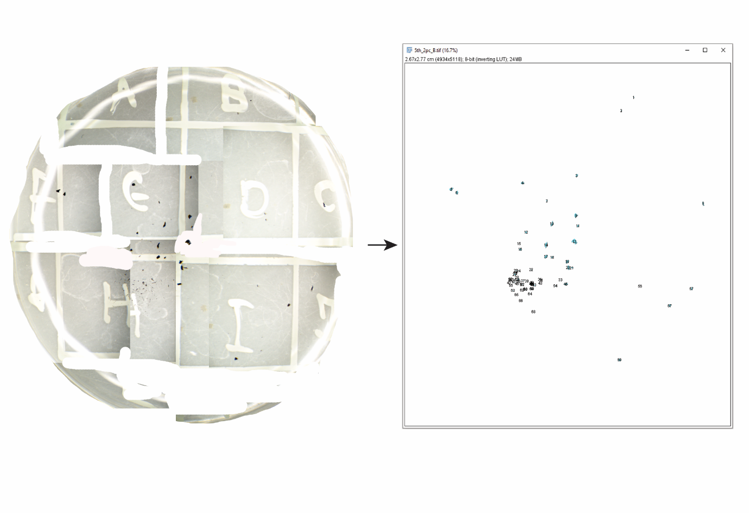

Figure S1. Reconstructed petri dish of NaClO 12.5% at the final time step (T4) and automated identification of charcoal fragments in ImageJ.
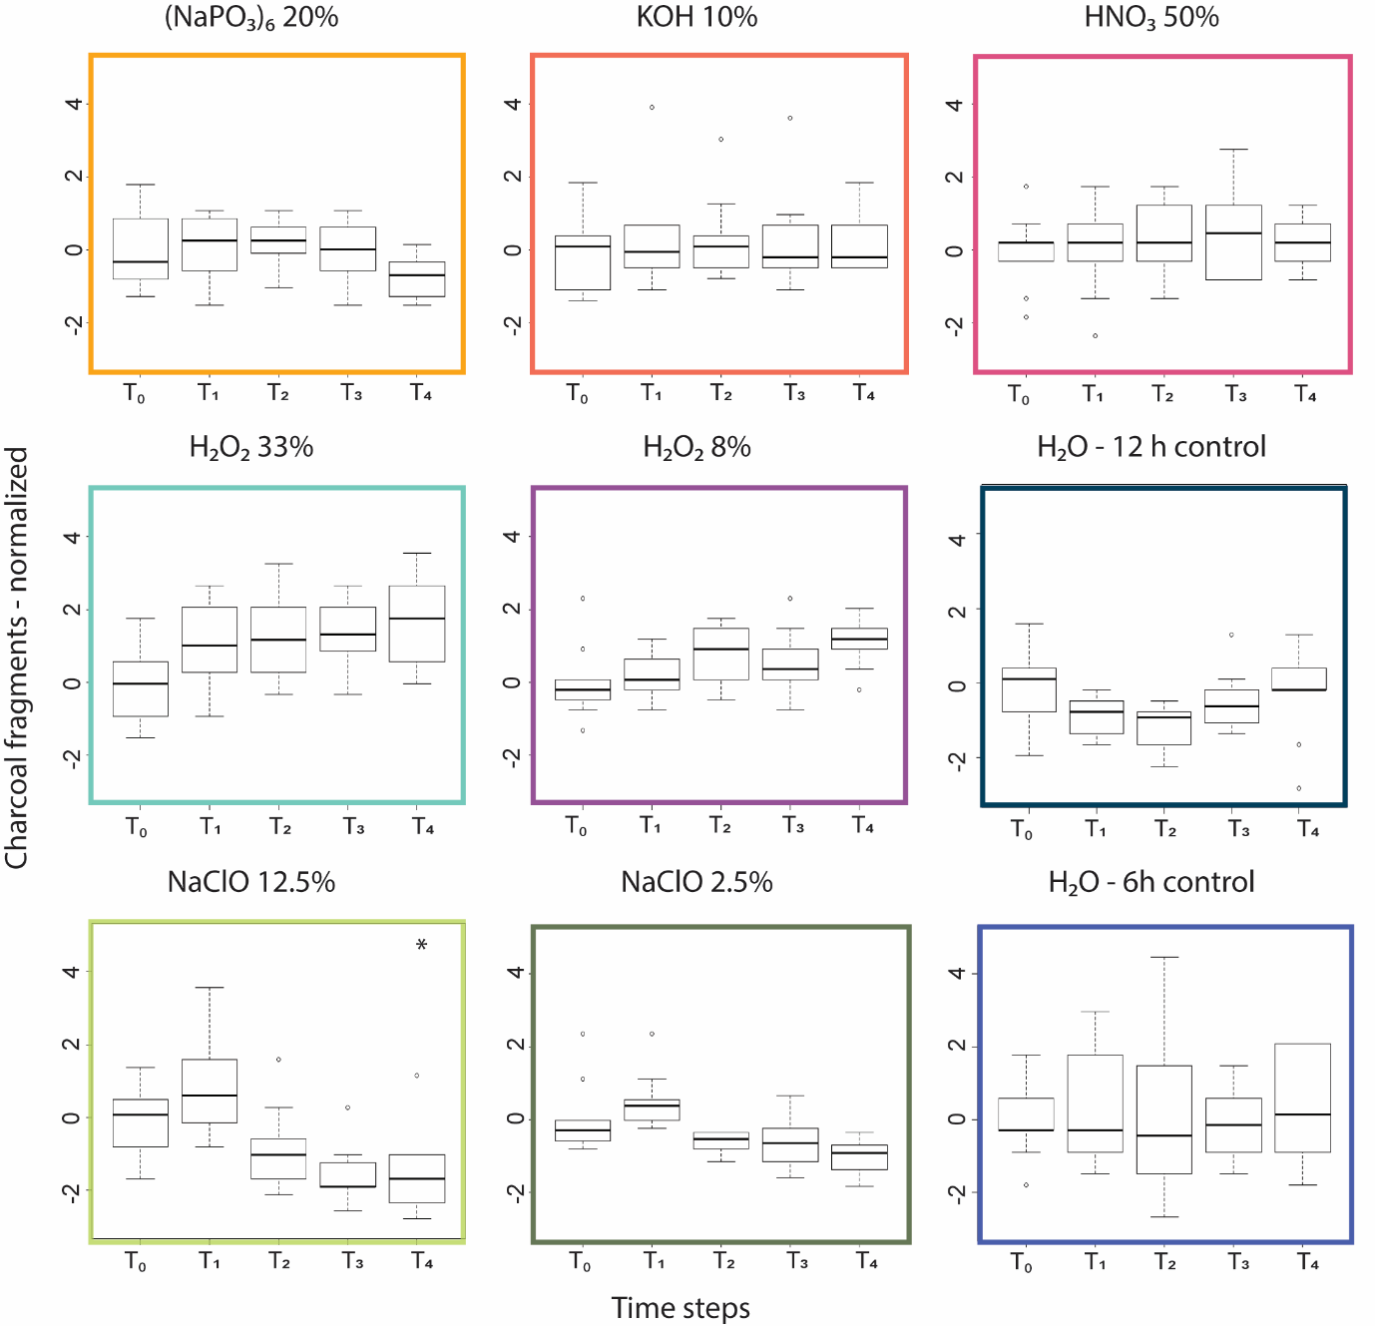
Figure S2. Charcoal number of fragments change over 12h and 6h time steps when subjected to widely used chemicals in charcoal analysis. Samples constitute a known mixture of modern charcoal types produced in the lab. For every chemical treatment and two H₂O control sets n = 10. Mixed ANOVAs were not possible for this data set due to violations on the assumption of sphericity. Color boxes are the same used as in Figures 2 and 3 to indicate the same treatments.

Table S1: Chemicals, concentrations, and exposure times used for the extraction of charcoal for fire studies around the world. More than one chemical usually indicates a second bleaching step. For full names of the chemicals see text. n/a = not available information in the referenced publication. Note this is not an exhaustive list. Studies were chosen on the basis that they were from all around the world and using different chemicals or combinations thereof.
Reference | Chemical | Conc. | Time | Sediment type | Country | Notes
Blarquez et al., 2018 | NaClO | 8% | 24 h | Peat | Canada
Hawthorne and Mitchell, 2016 | (NaPO₃)₆  H₂O₂ | 15%  diluted | 24 h  n/a | Lacustrine | Ireland
Crawford and Belcher, 2016 | NaClO | 8% | 20 h | Peat | UK
Fletcher et al., 2018 | NaClO | n/a | n/a | Lacustrine | Tasmania
Mariani and Fletcher, 2017 | NaClO | 5% | <2 weeks | Multiple | Australia
Walsh et al., 2017 | (NaPO₃)₆  NaClO | 5%  weak | >24 h  1h | Lacustrine | USA
Finsinger et al., 2017 | NaOH  NaClO | 10%  2% | n/a  n/a | Lacustrine | Romania
Anderson and Wahl, 2016 | (NaPO₃)₆  NaClO | 3%  6% | >24 h  n/a | Lacustrine | Guatemala
Pérez -Obiol et al., 2016 | KOH  NaClO | n/a  15% | 1.5 h  1.5 h | Peat | Spain | samples heated to 70°C
Chipman et al., 2015 | NaO₃P  NaClO | 10%  n/a | 20h  20h | Lacustrine | Alaska, USA | freeze-dried overnight / chemicals possibly mixed
Robin et al., 2013 | NaClO | 13% | 24 h | Peat | Germany
Genries et al., 2012 | NaP₂O₄  NaClO | 3%  10% | n/a  n/a | Lacustrine | Canada
Olsson et al., 2010 | NaClO | 5% | 24 h | Lacustrine | Sweden
Gardner and Whitlock, 2001 | (NaPO₃)₆  NaClO | 1%  5% | 24 h  5min | Lacustrine | Northwest USA | heated at low temperature to remove excessive invertebrate faeces
Glais et al., 2017 | NaOH  H₂O₂ | 10%  6% | 24 h  24 h | Peat | Greece
Finsinger et al., 2017 | H₂O₂ | 15% | overnight | Peat | Serbia
Spencer et al., 2017 | H₂O₂ | 3% | n/a | Lacustrine | USA
Pillai et al., 2017 | NaO₃P  H₂O₂ | 5%  8% | n/a  12h | wetland cores | India
Colombaroli et al., 2018 | NaO₃P  H₂O₂ | 5%  8% | n/a  12h | Lacustrine | Kenya
Rius et al., 2011 | NaOH  H₂O₂ | 10%  6% | 24 h  24 h | Multiple | France
Mustaphi and Pisaric, 2014 | NaO₃P | n/a | 24 h | Lacustrine | Canada
Miyabuchi et al., 2012 | (NaPO₃)₆  KOH  H₂O₂ | 5%  10%  1% | 24 h  24 h  n/a | Tephra | Japan
Olsson et al., 2010 | NaOH | 10% | 24 h | Lacustrine | Sweden
Thevenon et al., 2003 | HCL  HNO₃  H₂O₂ | 3M  conc.  33% | n/a  n/a  n/a | Lacustrine | Tanzania

Table S2: Mean and standard deviation of normalized replicates within each time step for the 12 h batch. Results of repeated measures ANOVA for the 12h batch—significance of the effect of treatment noted.
Overall | H₂O₂ 33% | 2.05±1.19
 | H₂O₂ 8% | 0.99±0.57 | 0.99±0.57
 | HNO₃ 50% | 1.38±0.81 | 1.38±0.81 | 1.38±0.81
 | KOH 10% | 1.65±1.08 | 1.65±1.08 | 1.65±1.08 | 1.65±1.08
 | (NaPO₃)₆ 20% | 1.95±1.11 | 1.95±1.11 | 1.95±1.11 | 1.95±1.11 | 1.95±1.11
T0 | H₂O₂ 33% | 0±1
 | H₂O₂ 8% | 0±1 | 0±1
 | HNO₃ 50% | 0±1 | 0±1 | 0±1
 | KOH 10% | 0±1 | 0±1 | 0±1 | 0±1
 | (NaPO₃)₆ 20% | 0±1 | 0±1 | 0±1 | 0±1 | 0±1
T1 | H₂O₂ 33% | 2.01±1.06
 | H₂O₂ 8% | 1.05±0.71 | 1.05±0.71
 | HNO₃ 50% | 1.42±0.82 | 1.42±0.82 | 1.42±0.82
 | KOH 10% | 1.17±1.22 | 1.17±1.22 | 1.17±1.22 | 1.17±1.22
 | (NaPO₃)₆ 20% | 2.14±1.14 | 2.14±1.14 | 2.14±1.14 | 2.14±1.14 | 2.14±1.14
T2 | H₂O₂ 33% | 2.79±0.78
 | H₂O₂ 8% | 1.43±0.58 | 1.43±0.58
 | HNO₃ 50% | 1.60±0.80 | 1.60±0.80 | 1.60±0.80
 | KOH 10% | 2.00±1.20 | 2.00±1.20 | 2.00±1.20 | 2.00±1.20
 | (NaPO₃)₆ 20% | 2.68±0.92 | 2.68±0.92 | 2.68±0.92 | 2.68±0.92 | 2.68±0.92
T3 | H₂O₂ 33% | 2.62±0.69
 | H₂O₂ 8% | 1.26±0.63 | 1.26±0.63
 | HNO₃ 50% | 1.85±0.86 | 1.85±0.86 | 1.85±0.86
 | KOH 10% | 2.39±1.14 | 2.39±1.14 | 2.39±1.14 | 2.39±1.14
 | (NaPO₃)₆ 20% | 2.56±0.98 | 2.56±0.98 | 2.56±0.98 | 2.56±0.98 | 2.56±0.98
T4 | H₂O2 33% | 2.81±0.64
 | H₂O₂ 8% | 1.21±0.42 | 1.21±0.42
 | HNO₃ 50% | 2.04±0.82 | 2.04±0.82 | 2.04±0.82
 | KOH 10% | 2.67±1.29 | 2.67±1.29 | 2.67±1.29 | 2.67±1.29
 | (NaPO₃)₆ 20% | 2.39±1.29 | 2.39±1.29 | 2.39±1.29 | 2.39±1.29 | 2.39±1.29
 |  | H₂O 12h | H₂O₂ 33% | H₂O₂ 8% | HNO₃ 50% | KOH 10%

p>0.5; p<0.05; p<0.01; p<0.001

Table S3: Mean and standard deviation of normalized replicates within each time step for the 6 h batch. Results of repeated measures ANOVA for the 6h batch—significance of the effect of treatment noted.
Overall | NaClO 2.5% | 0.06±0.62
 | H₂O | 0.24±0.26 | 0.24±0.26
T0 | NaClO 2.5% | 0±1
 | H₂O | 0±1 | 0±1
T1 | NaClO 2.5% | 0.920±0.42
 | H₂O | 0.500±0.54 | 0.500±0.54
T2 | NaClO 2.5% | 0.29±0.66
 | H₂O | −0.66±1.13 | −0.66±1.13
T3 | NaClO 2.5% | −0.12±0.62
 | H₂O | 0.47±1.36 | 0.47±1.36
T4 | NaClO 2.5% | −0.79±0.47
 | H₂O | 0.30±0.68 | 0.30±0.68
 |  | NaClO 12.5% | NaClO 2.5%

p>0.5; p<0.05; p<0.01; p<0.001

Table S4: Mean and standard deviation of normalized replicates within each chemical for the 12 h batch. Results of repeated measures ANOVA for the 12 h batch—significance of the effect of time noted.
Overall | T1 | 1.44±0.22
 | T2 | 1.92±0.21 | 1.92±0.21
 | T3 | 1.92±0.19 | 1.92±0.19 | 1.92±0.19
 | T4 | 1.20±0.35 | 1.20±0.35 | 1.20±0.35 | 1.20±0.35
H₂O 12h | T1 | 0.85±0.73
 | T2 | 1.05±0.91 | 1.05±0.91
 | T3 | 0.84±0.82 | 0.84±0.82 | 0.84±0.82
 | T4 | 0.88±0.77 | 0.88±0.77 | 0.88±0.77 | 0.88±0.77
H₂O₂ 33% | T1 | 2.01±1.06
 | T2 | 2.79±0.78 | 2.79±0.78
 | T3 | 2.62±0.69 | 2.62±0.69 | 2.62±0.69
 | T4 | 2.81±0.64 | 2.81±0.64 | 2.81±0.64 | 2.81±0.64
H₂O₂ 8% | T1 | 1.05±0.71
 | T2 | 1.43±0.57 | 1.43±0.57
 | T3 | 1.26±0.63 | 1.26±0.63 | 1.26±0.63
 | T4 | 1.21±0.42 | 1.21±0.42 | 1.21±0.42 | 1.21±0.42
HNO₃ 50% | T1 | 1.42±0.82
 | T2 | 1.60±0.80 | 1.60±0.80
 | T3 | 1.85±0.86 | 1.85±0.86 | 1.85±0.86
 | T4 | 2.04±0.82 | 2.04±0.82 | 2.04±0.82 | 2.04±0.82
KOH 10% | T1 | 1.17±1.22
 | T2 | 2.00±1.20 | 2.00±1.20
 | T3 | 2.39±1.14 | 2.39±1.14 | 2.39±1.14
 | T4 | 2.67±1.29 | 2.67±1.29 | 2.67±1.29 | 2.67±1.29
(NaPO₃)₆ 20% | T1 | 2.14±1.14
 | T2 | 2.68±0.92 | 2.68±0.92
 | T3 | 2.56±0.98 | 2.56±0.98 | 2.56±0.98
 | T4 | 2.38±1.29 | 2.38±1.29 | 2.38±1.29 | 2.38±1.29
 |  | T0 | T1 | T2 | T3

p>0.5; p<0.05; p<0.01; p<0.001

Table S5: Mean and standard deviation of normalized replicates within each chemical for the 6 h batch. Results of repeated measures ANOVA for the 6h batch—significance of the effect of time noted.

Overall | T1 | 0.28±0.06
 | T2 | −0.48±0.35 | −0.48±0.35
 | T3 | −0.53±0.53 | −0.53±0.53 | −0.53±0.53
 | T4 | −0.83±0.13 | −0.83±0.13 | −0.83±0.13 | −0.83±0.13
NaClO 12.5% | T1 | −0.59±0.45
 | T2 | −1.65±0.45 | −1.65±0.45
 | T3 | −1.94±0.33 | −1.94±0.33 | −1.94±0.33
 | T4 | −2.18±0.44 | −2.18±0.44 | −2.18±0.44 | −2.18±0.44
NaClO 2.5% | T1 | 0.92±0.42
 | T2 | 0.29±0.66 | 0.29±0.66
 | T3 | −0.11±0.62 | −0.11±0.62 | −0.11±0.62
 | T4 | 0.30±0.68 | 0.30±0.68 | 0.30±0.68 | 0.30±0.68
H₂O 6h | T1 | 0.50±0.54
 | T2 | −0.67±1.13 | −0.67±1.13
 | T3 | 0.47±1.36 | 0.47±1.36 | 0.47±1.36
 | T4 | 0.30±0.68 | 0.30±0.68 | 0.30±0.68 | 0.30±0.68
 |  | T0 | T1 | T2 | T3

p>0.5; p<0.05; p<0.01; p<0.001

Table S6: Spearman Correlation coefficients between sequences analysed with the same chemicals.
Chemical Treatment | Sequences | Spearman Correlation
H₂O₂ 33% | A vs D | 0.223
 | A vs G | 0.549*
 | D vs G | 0.517*
NaClO 12.5% | B vs E | 0.512
 | B vs H | 0.653*
 | E vs H | 0.741**
HNO₃ 50% | C vs F | 0.824**
 | C vs I | 0.591*
 | F vs I | 0.685**
**Correlation significant at the 0.01 level *Correlation significant at the 0.05 level

Table S7: Spearman Correlation coefficients between numbers (# cm¯³) and area (mm³ cm¯³) of fragments for the nine fossil sequences. Chemical treatment used to analyse each sequence also given.
 | Treatment | Spearman Correlation
SeqA | H₂O₂ 33% | 0.898**
SeqB | NaClO 12.5% | 0.897**
SeqC | HNO₃ 50% | 0.937**
SeqD | H₂O₂ 33% | 0.951**
SeqE | NaClO 12.5% | 0.833**
SeqF | HNO₃ 50% | 0.923**
SeqG | H₂O₂ 33% | 0.936**
SeqH | NaClO 12.5% | 0.916**
SeqI | HNO₃ 50% | 0.962**
**Correlation significant at the 0.01 level

REFERENCES
Anderson, L., & Wahl, D., 2016. Two Holocene paleofire records from Peten, Guatemala: Implications for natural fire regime and prehispanic Maya land use. Global and Planetary Change, 138, 82-92. https://doi.org/10.1016/j.gloplacha.2015.09.0123
Blarquez, O., Talbot, J., Paillard, J., Lapointe-Elmrabti, L., Pelletier, N., St-Pierre, C.G., 2018. Late Holocene influence of societies on the fire regime in southern Québec temperate forests. Quaternary Science Reviews, 180, 63-74.https://doi.org/10.1016/j.quascirev.2017.11.022
Chipman, M.L., Hudspith, V., Higuera, P.E., Duffy, P.A., Kelly, R., Oswald, W.W., Hu, F.S., 2015. Spatiotemporal patterns of tundra fires: late-Quaternary charcoal records from Alaska. Biogeosciences, 12(13), 4017-4027. doi:10.5194/bg-12-4017-2015
Colombaroli, D., van der Plas, G., Rucina, S., Verschuren, D., 2018. Determinants of savanna-fire dynamics in the eastern Lake Victoria catchment (western Kenya) during the last 1200 years. Quaternary International, 488, 67-80. https://doi.org/10.1016/j.quaint.2016.06.028
Crawford, A.J., & Belcher, C.M., 2016. Area–volume relationships for fossil charcoal and their relevance for fire history reconstruction. The Holocene, 26(5), 822-826. https://doi.org/10.1177/0959683615618264
Finsinger, W., Morales-Molino, C., Gałka, M., Valsecchi, V., Bojovic, S., Tinner, W., 2017. Holocene vegetation and fire dynamics at Crveni Potok, a small mire in the Dinaric Alps (Tara National Park, Serbia). Quaternary science reviews, 167, 63-77. https://doi.org/10.1016/j.quascirev.2017.04.032
Fletcher, M.S., Bowman, D.M.J.S., Whitlock, C., Mariani, M., Stahle, L., 2018. The changing role of fire in conifer-dominated temperate rainforest through the last 14,000 years. Quaternary Science Reviews, 182, 37-47. https://doi.org/10.1016/j.quascirev.2017.12.023
Gardner, J.J., Whitlock, C., 2001. Charcoal accumulation following a recent fire in the Cascade Range, northwestern USA, and its relevance for fire-history studies. The Holocene, 11(5), 541-549. https://doi.org/10.1191/095968301680223495
Genries, A., Finsinger, W., Asnong, H., Bergeron, Y., Carcaillet, C., Garneau, M., et al., 2012. Local versus regional processes: can soil characteristics overcome climate and fire regimes by modifying vegetation trajectories?. Journal of Quaternary Science, 27(7), 745-756. https://doi.org/10.1002/jqs.2560
Glais, A., Lespez, L., Vannière, B., Lopez-Saez, J.A., 2017. Human-shaped landscape history in NE Greece. A palaeoenvironmental perspective. Journal of Archaeological Science: Reports, 15, 405-422. https://doi.org/10.1016/j.jasrep.2017.06.017
Hawthorne, D., & Mitchell, F J., 2016. Identifying past fire regimes throughout the Holocene in Ireland using new and established methods of charcoal analysis. Quaternary Science Reviews, 137, 45-53. https://doi.org/10.1016/j.quascirev.2016.01.027
Mariani, M., Fletcher, M.S., 2017. Long-term climate dynamics in the extra-tropics of the South Pacific revealed from sedimentary charcoal analysis. Quaternary Science Reviews, 173, 181-192. https://doi.org/10.1016/j.quascirev.2017.08.007
Miyabuchi, Y., Sugiyama, S., Nagaoka, Y., 2012. Vegetation and fire history during the last 30,000 years based on phytolith and macroscopic charcoal records in the eastern and western areas of Aso Volcano, Japan. Quaternary International, 254, 28-35. https://doi.org/10.1016/j.quaint.2010.11.019
Mustaphi, C.J.C., Pisaric, M.F., 2014. Holocene climate–fire–vegetation interactions at a subalpine watershed in southeastern British Columbia, Canada. Quaternary Research, 81(2), 228-239. https://doi.org/10.1016/j.yqres.2013.12.002
Olsson, F., Gaillard, M.J., Lemdahl, G., Greisman, A., Lanos, P., Marguerie, D., et al., 2010. A continuous record of fire covering the last 10,500 calendar years from southern Sweden—The role of climate and human activities. Palaeogeography, Palaeoclimatology, Palaeoecology, 291(1-2), 128-141. https://doi.org/10.1016/j.palaeo.2009.07.013
Pérez-Obiol, R., García-Codron, J.C., Pelachs, A., Pérez-Haase, A., Soriano, J.M., 2016. Landscape dynamics and fire activity since 6740 cal yr BP in the Cantabrian region (La Molina peat bog, Puente Viesgo, Spain). Quaternary Science Reviews, 135, 65-78.
Pillai, A.A., Anoop, A., Sankaran, M., Sanyal, P., Jha, D.K., Ratnam, J., 2017. Mid-late Holocene vegetation response to climatic drivers and biotic disturbances in the Banni grasslands of western India. Palaeogeography, Palaeoclimatology, Palaeoecology, 485, 869-878. https://doi.org/10.1016/j.palaeo.2017.07.036
Rius, D., Vannière, B., Galop, D., Richard, H., 2011. Holocene fire regime changes from multiple-site sedimentary charcoal analyses in the Lourdes basin (Pyrenees, France). Quaternary Science Reviews, 30(13-14), 1696-1709. https://doi.org/10.1016/j.quascirev.2011.03.014
Robin, V., Knapp, H., Bork, H.R., & Nelle, O., 2013. Complementary use of pedoanthracology and peat macro-charcoal analysis for fire history assessment: illustration from Central Germany. Quaternary International, 289, 78-87. https://doi.org/10.1016/j.quaint.2012.03.031
Spencer, J., Jones, K.B., Gamble, D.W., Benedetti, M.M., Taylor, A.K., Lane, C.S., 2017. Late-Quaternary records of vegetation and fire in southeastern North Carolina from Jones Lake and Singletary Lake. Quaternary Science Reviews, 174, 33-53. https://doi.org/10.1016/j.quascirev.2017.09.001
Thevenon, F., Williamson, D., Vincens, A., Taieb, M., Merdaci, O., Decobert, M., Buchet, G., 2003. A late-Holocene charcoal record from Lake Masoko, SW Tanzania: climatic and anthropologic implications. The Holocene, 13(5), 785-792. https://doi.org/10.1191/0959683603hl665rr
Walsh, M.K., Lukens, M.L., McCutcheon, P.T., Burtchard, G.C., 2017. Fire-climate-human interactions during the postglacial period at Sunrise Ridge, Mount Rainier National Park, Washington (USA). Quaternary Science Reviews, 177, 246-264. https://doi.org/10.1016/j.quascirev.2017.10.032

