**The impact of methodological decisions on climate reconstructions using WA-PLS: Supplementary Information**

**Mark G. Turner, Dongyang Wei, I. Colin Prentice and Sandy P. Harrison**

This supplementary contains the following figures and tables:

**SI Figure 1**. Locations of samples in the EMBSeCBIO (Eastern Mediterranean-Black Sea-Caspian corridor BIOmes) database (EMB), the European Modern Pollen Database v3.0 (EMPD) and the additional sites in the SMPDS. Stars indicate location of example fossil cores.

**SI Figure 2**. Reconstructions of mean temperature of the coldest month (MTCO, ° C) during the last glacial period (80,000 to 10,000 calendar years before 2000) using the pollen records from 8 example cores, using the EMBSeCBIO (Eastern Mediterranean-Black Sea-Caspian corridor BIOmes) database (EMB), the European Modern Pollen Database v3.0 (EMPD), and the full SMPDS data set as training data sets. The reconstruction spread (±2σ) is obtained by resampling the training set 1,000 times*.*

**SI Figure 3**. Reconstructions of growing degree days above 0 ° C (GDD0, °days) during the last glacial period (80,000 to 10,000 calendar years before 2000) using the pollen records from 8 example cores, EMBSeCBIO (Eastern Mediterranean-Black Sea-Caspian corridor BIOmes) database (EMB), the European Modern Pollen Database v3.0 (EMPD), and the full SMPDS data set as training data sets. The reconstruction spread (±2σ) is obtained by resampling the training set 1,000 times.

**SI Figure 4**. Reconstructions of the square root of Moisture Index (sqrt(MI) during the last glacial period (80,000 to 10,000 calendar years before 2000) using the pollen records from 8 example cores, using the EMBSECBIO (Eastern Mediterranean-Black Sea-Caspian corridor BIOmes) database (EMB), the European Modern Pollen Database v3.0 (EMPD)), and the full SMPDS data set as training data sets. The reconstruction spread (±2σ) is obtained by resampling the training set 1,000 times. The reconstruction shown here does not account for the direct impact of CO2 on plant growth and thus will underestimate the actual value of (sqrt(MI)) during the glacial period (Wei et al, 2019a).

**SI Figure 5.** Comparison of reconstructions of mean temperature of the coldest month (MTCO, ° C) for downcore samples from Ioannina usingthe EMBSeCBIO (Eastern Mediterranean-Black Sea-Caspian corridor BIOmes) database (EMB) and the European Modern Pollen Database v3.0 (EMPD).

**SI Figure 6**. WA-PLS predictions for mean temperature of coldest month (MTCO, ° C), growing degree days above a baseline of 0 °C (GDD0, °C days) and the square root of Moisture Index (sqrt(MI)), compared with observations of modern climate for the 6 458 SMPDS sample sites. The righthand plots show the residuals against the predicted values. Red stars indicate the modern position on the climatic gradient of the 8 fossil sites used as examples*.*

**SI Figure 7**. Distribution of modern pollen samples in climate space, represented by growing degree days above 0oC (GDD0, °C days) and mean temperature of the coldest month (MTCO, °C), sampled by the full SMPDS (SMPDS) data set and after randomly reducing the data set by 70% (Red7).

**SI Figure 8**. Histogram comparing of the distribution of samples along the mean temperature of the coldest month (MTCO, °C) and growing degree days above 0 oC (GDD0, °C days) gradients using the full SMPDS set (Full SMPDS) and a set randomly removing 70% of the samples (Red7*).*

**SI Figure 9**. Change in mean standard deviation (reconstruction spread) of (a) mean temperature of the coldest month (MTCO, °C), (b) growing degree days above 0 oC (GDD0, °C days), and (c) square root of Moisture index (sqrt(MI), unitless) as the percentage of samples randomly removed increases. 10 runs were made for each reduction, each comprising 100 bootstrapped reconstructions.

**SI Figure 10**. Impact of reducing the sampling density of the modern training data set on reconstructions of temperature of the coldest month (MTCO, °C) during the last glacial period (100,000 to 10,000 calendar years before 2000) using the pollen record from Lago Grande di Monticchio. The plots show the impact of removing 70% of the modern samples randomly while preserving the overall range of climate space on the MTCO reconstructions, compared to reconstructions made with the full SMPDS data set.

**SI Figure 11**. Impact of reducing the sampling density of the modern training data set on reconstructions of growing degree days above a baseline of 0° C (GDD0, ° days) during the last glacial period (80,000 to 10,000 calendar years before 2000) using the pollen record from Lake Ioannina. The plots show the impact of removing 70% of the modern samples randomly while preserving the overall range of climate space on the GDD0 reconstructions, compared to reconstructions made with the full SMPDS data set.

**SI Figure 12**. Impact of reducing the sampling density of the modern training data set on reconstructions of growing degree days above a baseline of 0° C (GDD0, ° days) during the last glacial period (100,000 to 10,000 calendar years before 2000) using the pollen record from Lago Grande di Monticchio. The plots show the impact of removing 70% of the modern samples randomly while preserving the overall range of climate space on the GDD0 reconstructions, compared to reconstructions made with the full SMPDS data set.

**SI Figure 13**. Abundance in climate space of Asteroideae and its main subtaxa at the sample level, complementing GAMs in Figure 5. “GDD <2000” includes all samples in that range, etc. Scale applies to all plots.

**SI Figure 14.** Reconstructed mean temperature of the coldest month (MTCO, °C) at 8 sites in Europe, comparing regression using the full SMPDS set and after removing *Pinus*.

**SI Figure 15**. Reconstructed mean temperature of the coldest month (MTCO, °C) using the full SMPDS set compared to regressions based on only taxa found in the fossil set at (a) Megali Limni and (b) Ioannina. See SI Table 3.

**SI Figure 16.** Squared chord distances of the 10 nearest analogues in the SMPDS to the fossil samples at Ioannina. The lowest dot, or end of line, represents the nearest analogue.

**SI Table 1**. In addition to data from the EMPD and the EMBSeCBIO databases, the SMPDS modern training data set includes sites from the following publications.

**SI Table 2**. Details of the 8 sites from the Abrupt climate Changes and Environmental Responses (ACER) database (Sanchez Goñi et al., 2017) used as examples in this study.

**SI Table 3**. WA-PLS model parameters for all the data sets used in this study for reconstructions of mean temperature of the coldest month (MTCO, 0° C), growing degree days above a baseline of 0° C (GDD0, °day) and the square root of Moisture Index (√MI, unitless) Cross-validated *r*2, number of components with *p* < 0.05, root mean square error (RMSE), maximum bias, *p* tested by random *t*-test, and sample set size. Best components are identified by bold *p* value.

**SI Table 4**. WA-PLS model parameters for reconstructed mean temperature of the coldest month (MTCO, 0° C) comparing regression using the full SMPDS set with regression based only taxa found in the fossil set from (a) at Megali Limni (b) at Ioannina (see SI Figure 15). Cross-validated *r*2, number of components with *p* < 0.05, root mean square error (RMSE), maximum bias, and taxon set size.

**SI Table 5**. Amalgamated taxa as in Table 3, for MTCO, GDD0 and square root (MI), showing number of occurrences, total abundance, abundance-weighted SD of coefficients (optima) of component taxa, SD of coefficient of amalgamated taxon, and coefficient of amalgamated taxon. SDs are obtained by bootstrapping the sample set 1000 times.

**SI Table 6**. Component taxon data for amalgamated taxa in SI Table 5, for MTCO, GDD and square root (MI), showing number of occurrences, total abundance, SD of coefficients (optima) of component taxa, and coefficient of component taxa. SDs are obtained by bootstrapping the sample set 1000 times.

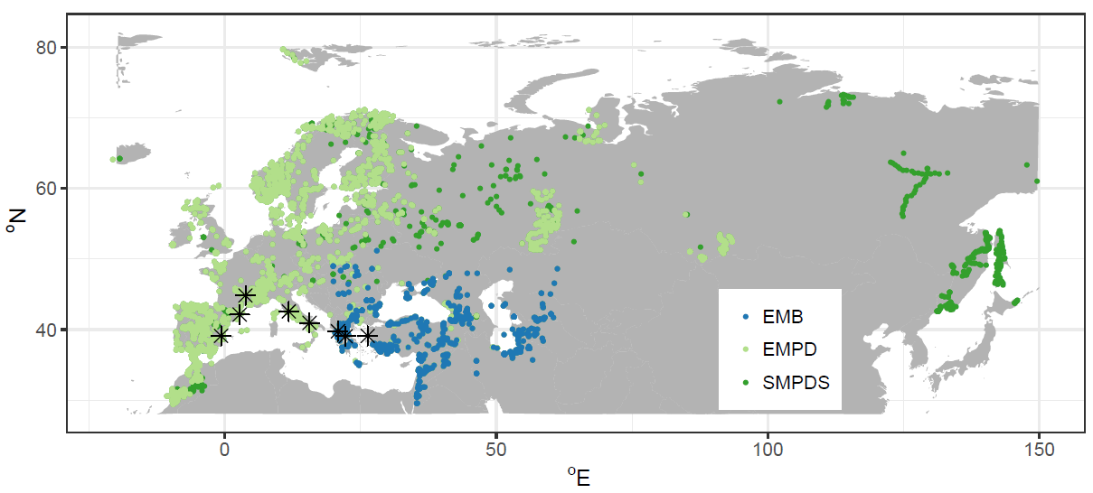

**SI Figure 1**. Locations of samples in the EMBSeCBIO (Eastern Mediterranean-Black Sea-Caspian corridor BIOmes) database (EMB), the European Modern Pollen Database v3.0 (EMPD) and the additional sites in the SMPDS. Stars indicate location of example fossil cores.

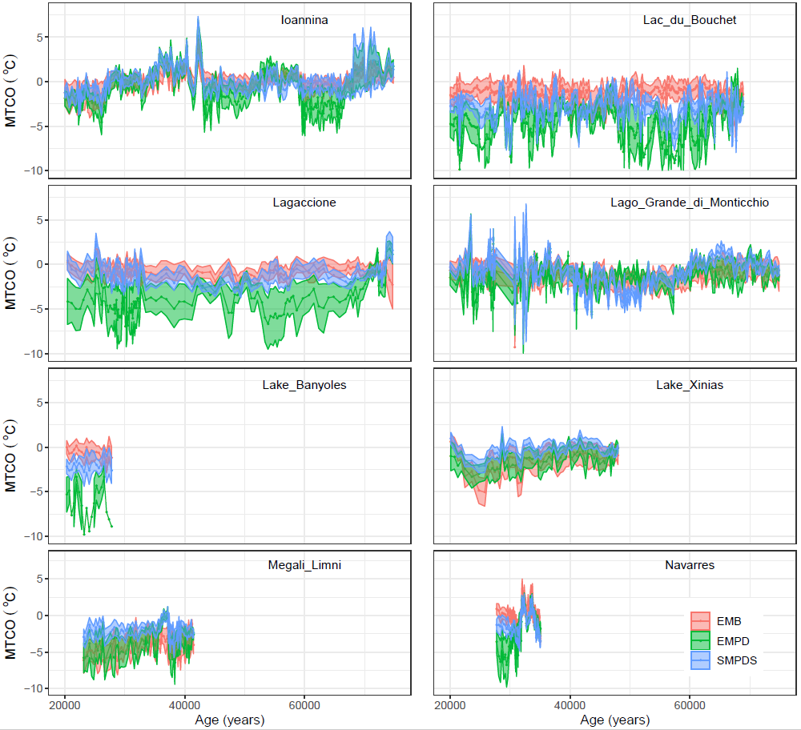

**SI Figure 2**. Reconstructions of mean temperature of the coldest month (MTCO, ° C) during the last glacial period (80,000 to 10,000 calendar years before 2000) using the pollen records from eight example cores, using the EMBSeCBIO (Eastern Mediterranean-Black Sea-Caspian corridor BIOmes) database (EMB), the European Modern Pollen Database v3.0 (EMPD), and the full SMPDS data set as training data sets. The reconstruction spread (±2σ) is obtained by resampling the training set 1,000 times*.*

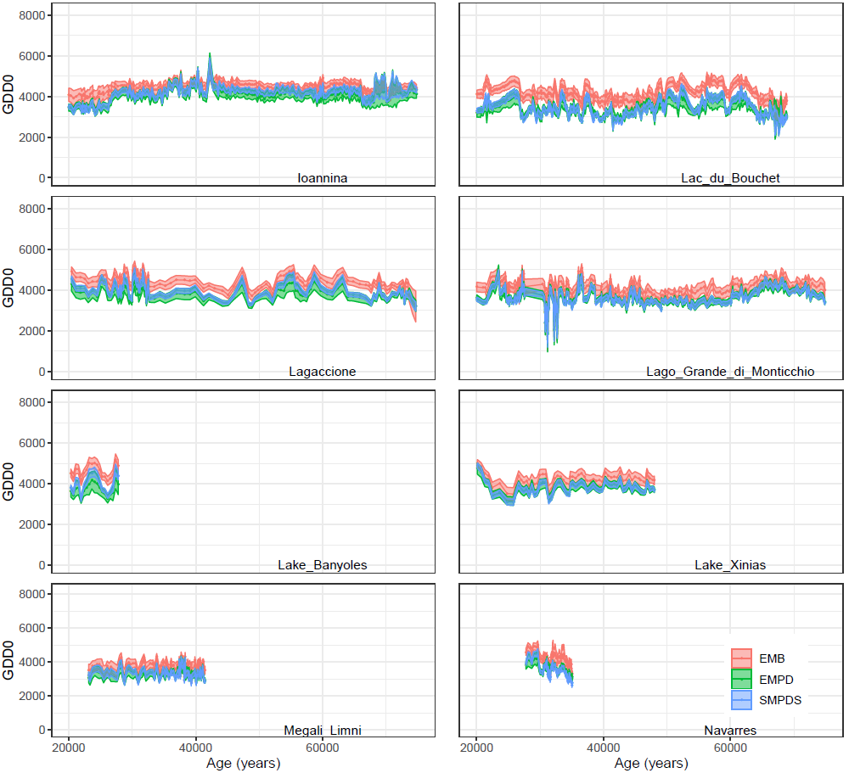

**SI Figure 3.** Reconstructions of growing degree days above 0 ° C (GDD0, °days) during the last glacial period (80,000 to 10,000 calendar years before 2000) using the pollen records from eight example cores, EMBSeCBIO (Eastern Mediterranean-Black Sea-Caspian corridor BIOmes) database (EMB), the European Modern Pollen Database v3.0 (EMPD), and the full SMPDS data set as training data sets. The reconstruction spread (±2σ) is obtained by resampling the training set 1,000 times.

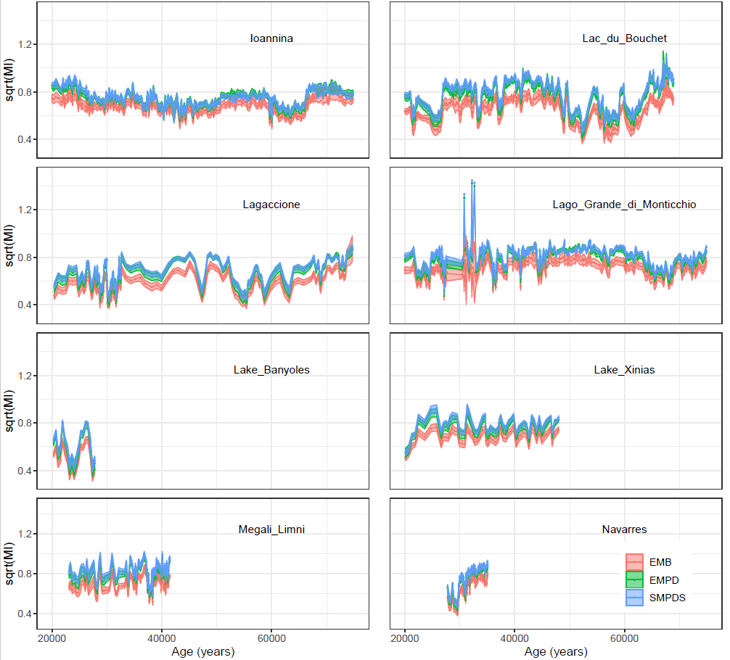

**SI Figure 4.** Reconstructions of the square root of Moisture Index (sqrt(MI)) during the last glacial period (80,000 to 10,000 calendar years before 2000) using the pollen records from eight example cores, using the EMBSECBIO (Eastern Mediterranean-Black Sea-Caspian corridor BIOmes) database (EMB), the European Modern Pollen Database v3.0 (EMPD), and the full SMPDS data set as training data sets. The reconstruction spread (±2σ) is obtained by resampling the training set 1,000 times. The reconstruction shown here does not account for the direct impact of CO2 on plant growth and thus will underestimate the actual value of (sqrt(MI)) during the glacial period (Wei et al., 2019a).

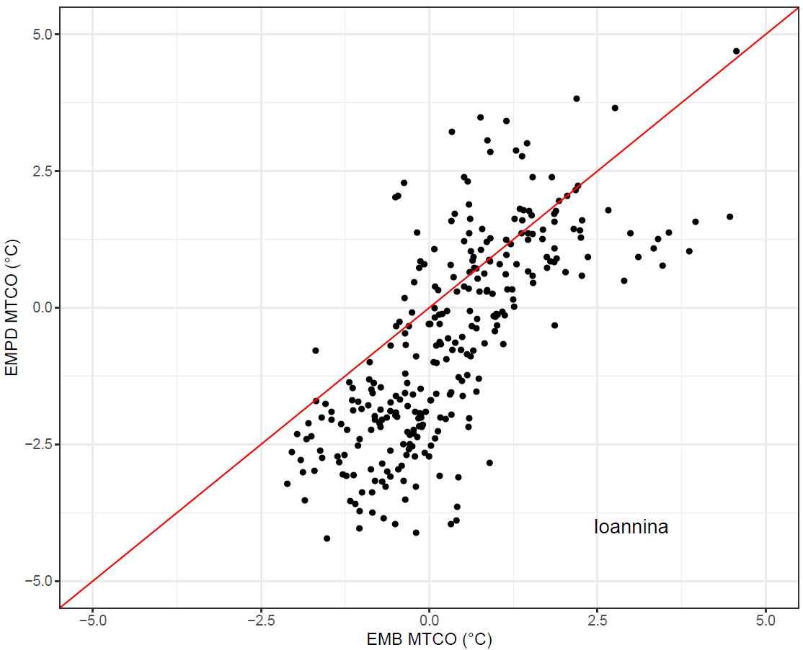

**SI Figure 5**. Comparison of reconstructions of mean temperature of the coldest month (MTCO, ° C) for downcore samples from Ioannina using the EMBSeCBIO (Eastern Mediterranean-Black Sea-Caspian corridor BIOmes) database (EMB) and the European Modern Pollen Database v3.0 (EMPD).

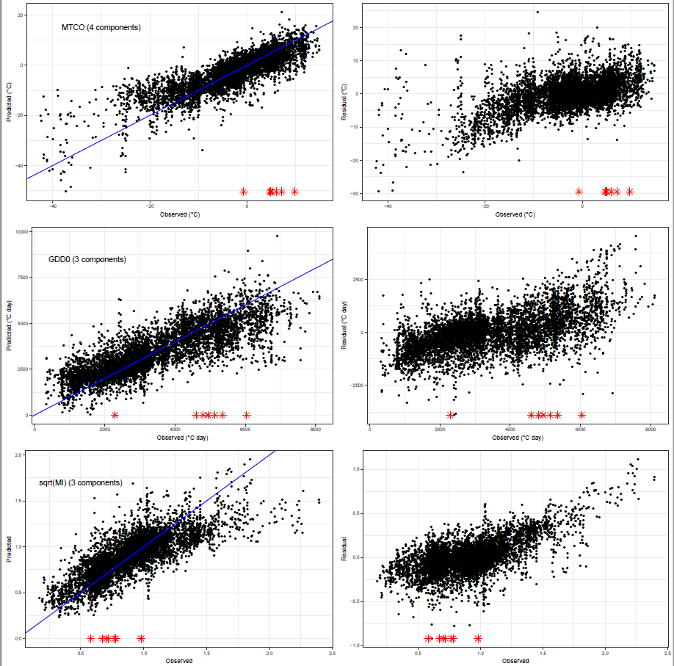

**SI Figure 6**. WA-PLS reconstructions for mean temperature of coldest month (MTCO, ° C), growing degree days above a baseline of 0 °C (GDD0, °C days) and the square root of Moisture Index (sqrt(MI)), compared with observations of modern climate for the 6458 SMPDS sample sites. The right-hand plots show the residuals against the predicted values. Red stars indicate the modern position on the climatic gradient of the eight fossil sites used as examples*.*

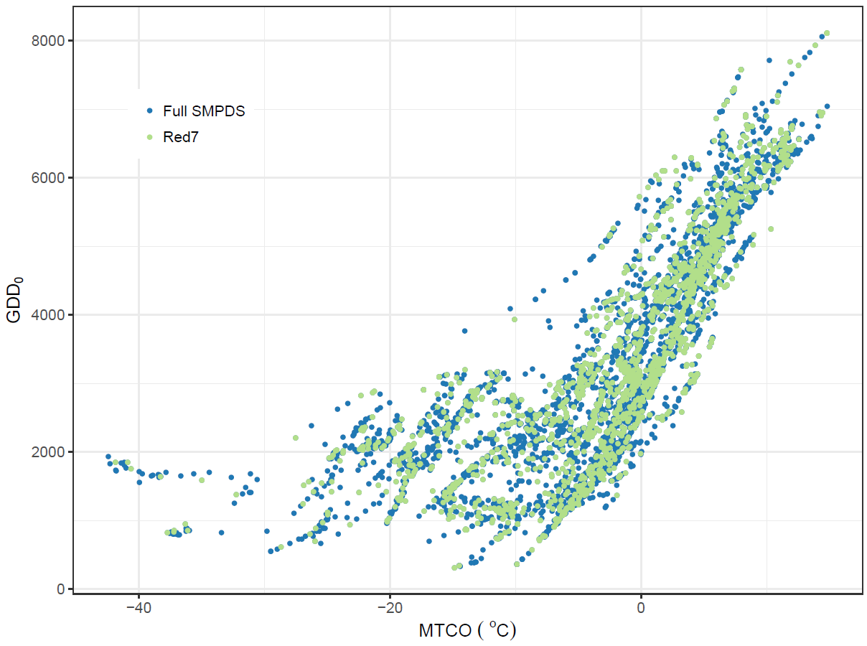

**SI Figure 7**. Distribution of modern pollen samples in climate space, represented by growing degree days above 0oC (GDD0, °C days) and mean temperature of the coldest month (MTCO, °C), sampled by the full SMPDS (SMPDS) data set and after randomly reducing the data set by 70% (Red7).

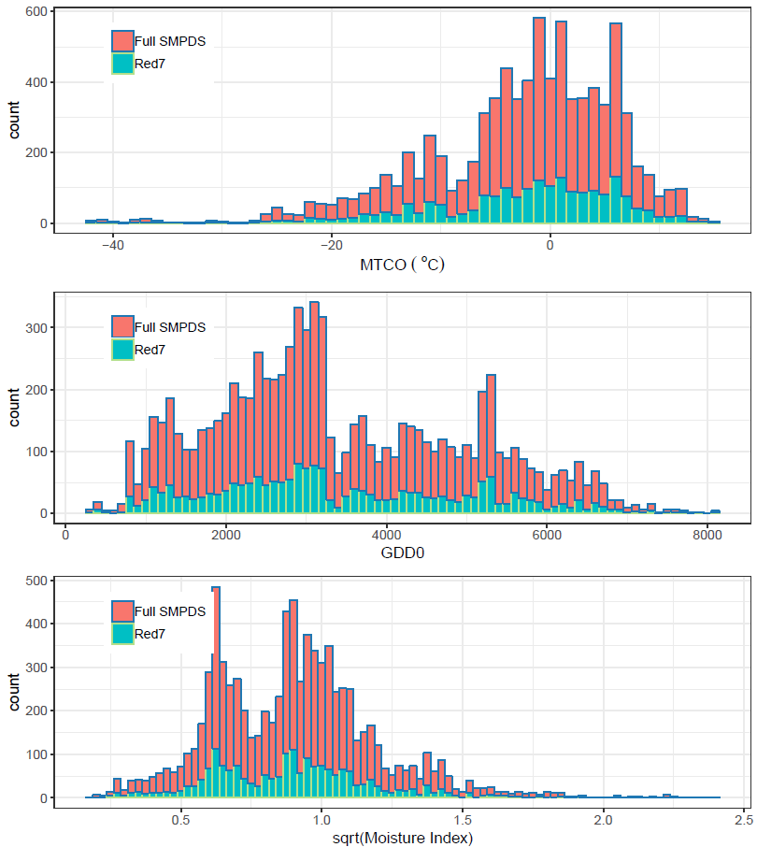**SI Figure 8**. Histograms comparing the distribution of samples along the mean temperature of the coldest month (MTCO, °C), growing degree days above 0oC (GDD0, °C days), and square root of Moisture Index (sqrt(Moisture Index) gradients using the full SMPDS set (Full SMPDS) and a set randomly removing 70% of the samples (Red7*).*

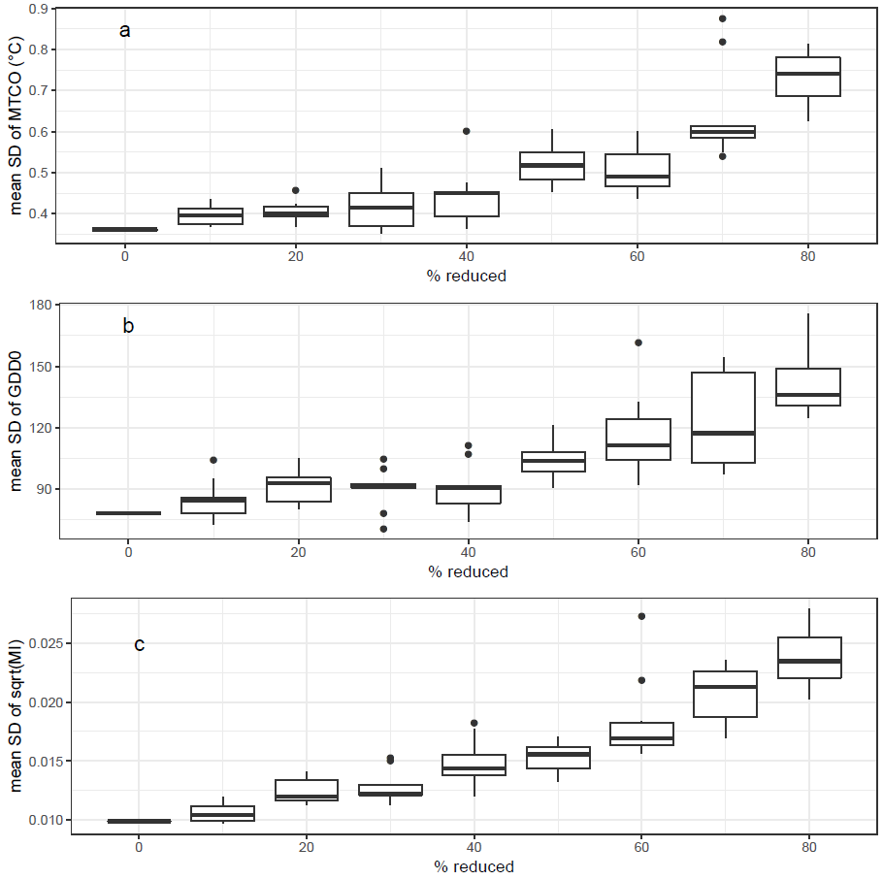

**SI Figure 9**. Change in mean standard deviation (reconstruction spread) of (a) mean temperature of the coldest month (MTCO, °C), (b) growing degree days above 0 oC (GDD0, °C days), and (c) square root of Moisture index (sqrt(MI), unitless) as the percentage of samples randomly removed increases. 10 runs were made for each reduction, each comprising 100 bootstrapped reconstructions.

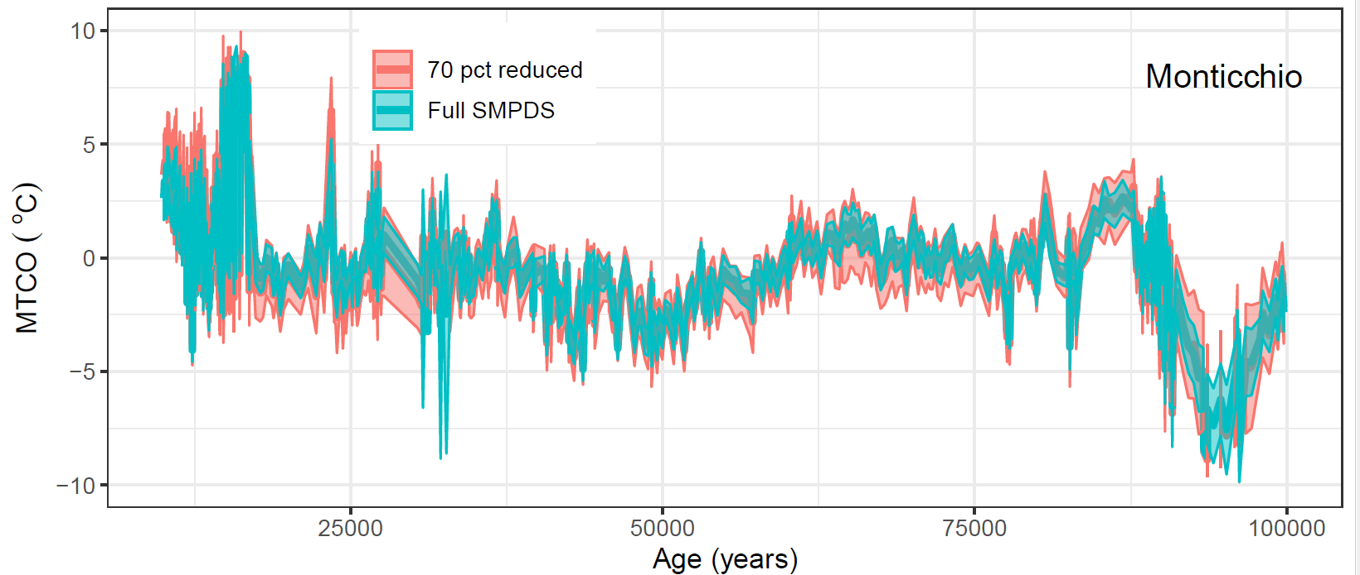

**SI Figure 10**. Impact of reducing the sampling density of the modern training data set on reconstructions of temperature of the coldest month (MTCO, °C) during the last glacial period (100,000 to 10,000 calendar years before 2000) using the pollen record from Lago Grande di Monticchio. The plots show the impact of removing 70% of the modern samples randomly while preserving the overall range of climate space on the MTCO reconstructions, compared to reconstructions made with the full SMPDS data set.

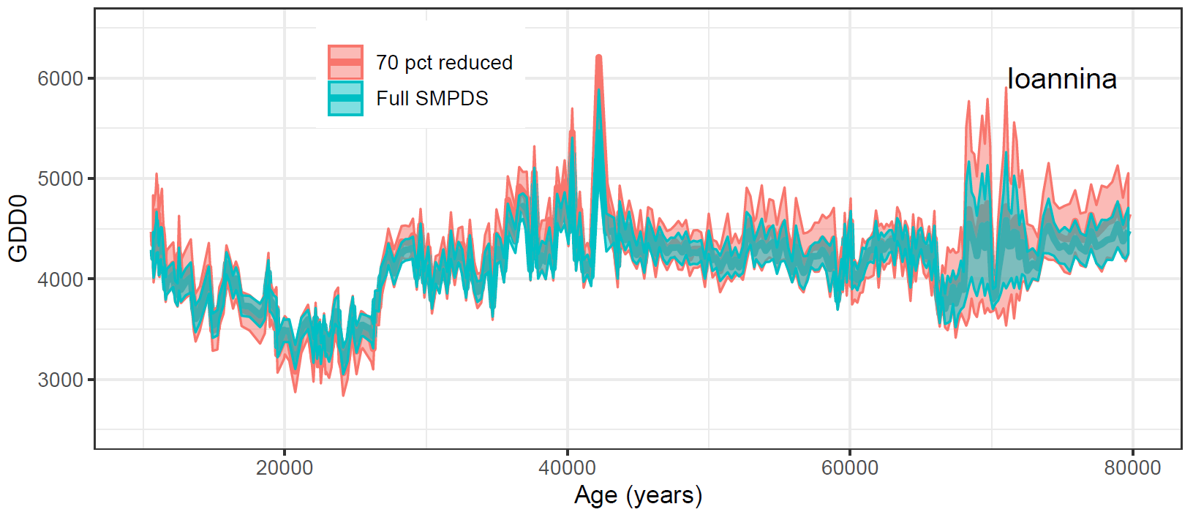

**SI Figure 11**. Impact of reducing the sampling density of the modern training data set on reconstructions of growing degree days above a baseline of 0° C (GDD0, ° days) during the last glacial period (80,000 to 10,000 calendar years before 2000) using the pollen record from Lake Ioannina. The plots show the impact of removing 70% of the modern samples randomly while preserving the overall range of climate space on the GDD0 reconstructions, compared to reconstructions made with the full SMPDS data set.

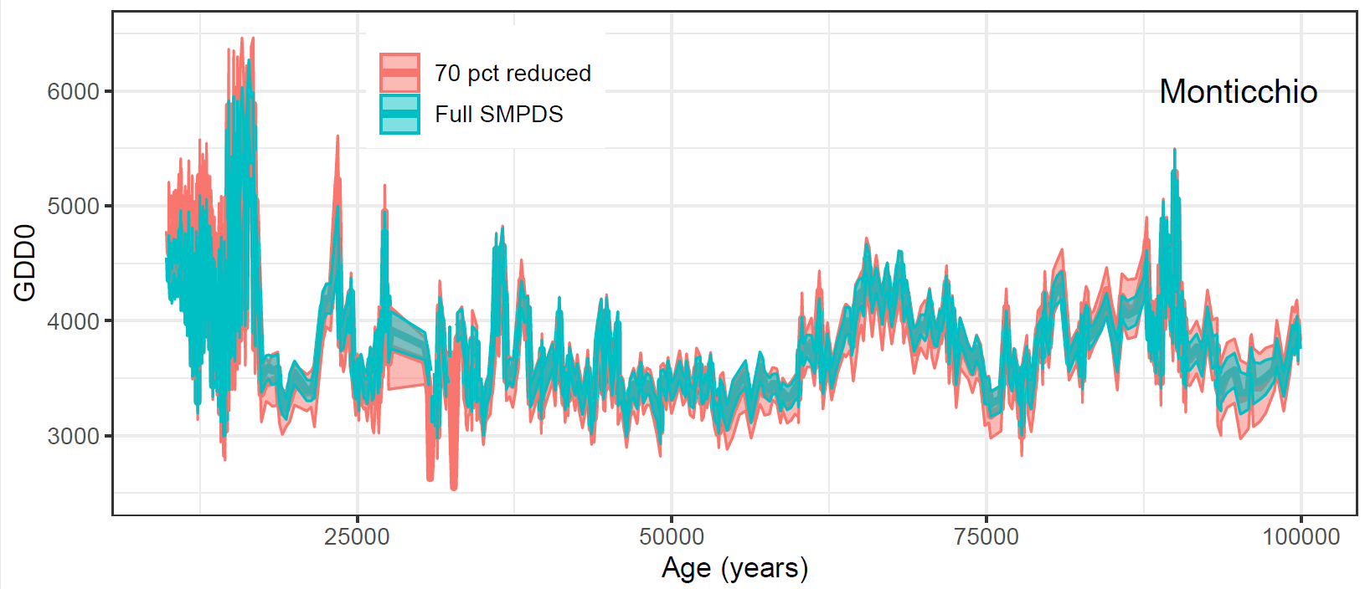

**SI Figure 12**. Impact of reducing the sampling density of the modern training data set on reconstructions of growing degree days above a baseline of 0° C (GDD0, ° days) during the last glacial period (100,000 to 10,000 calendar years before 2000) using the pollen record from Lago Grande di Monticchio. The plots show the impact of removing 70% of the modern samples randomly while preserving the overall range of climate space on the GDD0 reconstructions, compared to reconstructions made with the full SMPDS data set.

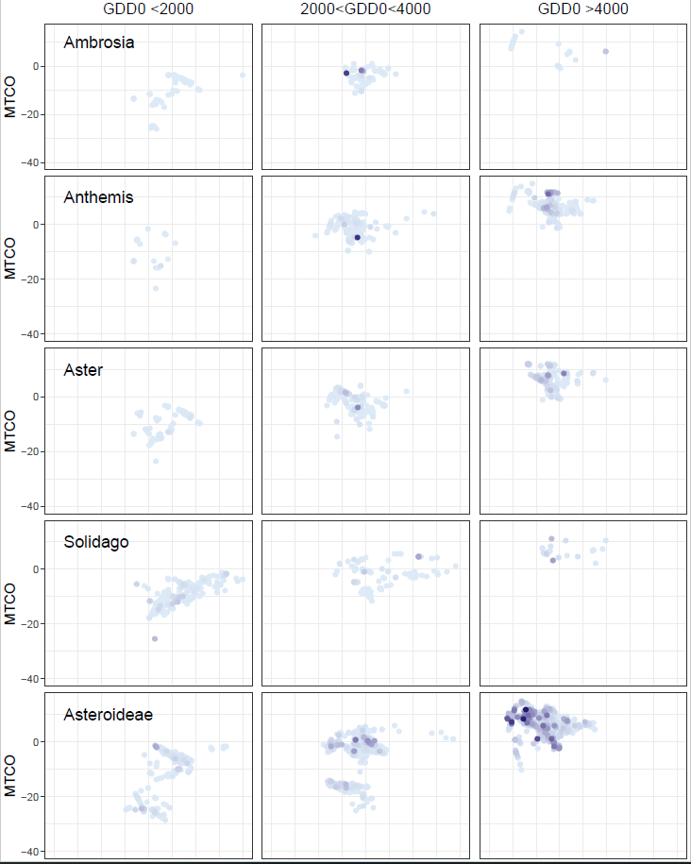

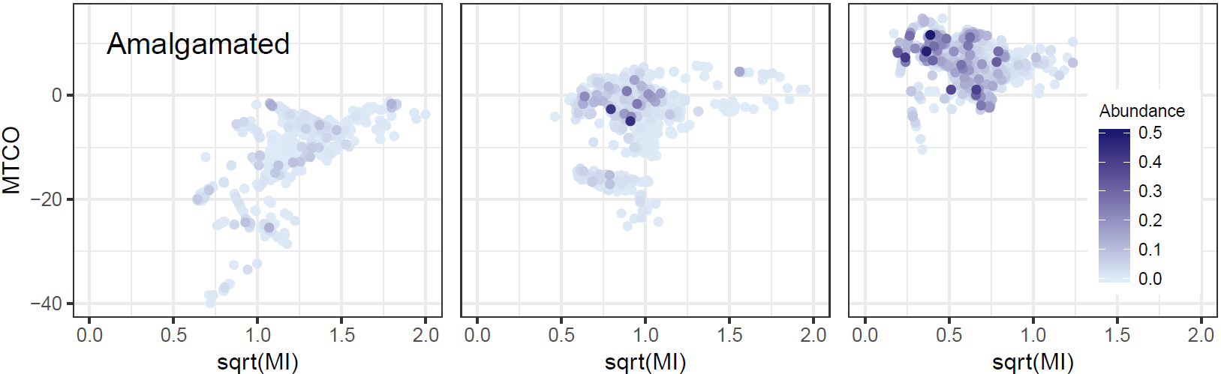

**SI Figure 13**. Abundance in climate space of Asteroideae and its main subtaxa at the sample level, complementing GAMs in Figure 6. “GDD <2000” includes all samples in that range, etc. Scale applies to all plots. 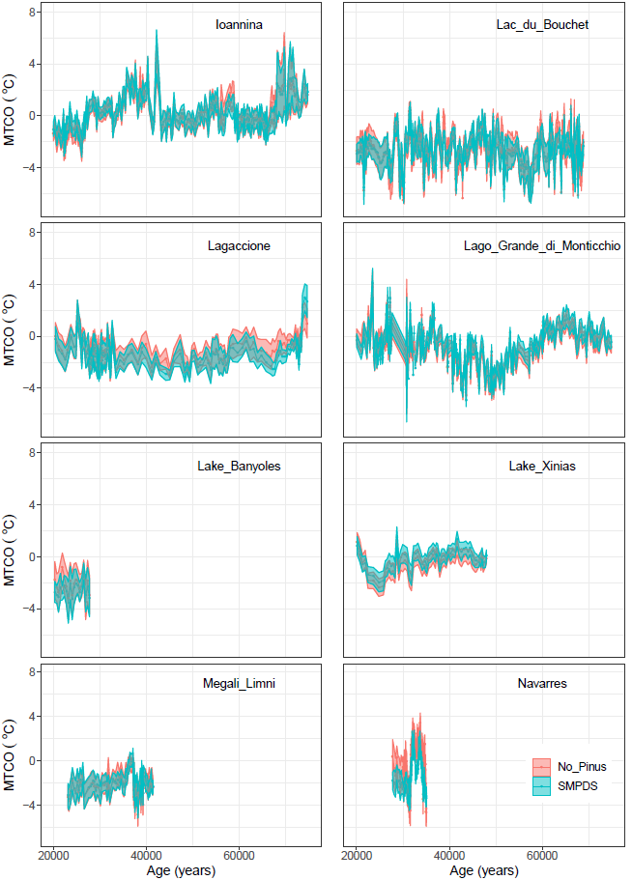

**SI Figure 14**. Reconstructed mean temperature of the coldest month (MTCO, °C) at eight sites in Europe, comparing regression using the full SMPDS set and after removing *Pinus*.

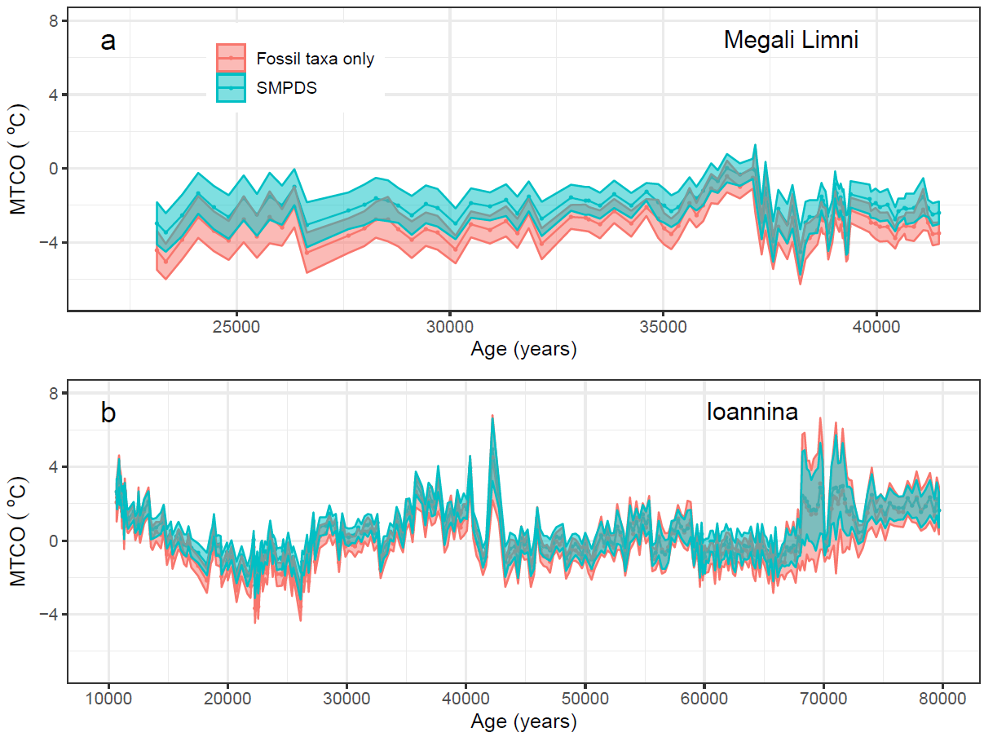

**SI Figure 15**. Reconstructed mean temperature of the coldest month (MTCO, °C) using the full SMPDS set compared to regressions based on only taxa found in the fossil set at (a) Megali Limni and (b) Ioannina. See SI Table 3.

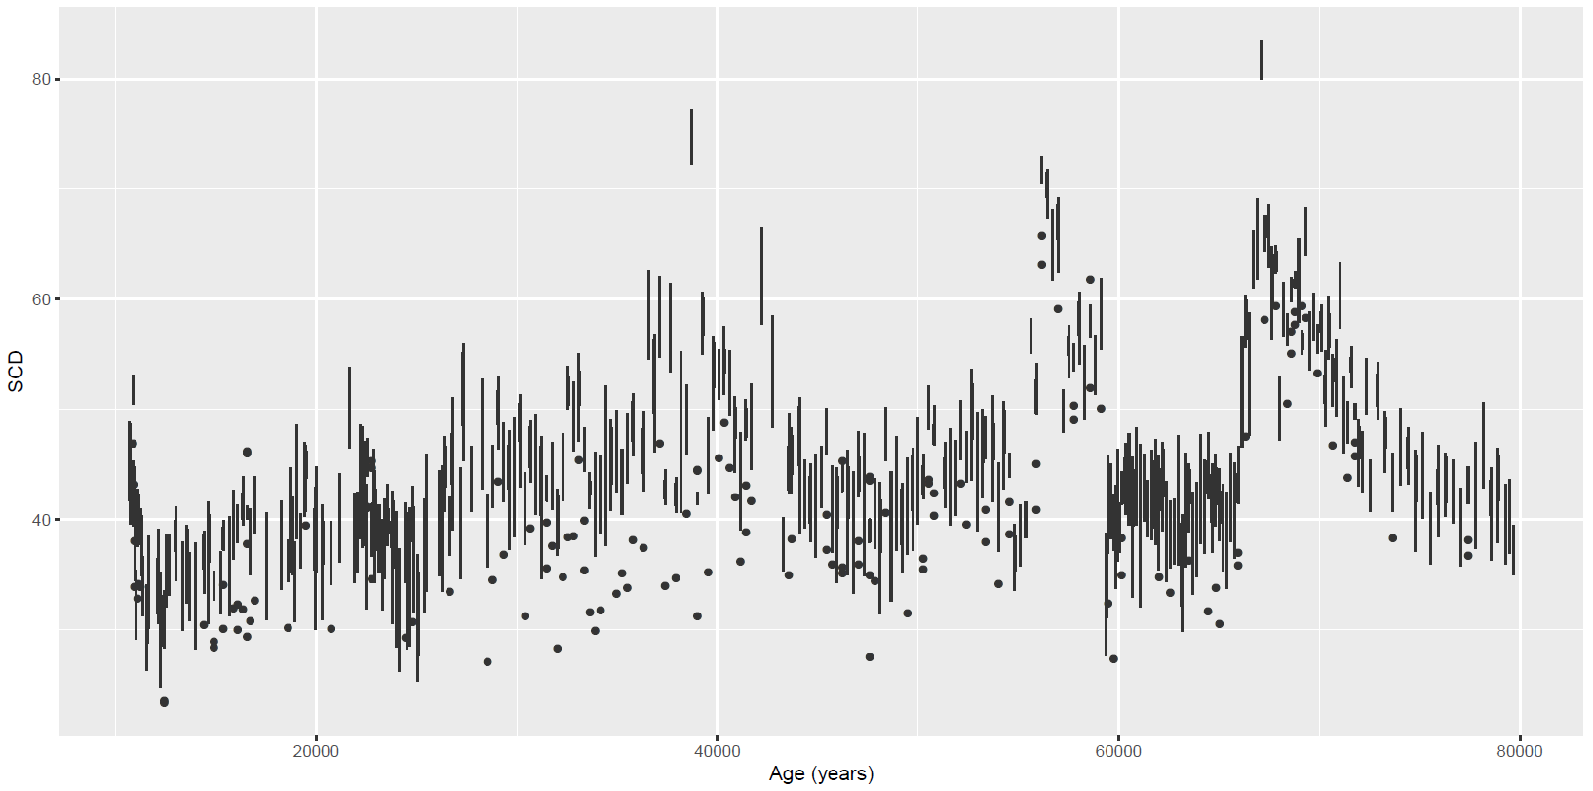

**SI Figure 16**. Squared chord distances of the 10 nearest analogues in the SMPDS to the fossil samples at Ioannina. The lowest dot, or end of line, represents the nearest analogue.

**SI Table 1**. In addition to data from the EMPD and the EMBSeCBIO databases, the SMPDS modern training data set includes sites from the following publications:

|  |
| --- |
| Bell, B.A. and Fletcher, W. J.: Modern surface pollen assemblages from the Middle and High Atlas, Morocco: Insights into pollen representation and transport, Grana, 55, 286-301, <https://doi.org/10.1080/00173134.2015.1108996>, 2016. |
| de Klerk, P., Haberl, A., Kaffke, A., Krebs, M., Matchutadze, I., Minke, M., Schulz, J., and Joosten, H.: Vegetation history and environmental development since ca 6000 cal yr BP in and around Ispani 2 (Kolkheti lowlands, Georgia), Quaternary Sci. Rev., 28, 890-910, <https://doi.org/10.1016/j.quascirev.2008.12.005>, 2009. |
| Grüger, E. and Jerz, H.: Untersuchung einer Doline auf dem Zugspitzplatt: Ein palynologischer Beitrag zur holozänen Gletschergeschichte im Wettersteingebirge, E&G Quaternary Sci. J., 59, 66-75, <https://doi.org/10.3285/eg.59.1-2.06>, 2010. |
| Matthias, I., Semmler, M. S. S., and Giesecke, T.: Pollen diversity captures landscape structure and diversity, J. Ecol.*,* 103, 880-890, <https://doi.org/10.1111/1365-2745.12404>, 2015. |
| Müller, S., Tarasov, P., Andreev, A. A., Tutken, T., Gartz, S., and Diekmann, B.: Late Quaternary vegetation and environments in the Verkhoyansk Mountains region (NE Asia) reconstructed from a 50-kyr fossil pollen record from Lake Billyakh, Quat. Sci. Rev., 29, 2071-2086, <https://doi.org/10.1016/j.quascirev.2010.04.024>, 2010. |
| Niemeyer, B., Klemm, J., Pestryakova, L. A., and Herzschuh, U.: Relative pollen productivity estimates for common taxa of the northern Siberian Arctic, Rev. Palaeobot. Palyno., 221, 71-82, <https://doi.org/10.1016/j.revpalbo.2015.06.008>, 2015. |
| Novenko, E., Mazei, N., and Kusilman, M.: Tree pollen representation in surface pollen assemblages from different vegetation zones of European Russia, Ecological Questions, 26, 61–65, <http://doi.org/10.12775/EQ.2017.018>, 2017. |
| Saadi, F. and Bernard, J.: Rapport entre la pluie pollinique actuelle, le climat et la vegetation dans les steppes à Artemisia et les milieu limitrophes au Maroc, Palaeoecol. Africa, 22, 67-86, 1991. |
| Tarasov, P. E., Nakagawa, T., Demske, D., Österle, H., Igarashi, Y., Kitagawa, J., Mokhova, L., Bazarova, V., Okuda, M., Gotanda, K., Miyoshi, N., Fujiki, T., Takemura, K., Yonenobu, H., and Fleck, A.: Progress in the reconstruction of Quaternary climate dynamics in the Northwest Pacific: A new modern analogue reference dataset and its application to the 430-kyr pollen record from Lake Biwa, Earth-sci. Rev,108, 64-79, <https://doi.org/10.1016/j.earscirev.2011.06.002>, 2011. |
| Werner, K., Tarasov, P. E., Andreev, A. A., Müller, S., Kienast, F., Zech, M., Zech, W., and Diekmann, B.: A 12.5-kyr history of vegetation dynamics and mire development with evidence of Younger Dryas larch presence in the Verkhoyansk Mountains, East Siberia, Russia, Boreas, 39, 56-68, <https://doi.org/10.1111/j.1502-3885.2009.00116.x>, 2010. |

**SI Table 2**. Details of the 8 sites from the Abrupt climate Changes and Environmental Responses (ACER) database (Sanchez Goñi et al., 2017) used as examples in this study.

| **Site** | **Lat** | **Long** | **References** |
| --- | --- | --- | --- |
| Lagaccione | 42.57 | 11.8 | Magri, D (1999): Late Quaternary vegetation history at Lagaccione near Lago di Bolsena (central Italy). Review of Palaeobotany and Palynology, 106(3-4), 171-208, doi:10.1016/S0034-6667(99)00006-8 |
| Magri, D (2008): Two long micro-charcoal records from central Italy. In: Charcoals from the Past: Cultural and Palaeoenvironmental Implications Proceedings of the Third International Meeting of Anthracology, Cavallino - Lecce (Italy), June 28th - July 1st 2004 BAR International Series 1807 |
| Lake_Banyoles | 42.13 | 2.75 | Pérez-Obiol, R P; Julia, R (1994): Climatic change on the Iberian Peninsula recorded in a 30,000-year pollen record from Lake Banyoles. Quaternary Research, 41(1), 91-98, doi:10.1006/qres.1994.1010 |
| Lake_Xinias | 39.05 | 22.27 | Bottema, S (1979): Pollen analytical investigations in Thessaly (Greece). Palaeohistoria, 21, 19-40, <http://rjh.ub.rug.nl/Palaeohistoria/article/view/24996/22455> |
| Megali_Limni | 39.1025 | 26.3208 | Margari, V; Gibbard, P L; Bryant, C L; Tzedakis, PC (2009): Character of vegetational and environmental changes in southern Europe during the last glacial period; evidence from Lesvos Island, Greece. Quaternary Science Reviews, 28(13-14), 1317-1339, doi:10.1016/j.quascirev.2009.01.008 |
| Margari, V; Pyle, D M; Bryant, C; Gibbard, P L (2007): Mediterranean tephra stratigraphy revisited: Results from a long terrestrial sequence on Lesvos Island, Greece. Journal of Volcanology and Geothermal Research, 163(1-4), 34-54, doi:10.1016/j.jvolgeores.2007.02.002 |
| Lago_Grande_di_Monticchio | 40.94 | 15.61 | Allen, J R M; Huntley, B (2000): Weichselian palynological records from southern Europe: correlation and chronology. Quaternary International, 73-74, 111-125, doi:10.1016/S1040-6182(00)00068-9 |
| Allen, J R M; Brandt, U; Brauer, A; Huntley, B; Keller, J; Kraml, M; Mackensen, A; Mingram, J; Negendank, J F W; Nowaczyk, N R; Watts, W A; Wulf, S; Zolitschka, B; Hubberten, H-W; Oberhänsli, H (1999): Rapid environmental changes in southern Europe during the last glacial period. Nature, 400(6746), 740-743, doi:10.1038/23432 |
| Allen, J R M; Watts, W A; Huntley, Brian (2000): Weichselian palynostratigraphy, palaeovegetation and palaeoenvironment; the record from Lago Grande di Monticchio, southern Italy. Quaternary International, 73-74, 91-110, doi:10.1016/S1040-6182(00)00067-7 |
| Brauer, A; Allen, J R M; Mingram, J; Dulski, P; Wulf, S; Huntley, B (2007): Evidence for last interglacial chronology and environmental change from Southern Europe. Proceedings of the National Academy of Sciences, 104(2), 450-455, doi:10.1073/pnas.0603321104 |
| Huntley, B; Watts, W A; Allen, J R M; Zolitschka, B (1999): Palaeoclimate, chronology and vegetation history of the Weichselian Lateglacial: comparative analysis of data from three cores at Lago Grande di Monticchio, southern Italy. Quaternary Science Reviews, 18(7), 945-960, doi:10.1016/S0277-3791(99)00007-4 |
| Navarres | 39.1 | -0.68 | Carrión, J S; van Geel, B (1999): Fine-resolution Upper Weichselian and Holocene palynological record from Navarrés (Valencia, Spain) and a discussion about factors of Mediterranean forest succession. Review of Palaeobotany and Palynology, 106, 209-236, doi:10.1016/S0034-6667(99)00009-3 |
| Lac_du_Bouchet | 44.83 | 3.82 | Reille, M; de Beaulieu, J-L (1990): Pollen analysis of a long upper Pleistocene continental sequence in a Velay maar (Massif Central, France). Palaeogeography, Palaeoclimatology, Palaeoecology, 80(1), 35-48, doi:10.1016/0031-0182(90)90032-3 |
| Ioannina | 39.75 | 20.85 | Tzedakis, P C; Frogley, M R; Lawson, I T; Preece, R C; Cacho, I; de Abreu, L (2004): Ecological thresholds and patterns of millennial-scale climate variability: The response of vegetation in Greece during the last glacial period. Geology, 32(2), 109, doi:10.1130/G20118.1 |
| Tzedakis, P C; Lawson, I T; Frogley, M R; Hewitt, G M; Preece, R C (2002): Buffered tree population changes in a Quaternary refugium: evolutionary emplications. Science, 297(5589), 2044-2047, doi:10.1126/science.1073083 |
|  |  |  |  |

**SI Table 3**. WA-PLS model parameters for all the data sets used in this study for reconstructions of mean temperature of the coldest month (MTCO, 0° C), growing degree days above a baseline of 0° C (GDD0, °day) and the square root of Moisture Index (√MI, unitless). Cross-validated *r*2, number of components, root mean square error (RMSE), maximum bias, *p* tested by random *t*-test, and sample set size. Best components are identified by bold *p* value.

|  |  |  |  |  |  |  |  |
| --- | --- | --- | --- | --- | --- | --- | --- |
| **Variable** | **Data Set** | *r***2** | **No of components** | **RMSE** | **Max. bias** | ***p*** | **No of samples** |
| MTCO | EMB | 0.377 | 1 | 4.08 | 20.6 | 0.001 | 1 088 |
|  | EMB | 0.417 | 2 | 3.97 | 19.6 | **0.002** |  |
|  | EMB | 0.418 | 3 | 4.02 | 18.6 | 0.534 |  |
|  | EMPD | 0.690 | 1 | 4.30 | 8.4 | 0.001 | 4 675 |
|  | EMPD | 0.731 | 2 | 4.01 | 5.7 | 0.001 |  |
|  | EMPD | 0.743 | 3 | 3.91 | 6.1 | **0.001** |  |
|  | EMPD | 0.743 | 4 | 3.92 | 5.9 | 0.500 |  |
|  | 70% reduced | 0.618 | 1 | 5.27 | 17.8 | 0.001 | 1930 |
|  | 70% reduced | 0.655 | 2 | 5.06 | 16.3 | **0.001** |  |
|  | 70% reduced | 0.661 | 3 | 5.09 | 17.2 | 0.133 |  |
|  | Megali Limni fossil assemblage (67 taxa) | 0.471 | 1 | 6.31 | 33.2 | 0.001 | 6 458 |
|  | 0.528 | 2 | 5.96 | 32.7 | 0.001 |  |
|  | 0.539 | 3 | 5.89 | 32.3 | 0.001 |  |
|  | 0.541 | 4 | 5.88 | 32.4 | **0.030** |  |
|  | Ioannina fossil assemblage (78 taxa) | 0.477 | 1 | 6.28 | 33.4 | 0.001 |  |
|  | 0.539 | 2 | 5.89 | 32.9 | 0.001 |  |
|  | 0.552 | 3 | 5.80 | 32.2 | **0.001** |  |
|  | SMPDS | 0.624 | 1 | 5.31 | 14.2 | 0.001 | 6 458 |
|  | SMPDS | 0.671 | 2 | 4.97 | 8.8 | 0.001 |  |
|  | SMPDS | 0.687 | 3 | 4.85 | 8.5 | 0.001 |  |
|  | SMPDS | 0.691 | 4 | 4.82 | 10.3 | **0.019** |  |
| GDD0 | EMB | 0.475 | 1 | 992 | 1843 | 0.001 | 1 088 |
|  | EMB | 0.508 | 2 | 960 | 1727 | **0.001** |  |
|  | EMB | 0.502 | 3 | 969 | 1690 | 0.889 |  |
|  | EMPD | 0.616 | 1 | 968 | 2567 | 0.001 | 4675 |
|  | EMPD | 0.654 | 2 | 917 | 1960 | 0.001 |  |
|  | EMPD | 0.667 | 3 | 901 | 1898 | **0.001** |  |
|  | 70% reduced | 0.603 | 1 | 974 | 2110 | 0.001 | 1878 |
|  | 70% reduced | 0.644 | 2 | 931 | 1948 | **0.001** |  |
|  | 70% reduced | 0.649 | 3 | 941 | 1793 | 0.334 |  |
|  | SMPDS | 0.600 | 1 | 987 | 2419 | 0.001 | 6458 |
|  | SMPDS | 0.646 | 2 | 929 | 2155 | 0.001 |  |
|  | SMPDS | 0.660 | 3 | 910 | 2039 | **0.001** |  |
| √MI | EMB | 0.574 | 1 | 0.130 | 0.449 | 0.001 | 1 088 |
|  | EMB | 0.592 | 2 | 0.128 | 0.439 | **0.010** |  |
|  | EMB | 0.587 | 3 | 0.129 | 0.423 | 0.700 |  |
|  | EMPD | 0.546 | 1 | 0.203 | 0.978 | 0.001 | 4 675 |
|  | EMPD | 0.595 | 2 | 0.191 | 0.851 | 0.001 |  |
|  | EMPD | 0.602 | 3 | 0.190 | 0.838 | **0.001** |  |
|  | 70% reduced | 0.542 | 1 | 0.194 | 1.069 | 0.001 | 1933 |
|  | 70% reduced | 0.591 | 2 | 0.185 | 0.972 | **0.001** |  |
|  | 70% reduced | 0.595 | 3 | 0.187 | 0.930 | 0.362 |  |
|  | SMPDS | 0.532 | 1 | 0.198 | 1.057 | 0.001 | 6 458 |
|  | SMPDS | 0.589 | 2 | 0.187 | 0.940 | 0.001 |  |
|  | SMPDS | 0.598 | 3 | 0.185 | 0.910 | **0.001** |  |
|  | SMPDS | 0.600 | 4 | 0.185 | 0.911 | 0.130 |  |

**SI Table 4.** WA-PLS model parameters for reconstructed mean temperature of the coldest month (MTCO, 0° C) comparing regression using the full SMPDS set with regression based only taxa found in the fossil set from (a) at Megali Limni (b) at Ioannina (see SI Figure 15). Cross-validated *r*2, number of components with *p* < 0.05, root mean square error (RMSE), maximum bias, and taxon set size.

|  |  |  |  |  |  |  |
| --- | --- | --- | --- | --- | --- | --- |
| Set | *r*2 | No of components | RMSE | Maximum bias | *p* | No of taxa |
| SMPDS set | 0.691 | 4 | 4.82 | 10.3 | 0.019 | 195 |
| Megali Limni fossil only | 0.541 | 4 | 5.88 | 32.4 | 0.030 | 67 |
| Ioannina fossil only | 0.552 | 3 | 5.80 | 32.2 | 0.001 | 78 |

**SI Table 5**. Amalgamated taxa as in Table 3, for MTCO, GDD0 and square root (MI), showing number of occurrences, total abundance, abundance-weighted SD of coefficients (optima) of component taxa, SD of coefficient of amalgamated taxon, and coefficient of amalgamated taxon. SDs are obtained by bootstrapping the sample set 1000 times.



**SI Table 6**. Component taxon data for amalgamated taxa in SI Table 4, for MTCO, GDD and square root (MI), showing number of occurrences, total abundance, SD of coefficients (optima) of component taxa, and coefficient of component taxa. SDs are obtained by bootstrapping the sample set 1000 times.

|  |  |  |  |  |  |  |  |  |  |
| --- | --- | --- | --- | --- | --- | --- | --- | --- | --- |
| **Amalgamated taxon** | **Component taxon** | **Occurrences** | **Total abundance** | **SD MTCO** | **Coefficient MTCO** | **SD GDD** | **Coefficient GDD** | **SD sqrt(MI)** | **Coefficient sqrt(MI)** |
| Apiaceae | | 5485 | 9617 |  |  |  |  |  |  |
|  | Aegopodium | 2 | 2 | 5.5 | -8.8 | 1350 | 6034 | 0.16 | -0.31 |
|  | Aegopodium.podagraria | 2 | 0 | 8.4 | -27.5 | 532 | -4630 | 0.96 | 1.37 |
|  | Ammi.type | 1 | 0 | 1.7 | -33.4 | 358 | 644 | 0.04 | 1.00 |
|  | Angelica | 4 | 6 | 12.2 | 4.7 | 4170 | 8807 | 0.85 | -0.60 |
|  | Angelica.archangelica | 1 | 0 | 6.6 | 69.4 | 445 | -1014 | 0.21 | 3.65 |
|  | Angelica.type | 84 | 17 | 4.0 | 6.4 | 473 | 538 | 0.22 | 2.44 |
|  | Anisosciadium.type | 6 | 1 | 14.1 | -3.4 | 3307 | 7855 | 0.34 | -0.07 |
|  | Anthriscus | 2 | 0 | 6.6 | -52.6 | 420 | -3992 | 0.20 | 1.30 |
|  | Anthriscus.sylvestris | 24 | 22 | 11.3 | -21.0 | 1121 | 1394 | 0.44 | 0.41 |
|  | Anthriscus.sylvestris.type | 66 | 10 | 3.7 | 8.5 | 625 | -769 | 0.12 | 1.93 |
|  | Anthriscus.type | 6 | 1 | 9.9 | -21.2 | 1477 | 163 | 0.55 | 0.23 |
|  | Apiaceae | 3084 | 3618 | 1.3 | 0.9 | 336 | 3174 | 0.05 | 0.99 |
|  | Apium.Berula | 13 | 2 | 3.6 | 15.8 | 875 | 7791 | 0.18 | -0.63 |
|  | Apium.type | 4 | 0 | 9.4 | 14.9 | 1095 | 4251 | 0.60 | 0.39 |
|  | Astrantia | 3 | 1 | 4.7 | 7.4 | 1806 | -1663 | 0.35 | 1.46 |
|  | Astrantia.type | 34 | 3 | 13.4 | -24.6 | 2212 | -771 | 0.20 | 1.22 |
|  | Athamanta.cretensis | 11 | 35 | 8.0 | -24.9 | 4804 | -4044 | 1.22 | 2.27 |
|  | Berula.erecta.type | 1 | 0 | 1.3 | 22.2 | 201 | 7315 | 0.04 | -0.24 |
|  | Bunium.type | 45 | 29 | 4.2 | 11.9 | 1380 | 9439 | 0.14 | -0.17 |
|  | Bupleurum | 14 | 4 | 8.4 | -3.6 | 3036 | -2433 | 0.47 | 2.02 |
|  | Bupleurum.type | 150 | 159 | 5.9 | -50.4 | 675 | -673 | 0.23 | 0.89 |
|  | Carum.carvi | 10 | 2 | 5.4 | 14.8 | 839 | -563 | 0.16 | 1.97 |
|  | Chaerophyllum | 5 | 2 | 12.1 | -15.3 | 4271 | -5583 | 0.60 | 2.44 |
|  | Chaerophyllum.hirsutum.type | 101 | 35 | 2.9 | -8.2 | 626 | -3610 | 0.13 | 2.45 |
|  | Chaerophyllum.type | 10 | 7 | 23.6 | -36.9 | 3675 | 557 | 0.11 | 0.75 |
|  | Conopodium | 3 | 1 | 18.8 | 64.7 | 1518 | 8932 | 0.50 | 2.64 |
|  | Conopodium.majus | 1 | 0 | 2.9 | 16.6 | 584 | 6549 | 0.32 | -1.27 |
|  | Daucaceae | 2 | 0 | 1.3 | -9.7 | 287 | 1974 | 0.11 | 0.29 |
|  | Daucus.carota | 38 | 3 | 6.2 | -0.2 | 1633 | -2029 | 0.30 | 2.32 |
|  | Daucus.carota.type | 2 | 0 | 11.2 | 24.4 | 3948 | 6312 | 0.25 | 1.13 |
|  | Daucus.type | 50 | 12 | 6.5 | -5.3 | 789 | 4420 | 0.24 | 0.20 |
|  | Echinophora | 5 | 3 | 5.9 | 6.6 | 1371 | 5850 | 0.14 | 1.02 |
|  | Echinophora.type | 2 | 0 | 4.3 | 29.3 | 1279 | 11793 | 0.10 | -0.91 |
|  | Eryngium | 265 | 282 | 4.1 | 8.5 | 1246 | 5736 | 0.09 | 1.01 |
|  | Eryngium.ilicifolium | 37 | 63 | 3.2 | 26.7 | 745 | 9613 | 0.12 | -0.24 |
|  | Eryngium.type | 138 | 152 | 8.6 | 22.1 | 1858 | 8491 | 0.20 | 0.22 |
|  | Falcaria.type | 402 | 2790 | 2.7 | -12.0 | 294 | 1284 | 0.06 | 0.93 |
|  | Ferula.type | 12 | 2 | 9.3 | 12.8 | 2719 | 6711 | 0.23 | 0.24 |
|  | Heracleum | 76 | 42 | 3.9 | -2.3 | 1118 | -806 | 0.24 | 1.79 |
|  | Heracleum.laciniatum.type | 1 | 0 | 5.5 | 29.8 | 881 | -804 | 0.35 | 5.64 |
|  | Heracleum.sphondylium | 25 | 8 | 10.0 | -68.8 | 1015 | 621 | 0.16 | 1.02 |
|  | Heracleum.type | 13 | 2 | 18.5 | -37.7 | 2793 | -669 | 0.22 | 0.16 |
|  | Laserpitium.latifolium.type | 4 | 0 | 9.6 | 8.4 | 1155 | -565 | 0.30 | 1.77 |
|  | Laserpitium.prutenicum | 2 | 1 | 7.3 | -5.3 | 3745 | -563 | 0.61 | 2.22 |
|  | Ligusticum.mutellina | 62 | 16 | 2.1 | -15.8 | 897 | -5266 | 0.23 | 2.78 |
|  | Malabaila | 13 | 3 | 4.3 | -5.6 | 2140 | 2956 | 0.23 | 0.20 |
|  | Meum | 9 | 6 | 5.6 | 0.2 | 868 | -5242 | 0.15 | 2.19 |
|  | Meum.athamanticum | 1 | 0 | 1.4 | -6.4 | 257 | -6191 | 0.06 | 3.03 |
|  | Neogaya.simplex.type | 2 | 0 | 13.6 | 1.4 | 815 | -831 | 0.92 | 2.67 |
|  | Oenanthe | 2 | 0 | 4.5 | -20.3 | 1122 | 4598 | 1.10 | -1.04 |
| **Amalgamated taxon** | **Component taxon** | **Occurrences** | **Total abundance** | **SD MTCO** | **Coefficient MTCO** | **SD GDD** | **Coefficient GDD** | **SD sqrt(MI)** | **Coefficient sqrt(MI)** |
|  | Oenanthe.type | 2 | 0 | 1.4 | -3.9 | 860 | 2952 | 0.04 | 0.55 |
|  | Orlaya | 5 | 1 | 4.4 | -0.9 | 1137 | 3712 | 0.25 | -0.19 |
|  | Orlaya.grandiflora | 2 | 0 | 3.7 | -8.7 | 552 | -3666 | 0.11 | 2.53 |
|  | Pastinaca.type | 4 | 1 | 15.2 | -13.8 | 2252 | 4523 | 0.19 | 0.40 |
|  | Peucedanum | 16 | 4 | 6.6 | -9.1 | 1422 | -3051 | 0.28 | 1.68 |
|  | Peucedanum.ostruthium | 1 | 0 | 2.2 | -24.8 | 440 | -7019 | 0.09 | 3.35 |
|  | Peucedanum.type | 128 | 65 | 7.7 | 0.8 | 2022 | 3274 | 0.32 | 1.15 |
|  | Pimpinella | 5 | 0 | 12.4 | -23.9 | 1657 | 578 | 0.36 | 0.57 |
|  | Pimpinella.major.type | 34 | 3 | 6.0 | -8.8 | 1542 | -3474 | 0.31 | 2.49 |
|  | Pimpinella.type | 274 | 2078 | 1.9 | -6.8 | 571 | 943 | 0.05 | 1.10 |
|  | Pleurospermum.austriacum | 3 | 0 | 9.2 | -17.0 | 5555 | 4430 | 1.09 | 1.18 |
|  | Sanicula | 13 | 5 | 13.7 | -1.0 | 1490 | -362 | 0.14 | 1.48 |
|  | Sanicula.europaea | 2 | 0 | 2.2 | -18.6 | 544 | -5902 | 0.10 | 2.93 |
|  | Sanicula.type | 38 | 52 | 2.5 | 3.2 | 748 | 4451 | 0.13 | 0.23 |
|  | Scandix | 5 | 4 | 7.0 | -11.3 | 1561 | 839 | 0.39 | 0.47 |
|  | Seseli.type | 9 | 2 | 17.9 | -29.6 | 3585 | -7763 | 0.68 | 3.33 |
|  | Smyrnium.type | 4 | 0 | 22.2 | -28.9 | 3935 | -1219 | 0.28 | 1.19 |
|  | Torilis | 3 | 4 | 21.2 | 2.1 | 5431 | 4126 | 0.41 | 0.53 |
|  | Torilis.arvensis | 5 | 1 | 9.5 | -8.5 | 2254 | -3331 | 1.48 | 3.52 |
|  | Torilis.type | 31 | 7 | 2.4 | 6.7 | 628 | 5517 | 0.09 | -0.31 |
|  | Turgenia.type | 51 | 44 | 5.4 | 3.8 | 1510 | 4051 | 0.19 | 0.34 |
| Asteroideae | | 6171 | 8053 |  |  |  |  |  |  |
|  | Achillea | 29 | 14 | 9.3 | -17.4 | 1132 | 2589 | 0.26 | 0.46 |
|  | Achillea.Aster | 24 | 22 | 3.8 | 8.8 | 1171 | 2945 | 0.20 | -0.01 |
|  | Achillea.Aster.type | 13 | 10 | 5.8 | -2.2 | 1083 | -5355 | 0.13 | 0.92 |
|  | Achillea.type | 341 | 230 | 3.5 | -5.4 | 1440 | -693 | 0.38 | 1.85 |
|  | Adenostyles.type | 2 | 1 | 2.3 | -6.6 | 1430 | -4210 | 0.41 | 2.90 |
|  | Ambrosia | 156 | 118 | 5.3 | -3.3 | 874 | 4456 | 0.11 | 0.65 |
|  | Ambrosia.artemisiifolia.type | 52 | 14 | 2.5 | -8.1 | 344 | 3142 | 0.09 | 0.67 |
|  | Ambrosia.type | 78 | 34 | 9.6 | 14.3 | 1920 | 8737 | 0.33 | 0.99 |
|  | Ambrosia.Xanthium | 7 | 1 | 4.7 | -79.1 | 556 | -6281 | 0.12 | 0.98 |
|  | Antennaria | 1 | 0 | 1.9 | 13.2 | 337 | -613 | 0.05 | 0.64 |
|  | Antennaria.type | 7 | 7 | 25.1 | 39.2 | 8377 | 11119 | 0.78 | 0.13 |
|  | Anthemis | 25 | 61 | 9.8 | 35.7 | 2403 | 11515 | 0.20 | 0.10 |
|  | Anthemis.type | 785 | 697 | 4.7 | 12.1 | 978 | 7425 | 0.10 | 0.32 |
|  | Arnica.montana | 47 | 12 | 2.1 | -6.4 | 617 | -1737 | 0.15 | 1.88 |
|  | Aster | 39 | 18 | 9.5 | -19.8 | 1175 | -721 | 0.23 | 0.63 |
|  | Aster.bellidiastrum | 1 | 0 | 2.2 | -24.8 | 440 | -7019 | 0.09 | 3.35 |
|  | Aster.type | 827 | 1016 | 1.3 | 16.5 | 368 | 8932 | 0.06 | 0.04 |
|  | Asteroideae | 2020 | 4543 | 1.1 | 11.7 | 307 | 6537 | 0.05 | 0.46 |
|  | Bellis | 13 | 8 | 26.2 | -13.8 | 4528 | 2585 | 0.52 | 0.57 |
|  | Bellis.type | 20 | 36 | 3.1 | 16.2 | 541 | 5010 | 0.06 | 1.09 |
|  | Bidens | 5 | 4 | 16.0 | -6.0 | 3363 | -2707 | 0.69 | 1.90 |
|  | Bidens.type | 60 | 37 | 4.1 | 14.7 | 1403 | 5280 | 0.17 | 0.54 |
|  | Calendula | 11 | 1 | 5.1 | 1.7 | 859 | 2929 | 0.46 | 0.94 |
|  | Calendula.type | 2 | 1 | 3.3 | 68.3 | 679 | 19527 | 0.09 | -0.03 |
|  | Chrysanthemum.alpinum | 1 | 0 | 2.2 | -24.8 | 440 | -7019 | 0.09 | 3.35 |
|  | Doronicum | 2 | 0 | 10.7 | 25.4 | 1689 | 12070 | 0.47 | -0.45 |
|  | Erigeron | 56 | 9 | 3.1 | -17.4 | 1132 | -4120 | 0.32 | 2.34 |
|  | Eupatorium | 1 | 0 | 2.0 | 23.1 | 465 | 6590 | 0.06 | 1.42 |
|  | Eupatorium.type | 1 | 1 | 1.4 | 31.7 | 159 | 2332 | 0.04 | 2.24 |
|  | Evax | 1 | 0 | 4.1 | 17.1 | 1329 | 9679 | 0.11 | 0.72 |
|  | Filago.type | 74 | 48 | 3.2 | 14.8 | 1577 | 12170 | 0.10 | -0.24 |
|  | Gnaphalium | 13 | 1 | 10.9 | -7.9 | 794 | -3178 | 0.57 | 2.77 |
|  | Gnaphalium.type | 29 | 3 | 6.4 | -24.3 | 1125 | -7796 | 0.31 | 3.26 |
|  | Helianthus | 23 | 11 | 4.0 | 41.6 | 934 | 13380 | 0.32 | 1.50 |
|  | Helianthus.type | 1 | 0 | 1.3 | 16.6 | 229 | 6595 | 0.04 | -0.06 |
|  | Homogyne | 39 | 3 | 5.1 | -13.9 | 1216 | -5609 | 0.29 | 2.80 |
| **Amalgamated taxon** | **Component taxon** | **Occurrences** | **Total abundance** | **SD MTCO** | **Coefficient MTCO** | **SD GDD** | **Coefficient GDD** | **SD sqrt(MI)** | **Coefficient sqrt(MI)** |
|  | Homogyne.alpina | 7 | 2 | 3.6 | -12.7 | 1014 | -34 | 0.20 | 0.50 |
|  | Inula | 1 | 0 | 2.1 | 12.1 | 282 | -68 | 0.05 | 1.68 |
|  | Inula.type | 4 | 1 | 14.5 | 15.6 | 2385 | 8943 | 0.69 | 0.19 |
|  | Matricaria.type | 263 | 300 | 2.6 | 2.8 | 1024 | 5477 | 0.10 | 0.31 |
|  | Petasites | 6 | 1 | 15.8 | 0.6 | 3087 | 4559 | 0.76 | 0.38 |
|  | Petasites.type | 3 | 0 | 15.1 | -11.6 | 4643 | -2114 | 0.58 | 1.48 |
|  | Senecio | 67 | 18 | 2.6 | -11.4 | 814 | -3489 | 0.18 | 2.43 |
|  | Senecio.type | 186 | 148 | 16.5 | -15.3 | 2531 | 2210 | 0.16 | 0.49 |
|  | Solidago | 82 | 65 | 12.3 | -19.4 | 838 | -2421 | 0.17 | 1.83 |
|  | Solidago.type | 323 | 214 | 5.1 | 7.3 | 1374 | 2779 | 0.26 | 1.44 |
|  | Solidago.virgaurea.type | 20 | 46 | 2.4 | 31.3 | 637 | 4056 | 0.18 | 3.85 |
|  | Tussilago.farfara | 2 | 0 | 15.5 | 22.8 | 8037 | 9311 | 0.80 | 1.18 |
|  | Tussilago.type | 6 | 0 | 8.2 | -34.9 | 1283 | -1334 | 0.20 | 1.13 |
|  | Xanthium | 290 | 179 | 4.5 | 6.0 | 1098 | 6333 | 0.10 | 0.46 |
|  | Xanthium.spinosum | 1 | 0 | 4.2 | 10.1 | 470 | 2474 | 0.17 | 0.72 |
|  | Xanthium.spinosum.type | 7 | 1 | 29.2 | -21.1 | 1556 | -688 | 0.42 | 0.38 |
|  | Xanthium.strumarium | 1 | 0 | 7.3 | 30.9 | 1610 | 9551 | 0.16 | -1.14 |
|  | Xanthium.type | 96 | 113 | 4.2 | 1.0 | 771 | 4393 | 0.11 | 0.72 |
| Carduoideae | | 2363 | 1620 |  |  |  |  |  |  |
|  | Arctium | 7 | 1 | 17.1 | -12.1 | 4369 | 4593 | 0.85 | 0.15 |
|  | Arctium.Jurinea | 18 | 8 | 5.5 | 4.4 | 2057 | 5039 | 0.21 | 0.10 |
|  | Arctium.type | 4 | 2 | 15.7 | 13.8 | 5636 | 6330 | 0.97 | 0.24 |
|  | Carduoideae | 20 | 20 | 3.8 | -3.6 | 1177 | 1800 | 0.18 | 0.71 |
|  | Carduus | 72 | 11 | 3.1 | -11.0 | 980 | -4964 | 0.16 | 2.69 |
|  | Carduus.type | 120 | 68 | 3.4 | 7.8 | 955 | 7405 | 0.17 | -0.08 |
|  | Carlina | 26 | 4 | 5.9 | -3.3 | 1525 | -4790 | 0.44 | 2.76 |
|  | Carlina.type | 6 | 2 | 8.3 | 22.1 | 2727 | 7926 | 0.18 | 0.52 |
|  | Carthamus | 20 | 5 | 5.7 | 7.1 | 2225 | 5748 | 0.20 | 0.46 |
|  | Centaurea | 262 | 507 | 2.8 | 7.3 | 1357 | 3199 | 0.21 | 1.00 |
|  | Centaurea.collina | 1 | 0 | 1.4 | -9.4 | 364 | -8785 | 0.06 | 2.87 |
|  | Centaurea.collina.type | 1 | 0 | 2.8 | 29.6 | 467 | 3137 | 0.07 | 1.13 |
|  | Centaurea.cyanus | 221 | 59 | 2.1 | -8.7 | 446 | 2896 | 0.09 | 0.53 |
|  | Centaurea.cyanus.type | 227 | 123 | 1.9 | 3.7 | 428 | 4449 | 0.07 | 0.45 |
|  | Centaurea.depressa.type | 4 | 3 | 4.1 | -0.3 | 3194 | 3563 | 0.31 | 0.31 |
|  | Centaurea.diffusa | 1 | 0 | 2.0 | -4.0 | 966 | 6100 | 0.14 | 0.06 |
|  | Centaurea.jacea | 11 | 5 | 10.4 | 2.7 | 1390 | 4175 | 0.29 | 1.24 |
|  | Centaurea.jacea.type | 113 | 73 | 2.4 | -10.1 | 818 | 557 | 0.10 | 0.75 |
|  | Centaurea.montana | 18 | 2 | 6.2 | 7.5 | 1272 | -2008 | 0.28 | 2.26 |
|  | Centaurea.montana.type | 4 | 1 | 19.9 | -94.7 | 3401 | -6312 | 0.72 | -0.05 |
|  | Centaurea.nigra | 10 | 4 | 11.0 | -11.3 | 3758 | -7100 | 0.83 | 2.61 |
|  | Centaurea.nigra.type | 141 | 51 | 3.6 | 7.2 | 754 | 5713 | 0.14 | 0.54 |
|  | Centaurea.rhenana.type | 1 | 0 | 3.9 | 12.7 | 337 | 4457 | 0.06 | 0.94 |
|  | Centaurea.scabiosa | 12 | 4 | 4.4 | 5.4 | 1633 | 4103 | 0.41 | 1.21 |
|  | Centaurea.scabiosa.type | 17 | 4 | 4.4 | -11.5 | 1150 | -113 | 0.37 | 1.00 |
|  | Centaurea.solstitialis | 2 | 0 | 3.9 | 38.9 | 962 | 11509 | 0.19 | 1.06 |
|  | Centaurea.solstitialis.type | 257 | 231 | 1.8 | 1.5 | 605 | 4805 | 0.09 | 0.36 |
|  | Centaurea.type | 17 | 21 | 3.2 | 40.2 | 1769 | 15153 | 0.20 | -1.78 |
|  | Cirsium | 124 | 35 | 4.9 | -17.0 | 595 | -388 | 0.17 | 1.28 |
|  | Cirsium.Carduus | 74 | 26 | 5.7 | -8.6 | 1026 | 3136 | 0.11 | 0.70 |
|  | Cirsium.Carduus.type | 1 | 1 | 1.2 | -9.9 | 243 | 3385 | 0.04 | 0.24 |
|  | Cirsium.Gundelia | 41 | 23 | 5.5 | -0.7 | 1558 | 4738 | 0.14 | -0.15 |
|  | Cirsium.type | 355 | 266 | 6.4 | 2.9 | 983 | 5214 | 0.12 | 0.62 |
|  | Cousinia | 14 | 15 | 4.8 | -11.6 | 1450 | -1782 | 0.20 | 1.02 |
|  | Echinops | 32 | 8 | 4.6 | 10.4 | 1342 | 6631 | 0.18 | 0.14 |
|  | Echinops.ritro | 1 | 0 | 2.2 | -11.1 | 569 | 5594 | 0.10 | 0.07 |
|  | Jurinea.type | 5 | 2 | 6.8 | 3.1 | 633 | 5200 | 0.46 | 0.73 |
|  | Onopordum.type | 8 | 2 | 9.1 | -3.5 | 2896 | 1557 | 0.38 | 0.58 |
|  | Saussurea | 27 | 8 | 6.3 | -8.9 | 869 | -2562 | 0.31 | 2.05 |
| **Amalgamated taxon** | **Component taxon** | **Occurrences** | **Total abundance** | **SD MTCO** | **Coefficient MTCO** | **SD GDD** | **Coefficient GDD** | **SD sqrt(MI)** | **Coefficient sqrt(MI)** |
|  | Saussurea.alpina | 9 | 2 | 8.9 | -13.5 | 1180 | -4305 | 0.28 | 1.83 |
|  | Saussurea.type | 48 | 17 | 17.0 | -69.8 | 1186 | -3222 | 0.14 | -0.25 |
|  | Serratula | 4 | 1 | 10.5 | -17.7 | 3775 | -7910 | 0.92 | 2.22 |
|  | Serratula.type | 7 | 3 | 7.7 | 24.8 | 2667 | 9202 | 0.37 | 1.07 |
| Cichorioideae | | 3260 | 8877 |  |  |  |  |  |  |
|  | Cichorioideae | 2950 | 8331 | 0.7 | 7.5 | 179 | 5508 | 0.03 | 0.60 |
|  | Cichorium | 16 | 34 | 9.9 | -36.7 | 1077 | -2633 | 0.19 | 1.34 |
|  | Cichorium.intybus.type | 31 | 20 | 4.9 | -13.1 | 1503 | -8329 | 0.21 | 2.72 |
|  | Cichorium.type | 59 | 125 | 4.4 | -42.2 | 809 | 166 | 0.08 | 0.54 |
|  | Crepis | 2 | 1 | 6.1 | 13.8 | 1740 | 5225 | 0.40 | 0.75 |
|  | Crepis.aurea | 1 | 0 | 2.2 | -24.8 | 440 | -7019 | 0.09 | 3.35 |
|  | Crepis.type | 1 | 0 | 1.3 | 27.9 | 207 | 6693 | 0.04 | 0.00 |
|  | Hieracium.type | 2 | 1 | 2.2 | 27.4 | 809 | 6610 | 0.20 | 0.96 |
|  | Lactuca | 16 | 4 | 8.1 | -1.5 | 2418 | 2312 | 0.29 | 0.78 |
|  | Lactuca.sativa.type | 1 | 0 | 1.2 | 20.8 | 234 | 1826 | 0.04 | 1.47 |
|  | Lactuca.type | 4 | 0 | 2.7 | 19.6 | 214 | 4939 | 0.04 | 0.22 |
|  | Leontodon.helveticus | 1 | 0 | 2.2 | -24.8 | 440 | -7019 | 0.09 | 3.35 |
|  | Leontodon.type | 20 | 27 | 10.6 | -8.0 | 872 | -2965 | 0.71 | 2.92 |
|  | Scorzonera.humilis.type | 15 | 15 | 6.3 | 5.6 | 874 | 3216 | 0.14 | 0.85 |
|  | Scorzonera.type | 6 | 9 | 6.4 | -7.9 | 2111 | 2515 | 0.54 | 0.01 |
|  | Sonchus.type | 10 | 1 | 6.3 | -8.4 | 684 | 3623 | 0.07 | 0.48 |
|  | Taraxacum | 36 | 10 | 8.6 | -40.2 | 1564 | -3322 | 0.26 | 1.24 |
|  | Taraxacum.type | 89 | 299 | 3.8 | -4.0 | 331 | 4349 | 0.22 | 0.36 |
| Cistus | | 956 | 1756 |  |  |  |  |  |  |
|  | Cistus | 202 | 666 | 2.7 | 15.5 | 640 | 7353 | 0.06 | 0.54 |
|  | Cistus.albidus.type | 12 | 6 | 12.8 | 37.0 | 2172 | 13274 | 0.39 | 0.28 |
|  | Cistus.incanus.type | 10 | 2 | 8.8 | 46.6 | 2078 | 16839 | 0.40 | -0.18 |
|  | Cistus.ladanifer | 222 | 432 | 1.1 | 2.2 | 345 | 4943 | 0.04 | 0.47 |
|  | Cistus.ladanifer.type | 14 | 18 | 6.1 | 18.4 | 857 | 9717 | 0.22 | -0.11 |
|  | Cistus.monspeliensis | 5 | 4 | 16.7 | 75.0 | 4049 | 24041 | 0.47 | -1.20 |
|  | Cistus.monspeliensis.type | 3 | 10 | 25.1 | 37.6 | 4726 | 12791 | 0.73 | 0.27 |
|  | Cistus.populifolius.type | 67 | 164 | 3.4 | 5.2 | 937 | 4235 | 0.08 | 0.70 |
|  | Cistus.salvifolius | 46 | 28 | 11.8 | 32.5 | 2645 | 11182 | 0.16 | 0.27 |
|  | Cistus.salviifolius.type | 7 | 9 | 13.3 | 50.8 | 2506 | 15361 | 0.36 | 0.06 |
|  | Cistus.type | 320 | 340 | 1.6 | 5.3 | 504 | 5077 | 0.05 | 0.55 |
|  | Cistus.villosus.type | 48 | 78 | 5.2 | 18.6 | 1201 | 7446 | 0.12 | 0.41 |
| Ephedra | | 813 | 913 |  |  |  |  |  |  |
|  | Ephedra | 79 | 69 | 19.5 | 7.8 | 2701 | 9331 | 0.24 | -0.49 |
|  | Ephedra.alata.type | 6 | 18 | 11.2 | -23.5 | 948 | 4555 | 0.54 | -0.90 |
|  | Ephedra.distachya | 198 | 309 | 4.3 | -4.0 | 1078 | 6798 | 0.19 | -0.27 |
|  | Ephedra.distachya.type | 118 | 62 | 7.5 | -7.1 | 971 | 6214 | 0.21 | -0.56 |
|  | Ephedra.fragilis | 68 | 60 | 3.3 | 4.5 | 1355 | 4166 | 0.26 | 0.92 |
|  | Ephedra.fragilis.type | 326 | 392 | 2.5 | 8.8 | 617 | 6251 | 0.09 | 0.42 |
|  | Ephedra.major | 1 | 0 | 1.5 | 23.3 | 308 | 2685 | 0.05 | 1.37 |
|  | Ephedra.type | 17 | 3 | 5.2 | -12.6 | 1503 | -509 | 0.19 | 1.13 |
| Plantaginaceae | | 5565 | 8012 |  |  |  |  |  |  |
|  | Globularia | 21 | 1 | 11.4 | -5.2 | 1853 | -3773 | 0.39 | 2.52 |
|  | Gratiola.officinalis | 2 | 0 | 1.5 | 17.8 | 407 | 4505 | 0.06 | 0.30 |
|  | Hippuris.vulgaris | 10 | 7 | 12.0 | 13.3 | 1177 | 2428 | 0.99 | 2.72 |
|  | Plantaginaceae | 73 | 61 | 3.9 | -14.1 | 1898 | 2514 | 0.22 | 0.41 |
|  | Plantago | 1156 | 2049 | 1.4 | 19.2 | 525 | 7305 | 0.09 | 0.51 |
|  | Plantago.afra.type | 1 | 0 | 1.7 | 23.9 | 465 | 10737 | 0.06 | 0.88 |
|  | Plantago.albicans | 38 | 37 | 8.6 | 2.2 | 1695 | 4828 | 0.10 | 0.06 |
|  | Plantago.alpina | 39 | 105 | 3.7 | -20.4 | 831 | -8347 | 0.15 | 2.82 |
|  | Plantago.alpina.type | 160 | 241 | 1.6 | -17.8 | 559 | -5527 | 0.15 | 2.63 |
|  | Plantago.coronopus | 243 | 546 | 3.7 | 18.7 | 832 | 8327 | 0.09 | 0.34 |
|  | Plantago.coronopus.type | 348 | 527 | 1.9 | 13.9 | 465 | 8662 | 0.09 | 0.13 |
|  | Plantago.cylindrica.type | 11 | 2 | 6.7 | -15.0 | 2992 | -1592 | 0.45 | 0.48 |
| **Amalgamated taxon** | **Component taxon** | **Occurrences** | **Total abundance** | **SD MTCO** | **Coefficient MTCO** | **SD GDD** | **Coefficient GDD** | **SD sqrt(MI)** | **Coefficient sqrt(MI)** |
|  | Plantago.lanceolata | 1407 | 1655 | 1.8 | 3.2 | 421 | 1961 | 0.07 | 1.46 |
|  | Plantago.lanceolata.Plantago.major.type | 3 | 3 | 9.1 | -16.6 | 1894 | 445 | 0.40 | -0.19 |
|  | Plantago.lanceolata.type | 1110 | 2082 | 1.7 | 6.2 | 471 | 5577 | 0.04 | 0.45 |
|  | Plantago.lusitanica | 4 | 3 | 36.6 | 41.3 | 11290 | 13788 | 0.80 | -0.84 |
|  | Plantago.major | 244 | 73 | 2.2 | -6.8 | 772 | -421 | 0.14 | 1.19 |
|  | Plantago.major.type | 93 | 69 | 11.2 | -20.7 | 2258 | 1649 | 0.12 | 0.54 |
|  | Plantago.maritima | 25 | 20 | 7.3 | 17.3 | 1557 | 6365 | 0.44 | 1.69 |
|  | Plantago.maritima.Plantago.alpina.type | 1 | 0 | 2.2 | -9.8 | 355 | -9180 | 0.05 | 1.27 |
|  | Plantago.maritima.type | 134 | 87 | 6.9 | -12.6 | 1858 | 5797 | 0.12 | 0.21 |
|  | Plantago.media | 116 | 40 | 3.0 | 13.4 | 397 | 129 | 0.09 | 1.71 |
|  | Plantago.media.type | 43 | 28 | 2.4 | 10.0 | 672 | 5667 | 0.29 | 0.86 |
|  | Plantago.montana.type | 42 | 14 | 3.6 | 15.7 | 891 | -612 | 0.20 | 1.82 |
|  | Plantago.ovata.type | 25 | 26 | 4.8 | 4.5 | 1915 | 8798 | 0.19 | -0.11 |
|  | Plantago.psyllium.type | 71 | 81 | 3.4 | 22.8 | 760 | 8542 | 0.11 | 0.30 |
|  | Plantago.tenuiflora.type | 9 | 4 | 6.0 | -4.1 | 1760 | 6250 | 0.25 | -0.83 |
|  | Plantago.type | 136 | 250 | 4.0 | 1.4 | 1069 | 2752 | 0.12 | 1.13 |
| Quercus deciduous | | 4920 | 34212 |  |  |  |  |  |  |
|  | Quercus | 2695 | 16051 | 0.7 | 3.7 | 132 | 4613 | 0.03 | 0.80 |
|  | Quercus.cerris | 1 | 1 | 3.0 | 18.5 | 371 | 2924 | 0.07 | -0.16 |
|  | Quercus.cerris.type | 747 | 6277 | 0.6 | 1.3 | 161 | 4944 | 0.02 | 0.62 |
|  | Quercus.deciduous | 992 | 8818 | 0.6 | 3.3 | 253 | 4385 | 0.03 | 0.82 |
|  | Quercus.infectoria.type | 1 | 1 | 1.4 | 17.9 | 316 | 9965 | 0.06 | -0.79 |
|  | Quercus.petraea | 2 | 27 | 3.8 | 1.0 | 1167 | 6584 | 0.22 | 0.40 |
|  | Quercus.robur | 75 | 1077 | 3.1 | 16.1 | 1106 | 6405 | 0.15 | 0.46 |
|  | Quercus.robur.Quercus.petraea | 4 | 1 | 4.0 | -5.6 | 1213 | 1722 | 0.13 | 0.65 |
|  | Quercus.robur.type | 403 | 1959 | 1.6 | 9.5 | 356 | 3948 | 0.07 | 1.03 |
| Quercus evergreen | | 2378 | 24196 |  |  |  |  |  |  |
|  | Quercus.coccifera | 307 | 4057 | 0.9 | 9.5 | 278 | 6268 | 0.02 | 0.56 |
|  | Quercus.coccifera.Quercus.ilex | 36 | 174 | 4.8 | 8.5 | 1192 | 5024 | 0.12 | 0.53 |
|  | Quercus.coccifera.type | 89 | 801 | 2.4 | 6.3 | 594 | 5487 | 0.17 | 0.12 |
|  | Quercus.evergreen | 1050 | 12664 | 0.3 | 4.6 | 106 | 4949 | 0.02 | 0.60 |
|  | Quercus.ilex | 126 | 184 | 3.0 | 23.1 | 1005 | 7902 | 0.11 | 0.04 |
|  | Quercus.ilex.type | 514 | 4553 | 0.7 | 4.2 | 211 | 4525 | 0.02 | 0.64 |
|  | Quercus.rotundifolia.type | 2 | 61 | 0.4 | 8.5 | 91 | 6895 | 0.02 | 0.20 |
|  | Quercus.suber | 165 | 1331 | 1.1 | 14.2 | 333 | 7369 | 0.03 | 0.55 |
|  | Quercus.suber.type | 89 | 370 | 2.8 | 23.7 | 611 | 9716 | 0.08 | 0.14 |