Supporting Online Material
Portable X-Ray Fluorescence Analysis Calibration
Geochemical analyses of the obsidian specimens were carried out at Bishop Museum using a Bruker Tracer III SD portable X-ray Fluorescence analyzer (pXRF). The instrument employs an x-ray tube with a Rh target and a 10 mm² silicon drift detector (SDD) with a typical resolution of 145 eV at 100,000 cps. Samples were analyzed in an air path through Bruker's "green" filter, which is composed of a 304.8 µm (12 mil) layer of Al, a 25.4 µm (1 mil) layer of Ti and a 152.4 µm (6 mil) layer of Cu. All samples were analyzed for 300 seconds, with an x-ray tube setting of 40 keV at 26 µA.
To calibrate the data, net peaks were stripped from spectra backgrounds using the Statistic-sensitive Non-linear Iterative Peak clipping (SNIP) algorithm described by Van Espen (2002) and these were normalized to the Compton scatter of Rh (18.5 – 19.5 keV). Elemental concentrations were calculated from the characteristic normalized net peak areas using a form of regression that includes factors to correct for interference peaks (Lucas-Tooth and Price 1961; see also Conrey et al. 2014; Steiner et al. 2017):
C_{i} = I_{i} (a_{i} + Σ a_{ij}I_{ij}) + b_{i}
where C_{i} is the concentration of element i, I_{i} is the net intensity of element i, I_{ij} is the net intensity of interference elements, and a_{i}, a_{ij} and b_{i} are empirically derived coefficients.
A set of ten international reference standards were used for calibration (AGV-2, BCR-2, BHVO-2, BIR-1a, DNC-1a, GSP-2, QLO-1, NIST SRM-278, NIST SRM-688 & W-2a) and eight elements were calculated as parts-per-million (ppm) concentrations - manganese (Mn), iron (Fe), zinc (Zn), rubidium (Rb), strontium (Sr), yttrium (Y), zirconium (Zr) and niobium (Nb). The reference standards were analyzed three times each, using the same settings as the artifacts, and the results averaged. Because a relatively small number of reference standards were available at the time of the analyses, corrections were kept to a minimum to avoid overfitting (Table S1, Figure S1).

Table S1. Calibration details. All concentration values are in parts-per-million (ppm).
Element | Conc. range | Mean  abs. error | RMS  error | R² | Interference peaks
Mn | 310 - 1549 | 36 | 47 | 0.988 | Fe Kα1 (Compton tail)
Fe | 14269 - 96524 | 1294 | 1448 | 0.997 | none
Zn | 54 - 127 | 2.6 | 3.4 | 0.982 | Cu Kα1 (Compton tail)
Rb | 0 - 245 | 1.4 | 2.0 | 0.999 | Fe Kα1 (sum peak)
Sr | 64 - 658 | 6.9 | 9.4 | 0.997 | none
Y | 16 - 39 | 0.8 | 1.2 | 0.980 | Rb Kα1 (Kβ overlap)
Zr | 15 - 550 | 4.5 | 5.7 | 0.999 | Sr Kα1 (Kβ overlap)
Nb | 1 - 27 | 1.0 | 1.3 | 0.972 | Y Kα1 (Kβ overlap)
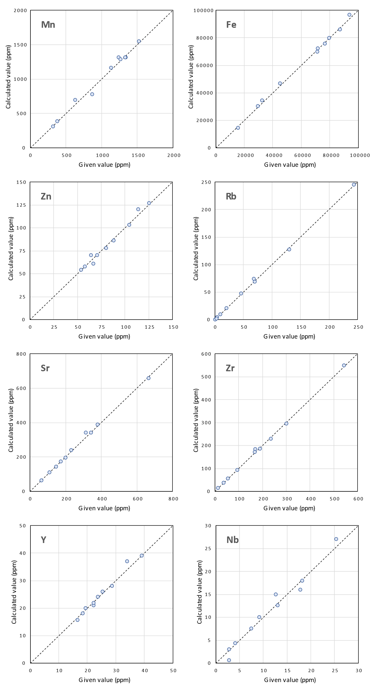
Figure S1. Given values versus calculated pXRF concentrations for the calibration.
References
Conrey, R.M., Goodman-Elgar, M., Bettencourt, N., Seyfarth, A., Van Hoose, A. and Wolff, J.A., 2014. Calibration of a portable X-ray fluorescence spectrometer in the analysis of archaeological samples using influence coefficients. Geochemistry: Exploration, Environment, Analysis, 14(3): 291-301.
Lucas-Tooth, H.J. and Price, B.J., 1961. A mathematical method for the investigation of interelement effects in x-ray fluorescence analysis. Metallurgia 64(2):149-152.
Steiner, A.E., Conrey, R.M. and Wolff, J.A., 2017. PXRF calibrations for volcanic rocks and the application of in-field analysis to the geosciences. Chemical Geology, 453:35-54.
Van Espen, P., 2002. Spectrum evaluation. In R.V. Grieken and A. Markowicz (eds), Handbook of X-ray Spectrometry. (2nd ed.). New York: Marcel Dekker. pp. 239-340.

