SUPPLEMENTARY MATERIAL

Surface exposure dating of the Pierre Sublobe of the James Lobe, Laurentide Ice Sheet

Heath, Stephanie L.¹, Hall, Brenda L.², Lowell, Thomas V.¹

¹ Department of Geology, University of Cincinnati, Cincinnati, OH, 45221, United States
² School of Earth and Climate Sciences and the Climate Change Institute, University of Maine, Orono, ME, 04469

Corresponding author:

Heath, Stephanie L.
Department of Geology
University of Cincinnati
500 Geology/Physics Building
Cincinnati, OH 45221
Email: heathsi@mail.uc.edu
Phone: 978-476-1951

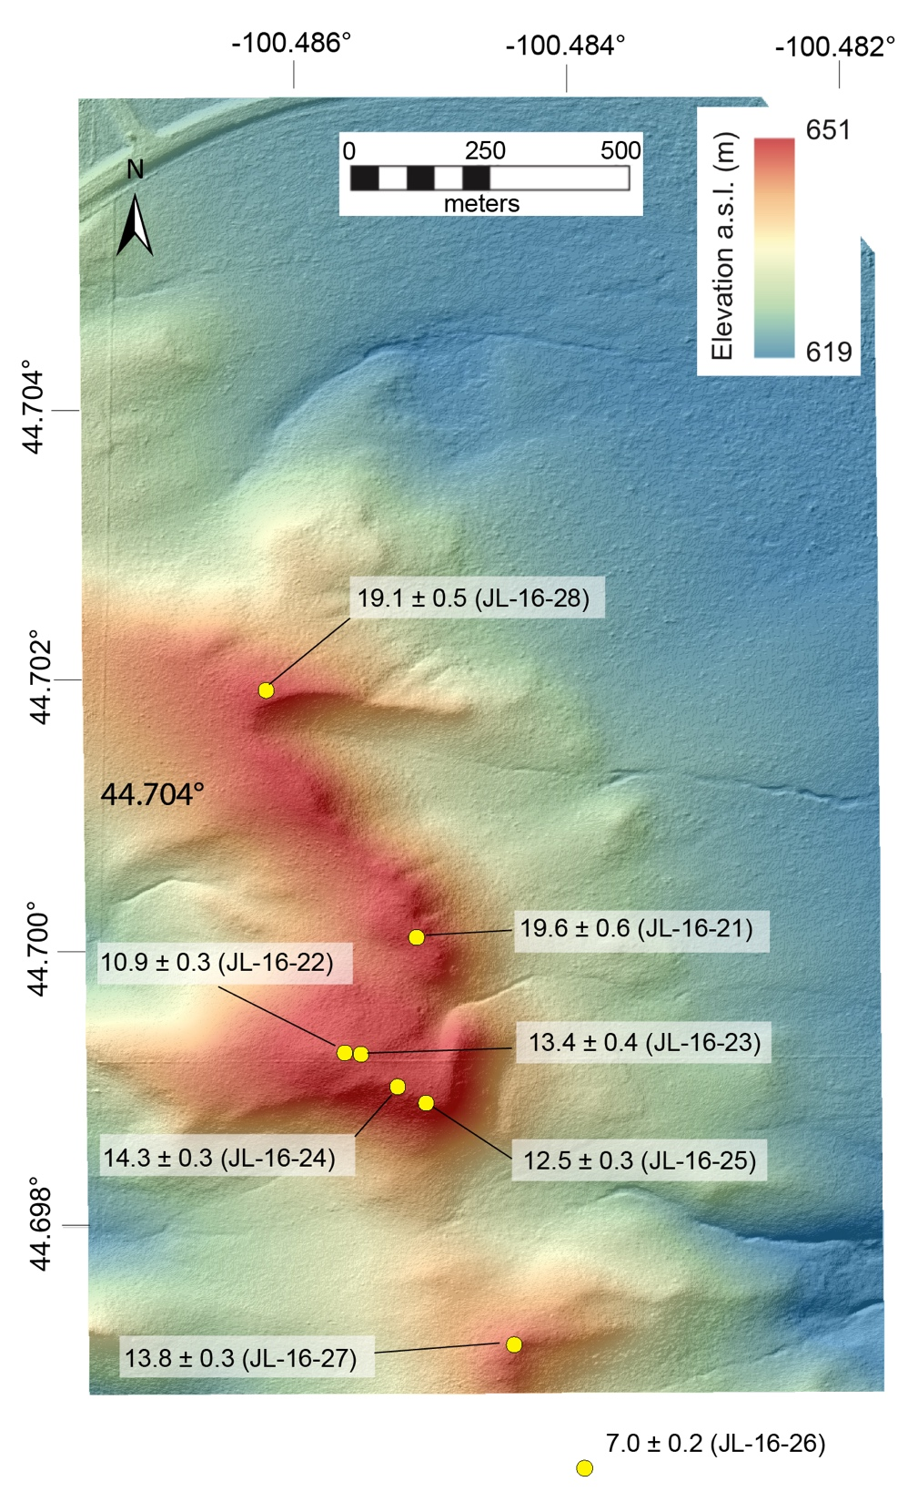
Supplementary Figure 1. Local DEM of the Black Dog site. Yellow dots represent individual samples. Higher elevation is represented by warmer color tones. Note that the samples were collected as close to the crest as possible, away from active gullying to the east and west. Sample JL-16-26 is plotted below the image, but the DEM was not acquired.

Supplementary Figure 2. Local DEM of the West Sully Site. Note gullying to the north and northeast, and the proximity of sample sites to the ridge crest.

Supplementary Figure 3. Local DEM of Sutton Rodeo. Color coding is the same as in Supplementary Figure 1. The north-south trending line on the left side of image is a dirt road and ditches. Other visible features are cattle dugouts, fence lines and tire tracks in grass.

Supplementary Figure 4. Local DEM of Bieber site. Sample JL-16-41 lies ~50 m to the west of the imaged area.

Supplementary Figure 5. Local DEM of Eagle Pass South. Color coding and symbols are the same as Supplementary Figure 1. There was no evidence of active gullying at this site. This site lies ~1.0 km south of the Eagle Pass North site.

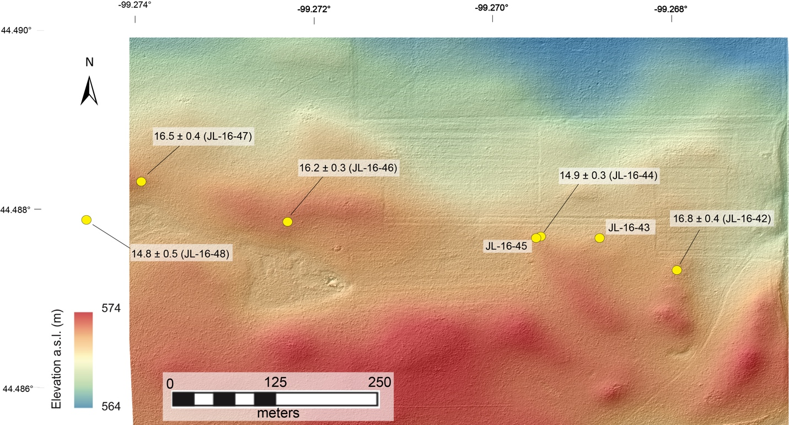
Supplementary Figure 6. Local DEM of Eagle Pass North. Color coding and symbols are the same as Supplementary Figure 1. Samples were collected on the crests of the very subtly different segments and mounds that made up this ridge.

Supplementary Figure 7. Example histogram from inheritance model by Applegate et al. (2012). When the moraine age is set at 20 ka (consistent with the oldest ages from both West Sully and Black Dog), the inheritance model produces a J-shaped distribution skewed to the left with ages that range from 20-50 ka.

