SOM 1
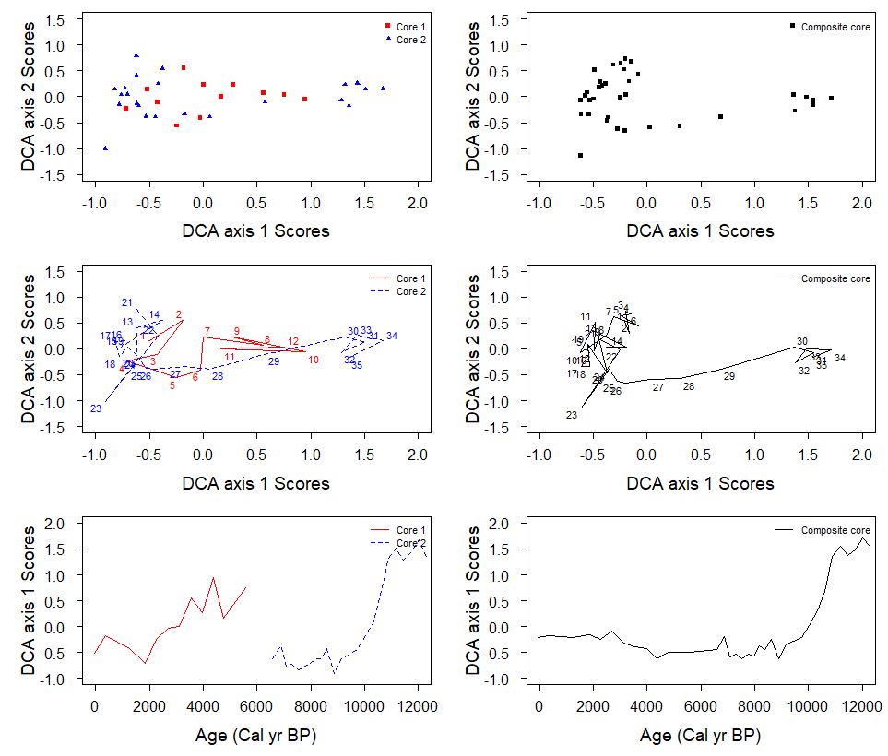
Fig. 1. Comparison of the DCA results for the individual cores and composite core for the chironomid assemblage from Lake Medvedevskoe.
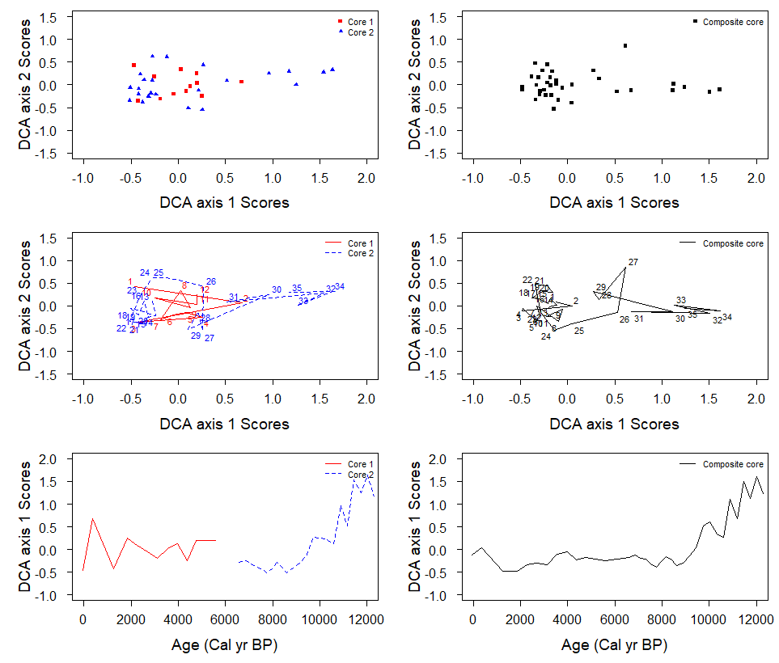
Fig. 2. Comparison of the DCA results for the individual cores and composite core for the cladocera assemblage from Lake Medvedevskoe.

