Supplementary information
S. Neogi, C.A.I. French, J.A. Durcan, R.N. Singh, & C.A. Petrie
Geoarchaeological insights into the location of Indus settlements on the plains of northwest India

SI.1. Methods

Geoarchaeology
The technique of soil micromorphology is adept at investigating soil texture, properties, processes and their inter-relationships in soils and sediments (Kubiëna 1970; Courty et al. 1989; Goldberg and Macphail 2006). Soil sampling for micromorphology removed intact soil blocks from vertical sections, which were impregnated with a crystic resin under vacuum, and when cured were then cut, mounted on large glass slides and polished to a thickness of c. 25-30um using a Brot multi-plate grinding machine following the method described by Murphy (1986; French 2015, App. 3) at the McBurney Laboratory, Department of Archaeology, University of Cambridge. Thin sections were analysed using a Leica 12 PolS and Wild M40 wide-view polarizing microscopes. The sections were all described using the accepted terminology of Bullock et al. (1985), Stoops (2003) and Stoops et al. (2010) (Table SI.2).
pH measurements were determined using a 10g to 25ml ratio of <2mm air-dried soil to distilled water with an Hanna HI8314 pH metre. Determining loss-on-ignition followed the protocol of the Department of Geography, University of Cambridge, to record the percentages of calcium and carbon in the soil (www.geog.cam.ac.uk/facilities/laboratories/techniques/psd.html). For loss-on-ignition, weighed sub-samples were heated to 105˚C for 6 hours to measure water content, then heated to 400˚C for 6 hours to measure carbohydrate content, then to 480˚C for 6 hours to measure total organic matter content, and finally heated to 950 ˚C for 6 hours to measure CO2 content lost from Ca CO3 within the sediment (Bengtsson and Ennell 1986). The calcium carbonate content can then be calculated by stoichiometry (Boreham et al. 2011). A Malvern Mastersizer was used for the particle size analysis (Table SI.3) using the same Geography facilities at Cambridge. For magnetic susceptibility measurements (Table SI.3) a Bartington MS2B metre was used, giving mass specific calculations of magnetic susceptibility for weighed, 10cm³ subsamples (English Heritage 2004: 27).

Luminescence dating
Figure SI.1. Radial plots of equivalent dose (De) distributions (in Gy) for each sample. The closed symbols show Individual De determinations, and the solid black line shows the central age model calculated sample De and the associated ±2σ uncertainty (grey shaded area).
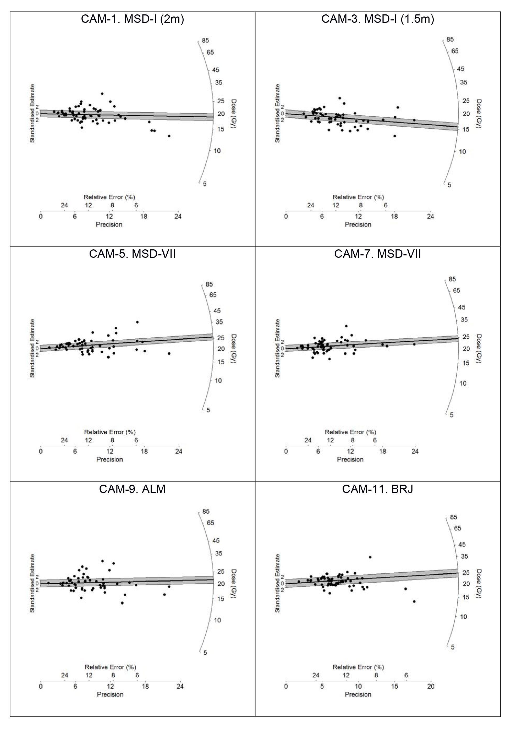

SI.2. Profile descriptions, micromorophological observations and geochemical results

SI.2.1. Alamgirpur
The site of Alamgirpur (Meerut district, Uttar Pradesh) was ﬁrst excavated under the direction of Y.D Sharma in 1958-1959 (Ghosh 1958) and was reinvestigated under R.N Singh in 2008 (Singh et al. 2013). The occupation of the site has been dated by a combination of material culture analysis and radiocarbon dating. Five profiles were exposed in the vicinity of Alamgirpur in order to characterize the local geomorphology, and samples for micromorphological analysis were collected from Proﬁles 1 and 3 (434-454 and 143-153cm below the top of the profile, respectively; Fig. SI.2-3, also Fig. 3). It was ascertained that these locations were the most likely to reveal information on the environmental conditions prior to the occupation on this mound.
Proﬁle 1 was located at the basal part of the much dissected settlement mound on its southern side (Fig. SI.3). A buried soil was observed here as a 24cm thick pale yellowish brown sandy silt, developed on a substrate of yellow silt with abundant CaCO₃ concretions. Proﬁle 2 was located close to Profile 1, but at a higher elevation (1m above the base). It had similar characteristics to Proﬁle 1, but the deposits were overlain by 20cm of archaeological deposits. Proﬁle 3 was observed 400m towards the south of the settlement mound, and comprised 75cm of very ﬁne sand over horizontally bedded white micaceous river sands. This profile was at the edge of a sand dune that had distinctive Indus period pottery sherds eroding from it. Proﬁle 4 was very similar to Profile 3, and located on the western edge of the same dune. Proﬁle 5 was dug 500m west of the archaeological mound on the ﬂat alluvial plain of the Hindon River.
In terms of physical parameters (Table SI.3), these profiles were strongly alkaline (pH 8-9.8) with a low total organic content (0.4-2.175%). A high calcium carbonate value (11.21%) was only present at the base of the profile. Magnetic susceptibility values were relatively not enhanced at 16.6-28.6SI. Although the textures of the soil samples vary considerably from sand/silt dominated to silt/clay domninated, these are probably determined as much by variation in the parent material as by pedogenic processes. Overall the range of particle size results confirms the presence of very fine soil materials indicative of deposition and sorting in low energy environments, especially in sample Profile 1 where silt and clay predominate, leading to a perched groundwater table and gleyic properties.
Sample 1/1 (434-454cm; Table SI.2; Fig. 4) was collected from the base of Proﬁle 1. It is mainly an apedal sandy soil, becoming a silty clay loam with depth. There are hints of a weakly developed sub-angular ped structure associated with fragments of highly oriented, birefringent, allochthonous and autochthonous micro-laminated pure (or limpid) clay throughout the groundmass as well as impure or dusty/silty clay pedofeatures increasing down-profile (Table SI.2; Fig. 4). This suggests that the fragments of clay are the products of recycling of the much older and pre-existing ‘B’ horizon material (cf. Brewer 1960; Kuhn et al. 2010). The other, less frequent, impure clay textural pedofeatures suggest several episodes of clay movement and re-deposition down-proﬁle (cf. Usai and Dalrymple 2003), possibly associated with the movements of groundwater and brief periods of alluvial aggradation and disturbance (cf. Fedoroff 1972).
High organic content indicates the presence of thick vegetation, though there has been replacement by amorphous iron. The ﬁne fabric is also masked to a great degree by amorphous sesquioxides (iron oxides/hydroxides) (Fig. 5). These features are suggestive of repeated waterlogging conditions, but with ﬂuctuations in the groundwater table and resultant alternating wetting and drying conditions. Wetter soil conditions after a period of soil development are indicated by these soil properties. Superimposition of one or more pedofeatures indicates the polygenetic nature of the soil, and the lack of CaCO₃ exhibited by the rare crystalline pedofeatures is further evidence of this enhanced moist environment.
Sample 3 (143-153cm) was collected from the middle of Proﬁle 3, where very fine sand interfaced with horizontally bedded white micaceous river sand. Microscopic observation (Table SI.2) indicates that the underlying parent material is a ﬁne to medium quartz sand. The soil horizon above was predominantly a coarse quartz sand, but it exhibited a bridged grain to striated appearance with dusty or impure clay. These features suggest a possible ﬂuvial component to this deposit. Therefore, it is likely that the ‘soil horizon’ observed in this profile is instead the former weathered surface of a levée formed from riverine deposition of the nearby River Hindon, but which did enjoy some measure of stability and weak pedogenic development in the past as an old ground surface. Indeed the presence of a few crystalline pedofeatures and nodules of CaCO₃ suggest some periods of surface drying (cf. Durand et al. 2010).
Figure SI.2. Map showing the location of the proﬁles around Alamgirpur (Map: C.A. Petrie)
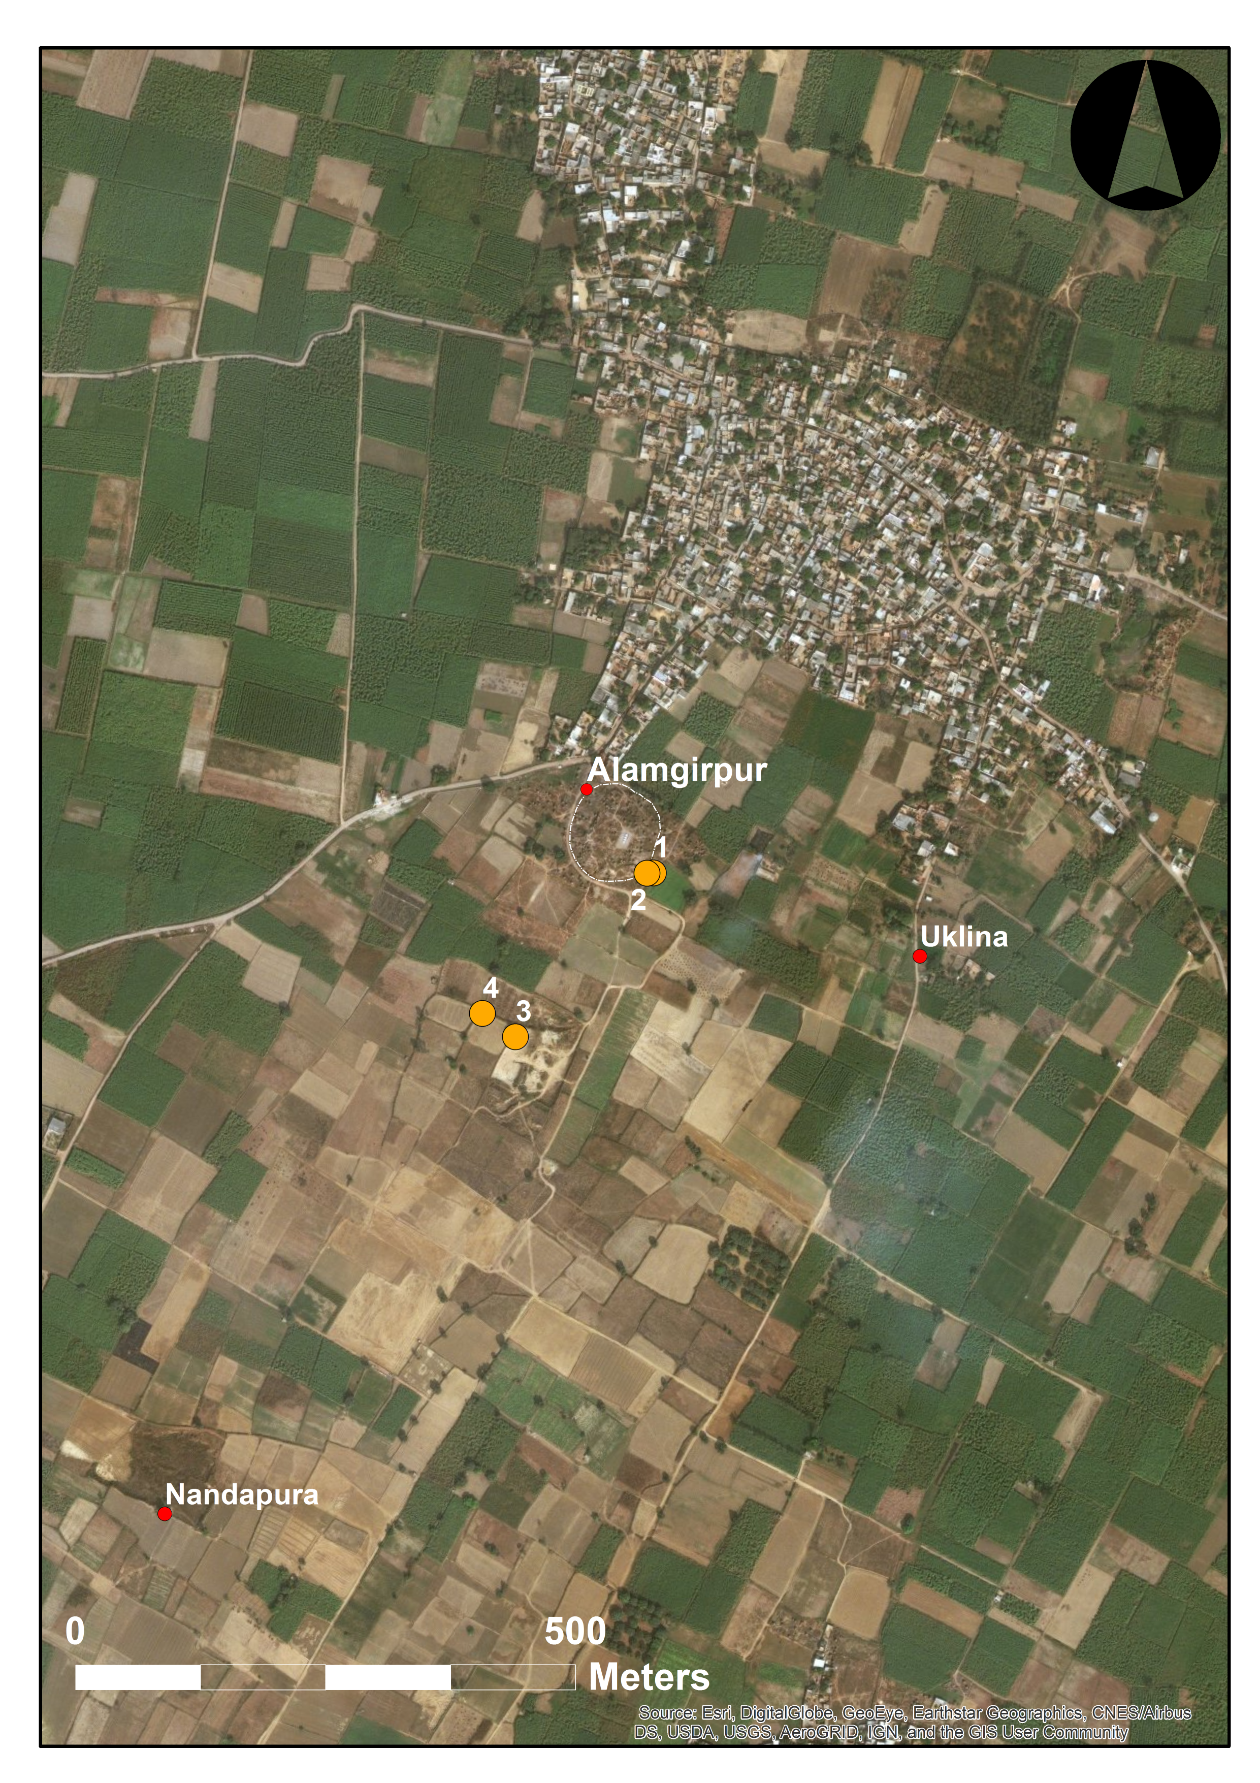
Figure SI.3. The sampling procedure at Alamgirpur Profile 1 (Photo: A.K. Pandey)

SI.2.2. Masudpur I
The mound sites of Masudpur I (locally known as Sampolia Khera) and Masudpur VII (locally known as Bhimwada Jodha) were excavated by the Land, Water and Settlement team in 2009 (Petrie et al. 2009, 2016; Singh et al. 2009, 2015a, 2015b). The occupation of both sites has been dated by a combination of material culture analysis and radiocarbon dating.
Samples for micromorphological analysis were collected as follows: Sample 10/2, Sample 10/3 from Proﬁle 10, and Sample 13 from Proﬁle 13 (Fig. SI.4, see also Fig. 6).
Sample 10/2 (105-113cm) is a ﬁne sandy loam with an apedal soil structure that overlies another soil identified in Sample 10/3 (see below). The parent material is well-sorted ﬁne sand and silt quartz and mica. Bridged grain and pellicular microstructures of the fabric reﬂect the homogeneous sandy nature of the soil. There were some included potsherds and fine bone fragments within the sandy matrix, and humiﬁed plant tissues were common. At least for part of the year a ﬂuctuating groundwater table has led to some gleying resulting in some iron oxide mottling (cf. Schwertmann 1993; Lindbo et al. 2010), despite sandy soils generally being well drained (Vinther et al. 2006). Nevertheless, there is some secondary CaCO₃ formation in the form of micrite which suggests that there has been some evapo-transpiration and surface drying, possibly as a consequence of semi-arid climatic conditions (cf. Courty et al. 1987; Durand et al. 2010). Sandy soils are generally free draining and leached, thus often preventing the accumulation of much of an organic-rich topsoil horizon (Moody 2006; Hassink et al. 1993), and this was probably the case here.
Sample 10/3 was collected at 113-122cm, and was thus slightly deeper than within Proﬁle 10. This sample exhibits a crumb to pellicular grain microstructured, ﬁne sandy loam composed of well-sorted quartz and mica. There is minor evidence of the inclusion of fine anthropogenic material of fragments of bone and potsherds. The organic content increases considerably from the MSD Sample 10/2 thin section and includes organic ﬁnes and plant tissue fragments. These soil properties indicate that this was probably a buried topsoil acting as a former land surface (cf. Liversage and Robinson 1993). In addition, the soil shows polygenetic properties and there is evidence for the accumulation of carbonates in the form of micrite, suggesting phases of surface drying, as well as gleying resulting in grey/brown mottling throughout the soil profile.
Sample 13 (205-212cm) was also a ﬁne sandy loam, but there are very striking differences between this thin section and MSD Samples 10/2 and 10/3. The ﬁne sand and silt components are very well-sorted, and the organic content is high and includes melanised ﬁnes and larger plant tissues. A channel microstructure is predominant. There are coatings of illuvial clay within many of the channels indicating that clay has moved downward through the soil proﬁle by the action of water. Amorphous sesquioxide mottling indicates that gleying has been underway, associated with a ﬂuctuating groundwater table. The features suggest that this part of the soil proﬁle was a ‘B’ horizon, but it exhibits polygenetic properties that have developed at different soil forming stages. The sandy parent material suggests initial ﬂuvial deposition, perhaps as part of an alluvial braid plain complex. Within this aggrading system, a cumulic topsoil developed which contained large amounts of organic material with a channel microstructure resulting from plant rooting (cf. French et al. 2009).
The micromorphology of Proﬁle 10/2 shows that at a depth of 105-113cm, sedimentary aggradation was the dominant geomorphological process. Beneath this, at a depth of 113-122cm in MSD Profile 10/3, a buried organic Ah horizon was recognised with characteristic crumb aggregates, and evidence for soil fauna and incorporation of organic matter (Emerson 1959). Beneath at a depth of 205-212cm, as observed in MSD Proﬁle 13, there was a buried ‘B’ horizon present with argic properties as deﬁned by the presence of illuvial clays.
Figure SI.5. Map showing the proﬁle locations at Masudpur I (Map: C.A. Petrie)
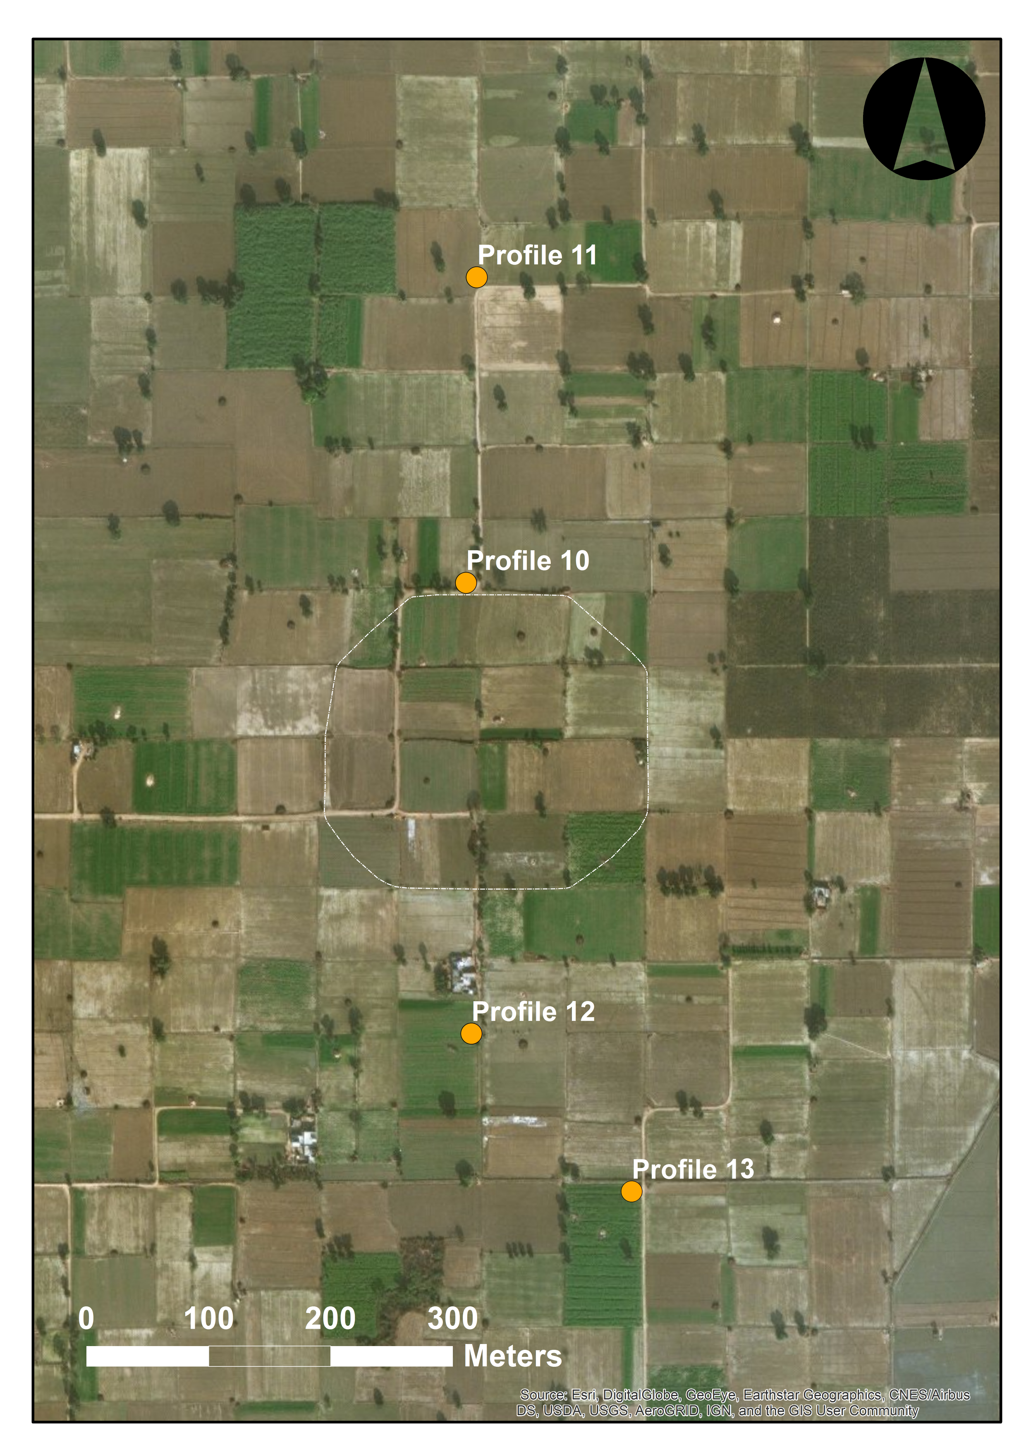

Figure SI.5. Photograph of cut section at Masudpur Profile 10 (Photo: C.A.I. French).
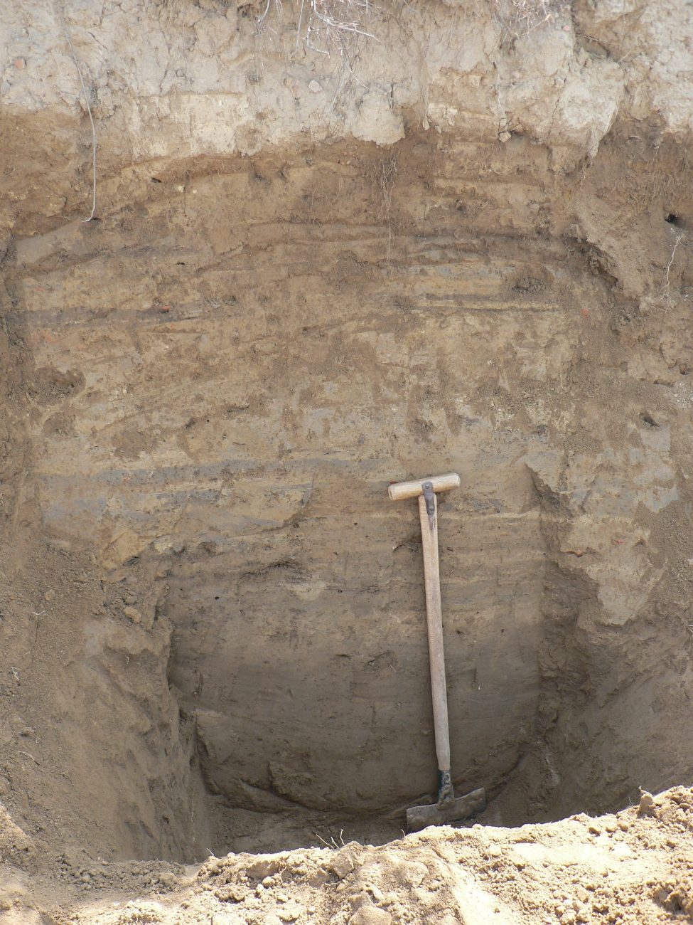

SI.2.3. Burj
The small-village sized site of Burj is located in the Fatehabad district of Haryana and was excavated by the Land, Water and Settlement team in 2010 to understand the nature and chronology of the transition between Late Harappan and Painted Grey Ware periods, which is much debated (Singh et al. 2010a). Although Late Harappan pottery was reported from the surface, excavations only revealed occupation during the Early Harappan and Painted Grey Ware (PGW) periods (Singh et al. 2010a).
Samples for micromorphological analysis were collected as follows: Sample 1/1, Sample 1/2, Sample 1/3 from Proﬁle 1 (Fig. SI.6-8). The physical characteristics of the Burj profiles exhibited very strong alkaline conditions (10.2-10.28), with low percentages of organic content (<1.24%) but high calcium carbonate content (12.56-21.47%) and low magnetic susceptibility values (Table SI.3). Texturally the samples were similar, with sand predominating (c. 50-65%) along with a considerable silt content (c. 30-43%), but relatively low values of clay present (<5.9%) (Table SI.3).
Sample 1/1 (24-37cm) was collected from near the top of Proﬁle 1, and micromorphological observations showed a generally apedal, porous, fine sandy silt loam with granular soil aggregates and channel microstructures (cf. Day and Holmgren 1952; Kooistra and Pulleman 2010; Stolt and Lindbo 2010; Stoops et al. 2010) with infrequent anthropogenic inclusions of bone. This suggests that this is a former organic Ah horizon with signiﬁcant rooting and turbation of the soil (Fig. 9). Secondary calcium carbonate has accumulated within the soil as well as amorphous iron oxides in the form of mottles and amorphous iron compounds giving the soil a brownish colour. The latter properties developed because of seasonal wetting and drying, as calcium carbonate forms when transpiration outweighs precipitation in a semi-arid environment (Durand et al. 2010). The parent material was ﬂuvial sands and silts which formed a complex of sedimentary deposition and channels.
Sample 1/2 (50-62 cm) has properties similar to the previous thin section (Sample 1/1) of the proﬁle. The soil is an apedal fine sandy silt loam with a decrease in porosity. The coarse minerals include very well-sorted quartz silt and ﬁne quartz sands. There is very little evidence of included anthropogenic material. The part of the proﬁle represented by this sample can be interpreted as a ﬂuvial sedimentary deposit of ﬁne sand and silt, which has been laid down relatively quickly. Subsequently, plant roots developed a channel microstructure. Bioturbation was a dominant process and has destroyed much of the evidence for sedimentation. During a later soil forming period, there was an accumulation of calcium carbonate within this part of the soil proﬁle. Monsoonal climatic conditions and cycles of wetting and drying appear to have developed iron mottling and ﬁne amorphous iron compounds throughout the ﬁne fabric characterised by brown colours.
Sample 1/3 (75-90cm) was collected from the lower part of Proﬁle 1. This is an apedal fine sandy silt loam with very well-sorted quartz particles and a vughy microstructure with channels. Again, there is a low organic content comprising amorphous ﬁne material and humiﬁed plant tissue residues. As with the other samples from Burj, the micromorphology of the soil indicates that organic content has previously been much higher. It is through the oxidation and biological diagenesis of the organics during subsequent soil forming periods that the organic component was transformed into secondary compounds. The soil at this depth has been subject to gleying processes through the repeated ﬂuctuation of the groundwater table. Perhaps the most interesting deﬁning characteristic of this part of the soil proﬁle, despite the particle size analysis suggesting that were a low clay content, is the signiﬁcant evidence of clay textural pedofeatures, including common coatings, infillings and fragments of micro-laminated pure and dusty clay in the groundmass and voids. This relatively clay enriched horizon suggests that this was an argillic Bt horizon, and based on the degree of development it must have been part of a soil sequum of some considerable age. The presence of a few anthropogenic markers, such as potsherds and bone fragments, suggests that the associated land surface was under human occupation (cf. Adderley et al. 2010). The evidence for precipitation of CaCO₃ diminishes at this depth in the Bt horizon, and there is the scant presence of micrite within the ﬁne fabric. This could indicate the later precipitation of carbonate-rich water as a result of drying of the environment during the later Holocene (cf. Sehgal and Stoops 1972).
Figure SI.6. Map showing the Proﬁle locations at Burj (Map: C.A. Petrie)
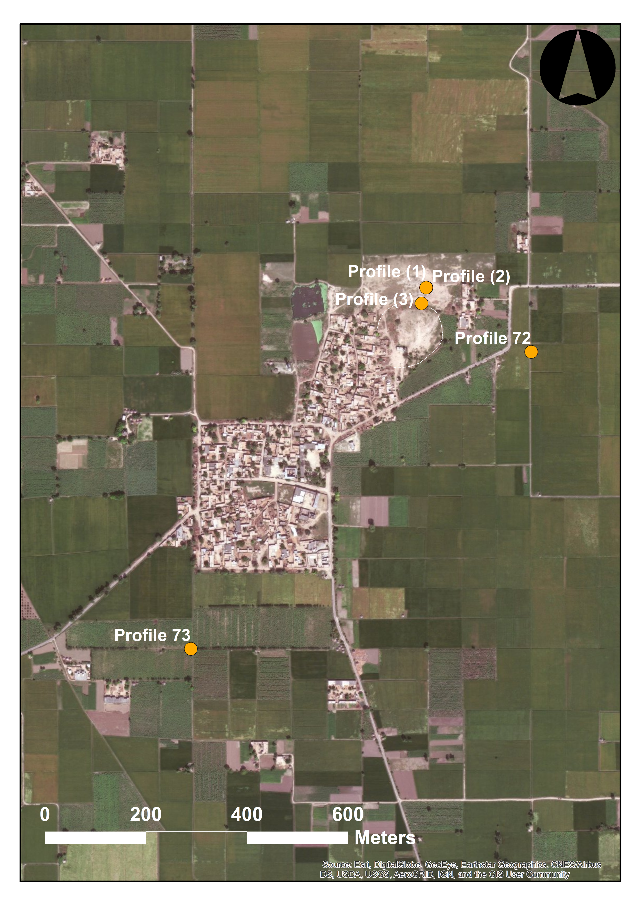

Figure SI.7. Photograph of the cut section at Burj Profile 1 with the location of soil blocks indicated (Photo: C.A.I. French).
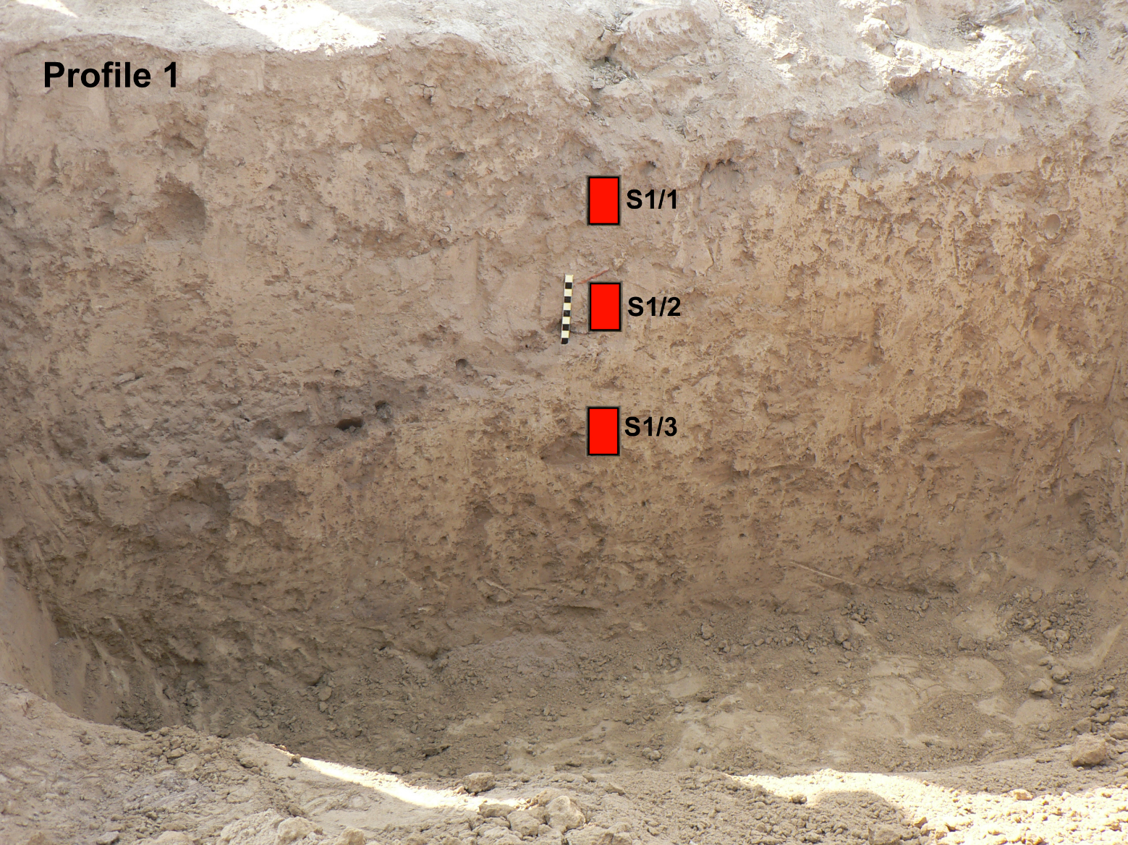
Figure SI.8 Photograph of the cut section at Burj Profile 2 (Photo: C.A.I. French).
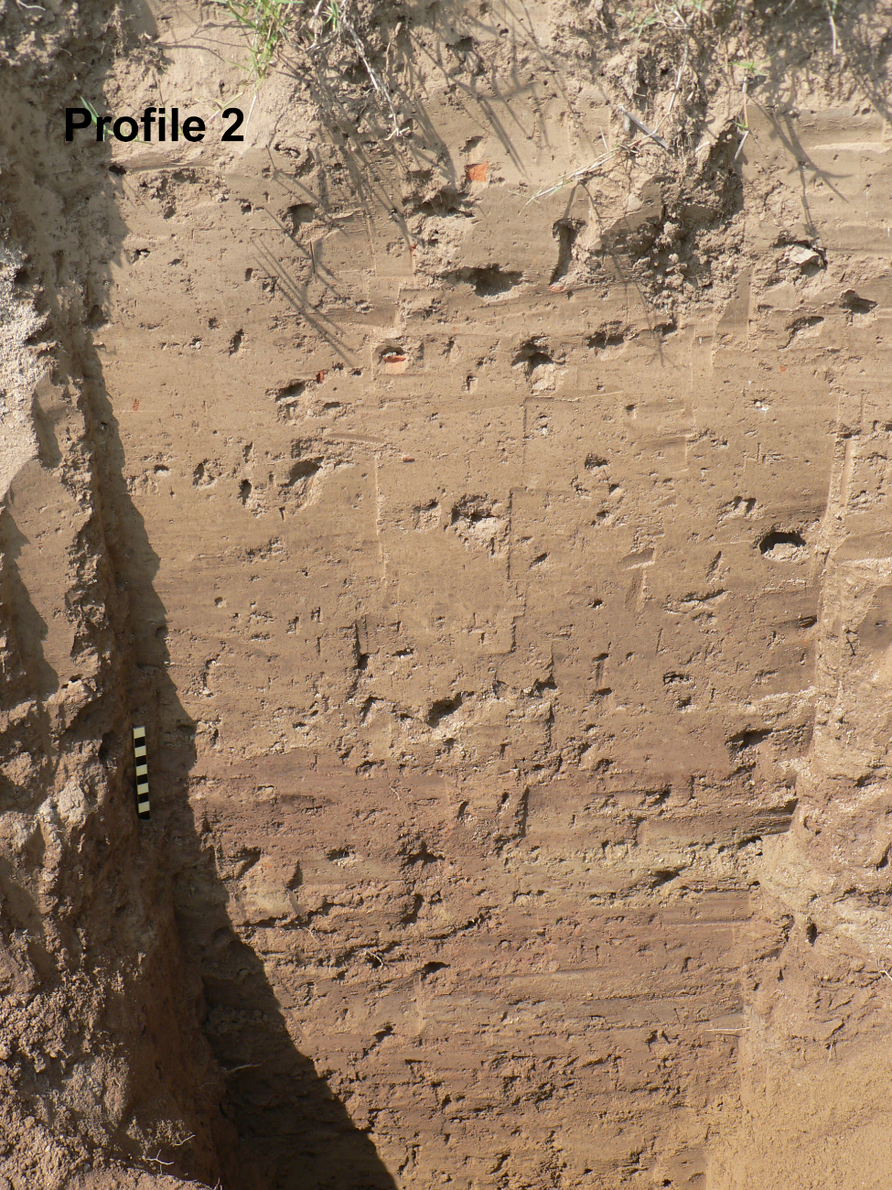
Table SI.1. Profile descriptions for Alamgirpur, Masudpur I, Masudpur VII, and Burj
Site/Profile | Depth below modern ground surface (cm) | Field description
Alamgirpur:
Profile 1 | 0-24 | pale yellowish brown silt; c. 30cm removed; modern ploughsoil (Ap)
 | 24-75 | yellowish fine sandy silt with frequent calcitic nodules; B/C
Profile 2 | 0-20 | pale brown silt with pottery sherds; modern ploughsoil (Ap)
 | 20-40 | pale yellowish brown sandy silt
 | 40+ | yellowish brown sandy silt with frequent calcitic nodules; B/C
Profile 3 | 0-25 | homogeneous fine sand; modern ploughsoil (Ap) with pottery sherds
 | 25-100 | very fine sand/silt; aeolian deposit
 | 100+ | white, laminated, micaceous riverine sand
Profile 4 | 0-25 | homogeneous fine sand; modern ploughsoil (Ap) with pottery sherds
 | 25-100 | very fine sand/silt; aeolian deposit
 | 100+ | white, laminated, micaceous riverine sand; B/C
Profile 5 | 0-20 | pale brown fine sandy loam; modern ploughsoil (Ap) with pot sherds
 | 20-200 | reddish brown silty clay loam; alluvium
 | 200-300 | brown silty clay loam with some sand and calcium carbonate concretions; alluvium
 | 300-330 | very fine and soft, pale brown micaceous fine sand with some calcium carbonate concretions; riverine sands
 | 330-360 | highly micaceous, yellowish brown fine sand with lesser/almost no concretions; riverine sands
 | 360-390 | dark grey fine-medium sand with occasional yellowish/orange mottles; gleyed riverine sands
 | 390-400 | grey/bluish grey, highly micaceous, fine-medium sand; wet/gleyed riverine sands
 | 400+ | groundwater table
Masudpur I:
Profile 10 | 0-100 | horizontally banded pale yellowish brown fine sandy silt; modern ploughsoil (Ap) with frequent pot sherds
 | 100-107 | dark grey very fine sandy silt; buried Ah horizon
 | 107-135 | pale brown very fine sandy silt; buried B horizon
 | 135+ | pale yellowish brown very fine sandy silt with frequent calcitic nodules; B/C
Profile 11 | 0-45 | pale brown silt; modern ploughsoil (Ap)
 | 45-155 | brown silt; alluvium
 | 155-170 | yellowish/greyish brown very fine sandy silt; upper channel fill deposits
 | 170-292 | yellowish brown very fine-fine sand, becoming coarse with depth; channel fill deposits
 | 292+ | yellow fine-medium sand with frequent calcitic nodules; B/C
Profile 12 | 0-75 | pale brown silt; modern ploughsoil (Ap)
 | 75-170+ | dark greyish brown very fine sandy silt with irregular to columnar blocky ped structure; alluvium; not bottomed
Profile 13 | 0-185 | dark brown silt with irregular to columnar blocky ped structure; modern ploughsoil (Ap) in alluvium
 | 185-215 | as above with orange mottling; part oxidized/gleyed alluvium
 | 215+ | yellowish brown very fine sandy silt; upper channel fill deposits
Masudpur VII:
Profile 15 | 0-193 | pale brown very fine sand; modern ploughsoil (Ap) with Indus archaeological levels
 | 193-213 | yellowish brown fine sand; upper B/C
 | 213-268 | sterile pale yellowish brown fine sand; B/C
 | 268+ | pale yellow very fine-medium sand with frequent calcitic modules; dune C
Burj:
Profile 1 | 0-24 | pale brown silt; c. 40cm removed; base of modern ploughsoil (Ap)
 | 24-75 | yellowish brown very fine sandy silt with occasional freshwater bivalve; alluvium/reworked channel bed deposits acting as a B horizon
 | 75+ | yellowish brown very fine sandy silt with frequent calcitic nodules; B/C
Profile 2 | 0-20 | pale brown silt with pottery sherds; modern ploughsoil (Ap)
 | 20-60 | yellowish brown very fine sandy silt; B horizon
 | 60+ | yellowish brown very fine sandy silt with frequent calcitic nodules; B/C
Profile 3 | 0-75 | homogeneous pale brown silt; modern ploughsoil (Ap) with pottery sherds
 | 75-125 | horizontally banded archaeological levels of alternating dark reddish brown and pale grey silt; repeated stop/start alluvial deposition and surface drying out
 | 125+ | pale yellowish brown calcitic silt; B/C
Profile 72 | 0-120 | sandy silt; modern ploughsoil (Ap) with Indus archaeological material
 | 120-145+ | pale yellowish brown sandy silt; B/C
Profile 73 | 0-30 | pale yellowish brown sandy silt; modern ploughsoil (Ap)
 | 30-60 | dark greyish brown sandy silt; gleyed B horizon
 | 60-100 | pale yellowish sandy silt with calcitic nodules; B/C

Table SI.2. Summary micromorphological observations for Alamgirpur, Masudpur I, and Burj
Site/sample | Main fabric | Other features and inclusions | Interpretation
Alamgirpur:
1/1 upper, 434-444cm | very fine-fine sandy loam exhibiting weakly developed sub-angular blocky microstructure superimposed on channel microstructure | common dark brown amorphous organic fine material & abundant humified plant tissues; groundmass abundantly striated with pure/dusty clays; voids coated with pure/dusty clay; few fragments of highly oriented micro-laminated pure clay; common dense infillings of voids with aggregates of same fine groundmass fabric; frequent amorphous sesquioxide staining of groundmass & replacing plant remains; few CaCO3 nodules | humic sandy loam soil with illuvial fines indicative of former stability & some soil formation; subsequent secondary formation of iron & calcium carbonate through strong drying conditions
1/1 lower, 444-454cm | silty clay loam exhibiting moderately well-developed sub-angular blocky microstructure with abundant channels & vughs | common dark brown amorphous organic fine material & abundant humified plant tissues; groundmass abundantly striated with pure/dusty clays & voids commonly coated with pure/dusty clay; common dense infillings of voids with aggregates of same groundmass fabric; frequent amorphous sesquioxides around pore space & as nodules; common micritic coatings of voids; few CaCO3 nodules | humic silty clay loam with organised clay component & some structural development indicative of argillic B horizon, which becomes strongly gleyed and subject to wetting/drying episodes
3/1, 143-153cm | coarse sandy/silty clay loam with channel microstructure superimposed on single to bridged grain; developed on fine-medium quartz sand | few fragments of pottery, bone & mud-brick; common dark brown amorphous organic fine material & humified plant tissues; groundmass abundantly striated with pure/dusty clays; voids coated with pure/dusty clay; common dense infillings of voids with aggregates of same groundmass fabric; common amorphous sesquioxides around pore space & replacing plant remains; common micritic coatings of voids; few CaCO3 nodules; few silt crusts | weathered surface of levee with fine anthropogenic and overbank alluvial inputs
Masudpur I:
10/2: 105-113cm | apedal to bridged grain, fine sandy loam | few fragments of pottery & bone; few to common amorphous organic fine material & humified plant tissues rare aggregates of same groundmass fabric; rare dusty clay coatings of voids; some secondary amorphous sesquioxide mottling; some secondary micrite formation | weakly developed sandy loam soil with some input of anthropogenic material, minor illuviation of fines, & secondary formation of iron & calcium carbonate through seasonal wetting/drying
10/3, 113-122cm | crumb to pellicular grain structured, ﬁne sandy loam | few fragments of pottery, bone & mud-brick; common dark brown amorphous organic fine material & humified plant tissues; few phytoliths; common void coatings with pure & dusty clay; few fragments of pure clay; common infillings of voids with aggregates of same groundmass fabric; common amorphous sesquioxides around pore space & replacing plant remains; few CaCO3 nodules; few silt crusts | weakly developed sandy loam soil with gleying & surface drying
13, 205-212cm | single to bridged grain structured fine sandy loam with few channels | common dark brown amorphous organic fine material & humified plant tissues; few phytoliths; common void coatings with pure & dusty clay; common fragments of pure clay; frequent infillings of voids with aggregates of same groundmass fabric; common amorphous sesquioxides around pore space & replacing plant remains; few CaCO3 nodules | sandy loam soil with strong illuvial fines component suggesting longer-term pedogenesis
Burj:
1/1, 24-37cm | finely aggregated, channelled & vughy, fine sandy silt loam | few dusty clay around grains and lining pore space; occasional zones/nodules of CaCO3; few sesquioxide nodules & mottles; few fragments of bone | bioturbated & rooted A horizon with secondary formation of iron & calcium carbonate
1/2, 50-62cm | finely aggregated, channelled & vughy, fine sandy silt loam | few humified plant tissues; few dusty clay around grains and lining pore space; common zones/infills/coatings/nodules of micritic CaCO3; few sesquioxide nodules & mottles; few fragments of bone | bioturbated & rooted A horizon with strong secondary formation of calcium carbonate indicating surface drying
1/3, 75-90cm | channelled & vughy, fine sandy silt loam | few humified plant tissues; common micro-laminated pure & dusty clay around grains and lining pore space; few nodules of micritic CaCO3; common sesquioxide nodules & mottles; few fragments of pot & bone | clay-enriched Bt horizon implying more moist, vegetated and stable conditions in the past

Table SI.3. Selected pH, loss-on-ignition organic and calcium carbonate contents, magnetic susceptibility, and summary particle size analysis results for Alamgirpur, Masudpur I and Burj
Site/sample number | pH | % organic content | % calcium carbonate | Magnetic susceptibility  (x10⁻⁸ SI) | % sand | % silt | % clay
Alamgirpur:
3, 143-153cm | 8.07 | 0.415 | 1.68 | 23 | 88.89 | 10.34 | 0.77
1, 444-454cm | 8.43 | 2.175 | 3.89 | 16.6 | 4.09 | 53.9 | 41.93
6, 460-470cm | 9.81 | 1.735 | 11.2 | 28.7 | 37.43 | 55.35 | 7.19
Masudpur I:
10/2, 105-113cm | 9.16 | 1.07 | 7.2 | 20.3 | 73.55 | 22.16 | 4.29
10/3, 113-122cm | 9.36 | 0.95 | 4.1 | 16.2 | 74.38 | 21.19 | 4.43
13, 205-212cm | 8.61 | 1.26 | 2.6 | 13.4 | 52.2 | 41.29 | 6.51
Burj:
1/1, 24-37cm | 10.2 | 0.945 | 12.56 | 24.0 | 60.03 | 34.89 | 5.08
1/2, 50-62cm | 10.24 | 1.24 | 21.47 | 18.5 | 64.44 | 30.56 | 5.02
1/3, 75-90cm | 10.28 | 0.88 | 16.7 | 11.4 | 50.75 | 43.35 | 5.9

Table SI.4. Equivalent dose (D_{e}), dose rate (Ḋ) and OSL age summary. D_{e}s, Ḋ and ages are shown to two decimal places, with all calculations made prior to rounding.
Site | Depth (m) | # Grains accepted (measured) | Over-dispersion (%) | CAM D_{e} (Gy) | Beta (Gy.ka⁻¹) | Gamma (Gy.ka⁻¹) | Cosmic (Gy.ka⁻¹) | Dose rate (Gy.ka⁻¹) | Age (ka)
ALM | 1 | 55 (6600) | 46.9 ± 3.7 | 21.43 ± 1.49 | 2.88 ± 0.23 | 1.85 ± 0.12 | 0.14 ± 0.01 | 4.87 ± 0.26 | 4.47 ± 0.40
MSD I | 2 | 61 (1500) | 38.6 ± 2.8 | 18.64 ± 1.06 | 2.18 ± 0.17 | 1.48 ± 0.10 | 0.16 ± 0.02 | 3.82 ± 0.20 | 4.89 ± 0.37
MSD I | 1.5 | 56 (2000) | 37.7 ± 2.9 | 15.69 ± 0.91 | 2.25 ± 0.18 | 1.50 ± 0.10 | 0.17 ± 0.02 | 3.91 ± 0.20 | 4.01 ± 0.31
MSD VII | 3 | 55 (2600) | 38.8 ± 3.0 | 25.79 ± 1.55 | 2.05 ± 0.17 | 1.34 ± 0.09 | 0.14 ± 0.01 | 3.53 ± 0.19 | 7.32 ± 0.59
MSD VII | 3 | 59 (3800) | 40.1 ± 3.0 | 24.24 ± 1.44 | 2.26 ± 0.18 | 1.36 ± 0.09 | 0.14 ± 0.01 | 3.75 ± 0.20 | 6.47 ± 0.52
BRJ | 1 | 62 (3300) | 38.3 ± 2.8 | 24.91 ± 1.40 | 2.67 ± 0.22 | 1.69 ± 0.11 | 0.18 ± 0.02 | 4.54 ± 0.24 | 5.48 ± 0.42

Supplementary Information Bibliography
Adderley, W.P., Wilson, C., Simpson, I., Davidson, D., 2010. Anthropogenic features. In: Stoops, G., Marcelino, V., Mees, F. (Eds.), Interpretation of Micromorphological Features of Soils and Regoliths. Elsevier, Amsterdam, pp. 569–588.
Bengtsson, L., Enell, M., 1986. Chemical analysis. In: Berglund, B.E. (Ed.), Handbook of Holocene Palaeoecology and Palaeohydrology. John Wiley, Chichester, UK, pp. 323–451.
Boreham, S., Conneller, C., Milner, N., Taylor, B., Needham, A., Boreham, J., Rolfe, C.J., 2011. Geochemical indicators of preservation status and site deterioration at Star Carr. Journal of Archaeological Science 38, 2833–2857.
Brewer, R., 1960. Cutans: their deﬁnition, recognition, and interpretation. Journal of Soil Science 11, 280–292.
Bullock, P., Fedoro, N., Jongerius, A., Stoops, G., Tursina, T., 1985. Handbook of Soil Thin Section Description. Waine Research, Albrighton, Wolverhampton, UK.
Day, P.R., Holmgren, G.G., 1952. Microscopic changes in soil structure during compression. Soil Science Society of America Journal 16, 73–77.
Emerson, W.W., 1959. The structure of soil crumbs. Journal of Soil Science 10, 235–244.
English Heritage, 2004. Geoarchaeology: Using Earth Sciences to Understand the Archaeological Record. English Heritage, Swindon, UK.
French, C., Periman, R., Cummings, L.S., Hall, S., Goodman-Elgar, M., Boreham, J., 2009. Holocene alluvial sequences, cumulic soils and ﬁre signatures in the middle Rio Puerco basin at Guadalupe Ruin, New Mexico. Geoarchaeology 24, 638–676.
Kooistra, M.J., Pulleman, M.M., 2010. Features related to faunal activity. In: Stoops, G., Marcelino, V., Mees, F. (Eds.), Interpretation of Micromorphological Features of Soils and Regoliths. Elsevier, Amsterdam, pp. 397–418.
Kubiëna, W.L., 1970. Micromorphological Features of Soil Geography. Rutgers University Press, New Brunswick, NJ.
Liversage, D., Robinson, D., 1993. Prehistoric settlement and landscape development in the sandhill belt of southern Thy. Journal of Danish Archaeology 11, 39–56.
Schwertmann, U., 1993. Relations between iron oxides, soil color, and soil formation. In: Bigham, J.M., Ciolkosz, E.J. (Eds.), Soil Color. SSSA Special Publication 31. Soil Science Society of America, Madison, WI, pp. 51–69.
Sehgal, J.L., Stoops, G., 1972. Pedogenic calcite accumulation in arid and semi-arid regions of the Indo-Gangetic alluvial plain of erstwhile Punjab (India) and their morphology and origin. Geoderma 8, 59–72.
Stoops, G., 2003. Guidelines for Analysis and Description of Soil and Regolith Thin Sections. Soil Science Society of America, Madison, WI.
Stoops, G., Marcelino, V., Mees, F. (Eds.), 2010. Interpretation of Micromorphological Features of Soils and Regoliths. Elsevier, Amsterdam.
Usai, M.-R., Dalrymple, J.B., 2003. Characteristics of silica-rich pedofeatures in a buried paleosol. Catena 54, 557–571.
Vinther, F.P., Hansen, E.M., Eriksen, J., 2006. Leaching of soil organic carbon and nitrogen in sandy soils after cultivating grass-clover swards. Biology and Fertility of Soils 43, 12–19.

