Grass habitat analysis and phytolith based quantitative reconstruction of Asian monsoon climate change in the sand-loess transitional zone, Northern China
Supplemental information
Hanlin Wang¹, Huayu Lu^{1*}, Hongyan Zhang¹, Shuangwen Yi¹, Yao Gu¹, Chenghong Liang¹
1. School of Geography and Ocean Science, Jiangsu Collaborative Innovation Centre for Climate Change, Nanjing University, Nanjing 210023, China (e-mail: huayulu@nju.edu.cn).

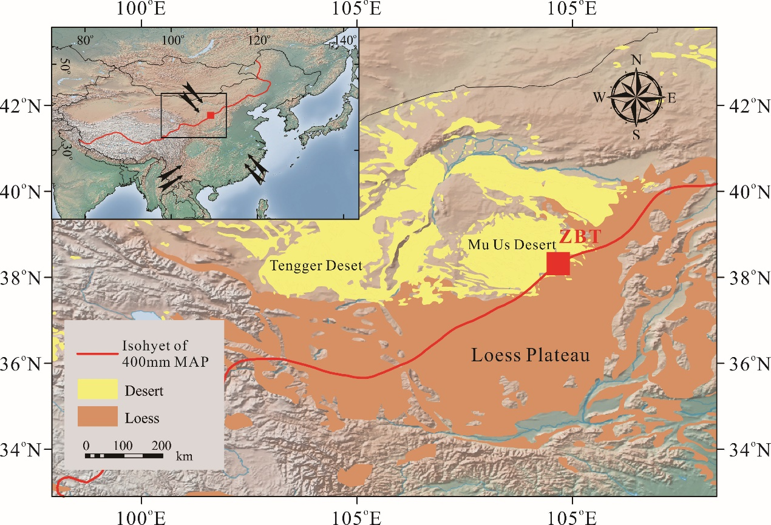
Fig. S1. Landform, climate of study site. The sampling site at Zhengbeitai (ZBT), Yuli, Asian monsoon marginal region. Prevailing modern atmospheric circulation patterns are indicated by arrows.
Method and result for global species-climate database
Global species-climate dataset
The method we used mainly follow Edward and Smith (2010). We extracted all geo-referenced natural history collection of Poaceae species, which available via the Global Biodiversity Information Facility (GBIF) web portal (http://www.gbif.org/). For each set of coordinates we extracted monthly temperature and precipitation values from CliMond database at 10′ resolution (∼18 km at the equator) (Kriticos et al. 2012) (https://www.climond.org/). The original collection data consisted of 17,987,291 record, after screening empty (no coordinates/genus/species data) and duplicate records, we got a dataset consisted of 9,979,097 independent collection spanning 751 genus, 9921 species. We excluded all hybrid species/genus and species with few than 10 independent localities, reducing the dataset to 9,961,948 collection spanning 567 genus, 6,018 species. The mean number of collections per specie is 1,655, this value was heavily influenced by several species (e.g. Holcus lanatus, Dactylis glomerata, Festuca rubra, Agrostis stolonifera, Poa trivialis) with huge number of collections. After the 5% most heavily collected species were removed, the mean number of collections per species is 257. After matching with climatic data, the final database consisted of 9,390,524 collections spanning 567 genus, 6010 species with corresponding MAT, Warmest Month Mean Temperature (WMMT), Coldest Month Mean Temperature (CMMT), MAP, Warmest Month Mean Precipitation (WMMP), Coldest Month Mean Precipitation (CMMP) and Difference in Temperature of warmest and coldest months (DT). The phylogenetic classification of the Poaceae follow latest molecular and morphological studies (Soreng et al., 2015, 2017).
For each species, our dataset could capture its ecological amplitude, or optimum range or just a random range inside its ecological amplitude. However, the climate range of each subfamily calculated from the union of climate range of all its species is obvious approach its tolerance limit or extends beyond its ecological amplitude (Table S1). For example, Bambusoideae with lower limit of MAT=1℃ and MAP=40 mm, while Pooideae with upper limit of MAT=30℃ and MAP=6000 mm. there are several possible explanations for this problem: 1) Large collection data (~10 million) result in large climate range which approach each specie’s ecological amplitude. 2) There are some flaws of collection data due to the introduction of species which growth under human care, such as Triticum aestivum. 3) Landform could also biases the result by changing the local environment.
Table S1. Climate range of each subfamily of Poaceae calculated by means of the union of climate range of all its species of Poaceae in China.
Subfamily | MAT  (℃) | WMMT  (℃) | CMMT  (℃) | MAP  (mm) | WMMP (mm) | CMMP (mm) | DT  (℃)
Aristidoideae | -4~30.5 | 3.9~37.8 | -19.9~27.8 | 2~3241 | 0~298 | 0~540 | 0.4~39.2
Arundinoideae | -6.6~30.0 | 5.2~37.3 | -28.3~27.2 | 7~6128 | 0~741 | 0~551 | 0.4~45.1
Bambusoideae | 1.0~28.2 | 7.9~35.2 | -13.6~26.9 | 40~7312 | 0~1290 | 0~654 | 0.6~30.4
Chloridoideae | -6.4~30.5 | 3.9~36.4 | -29.1~28.1 | 0~7527 | 0~741 | 0~1301 | 0.4~47.7
Danthonioideae | -6.4~27.5 | 5.4~35.9 | -19.9~23.2 | 41~3577 | 0~326 | 0~310 | 0.7~30.1
Micrairoideae | -1.9~27.9 | 6.5~33.6 | -10.5~27.2 | 25~6395 | 1~714 | 0~636 | 0.6~31.1
Oryzoideae | -6.9~30.2 | 5~37.4 | -25.7~27.9 | 2~8095 | 0~1507 | 0~1344 | 0.5~45.3
Panicoideae | -12.0~30.2 | 0.7~38.3 | -37.3~28.0 | 0~7830 | 0~784 | 0~1305 | 0.3~51.0
Pooideae | -30.9~30.2 | -13.6~38.3 | -49.2~27.0 | 0~6156 | 0~1507 | 0~961 | 0.3~61.3
MAT: mean annual temperature; WMMT: Warmest Month Mean Temperature; CMMT: Coldest Month Mean Temperature; MAP: Mean Annual Precipitation; WMMP: Warmest Month Mean Precipitation; CMMP: coldest Month Mean Precipitation; DT: Difference in Temperature of warmest and coldest months.
For the above reasons, it’s inappropriate to use the climate range of each species which approach its tolerance limit or extends beyond its ecological amplitude to calculate the climate range of each subfamily, the optimum range of each species in which species can growth and reproduction is the best choice however difficult to obtain. In order to simplify the problem, here we make an assumption: for each species, the mean value of its environmental factor of all its collection localities within its optimum range, and we use this value as its optimum value. (e.g. Achnatherum bromoides had 497 collections, the optimum mean annual temperature (MAT) of Achnatherum bromoides is the mean value of MAT of its 497 collection localities) The biases of this value prone to inherent biases in sampling, human activity, the competition between species and landform could also biases the value. It’s important to notice the climate range of each subfamily calculated by this method range from the lowest optimum value of its species to the highest, the actual climate range is larger.
Environment niche of global grasses
Climate data extracted from all available geo-referenced grasses provided clear evidence that certain grass lineages have been specialized in certain habitats (Fig. S2). For temperature, Pooideae and Danthonioideae stand out and occupy very cool environment, suggested either by MAT or WMMT, CMMT (Fig. S2). Pooideae also stand out and able to tolerate most drastic temperature change, while Bambusoideae prefer more stable environments (Fig. S2). For precipitation, Bambusoideae stand apart as inhabiting wettest environments in all subfamilies, open habitat grasses Panicoideae and Micrairoideae along with close habitat grasses Oryzoideae occupy more humid environment suggested by MAP and WMMP. Pooideae occupy the dry end of the spectrum alongside Aristidoideae and Chloridoieae (Fig S2). For seasonal change of precipitation, Danthonioideae prefer dry summer and mild winter, Pooideae, Oryzoideae and Arundinoideae seems got no preference, while other grasses prefer rain hot during the same period (Fig. S2). The climate range of each subfamily of Poaceae are too wide for quantitative reconstruction (Table S2). Take MAT as example, even the present of all nine subfamily make the MAT range from 8.4-21℃.
Table S2. Climate range of each subfamily of Poaceae in global scale.
Subfamily | MAT  (℃) | WMMT  (℃) | CMMT  (℃) | MAP  (mm) | WMMP  (mm) | CMMP  (mm) | DT  (℃)
Aristidoideae | 2.1~28.4 | 10.8~33.2 | -7.8~25.5 | 34~1966 | 0~276 | 0-144 | 0.9~29.0
Arundinoideae | 5.3~25.4 | 15.5~30.2 | -6.5~19.3 | 51~2069 | 3~266 | 1~160 | 4.2~24.3
Bambusoideae | 6.9~27.2 | 10.5~30.2 | -3.4~25.9 | 685~4902 | 22~501 | 4~535 | 0.7~25.0
Chloridoideae | 0.1~29.0 | 9.3~34.2 | -18.3~25.8 | 73~4093 | 0~437 | 0~362 | 0.8~37.1
Danthonioideae | 3.3~21.0 | 10.1~26.8 | -7.6~20.3 | 134~5927 | 5~542 | 8~523 | 1.0~26.7
Micrairoideae | 8.4~27.5 | 18.1~31.5 | -3.0~25.0 | 258~2885 | 26~355 | 1~230 | 1.1~21.4
Oryzoideae | 5.6~27.8 | 13.7~31.2 | -10.3~25.7 | 168~2717 | 6~275 | 6~236 | 2.0~30.0
Panicoideae | 1.1~29.2 | 12.3~34.2 | -11.9~35.9 | 102~3610 | 4~360 | 0~496 | 0.9~31.5
Pooideae | -18.3~22.5 | 3.3~30.7 | -35.8~20.4 | 23~5518 | 0~502 | 1~482 | 0.8~47.5
MAT: mean annual temperature; WMMT: Warmest Month Mean Temperature; CMMT: Coldest Month Mean Temperature; MAP: Mean Annual Precipitation; WMMP: Warmest Month Mean Precipitation; CMMP: coldest Month Mean Precipitation; DT: Difference in Temperature of warmest and coldest months.
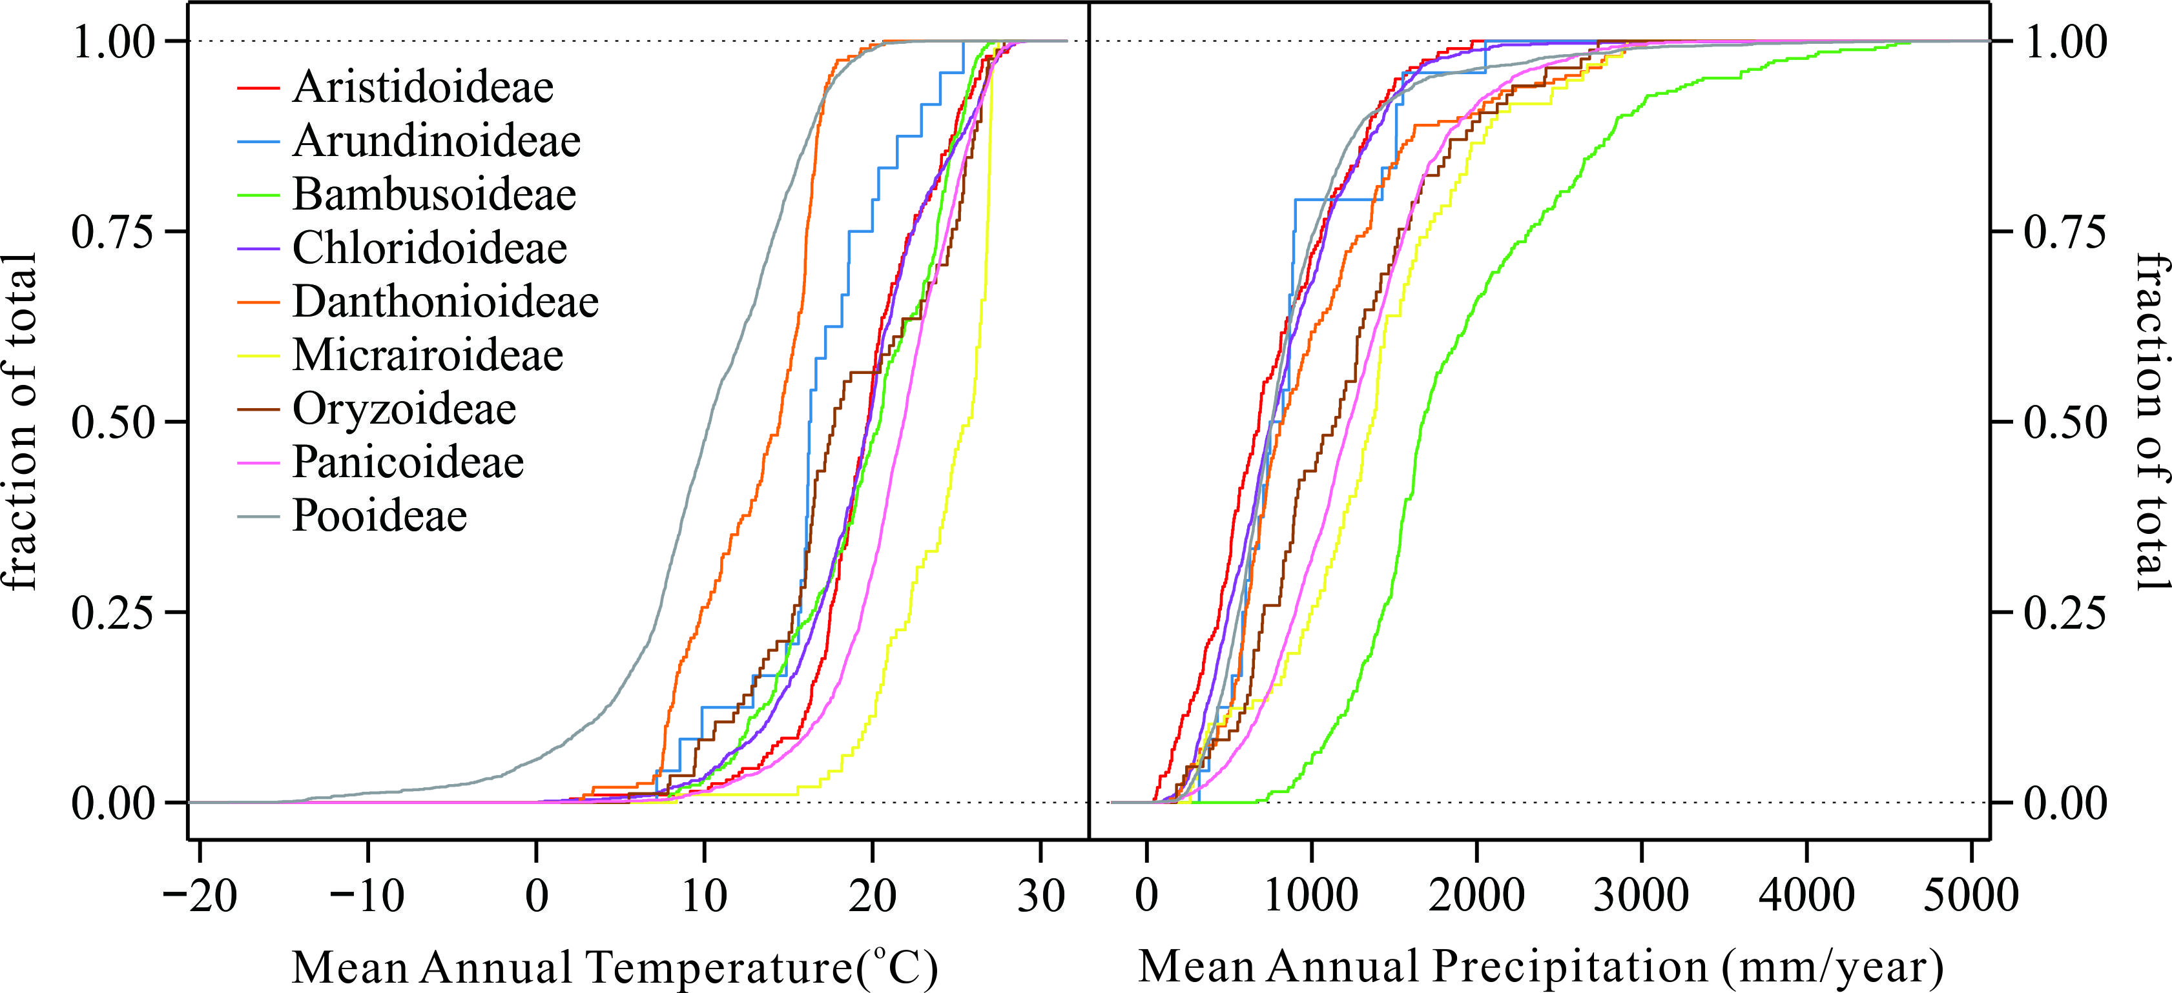
Fig. S2. Species accumulation curves for mean annual temperature and precipitation, sorted by major grass subfamilies. These data represent 9,390,524 independent collection localities across 6,010 species. Data from Global Biodiversity Information Facility (GBIF) web portal (http://www.gbif.org/).
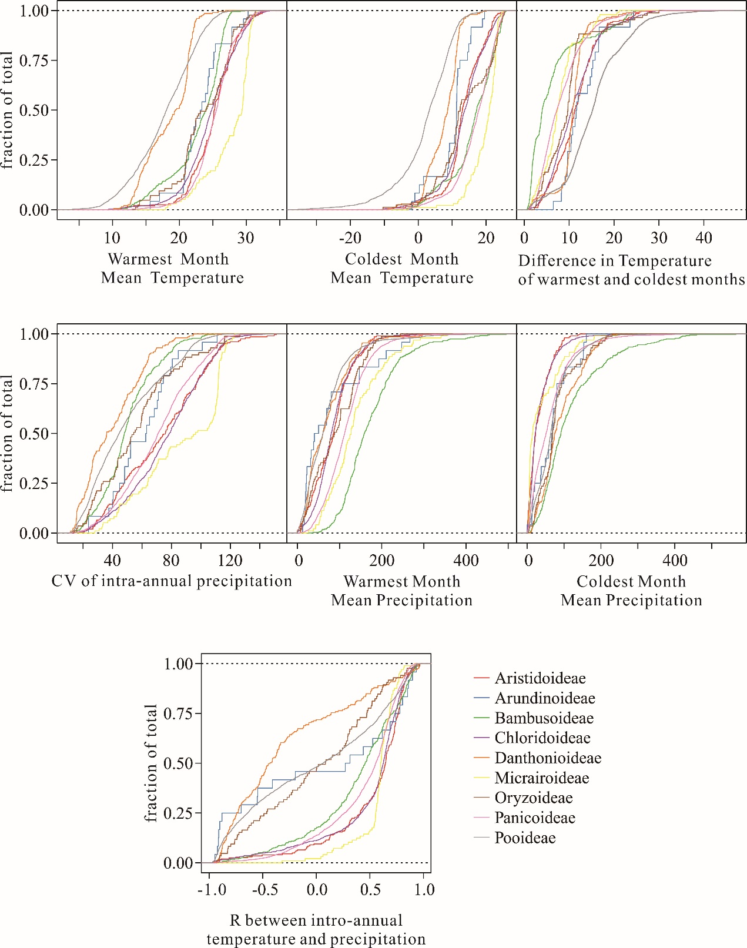
Fig. S2 (continued). Species accumulation curves for WMMT, CMMT, DT, CV of intra-annual precipitation, WMMP, CMMP, R between intro-annual temperature and precipitation, sorted by major grass subfamilies. These data represent 9,390,524 independent collection localities across 6,010 species. Data from Global Biodiversity Information Facility (GBIF) web portal (http://www.gbif.org/).
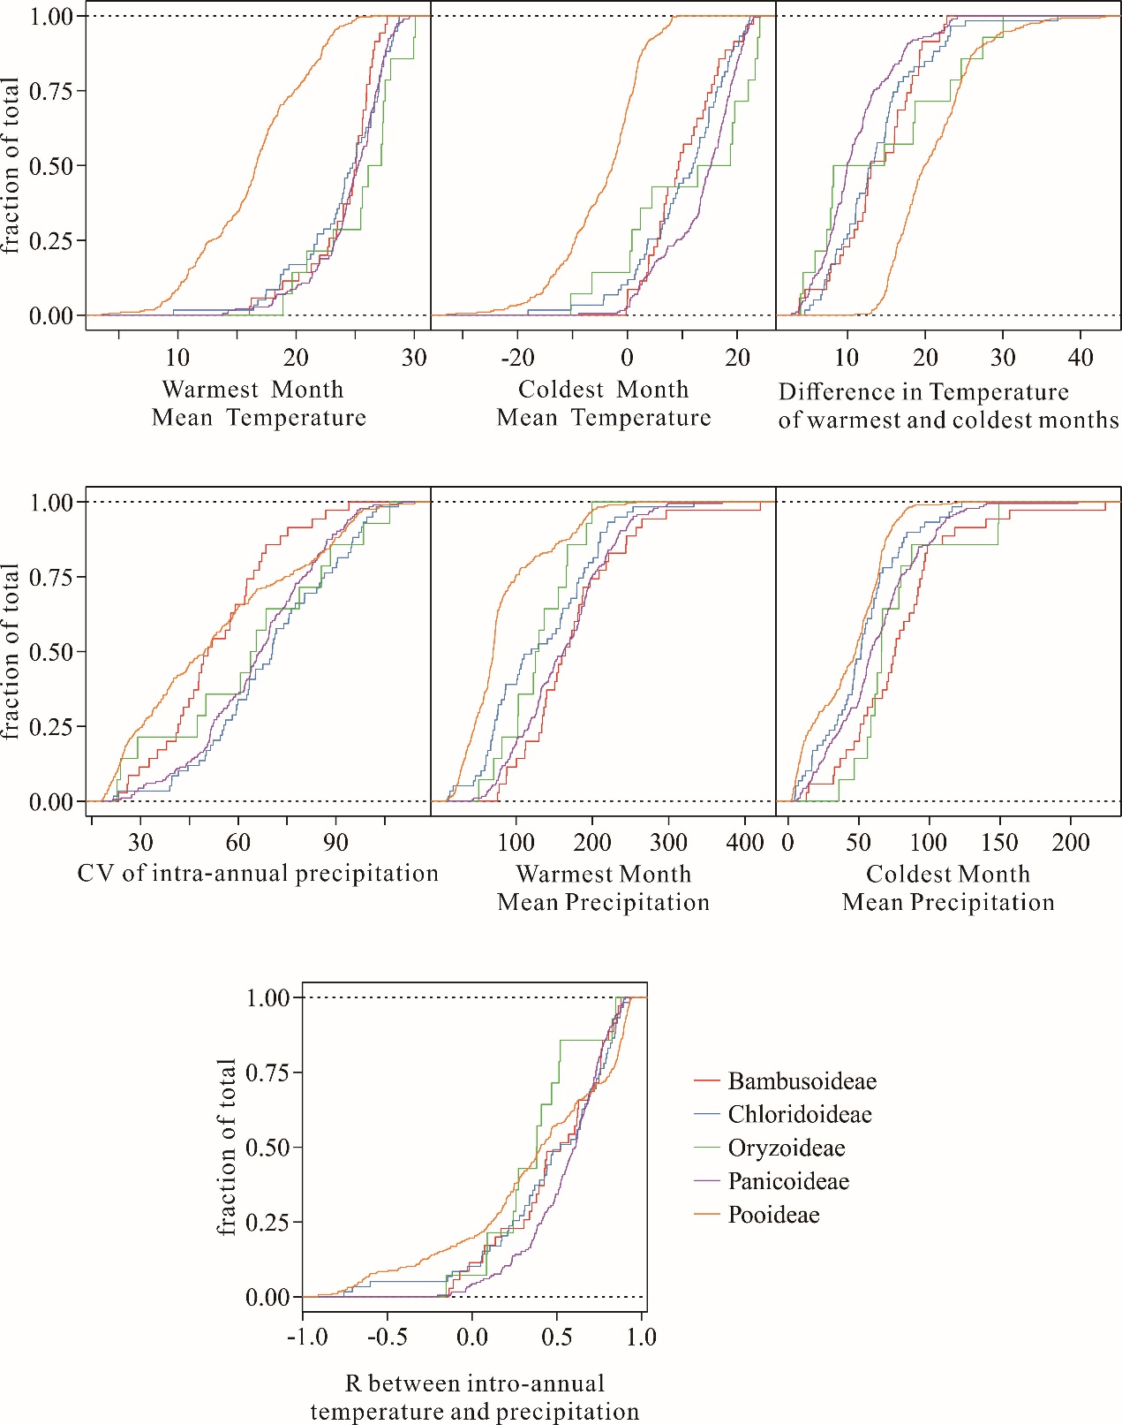
Fig. S3. Species accumulation curves for the WMMT, CMMT, DT, CV of intra-annual precipitation, WMMP, CMMP, R between intro-annual temperature and precipitation, in China, sorted by major grass subfamilies. These data represent the 598 species record in Flora of China (http://foc.eflora.cn/), but the collection localities were not necessarily in China.
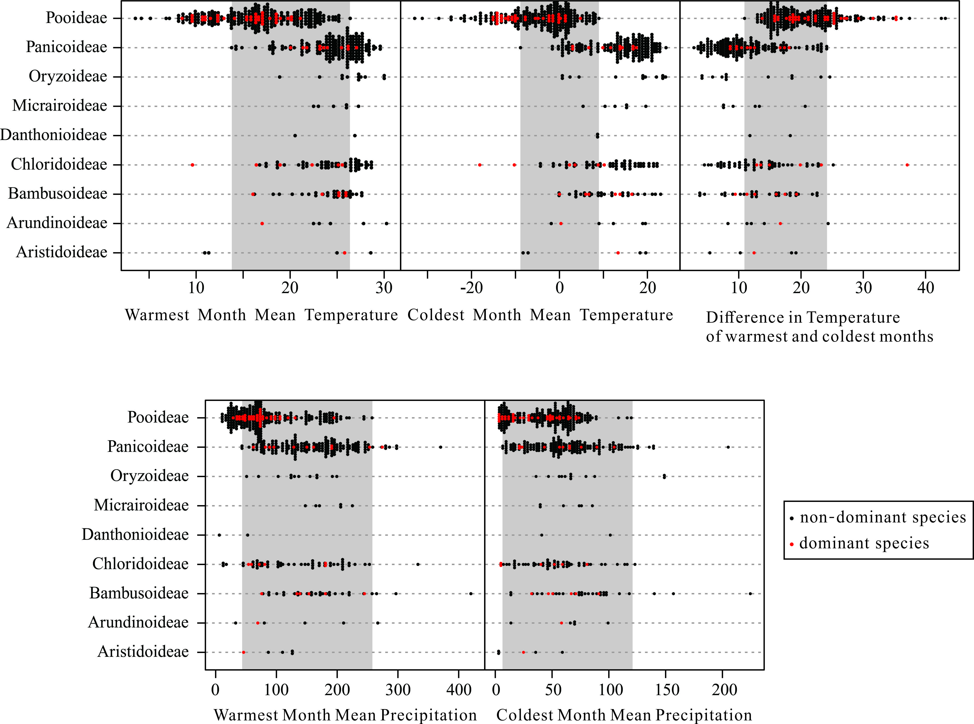
Fig. S4. Wilkinson dot plot for climate paremeters of 598 species in China, sorted by major grass subfamilies. Red dots represent species that dominant the grassland according to the ecosystem data of China. Grey boxes represent the climate range reconstructed using the Coexistence Approach on phytolith assemblages in the ZBT section.
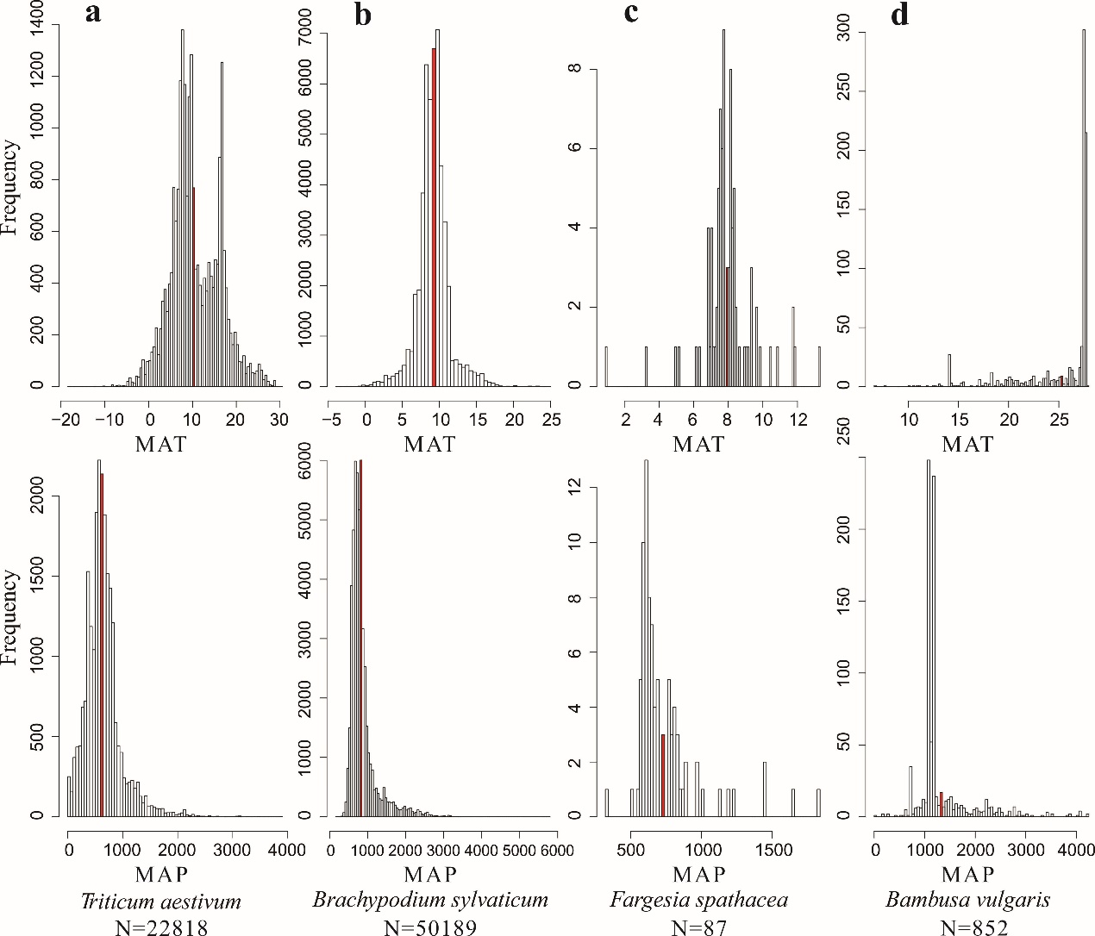
Fig. S5. Histogram of MAT and MAP of Triticum aestivum (a), Brachypodium sylvaticum (b), Fargesia spathacea (c) and Bambusa vulgaris (d). Triticum aestivum and Brachypodium sylvaticum from Pooideae, Fargesia spathacea and Bambusa vulgaris from Bambusoideae. Red line indicate the mean value of each parameter.
Addition illustrate for Fig. S5: The main point of Fig. S5 is to explain why we using the mean value of climate parameter of each species to calculate the climate range of each subfamily in stand of the climate range of each species. Triticum aestivum is a species that cultivated worldwide, the huge range of its MAT and MAP (Fig. S5a) mainly result from agricultural activities. Fig. S5b show the up limit of MAP of Brachypodium sylvaticum is ~6000 mm, which obvious approach its tolerance limit or extends beyond its ecological amplitude, Therefore, it is inappropriate to use its full climate range. Another option is using the optimal range of each species. Theoretically, using the fitting curve to match the distribution of climate parameter, the confidence intervals of this parameter is analogous to the optimal range. However the distribution of climate parameter did not constant, some of them are normal distribution, and some of them are F-distribution, it’s impossible to calculate the confidence intervals of each parameter of each species due to uneven distribution and huge data (~10 million), some species do not have enough collections to identify distribution function (Fig. S5c, notice some species got only 10 collections). Thus, compromise must be made, the mean value of each parameter of each species is the simple way, and this value most likely localities within its optimum range (Fig. S5).

Table S3. Assemblage data and estimation of vegetation for phytolith assemblages extracted from the profile.
 |  |  |  | GSSC
 |  | FI-TOT |  |  |  |  | PACMAD TOT |  |  |  |  |  |  |  |  |  | Tree cover |  | Grass community
Lab No. | Age (ka) | Palm | Other FI | CH TOT | POOID-D | POOID-ND | PAN | CHLOR | PACMAD-general | OTHG | AQ | NDG | NDO | Sponge spicules | Total phytolith count | FI TOT+GSSC count | FI-t ratio | FI-t ratio 95% C.I. | Pooideae-ratio | Pooideae-ratio 95%C.I.
ZBTN-0 | 0.8 | 0.0 | 0.2 | 0.3 | 8.6 | 25.0 | 17.5 | 1.6 | 16.2 | 0.2 | 0.0 | 16.8 | 13.8 | 6 | 573 | 398 | 0.25% | 0.49% | 48.99% | 4.91%
ZBTN-50 | 2.3 | 0.0 | 0.9 | 0.0 | 8.3 | 26.8 | 2.2 | 0.5 | 2.3 | 0.0 | 0.0 | 30.1 | 28.8 | 12 | 555 | 228 | 2.19% | 1.90% | 87.44% | 4.30%
ZBTN-100 | 3.0 | 0.0 | 0.2 | 0.0 | 1.7 | 7.4 | 0.2 | 0.3 | 0.1 | 0.2 | 0.0 | 39.4 | 50.6 | 84 | 2386 | 240 | 2.08% | 1.81% | 94.35% | 2.92%
ZBTN-150 | 4.0 | 0.0 | 0.1 | 0.1 | 10.7 | 17.6 | 3.5 | 0.9 | 0.8 | 0.0 | 0.1 | 30.2 | 36.0 | 10 | 980 | 330 | 0.30% | 0.59% | 84.50% | 3.90%
ZBTN-200 | 5.4 | 0.0 | 0.2 | 0.6 | 16.3 | 27.5 | 4.2 | 1.6 | 2.6 | 0.0 | 0.2 | 20.1 | 26.8 | 2 | 626 | 331 | 0.30% | 0.59% | 84.24% | 3.93%
ZBTN-250 | 6.3 | 0.0 | 0.0 | 1.5 | 20.6 | 20.4 | 13.7 | 1.4 | 2.7 | 0.0 | 0.2 | 15.5 | 23.9 | 3 | 582 | 352 | 0.00% | 0.00% | 70.45% | 4.77%
ZBTN-300 | 11.0 | 0.0 | 0.0 | 0.4 | 14.6 | 13.7 | 4.4 | 4.3 | 1.0 | 0.0 | 0.0 | 23.1 | 38.6 | 20 | 937 | 359 | 0.00% | 0.00% | 74.93% | 4.48%
ZBTN-350 | 12.5 | 0.0 | 0.0 | 0.9 | 18.1 | 11.1 | 5.7 | 4.3 | 1.9 | 0.0 | 0.0 | 32.4 | 25.5 | 15 | 882 | 371 | 0.00% | 0.00% | 71.70% | 4.71%
ZBTN-400 | 13.6 | 0.0 | 0.6 | 0.0 | 14.1 | 14.7 | 2.3 | 2.3 | 2.3 | 1.1 | 0.0 | 34.5 | 28.2 | 1 | 177 | 66 | 1.52% | 2.95% | 80.95% | 9.47%
ZBTN-450 | 14.7 | N/A | N/A | N/A | N/A | N/A | N/A | N/A | N/A | N/A | N/A | N/A | N/A | N/A | N/A | N/A | N/A | N/A | N/A | N/A
ZBTN-500 | 58.4 | 0.0 | 0.0 | 0.0 | 10.4 | 13.3 | 9.6 | 2.2 | 5.9 | 0.0 | 0.0 | 36.3 | 22.2 | 1 | 135 | 56 | 0.00% | 0.00% | 57.14% | 12.96%
ZBTN-550 | 62.6 | N/A | N/A | N/A | N/A | N/A | N/A | N/A | N/A | N/A | N/A | N/A | N/A | N/A | N/A | N/A | N/A | N/A | N/A | N/A
ZBTN-600 | 65.7 | N/A | N/A | N/A | N/A | N/A | N/A | N/A | N/A | N/A | N/A | N/A | N/A | N/A | N/A | N/A | N/A | N/A | N/A | N/A
ZBTN-650 | 68.1 | 0.0 | 0.0 | 0.0 | 15.7 | 29.3 | 1.0 | 2.0 | 2.3 | 2.0 | 0.0 | 29.8 | 17.9 | 5 | 396 | 207 | 0.00% | 0.00% | 89.45% | 4.19%
ZBTN-700 | 70.4 | 0.0 | 0.4 | 0.0 | 10.1 | 41.8 | 2.5 | 0.8 | 1.3 | 2.5 | 0.0 | 22.8 | 17.7 | 0 | 237 | 141 | 0.71% | 1.39% | 91.79% | 4.53%
ZBTN-750 | 72.5 | 0.0 | 0.7 | 1.0 | 9.7 | 26.4 | 6.3 | 2.8 | 2.1 | 2.1 | 0.0 | 27.4 | 21.5 | 5 | 288 | 147 | 1.36% | 1.87% | 76.98% | 6.81%
ZBTN-800 | 74.7 | N/A | N/A | N/A | N/A | N/A | N/A | N/A | N/A | N/A | N/A | N/A | N/A | N/A | N/A | N/A | N/A | N/A | N/A | N/A
ZBTN-850 | 76.8 | N/A | N/A | N/A | N/A | N/A | N/A | N/A | N/A | N/A | N/A | N/A | N/A | N/A | N/A | N/A | N/A | N/A | N/A | N/A
: | : | : | : | : | : | : | : | : | : | : | : | : | : | : | : | : | : | : | : | :
: | : | : | : | : | : | : | : | : | : | : | : | : | : | : | : | : | : | : | : | :
ZBTN-1650 | 106.6 | N/A | N/A | N/A | N/A | N/A | N/A | N/A | N/A | N/A | N/A | N/A | N/A | N/A | N/A | N/A | N/A | N/A | N/A | N/A

FI = forest indicator taxa
GSSC = grass silica short cell produced exclusively by grasses (Poaceae)
BO clade = Bambusoideae + Oryzoideae
PACMAD clade = Panicoideae, Arundinoideae, Chloridoideae, Micrairoideae, Aristidoideae, and Danthonioideae
FI TOT = sum of forest indicator phytoliths
CH TOT = morphotypes typical of closed-habitat grasses in the BO clade, and a variety of basal grasses
POOID-D (Pooideae, diagnostic) = GSSC morphotypes that are diagnostic of grasses in the Pooideae
POOID-ND (Pooideae, non-diagnostic) = GSSC morphotypes that are produced in high frequencies by many grasses in the Pooideae,but that are also found in other grasses
PAN = forms typical of Panicoideae
CHLOR = forms typical of Chloridoideae
PACMAD general = morphotypes found in open-habitat grasses in the PACMAD clade
OTHG = other (non-diagnostic, unknown, and unidentifiable) Poaceae GSSCs
AQ = phytoliths from wetland plants, including an unknown aquatic monocotyledon
NDG = non-diagnostic, potential grass phytoliths
NDO = non-diagnostic and unclassified phytoliths

Supplemental References
Edwards, E. J., and Smith, S. A., 2010. Phylogenetic analyses reveal the shady history of C4 grasses. Proceedings of the National Academy of Sciences of the United States of America 107, 2532-2537.
Kriticos, D. J., Webber, B. L., Leriche, A., Ota, N., Macadam, I., Bathols, J., and Scott, J. K., 2012. CliMond: global high-resolution historical and future scenario climate surfaces for bioclimatic modelling. Methods in Ecology and Evolution 3, 53-64.
Soreng, R. J., Peterson, P. M., Romaschenko, K., Davidse, G., Teisher, J. K., Clark, L. G., Barberá, P., Gillespie, L. J., and Zuloaga, F. O., 2017. A worldwide phylogenetic classification of the Poaceae (Gramineae) II: An update and a comparison of two 2015 classifications. Journal of Systematics and Evolution 55, 259-290.
Soreng, R. J., Peterson, P. M., Romaschenko, K., Davidse, G., Zuloaga, F. O., Judziewicz, E. J., Filgueiras, T. S., Davis, J. I., and Morrone, O., 2015. A worldwide phylogenetic classification of the Poaceae (Gramineae). Journal of Systematics and Evolution 53, 117-137.

