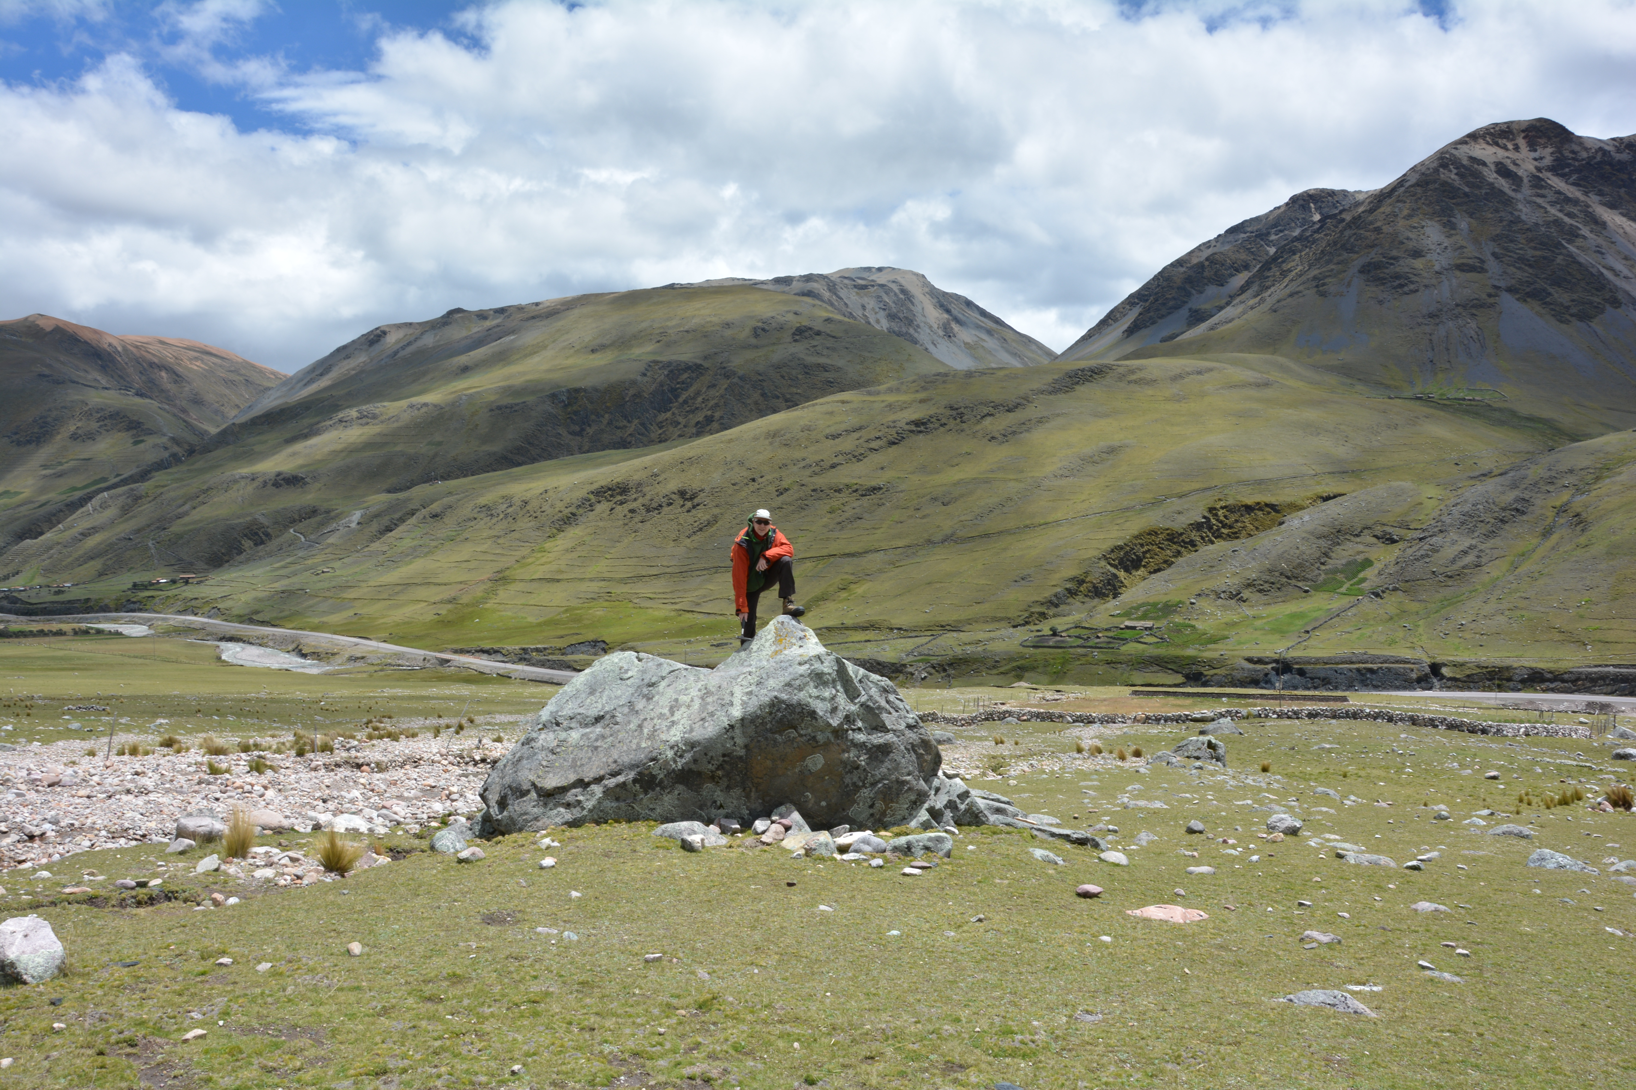

Supplementary Figure S1. Picture of the largest boulder (sample 15P9) deposited on the Mallma fan near the active channel. View is towards the northwest.

