Supplementary material

Concerning 3.3. Determination of quartz contents
Subpopulations
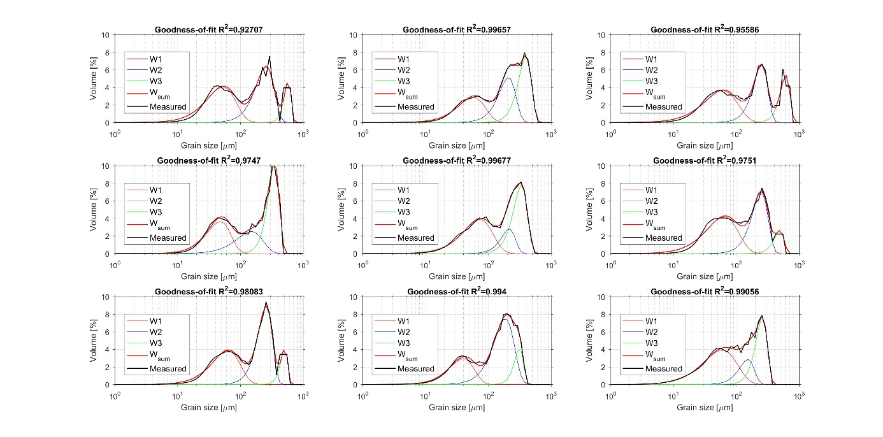
Supp-Fig. 1. Measured grain size distribution curves of samples and results of parametric curve-fitting decomposition. W1 subpopulations are regarded as the product of accumulation of far-travelled Saharan dust material.

The fine-grained subpopulation (decomposed by using parametric curve fitting as W1) of measured grain size distributions are regarded as Saharan dust. Previous studies dealing with grain size distributions of aeolian dust deposits reported similar particle size values of deposited Saharan dust material on Canary Islands (e.g. Menéndez et al., 2007, 2014; von Suchodoletz et al., 2013). The coarse silt-sized sedimentary material (with small proportion of fine sand) can be transported during dust storms several hundred kilometres from the source areas (Prins et al., 2007; Vandenberghe, 2013; Varga et al., in press). Varga et al. (2014) reported washout of coarse silt-sized Saharan dust material even further, from Central Europe.
Intensity
Mean grayscale intensity and standard deviation of particles were measured as the bottom light transmits through the particles. White light intensity of each pixel of particles is recorded on a scale from 0 to 255, where zero is the black, 255 is white. The automatically recorded dimensionless values serve as a proxy of optical properties. Mean intensity values are dependent on chemical composition, mineralogy and particle thickness, while standard deviations of intensities are controlled by the heterogeneity of particle constitution and surface morphology.
The comparison of acquired Raman spectra and mean grayscale intensities of particles indicated that there were two distinct group of mineral grains. In a given size-class the grayscale intensities of quartz grains were higher (meaning brighter, lighter) particles, while carbonates were darker with lower intensity values.

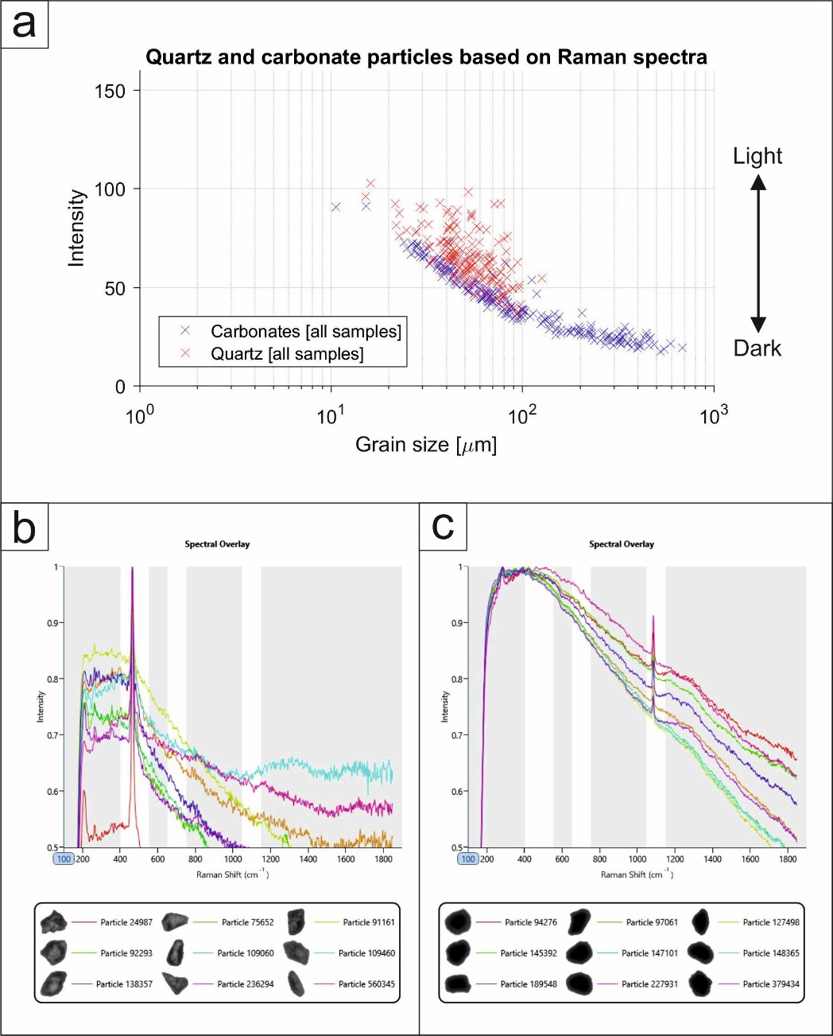
Supp-Fig. 2. Relationship among grain size, grayscale intensity and mineral composition of particles: (a) grains size vs. intensity scatter plot of quartz and carbonate particles; (b) Raman spectra and micrographs of typical silt-sized quartz particles; (c) Raman spectra and micrographs of typical silt- sized carbonate particles.

Literature:
Menéndez, I., Díaz-Hernández, J.L., Mangas, J., Alonso, I., Sánchez-Soto, P.J. (2007). Airborne dust accumulation and soil development in the North-East sector of Gran Canaria (Canary Islands, Spain) Journal of Arid Environments 71, pp. 57-81.
Menéndez, I., Pérez-Chacón, E., Mangas, J., Tauler, E., Engelbrecht, J.P., Derbyshire, E., Cana, L., Alonso, I. (2014). Dust deposits on La Graciosa Island (Canary Islands, Spain): Texture, mineralogy and a case study of recent dust plume transport. CATENA 117, pp. 133-144.
Prins, M.A., Vriend, M., Nugteren, G., Vandenberghe, J., Lu, H., Zheng, H., Weltje, G.J. (2007). Late Quaternary aeolian dust input variability on the Chinese Loess Plateau: inferences from unmixing of loess grain-size records. Quaternary Science Reviews 26, pp. 230-242.
von Suchodoletz, H., Glaser, B., Thrippleton, T., Broder, T., Zang, U., Eigenmann, R., Kopp, B., Reichert, M., Ludwig, Z. (2013). The influence of Saharan dust deposits on La Palma soil properties (Canary Islands, Spain). CATENA 103, pp. 44-52.
Vandenberghe, J. (2013). Grain size of fine-grained windblown sediment: A powerful proxy for process identification. Earth-Science Reviews 121, pp. 18-30.
Varga, Gy., Cserháti Cs., Kovács, J., Szeberényi, J., Bradák, B. (2014). Unusual Saharan dust events in the Central European Carpathian Basin in 2013 and early 2014. Weather 69, pp. 309-313.
Varga, Gy., Újvári, G., Kovács, J. (in press). Interpretation of sedimentary (sub)populations extracted from grain size distributions of Central European loess-paleosol series. Quaternary International

