Supplementary Information - images

Figure S1: Radial plots showing dose distributions for samples EVA1524 (left) and EVA1523 (right).
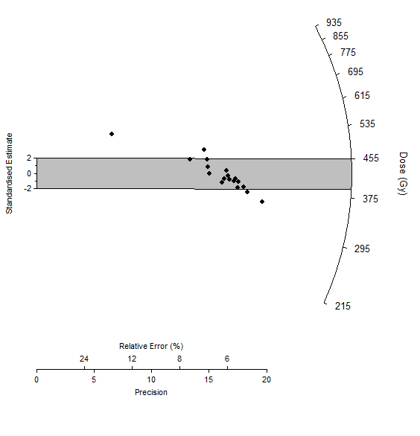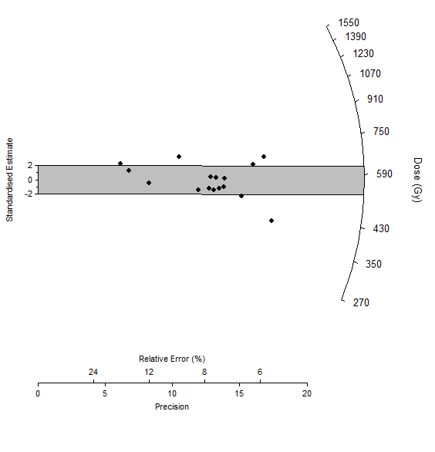
Figure S2: Photo of the TRP 2 section (S. Nigmatova, 2004).

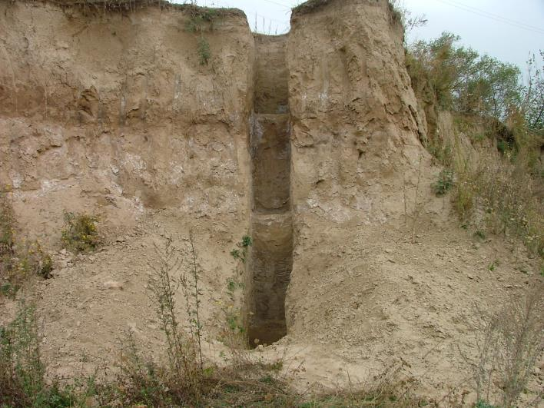

Figure S3: Photo from the hilltop (R. Iovita, 2013). Profile TRP 1 is located below the small red roof in the center; profile TRP 2 has been removed recently (center of image)

