Supplementary Materials

Excavation Procedures

A site datum was established in DGP, assigned at a relative horizontal location of 0, 0 and a relative vertical elevation of 1000 meters. The horizontal axes of all locations within the cave were established by measuring the distance and direction from the site datum. Likewise, the elevation of each excavation location was determined relative to the site datum. The inclination and orientation of any bones longer than five cm were recorded with a Brunton compass.
Excavations were initially conducted in 10-cm levels, but were later adjusted to 5-cm intervals. All excavations were conducted within natural stratigraphic units to avoid potential temporal contamination. In other words, if a new stratigraphic unit was encountered before the excavation level had been reached, a new bag for sediment collection was created and then the level was completed (e.g., Level 10 Unit 2, Level 10 Unit 3 were separated).All excavated sediments were bagged and labeled with the site name, excavation location (Sq.1, Sq.2, NE, NW, etc.), numerical level, numerical stratigraphic unit, relative elevation, excavator’s name, and date of excavation.
All excavated sediments were removed from the cave and were screen washed (wet sieved) through 0.16 cm (1/16th in) mesh. Before “washing,” each bag was assigned a sequential number for each individual year (e.g., 2005 - 1, 2, 3...).All bags were weighed in order to account for the volume of sediments excavated from each stratigraphic unit and excavation level. The data were entered into a log book. Rocks larger than gravel were discarded and fragile specimens (ex. skulls, jaws, teeth) were isolated in separate containers during the washing process to reduce the potential for future damage to specimens. Once drying was complete, the residue, screen concentrate, was then placed in gallon-size, zip-top plastic bags with the excavation tags and bag numbers.
Materials were taken to a field laboratory where each bag and its data were entered into a laboratory catalogue. Remaining fragile bones like jaws, skulls, and isolated teeth were picked from the dried screen concentrate. All of these materials were transported to the Pennsylvania State University (PSU) for further processing.

Specimen Identification

The mammal fauna of DGP is diverse with at least 37 identifiable taxa (Supplementary Table 1).
There are two species of shrews (Soricidae) represented in the samples analyzed: Sorex arcticus, and a smaller shrew, Sorex sp., which was not identifiable to species. S. arcticus is a large shrew with a post mandibular foramen characteristic of the species (Guilday et al., 1964).The smaller specimens representing Sorex are distinguishable from both S. palustris and S. arcticus by size, but lack other defining characters.
Lagomorphs have a distinct post cranial skeleton as well as dentition. Two genera of rabbits and hares, Sylvilagus and Lepus, are present in DGP. Individual teeth, except for p3, are not diagnostic for these two genera (Hulbert, 1984).Hulbert (1984) also found that with single and fragmentary remains of rabbits, generic identification can be difficult and sometimes even tenuous. We have differentiated the two genera based on size. Pikas, Ochotona sp., are very small lagomorphs with distinct dentitions that are distinguishable from both Sylvilagus and Lepus, and are also found in small numbers in DGP.
Sciurids are the most diverse group of rodents in the DGP fauna. Ground squirrels are a diverse group in the western United States and several different genera are recognized (Helgen et al., 2009). Material from DGP has been assigned to Ictidomys sp. based upon its size and tooth morphology (Helgen et al.2009). Tamiasciurus has diagnostic teeth, and Tamiasciurus hudsonicus is the resident species in the Black Hills today, but it is not easily differentiated from Tamiasciurus douglassi, another wide spread species of tree squirrel, on the basis of dental morphology. The teeth of Cynomys, another taxon in the DGP fauna, are large and hypsodont. Marmota, marmots, are the largest sciurids in the DGP fauna. They are easily distinguished from all other rodents by their size and morphology of their teeth, including their striated incisors. Additionally, two unknown species of Tamias (one larger and one smaller) have been identified, as well Sciurus sp.
Several other larger rodents are found in DGP. Gophers are represented by Thomomys sp. with teeth that can easily be differentiated from two other gopher genera, Geomys and Cratogeomys (Russell, 1968); Thomomys currently lives in the Black Hills. Erethizon dorsatum, the porcupine, is the largest rodent in DGP and is easily recognized by the size and complex dental pattern of its cheek teeth. The robust size of the incisors is also diagnostic for this taxon. Remains of modern porcupines were found as modern float on the cave floor in DGP as well as buried fossils. Porcupines inhabit a wide variety of environments (Woods 1973). Neotoma sp. is another taxon that currently lives in and around DGP that is also represented in the fossil fauna. The modern species found in the Black Hills is N. cinerea. Neotoma teeth contain cement or dentine tracts. Neotoma teeth are diagnostic with flat-crowned occlusal surfaces, with prismatic enamel patterns. They are larger than any of the other cricetids. Again, teeth are the most diagnostic part of the skeleton but because of the variability of shape in Neotoma teeth, species assignment is difficult for the fossil taxon in DGP.
There are two genera of pocket mice, Perognathus and Chaetodipus, with a wide array of species in both genera (Williams et al., 1993).Both genera have bilophodont teeth, but Perognathus is usually much smaller than Chaetodipus. Heteromyid rodents in general prefer arid to semiarid environments today (Schmidly et al., 1993) and both Chaetodipus and Perognathus eat seeds (Reichman and Price, 1993). Peromyscus is one of the most widely distributed and abundant groups of mice in North America. Peromyscus teeth are brachydont and bunodont with alternating simple cusps and they usually possess a cingulum (Hooper 1957). This simple dental pattern is distinctly different from the complex ones of other species like Zapus, Mus, Rattus, and Sigmodon. Unfortunately, the teeth of most species of Peromyscus are generally not diagnostic for species assignment (Hooper, 1957). The teeth of Peromyscus are generally larger than Reithrodontomys and smaller than Onychomys. In addition to size, the teeth of Onychomys are more open and do not contain any accessory styles or stylids. Peromyscus, Reithrodontomys, and Onychomys have all been recovered from DGP.
Arvicoline rodents are highly abundant throughout the cave assemblage. They have both rooted and rootless (ever growing) teeth, with flat-crowned and prismatic occlusal surfaces. Myodes (= Clethrionomys), like Phenacomys, is a microtine rodent with rooted teeth; but, unlike Phenacomys, Myodes has cementum in the re-entrant angles of all of its teeth. The enamel pattern of all of the molars of Myodes is also distinct in comparison to other genera of arvicoline rodents (Semken and Wallace, 2002). Phenacomys has a rooted tooth distinct from Myodes, and both genera are represented in DGP. Today, Myodes occurs at elevations higher than DGP in the Black Hills (Higgins et al., 2002), and Phenacomys has been extirpated.
All teeth of Microtus (rodents belonging to the family Microtinae, familiarly known as voles) are rootless, contain cementum, and have diagnostic enamel patterns (Guilday et al., 1964) that are easily differentiated from other arvicoline rodents (Semken and Wallace, 2002). Most teeth belonging to the genus Microtus have indistinguishable morphological similarities in dentition and cannot be identified to species level (Bell and Barnosky, 2000; Bell and Bever, 2006; however, see McGuire, 2011). The teeth of the Microtus from DGB can, however, be categorized into two distinctive groupings based on the morphology of the lower first molar (m1): a 3-closed triangle morphoclade and a 5 to 7-closed triangle morphoclade. The 3-closed triangle morphoclade has a lower first molar (m1) with three closed triangles and an upper third molar (M3) with a simple hook at the posterior end of the tooth. Only two species, M. ochrogaster and M. pinetorum, occur in this morphoclade in the latest Pleistocene and today. The 5 to 7-closed triangle morphoclade includes species such as M. pennsylvanicus, M. montanus, M. richardsoni, M. xanthognathus, etc. These species have an upper third molar with two hooks on the posterior end of the tooth.
Microtus pennsylvanicus is a member of the 5 to7-closed triangle morphoclade, but it can frequently be distinguished from other morphologically similar species by the predominance of an extra loop (“button”) at the back of the upper second molar (M2) (Guilday et al., 1964; Guilday, 1982; Semken and Wallace, 2010). Bell and Repenning (1999) found that this trait can occur infrequently (<10%) in other species of Microtus; whereas, in populations of M. pennsylvanicus over 90% of the M2s had a “button.” Therefore, a population of M2s, not a single tooth, is needed to make a species assignment from a fossil assemblage. None of the M2s from DGP have the "button" morphology, which suggests that the animal found in DGP is likely a Microtus species other than M. pennsylvanicus.
Synaptomys is differentiated by teeth with lingual re-entrants extending beyond the midline, and the teeth have cementum. Synaptomys cooperi has small labial triangles, whereas S. borealis lacks these triangles or they are very weakly developed (Semken and Wallace, 2002). Both species occur in the DGP fauna and both of them live in boreal forest environments today. Synaptomys cooperi inhabits the southern boreal forest, mixed forest, and riparian forest of the eastern United States and southeastern Canada (Banfield, 1974). Synaptomys borealis occurs in the central and northern boreal forest and ranges into alpine tundra environments, as well (Banfield, 1974).
Dicrostonyx teeth have a diagnostic dental pattern and lack cementum, but Dicrostonyx hudsonius is the only species that can be identified on the basis of cheek tooth morphology (Gromov and Polyakov, 1977). The dentitions of the other two North American species, D. groenlandicus and D. richardsoni, are indistinguishable from each other. Ancient DNA analyses of the DGP fossils have verified the occurrence of D. richardsoni at DGP (Fulton et al., 2013). Today this species is restricted to tundra environment in a small area along the western margin of Hudson’s Bay (Engstrom et al., 1993; Jarrel and Fredga, 1993; Fredga et al., 1999).
DGP has few remains of some larger mammal species which were not included in the analyses of this paper because of their rarity and tendency for having large home ranges. Antilocapra americana is represented by a small metapodial and partial jaw with teeth. Cervus elaphus is documented by an isolated tooth. Canis latrans and Vulpes vulpes are represented by isolated teeth.

Table 1. Complete mammal fauna from DGP as of 2014. This list includes all taxa; statistical analyses were conducted solely on the small rodents (<2 kg), shrews, and lagomorphs.
Level | 3 |  |  | 4 |  | 5 |  | 6 |  |  | 7 |  |  |  |  |  | 8
Unit | 1 | 2 | 3 | 2 | 3 | 2 | 3 | 2/3 | 3 | 4 | 2 | 2/3 | 3 | 4 | 5 | 6 | 2 | 2/3 | 3 | 4 | 5 | 6 | 7
Rodentia
Unspecified Rodentia | 15 |  | 1 | 12 | 3 |  | 3 | 12 | 4 |  | 1 | 4 | 9 | 4 |  | 3 | 1 | 5 | 1
Microtinae | 3 | 3 | 2 | 10 |  |  | 3 | 2 | 2 |  |  |  | 12 | 2 | 1 | 7 |  | 2 | 2 |  | 3 |  | 1
Microtus sp. | 21 | 10 | 1 | 38 | 1 |  | 11 | 9 | 2 | 1 | 1 | 2 | 37 | 7 | 4 | 4 | 5 | 9 | 2 | 1 | 10 | 2 | 4
5-7 Triangle clade |  | 3 |  |  |  |  |  | 1 |  |  |  | 1 |  |  |  | 2
3 Triangle clade | 16 | 1 | 3 | 13 | 2 | 2 | 8 | 4 |  |  |  | 4 | 21 | 7 | 2 | 3 |  | 7 | 4 |  | 4 | 2 | 1
Myodes | 3 |  |  | 4 |  |  | 2 |  | 1 |  |  |  | 7 |  |  | 43 | 1 | 9 | 4 | 2 | 2 |  | 1
Phenacomys sp.
Synaptomys cooperi |  |  |  | 2 |  |  |  |  |  |  |  |  | 2 |  |  | 1 |  |  |  |  | 1 | 1
Synaptomys borealis |  |  |  |  |  |  | 1
Dicrostonyx cf. richardsoni |  |  |  |  |  |  |  |  | 1 |  |  |  | 1 |  |  | 2 |  | 1 |  |  |  | 2
Neotoma sp. | 10 | 4 |  | 17 | 1 | 2 | 13 | 3 |  |  |  |  | 7 | 1 |  |  | 1 | 3 | 4
Unspecified Sciuridae |  |  |  | 2 |  | 1 |  |  |  |  |  |  | 3 | 2
Sciuris sp. | 7 | 2
Tamias sp. |  |  |  |  |  | 2
Tamias sp. (small) | 1 |  |  |  |  |  |  |  |  |  |  |  | 1
Marmota sp. | 2 |  |  | 3 |  |  | 4 | 1 |  |  |  |  | 2 | 2 |  |  | 7 | 1 | 1 | 1
Tamiasciurus sp. |  |  |  |  |  |  |  |  |  |  |  |  |  |  |  | 1
Ictodomys sp. | 5 |  |  |  |  | 1
Cynomys sp. |  |  |  | 1 |  |  | 1 |  |  |  |  | 1 | 4 | 4 |  |  | 1
Thomomys sp. | 21 | 3 | 1 | 32 |  | 4 | 24 | 6 | 3 | 1 | 2 | 5 | 25 | 3 |  | 1 | 2 | 11 | 3
Peromyscus sp. | 7 |  |  | 2 |  | 1 | 6 | 1 |  |  |  |  |  |  |  |  |  |  | 1
Reithrodontomys sp. | 1 |  |  | 1 |  |  |  |  |  |  |  | 1 | 3 |  |  |  |  | 1
Onychomys sp. | 15 |  |  | 26 |  | 1 | 7 |  | 1 | 1 | 1 |  | 14 | 2 |  |  |  | 3 | 1
Chaetodipus sp. | 14 | 1 |  | 18 |  | 1 | 7 | 2 |  | 1 |  | 2 | 12 | 1 |  |  | 2 | 3 |  | 1
Perognathus sp. |  |  |  | 3 |  |  | 1 | 2 |  |  |  |  | 2 |  |  |  |  | 3 | 3
Lagomorpha
Ochotona sp.
Sylvilagus sp. | 37 | 3 | 4 | 54 | 7 | 4 | 44 | 20 | 7 | 8 | 4 | 12 | 33 | 4 |  | 2 | 3 | 21 | 6 | 2
Lepus sp. |  |  |  | 3 |  |  | 1 | 1 |  |  |  |  |  |  |  |  |  | 4 | 1
Eulipotyphla: Soricidae
Sorex sp. (smaller) |  |  |  | 1
Sorex arcticus |  |  |  |  |  |  |  |  |  |  |  |  | 1
Carnivora
Unspecified Carnivora |  |  |  | 3 |  |  |  |  |  |  |  |  | 1
Carnivora small |  |  |  |  |  |  | 1
Canidae
Vulpes sp. |  |  |  |  |  |  |  |  | 1
Vulpes vulpes | 1
Mustella |  |  |  |  |  |  |  |  |  |  |  |  | 1
Level | 3 |  |  | 4 |  | 5 |  | 6 |  |  | 7 |  |  |  |  |  | 8
Unit | 1 | 2 | 3 | 2 | 3 | 2 | 3 | 2/3 | 3 | 4 | 2 | 2/3 | 3 | 4 | 5 | 6 | 2 | 2/3 | 3 | 4 | 5 | 6 | 7
Perissodactyla: Equidae
Equus sp. |  |  |  | 1
Artiodactyla: Cervidae
Odocoileus sp. |  |  |  | 1

Level | 9 |  |  |  | 10 |  | 11 |  | 12 |  | 13 |  | 14
Unit | 3 | 3/4 | 4 | 5 | 4 | 6 | 5 | 6 | 2 | 6 | 6 | 8 | 6 | 8
Rodentia
Unspecified Rodentia | 4 |  | 6 | 5 | 10 | 3 | 3 | 23 | 27 | 2 | 1
Microtinae | 5 | 6 | 4 | 1 | 7 | 1 | 5 | 23 |  | 15 | 16 | 19 | 8 | 36
Microtus sp. | 16 | 2 | 1 | 3 | 30 | 2 | 7 | 39 |  | 13 | 7 | 10 | 4 | 31
5-7 Triangle clade | 1 |  |  |  | 1 |  |  | 2 |  | 2 | 1 | 6 | 1 | 21
3 Triangle clade | 12 |  | 6 | 1 | 10 | 1 | 2 | 21 |  | 3 | 2 | 1 | 1 | 5
Myodes | 19 |  | 3 | 7 | 48 | 1 | 26 | 155 | 3 | 163 | 91 | 120 | 19 | 63
Phenacomys sp. |  |  |  |  |  |  |  |  | 3
Synaptomys cooperi | 1 |  |  |  | 3 | 1 |  | 13 |  |  |  |  | 2
Synaptomys borealis |  |  | 1 |  | 1 | 1 |  | 2
Dicrostonyx cf. richardsoni |  |  | 1 | 1 | 6 |  | 1 | 18 |  | 4 | 6 | 19 | 18 | 86
Neotoma sp. | 5 | 1 |  | 3 | 4 |  |  | 2 | 3 | 5 | 3
Unspecified Sciuridae |  |  | 1 |  |  |  |  |  | 11 | 1
Sciuris sp. |  |  |  |  |  |  | 1 |  |  | 2 |  | 1 |  | 1
Tamias sp. |  |  |  |  |  |  |  |  | 2 | 5
Tamias sp. (small) |  |  |  |  | 1 |  | 2 | 2 | 5 | 2 | 1 |  |  | 2
Marmota sp. |  | 1 |  |  | 3 | 1 |  | 1 | 2
Tamiasciurus sp. |  |  |  |  |  |  |  |  | 5 |  |  | 1
Ictodomys sp. |  |  |  |  |  |  |  |  | 32 |  |  |  |  | 3
Cynomys sp. |  |  |  | 3
Thomomys sp. | 25 | 2 | 2 | 6 | 25 |  | 10 | 7 |  | 3 | 1
Peromyscus sp. |  |  | 6 |  | 8 | 1 | 8 | 7 |  | 4 | 1 | 2
Reithrodontomys sp. |  |  |  |  | 1 | 1 |  | 1 |  | 3
Onychomys sp. | 4 | 1 |  | 6 | 4 |  |  | 13 | 26 | 4 | 3 | 2 | 3 | 5
Chaetodipus sp. |  |  | 1 | 1 |  | 1 |  | 1 |  |  | 1
Perognathus sp. |  |  | 1 |  |  | 1 |  | 3
Lagomorpha
Ochotona sp. |  |  | 1 |  |  |  |  | 2 |  | 1 |  | 2 |  | 3
Sylvilagus sp. | 23 | 8 | 16 | 10 | 47 | 9 | 7 | 8 |  | 10 | 4 |  |  | 2
Lepus sp. | 3 |  |  |  | 5 |  |  | 10
Eulipotyphla: Soricidae
Sorex sp. (smaller) |  |  |  |  | 1 |  |  |  | 2
Sorex arcticus |  |  |  |  |  |  |  |  | 1
Carnivora
Unspecified Carnivora |  |  | 1 |  | 2 | 1
Level | 9 |  |  |  | 10 |  | 11 |  | 12 |  | 13 |  | 14
Unit | 3 | 3/4 | 4 | 5 | 4 | 6 | 5 | 6 | 2 | 6 | 6 | 8 | 6 | 8
Carnivora small | 4 |  |  |  | 1 | 2 |  |  | 3
Canidae | 2
Vulpes sp.
Vulpes vulpes | 1
Mustella
Perissodactyla: Equidae
Equus sp.
Artiodactyla: Cervidae
Odocoileus sp.

Stratigraphy of Don's Gooseberry Pit

The natural strata identified in DGP are described in Supplementary Table 2. Supplementary Figures 1-4 illustrate the nature of some of the deposits discussed in the text. Because of narrowness of the cave chamber, it was not possible to get good photographs of the entire stratigraphic sequence. The photographs here illustrate the nature of the deposits, their contacts, and burrowing.

Table 2. Descriptions of stratigraphic units in Don’s Gooseberry Pit by Don Brandborg and Angela Mathias.

Unit 1: Black to dark gray loam with abundant organic remains, abundant pebbles
and cobbles with some up to 10 cm (4 in.) in diameter, extremely fossiliferous.

Unit 2: Black loamy soil with abundant organics, pebbles are smaller than in Unit 1 with an average diameter of ca. 2.5 cm (1 in.) but some ranging up to 10 cm (4 in.), extremely fossiliferous.

Unit 3: Tan to yellowish brown sediment with small pebbles, some up to 2.5 cm
(1 in.), pebbles are reddish color, fossiliferous.

Unit 4: Brownish sediment with fewer pebbles that have a tan color to them, fossiliferous.

Unit 5A: Dark brown sediment with few pebbles or other clasts, fossiliferous. This unit was identified in 2005.

Unit 5B: This unit was identified as Unit 5 in Don’s 2006 field notes. It was uncovered at level IX in the SW quad of the original grid unit started by Angie and Don in 2004. This unit is a light brown (4/4 7.5 YR) sandy sediment with large limestone rocks, some as large as 30 cm, and reddish cobbles (ca.10 cm thick).

Unit 6: Exposed at level XI SW Quad, extremely rocky with a clay matrix.

Unit 7: Exposed at level XII SW Quad under rocks from Unit 6. Loamy material that is not well-consolidated and similar to Unit 2. It had small clay clasts similar to Unit 6. The color was 4/6 7.5 YR.

Unit 8: Yellow to brown sticky clay with some large limestone clasts but without cobbles and pebbles that composed Unit 6.

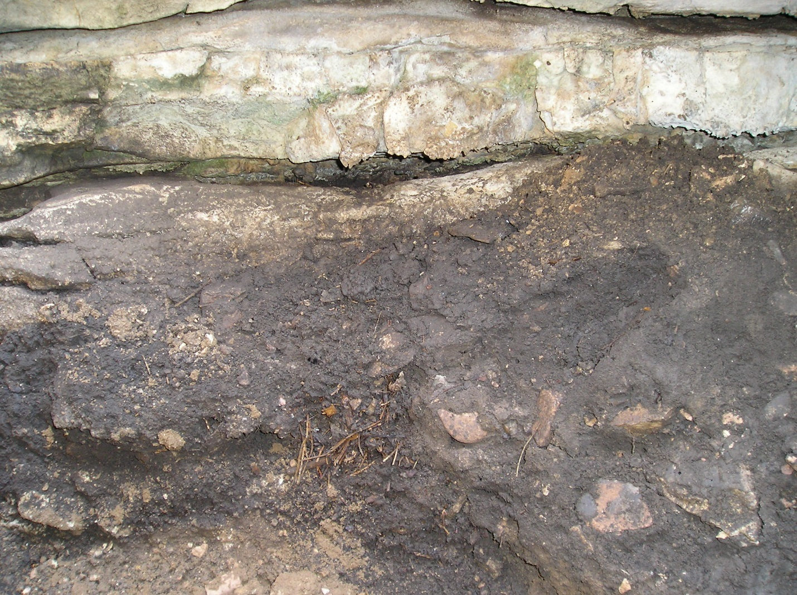
Figure 1. Contacts between limestone roof, unit 2 (including buried Neotoma midden – debris in bottom center of figure), and unit 3.

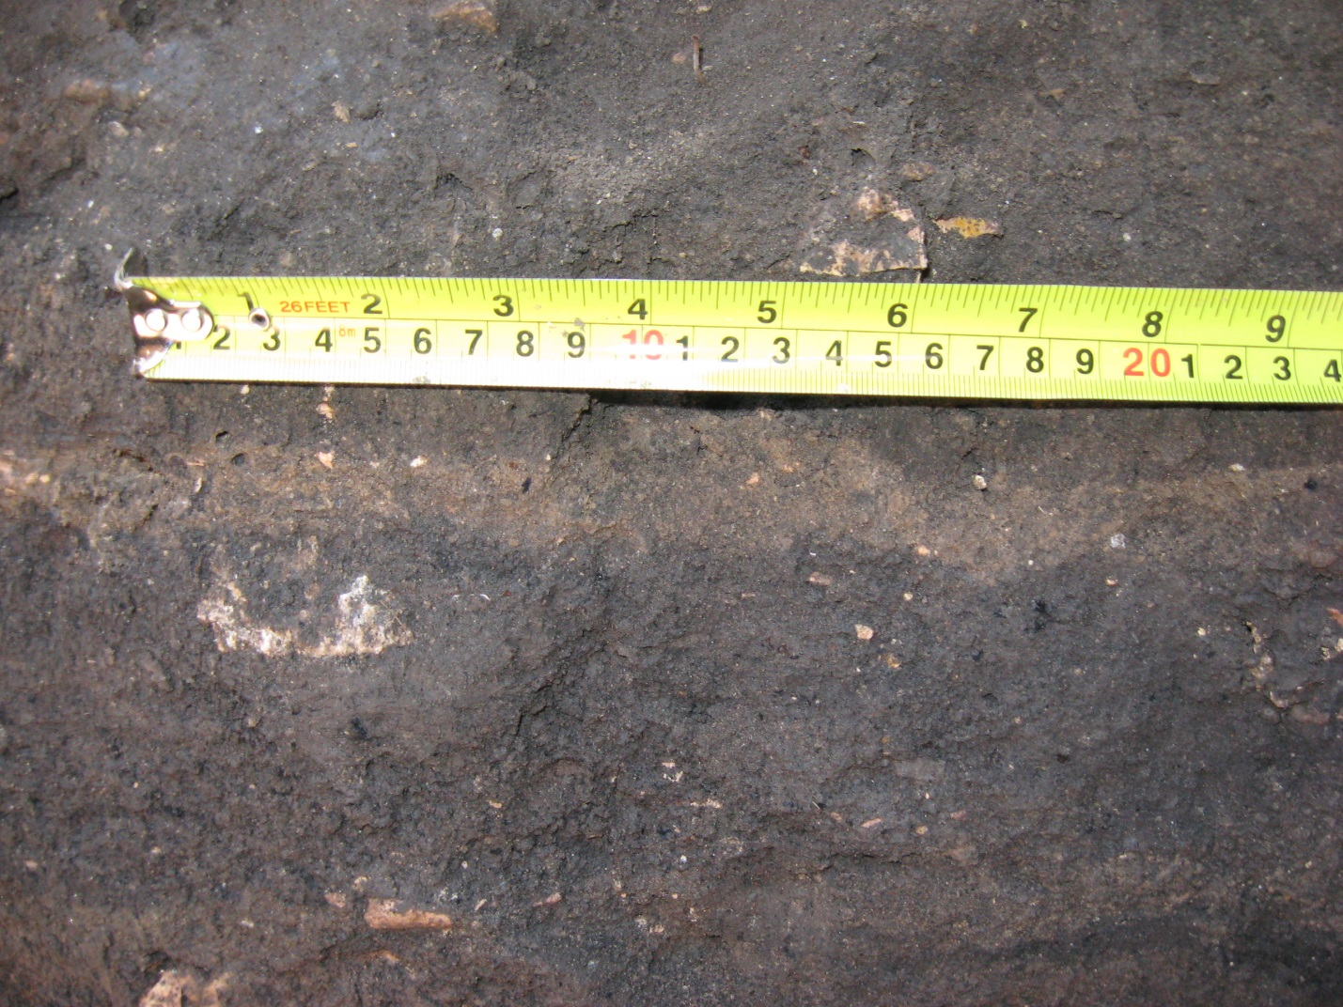
Figure 2. Stratified deposits showing contacts between from top to bottom units 3 (dark stratum), 4 (narrow tan stratum), and 5 (dark stratum).
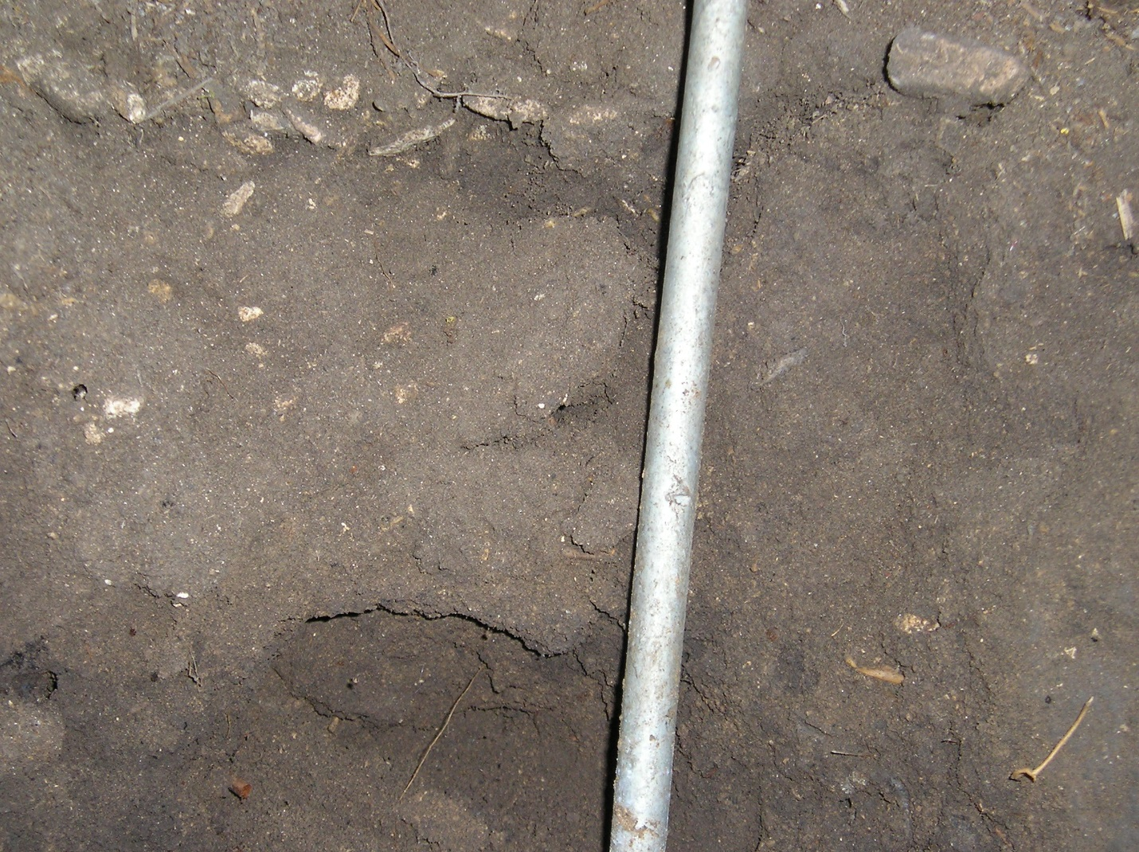
Figure 3. Pebble line in unit 4 disrupted by rodent burrow (right of vertical pin) with a small side chamber (left of vertical pin in lower part of photo. All burrows were excavated separately and their contents were not included in the analyses.

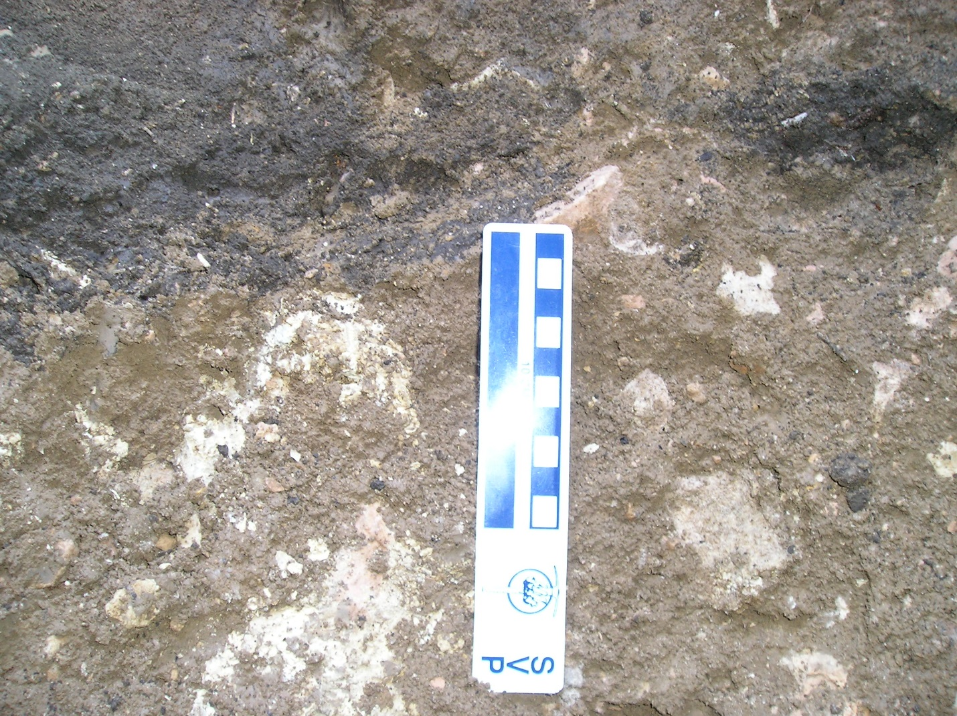
Figure 4. Contact between units 5A and 6.

Taphonomy of Don's Gooseberry Pit

The study of the taphonomy of DGP is on-going so for this report we discuss a few preliminary observations that may help the reader understand how the deposits formed and the fauna accumulated.
DGP is a small pit cave that has filled with sediment to within a meter of its surface opening (Fig. 5). The entrance of the cave is located on a ridge top so its catchment area is quite limited. The entrance is a relatively small oblong oval (25 cm x 50 cm) (Fig. 6) which probably accounts for the predominance of small vertebrate (rodents, insectivores, lagomorophs, amphibians, etc.) remains. Below the entrance, the cave walls bell-out to form a small chamber. DGP likely functioned as an effective pit-trap for animals before becoming substantially infilled with sediments. As the pit became progressively shallower, it would still have remained an effective trap for smaller animals (e.g., toads, small rodents, etc.) (Fig. 6). In a preliminary, unpublished study, Pardi (2006) demonstrated that the body size of organisms decreased with decreasing depth of the pit. In other words, the remains of larger taxa were found at greater depth intermixed with smaller species. When the depth of the fill made it possible for large- to medium-sized taxa (e.g., coyotes, foxes, raccoons, etc.) to easily access and exit the cave, DGP could have served as a den for small carnivores. Many bones of prey species like lagomorphs show signs of chewing and fracturing. Remains of larger animals (Bison, Odocoileus, Cervus, etc.) are generally represented by single and/or isolated specimens. They probably washed into the cave or were brought into it by Neotoma or carnivores. Almost all of the deposits and excavation levels in DGP were extremely fossiliferous.

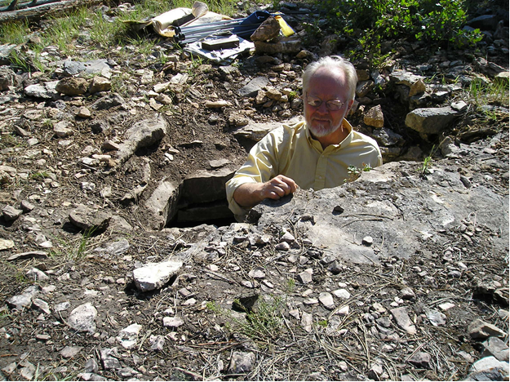
Figure 5.Don Brandborg standing in DGP before excavations began.

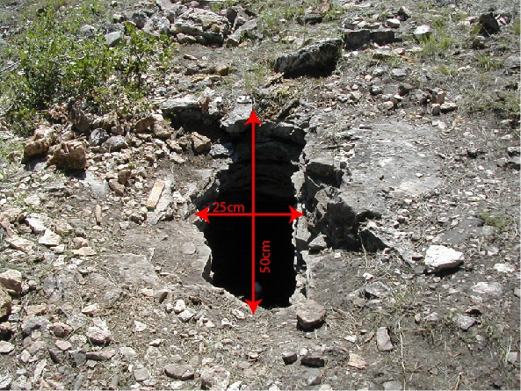

Figure 6.Opening of DGP with dimensions. The edge of the opening oriented with the top of the figure has been worn smooth; we infer this as an indication that water and debris primarily entered the cave from this direction.

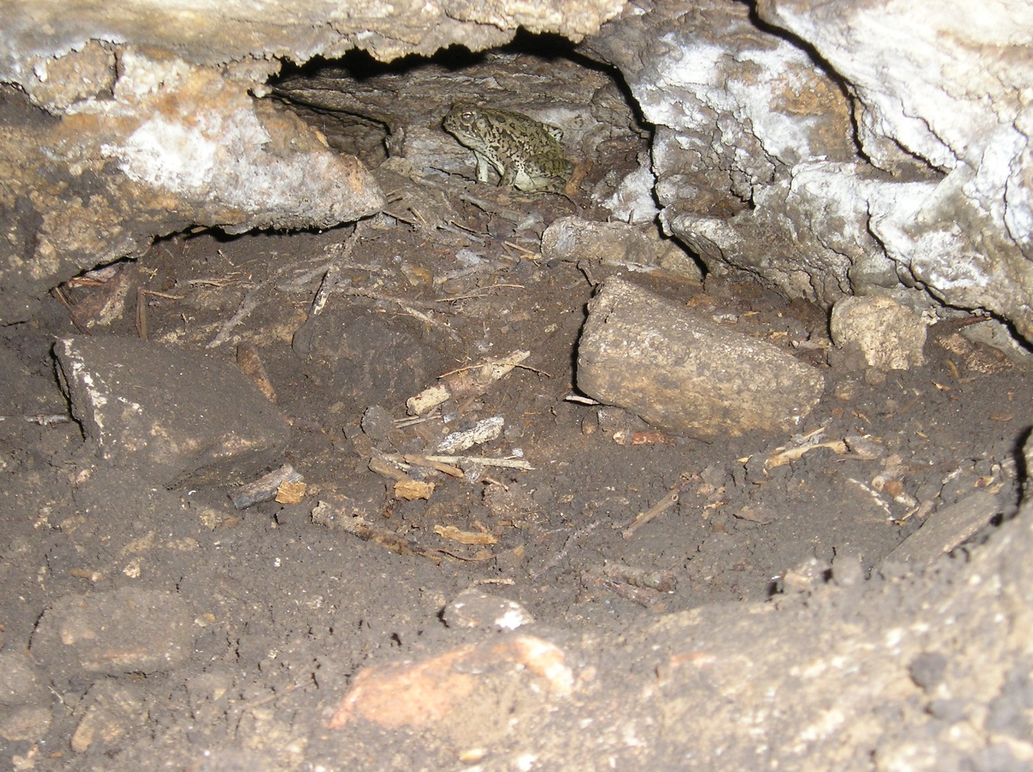

Figure 7. Live toad (Bufo) found trapped in the cave.

Literature Cited
Banfield, A.W.F., 1974. The Mammals of Canada. University of Toronto Press, Toronto.
Bell, C.J., and Barnosky, A.D., 2000. The microtine rodents from the Pit locality in Porcupine Cave, Park County, Colorado. Annals of Carnegie Museum 69, 93 – 134.
Bell, C.J., and Bever, G.S., 2006. Description and significance of the Microtus (Rodentia: Arvicolinae) from the type Irvington fauna, Alameda County, California. Journal of Vertebrate Paleontology 26, 371 – 380.
Bell, C.J., and Repenning, C.A., 1999. Observations on dental variation in Microtus from the Cudahy Ash Pit Fauna, Meade County Kansas and implications for Irvingtonian microtine rodent biochronology. Journal of Vertebrate Paleontology 19, 757 – 766.
Engstrom, M.D., Baker, A.J., Eger, J.L., Boonstra, R., and Brooks, R.J., 1993. Chromosomal and mitochondrial DNA variation in four laboratory populations of collared lemmings (Dicrostonyx). Canadian Journal of Zoology 71, 42 – 48.
Fredga, K., Fedorov, V., Jarrell, G., Jonsson, L., 1999. Genetic diversity in Arctic lemmings. Ambio 28, 261 – 269.
Fulton, T.L., Norris, R.W., Graham, R.W., Semken, H.A., Jr., Shapiro, B., 2013. Ancient DNA supports a southern refugium for Richardson’s lemming (Dicrostonyx richardsoni) during the last glacial maximum. Molecular Ecology 22, 2540 – 2548.
Gromov, I.M., and Polyakov I.Y., 1977. Polevki [Voles (Microtinae)]. Moskow-Leningrad, Nauka.
Guilday, J.E., 1982. Dental variation in Microtus xanthognathus, M. chrotorrhinus, and M. pennsylvanicus (Rodentia: mammalia). Annals of Carnegie Museum of Natural History 51, 211 – 230.
Guilday, J.E., Martin, P.S., and McCrady, A.D.1964. New Paris No.4: a Pleistocene cave deposit in Bedford County, Pennsylvania. Bulletin of the National Speleological Society 26.
Helgen, K.M., Cole, F.R., Helgen, L.E., and Wilson, D.E., 2009. Generic revision in the Holarctic ground squirrel genus Spermophilus. Journal of Mammalogy 90, 270 – 305.
Higgins, K.F., Stukel, E.D., Goulet, J.M., and Backlund, D.C., 2002. Wild Mammals of South Dakota. South Dakota Department of Game, Fish and Parks, Pierre.
Hooper, E.T., 1957. Dental Patterns in Mice of the Genus Peromyscus. Miscellaneous Publications Museum of Zoology, University of Michigan, 99, Ann Arbor.
Hulbert, R.C., Jr., 1984. Latest Pleistocene and Holocene leporid faunas from Texas: their composition, distribution and climatic implications. Southwestern Naturalist 29, 197 – 210.
Jarrell, G.H., and Fredga, K.1993. How many kinds of lemmings? A taxonomic overview, pp. 45-57. IN Stenseth, N.C., Ims, R.A., (Eds.), The Biology of Lemmings, London: Academic Press.
McGuire, J.L., 2011. Identifying California Microtus species using geometric morphometrics documents Quaternary geographic range contractions. Journal of Mammalogy 92, 1383 – 1394.
Pardi, M.I., 2006. Taphonomy of Two Horizons from Don's Gooseberry Pit, Black Hills, SD (Undergraduate Senior Thesis, Pennsylvania State University).
Reichman, O.J., and Price, M.V., 1993. Ecological aspects of heteromyid foraging, pp. 596 – 617. IN Biology of the Heteromyidae, Genoways, H.H., and Brown, J.H., (Eds.), Special Publication No. 10 of the American Society of Mammalogists.
Russell, R.J., 1968. Evolution of the pocket gophers of subfamily Geomyinae. University of Kansas Museum of Natural History Publication16, 473 – 579.
Schmidly, D.J., Wilkins, K.T., and Derr, J.N., 1993. Biogeography, pp. 319 – 356. IN Biology of the Heteromyidae, Genoways, H.H., and Brown, J.H., (Eds.), Special Publication No. 10 of the American Society of Mammalogists.
Semken, H.A., Jr., and Wallace, S.C., 2002. Key to arvicoline (“microtine” rodent) and arvicoline-like first lower molars recovered from late Wisconsinan and Holocene archaeological sites of eastern North America. Journal of Archaeological Science 29, 23 – 31.
Williams, D.F., Genoways, H.H., and Braun, J.K., 1993. Taxonomy and systematics, pp. 38 – 196. IN Biology of the Heteromyidae, Genoways, H.H., and Brown, J.H., (Eds.), Special Publication No. 10 of the American Society of Mammalogists.
Woods, C.A., 1973. Erithezon dorsatum. Mammalian Species 29, 16.

