**Impact of mid-to-late Holocene precipitation changes on vegetation across lowland tropical South America: a palaeo-data synthesis:**

**Authors:** Richard J. Smith and Francis E. Mayle

**Supplementary Information**

**Figure S1.** Summary tables of vegetation changes at each palaeoecological site, alongside regional maps of the location of each site. Site IDs correspond to those in Table 1.

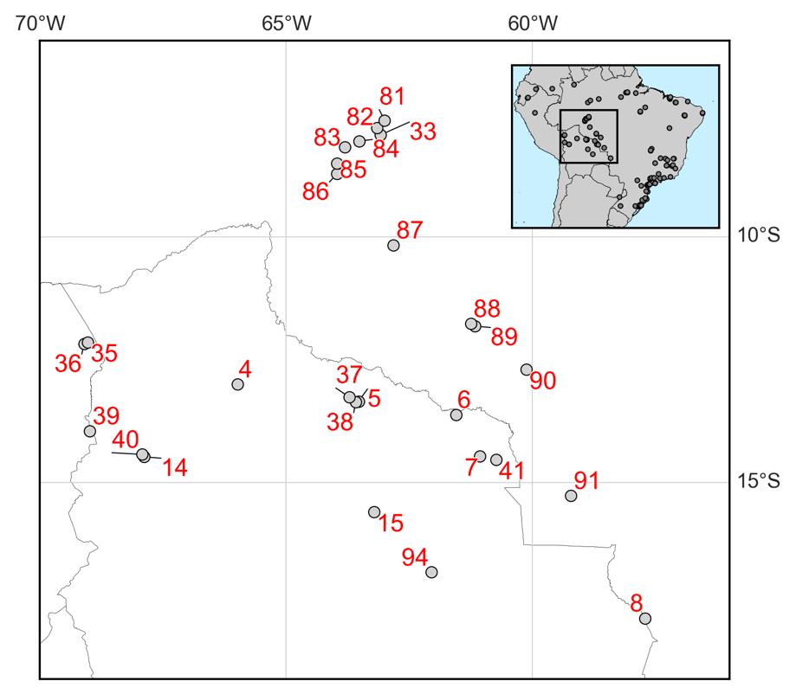../plotting/maps/veg_recon/tables/sw_summary_2017_07_28_12_23_32.pdf../plotting/maps/veg_recon/tables/cw_summary_2017_07_28_12_23_32.pdf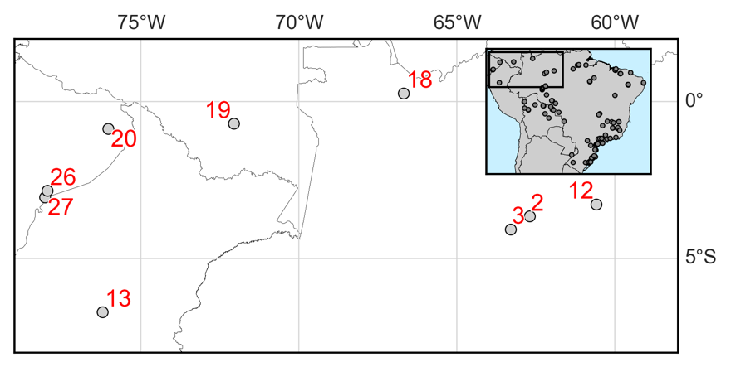

**(b) South-Western Amazonia**

**(a) Central and western lowland Amazonia**

../plotting/maps/veg_recon/tables/sb_summary_2017_07_28_12_23_32.pdf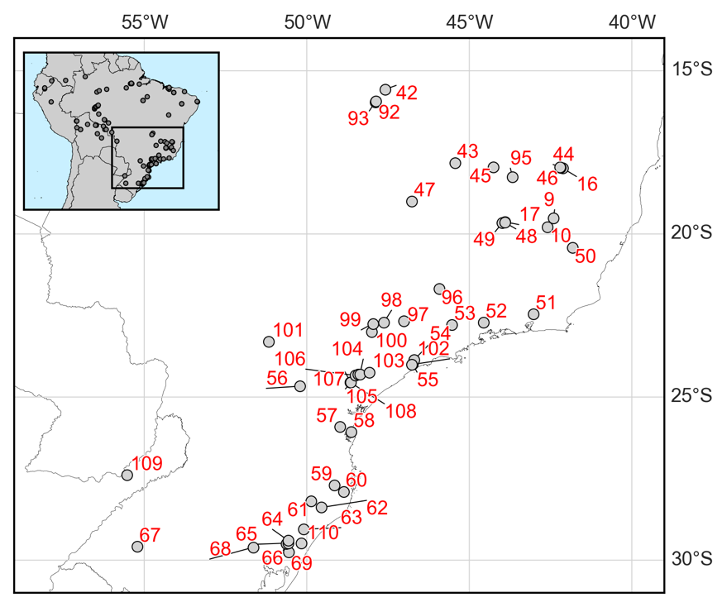

**(c) South-eastern Brazil**

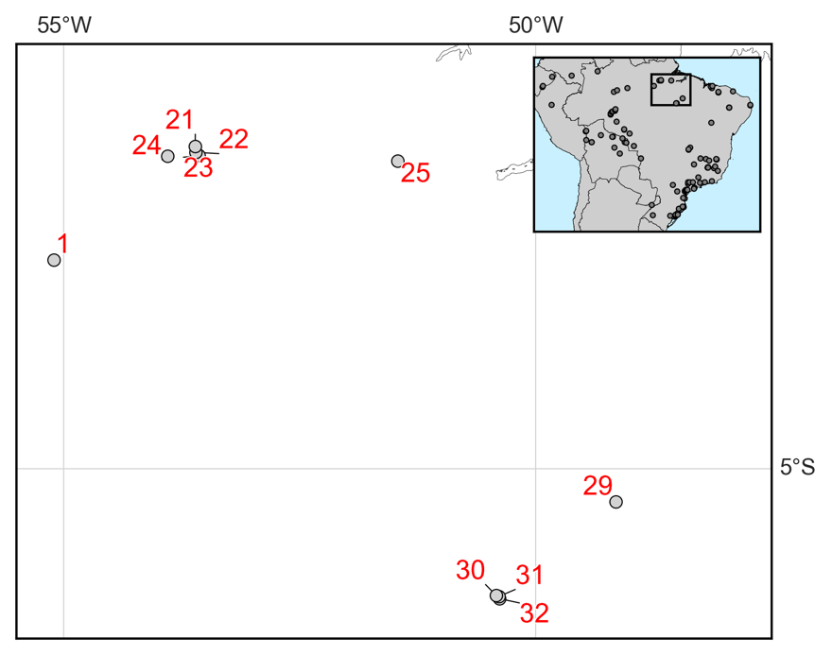

**(d) Eastern Amazonia**

../plotting/maps/veg_recon/tables/ne_summary_2017_07_28_12_23_32.pdf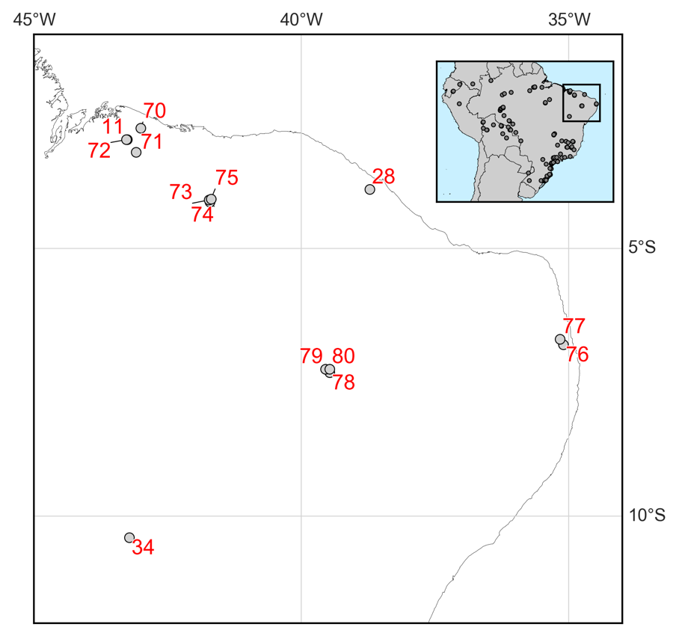

**(e) North-eastern Brazil**

|  |  |  |  |  |  |
| --- | --- | --- | --- | --- | --- |
| **Palaeoecological classifications** | | | | | |
| ../../../../../../Desktop/Screen%20Shot%202017-07-31%20at%2012.17.57.p | Humid Evergreen Tropical Forest | ../../../../../../Desktop/Screen%20Shot%202017-07-31%20at%2012.18.01.p | Semi-deciduous tropical forest | ../../../../../../Desktop/Screen%20Shot%202017-07-31%20at%2012.18.04.p | Araucaria forest |
| ../../../../../../Desktop/Screen%20Shot%202017-07-31%20at%2012.17.59.p | Savannah/Grassland/Scrubland | ../../../../../../Desktop/Screen%20Shot%202017-07-31%20at%2012.18.07.p | Cloud/Montane Forest | ../../../../../../Desktop/Screen%20Shot%202017-07-31%20at%2012.18.06.p | Palm Swamp |
| ../../../../../../Desktop/Screen%20Shot%202017-07-31%20at%2012.18.02.p | Gallery Forest |  |  |  |  |