Suchodoletz et al.: Supporting Online Material
Descriptions, detailed drawings, analytical results and positions of dating samples of the investigated sections

Section Shulaveris Ghele 1 (SH-1)
(41°23’24.7‘‘N, 44°48’14.0‘‘E; 385 m a.s.l.)
The base of section SH-1 between 6.5 and ca. 5.0/4.5 m is formed by a gravel body with some intercalated sandy lenses. Between 5.0/4.5 and 1.5 m yellowish-ocherous sandy loam containing singular pebbles is found. Between 2.9 and 2.5 m this layer is interrupted by a gravel body with some sandy lenses, and a Ck horizon with ca. 1 cm thick carbonate concretions occurs between 1.5 and 2.5 m. A gravel body between 1.5 and 0.5 m also contains sandy lenses and is overlain by a dark-brown loamy layer with an angular blocky structure that contains singular broken snail shells and charcoal pieces. Its distinct upper and gradual lower boundary, dark-brown colour, angular blocky structure and the underlying intensively developed Ck horizon indicate the Bw horizon of an intensively developed cambisol. This cambisol contains carbonate what can at least partly be explained with secondary recalcification that is seen by carbonate stains on the ped surfaces. The buried cambisol is overlain by ca. 30 cm thick brownish sandy loam that is overprinted by the very weakly developed recent fluvisol.

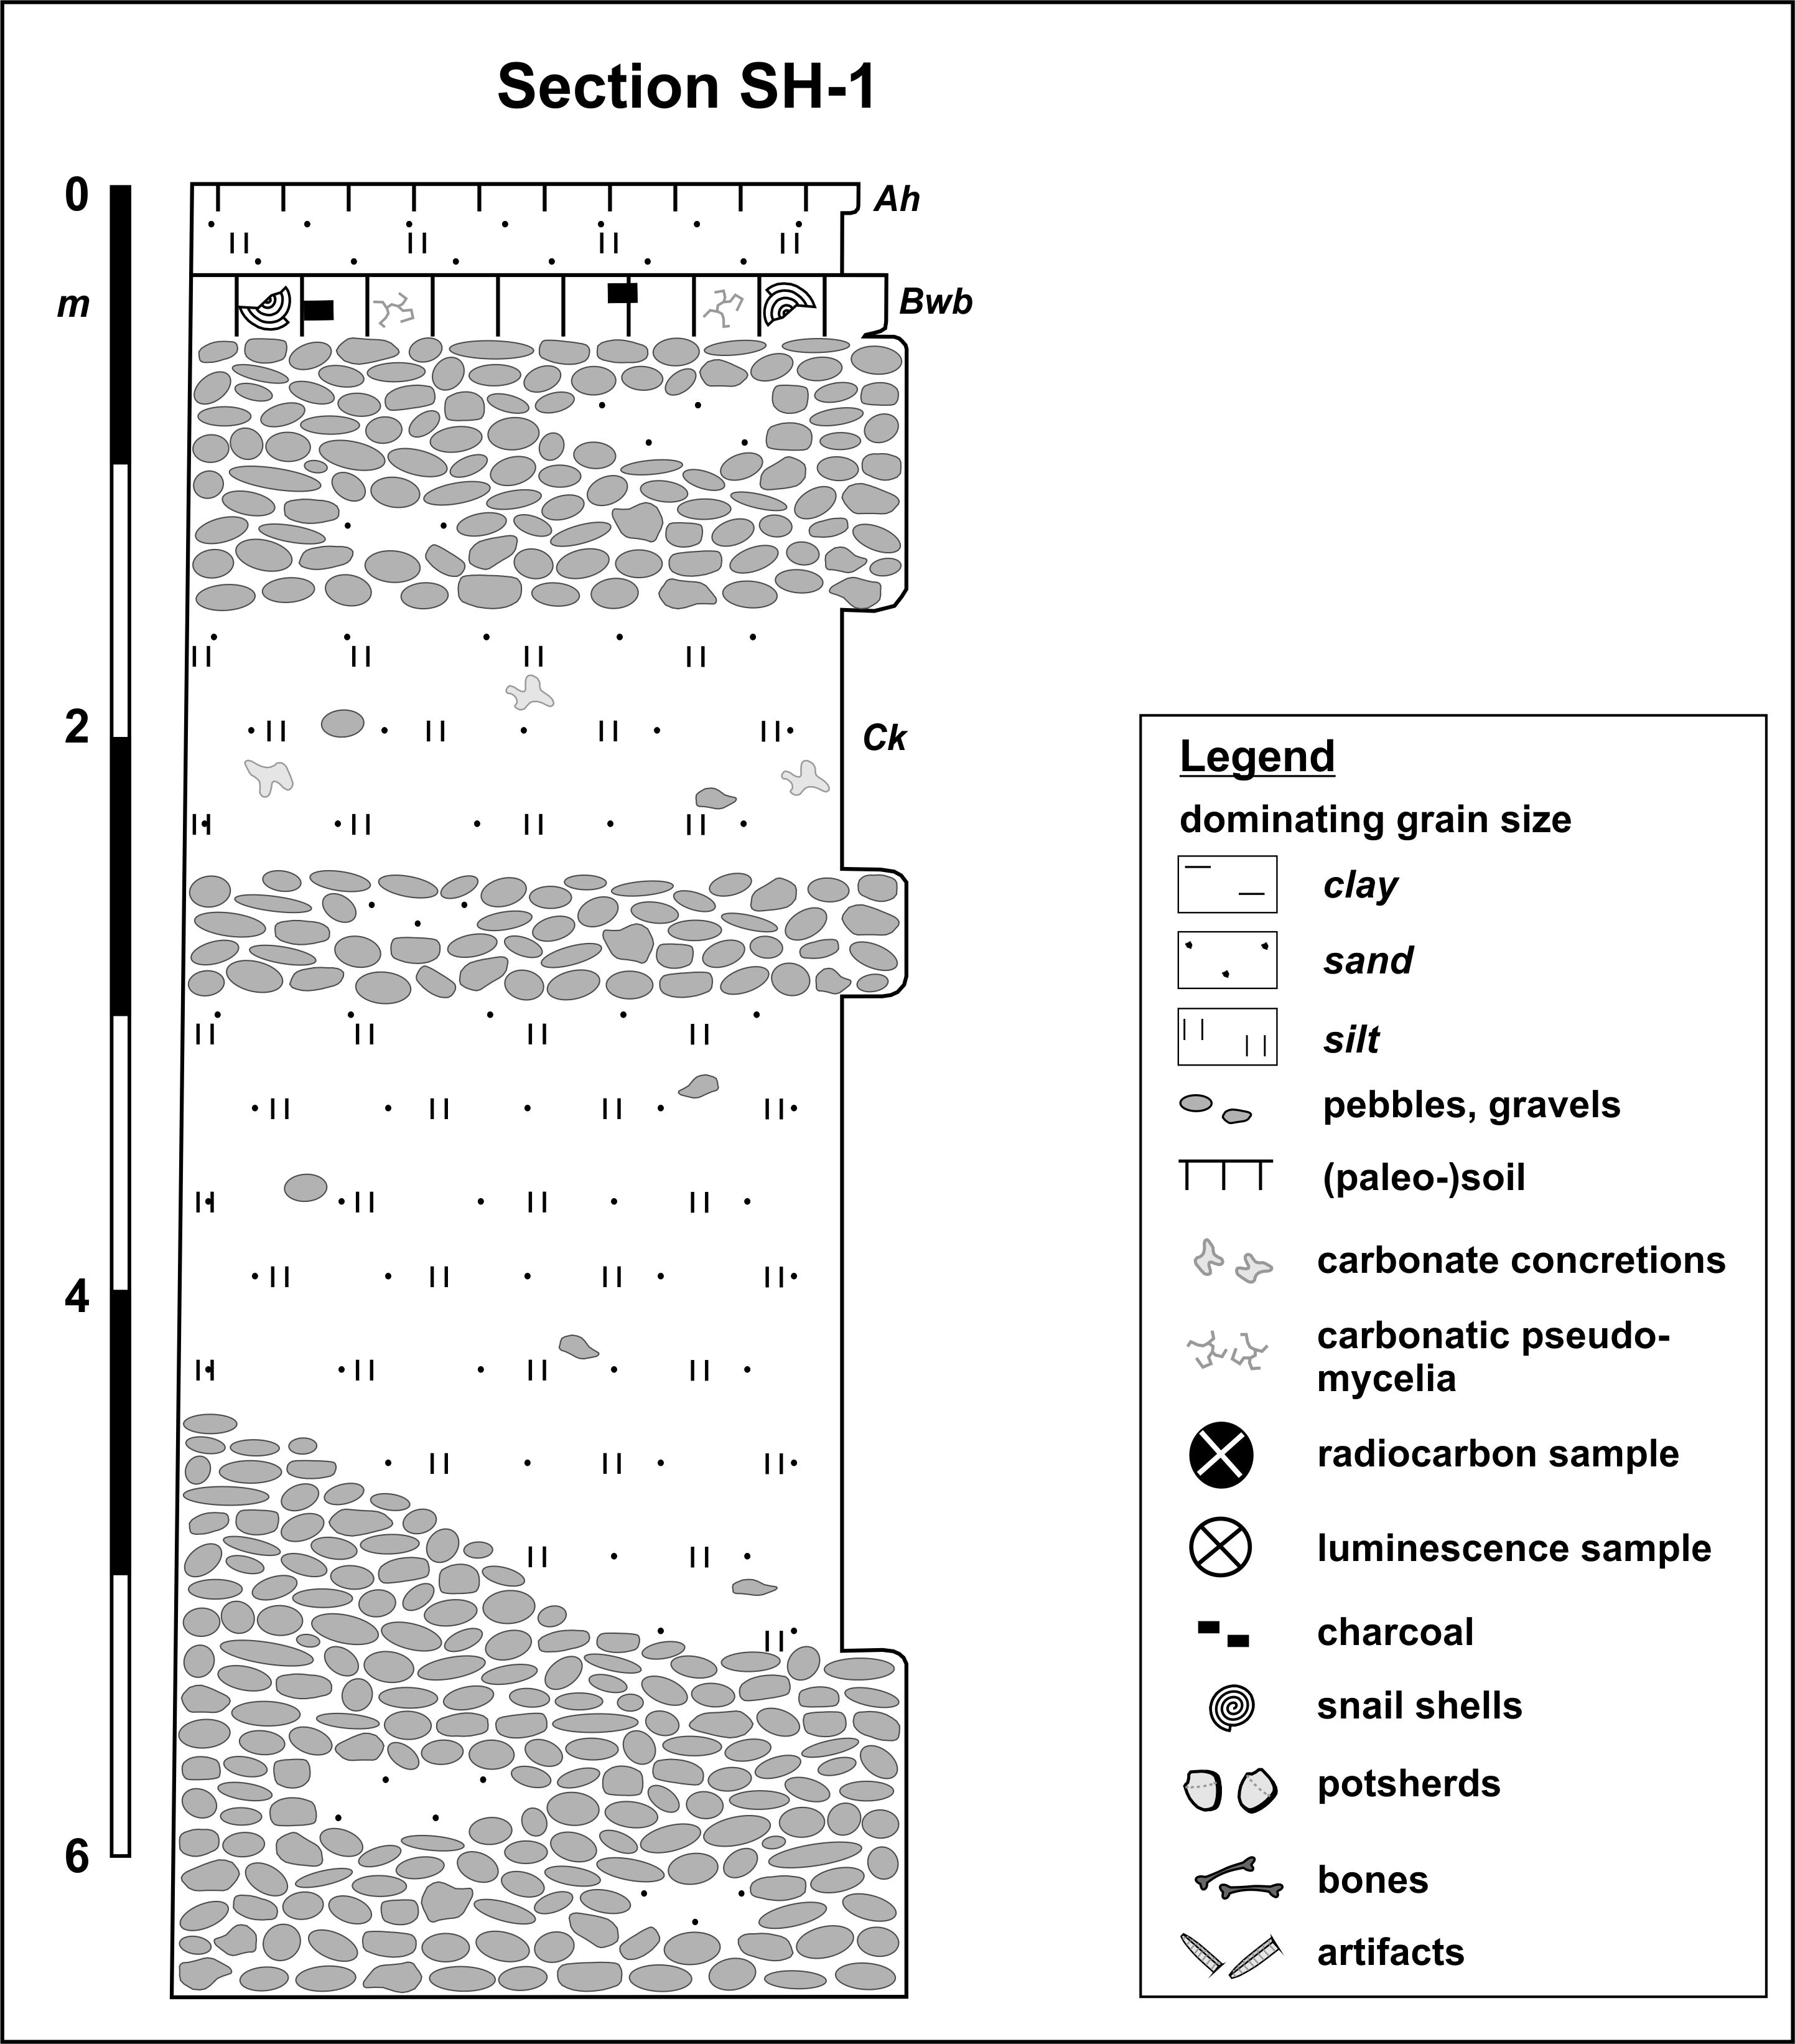
Section Shulaveris Ghele 2 (SH-2)
(41°23’25.1‘‘N, 44°48’20.5‘‘E; 380 m a.s.l.)
The ca. 4.5 m thick section SH-2 mostly consists of layered brownish-greyish loamy sand and contains several charcoal pieces as well as intact and broken snail shells. Between ca. 4.0 and 2.5 m this material is intercalated by a large gravel body with some sandy lenses. Radiocarbon dating of a charcoal piece taken at 4.1 m gave an age of 1.0 ± 0.04 cal. ka BP. The weakly developed recent fluvisol is developed in the upper part of this material.

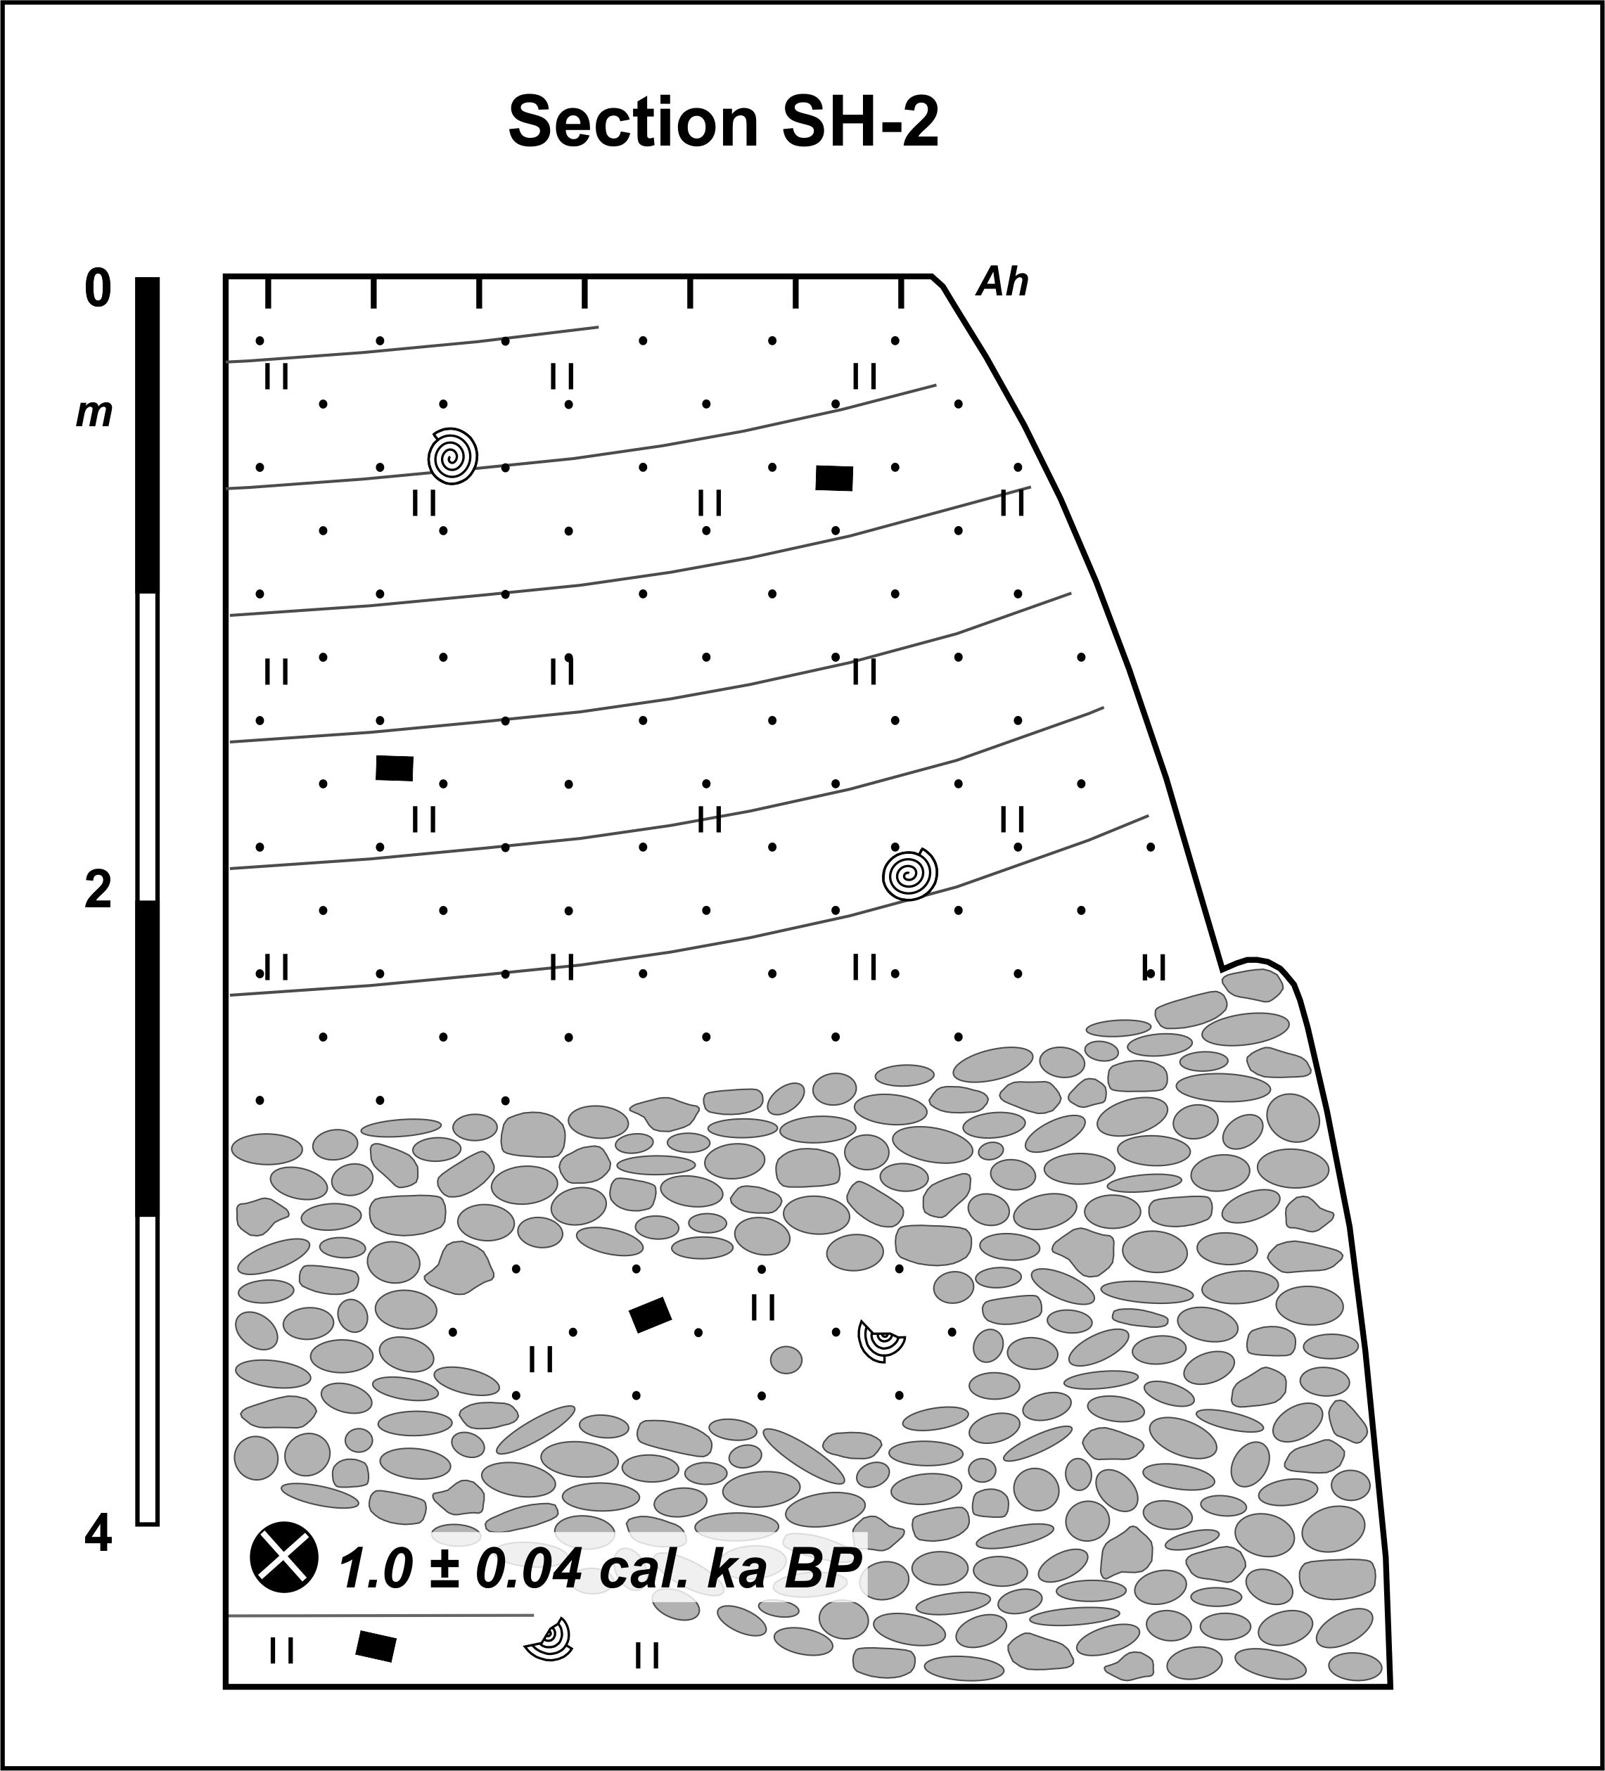

Section Shulaveris Ghele 3 (SH-3)
(41°23’24.3‘‘N, 44°48’22.8‘‘E; 380 m a.s.l.)
The base of the right-hand part of section SH-3 between 6.0 and 2.0 m is formed by a gravel body that contains some sandy lenses. Between 2.0 and 1.5 m the gravel is interfingered with a sand layer that shows a fining trend upwards. Between ca. 1.5 and 1.0 m brownish loam that contains singular pebbles is found. In this material a Ck horizon with ca. 1 cm thick carbonate concretions is developed. Between 1.0 and 0.5 m a dark-brown layer of clayey loam with a subangular blocky structure is found that contains singular broken snail shells and charcoal pieces. Its distinct upper and gradual lower boundary, dark-brown colour, subangular blocky structure, the underlying intensively developed Ck horizon as well as systematically decreasing carbonate contents (from 18 to 3 %) and pH-values (from 7.7 to 7.5) and increasing TOC-contents (from 0.2 to 2.8 %) towards its surface evidence the Bw horizon of an intensively developed cambisol. The cambisol shows carbonate contents between 3 and 8 % what can at least partly be explained with secondary recalcification that is seen by carbonate stains on the ped surfaces. The buried cambisol is discordantly overlain by a ca. 50 cm thick layer of yellowish-whitish sandy loam with intercalated gravel bands and lenses that contains singular broken snail shells and small carbonate mycelia. The weakly developed recent fluvisol is developed in this material. In the left-hand part of this section the layers from the dark-brown coloured Bw horizon downwards were discordantly incised up to ca. 4.2 m. The base of the sediments filling this incision is formed by reddish-ocherous clayey loam that contains numerous carbonate concretions, but it is not clear whether these concretions belong to the lower part of a paleosol or if they were redeposited . This layer is overlain by reddish slightly clayey loam that contains singular redeposited carbonate concretions in its lower, and potsherds, charcoal pieces and some carbonate mycelia in its upper part. Radiocarbon dating of a charcoal piece from its upper part gave an age of 1.9 ± 0.04 cal. ka BP. Finally, between 3.0 and 2.4 m that layer is overlain by a gravel body that merges with the gravelly and sandy-loamy material in the uppermost 50 cm of the right-hand part of this section. In the upper part of this material the weakly developed recent fluvisol was formed.

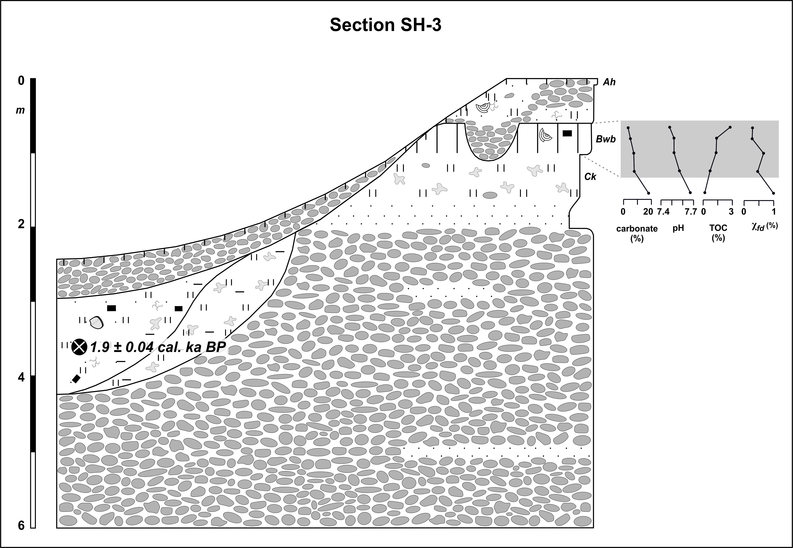

Section Shulaveris Ghele 4 (SH-4)
(41°23’26.3‘‘N, 44°48’25.1‘‘E; 380 m a.s.l.)
The oldest sediments of section SH-4 are found in the central part between 5.0 and 1.0 m and consist of yellowish-ocherous sandy loam with intercalated gravel layers. These sediments are strongly incised, and the overlying stratigraphic unit shows gravel bodies at the base. These are overlain by reddish-brownish loamy material, and an underlying Ck horizon with numerous carbonate concretions indicates overprinting by pedogenesis. However, given intensive erosion the type of that paleosol could not be determined. The eroded paleosol traces the former shape of the valley up to a depth of ca. 3.0 m. Overyling sediments consist of loamy to sandy material. This material shows some intercalated gravel layers and contains singular charcoal pieces, bones, carbonate pseudomycelia and in its upper part also potsherds. Radiocarbon dating of a charcoal piece gave an age of 6.1 ± 0.07 cal. ka BP, and nearby IRSL-dating an age of 5.9 ± 2.6 ka. At the top of these sediments a ca. 20 - 30 cm thick brownish layer consists of loamy sand and shows a subangular blocky structure. Although showing gradual upper and lower boundaries, the brownish colour, subangular blocky structure as well as systematically decreasing pH-values (from 7.5 to 7.4) as well as increasing TOC-contents (from 0.1 to 0.3 %) and χ_{fd}-values (from 0 to 0.4 %) towards its surface evidence the Bw horizon of a cambisol. Carbonate contents increasing from 6 to 8 % towards the paleosol surface can be explained with secondary recalcification that is seen in carbonatic pseudomycelia found throughout the soil matrix. The buried cambisol is overlain by a layer of ocherous loamy sand. In the right-hand part of this section this layer extends from 3.5 m up to the surface and contains some intercalated gravel bands and layers. Its upper part was overprinted by the weakly developed recent fluvisol. Several large charcoal pieces were found in this layer, and radiocarbon dating of one piece gave an age of 0.48 ± 0.03 cal. ka BP.

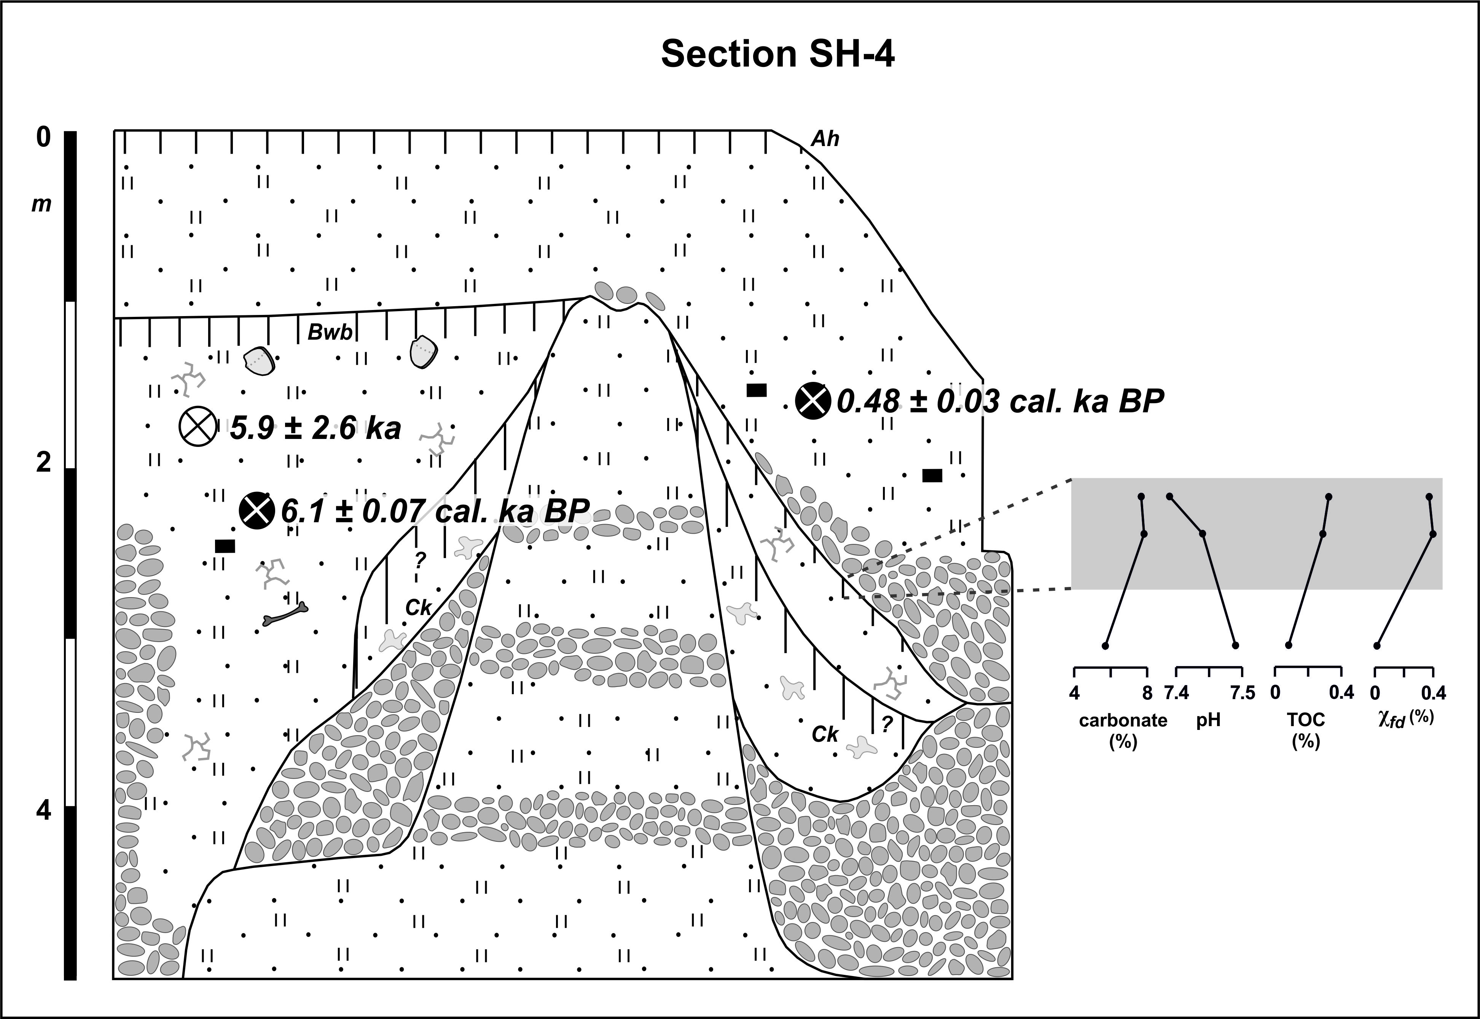

Section Shulaveris Ghele 5 (SH-5)
(41°23’26.3‘‘N, 44°48’25.1‘‘E; 380 m a.s.l.)
The base of section SH-5 between 5.0 and 3.5 m is formed by yellowish-ocherous sandy loam with intercalated gravel bodies and bands. A slightly reddish loamy layer of 10 cm thickness with slight clay coatings in root channels found at 3.5 m was interpreted as the lower part of the Bt horizon of a former luvisol. The overlying layer between 3.5 and 2.5 m consists of yellowish-ocherous sandy loam and is intercalaed by sand and gravel lenses. A slightly reddish loamy layer of ca. 10 cm thickness with intensive clay coatings in root channels was found at 2.5 m and was also interpreted as the lower part of the Bt horizon of a former luvisol. Both Bt horizons are carbonatic what can be explained with secondary recalcification as seen by carbonate mycelia in their matrices. Overlying yellowish loamy sediments up to 0.75 m contain singular pebbles, and a Ck horizon with ca. 1 cm thick carbonate concretions is developed in their upper part. Up to 0.3 m an angular blocky dark-brown layer is found that contains singular charcoal pieces and snail shells. Its distinct upper and gradual lower boundary, brownish colour, angular blocky structure and the underlying well-developed Ck horizon indicate the Bw horizon of a cambisol. This buried cambisol is overlain by greyish sandy loam with intercalated gravel lenses and singular pebbles that contains some charcoal pieces as well as broken and intact snail shells. The weakly developed recent fluvisol is developed in the upper part of these sediments. Radiocarbon dating of a charcoal piece from the uppermost layer gave an age of 0.35 ± 0.07 cal. ka BP. In the central part of this section the dark brown buried cambisol diverges into two similar-looking cambisols that are separated by up to 1.45 m thick sandy and loamy sediments. Although showing rather gradual upper and lower boundaries, both buried cambisols show systematically decreasing carbonate (lower soil from 13 to 6 %; upper soil from 14 to 7 %) and increasing TOC-contents (lower soil from 0.2 to 0.6 %; upper soil from 0.6 to 1.2 %) and χ_{fd}-values (lower soil from 0.5 to 1.1 %; upper soil from 0.8 to 1.0 %) towards their surfaces. Carbonate values between 4 and 7 % in their matrices can at least partly be explained with secondary recalcification that is seen by carbonate stains on the ped surfaces. The ca. 30 cm thick lower cambisol is underlain by a Ck horizon with carbonate concretions of ca. 1 cm thickness and contains snail shells as well as singular charcoal pieces. The ca. 40 cm thick upper cambisol is underlain by carbonatic pseudomycelia. Radiocarbon dating of a charcoal piece from the upper part of the lower buried cambisol gave an age of 3.0 ± 0.06 cal. ka BP. The sandy-loamy sediments separating both buried paleosols are intercalated by several sand and gravel lenses and contain broken snail shells and charcoal pieces. One of these pieces was radiocarbon-dated to 4.8 ± 0.07 cal. ka BP, and a neighbouring IRSL-sample gave an age of 5.5 ± 2.5 ka.
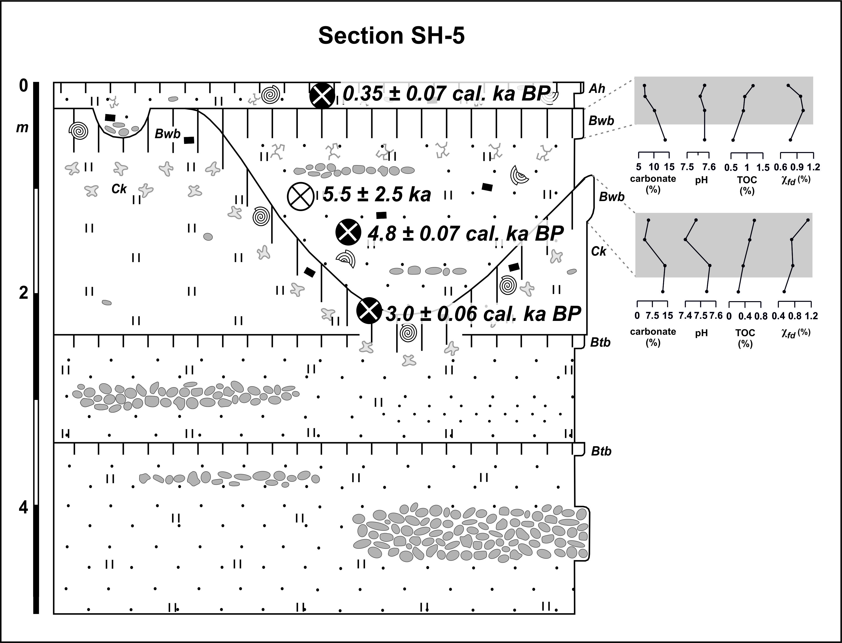
Section Shulaveris Ghele 6a (SH-6a)
(41°23’26.3‘‘N, 44°49’16.2‘‘E; 365 m a.s.l.)
Section SH-6a is located at the NE-wall of the Shulaveris Ghele valley opposite to the late Neolithic settlement site „Gadachrili Gora“. The base of this section between 6.5 and 2.9 m is formed by ocherous sandy loam that is intercalated by gravel bodies and lenses. A reddish loamy layer of some cm thickness at 2.9 m shows singular clay coatings in root channels, and an underlying Ck horizon with carbonate concretions of some mm thickness is found in its lower part. It was interpreted as the lower part of the Bt horizon of a former luvisol. This Bt horizon is carbonatic what can be explained with secondary recalcification as seen by carbonatic pseudomycelia in its matrix. The buried luvisol is overlain by yellowish loam. All these sediments were discordantly incised by late Neolithic human excavation activities, and subsequently the excavated ditches were filled up with greyish loamy sediments that contain some charcoal pieces. These fillings are overlain by a greyish-blackish clayey loamy layer of some cm thickness that contains charcoal pieces, potsherds, bones and obsidian artifacts. Up to 1.3 m this layer is overlain by sandy loam with singular pebbles and gravel layers that contains some charcoal pieces. IRSL-dating in these sediments gave an age of 10.0 ± 5.0 ka. Above, a blackish-brownish and angular blocky layer of clayey loam between 1.3 and 0.95 m is underlain by carbonatic pseudomycelia. Due to its distinct upper and gradual lower limit, blackish-brownish colour, angular blocky structure and the underlying carbonatic pseudomycelia this layer is interpreted as the Bw horizon of a cambisol. The cambisol contains carbonate what can at least partly be explained with secondary recalcification seen in slight carbonate stains of the ped surfaces. Up to the surface the buried cambisol is overlain by greyish loam that contains singular pebbles and small carbonate pseudomycelia, and the weakly developed recent fluvisol was formed in the upper part of this material.

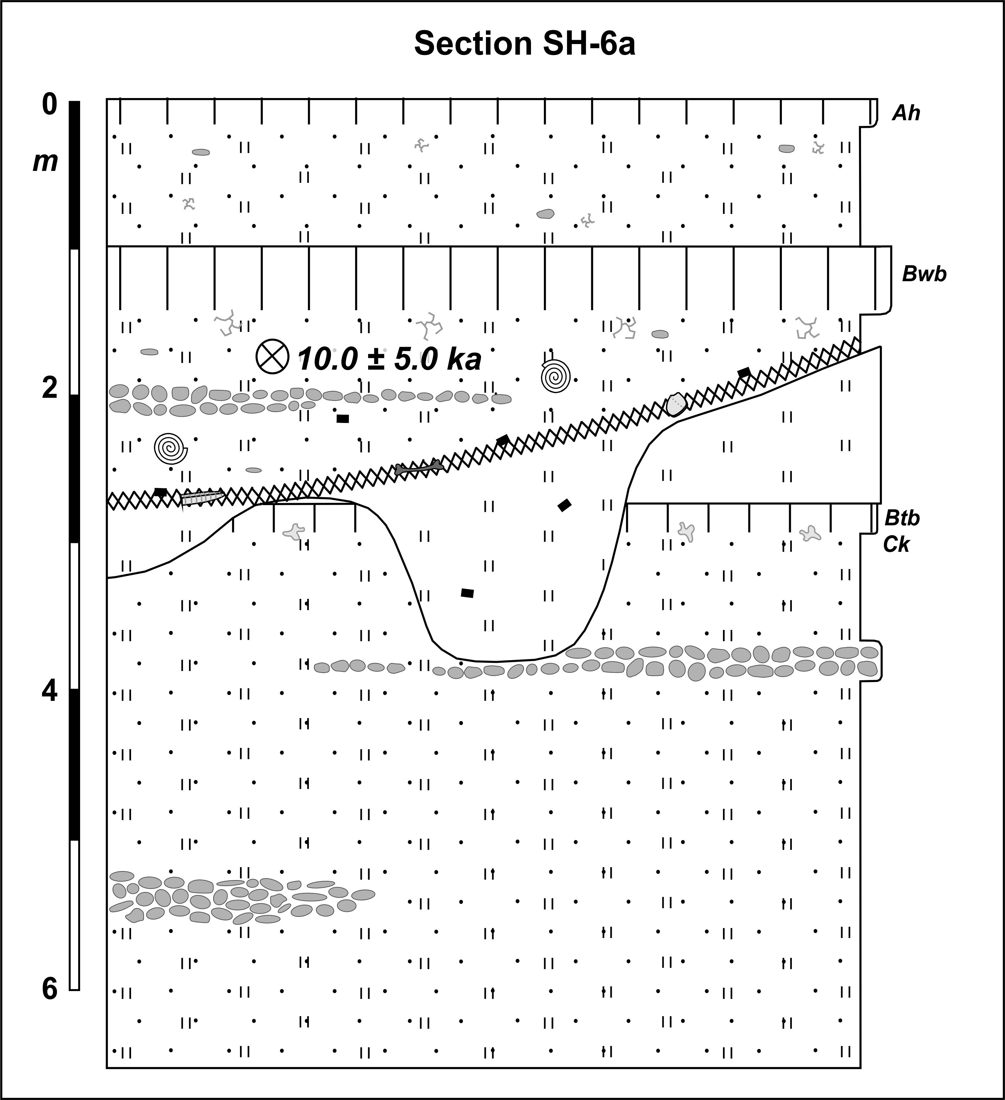

Section Shulaveris Ghele 6b (SH-6b)
(41°23’26.3‘‘N, 44°49’16.2‘‘E; 365 m a.s.l.)
Section SH-6b crops out natural sediments and a part of the late Neolithic settlement „Gadachrili Gora“ that is eroded by the Shulaveris Ghele River today. A part of the sediments in the center of this section was not accessible due to collapsed slope material. The base of this section between 7.0 and 3.4 m is formed by sandy loam that contains some intercalated gravel beds. A slightly reddish loamy layer of ca. 10 cm thickness at 6.0 m was only found in the left-hand part of this section. It was interpreted as the lower part of a mostly eroded paleosol of unknown type. Similarly, a reddish loamy layer of ca. 10 cm thickness at 3.4 m that is underlain by a Ck horizon with carbonate concretions of some mm thickness was also interpreted as the lower part of a mostly eroded paleosol. However, also for this soil the type could not be determined. Both paleosols contain carbonate what can be explained with secondary recalcification as seen by carbonatic pseudomycelia in their matrices. The upper paleosol is overlain by yellowish loam that was discordantly incised by human excavation activities during the late Neolithic period. Overlying sediments in the upper left-hand part of this section consist of loamy-sandy human-derived layers of the late Neolithic settlement and contain charcoal pieces, bones, obsidian artifacts and potsherds. The greyish filling of the excavated ditch in the right-hand part of the section consists of loamy sediments and contains charcoal pieces and bones. This filling is overlain by a greyish-blackish layer of some cm thickness that consists of clayey loam and contains charcoal pieces and bones. Above, up to 0.9 m ocherous sandy loam with some intercalated gravel layers contains singular pebbles, snail shells and charcoal pieces. Radiocarbon dating of one piece gave an age of 7.7 ± 0.04 cal. ka BP. Between 0.9 and 0.6 m a blackish-brownish and angular blocky layer is found that is underlain by a layer of carbonatic pseudomycelia. Due to its distinct upper and gradual lower boundary, blackish-brownish colour, angular blocky structure and the underlying carbonatic pseudomycelia this layer was interpreted as the Bw horizon of a cambisol. The cambisol contains carbonate what can at least partly be explained with secondary recalcification seen in slight carbonate stains of the ped surfaces. Up to the surface the buried cambisol is overlain by greyish loam that contains singular pebbles and small carbonate pseudomycelia. In the upper part of this material the weakly developed recent fluvisol was formed.

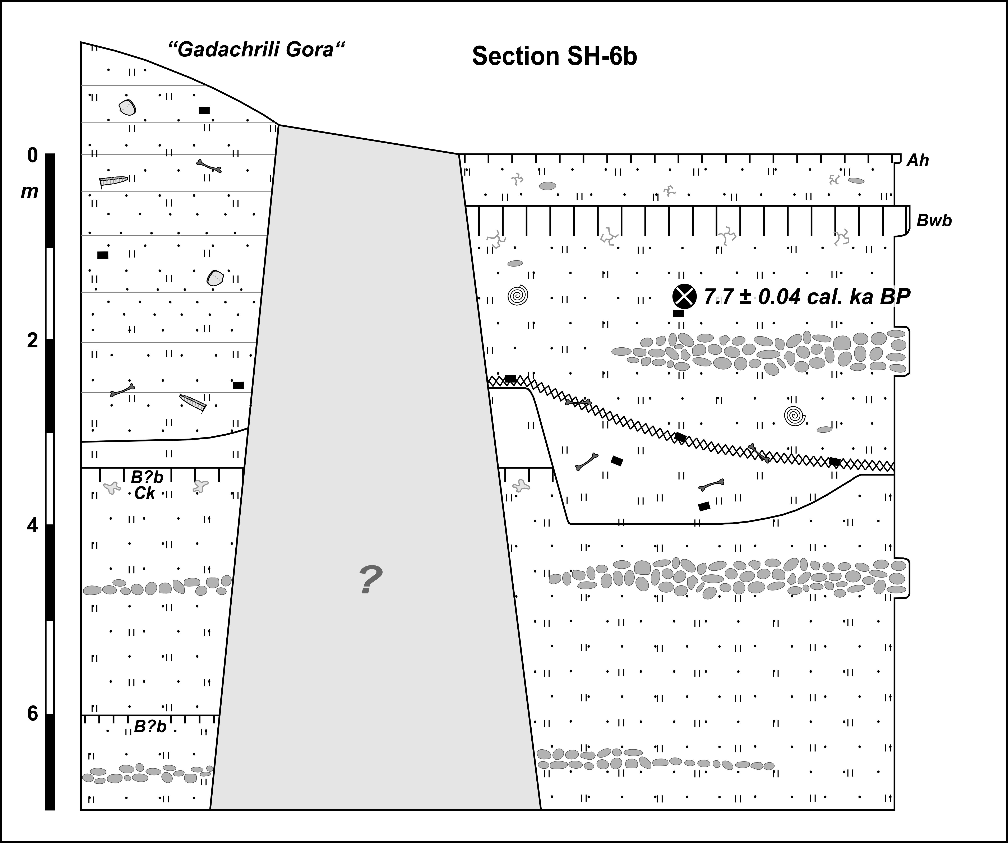
Section Shulaveris Ghele 7 (SH-7)
(41°23’28.3‘‘N, 44°49’27.1‘‘E; 360 m a.s.l.)
The base of section SH-7 between 6.0 and 4.0 m is formed by yellowish sandy loam with singular pebbles that contains broken snail shells. A slightly reddish loamy layer of some cm thickness at 4.0 m shows some clay coatings in root channels. Accordingly, it was interpreted as the lower part of the Bt horizon of a former luvisol. Sandy to silty yellowish sediments with singular pebbles and gravel layers occur between 4.0 and 1.5 m. IRSL-dating in their lower part gave an age of 38.3 ± 17.0 ka. A slightly reddish loamy layer of some cm thickness at 1.5 m showed strong clay coatings in root channels and was also interpreted as the lower part of the Bt horizon of a former luvisol. Both Bt horizons are carbonatic what can be explained with secondary recalcification as seen by carbonatic pseudomycelia in their matrices. IRSL-dating just below the upper buried luvisol gave an age of 30.2 ± 13.5 ka. Overlying silty sediments up to 0.9 m contain singular pebbles and broken snail shells, and a Ck horizon with ca. 1 cm large carbonate concretions is found. IRSL-dating in the upper part of this layer gave an age of 8.0 ± 3.3 ka. A dark brown angular blocky and loamy layer between 0.9 and 0.5 m contains singular charcoal pieces. Its distinct upper and gradual lower boundary, dark brown colour, angular blocky structure and the underlying Ck horizon indicate the Bw horizon of a cambisol. The cambisol contains some carbonate what can at least partly be explained with secondary recalcification as seen by carbonate stains of the ped surfaces. The buried cambisol is overlain by a ca. 50 cm thick layer of brownish sandy loam that contains some intact and broken snail shells. The weakly developed recent fluvisol was formed in the upper part of these sediments.

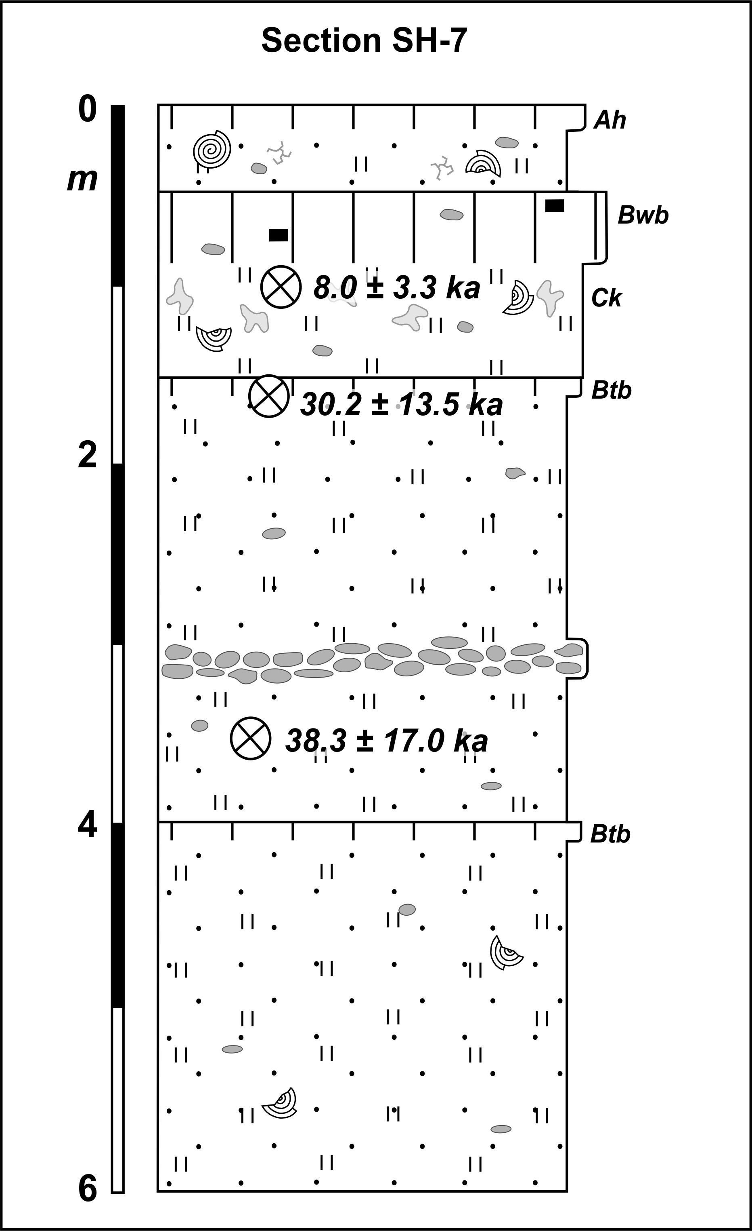
Section Shulaveris Ghele 8 (SH-8)
(41°23’38.7‘‘N, 44°49’36.5‘‘E; 355 m a.s.l.)
Section SH-8 is located at the southeastern wall of the recent eastern Shulaveris Ghele valley adjacent to the late Neolithic settlement site „Imiris Gora“. The base of this section between 6.0 and 3.5 m is formed by yellowish sandy loam that contains singular pebbles and gravel bodies. A slightly reddish loamy layer at 4.0 m with slight clay coatings in root channels was interpreted as the lower part of the Bt horizon of a former luvisol. This Bt horizon is carbonatic what can be explained with secondary recalcification as seen by carbonatic pseudomycelia in its matrix. Up to ca. 5.0 m these basal sediments were discordantly incised by late Neolithic excavation activities. Subsequently, the ditches were filled up to ca. 2.7 m with yellowish sandy and loamy material that contains numerous potsherds, bones, charcoal pieces, obsidian artifacts and thin black-couloured charcoal-rich layers. One charcoal piece was radiocarbon-dated to 7.7 ± 0.06 cal. ka BP. In the left-hand part of this section these sediments were incised up to ca. 1.5 m deep and subsequently filled up with sandy to loamy sediments. These sediments are intercalated with three greyish-blackish loamy-clayey and organic-rich layers that contain singular bones, potsherds, charcoal pieces and in the upper part also snail shells. Brownish clayey loam between 2.9 and 2.7 m at the top of these sediments shows a slightly reduced pH-value (from 7.6 to 7.5) compared with underlying material. This suggests a very weakly developed fluvisol. Different properties of the material deposited above (sandier, higher pH, more carbonate) indicate a sedimentation hiatus and thereby support the interpretation of the underlying horizon as a weakly developed fluvisol. This soil contains 9.5 % carbonate what can at least partly be explained with secondary recalcification as seen by carbonate stains in root channels. A sand layer with various thicknesses between ca. 2.7 and 2.5 m is overlain by ocherous-greyish sandy loam that extends up to 2.3 m. Brownish-greyish clayey loam with a weakly developed angular blocky structure between 2.3 and 1.9 m contains some snail shells. The brownish-greyish colour, weakly developed angular blocky structure, reduced carbonate contents (from 14 to 6 %) as well as enhanced values of TOC (from 0.4 to 0.6 %) and χ_{fd} (from 1.5 to 2.6 %) indicate the Bw horizon of a weakly developed cambisol. Carbonate contents between 9 and 5 % of the soil matrix can at least partly be explained with secondary recalcification as seen by carbonate stains in root channels. Up to 1.7 m this buried cambisol is overlain by ocherous-greyish sandy loam. Brownish-greyish clayey loam between 1.7 and 1.4 m contains some snail shells and charcoal pieces, and slightly reduced carbonate contents (from 8.8 to 6.4 %) and very slightly increased TOC-values (from 0.45 to 0.5 %) indicate a weakly developed fluvisol. Carbonate contents around 6.4 % in the soil matrix can at least partly be explained with secondary recalcification as seen by carbonate stains in root channels. Up to 1.05 m this buried fluvisol is overlain by ocherous-greyish sandy loam. Above, up to 0.8 m a dark brown layer of clayey loam with an angular blocky structure occurs that shows clay coatings in its lower part. Radiocarbon dating of a charcoal piece from its upper part gave an age of 1.0 ± 0.05 cal. ka BP. Its gradual lower but distinct upper boundary, dark brown colour, angular blocky structure, clay coatings in the lower part, reduced carbonate contents (from 7.7 to 4.5 %) as well as increased values of TOC (from 0.5 to 1.3 %) and χ_{fd} (from 1.0 to 1.8 %) demonstrate the Btw horizon of a luvic cambisol. Clay illuviation despite recent pH-values between 7.7 and 7.6 and carbonate contents between 6 and 4 % in the soil matrix can possibly be explained with secondary recalcification that is seen by carbonate stains along ped surfaces. The buried luvic cambisol is discordantly overlain by greyish sandy loam that contains individual pebbles and shows some intercalated gravel layers. This material contains small carbonatic pseudomycelia, snail shells and charcoal pieces, and radiocarbon dating of one piece gave an age of 0.37 ± 0.06 cal. ka BP. The weakly developed recent fluvisol was formed in the upper part of these sediments.
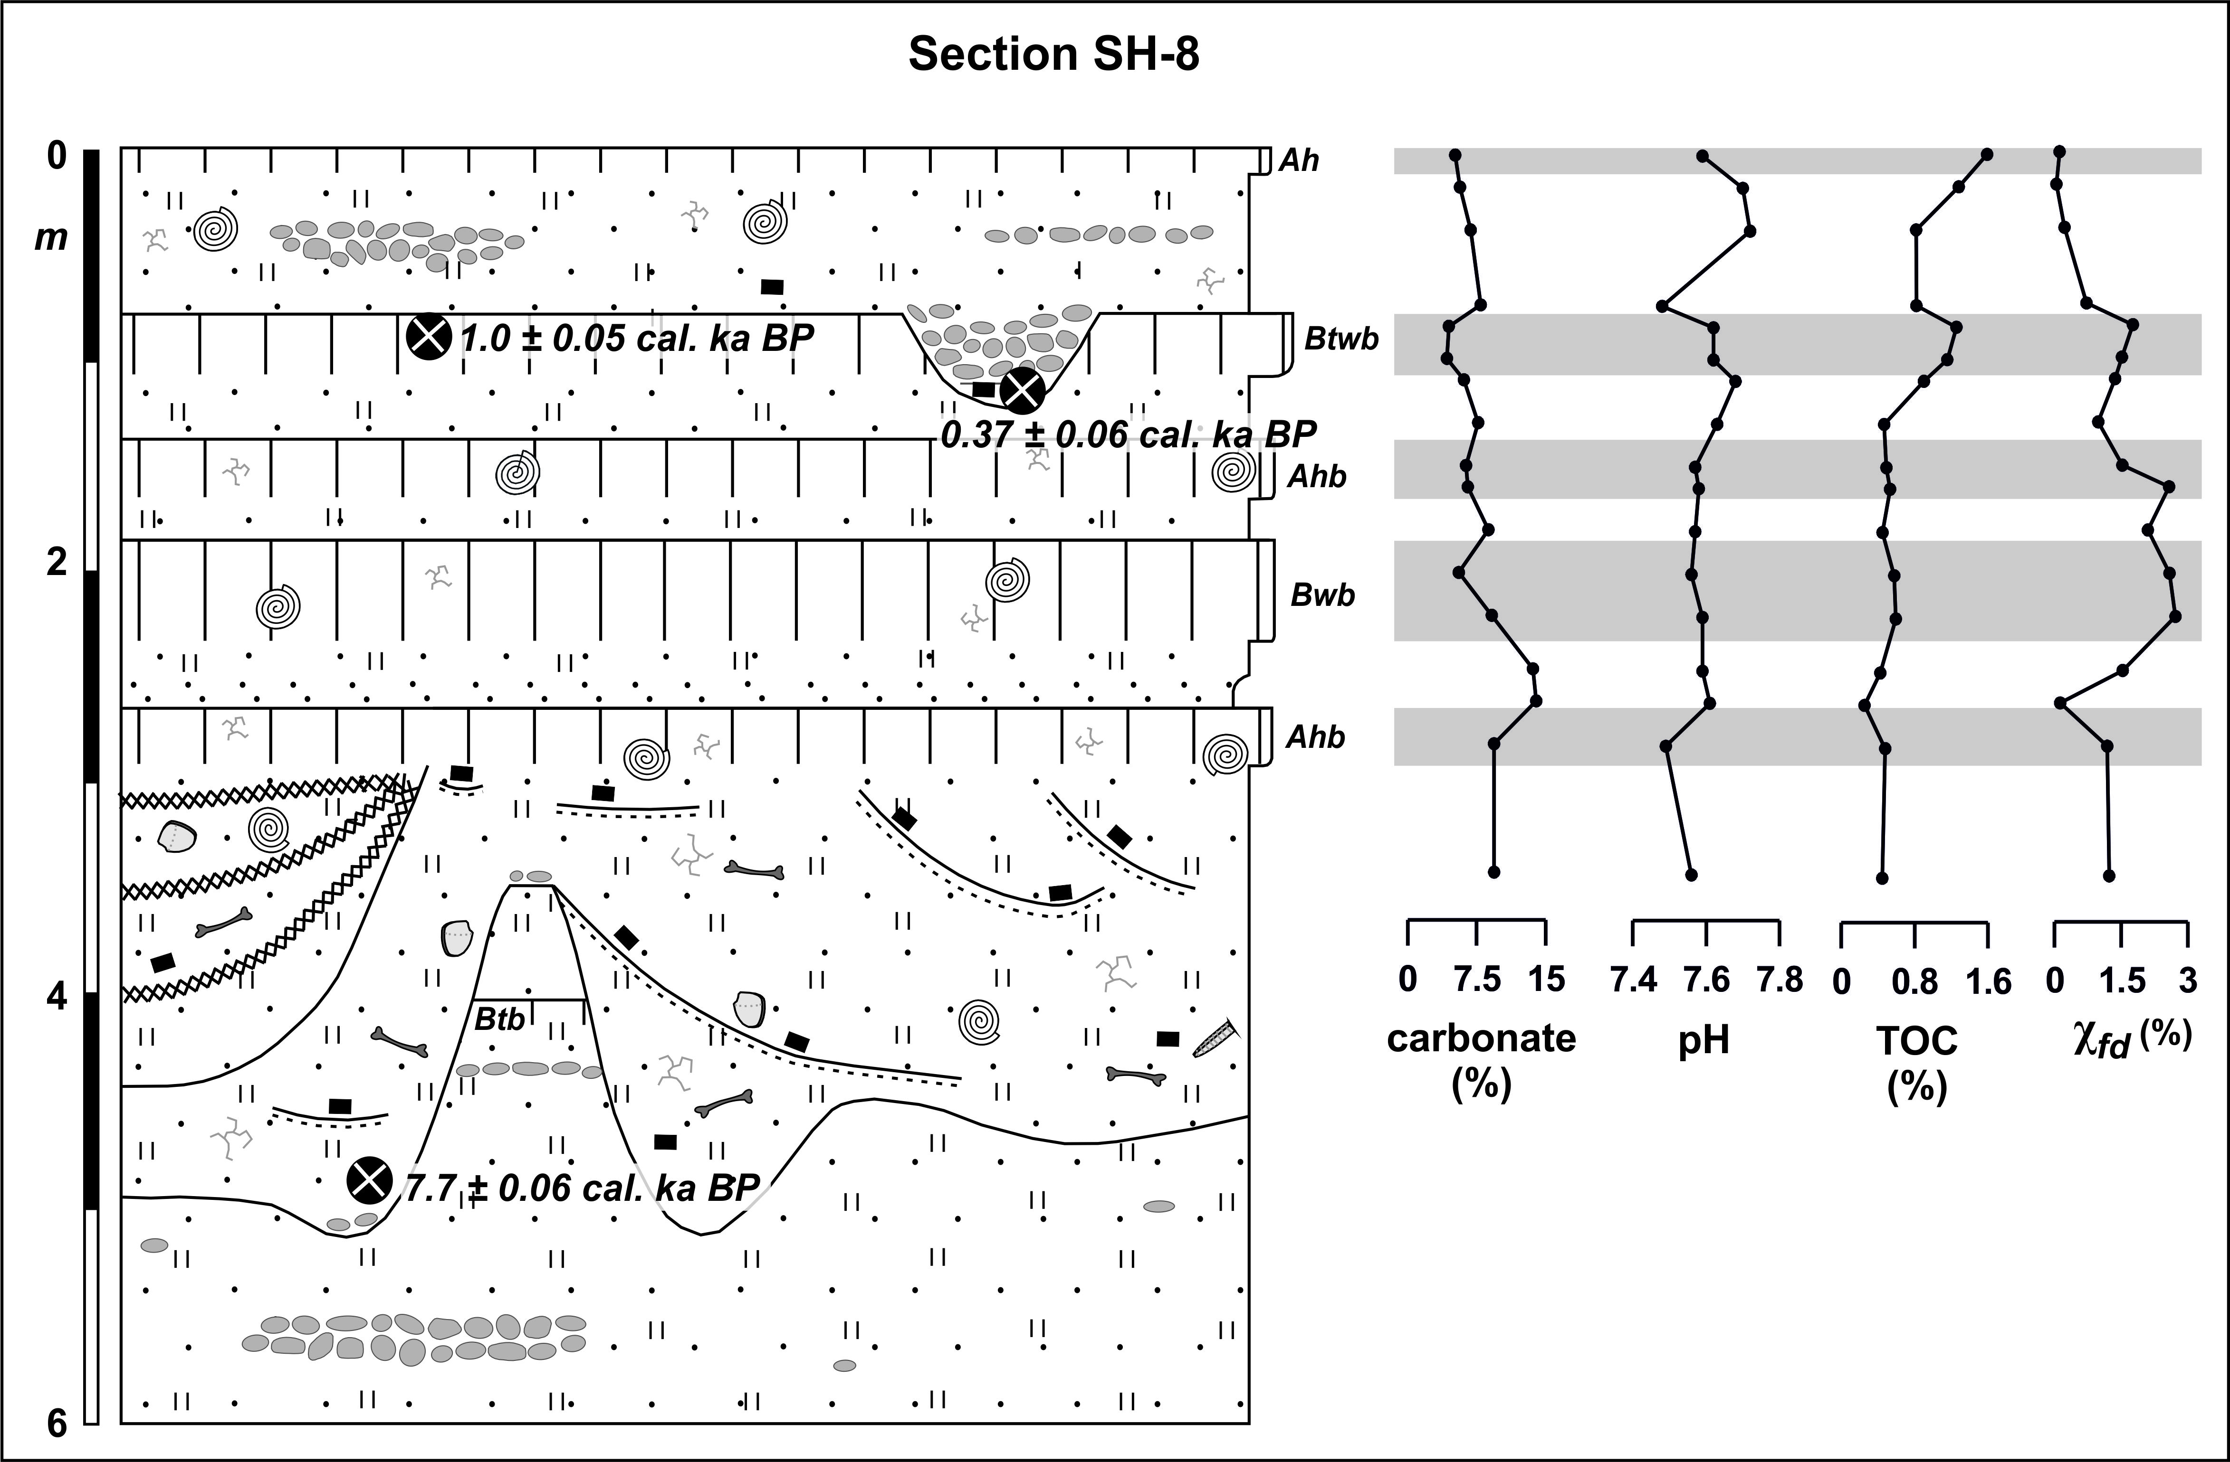

Shulaveris Ghele – drilling 1 in old western river bed
(41°23’21.1 ‘‘N, 44°46’56.3‘‘E; 400 m a.s.l.)
Hand-drilling 1 was performed in the upstream part of the former western course of the Shulaveris Ghele River ca. 600 m north of the recent river bed. The base of the drilled sediments between 5.0 and 4.7 m consists of yellowish-ocherous sandy loam. Up to 3.0 m the loam is overlain by a sandy layer that shows a fining trend upwards, i.e. from coarse sand at the base to fine sand in the upper part. This sand layer contains singular snail shells, and a charcoal piece found at 4.1 m was radiocarbon-dated to 6.0 ± 0.03 cal. ka BP. Between 3.0 and 2.0 m the sand grades into ocherous-brownish sandy loam that contains singular pebbles and some charcoal pieces. Up to the surface these sediments are overlain by brownish-greyish clayey loam that contains singular basaltic pebbles, small carbonatic pseudomycelia and in its lower part also charcoal pieces. The recent blackish-brownish vertic cambisol is developed in the upper 60 - 70 cm below the surface.

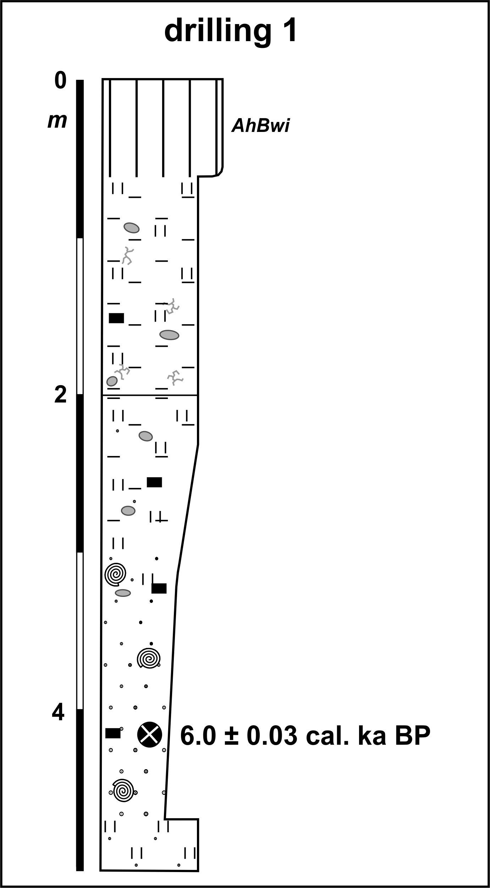
Shulaveris Ghele – drilling 2 in old western river bed
(41°24’31.1 ‘‘N, 44°46’35.9‘‘E; 370 m a.s.l.)
Hand-drilling 2 was performed in the downstream part of the former western course of the Shulaveris Ghele River ca. 100 m upstream of the small dejection cone at the lower end of this river bed. The base of the drilled sediments between 2.0 and 0.7 m consists of light-brown sandy loam with singular carbonatic pebbles that fines towards the top. Up to the surface this material is overprinted by the recent blackish-brownish vertic cambisol that contains singular carbonatic pebbles. Between 70 and 90 cm a Ck horizon with ca. 1 cm thick carbonate concretions is developed.

