**Supplementary materials**

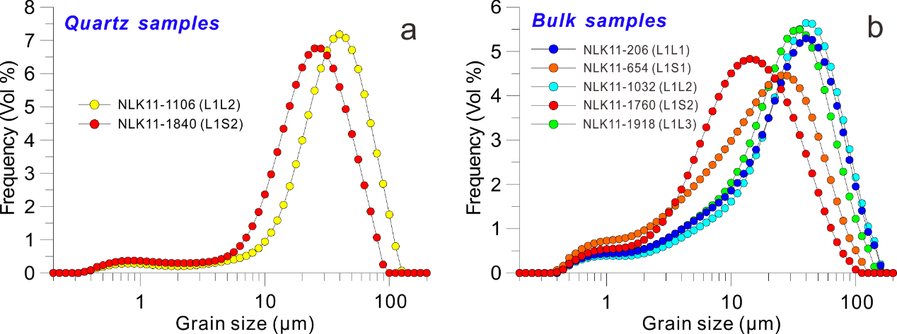

Fig. S1 Comparison of grain size distribution between purified quartz subsamples of paleosol and primary loess (a), and between bulk samples of paleosols and primary loess (b). Quartz grains were exacted following the method of Sun et al. (2000). The isolated quartz grain samples were placed into the Malvern 2000 laser instrument for mineral-specific grain size measurements so that comparisons of quartz grain and bulk samples could be performed to illustrate the weathering degree of NLK loess visually.



Fig. S2 XRD patterns (59° ~ 62° 2θ) show the 060 reflections of 1.54 Å for the representative eleven samples are more prominent compared to 1.5 Å indicating dominance of trioctahedral smectites.

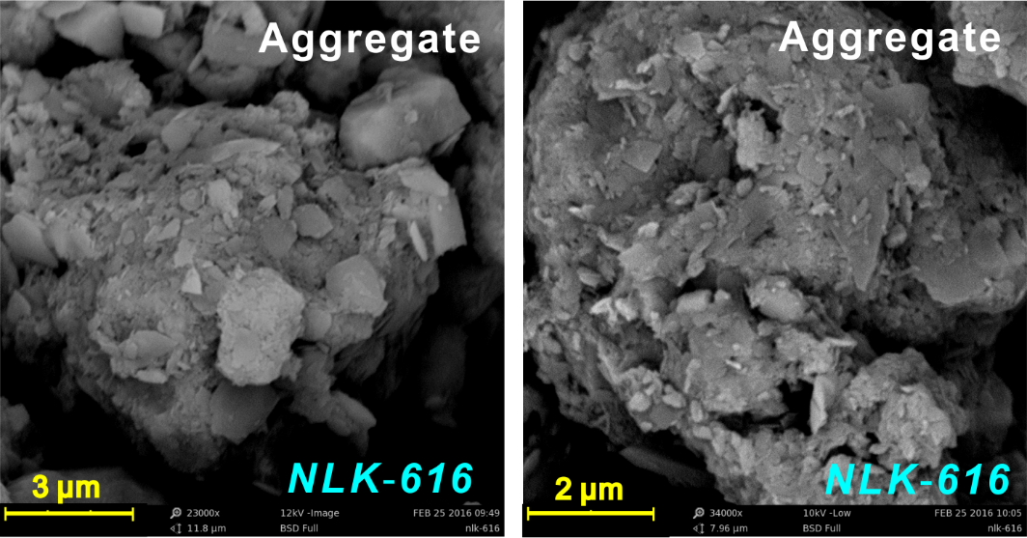

Fig. S3 The SEM observations to aggregates in bulk samples. The fine particles in NLK loess can be transported in the form of aggregates, especially for clay fractions.

**Note S1 Calculation of the relative abundances of the major minerals**

With regard to the mineral composition of bulk samples, mineral phases, at first, were identified using the “Highscore” software, and then peak areas of each mineral were measured with the “MacDiff” software on the basis of XRD patterns of bulk samples. Levenberg-Marquardt (LM) method (Zeng et al., 2014) was used to calculate the relative abundances of the major minerals in NLK loess. The results showed that the main crystalline phases are quartz, muscovite, albite, calcite, etc. and thereinto, muscovite contents only used in this paper varied from 18% to 36%.

**References**

Sun, Y., Lu, H., An, Z., 2000. Grain size distribution of quartz isolated from Chinese loess/ paleosol. Chinese Science Bulletin 45, 2296-2298.

Zeng, M.X., Song, Y.G., An, Z.S., Chang, H., Li, Y., 2014. Clay mineral records of the Erlangjian drill core sediments from the Lake Qinghai Basin, China. Science China-Earth Sciences 57, 1846-1859.