Supplementary material
New speleothem data from Molinos and Ejulve caves reveal Holocene winter hydrological variability in northeastern Iberia (Teruel, NE Spain), by Ana Moreno, Carlos Pérez-Mejías et al.

1. Monitoring survey: rainfall, dripwaters and in-situ farmed calcite in Molinos and Ejulve caves
Precipitation was sampled every rainfall event during three years (2010-2012) in the vicinity of Molinos (Teruel) and analyzed for isotopic composition (more details in Moreno et al., 2014) allowing discriminating three different synoptic patterns: Atlantic frontal systems, Mediterranean cyclogenesis (“backdoor” cold fronts) and summer convective situations (coloured dots in Fig. S1). Importantly, those periods when more intense precipitation takes place (see Fig. S1 mid-March, mid-May and November) are clearly influenced by “backdoor” cold fronts of Mediterranean origin. In addition to this “source effect” both air temperature and amount of precipitation have an effect on rainfall δ¹⁸O values, imprinting a seasonal variability slightly modulated by an “amount effect” when rainfall events are more frequent or intense (more clear in spring). In that previous monitoring study, correlations among isotopic composition of rainfall and large-scale atmospheric patterns, such as the North Atlantic Oscillation (NAO) or the Western Mediterranean Oscillation (WeMOi) indexes was explored (Moreno et al 2014) indicating a significant correlation only with WeMOi. This index is able to explain the pluviometric variability in the eastern fringe of the Iberian Peninsula since it allows the detection of the variability relevant to the cyclogenesis next to the western Mediterranean (Martin-Vide and Lopez-Bustins, 2006).

Rainfall at the studied location is transferred to the caves basically throughout fall to spring as indicated by dripwater rates (Moreno et al., 2014; Pérez-Mejías, 2013). Coherently, calcite precipitates are found from November to April in Molinos cave, the seasons of positive water balance. In Ejulve cave, although calcite precipitates are observed all year round, they dominate during spring season (Fig. S1). Therefore, we expect a biased signal towards winter-spring values in Molinos and Ejulve speleothem records calcite formation. Additionally, an increase in both δ¹³C and Mg/Ca values is observed towards summer in the in-farmed carbonates recovered seasonally from that cave (Fig. S1).
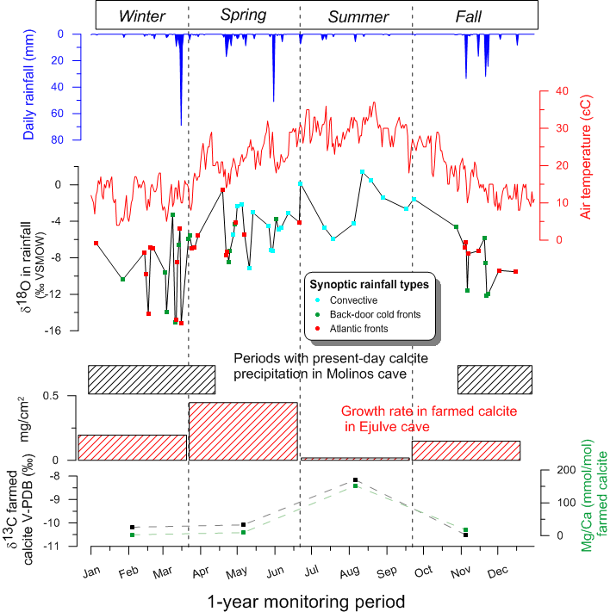
Fig. S1. Data from the monitoring survey in Molinos and Ejulve caves. From top to bottom: daily rainfall (mm) and maximum daily temperature from nearby meteorological station in Gallipuén reservoir (see Fig. 2 in the main text), variations of δ¹⁸O measured in rainfall samples indicating by colours the origin of those rainfall events. Rainfall and meteorological data are from 2011. Boxes with black and red dashed lines indicate periods with present-day calcite precipitation in Molinos (along 2011) and Ejulve caves (along 2013-2014), respectively. δ¹³C and Mg/Ca points show seasonally-averaged data for in-farmed calcite recovered on the site where stalagmite HOR was collected in Ejulve cave. Note that since the monitoring survey was not carried out simultaneously in both caves, one year data is taken as reference (2011 for Molinos and 2013-2014 for Ejulve).

2. Chronology

The three studied stalagmites (MO-1, MO-7, HOR) were inactive at the time of sampling. MO-1 stalagmite is a cylindrical speleothem, of 12 cm wide at the base, which grew as two different stalagmites after a well-marked surface interpreted as a potential growth hiatus. One of the twin stalagmites ceases its growth before the other one. This last one continues as a very thin and fragile stalagmite reaching a total length of 115 cm (Fig. S2). The other stalagmite from Molinos cave, MO-7 speleothem, is a large sample that grew during MIS 5 and MIS3 intervals while the Holocene section (Fig. S2) is represented by the uppermost 15 cm of the stalagmite with a growth hiatus that separates a gray, massive and crystalline section from an upper finely laminated part. HOR sample from Ejulve cave is a long (140 cm) cylindrical speleothem, with a very constant diameter (7 cm). Its growth appears continuous. Internally, MO-1 and HOR stalagmites have a similar type of lamination, both including pairs of dark-compact and light-porous laminations (Genty and Quinif, 1996) usually difficult to distinguish or to count due to their irregular pattern (Fig. S2). Additionally, thin slide observations from HOR sample showed a dominance of the columnar fabric with different subtypes (elongated-acicular, microcrystalline and compact) usually associated with low degrees of kinetic fractionation (Frisia et al., 2000). MO-7 Holocene interval is made of denser calcite, with a dominant columnar fabric, with extremely fine laminations, very flat and regular, that probably formed slowly (Fig. S2) and that have constituted the core of a cyclicity study (Muñoz et al., 2015).

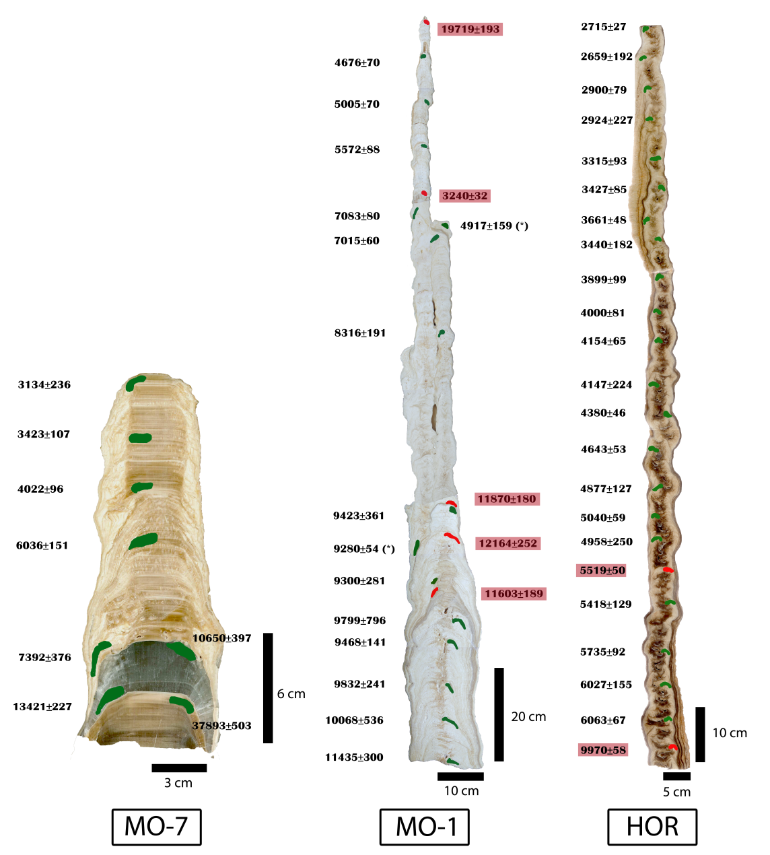
Fig. S2. Polished slabs of the three studied stalagmites (MO-7, MO-1 and HOR) showing the position of U-Th dates (see Table S1). Dates not included in the age models are indicated in red. Two dates with (*) in MO-1 sample were in order but not used in the age model due to their position in the twin stalagmite. Note the different scale of the three stalagmites thus indicating very distinct growth rate during the Holocene.

To construct the HOR sample age model, the basal 6.5 cm are not considered and data are presented after the hiatus located at the base, thus finally covering from 6071 ± 70 to 2708 ± 30 years BP, being constrained by 21 U-Th dates (Table S1). The age model for MO-7 is constrained by 7 U-Th dates with a marked hiatus among 10.65 and 7.39 ka (Fig. S2). Only two ages define the older part, obtained from a crystalline, non-laminated, gray interval, and, consequently, a linear interpolation was made to obtain the intermediate ages. The age model for interval above the hiatus (from 7.1 to 2.6 ka) is obtained by lamina counting anchored by U-Th dates (Muñoz et al., 2015). The average growth rate of this sample is ten times lower than HOR speleothem and, approximately, 5 times lower than MO-1 sample. To build the MO-1 chronology, we had 20 U-Th, from which only 13 were considered valid after rejecting 5 clear reversals and 2 U-Th dates obtained in the twin stalagmite that were not easily translated to the studied stalagmite (Table S1). Since one of the failed samples was right above the hiatus-like surface, assigning a time for the potential hiatus is not feasible. Thus, two independent models were produced for base and top of MO-1 sample, respectively. The age model for the upper part of the sample, starting with the first valid date after the hiatus (8.3 ka), is well constrained by six dates with low errors.

Initially, StalAge software (Scholz and Hoffmann, 2011) was employed to construct the age model of HOR and MO-1 while lamina counting, anchored by U-Th dates, was used for MO-7 following a previously published procedure (Domínguez-Villar et al., 2012). Chronology for MO-7 sample is already published (Muñoz et al., 2015). Results are presented in Fig. S3.

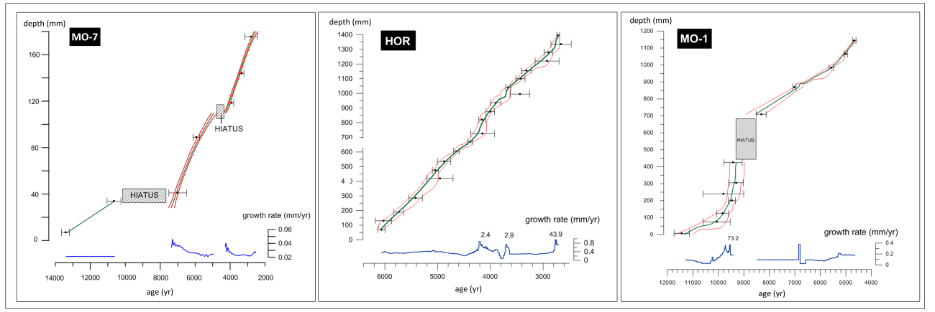
Fig. S3. Age models (green curves) with the error range indicated by StalAge software (only for MO-1 and HOR samples; MO-7 age model is obtained from (Muñoz et al., 2015) combining U-Th dates and lamina counting. Variation in growth rates is also indicated together with the position of hiatus.

However, the high resolution provided by the isotopic records (decadal scale in the case of HOR record) was not well-resolved by the constructed age models due to the uncertainties of the U-Th dates (see Table S1). Additionally, the temporally overlapping sections of the three speleothems allowed us to assemble a composite record. Thus, Iscam software (Fohlmeister, 2012) was selected to determine the most probable age-depth model for the three stalagmites since it allows considering the overlapping δ¹⁸O profiles as complementary information to U-Th dates. Thus, we a priori assume that the δ¹⁸O records of the three stalagmites represent one common signal, assumption that is sustained by the close location of these two caves (separated by only 12 km) thus being under the same rainfall events. In this area, isotopic composition of rainfall appears as the dominant factor controlling δ¹⁸O values in the cave carbonates (Moreno et al., 2014). Additionally, other characteristics relative to soil, vegetation cover and residence time in the epikarst are very similar in the two caves and non-equilibrium fractionation appears negligible when explored throughout present-day in-farmed calcite precipitates (Moreno et al., 2014) and after examination of thin slides (see above). Therefore, Iscam provides a composite δ¹⁸O record that can be compared to previous δ¹⁸O profiles for the three speleothems when age models were constructed independently (Fig. S4).

The 95% significance limit of the point-wise linearly interpolated age model is 0.65 for the correlation of stalagmite HOR and MO-1 and 0.69 between MO-7 and the combined stack of HOR/MO-1 thus demonstrating a statistically significant correlation among the samples. Finally, the age model for every series is provided by Iscam and used throughout this manuscript to interpret the observed δ¹³C and Mg/Ca variability. Although isotopic composition of rainfall appears as the dominant factor controlling δ¹⁸O values in the cave carbonates from Molinos (Moreno et al., 2014) and probably Ejulve caves, rainfall δ¹⁸O values depend on temperature, amount of precipitation and, importantly, variation in the moisture source thus difficulting interpretation of δ¹⁸O in terms of one climate variable. Thus, δ¹⁸O profiles are not used for paleoenvironmental/paleoclimate interpretations since the factors influencing δ¹⁸O record in Holocene speleothems in this area are not yet fully understood.
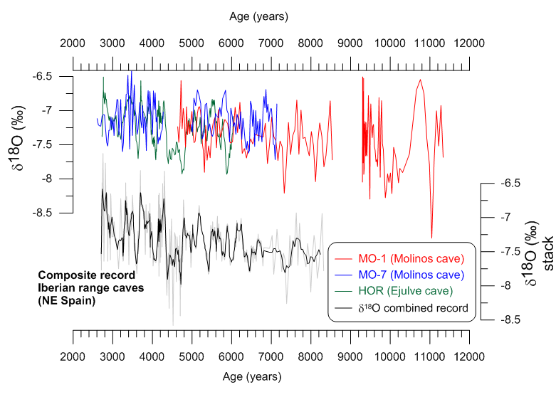Fig. S4. Time series of δ¹⁸O for HOR, MO-1 and MO-7 with previous age model (using Stal Age and lamina counting) compared to the composite δ¹⁸O record obtained by Iscam (gray line). Black line in the composite record is the 5-points running average.

References
Domínguez-Villar, D., Baker, A., Fairchild, I.J., Edwards, R.L., 2012. A method to anchor floating chronologies in annually laminated speleothems with U–Th dates. Quaternary Geochronology 14, 57–66. doi:10.1016/j.quageo.2012.04.019
Fairchild, I.J., Borsato, A., Tooth, A.F., Frisia, S., Hawkesworth, C.J., Huang, Y.M., McDermott, F., Spiro, B., 2000. Controls on trace element (Sr-Mg) compositions of carbonate cave waters: implications for speleothem climatic records. Chemical Geology 166, 255–269.
Fohlmeister, J., 2012. A statistical approach to construct composite climate records of dated archives. Quaternary Geochronology 14, 48–56. doi:10.1016/j.quageo.2012.06.007
Frisia, S., Borsato, A., Fairchild, I.J., McDermott, F., 2000. Calcite fabrics, growth mechanisms, and environments of formation in speleothems from the Italian Alps and southwestern Ireland. Journal of Sedimentary Research 70, 1183–1196.
Genty, D., Quinif, Y., 1996. Annually laminated sequences in the internal structure of some Belgian stalagmites; importance for paleoclimatology. Journal of Sedimentary Research 66, 275–288. doi:10.1306/D426831A-2B26-11D7-8648000102C1865D
Martin-Vide, J., Lopez-Bustins, J.-A., 2006. The Western Mediterranean Oscillation and rainfall in the Iberian Peninsula. International Journal of Climatology 26, 1455–1475. doi:10.1002/joc.1388
Moreno, A., Sancho, C., Bartolomé, M., Oliva-Urcia, B., Delgado-Huertas, A., Estrela, M.J., Corell, D., López-Moreno, J.I., Cacho, I., 2014. Climate controls on rainfall isotopes and their effects on cave drip water and speleothem growth: the case of Molinos cave (Teruel, NE Spain). Clim Dyn 43, 221–241. doi:10.1007/s00382-014-2140-6
Muñoz, A., Bartolomé, M., Muñoz, A., Sancho, C., Moreno, A., Hellstrom, J.C., Osácar, M.C., Cacho, I., 2015. Solar influence and hydrological variability during the Holocene from a speleothem annual record (Molinos Cave, NE Spain). Terra Nova 27, 300–311. doi:10.1111/ter.12160
Scholz, D., Hoffmann, D.L., 2011. StalAge - An algorithm designed for construction of speleothem age models. Quaternary Geochronology 6, 369–382. doi:10.1016/j.quageo.2011.02.002

