Supplementary Material

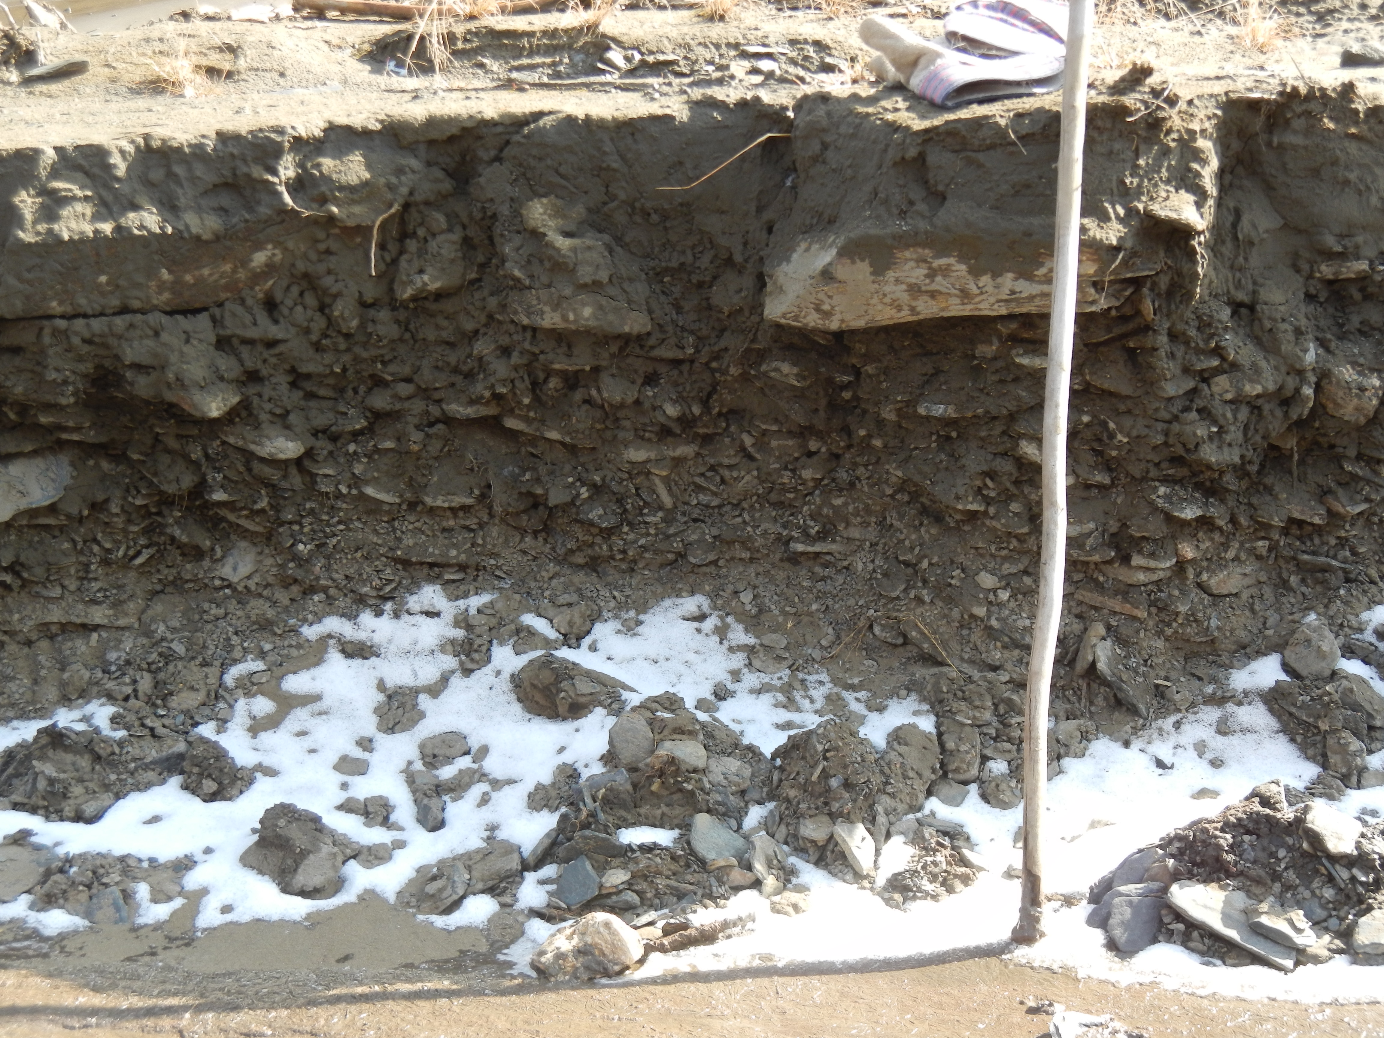
Supplementary Figure 1. Diamicton of unit 1. Vertical section ~0.5 m high.

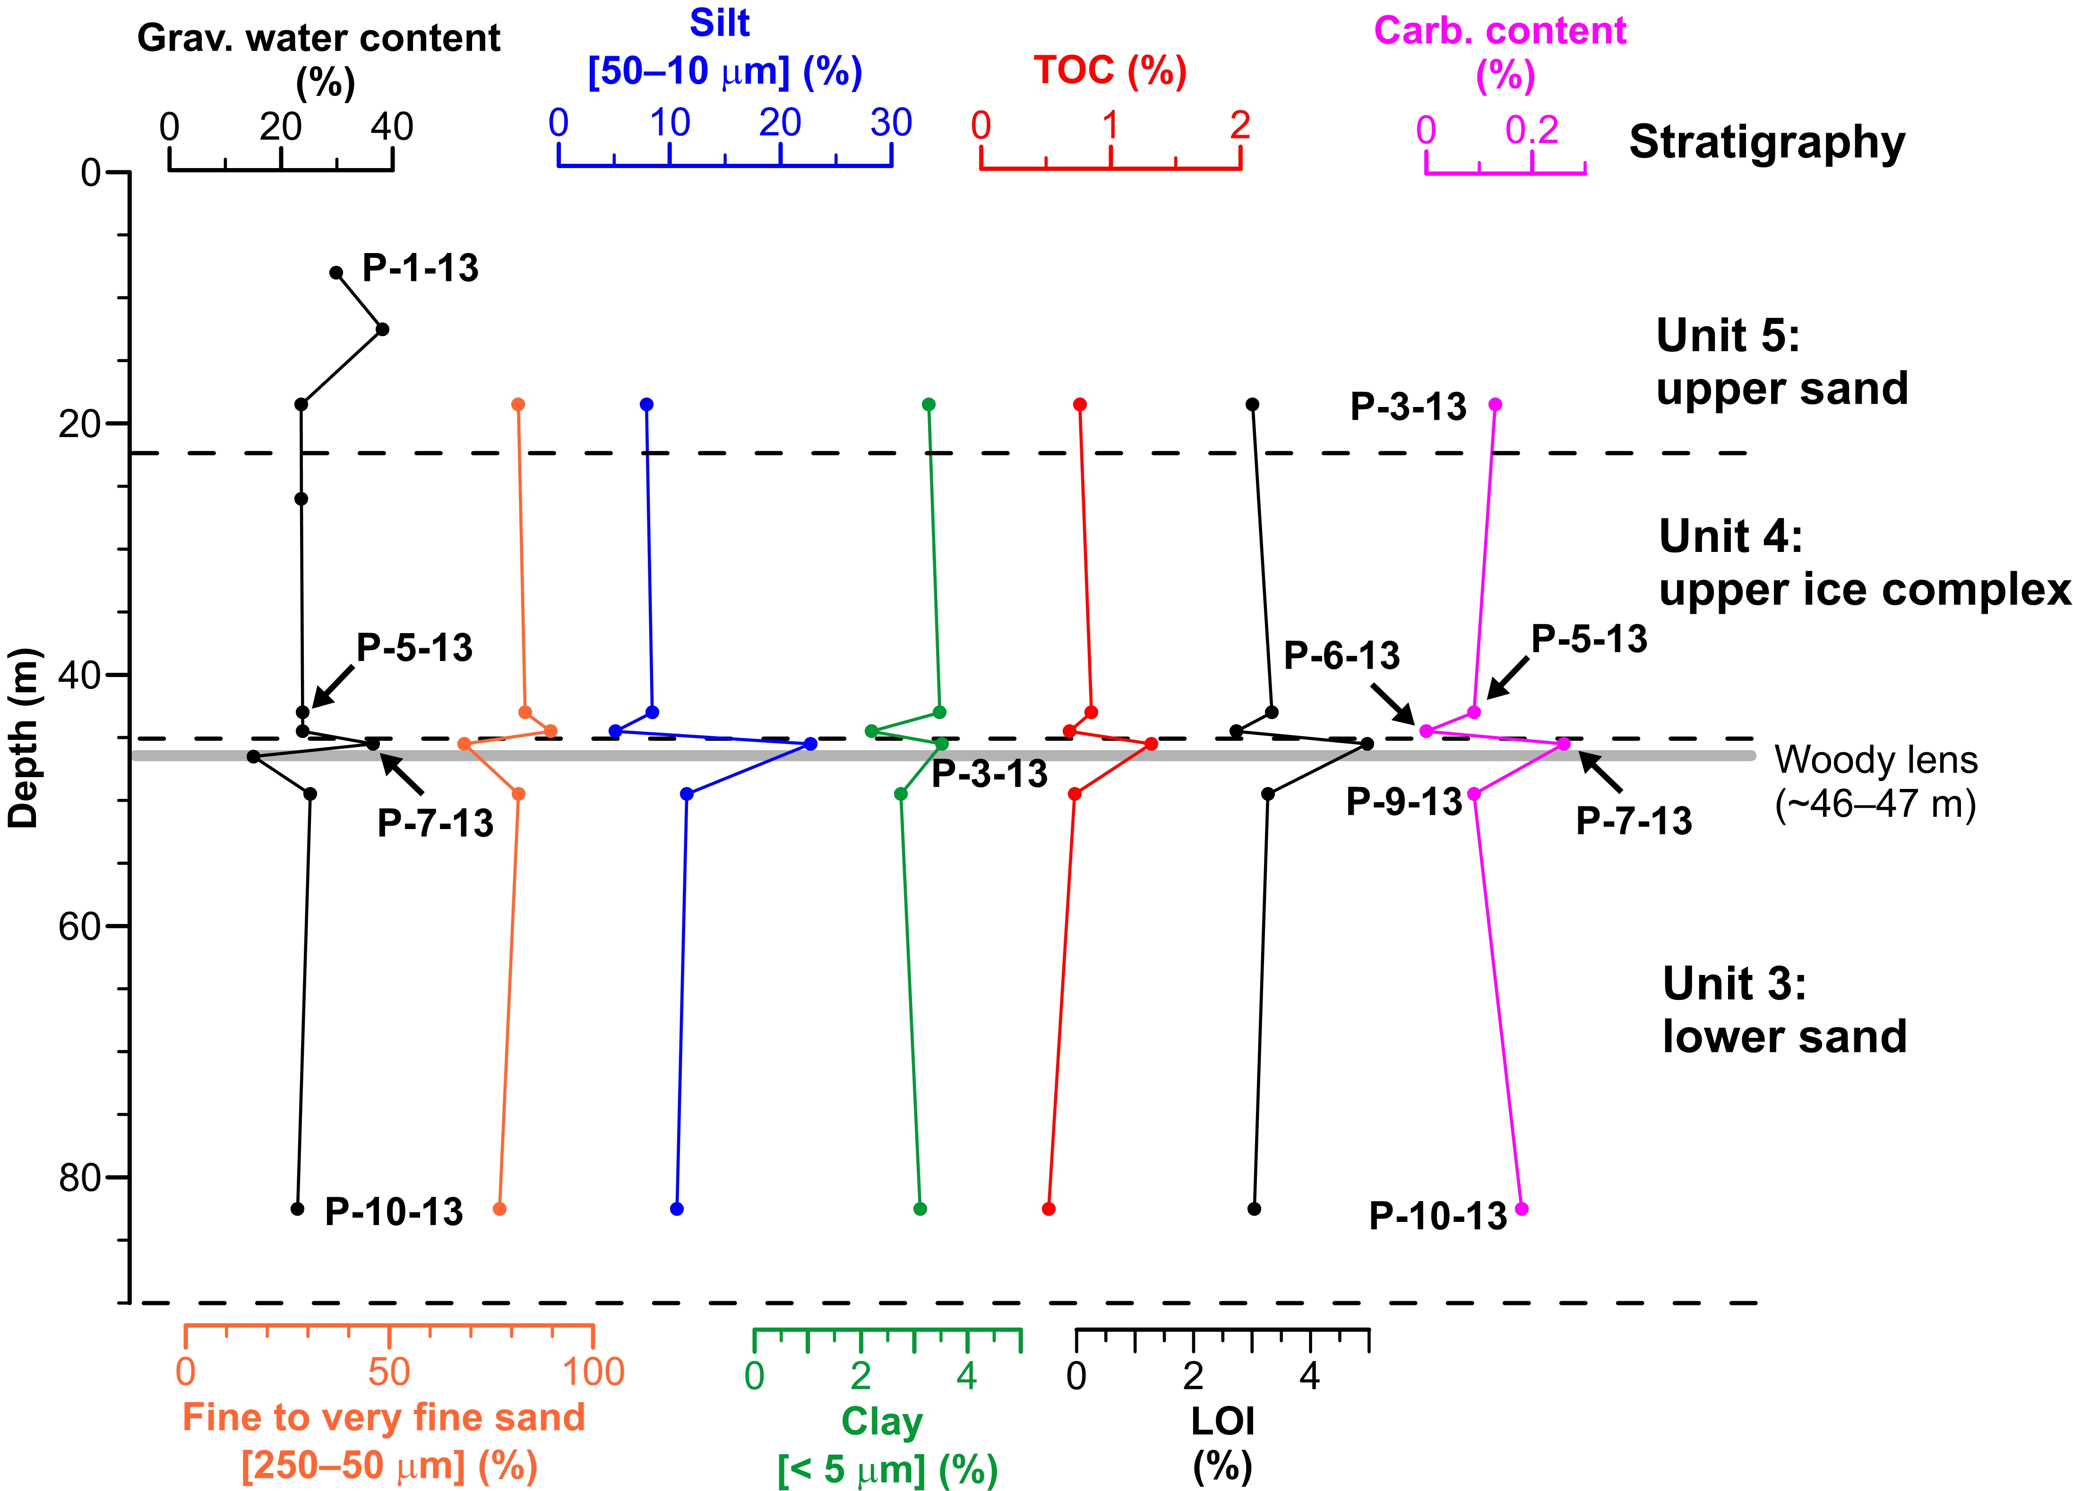

Supplementary Figure 2. Sediment properties from units 3–5 at Batagaika.

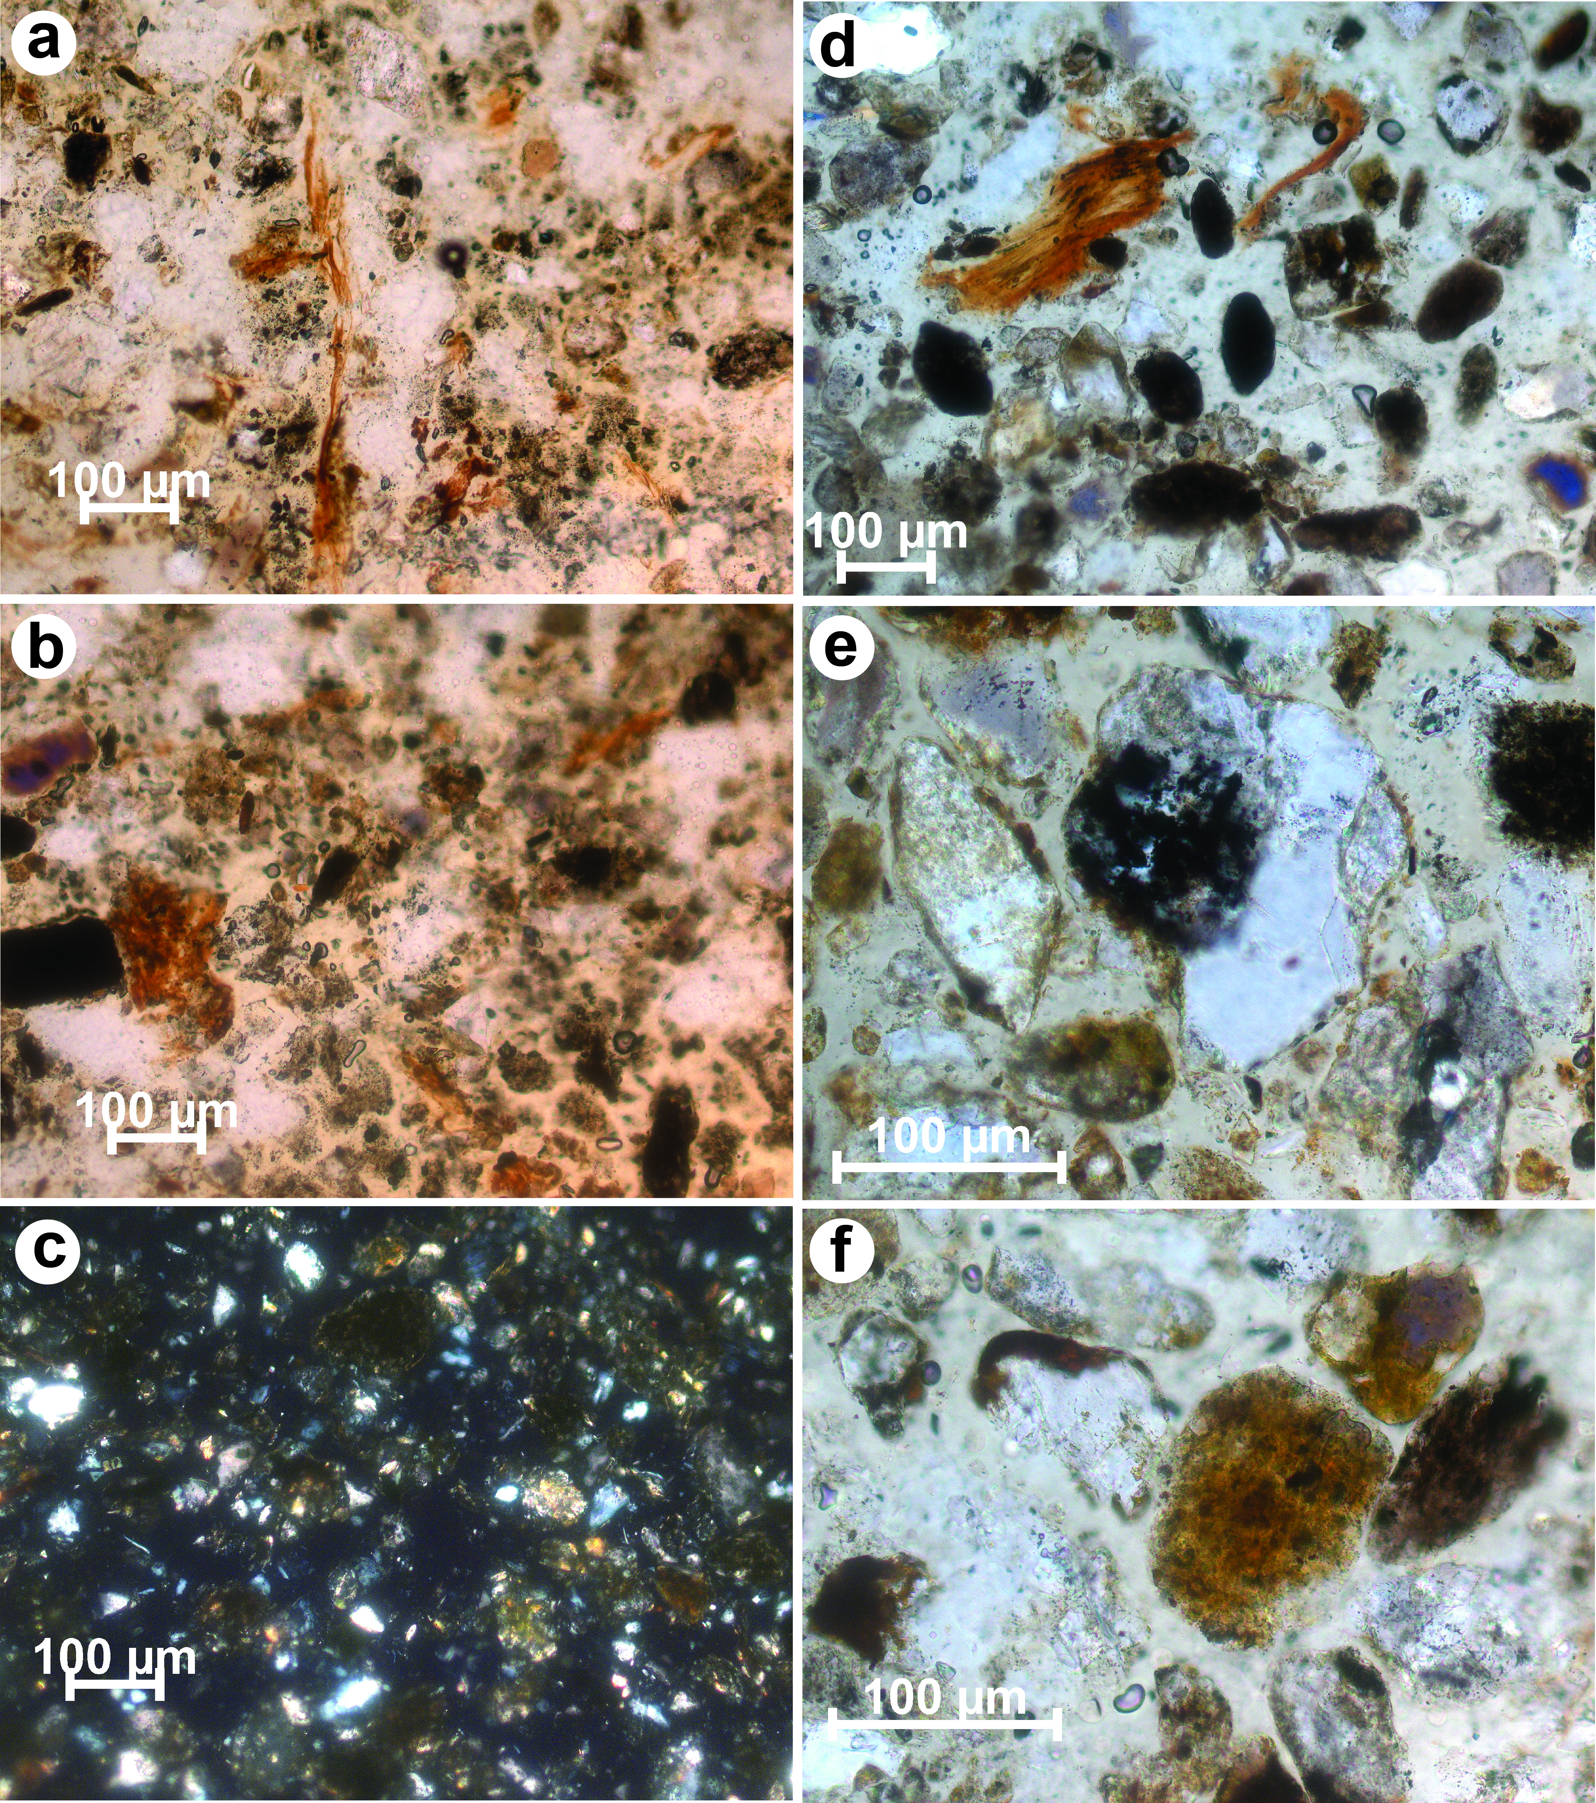
Supplementary Figure 3. Photomicrographs of thin sections: (a)–(c) sample P-7-13 (top of unit 3), (d)–(f) sample P-9-13 (upper part of unit 3). (a) Root remains and humus coatings, (b) detritus and carbonaceous particles, (c) general view, (d) detritus and humus coatings, (e) clots of humic substances and (f) Fe-oxide coating on sandy grains. All in plane-polarized light, except for (c): cross-polarized light.

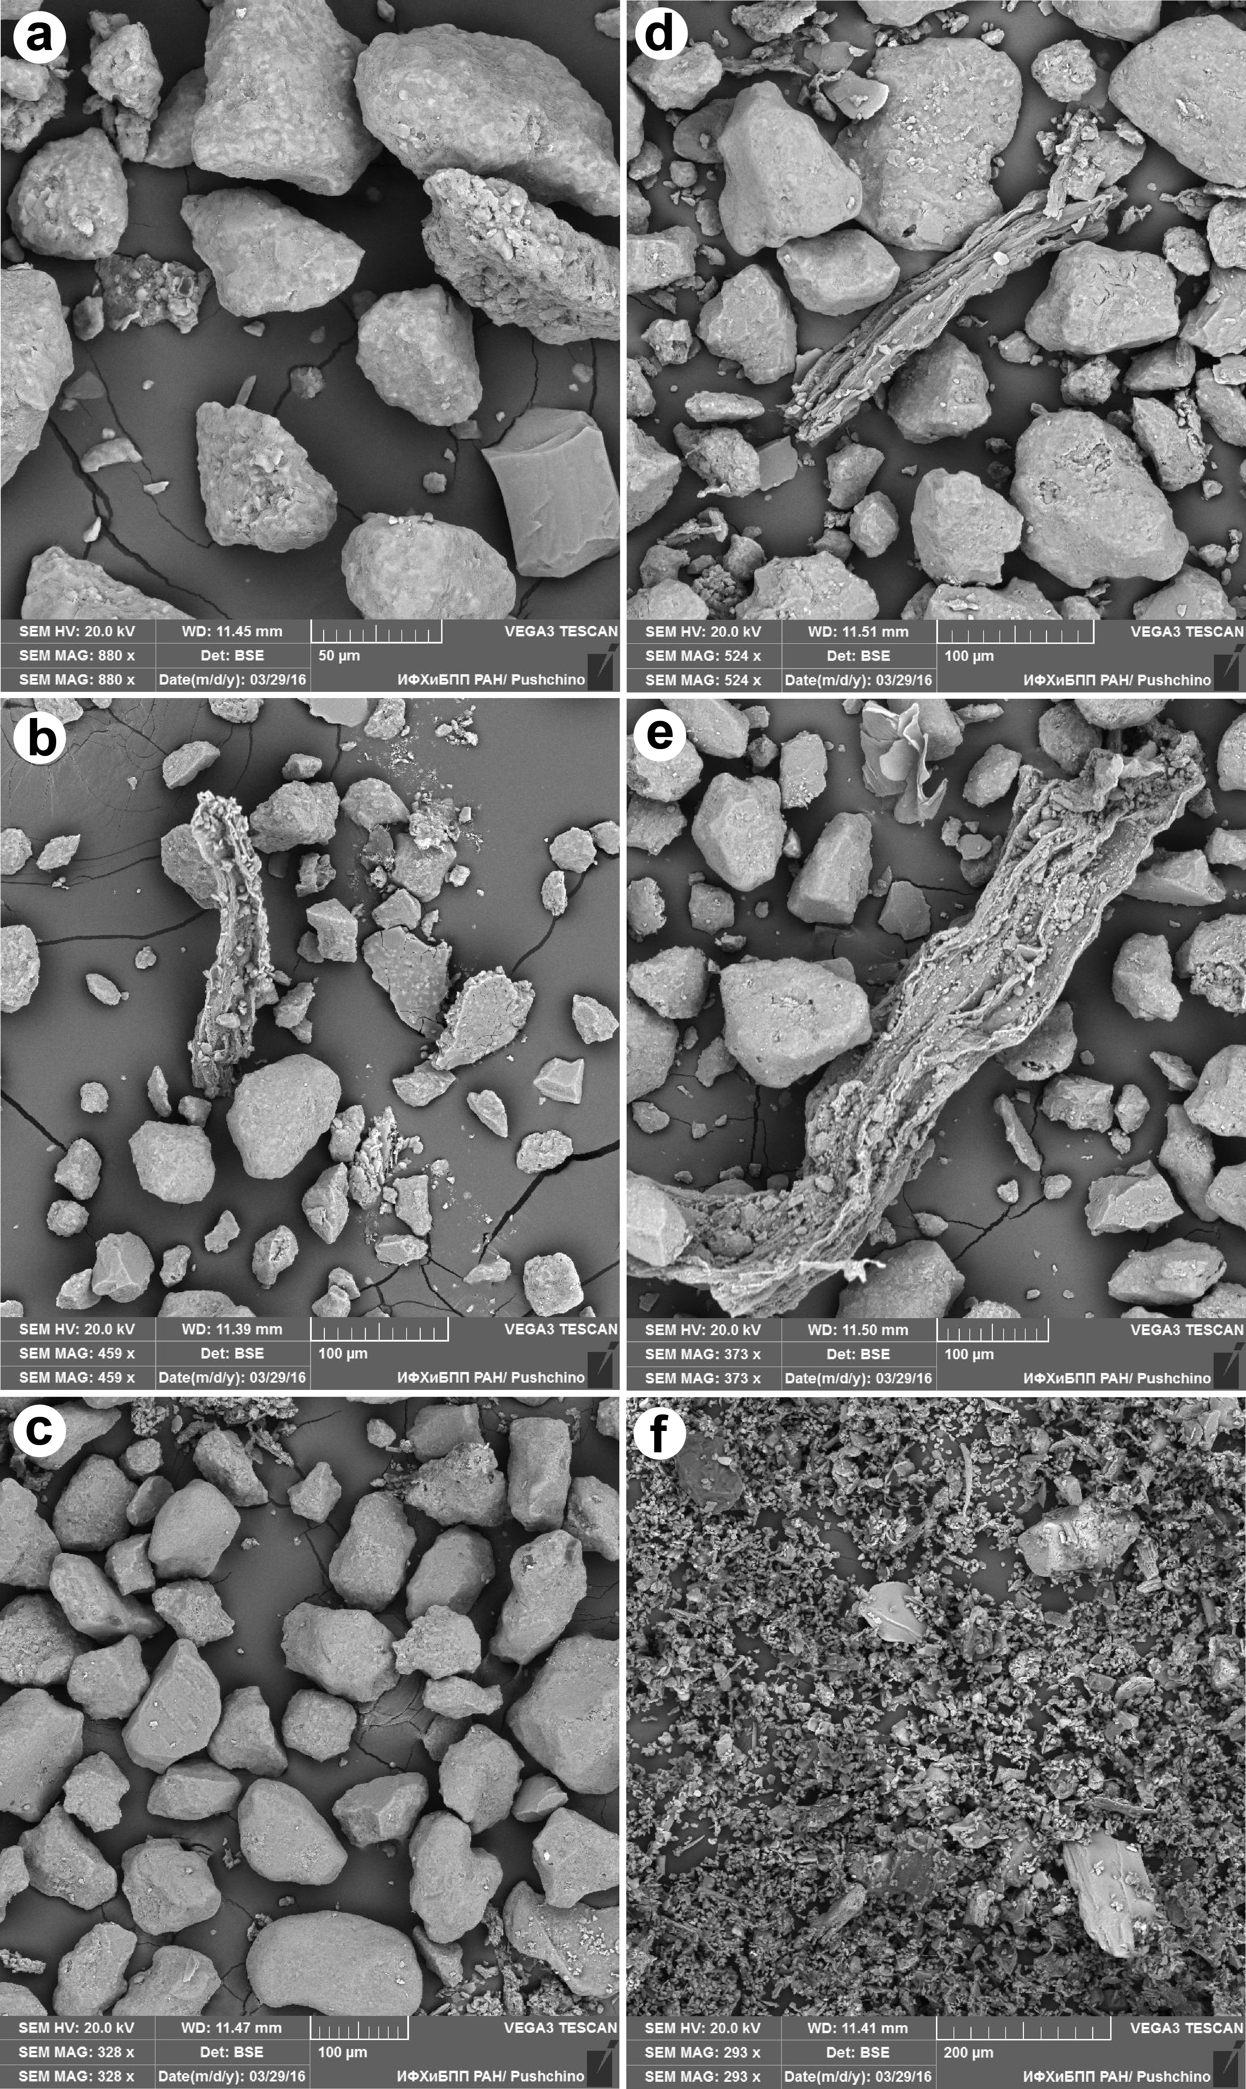
Supplementary Figure 4. Scanning electron microscope images of grains from samples P-3-13 (a), P-5/1-13 (b), P-6-13 (c), P-7-13 (d), P-9-13 (e) and P-10-13 (f).

