Supplementary online data of OSL Geochronology Experiments
After HCl wash, the residue was treated with 30% H₂O₂ (to remove organic debris) and then dry sieved for 90-150 μm or 150-210 μm size fractions. Magnetic and feldspathic grains were then removed using a Frantz magnetic separator. The samples were then etched for 80 minutes in excess 40% HF (to maintain the pH) with continuous stirring followed by a reaction with of 12N HCl for 30 minutes. This ensured conversion of water insoluble fluorides to water soluble chlorides. Etched grains were mounted as a monolayer of 3 mm diameter on stainless steel discs using SilkosprayTM and the purity of these grains vis a vis feldspar contamination was checked by infrared stimulated luminescence. Those contaminated were retched with 10% HF for 10min.
Optical stimulation was by blue-green light stimulation source provided with the Risoe TA-DA-15 reader. The detection optics comprised 2×U-340 and BG-39 filters. Beta irradiation was made using a 25 m Ci ⁹⁰Sr / ⁹⁰Y source. The samples were analyzed using NCF- SAR protocol (Singhvi et al., 2011). Typical preheat to 220°C for 10 seconds and the cut heat was 220°C. Depending on the sample yield, about 15 - 40 discs were measured. Typical recycling ratio was 1+/- 0.1, and the dose recovery test reproduced doses to within 10%.
For fine grains, the infrared stimulated luminescence (IRSL) was used. Polyminerallic fine grain (4-11 μm) fraction was extracted after a sequential pretreatment of the samples with HCl (to remove carbonates) and H₂O₂ (to remove organic carbon). This was followed by deflocculation using 0.01N sodium oxalate solution. The samples were then suspended in an acetone column and the ~ 4-11 μm grain fraction was separated using Stoke’s settling times of 1.5 and 15 min. The separated fraction was re-suspended in acetone and equal volumes were pipetted on to 9.65 mm aluminum discs and dried at ~45°C (Singhvi et al., 2001). The samples were analyzed in an automated Risoe TL-DA-15 system. The detection optics comprised Corning 7-59 and Schott BG-39 filters coupled to an EMI 9635 QA Photomultiplier tube. Beta irradiation was carried out on plate using 25 mCi ⁹⁰Sr/⁹⁰Y beta sources and alpha-irradiation was carried out in vacuum using Americium-241 alpha source (Singhvi and Aitken, 1978). Samples were analyzed using IRSL- Single Aliquot Regeneration dose technique with late light subtraction (Aitken, 1998). Preheat plateau was observed between 200°C to 280°C and therefore a preheat of 220°C for 60 seconds and an illumination of 100 seconds was used. Dose recovery test (given verses the recovered dose) gave recovered doses to within 10% of administered doses. Given that signal were feldspar dominated, fading test was done on all fine grain samples. The g values ranged from 3.6 g_{2days} (%/decade) to 7.7g_{2days} (%/decade). The palaeodose (D_{e}) values were appropriately corrected for the fading rates (Auclair et al., 2003).
- Typical optical decay curve of quartz extracted from a) Coastal aeolianite (DD-1) and b) beach Ridge (OD-1), fluvially reworked miliolite (GP-2) (Fig. 1).

- Typical Growth Curve of few selected samples reconstructed using single aliquot regeneration method for, a) Sample DD-1 from Coastal aeolianite; b), Samples OD-1 from beach ridge and, c) Sample GP-2 from fluvially reworked miliolites, (Fig 2).

- Preheat plateau, using average of measurements on three discs per preheat temperature. A plateau in De values from 200-280°C was seen and a temperature of 220°C was selected (Fig. 3).

- Dose Recovery test comprising 5 discs for each sample. These were bleached under an Ultra vitalux Wotan Sun lamp with a window glass in between to reduce the UV flux from it. Measured De's were within 10% of the administered Doses. (Table 1)

- Typical distribution of paleodoses for a sample each of coastal, aeolian and fluvial environment is given in Fig. 4. Median of error was used for bin width.

Table-1 Dose recovery test data.
Sample Name | Given Dose (Gy; calibration error 5%) | Dose Recovered (Gy) | Dose recovery ratio
MVA-1 | 16 | 15.4±0.4 | 0.96±0.02
ANP-4 | 23.6 | 22.8±0.8 | 0.95±0.03
GP-2 | 17.6 | 16.8±1.6 | 0.95±0.09
KCD-2 | 94.6 | 95.8±2.0 | 1.01±0.02
MG-4 | 36.5 | 37.2±1.5 | 1.02±0.04
RT-1 | 81.8 | 82.4±4.8 | 1.02±0.06
ANP-2 | 55.7 | 55.2±2.2 | 0.99±0.04
MG-8 | 48.5 | 48.6±1.8 | 1.0±0.04

Figure 1
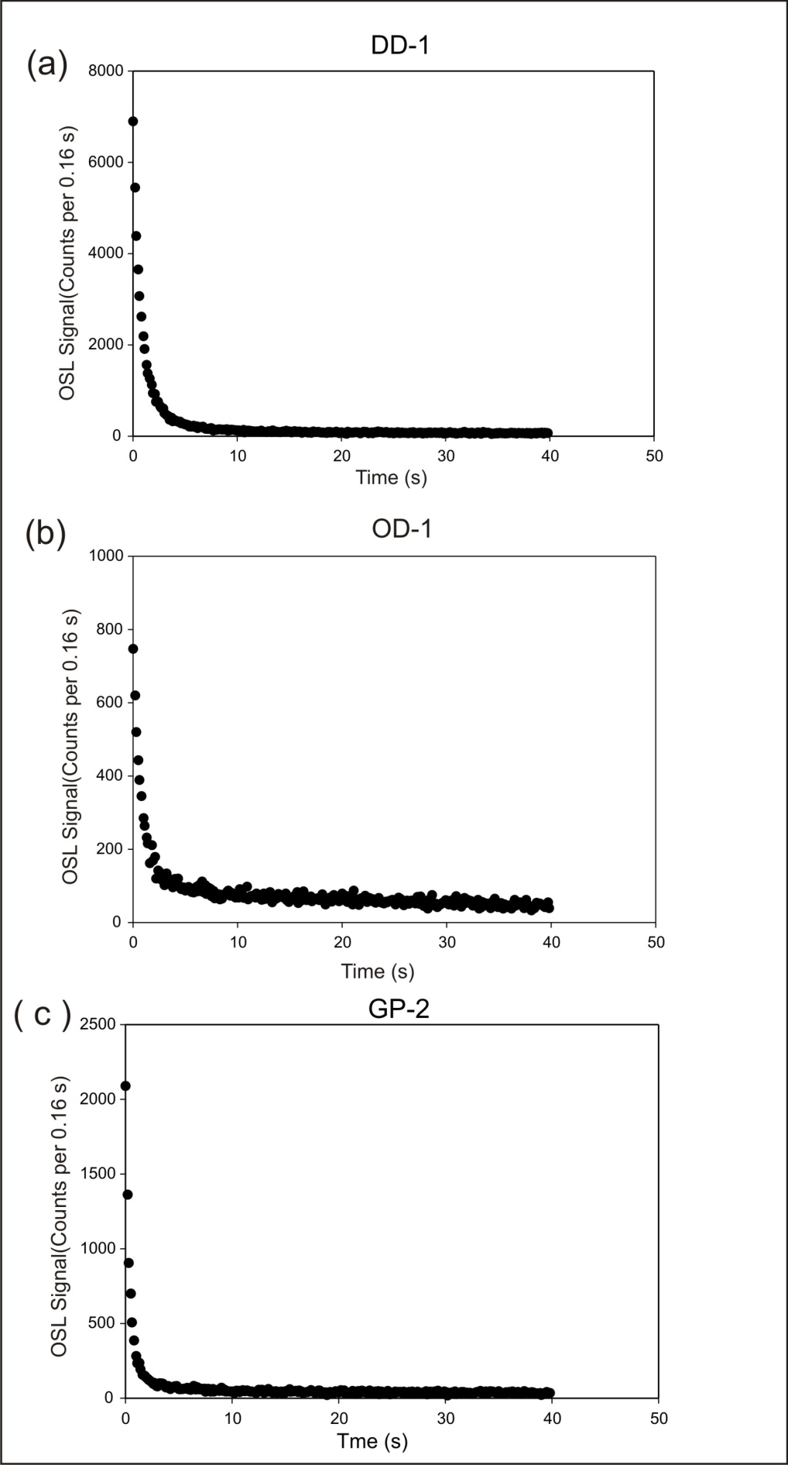
Figure 2
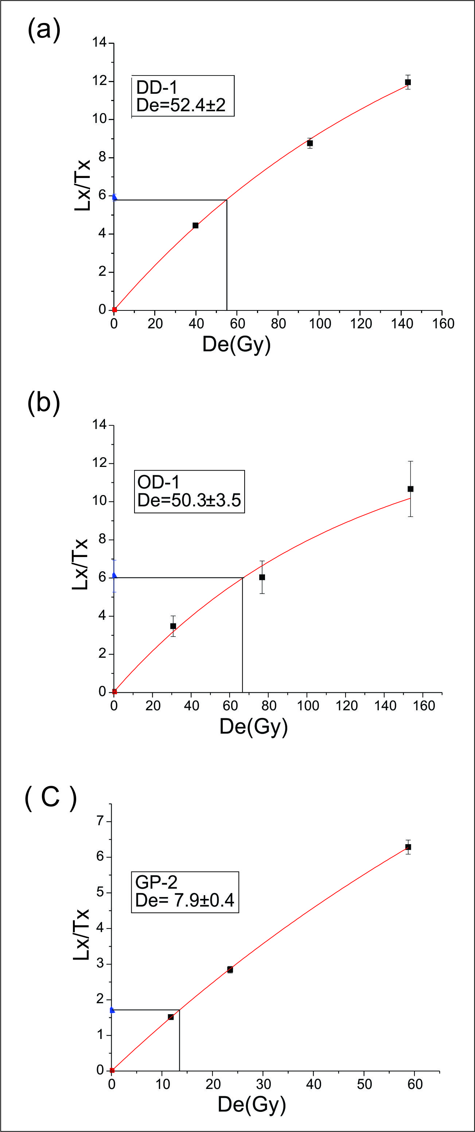
Figure 3
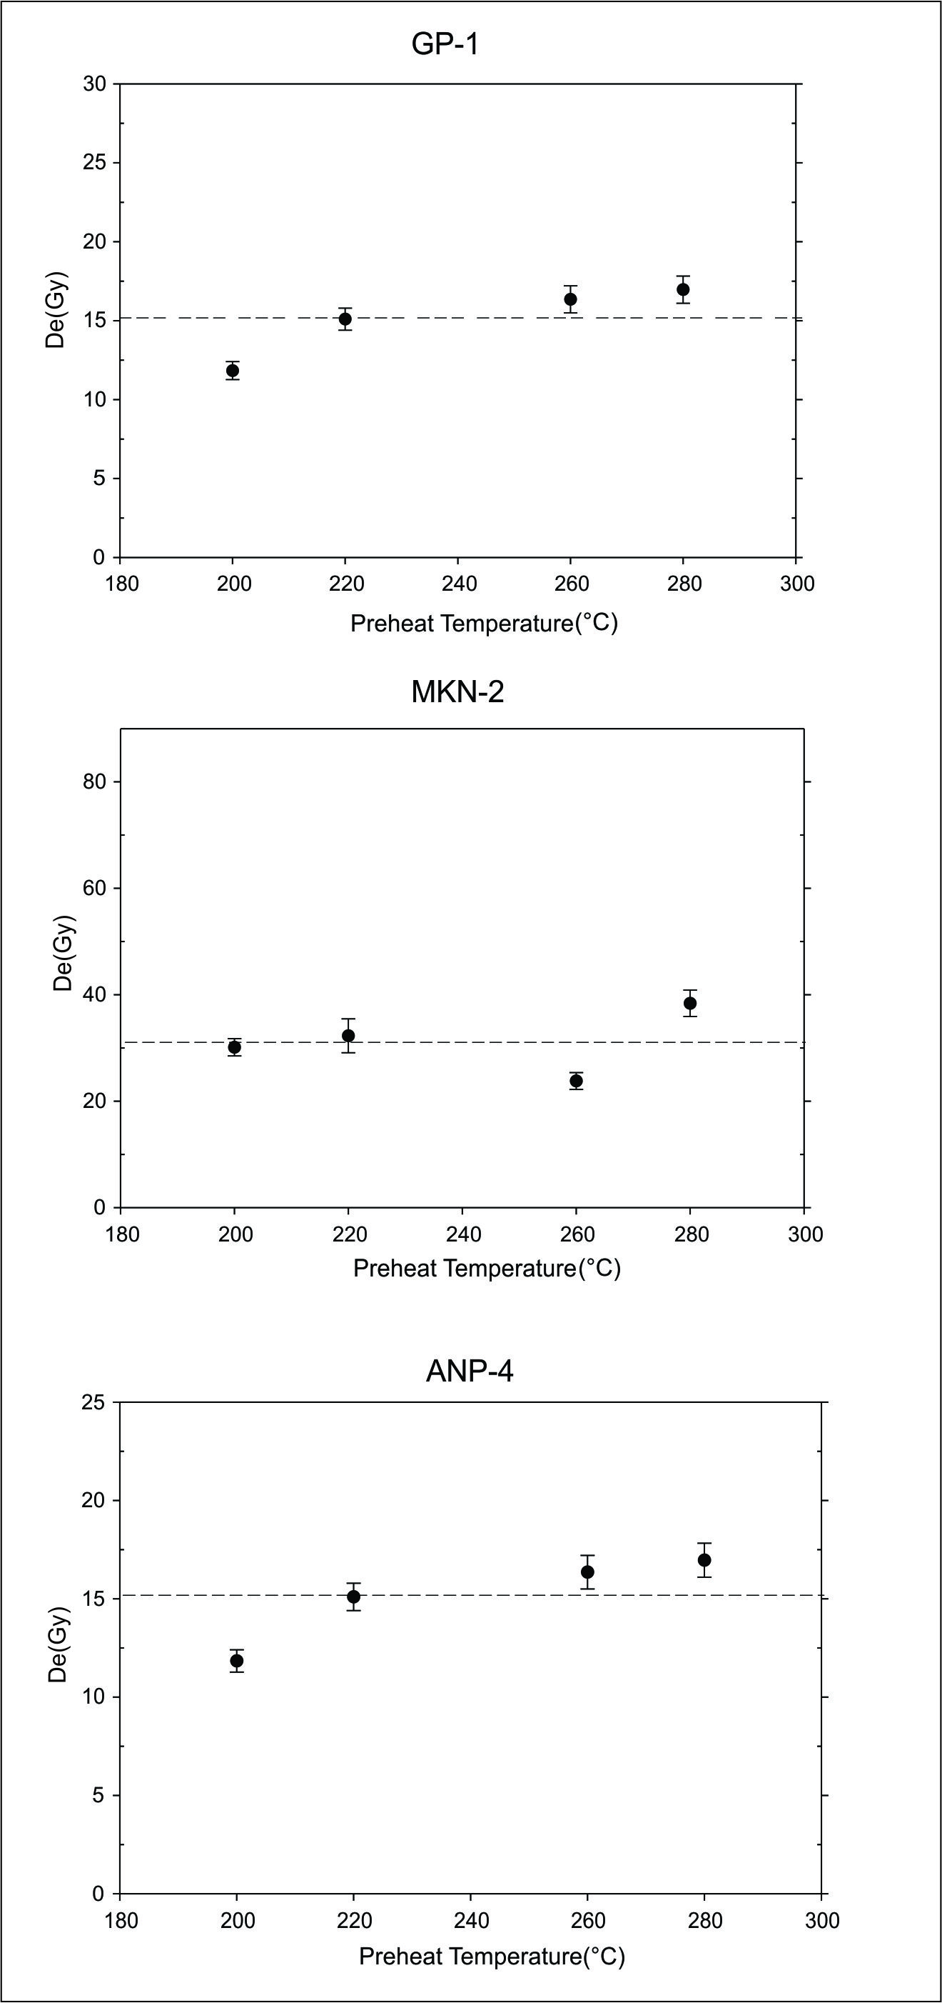
Figure 4
