Supplementary online data of field occurrences of the Quaternary carbonate deposits in Saurashtra, western India
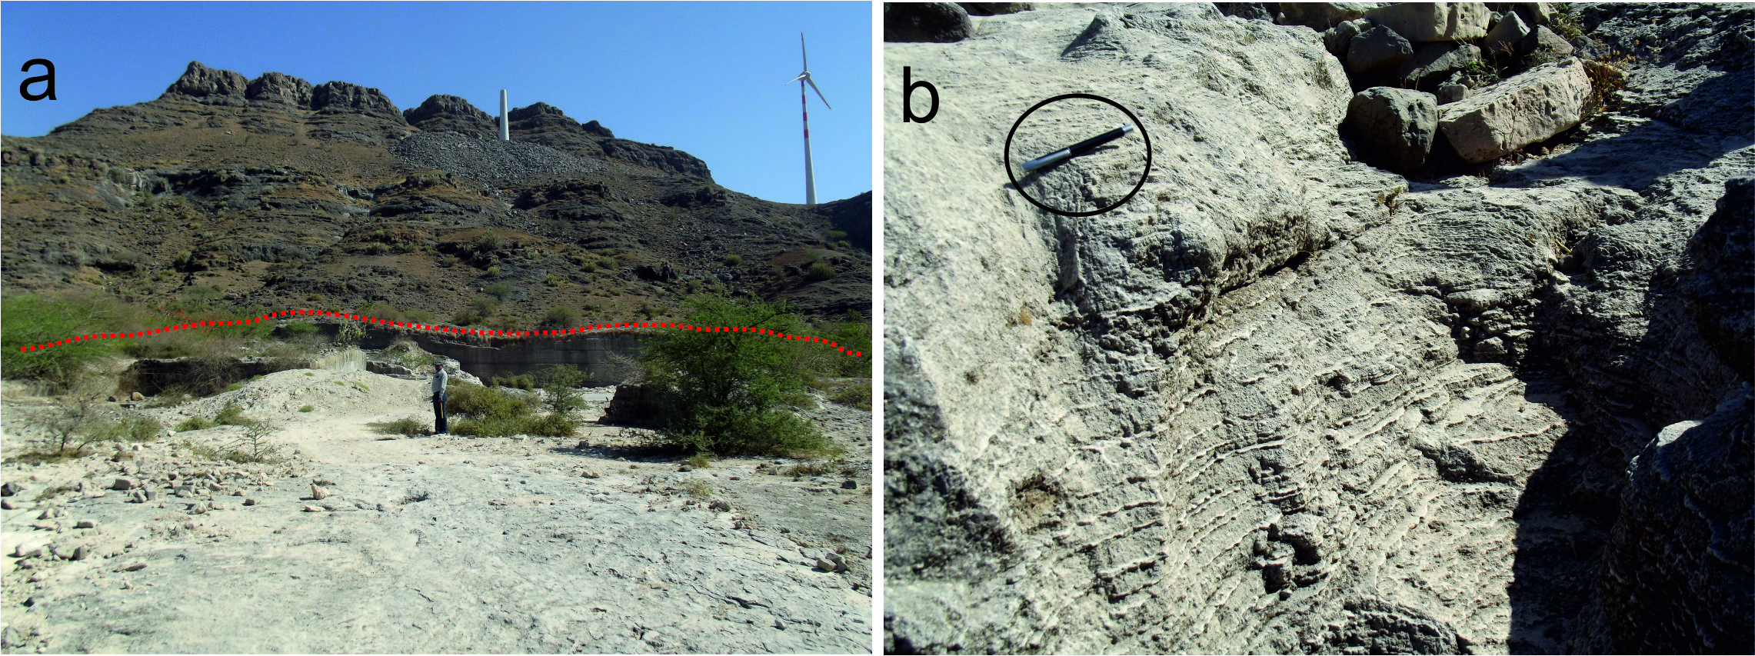
Photo 1: (a) obstacle dune deposit of miliolite. The Gop hill is in the background. The height of person for scale, is 160 cm. (b) Fluvially reworked deposits of miliolite at the base of the Gop hill. These showing fine lamination of gravel mixed carbonate sand and silt. The length of the pen for scale (encircled) is 12 cm.

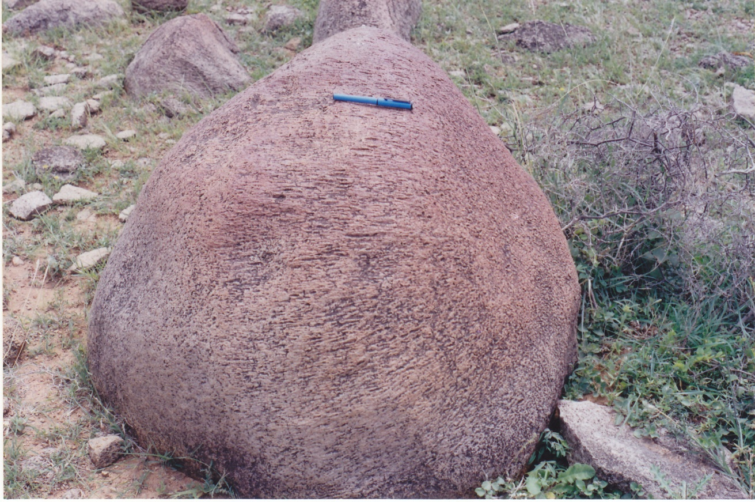
Photo 2: Wind abrasion marks on granophyre boulders near Adityana. Orientations of linear marks suggest sand laden high velocity westerly winds. The length of the pen for scale is 12 cm.

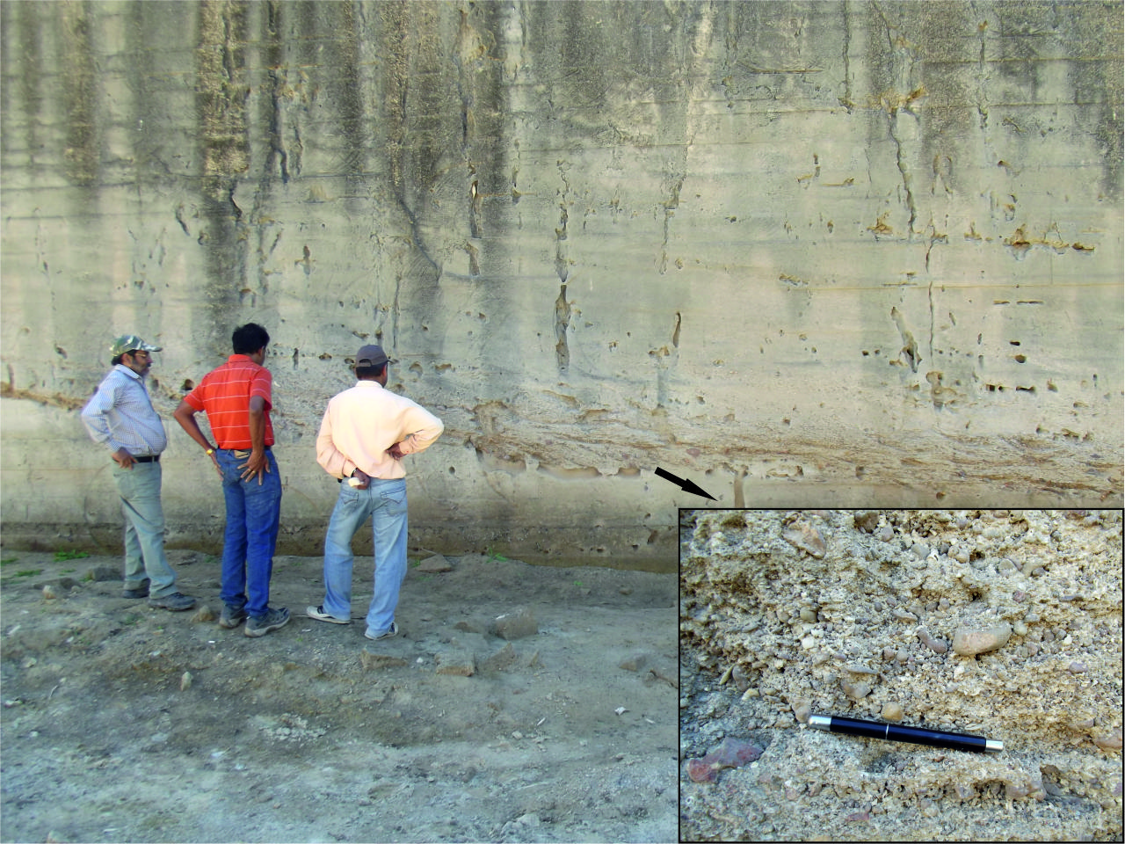
Photo 3: Field photograph of a shell limestone sequence in an abandoned quarry near the coast at Makanpur. Inset photo provides a close up view of beach shingle layer. The length of the pen is 12 cm.

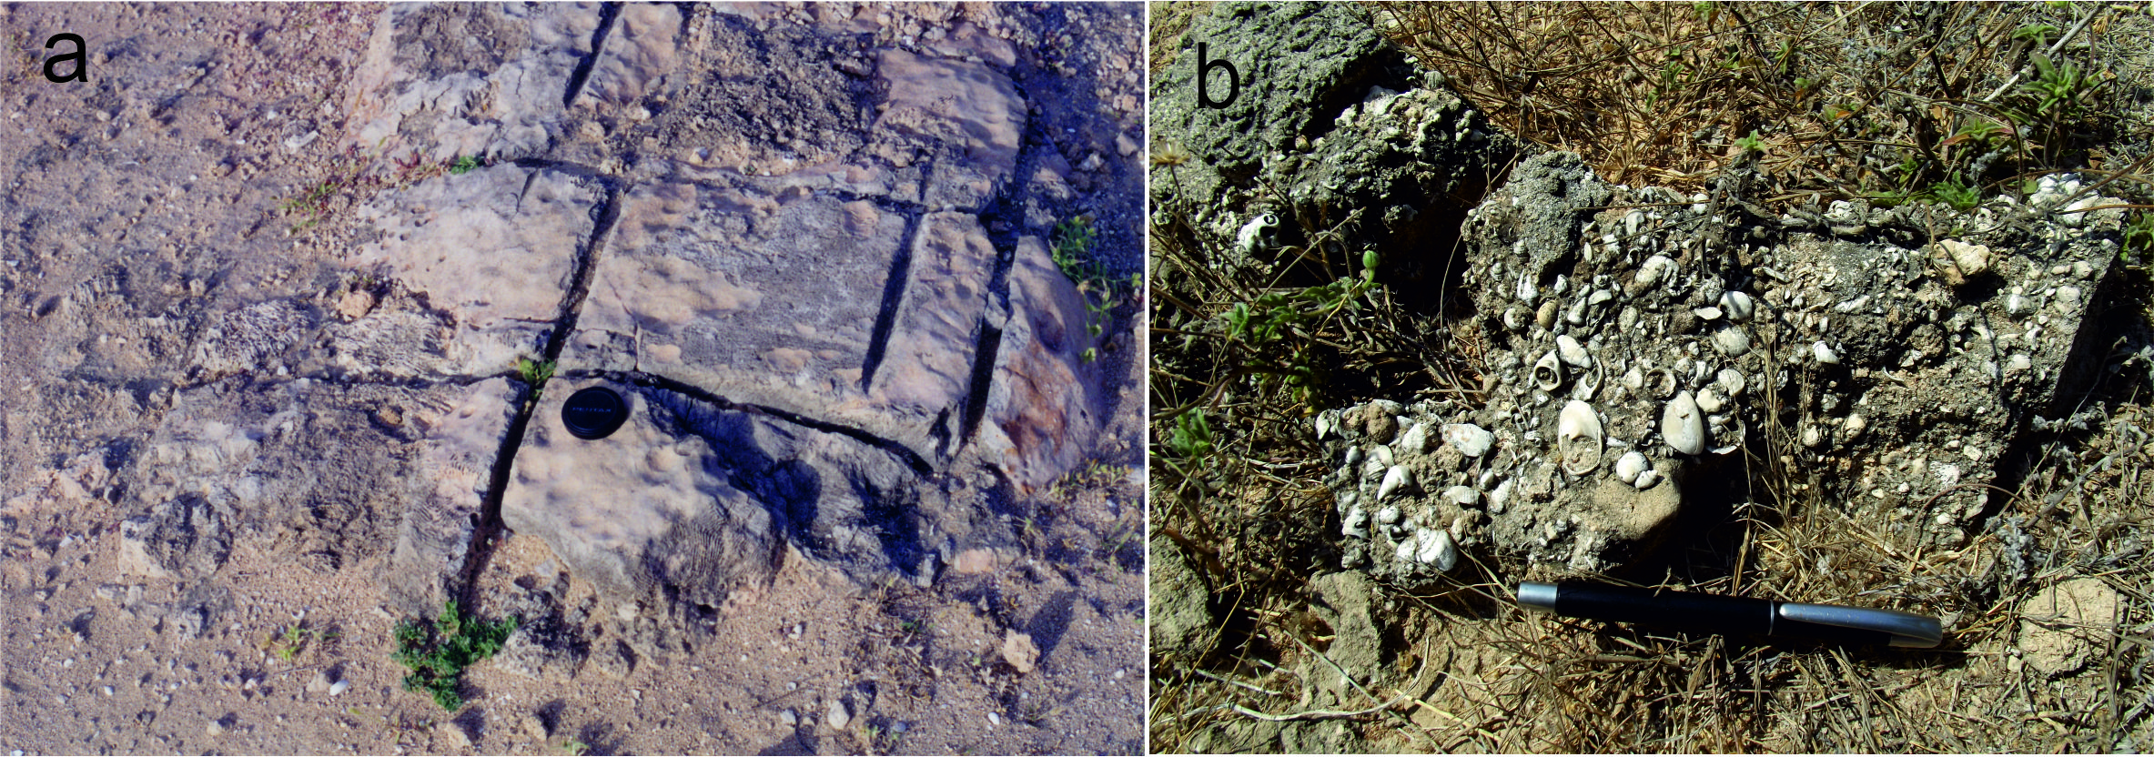
Photo 4: (a) Dead coral reef at the bottom of an abandoned quarry on the coast at Mangrol. The diameter of the cap of camera lens is 7 cm. (b) Details of bioclasts associated with the coral reef representing bioherm deposit on the coast at Mangrol. The length of pen is 12 cm.

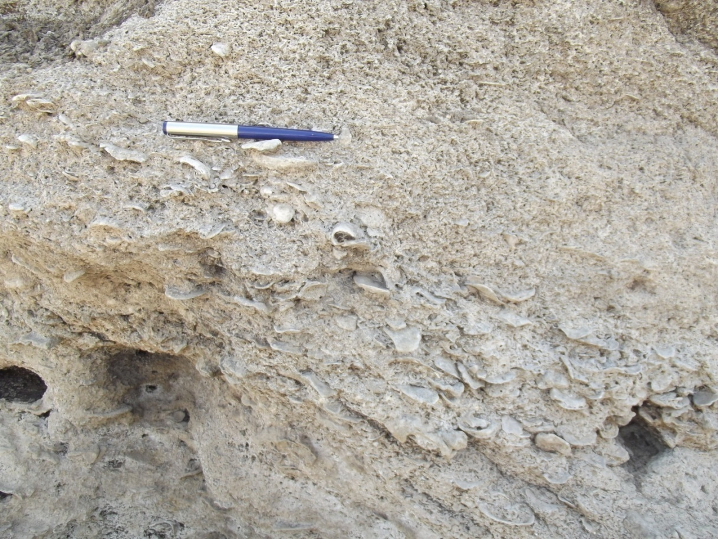
Photo 5: Field photograph of the lower unit of the sequence at Noli bridge near Mangrol. This shows oysters embedded in the shell limestone matrix. The length of pen for scale is 10 cm.

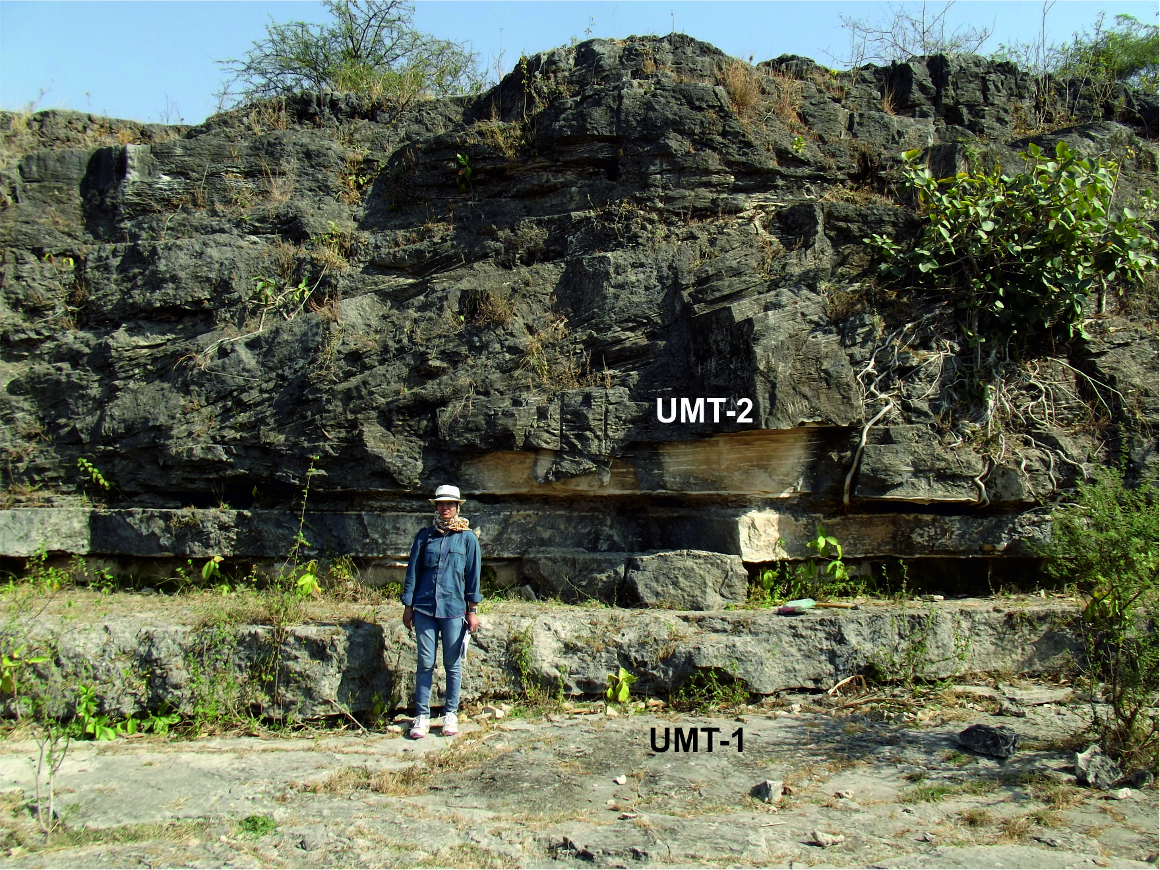
Photo 6: The sequence at Hiran River at Umrethi showing sub horizontal lower unit overlain by a wedge shape planer cross-stratified upper unit of miliolite with a sharp boundary. The positions of OSL samples are also shown. The height of person standing for scale is 160 cm.
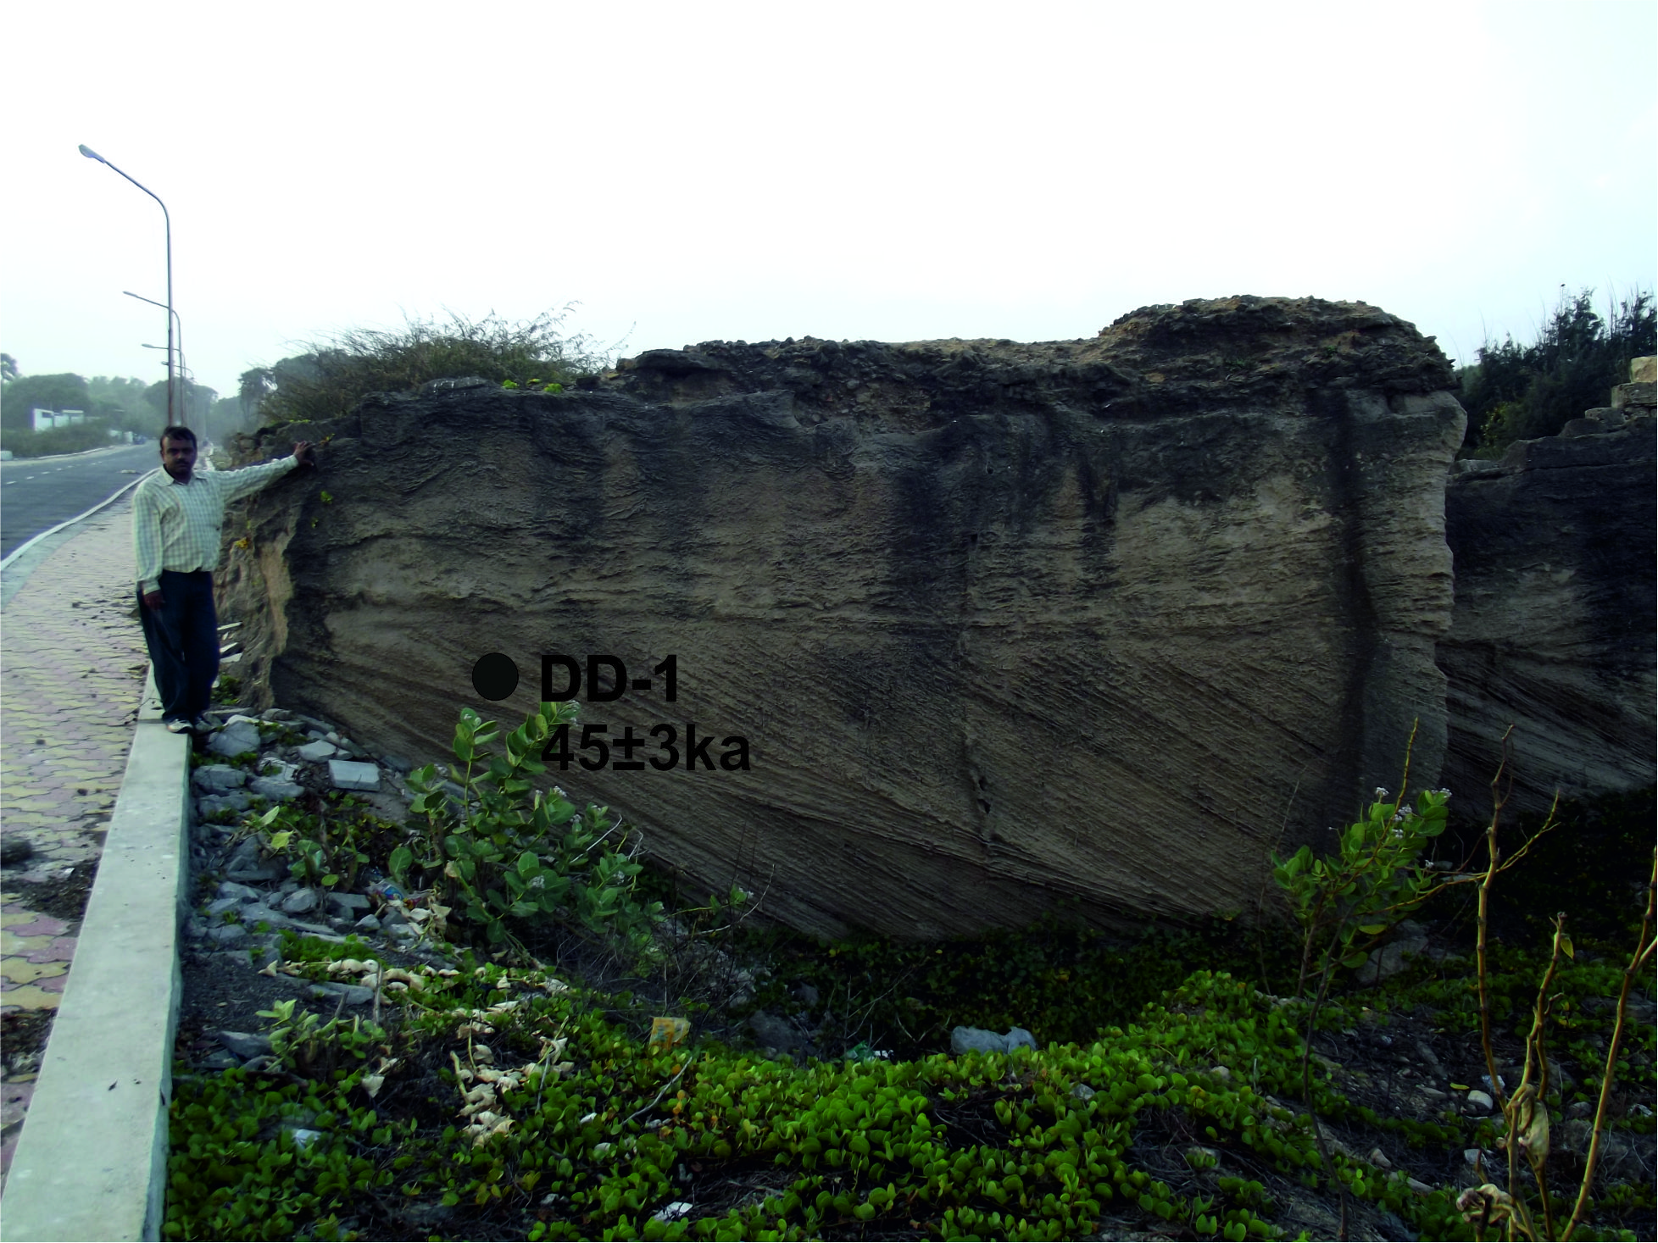
Photo 7: Field photograph of a miliolite exposure in a quarry at the site Phudams. This shows the position of sample DD-1 along with its OSL age. The lower part of the sequence shows typical wedge type planer cross stratifications and the upper part exhibits modification of aeolian deposits due to the flow of fluid from sea ward side. The height of person standing for scale is 160 cm.

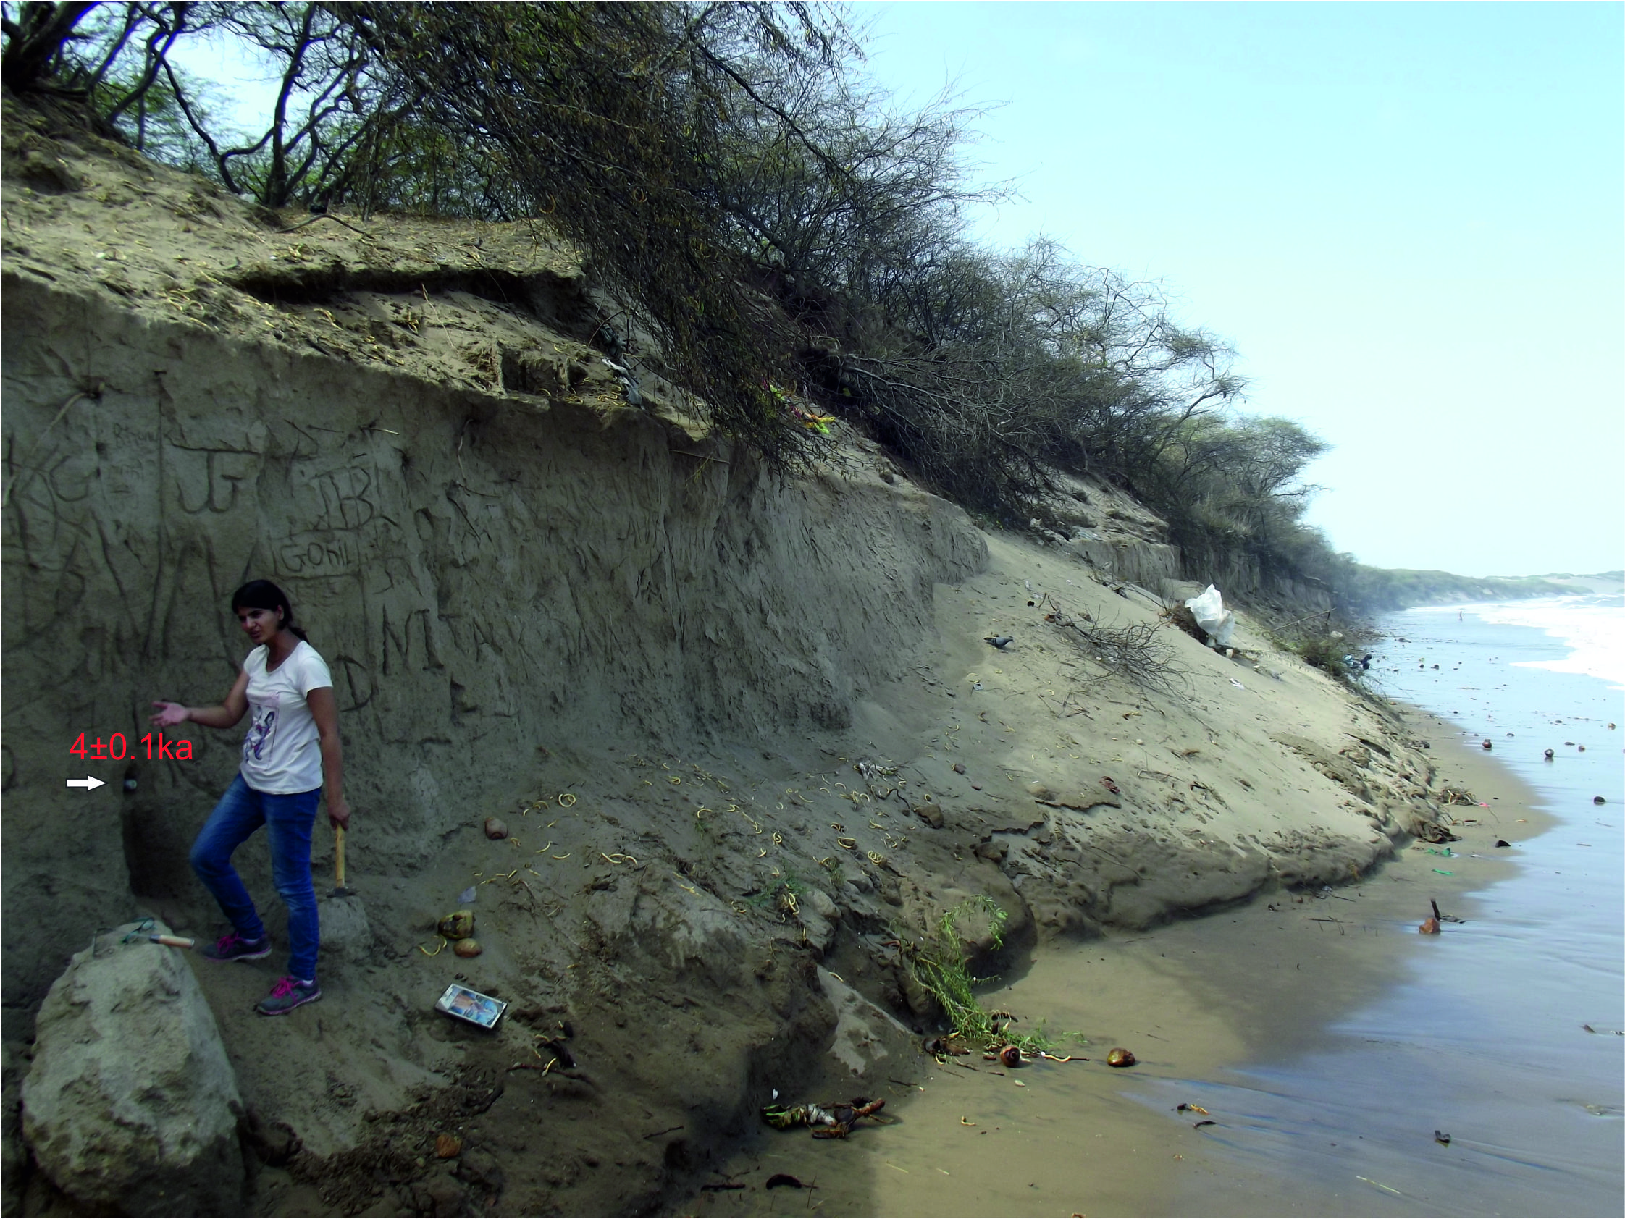
Photo 8: Photograph of a partially eroded stabilized coastal dune made up of carbonate sand near Mahuva. The arrow indicates the location of OSL sample the age in ka. Presently, the high tide level reaches up to the base of the section. The height of person for scale is 160 cm.
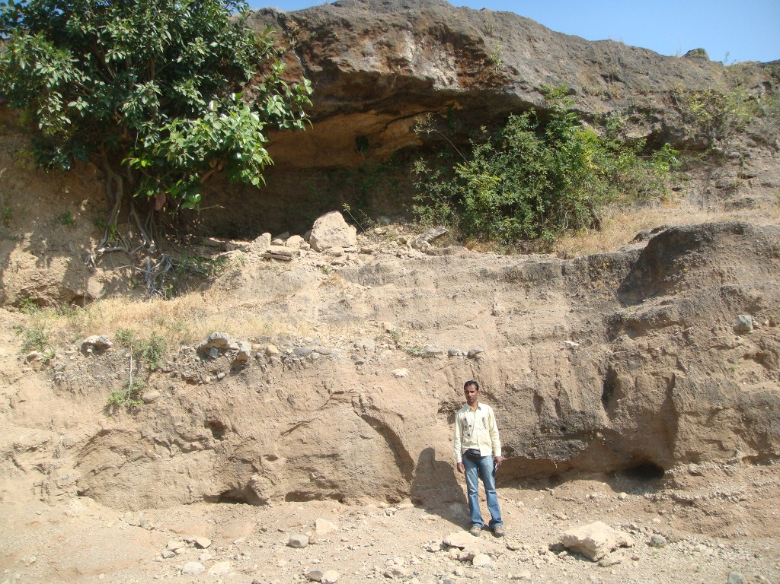
Photo 9: Field photograph of the sequence at Ojat Rive near Anandpur. This exhibits trough cross bedded gravel (Gt) facies in the lower part; overlain by planer cross bedded silty sand (Sp) facies. Over this rests fluvially reworked miliolite sheet. The height of person standing for scale is 165 cm.

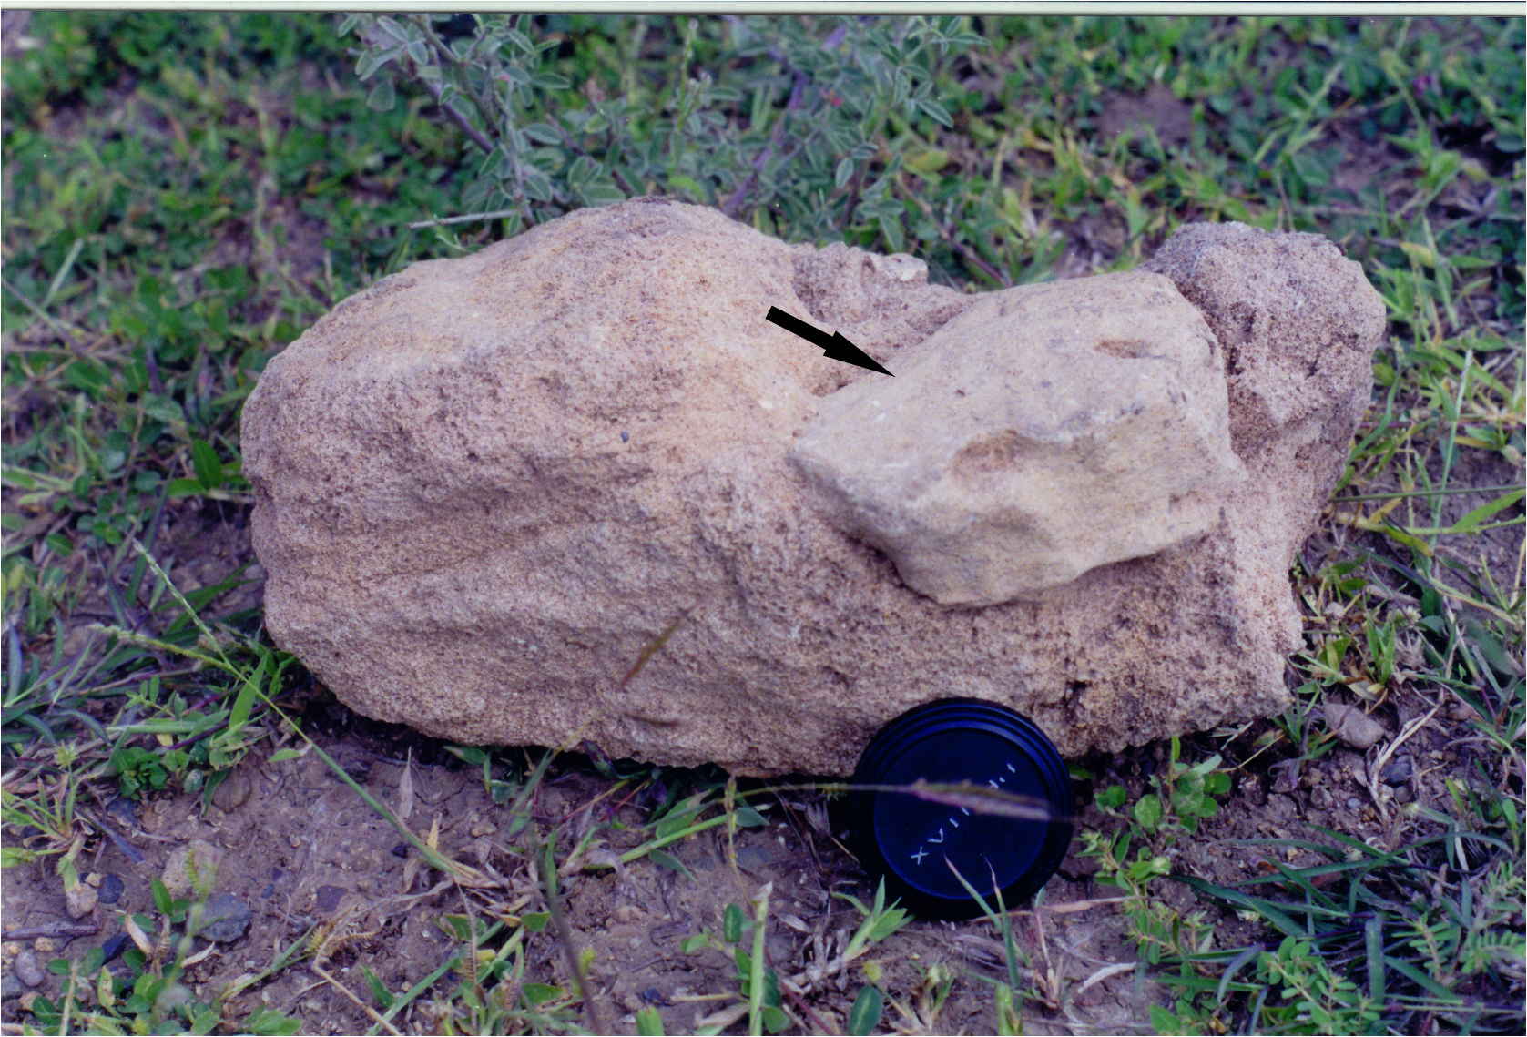
Photo 10: A photograph of miliolite block from fluvially reworked unit near Anandpur showing a sub angular pebble of older miliolite trapped within (arrow). The diameter of lens cap for scale is 7 cm.

