Data repository II for:
North Atlantic controlled depositional cycles in MIS5e layered sediments from the Dead Sea basin
Content: High resolution scans of 18 sections from the DSDDP core containing various types of halite intercalating with clastics.
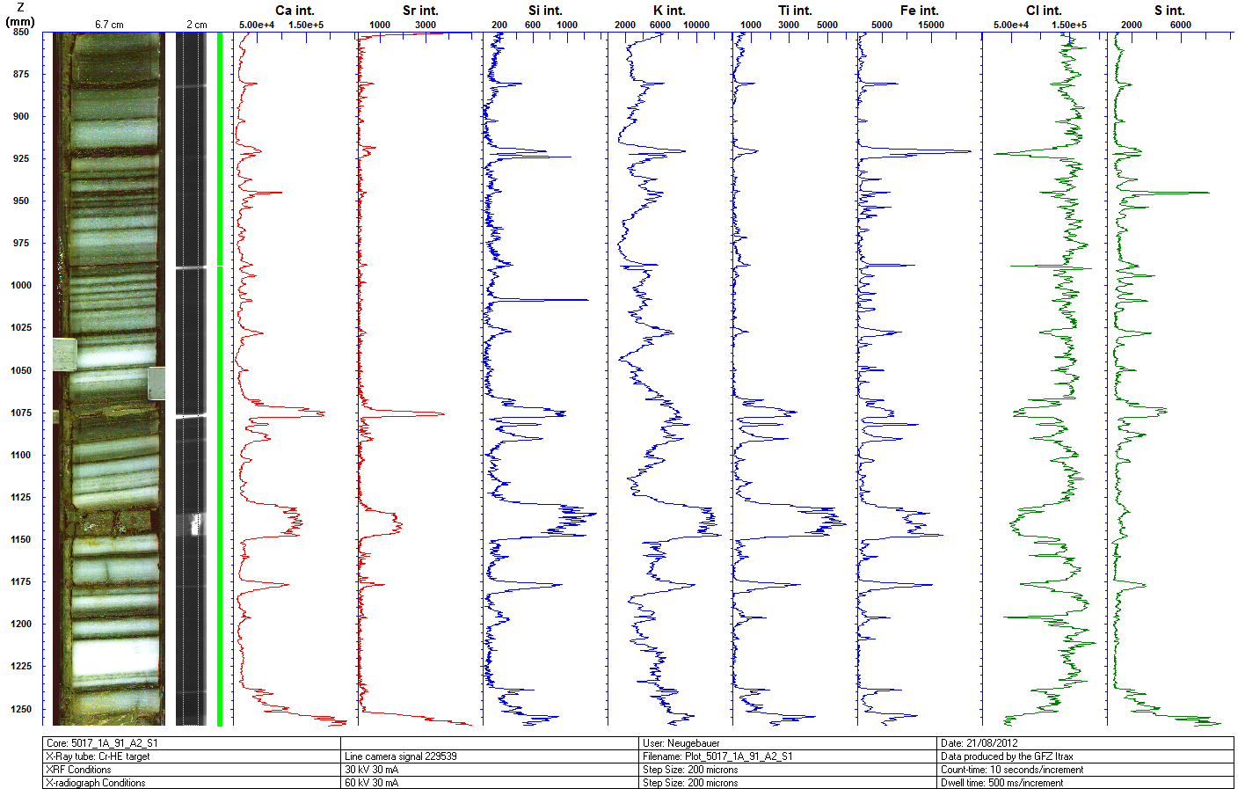
Scan 1| 91_2

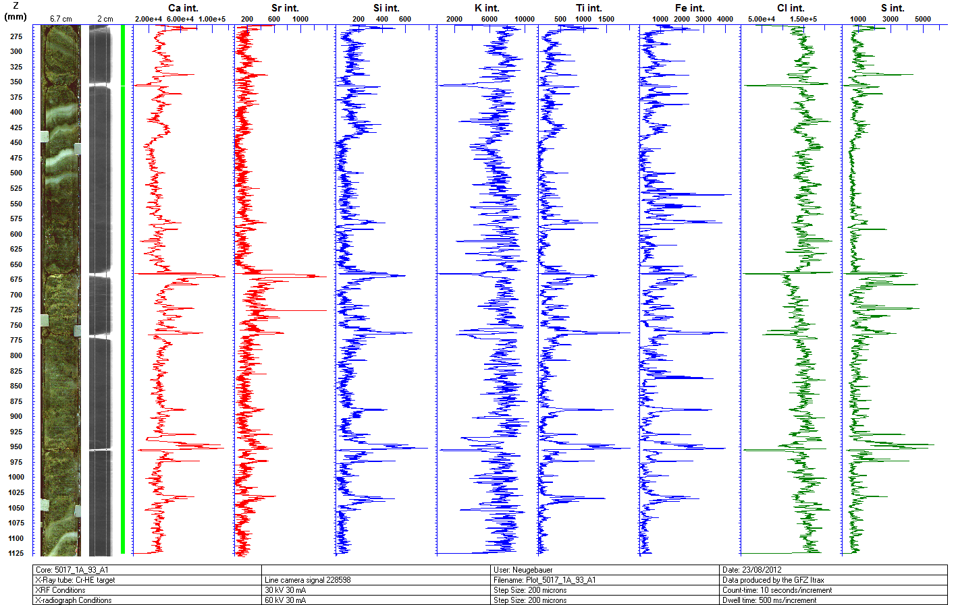
Scan 2| 93_1

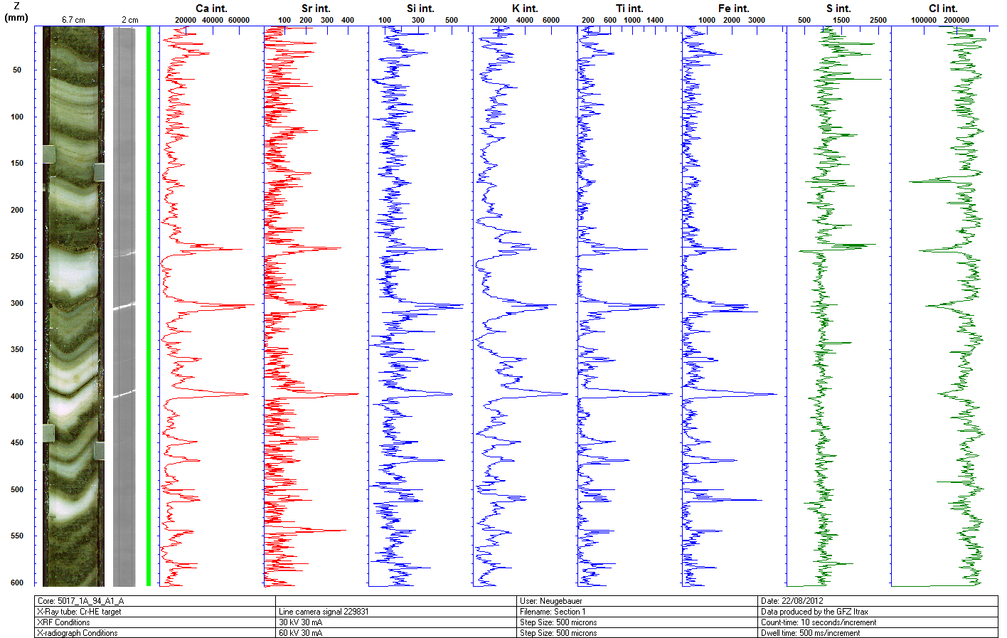
Scan 3| 94_1

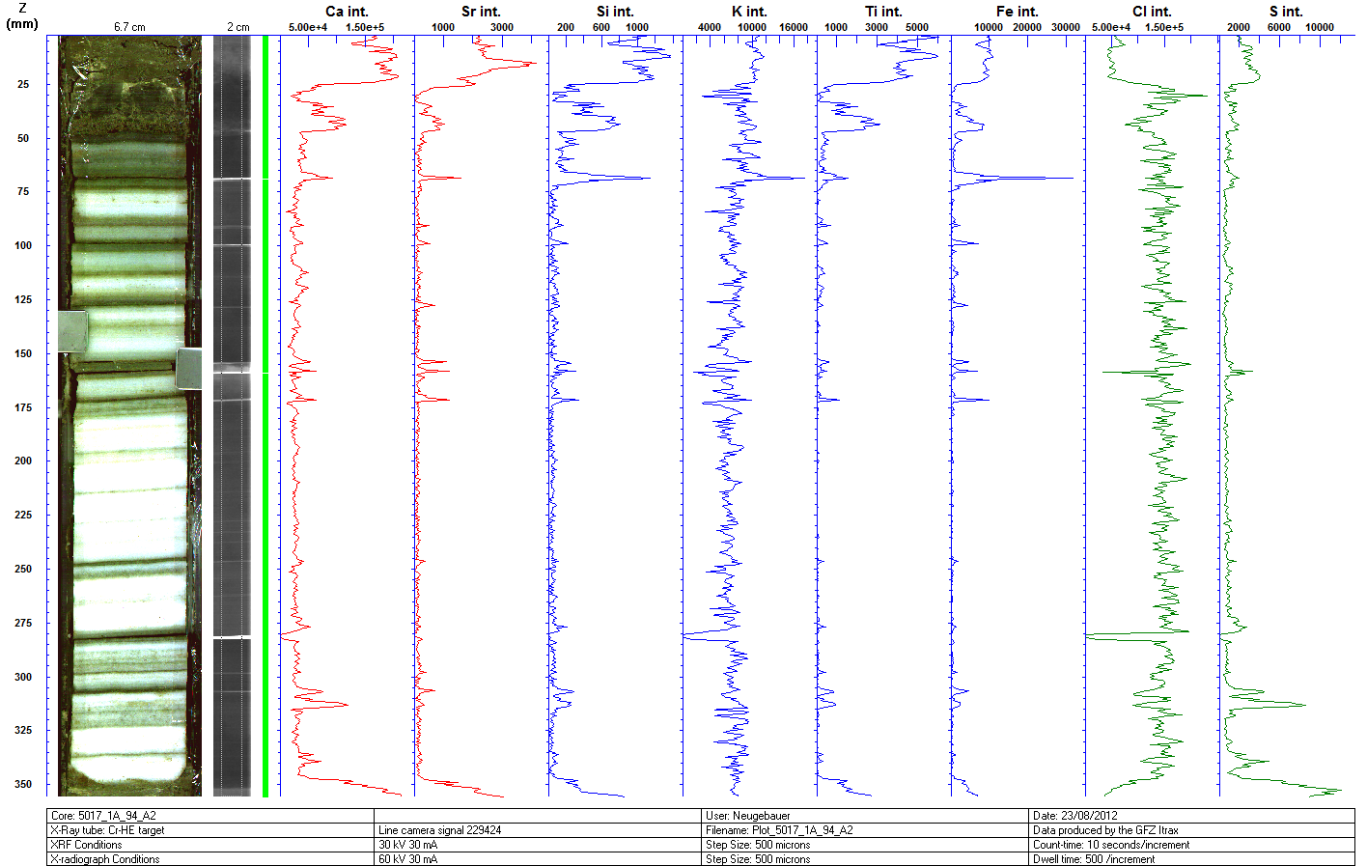
Scan 4| 94_2

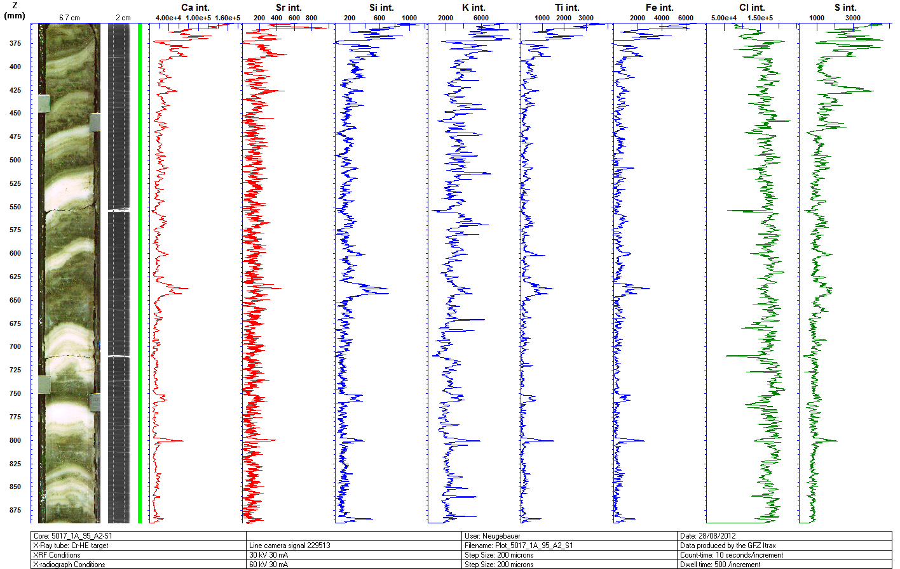
Scan 5| 95_2

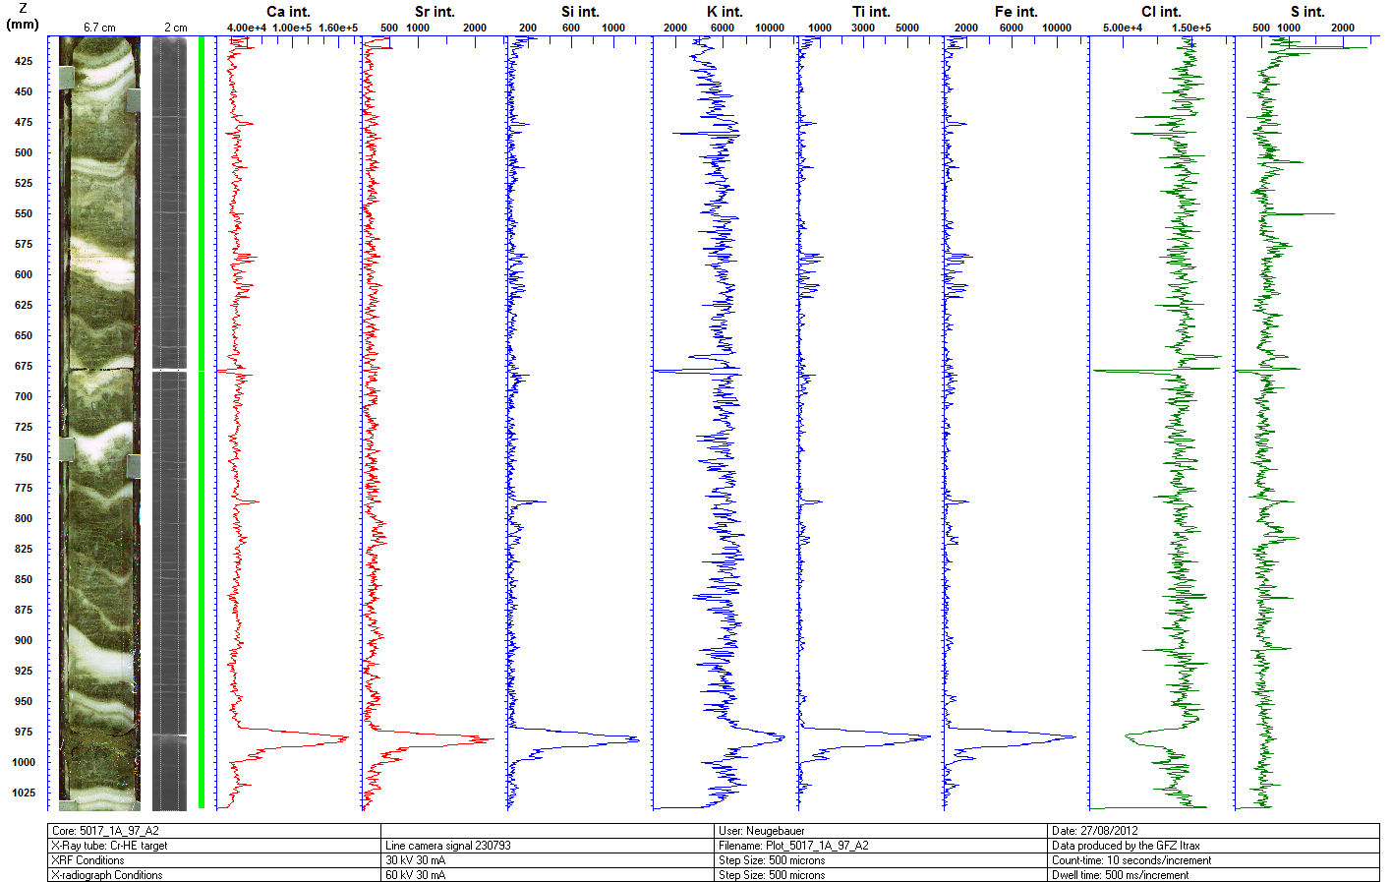
Scan 6| 97_2

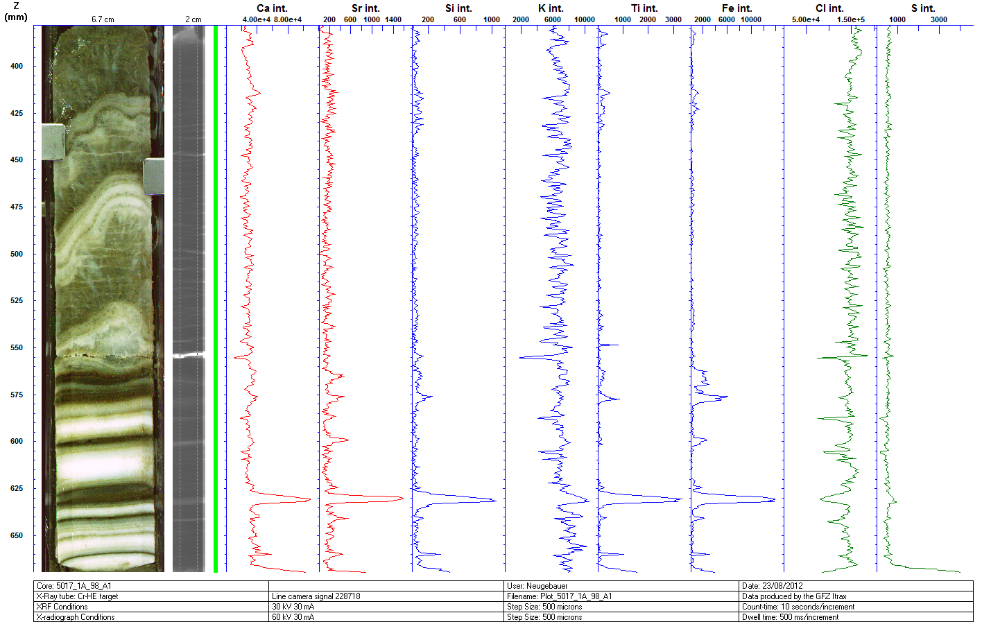
Scan 7| 98_1

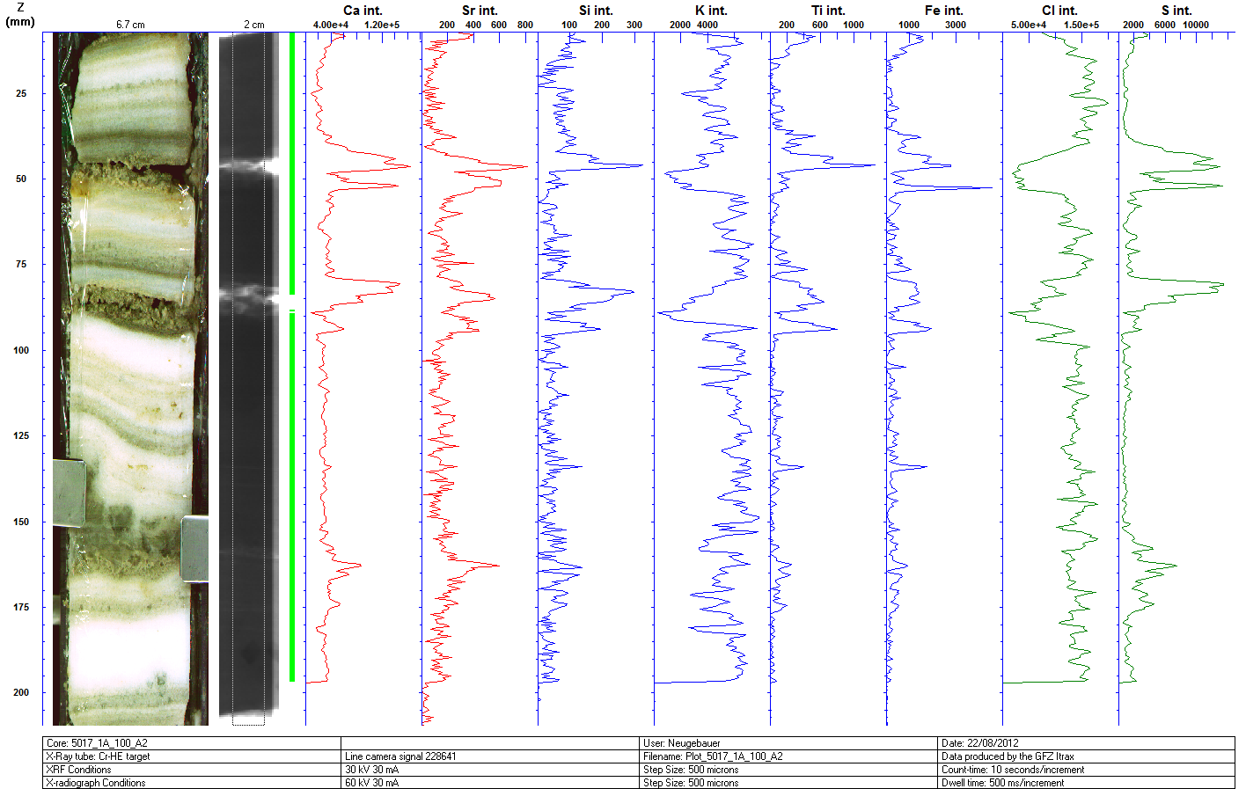
Scan 8| 100_2

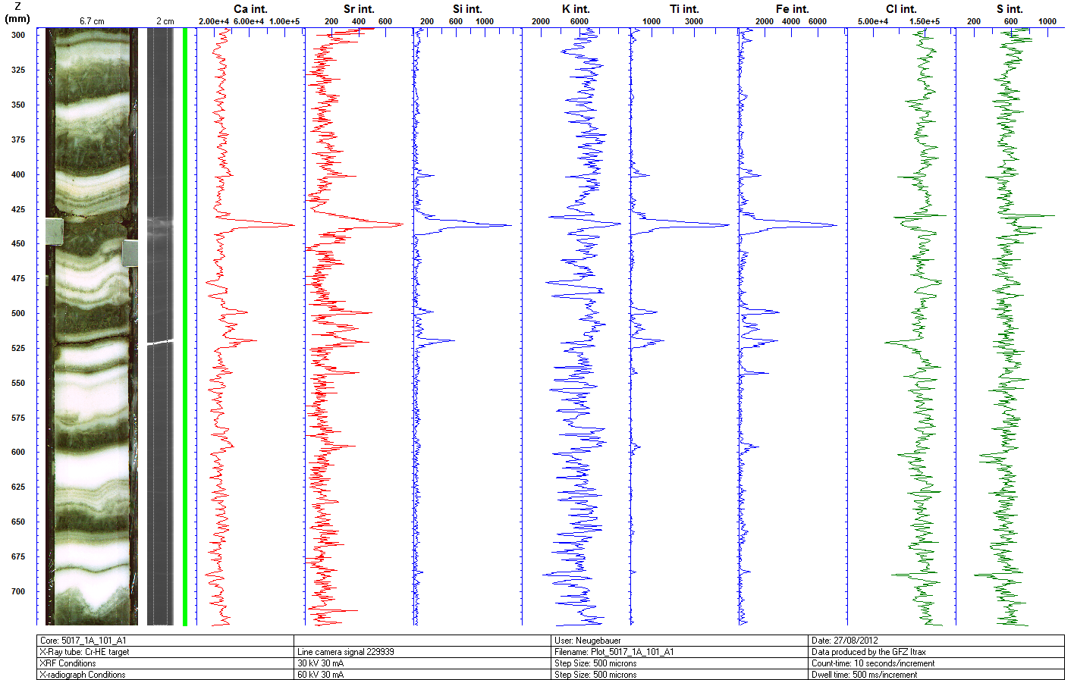
Scan 9| 101_1

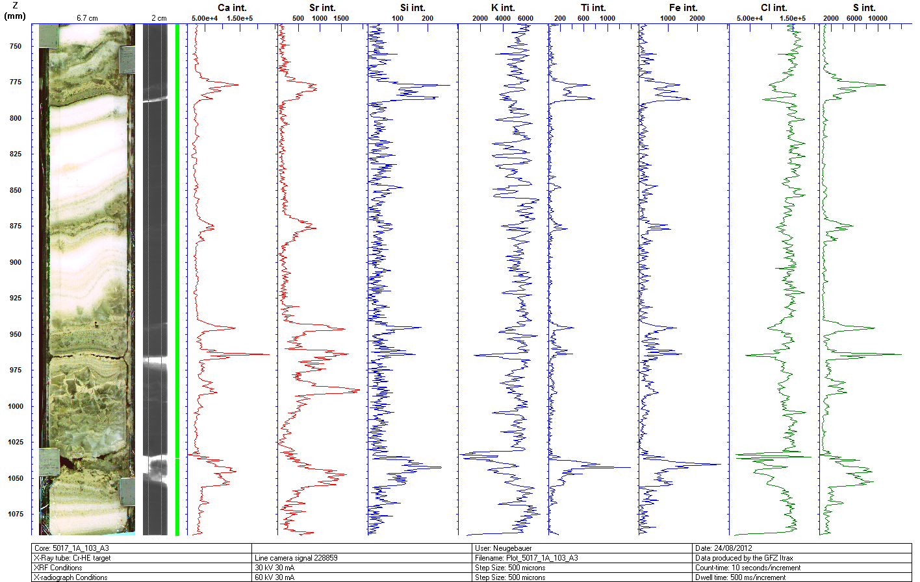
Scan 10| 103_3

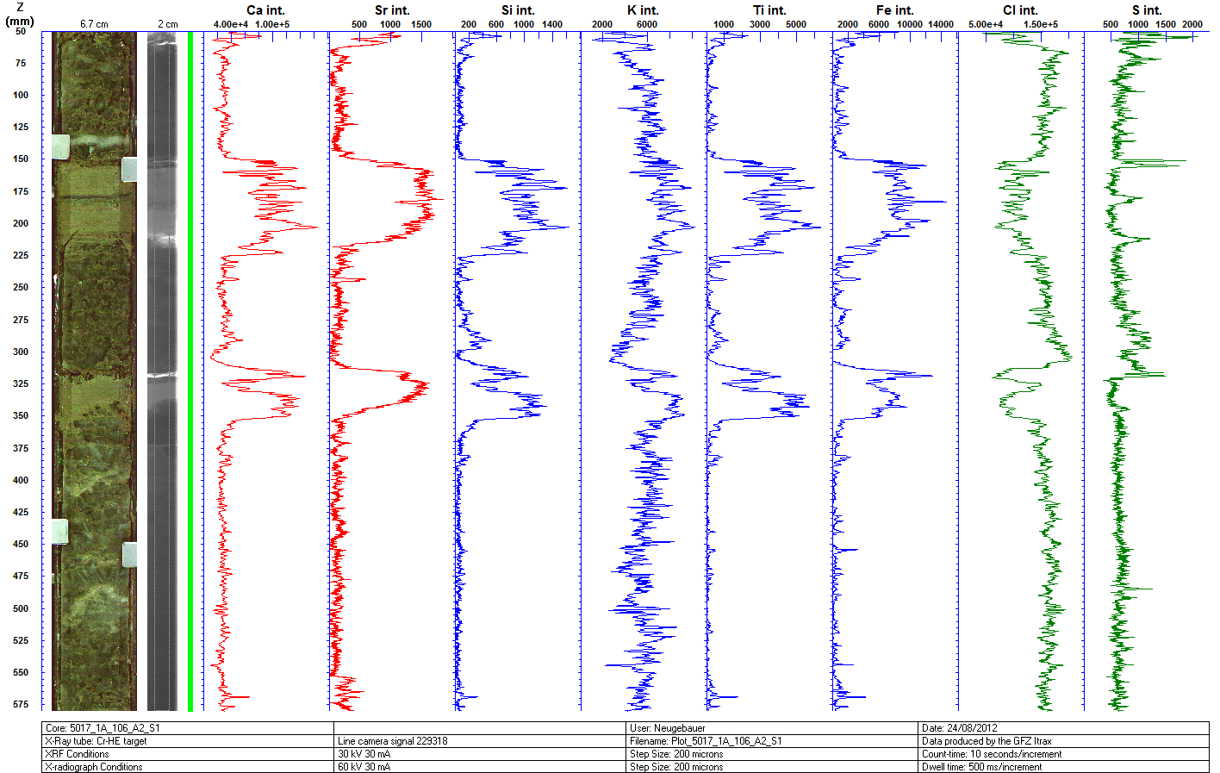
Scan 11| 106_2 (1)

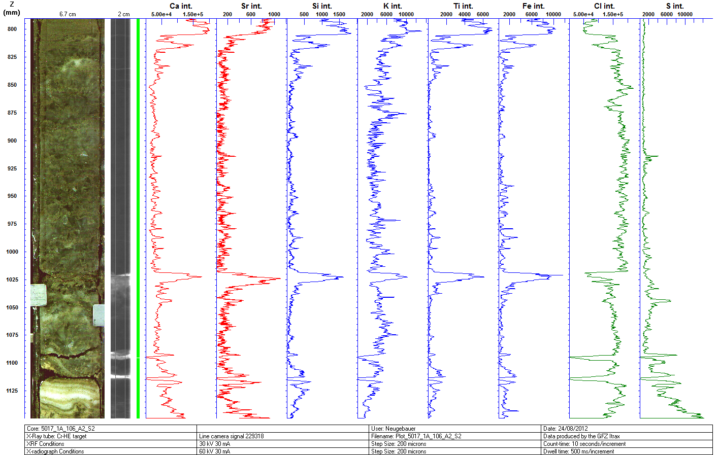
Scan 12| 106_2 (2)

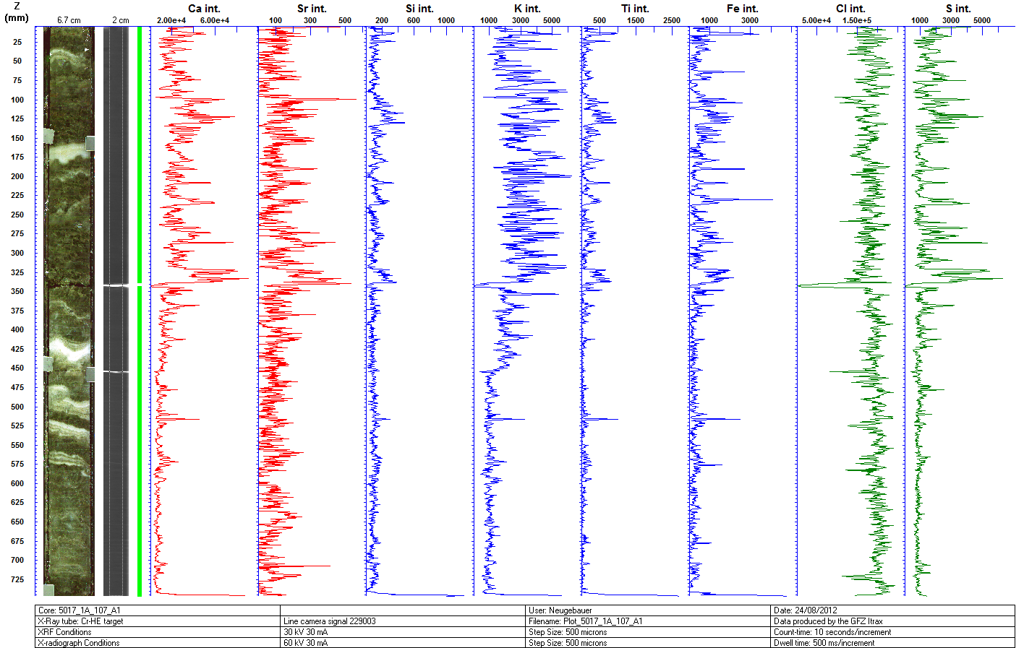
Scan 13| 107_1

