Chronology of newly-discovered Paleolithic artifact assemblages in Lantian (Shaanxi Province), central China

Supplementary material

The luminance characteristics
Representative quartz OSL and K-feldspar pIRIR₂₉₀ dose response curves and decay curves (inset) are presented in Fig. S1. For quartz, the OSL signals decrease very quickly during the first second of stimulation, indicating that the signal is dominated by the fast component (Singarayer and Bailey, 2003). The criterion suggested by Thomsen et al. (2016) was used to ensure that only those aliquots capable of measuring the dose of interest are included in the calculation of the mean De. That is, aliquots with 2xD₀ values smaller than the dose we are trying to measure (derived from all aliquots) are not incorporated in the final De calculation, irrespective of the De value of the individual aliquot. In the case of three samples, all of the aliquots were rejected. The natural OSL signal of these samples lies very close to the saturation level on the dose response curve (Fig. S1, A) and the corresponding De values are greater than 200 Gy. This is consistent with suggestions that the upper limit of SAR-based quartz OSL dating is around ~200 Gy in loess, and ages derived from these high doses are likely to be underestimates (e.g. Zhou and Shackleton 2001; Buylaert et al. 2007; Lai 2010; Chapot et al. 2012; Timar Gabor and Wintle 2013; Lai and Fan 2014). For these samples, only a minimum age is presented in Table 1.
The feldspar pIRIR₂₉₀ dose response curve has a much more extended dose range compared to quartz OSL (Fig. S1, B), indicating its usefulness for dating samples beyond the quartz OSL limit. pIRIR₂₉₀ De and ages have a wider range compared to quartz OSL (Table 1): the maximum De value can reach ~600 Gy and give ages back to approximately ~170 ka, following suggestions that pIRIR₂₉₀ signals can be used to determine older ages back to ~200 ka (Li and Li; 2012; Buylaert, et al., 2012).
The resulting quartz OSL and pIRIR₂₉₀ De and ages are summarized in Table 1. It can be seen that the quartz yields ages back to ~48 ka, but beyond this they are systematically underestimated. The pIRIR₂₉₀ can reach ~170 ka and is in good agreement with the expected ages with the increase of depth. Therefore, we use the pIRIR₂₉₀ data as preferred ages.
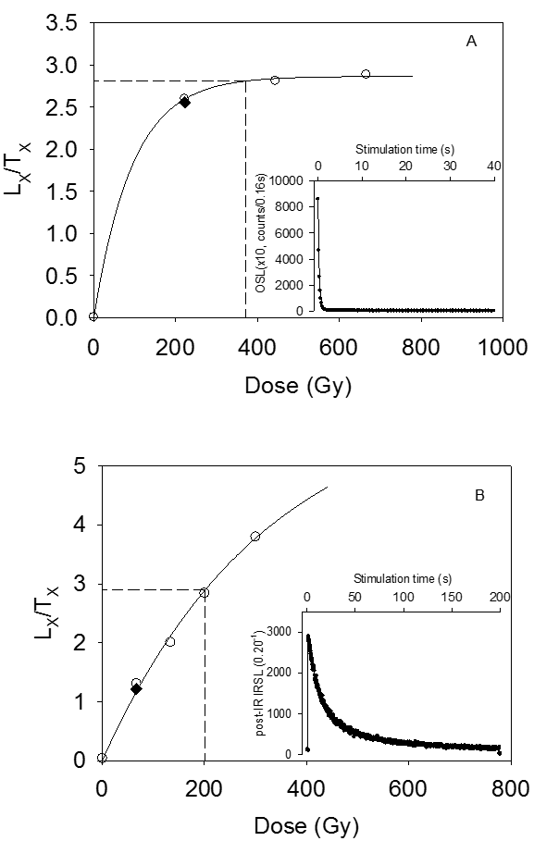
Fig. S1 Typical dose response curves for A. quartz B. K-feldspar aliquots of sample DZ-4 (inset shows the natural decay curves).
References
Buylaert, J.P., Jain, M., Murray, A.S., Thomsen, K.J., Thiel, C., Sohbati, R., 2012. A robust feldspar luminescence dating method for Middle and Late Pleistocene sediments. Boreas 41, 435-451.
Buylaert, J.-P., Vandenberghe, D., Murray, A. S., Huot, S., De Corte,F. & Van den Haute, P. 2007: Luminescence dating of old (>70 ka) Chinese loess: a comparison of single-aliquot OSL and IRSL techniques. Quaternary Geochronology 5, 9–14.
Chapot, M. S., Roberts, H. M., Duller, G. A. T. & Lai, Z. P. 2012: A comparison of natural-and laboratory-generated dose response curves for quartz optically stimulated luminescence signals from Chinese Loess. Radiation Measurements 47, 1045–1052.
Lai, Z. P. & Fan, A. C. 2014: Examining quartz OSL age underestimation for loess samples from Luochuan in the Chinese Loess Plateau. Geochronometria 41, 57–64.
Lai, Z.P., 2010. Chronology and the upper dating limit for loess samples from Luochuan section in the Chinese Loess Plateau using quartz OSL SAR protocol. Journal of Asian Earth Sciences 37(2), 176-185.
Li, B., Li, S.-H., 2012. Luminescence dating of K-feldspar from sediments: a protocol without anomalous fading correction. A reply to the comments by Thomsen et al. on Quat. Geochronol. 8, 49-51.
Singarayer, J.S., Bailey, R.M. 2003. Further investigations of the quartz optically stimulated luminescence components using linear modulation. Radiation Measurements 37, 451-458.
Thomsen, K.J., Murray, A.S., Buylaert, J.-P., Jain, M., Hansen, J.H., Aubry, T. 2016, Testing single-grain quartz OSL methods using sediment samples with independent age control from the Bordes-Fitte rockshelter (Roches d'Abilly site, Central France). Quaternary Geochronology 31, 77-79.
Timar-Gabor, A., Wintle, A. G. 2013: On natural and laboratory generated dose response curves for quartz of different grain sizes from Romanian loess. Quaternary Geochronology 18, 34–40.
Zhou, L. P. & Shackleton, N. J. 2001: Photon-stimulated luminescence of quartz from loess and effects of sensitivity change on palaeodose determination. Quaternary Science Reviews 20, 853–857.

