Supplementary Material
Size and spatial structure of the soil and lacustrine charcoal pool across a boreal forest watershed
Mikael Ohlson, Isabella Kasin, Anveig Nordtug Wist and Anne E. Bjune

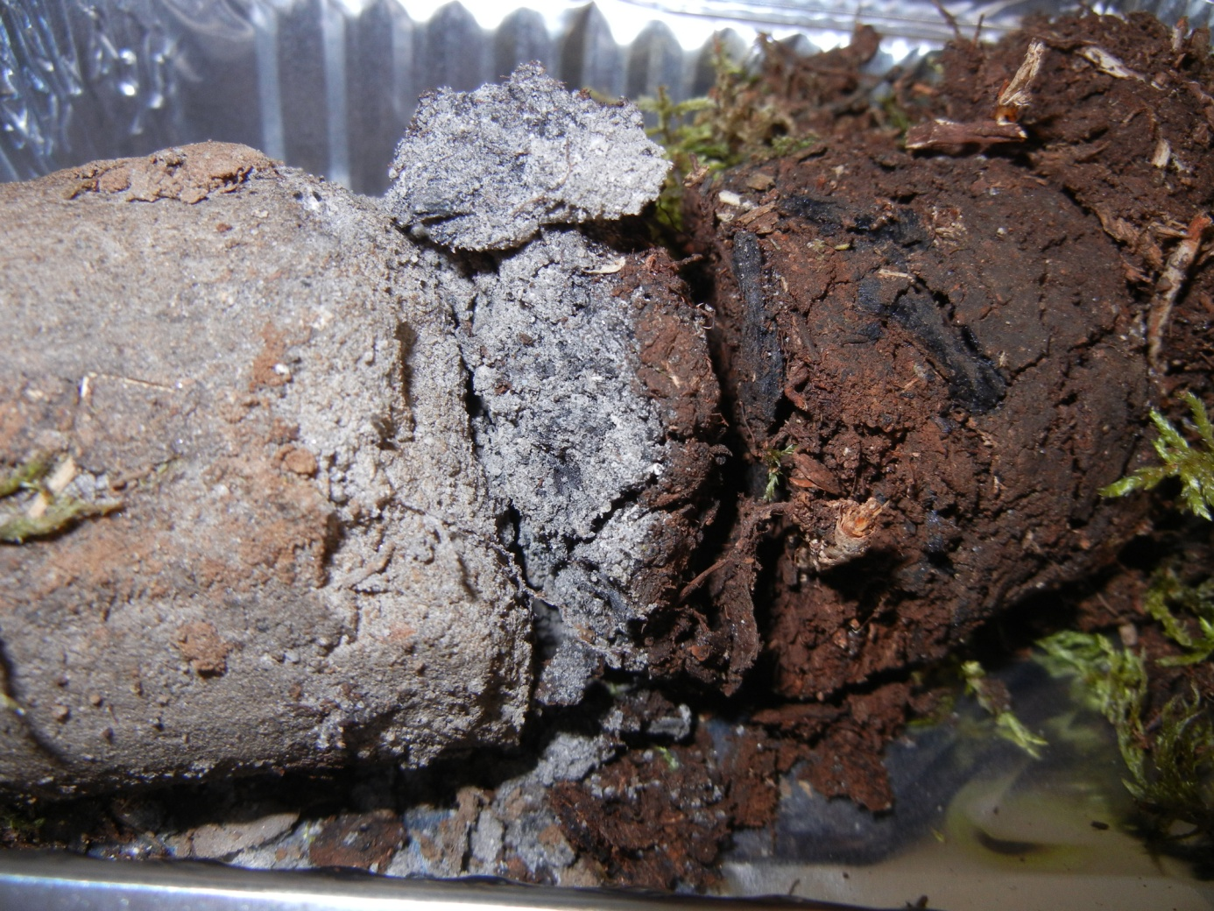
Soil profile and a soil sample from the study forest landscape at Lake Kapteinstjern in SE Norway. Note the large pieces of charcoal in the organic soil just above the mineral soil, the charcoal richness in the uppermost cm of the bleached mineral soil, and the marked decline of charcoal deeper down in the mineral soil.

