Supplementary Information
List of information included below:
Supplementary Appendix 1. Specimens of Mammoth (Mammuthus sp.), American mastodon (Mammut americanum), and caribou (Rangifer tarandus) included in this study. Radiocarbon lab number, museum catalog number, ¹⁴C date, Literature source, and location are provided. Dates are rounded to the nearest decade.
Supplementary Figure 1. Posterior probability density plots for dates of earliest appearance for (A) caribou (Rangifer tarandus), (B) Mammoth (Mammuthus sp.), and (C) American mastodon.
Supplementary Figure 2. Posterior probability density plots for dates of earliest appearance for (A) caribou (Rangifer tarandus), (B) Mammoth (Mammuthus sp.), and (C) American mastodon.
Supplementary Table 1. Colonization and extinction dates calculated using the Gaussian-resampled inversely-weighted McInerney et al. (GRIWM) method of Bradshaw et al. (2012).

Appendix S1. Specimens of Mammoth (Mammuthus sp.), American mastodon (Mammut americanum), and caribou (Rangifer tarandus) included in this study. Radiocarbon lab number, museum catalog number, ¹⁴C date, Literature source, and location are provided. Dates are rounded to the nearest decade.
Name | Lab. No. | Mus. Cat. No. | ¹⁴C Date | ¹⁴C error | Cal BP | Source | Lat-Long
Mammoth (Mammuthus sp.)
Chemung (Watkins Glen) Mammoth | Beta-176929 | NY-CHE | 10890 | 50 | 12620-12920 | (Griggs and Kromer, 2008) | N 42.246104,W -76.8428
Chittenango Mammoth | OS-93430 | NYSM VP-26 | 11250 | 65 | 12950-13300 | (Feranec and Kozlowski, 2012) | 43.05898,W -75.866261
Lewiston Mammoth A | OS-97864 | NYSM VP-27 | 10300 | 65 | 11830-12400 | This Study (tooth dentine collagen) | N 43.172555, W -79.035878
Lewiston Mammoth B | OS-97774 | NYSM VP-29 | 10350 | 95 | 11830-12540 | This Study (tooth dentine collagen) | N 43.172555, W -79.035878
Clyde Barge Canal Mammoth | OS-85534 | NYSM VP-32 | 11750 | 65 | 13400-13750 | (Feranec and Kozlowski, 2012) | N 43.059027, W -76.8384
Kitchiwan Mammoth | OS-97775 | NYSM VP-43 | 12950 | 100 | 15070-16330 | This Study (bone collagen) | N 41.209808, W -73.814929
Randolph Mammoth | OS-93354 | NYSM VP-95 | 10350 | 45 | 12050-12400 | (Feranec and Kozlowski, 2012) | N 42.154846, W -78.938913
American Mastodon (Mammut americanum)
Doerfel Mastodon | NA | C4NW-17 | 11460 | 60 | 13200-13450 | (Thompson et al., 2008) | N 42.561389, W -78.714167
Hiscock Mastodon | TO-3194 | E2664 | 10990 | 100 | 12660-13100 | (Laub et al., 1996) | N 43.084937, W -78.081679
Hiscock Mastodon | CAMS-62560 | E27183 F8NW-75 | 10810 | 50 | 12600-12850 | (Laub, 2003) | N 43.084937, W -78.081679
Hiscock Mastodon | CAMS-27143 | E9NW-145 | 10790 | 70 | 12550-12850 | (Laub, 2003) | N 43.084937, W -78.081679
Hiscock Mastodon | CAMS-17407 | F7SE-129 | 10630 | 80 | 12400-12700 | (Laub, 2003) | N 43.084937, W -78.081679
Hiscock mastodon | Beta-236608 | G2NW-19 | 10430 | 60 | 12100-12540 | (Laub, 2010) | N 43.084937, W -78.081679
Hiscock Mastodon | Beta-24412 | G5SE-138 | 10520 | 120 | 12050-12650 | (Laub, 2003) | N 43.084937, W -78.081679
Hiscock Mastodon | AA-6977 | G7NE-104 | 11390 | 80 | 13110-13410 | (Laub et al., 1996) | N 43.084937, W -78.081679
Hiscock Mastodon | CAMS-30528 | H7NW-181 | 11100 | 80 | 12700-13150 | (Laub, 2003) | N 43.084937, W -78.081679
Hiscock Mastodon | CAMS-30529 | H7NW-181 | 11070 | 70 | 12700-13100 | (Laub, 2003) | N 43.084937, W -78.081679
Hiscock Mastodon | GX-22038-AMS | H7NW-181 | 10930 | 70 | 12650-13050 | (Laub, 2003) | N 43.084937, W -78.081679
H7NW-181 Pooled Mean |  | H7NW-181 | 11030 | 42 | 12760-13030
Chemung (Watkins Glen) Mastodon | Beta-176930 | NY-CHE | 10840 | 60 | 12590-12890 | (Griggs and Kromer, 2008) | N 42.246104, W -76.8428
North Java Mastodon | Beta-176928 | NY-NJV | 11630 | 60 | 13310-13670 | (Griggs and Kromer, 2008) | N 42.649444, W -78.387222
Temple Hill Mastodon | NZA12584 | NYSM VP-100 | 11000 | 80 | 12680-13090 | (Robinson et al., 2005) | N 41.470708, W -74.068537
Temple Hill Mastodon | OS-93337 | NYSM VP-100 | 10900 | 40 | 12650-12900 | (Feranec and Kozlowski, 2012) | N 41.470708, W -74.068537
Temple Hill Pooled Mean |  | NYSM VP-100 | 10920 | 36 | 12710-12840
Cohoes Mastodon | OS-97863 | NYSM VP-101 | 11150 | 85 | 12770-13250 | This Study (tooth dentine collagen) | N 42.782846, W -73.706256
Cohoes Mastodon | CURL-2107 | NYSM VP-101 | 11070 | 60 | 12790-13070 | This Study (bone collagen)
Cohoes Mastodon Pooled Mean |  | NYSM VP-101 | 11100 | 49 | 12820-13080 | This Study
Arborio Mastodon | OS-93884 | NYSM VP-102 | 11750 | 60 | 13400-13750 | (Feranec and Kozlowski, 2012) | N 41.502246, W -74.230542
Ellenville Mastodon | OS-94876 | NYSM VP-49 | 10850 | 45 | 12600-12900 | (Feranec and Kozlowski, 2012) | N 41.712224, W -74.392505
Perkinsville Mastodon | OS-93357 | NYSM VP-54 | 11500 | 45 | 13250-13450 | (Feranec and Kozlowski, 2012) | N 42.546631, W -77.623558
Colgan-King Ferry Mastodon | OS-95596 | NYSM VP-92 | 10400 | 50 | 12080-12520 | This Study (tusk dentine collagen) | N 42.702303, W -76.595446
Pirello Mastodon | OS-93338 | NYSM VP-93 | 11700 | 40 | 13400-13700 | (Feranec and Kozlowski, 2012) | N 43.160318, W -77.123061
Tunkamoose Mastodon (1) | OS-78281 | NYSM VP-94 | 12350 | 65 | 14050-14900 | (Feranec and Kozlowski, 2012) | N 41.313499, W -74.512968
Tunkamoose Mastodon (2) | OS-78282 | NYSM VP-94 | 12300 | 45 | 14000-14900 | (Feranec and Kozlowski, 2012) | N 41.313499, W -74.512968
Tunkamoose Pooled mean | ¹ | NYSM VP-94 | 12320 | 37 | 14080-14560
Hyde Park Mastodon | Beta-135234 | PRI 49820 | 11480 | 60 | 13200-13450 | (Robinson and Burney, 2008) | N 41.77564, W -73.899059
Farview Mastodon | NA | RMSC 94.008.01-144 | 11570 | 105 | 13250-13700 | (Thompson et al., 2008) | N 42.886027, W -77.763891
Caribou (Rangifer tarandus)
Hiscock Caribou (1) | CAMS-72353 | I3NE-164 | 11450 | 50 | 13190-13430 | (Laub, 1995) | N 43.084937, W -78.081679
Hiscock Caribou (2) | CAMS-105852 | J4NE-49 | 11040 | 40 | 12730-13090 | (Laub, 1995) | N 43.084937, W -78.081679
Hiscock Caribou (3) | CAMS-94852 | J4SE-33 | 11580 | 35 | 13290-13560 | (Laub, 1995) | N 43.084937, W -78.081679
DQC Caribou (1) | CAMS-12849 | NYSM VP-10165 | 13320 | 70 | 15620-16810 | (Funk et al., 1994) | N 41.359722, W -74.363611
DQC Caribou (4) | CAMS-12586 | NYSM VP-5397 | 12720 | 70 | 14650-15540 | (Funk et al., 1994) | N 41.359722, W -74.363611
DQC Caribou (5) | CAMS-13305 | NYSM VP-5415 | 13150 | 90 | 15240-16560 | (Funk et al., 1994) | N 41.359722, W -74.363611
DQC Caribou (7) | CAMS-12589 | NYSM VP-5569 | 12750 | 70 | 14700-15600 | (Funk et al., 1994) | N 41.359722, W -74.363611
DQC Caribou (6) | CAMS-13304 | NYSM VP-5570 | 13840 | 80 | 16750-17150 | (Funk et al., 1994) | N 41.359722, W -74.363611
DQC Caribou (2) | CAMS-13298 | NYSM VP-8825 | 12920 | 70 | 15040-16150 | (Funk et al., 1994) | N 41.359722, W -74.363611
DQC Caribou (3) | CAMS-13296 | NYSM VP-8827 | 13180 | 80 | 15290-16610 | (Funk et al., 1994) | N 41.359722, W -74.363611
DQC Caribou (8) | OS-66473 | NYSM VP-9370 | 12900 | 70 | 15000-15500 | (Feranec and Kozlowski, 2010) | N 41.359722, W -74.363611
DQC Caribou (9) | OS-65556 | NYSM VP-9371 | 12900 | 50 | 15000-15500 | (Feranec and Kozlowski, 2010) | N 41.359722, W -74.363611
DQC Caribou Pooled Mean² |  |  | 12900 | 41 | 15220-15610
¹, VP-94 represented by two individual tusks from same individual
², VP-9370 and VP-9371 are specimens from same individual

Supplementary Figure 1. Posterior probability density plots for dates of earliest appearance for (A) caribou (Rangifer tarandus), (B) Mammoth (Mammuthus sp.), and (C) American mastodon.
(A). Caribou (Rangifer tarandus)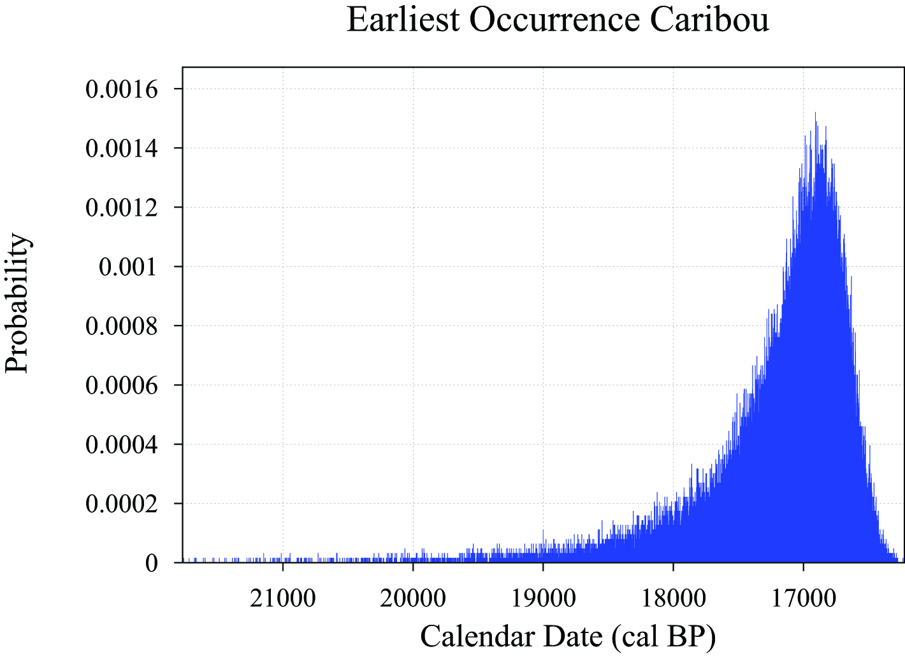

(B). Mammoth (Mammuthus sp.)
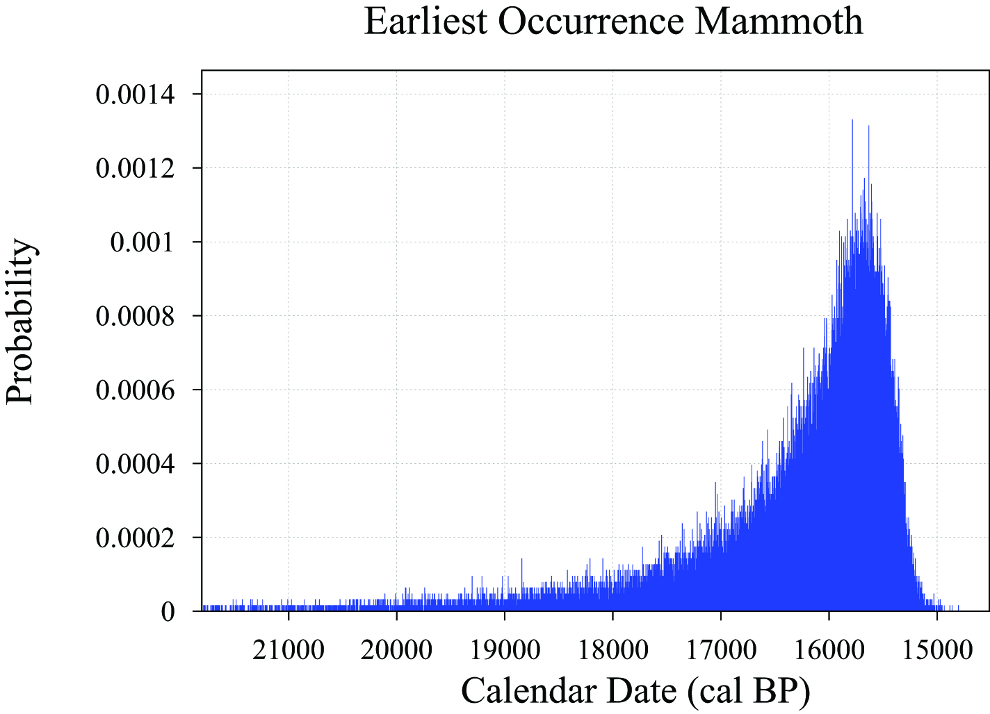

(C). American mastodon (Mammut americanum)
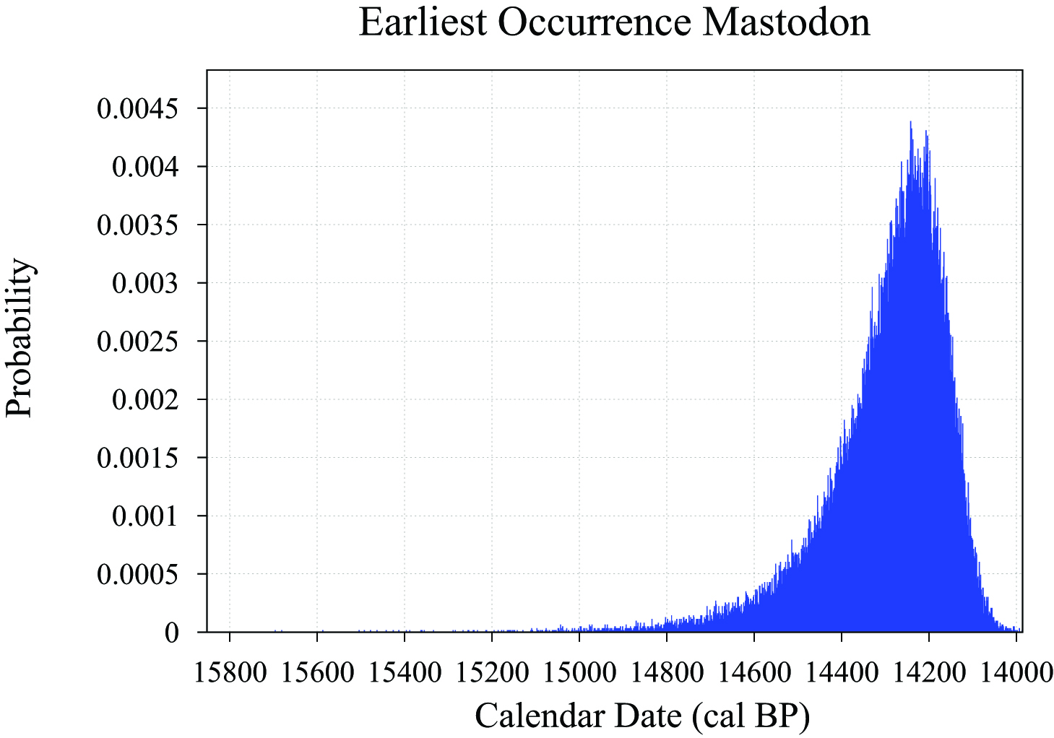

Supplementary Figure 2. Posterior probability density plots for dates of earliest appearance for (A) caribou (Rangifer tarandus), (B) Mammoth (Mammuthus sp.), and (C) American mastodon.

(A). Caribou (Rangifer tarandus)
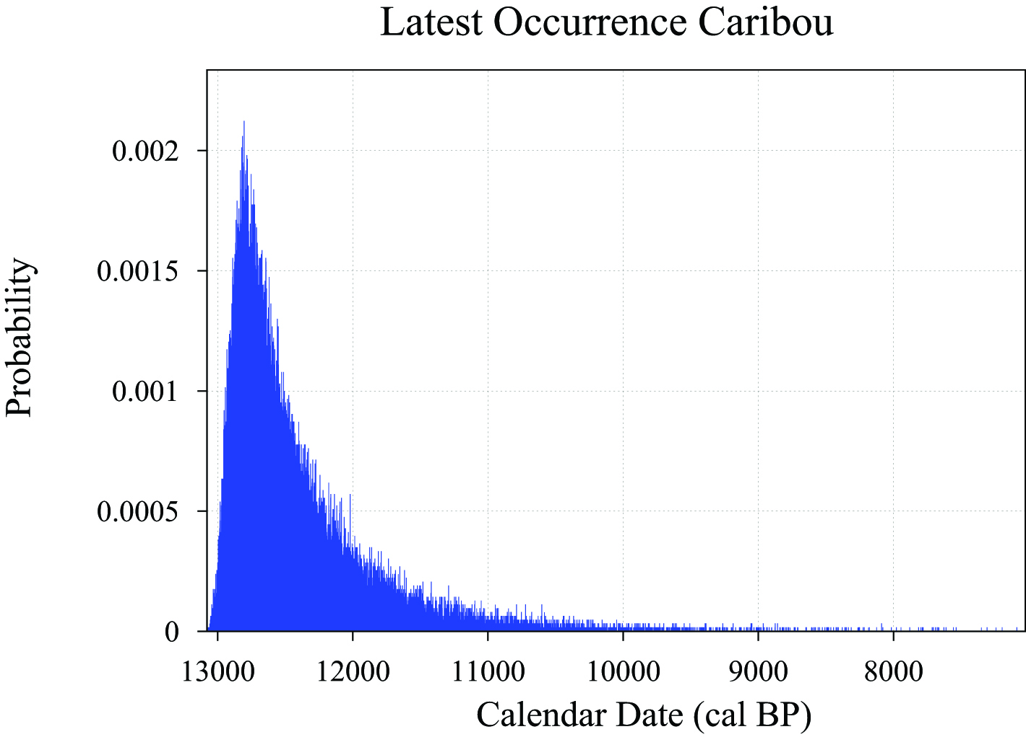

(B). Mammoth (Mammuthus sp.)
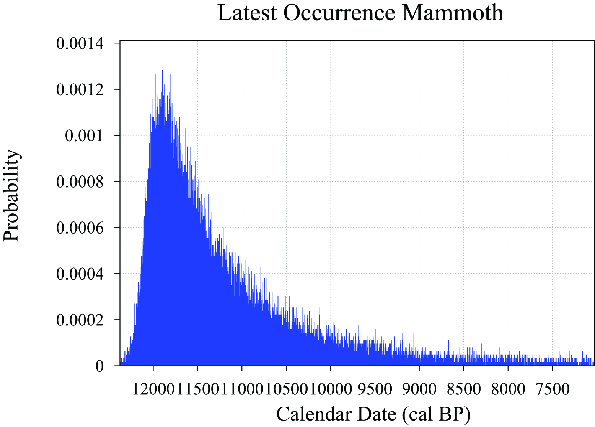

(C). American mastodon (Mammut americanum)
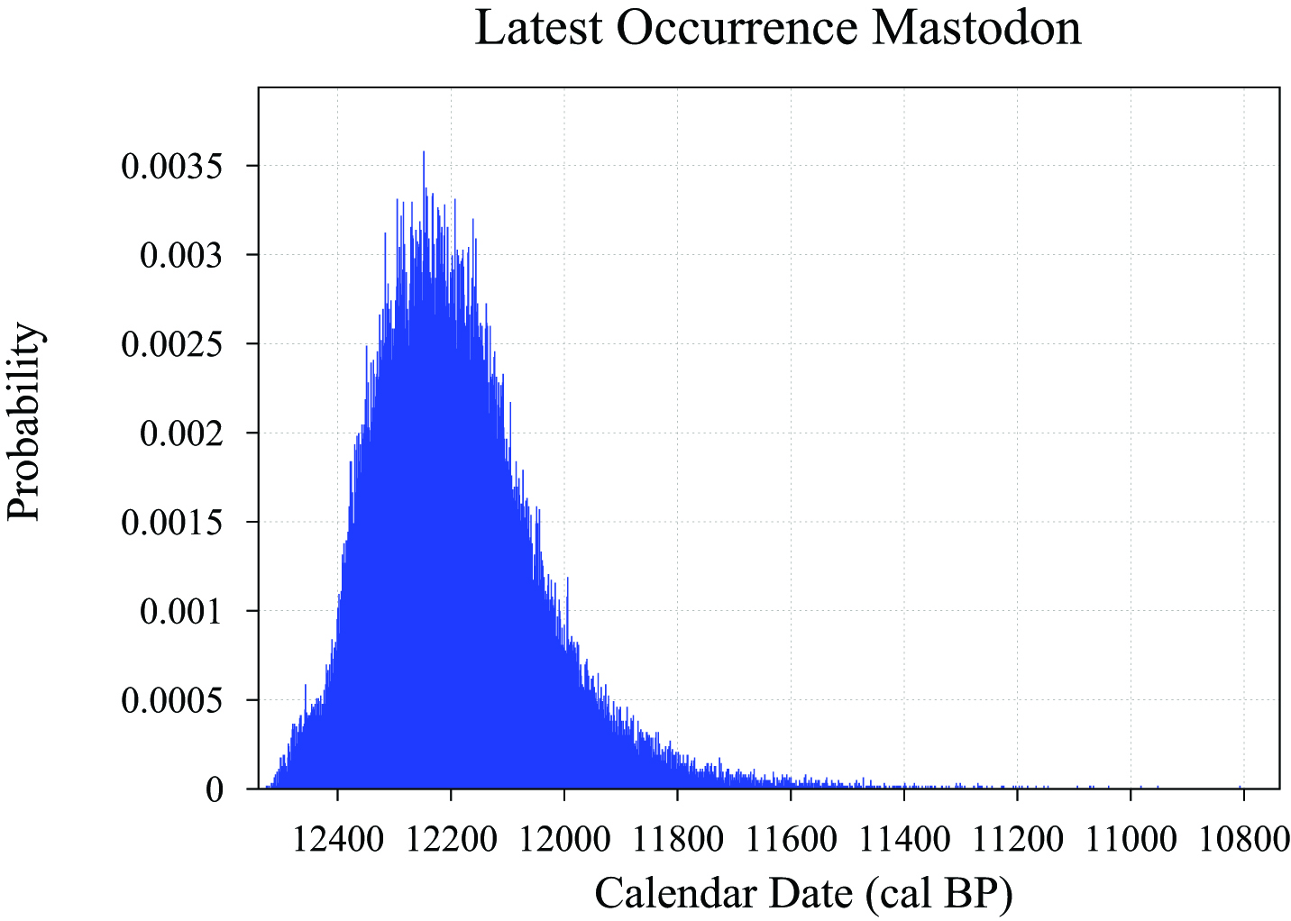

Supplementary Table 1. Colonization and extinction dates calculated using the Gaussian-resampled inversely-weighted McInerney et al. (GRIWM) method (Bradshaw et al., 2012). This technique provides comparable dates to the Bayesian method used in this manuscript.

Species | Earliest Occurrence  median (cal BP) | Earliest Occurrence  95% CI (cal BP) | Latest Occurrence  median (cal BP) | Latest Occurrence  95% CI (cal BP)
Caribou  (Rangifer tarandus) | 17594 | 18102‒17048 | ‒ª | ‒ª
Mammoth  (Mammuthus sp.) | 17635 | 18011‒17271 | 11792 | 12156‒11213
American mastodon  (Mammut americanum) | 14723 | 14829‒14617 | 11994 | 12301‒11566
ªCaribou known in NY State until late 18th century AD (Cringan, 1957; @ 200 cal BP).

Supplementary Information References Cited
Bradshaw, C.J.A., Cooper, A., Turney, C.S.M., Brook, B.W., 2012. Robust estimates of extinction time in the geological record. Quaternary Science Reviews 33, 14–19. doi:10.1016/j.quascirev.2011.11.021
Feranec, R., Kozlowski, A., 2012. New AMS radiocarbon dates from Late Pleistocene mastodons and mammoths in New York State, USA. Radiocarbon 54, 275–279. doi:10.2458/azu_js_rc.v54i2.16009
Feranec, R.S., Kozlowski, A.L., 2010. AMS radiocarbon dates from Pleistocene and Holocene mammals housed in the New York State Museum, Albany, New York, USA. Radiocarbon 52, 205–208. doi:10.2458/azu_js_rc.52.3247
Funk, R.E., Steadman, D.W., Funk, R.E., Steadman, D.W., 1994. Archaeological and Paleoenvironmental Investigations in the Dutchess Quarry Caves, Orange County, New York. Persimmon Press, Buffalo, NY.
Griggs, C.B., Kromer, B., 2008. Wood Macrofossils and dendrochronology of three mastodon sites in upstate New York. Paleontographica Americana 61, 49–61.
Laub, R.S., 2010. Observations from the Hiscock Site (New York) bearing on a late-Pleistocene extraterrestrial impact event. Current Research in the Pleistocene 27, 168–171.
Laub, R.S., 2003. The Hiscock Site: Late Pleistocene and Holocene Paleoecology and Archaeology of Western New York State. Bulletin of the Buffalo Society of Natural Sciences 37, 1–327.
Laub, R.S., 1995. The Hiscock Site (Western New York): recent developments in the study of the late-Pleistocene component. Current Research in the Pleistocene 12, 26–29.
Laub, R.S., Tomenchuck, J., Storck, P.L., 1996. A dated mastodon bone artifact from the late Pleistocene of New York. Archaeology of Eastern North America 24, 1–17.
Robinson, G.S., Burney, D.A., 2008. The Hyde Park mastodon and palynological clues to megafaunal extinction. Paleontographica Americana 61, 291–299.
Robinson, G.S., Pigott Burney, L., Burney, D.A., 2005. Landscape paleoecology and megafaunal extinction in southeastern New York State. Ecological Monographs 75, 295–315. doi:10.1890/03-4064
Thompson, L.M., McIntosh, G.C., Allmon, W.D., 2008. Discoveries of the American mastodon (Mammut americanum) in New York State: 1922-2007. Paleontographica Americana 61, 25–41.

