Luminescence ages for three ‘Middle Palaeolithic’ sites in the Nihewan Basin, northern China, and their archaeological and palaeoenvironmental implications
Yu-Jie Guo, Bo Li, Jia-Fu Zhang, Bao-Yin Yuan, Fei Xie, Wei-Wen Huang, Richard G. Roberts

Supplementary Materials and Methods

Supplementary Tables

Supplementary Figures

Supplementary Materials and Methods

1. Experimental procedures and analytical facilities
The samples were first treated using HCl acid and solutions of H₂O₂ to eliminate carbonates and organic matter, respectively. Grains of 63−90 and 63−106 μm in diameter were obtained from the Motianling samples by wet sieving, and grains of 90−150 μm and 180−212 μm in diameter were obtained by dry sieving of the Queergou and Banjingzi samples. K-feldspar grains were obtained by density separation using a heavy liquid solution with density of 2.58 g/cm³. Finally, the 63−90 and 63−106 μm K-feldspar grains were etched in 10% HF acid for 10 min and the 90−150 and 180−212 μm portions were etched in 10% HF acid for 40 min to remove the alpha-irradiated rinds but avoid dissolving most of the grains. Sample MTL-OSL-05 consists of silty clay, so the polymineral fine-grain fraction (4–11 μm in diameter) was isolated by settling in sodium oxalate (dispersant) solution according to Stokes’ Law (Zhang and Zhou, 2007). The K-feldspar grains and polymineral fine grains from Motianling and Queergou were measured using a pMET-pIRIR procedure (Li et al., 2014a; Guo et al., 2015) for single aliquots composed of multiple grains. The individual K-feldspar grains from Banjingzi were analysed using a single-grain SAR MET-pIRIR procedure (Blegen et al., 2015). The coarse-grain (>63 μm) multi-grain aliquots were made by loading K-feldspar grains on to the central ~5 mm-diameter portions of 9.8 mm-diameter stainless steel discs, amounting to several hundreds of grains on each aliquot. The fine-grain (4–11 μm) multi-grain aliquots of sample MTL-OSL-05 were prepared by settling in acetone on to 9.8 mm-diameter stainless steel discs, amounting ~1 mg of fine grains on each aliquot. The single-grain measurements were made using standard single-grain discs (i.e., gold-plated aluminium discs drilled with 100 holes that are each 300 μm in diameter and 300 μm deep) (Bøtter-Jensen et al., 2000). Discs were visually inspected under a microscope to ensure that each hole contained only a single grain.
The K-feldspar and polymineral IRSL measurements were performed on an automated Risø TL/OSL-DA-20 reader equipped with a ⁹⁰Sr/⁹⁰Y beta source. Dose rate calibrations were made for each hole in the single-grain discs, to account for spatial differences in dose rate. Photon stimulation was achieved using IR diodes (870 ∆ 40 nm) for multi-grain measurements and an IR laser (830 nm) for single-grain measurements. The luminescence emissions were detected by an Electron Tubes Ltd 9235B photomultiplier tube fitted with Schott BG-39 and Corning 7-59 filters to restrict the transmission to wavelengths of 320−480 nm. Solar bleaching treatments were carried out using a Dr Hönle solar simulator (Model: UVACUBE 400).

2. Environmental dose rates measurements
For samples QEG-OSL-2, BJZ-OSL-1 and -5, the gamma dose rates were measured in the field using in situ gamma-ray spectrometry (to take account of the inhomogeneity of the surrounding sediments) and their beta dose rates were estimated using low-level beta counting (Bøtter-Jensen and Mejdahl, 1988) and the procedures described in Jacobs and Roberts (2015). For the other samples, the beta dose rates were measured directly by beta counting and the gamma dose rates were measured in the laboratory using a combination of thick-source alpha counting (TSAC) and X-ray fluorescence (XRF) spectroscopy. The U and Th contents were determined from TSAC measurements and K concentrations were obtained by XRF spectroscopy. We compared the latter gamma dose rates with those deduced from TSAC and beta counting, and also compared the beta dose rates estimated from beta counting with those calculated from TSAC and XRF measurements. The results of these comparisons are shown in Supplementary Fig. 1. The gamma dose rates (Supplementary Fig. 1b) are statistically consistent for each of the samples, whereas three of the beta dose rates differ statistically from a ratio of unity (the 1:1 dashed line in Supplementary Fig. 1a). To determine the final dose rates and ages, we used the gamma dose rates determined by TSAC and XRF spectroscopy (as this combination provides an independent measure of K) or by in situ gamma-ray spectrometry (samples QEG-OSL-2, BJZ-OSL-1 and -5), and the beta dose rates measured directly by beta counting, which has been shown to yield accurate results using our instruments and sample preparation, presentation and measurement procedures (Jacobs and Roberts, 2015).
We corrected the dose rates for attenuation due to interstitial water content. The measured water content of loess sample MTL-OSL-02 from Motianling is 9.3%, but below 5% for the other samples. We consider these measured values as underestimates of the long-term water contents, because the sampling sections (especially at the archaeological locations) have been exposed for a prolonged period since excavation and are likely, therefore, to have dried out considerably. To better assess the probable long-term water contents of our samples, two fluvial samples were measured: a silty sand and a silt from a freshly exposed section of the Nihewan Formation near the Xiaochangliang site (Fig. 1c). These samples yielded water contents of ~9% and ~14%, respectively. For the dose rate and age calculations, therefore, we used long-term water content values of 10 ± 3% for the loess samples, 15 ± 5% for the fluvial samples and 20 ± 5% for the lacustrine samples (Table 1), which are similar to those used by Zhao et al. (2010) for their samples from the Haojiatai section. The calculated ages are not especially sensitive to the assumed water content, increasing (or decreasing) by only ~0.7% for each 1% increase (or decrease) in water content.

3. Equivalent dose measurements

3.1 Single-aliquot measurements
For the Motianling and Queergou samples, we applied the single-aliquot pMET-pIRIR procedure (Li et al., 2014a) to obtain D_{e} values for the K-feldspar grains. The experimental procedure is listed in Supplementary Table 1a. In this procedure, IRSL measurements are made successively at five stimulation temperatures (50, 100, 150, 200 and 250 °C). Aliquots were held for 10, 10, 20, 30 and 50 s before IR stimulation at each of these temperatures, respectively, to monitor and minimise interference from isothermal decay signals (Fu et al., 2012). Aliquots were stimulated by IR photons for 100 s at each stimulation temperatures, and the net IRSL signal obtained from the first 10 s of the IRSL decay curve was used for D_{e} estimation, after subtracting a ‘late light’ background count from the final 10 s of decay. A preheat of 310 °C for 60 s was used for each of the natural, regenerative and test doses, and a test dose of 51 Gy was used for all the samples.
IRSL decay curves and dose response curves
Typical natural IRSL (50 °C) and MET-pIRIR (100–250 °C) decay curves are shown in Supplementary Fig. 2 for single aliquots of polymineral sample MTL-OSL-05 and K-feldspar samples MTL-OSL-07 and QEG-OSL-2. For all three samples, the initial intensity of the IRSL signal (50 °C) is strongest, while the initial intensity of the MET-pIRIR signals increases gradually from 100 to 200 °C before decreasing slightly at 250 °C. The dose response curves (DRCs) for signals L_{x}/T_{x}, L_{x} and T_{x} were constructed using a series of regenerative doses, including a duplicate dose to determine the recycling ratio for the L_{x}/T_{x} signal (or the reproducibility ratios for the L_{x} and T_{x} signals; Li et al., 2014a) and a zero dose (0 Gy) to determine the extent of recuperation for each of the L_{x}/T_{x}, L_{x} and T_{x} signals. The recycling (and reproducibility) ratios for all aliquots used to establish the standardised growth curves (SGCs) for the Motianling and Queergou samples were found to be consistent with unity, and the extent of recuperation less than 5%, for all the 250 °C MET-pIRIR L_{x}/T_{x}, L_{x} and T_{x} signals.
To reduce instrument time, we employed the SGC method proposed by Li et al. (2015a, b). Li et al. (2015b) observed that, for K-feldspars from different regions of the world, the non-fading IRSL signals share similar DRCs if they are appropriately normalised using one of the regenerative dose signals; this procedure is called regenerative-dose normalisation or ‘re-normalisation’ (Li et al., 2015a, b). To compare the SGCs for the Motianling and Queergou samples, we have plotted the normalised 250 °C L_{x}/T_{x} , L_{x} and T_{x} (and L_{n}/T_{n} , L_{n} and T_{n} ) signals for samples MTL-OSL-02, -07 and -09 and QEG-OSL-1, -2 and -6 in Supplementary Fig. 6. The L_{x}/T_{x} and T_{x} signals follow a similar dose response curve for all samples, but the normalised L_{x} signals start to diverge above a dose of ~1200 Gy. The latter phenomenon might be due to the K-feldspars at these two sites having different luminescence properties as a result of their geological origins (e.g., crystallisation processes) or post-depositional changes (e.g., diagenesis and weathering).
Residual dose, dose recovery and anomalous fading tests
To check that the MET-pIRIR traps in these samples can be bleached sufficiently by sunlight, residual dose tests were carried out on samples MTL-OSL-02, -03 and -05 and QEG-OSL-2 and -3. Between four and six aliquots of each sample were bleached for 4 hr in the solar stimulator, and the residual doses were then measured using the conventional SAR MET-pIRIR procedure (Li and Li, 2011). This is similar to the procedure shown in Supplementary Table 1a, except that a ‘hot’ IR bleach (at 320 °C) is used in place of the solar simulator bleach at the end of each SAR cycle. The residual doses measured at various IR stimulation temperatures are plotted in Supplementary Fig. 7. The residual doses increase with IR stimulation temperature, similar to the results reported previously for other samples (Li and Li, 2011; Li et al., 2014b). The residual doses measured at 250 °C for samples MTL-OSL-02, -03 and -05 and QEG-OSL-2 and -3 are 11.5 ± 0.4, 12.0 ± 0.4, 43.7 ± 8.3, 15.7 ± 3.6 and 15.2 ± 2.2 Gy, respectively, which correspond to about 2.3%, 1.2%, 4.3%, 1.7% and 1.7% of their respective equivalent doses. Thus, except for polymineral sample MTL-OSL-05, the residual doses are small compared to the natural dose (i.e., the measured D_{e}). For purposes of age calculation, a residual dose was subtracted from the D_{e} estimate of each sample. The values used were 11.5 ± 0.4 Gy for loess samples MTL-OSL-01 and -02, 12.0 ± 0.4 Gy for lacustrine samples MTL-OSL-03, -04 and -06 to -10, and 43.7 ± 8.3 Gy for polymineral sample MTL-OSL-05. A residual dose of 15.3 ± 1.9 Gy (weighted mean of the residual doses for samples QEG-OSL-2 and -3) was subtracted from the measured D_{e} values of the fluvial samples from Queergou (QEG-OSL-1 to -6) prior to age determination.
Dose recovery tests (Galbraith et al., 1999) using the SAR pMET-pIRIR procedure were carried out on samples MTL-OSL-05, MTL-OSL-07 and QEG-OSL-2 to check its suitability for K-feldspars from these two sites, at least under controlled laboratory conditions. The dose recovery test on sample MTL-OSL-07 has been presented previously (Guo et al., 2015), which showed that the measured (recovered) dose is consistent with the given dose when the stimulation temperature is above 150 ºC. Here, we applied the same experimental procedures to samples MTL-OSL-05 and QEG-OSL-2 using doses of 920 and 800 Gy as the surrogate natural doses, respectively. The ratios of recovered to given dose at various IR stimulation temperatures are shown in Supplementary Fig. 8. The dose recovery ratios for the L_{x}/T_{x}, L_{x} and T_{x} signals are consistent with unity at 1σ when the IR stimulation temperature is 250 °C: ratios of 1.11 ± 0.27, 0.96 ± 0.09 and 0.67 ± 0.34 were obtained for the L_{x}/T_{x}, L_{x} and T_{x} signals of sample MTL-OSL-05, and corresponding ratios of 1.03 ± 0.09, 1.02 ± 0.08 and 0.96 ± 0.10 were obtained for sample QEG-OSL-2. For sample MTL-OSL-05, the dose recovery ratio for the L_{x}/T_{x} signal is consistent with unity at IR stimulation temperatures of 100–250 °C, but the ratios have large uncertainties because the given dose is close to the saturation dose. The results of these dose recovery tests suggest that the SAR pMET-pIRIR procedure is suitable for determining D_{e} values for samples from Motianling and Queergou at the highest IR stimulation temperature (250 °C).
Anomalous fading tests were also conducted to check that the MET-pIRIR procedure was able to isolate the non-fading signals in our samples. Guo et al. (2015) conducted this test on sample MTL-OSL-07 and showed that a negligible fading rate (g-value of less than 1% per decade) was obtained at IR stimulation temperatures of 250 °C and above. Here, we used the same procedure as Guo et al. (2015) to test for anomalous fading in samples QEG-OSL-2 and BJZ-OSL-5. The g-values (normalised to a delay time of 2 days) are plotted as a function of IR stimulation temperature in Supplementary Fig. 9. The fading rate is lower at higher stimulation temperatures, as has been reported in several previous studies (reviewed by Li et al., 2014b). The signals measured at 250 and 280 °C yielded negligible fading rates, with respective g-values of 0.8 ± 0.6 and 0.1 ± 0.6 % per decade for QEG-OSL-2, and 0.8 ± 0.3 and ─0.6 ± 0.9 % per decade for BJZ-OSL-5. The fading corrected ages for samples BJZ-OSL-1, -3 and -5 are 94 ± 6, 84 ± 5 and 94 ± 5 ka, statistically consistent with the uncorrected ages of 89 ± 5, 80 ± 4 and 89 ± 5 ka (Table 1), respectively. We, therefore, have not applied fading correction to the final ages for any of our samples.
D_{e} values for the Motianling and Queergou samples
The D_{e} values obtained for the MET-pIRIR signals of samples MTL-OSL-05 and QEG-OSL-2 are plotted against the corresponding IR stimulation temperatures in Supplementary Fig. 10. The D_{e} values increase with IR stimulation temperature, as expected. For MTL-OSL-05, the D_{e} values for the L_{x}/T_{x} and L_{x} signals are statistically indistinguishable, although the latter are systematically smaller; the D_{e} values for the T_{x} signals are also smaller at all stimulation temperatures. The D_{e} values for the L_{x}/T_{x}, L_{x} and T_{x} signals are statistically consistent at 250 °C, and a D_{e} plateau is obtained for the L_{x}/T_{x} signals measured at 200 °C and above. For sample QEG-OSL-2, the D_{e} values obtained from the L_{x}/T_{x}, L_{x} and T_{x} signals are consistent at each stimulation temperature, and a D_{e} plateau is obtained for the T_{x} signals measured at 200 °C and above. The pattern of D_{e} values for the L_{x}/T_{x}, L_{x} and T_{x} signals with IR stimulation temperature is consistent with the dose recovery ratios shown in Supplementary Fig. 8 for these two samples, and with the results for MTL-OSL-07 reported previously (Guo et al., 2015). These findings demonstrate the value of performing a dose recovery test of the pMET-pIRIR procedure to validate its suitability for dating sediments from the Nihewan Basin (Guo et al., 2015).
3.2 Single-grain measurements
A MET-pIRIR procedure for individual K-feldspar grains (Blegen et al., 2015) was applied to the samples from Banjingzi. This single-grain procedure is similar to the conventional SAR MET-pIRIR procedure (Li and Li, 2011), except that an IR laser is used instead of IR diodes to stimulate the grains (Supplementary Table 1b). D_{e} values were estimated from the sensitivity-corrected L_{n}/T_{n} and L_{x}/T_{x} signals. Each grain was measured for 1.10 s, with the IR laser turned off for the first and last 0.05 s to monitor for interference from isothermal decay (Fu et al., 2012). Supplementary Fig. 11a shows a typical natural IRSL decay curve for a K-feldspar grain from sample BJZ-OSL-3. The D_{e} value was calculated from the IRSL signal integrated over the first 0.05 s of the 1 s stimulation decay curve, minus the counts obtained from the last 0.05 s of decay.
The DRC for each K-feldspar grain was constructed using the L_{x}/T_{x} signals induced by a series of regenerative doses, including a duplicate dose and a zero dose to determine the recycling ratio and extent of recuperation, respectively. The L_{x}/T_{x} and L_{n}/T_{n} signals for a K-feldspar grain from sample BJZ-OSL-3 are shown in Supplementary Fig. 11b, together with the fitted DRC. Grains with unsuitable IRSL properties were rejected using the criteria employed by Blegen et al. (2015): (1) the initial T_{n} signal is less than 3 times its corresponding background count, or the relative error on the test dose signal is greater than 20%; (2) the recycling ratio differs from unity by more than 2σ; (3) the extent of recuperation is greater than 10%; and (4) the L_{n}/T_{n} value exceeds the saturation level of the DRC. A total of 500 individual grains were measured for each sample, of which 133, 172 and 199 grains were accepted for samples BJZ-OSL-1, -3 and -5, respectively, after applying these rejection criteria. Supplementary Table 2 indicates the numbers of grains rejected according to each of these criteria.
To check the suitability of the single-grain MET-pIRIR procedure for the Banjingzi samples, a dose recovery test was carried out on sample BJZ-OSL-3. Two hundred grains were bleached for 4 hr using the solar simulator, after which a dose of 310 Gy was given as the surrogate natural dose. Grains were then measured using the procedure listed in Supplementary Table 1b. A total of 66 grains were accepted after applying the rejection criteria described above. The dose recovery ratios for the accepted grains are displayed in Supplementary Fig. 12a. The weighted mean ratio, calculated using the central age model (CAM) (Galbraith et al., 1999; Galbraith and Roberts, 2012), is 1.04 ± 0.03, with an over-dispersion (OD) value of 14.3 ± 2.3 %. If the residual dose of 12.4 ± 1.0 Gy (see below) is subtracted from the measured dose, then the mean ratio is 1.00 ± 0.03. Both ratios are consistent with unity, which suggests that the single-grain MET-pIRIR procedure is appropriate for the K-feldspars from Banjingzi.
A residual dose test was conducted on single grains from sample BJZ-OSL-3. A total of 200 grains were bleached for 4 hr in the solar stimulator, and the residual doses were measured using the procedure listed in Supplementary Table 1b. A total of 38 grains were finally accepted, and their D_{e} values are plotted in Supplementary Fig. 12b. All of the grains, except one, have residual doses consistent with the weighted mean value of 12.4 ± 1.0 Gy, which represents less than 5% of the natural doses of the three Banjingzi samples. We subtracted this residual dose from the measured D_{e} estimates to obtain the final D_{e} values for age determination.
The measured D_{e} values for the accepted grains of samples BJZ-OSL-1, -2 and -3 are displayed in Fig. 9a, b and c, respectively. Each of the distributions has a few high D_{e} values that fall well outside the D_{e} distribution for the majority of grains. The grains with unusually high D_{e} values have natural (L_{n}/T_{n}) IRSL signals that are close to the saturation level of their individual DRCs. D_{e} values that exceed three times the characteristic saturation dose (D₀) lie within 5% of the saturation level of the DRC and, thus, may yield inaccurate estimates of D_{e}. If grains with D_{e} values >3D₀ are rejected as unreliable, then most of the outlying D_{e} values are removed from the distributions (Fig. 9d–f). The remaining grains of samples BJZ-OSL-1, -2 and -3 have weighted mean D_{e} values of 334 ± 11, 283 ± 7 and 350 ± 8 Gy, respectively, and OD values of ~30%.
To formally determine the D_{e} values of the majority of grains in each sample, we applied the finite mixture model (FMM) (Roberts et al., 2000; Galbraith, 2005; Galbraith and Roberts, 2012) to estimate the D_{e} values and relative proportions of grains in each fitted component; worked examples of the FMM are given in David et al. (2007) and Jacobs et al. (2008). The optimum fit was obtained for each distribution using maximum log likelihood (llik) and the Bayes Information Criterion (BIC) (Galbraith, 2005). We first fitted the distributions with a 2-component mixture, increasing the OD value progressively from 10% to 30% on the basis of the dose recovery test results and the spread in D_{e} values remaining after excluding those >3D₀. A worked example is provided for sample BJZ-OSL-5 in Supplementary Table 3, listing the weighted mean D_{e} values and relative proportions of grains in each component. The optimal fit is indicated by the smallest BIC score, which corresponds to an OD value of 24% for this sample. We also tested the FMM for a 3-component mixture, but obtained inferior fits (see Supplementary Table 3). For all three samples, the optimum fits were obtained for a 2-component mixture with OD values of 28%, 26% and 24% for samples BJZ-OSL-1, -3 and -5, respectively. The main D_{e} component accounts for about 86.5%, 94.2% and 87.4% of the total number of accepted grains (Fig. 9a–c) and we consider the corresponding weighted mean D_{e} values (328 ± 11, 279 ± 7 and 334 ± 8 Gy) to represent the true burial doses for these samples. These D_{e} values were used for age determination, after subtracting a residual dose of 12.4 ± 1.0 Gy. We note that these FMM D_{e} values are statistically indistinguishable from the CAM D_{e} values obtained after removing all grains with D_{e} values >3D₀, thus demonstrating that the IRSL ages are insensitive to the particular model chosen for final D_{e} determination.

References
Blegen, N., Tryon, C.A., Faith, J.T., Peppe, D.J., Beverly, E.J., Li, B., Jacobs, Z., 2015. Distal tephras of the eastern Lake Victoria basin, equatorial East Africa: correlations, chronology and a context for early modern humans. Quaternary Science Reviews 122, 89─111.
Bøtter-Jensen, L., Mejdahl, V., 1988. Assessment of beta dose rate using a GM multicounter system Nuclear Tracks and Radiation Measurements 14, 187–191.
Bøtter-Jensen, L., Bulur, E., Duller, G.A.T., Murray, A.S., 2000. Advances in luminescence instrument systems. Radiation Measurements 32, 523─528.
David, B., Roberts, R.G., Magee, J., Mialanes, J., Turney, C., Bird, M., White, C., Fifield, L.K., Tibby, J., 2007. Sediment mixing at Nonda Rock: investigations of stratigraphic integrity at an early archaeological site in northern Australia and implications for the human colonisation of the continent. Journal of Quaternary Science 22, 449─479.
Fu, X., Li, B., Li, S.H., 2012. Testing a multi-step post-IR IRSL dating method using polymineral fine grains from Chinese loess. Quaternary Geochronology 10, 8–15.
Galbraith, R.F., 2005. Statistics for Fission Track Analysis. Chapman & Hall/CRC Press, Boca Raton.
Galbraith, R.F., Roberts, R.G., Laslett, G.M., Yoshida, H., Olley, J.M., 1999. Optical dating of single and multiple grains of quartz from Jinmium rock shelter, northern Australia: Part I, experimental design and statistical models. Archaeometry 41, 339─364.
Galbraith, R.F., Roberts, R.G., 2012. Statistical aspects of equivalent dose and error calculation and display in OSL dating: an overview and some recommendations. Quaternary Geochronology 11, 1─27.
Guo, Y.J., Li, B., Zhang, J.F., Roberts, R.G., 2015. Luminescence-based chronologies for Palaeolithic sites in the Nihewan Basin, northern China: First tests using newly developed optical dating procedures for potassium feldspar grains. Journal of Archaeological Science: Reports 3, 31–40.
Jacobs, Z., Wintle, A.G., Duller, G. A., Roberts, R.G., Wadley, L., 2008. New ages for the post-Howiesons Poort, late and final Middle Stone Age at Sibudu, South Africa. Journal of Archaeological Science 35, 1790─1807.
Jacobs, Z., Roberts, R.G., 2015. An improved single grain OSL chronology for the sedimentary deposits from Diepkloof Rockshelter, Western Cape, South Africa. Journal of Archaeological Science (http://dx.doi.org/10.1016/j.jas.2015.01.023 in press).
Li, B., Li, S.H., 2011. Luminescence dating of K-feldspar from sediments: a protocol without anomalous fading correction. Quaternary Geochronology 6, 468–479.
Li, B., Roberts, R.G., Jacobs, Z., Li, S.H., 2014a. A single-aliquot luminescence dating procedure for K-feldspar based on the dose-dependent MET-pIRIR signal sensitivity. Quaternary Geochronology 20, 51–64.
Li, B., Jacobs, Z., Roberts, R.G., Li, S.H. 2014b. Review and assessment of the potential of post-IR IRSL dating methods to circumvent the problem of anomalous fading in feldspar luminescence. Geochronometria 41, 178─201.
Li, B., Roberts, R.G., Jacobs, Z., Li, S.H., 2015a. Potential of establishing a ‘global standardised growth curve’ (gSGC) for optical dating of quartz from sediments. Quaternary Geochronology 27, 94─104.
Li, B., Roberts, R.G., Jacobs, Z., Li, S. H., Guo, Y.J., 2015b. Construction of a ‘global standardised growth curve’ (gSGC) for infrared stimulated luminescence dating of K-feldspar. Quaternary Geochronology 27, 119─130.
Roberts, R.G., Galbraith, R.F., Yoshida, H., Laslett, G.M., Olley, J.M., 2000. Distinguishing dose populations in sediment mixtures: a test of single-grain optical dating procedures using mixtures of laboratory-dosed quartz. Radiation Measurements 32, 459–465.
Zhang, J.F., Zhou, L.P., 2007. Optimization of the ‘double SAR’ procedure for polymineral fine grains. Radiation Measurements 42, 1475─1482.

Supplementary Tables:

Supplementary Table 1. The single-aliquot regenerative-dose (SAR) procedure for multiple elevated temperature post-infrared IRSL (MET-pIRIR) measurements and pre-dose MET-pIRIR (pMET-pIRIR) measurements (Li and Li, 2011; Li et al., 2014a).
- Single-aliquot procedure (pMET-pIRIR)
Step |  | Treatment |  | Signal
1 |  | Give regenerative dose, D_{i}ª
2 |  | Preheat at 310 °C for 60 s
3 |  | IRSL measurement at 50 °C for 100 s |  | L_{x(50)}
4 |  | IRSL measurement at 100 °C for 100 s |  | L_{x(100)}
5 |  | IRSL measurement at 150 °C for 100 s |  | L_{x(150)}
6 |  | IRSL measurement at 200 °C for 100 s |  | L_{x(200)}
7 |  | IRSL measurement at 250 °C for 100 s |  | L_{x(250)}
8 |  | Give test dose, D_{t} (51 Gy)
9 |  | Preheat at 310 °C for 60 s
10 |  | IRSL measurement at 50 °C for 100 s |  | T_{x(50)}
11 |  | IRSL measurement at 100 °C for 100 s |  | T_{x(100)}
12 |  | IRSL measurement at 150 °C for 100 s |  | T_{x(150)}
13 |  | IRSL measurement at 200 °C for 100 s |  | T_{x(200)}
14 |  | IRSL measurement at 250 °C for 100 s |  | T_{x(250)}
15 |  | Solar simulator bleach for 2 hr
16 |  | Return to step 1
- Single-grain procedure (MET-pIRIR)
Step | Treatment |  | Signal
1 | Give regenerative dose, D_{i}ª
2 | Preheat at 310 °C for 60 s
3 | IRSL measurement at 50 °C for 100 s |  | L_{x(50)}
4 | IRSL measurement at 100 °C for 100 s |  | L_{x(100)}
5 | IRSL measurement at 150 °C for 100 s |  | L_{x(150)}
6 | IRSL measurement at 200 °C for 100 s |  | L_{x(200)}
7 | SG IRSL measurement at 250 °C for 100 s |  | L_{x(250)}
8 | Give test dose, D_{t}
9 | Preheat at 310 °C for 60 s
10 | IRSL measurement at 50 °C for 100 s |  | T_{x(50)}
11 | IRSL measurement at 100 °C for 100 s |  | T_{x(100)}
12 | IRSL measurement at 150 °C for 100 s |  | T_{x(150)}
13 | IRSL measurement at 200 °C for 100 s |  | T_{x(200)}
14 | SG IRSL measurement at 250 °C for 100 s |  | T_{x(250)}
15 | IR bleach at 320 °C for 100 s
16 | Return to step 1

ª For the natural sample, i = 0 and D_{i} = 0 Gy, and the observed signals are denoted as L_{n} and T_{n}. The entire sequence is repeated for several regenerative doses, including a zero dose and a repeat dose.

Supplementary Table 2. Number of single grains measured, rejected and accepted for D_{e} determination.
Sample name | No. of grains measured | Weak T_{n} signal ª or  test dose relative error >20% ^{b} | Poor recycling ratio ^{c} | Recuperation >10% ^{d} | Above saturation ^{e} | Sum of rejected grains | Total number of accepted grains
BJZ-OSL-1 | 500 | 318 | 28 | 5 | 16 (18) | 367 | 133
BJZ-OSL-3 | 500 | 265 | 49 | 9 | 5 (9) | 328 | 172
BJZ-OSL-5 | 500 | 265 | 21 | 5 | 10 (14) | 301 | 199

ª T_{n} is the test dose IRSL signal measured after the natural IRSL signal. Grains were rejected if the initial 0.05 s of the T_{n} signal was less than 3 times its corresponding background count (calculated from the last 0.05 s of the 1 s stimulation).
^{b} Grains were rejected if the relative error on the test dose signal (T_{n}) exceeded 20%.
^{c} The recycling ratio is the ratio of the sensitivity-corrected IRSL signal obtained for duplicate doses. It is used to test the efficacy of the test dose correction procedure. Grains were rejected if the recycling ratio differed from unity by more than 2σ.
^{d} Recuperation is the ratio of the sensitivity-corrected ‘zero dose’ IRSL signal (i.e., the signal measured after a 0 Gy regenerative dose) relative to the sensitivity-corrected IRSL signal for the natural dose. Grains were rejected if the recuperation ratio was more than 10%.
^{e} Number of grains with sensitivity-corrected natural signals exceeding those of any of the sensitivity-corrected regenerated signals. Finite estimates of D_{e} could not be obtained from such grains, so they were rejected. Values in parentheses are the numbers of grains with D_{e} values more than 3 times the D₀ values of their individual dose response curves. As such D_{e} values lie within 5% of the saturation limit of the dose response curves and have correspondingly large uncertainties, we consider them as potentially unreliable estimates of D_{e} and have treated them as described in the Supplementary text (section 3.2).

Supplementary Table 3. A worked example of the finite mixture model (FMM) estimates of the maximum log likelihood (llik) and Bayes Information Criterion (BIC) values for the 2 or 3 discrete components fitted to the D_{e} distribution of sample BJZ-OSL-5.
Number of components | Over-dispersion (%) | Component | Proportion (%) | D_{e} (Gy) | IIik | BIC
2 | 10 | 1 | 84.8 ± 2.8 | 326.3 ± 4.0 | ─ 169.7 | 355.2
 |  | 2 | 15.2 ± 2.8 | 903.1 ± 31.8
 | 15 | 1 | 85.4 ± 2.8 | 328.2 ± 5.2 | ─ 117.7 | 251.2
 |  | 2 | 14.6 ± 2.8 | 902.5 ± 42.3
 | 20 | 1 | 86.3 ± 2.8 | 331.0 ± 6.5 | ─ 99.6 | 215.0
 |  | 2 | 13.7 ± 2.8 | 913.8 ± 53.8
 | 21 | 1 | 86.6 ± 2.8 | 331.7 ± 6.8 | ─ 98.1 | 212.1
 |  | 2 | 13.4 ± 2.8 | 917.4 ± 56.7
 | 22 | 1 | 86.8 ± 2.9 | 332.5 ± 7.1 | ─ 97.2 | 210.3
 |  | 2 | 13.2 ± 2.9 | 921.5 ± 59.8
 | 23 | 1 | 87.1 ± 2.9 | 333.3 ± 7.3 | ─ 96.7 | 209.2
 |  | 2 | 12.9 ± 2.9 | 926.1 ± 63.2
 | 24 | 1 | 87.4 ± 2.9 | 334.2 ± 7.6 | ─ 96.5 ª | 208.9 ª
 |  | 2 | 12.6 ± 2.9 | 931.2 ± 66.8
 | 25 | 1 | 87.7 ± 2.9 | 335.1 ± 7.9 | ─ 96.6 | 209.1
 |  | 2 | 12.3 ± 2.9 | 936.7 ± 70.6
 | 26 | 1 | 88.0 ± 2.9 | 336.1 ± 8.2 | ─ 97.0 | 209.8
 |  | 2 | 12.0 ± 2.9 | 942.6 ± 74.7
 | 27 | 1 | 88.4 ± 2.9 | 337.1 ± 8.5 | ─ 97.6 | 211.0
 |  | 2 | 11.6 ± 2.9 | 948.7 ± 79.0
 | 28 | 1 | 88.7 ± 2.9 | 338.2 ± 8.8 | ─ 98.3 | 212.5
 |  | 2 | 11.3 ± 2.9 | 955.0 ± 83.5
 | 29 | 1 | 89.0 ± 2.8 | 339.2 ± 9.1 | ─ 99.2 | 214.3
 |  | 2 | 11.0 ± 2.8 | 961.3 ± 88.2
 | 30 | 1 | 89.4 ± 2.8 | 340.3 ± 9.4 | ─ 100.3 | 216.4
 |  | 2 | 10.7 ± 2.8 | 967.7 ± 93.2
3 | 10 | 1 | 43.9 ± 6.6 | 277.2 ± 7.9 | ─ 116.6 | 259.7
 |  | 2 | 43.9 ± 6.4 | 401.4 ± 13.6
 |  | 3 | 12.2 ± 2.6 | 967.5 ± 36.0
 | 15 | 1 | 55.5 ± 16.7 | 293.8 ± 17.2 | ─ 101.7 | 229.9
 |  | 2 | 33.5 ± 15.2 | 425.5 ± 51.6
 |  | 3 | 11.0 ± 3.1 | 990.4 ± 71.8
 | 20 | 1 | 75.7 ± nd ^{b} | 317.7 ± nd ^{b} | ─ 96.2 | 218.8
 |  | 2 | 15.0 ± nd ^{b} | 508.6 ± nd ^{b}
 |  | 3 | 9.4 ± 1.8 | 1034.1 ± 47.9

ª The optimum combination is a 2-component mixture with an overdispersion value of 24%.
^{b} Parameter redundancy is indicated by lack of model convergence (nd = not determined).

Supplementary Figures:

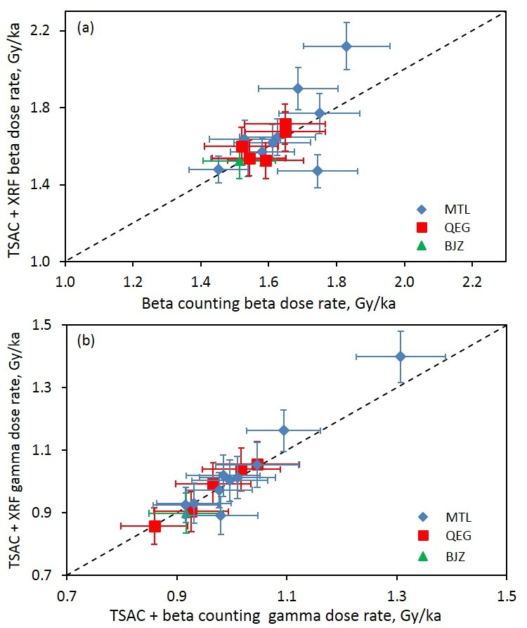
Supplementary Figure 1. (a) Beta dose rates for the samples in this study (except QEG-OSL-2, BJZ-OSL-1 and -5) measured by low-level beta counting, plotted against those determined by a combination of thick-source alpha counting (TSAC) and X-ray fluorescence (XRF) spectroscopy. (b) Gamma dose rates for the samples in this study (except QEG-OSL-2, BJZ-OSL-1 and -5) determined by a combination of TSAC and beta counting, plotted against those determined by a combination of TSAC and XRF spectroscopy.
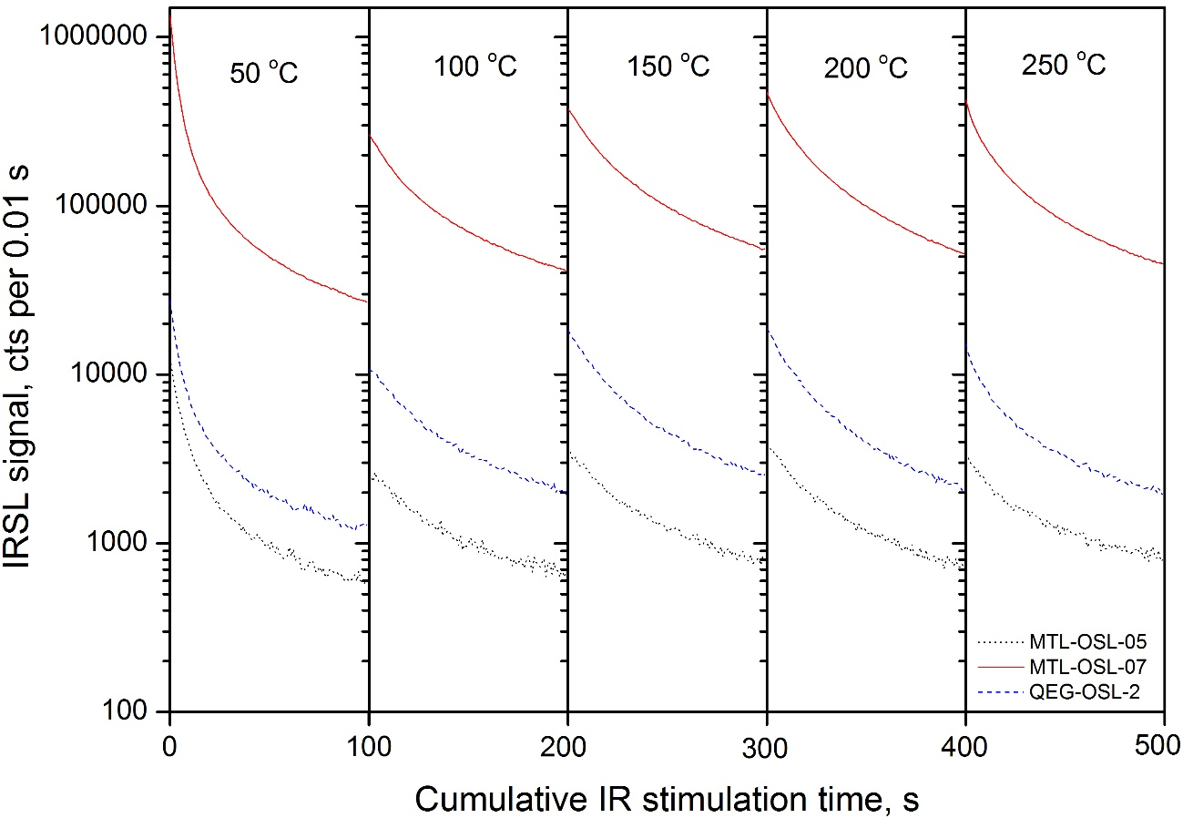
Supplementary Figure 2. Typical IRSL (50 °C) and MET-pIRIR (100─250 °C) decay curves for samples MTL-OSL-05, MTL-OSL-07 and QEG-OSL-02.
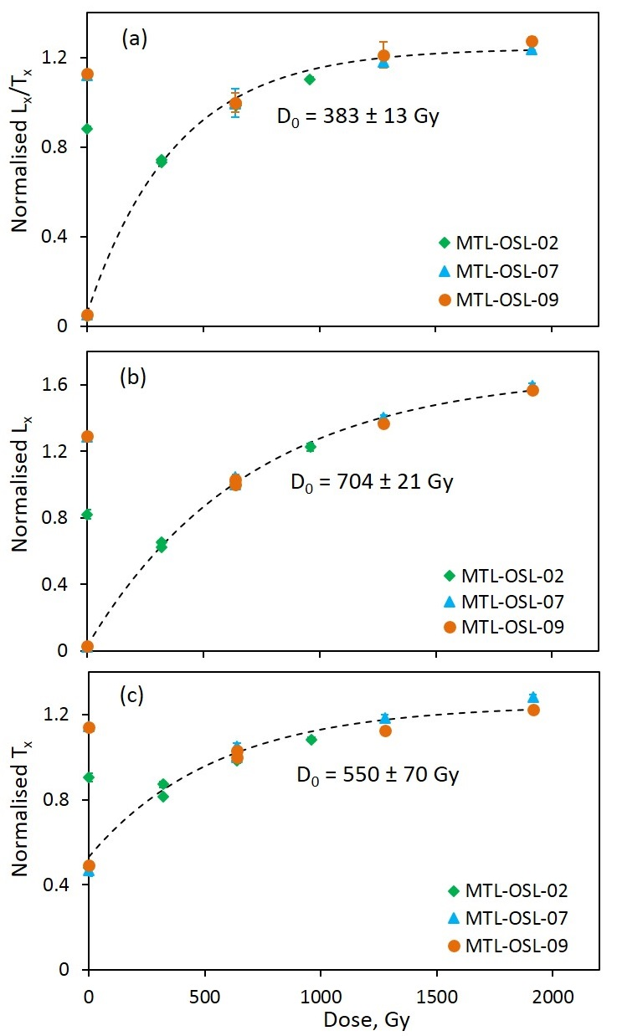
Supplementary Figure 3. Standardised growth curves (SGCs) for the (a) L_{x}/T_{x}, (b) L_{x} and (c) T_{x} signals measured at 250 °C using the SAR pMET-pIRIR procedure for samples MTL-OSL-02, -07 and -09. The natural signals are shown as the upper set of data points on the y-axis. Each data point represents the mean value for 4–6 aliquots and the vertical bars indicate the corresponding standard errors. The curves were fitted using a single saturating exponential function of the form , where I is the normalised IRSL intensity, D is the regenerative dose, D₀ is the characteristic saturation dose, and the sum of I₀ and c is the saturation value of the exponential curve. The curves have been normalised to unity at a dose of 638 Gy.

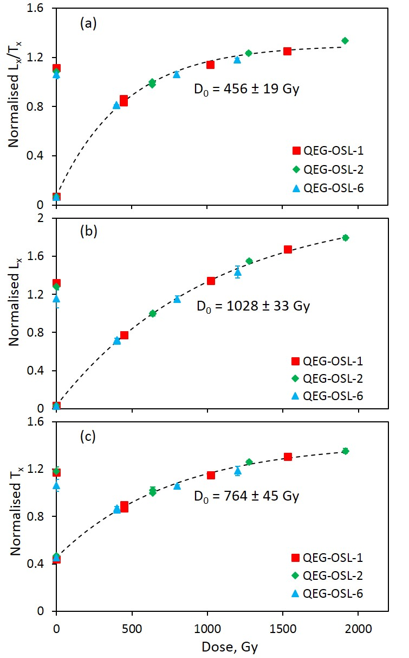
Supplementary Figure 4. Standardised growth curves (SGCs) for the (a) L_{x}/T_{x}, (b) L_{x} and (c) T_{x} signals measured at 250 °C using the SAR pMET-pIRIR procedure for samples QEG-OSL-1, -2 and -6. Other details as in Supplementary Figure 3, except that each data point is based on 4─8 aliquots.

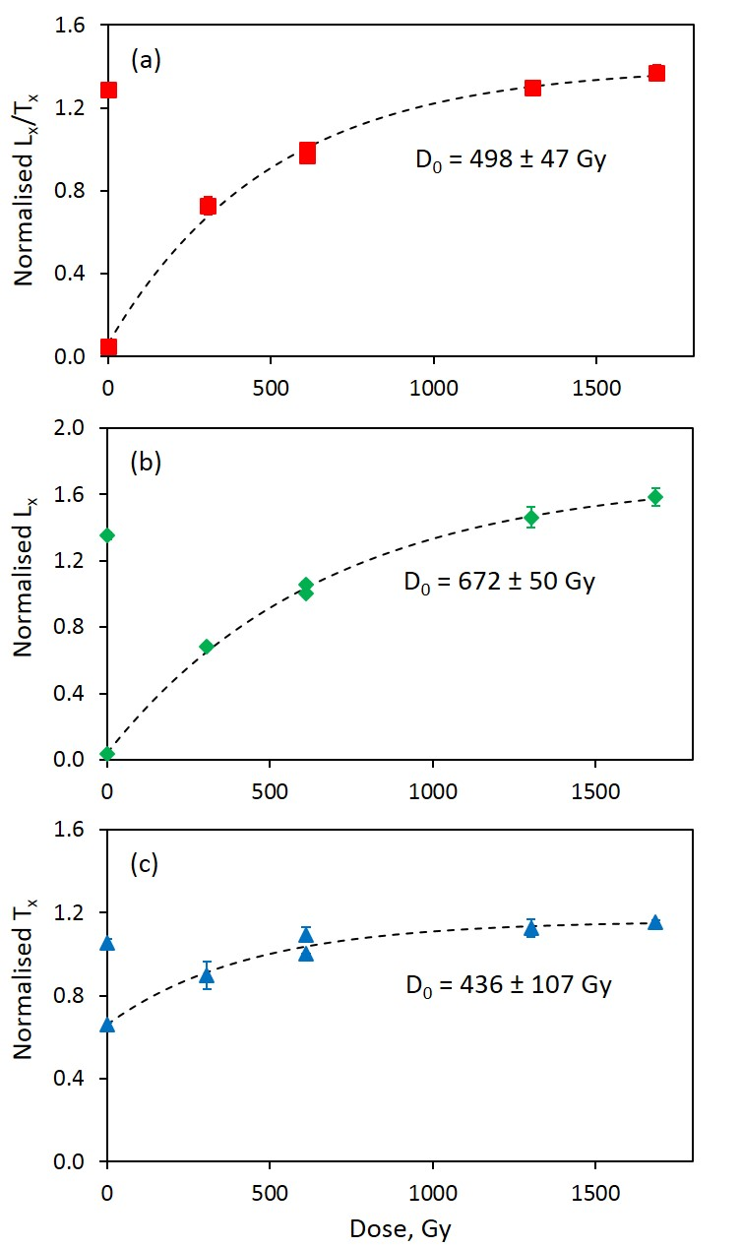
Supplementary Figure 5. Dose response curves (DRCs) for the (a) L_{x}/T_{x}, (b) L_{x} and (c) T_{x} signals measured at 250 °C using the SAR pMET-pIRIR procedure for polymineral sample MTL-OSL-05. Other details as in Supplementary Figure 3, except that the curves have been normalised to unity at a dose of 611 Gy.
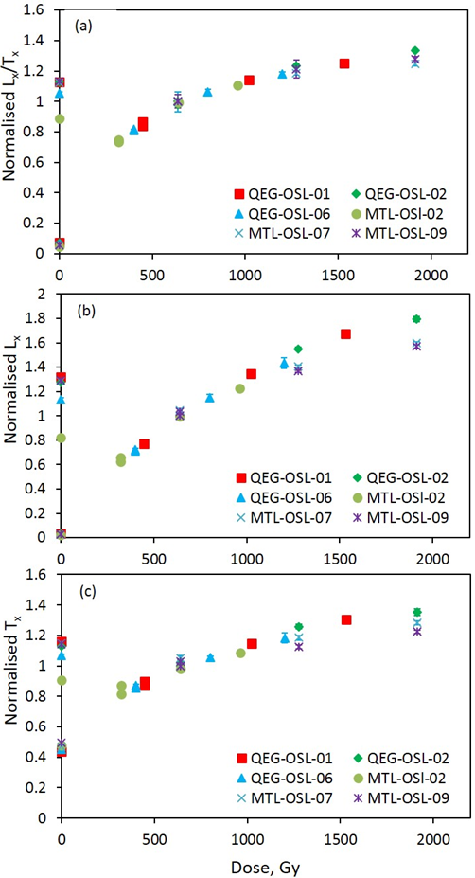
Supplementary Figure 6. Normalised regenerative dose signals for (a) L_{x}/T_{x}, (b) L_{x} and (c) T_{x} for samples MTL-OSL-02, -07 and -09 and QEG-OSL-1, -2 and -6. The natural signals are shown as the upper set of data points on the y-axis.

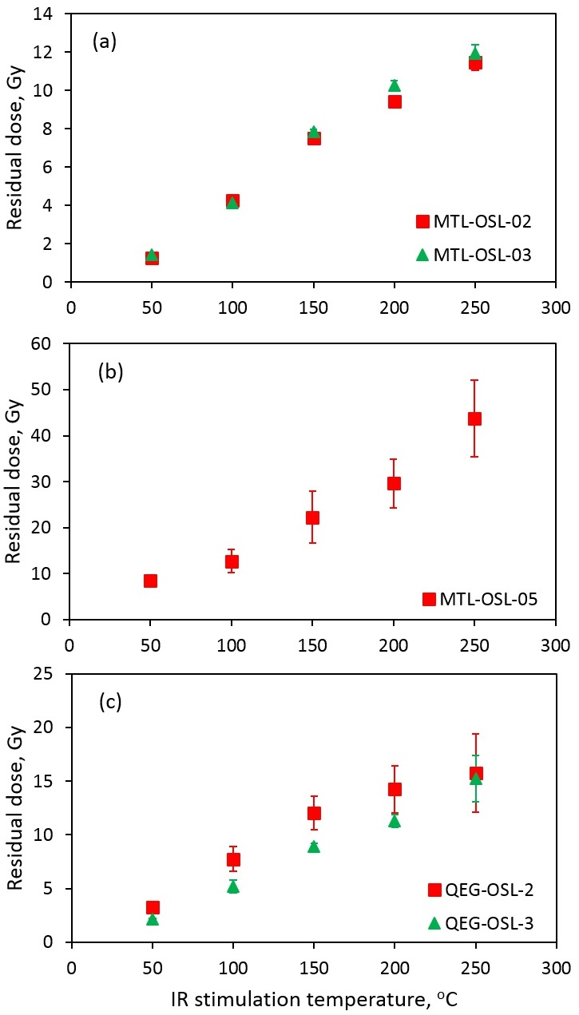
Supplementary Figure 7. Residual (unbleachable) doses measured for samples (a) MTL-OSL-02 and -03, (b) MTL-OSL-05, and (c) QEG-OSL-2 and -3 using the SAR MET-pIRIR procedure, plotted against IR stimulation temperature. Each data point represents the mean value for 4–6 aliquots and the vertical bars indicate the corresponding standard errors.
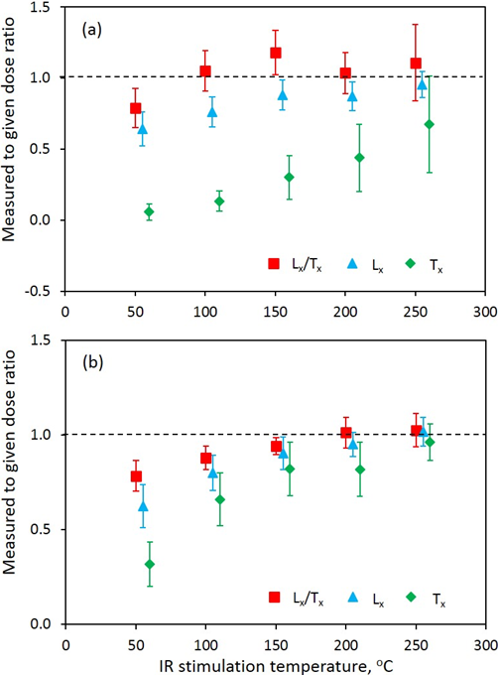

Supplementary Figure 8. Dose recovery ratios for the L_{x}/T_{x}, L_{x} and T_{x} signals from samples (a) MTL-OSL-05 and (b) QEG-OSL-2 obtained using the SAR pMET-pIRIR procedure, plotted against IR stimulation temperature. Each data point represents the mean value for 4–6 aliquots and the vertical bars indicate the corresponding standard errors. For clarity, the L_{x} and T_{x} data points are offset laterally at each stimulation temperature.

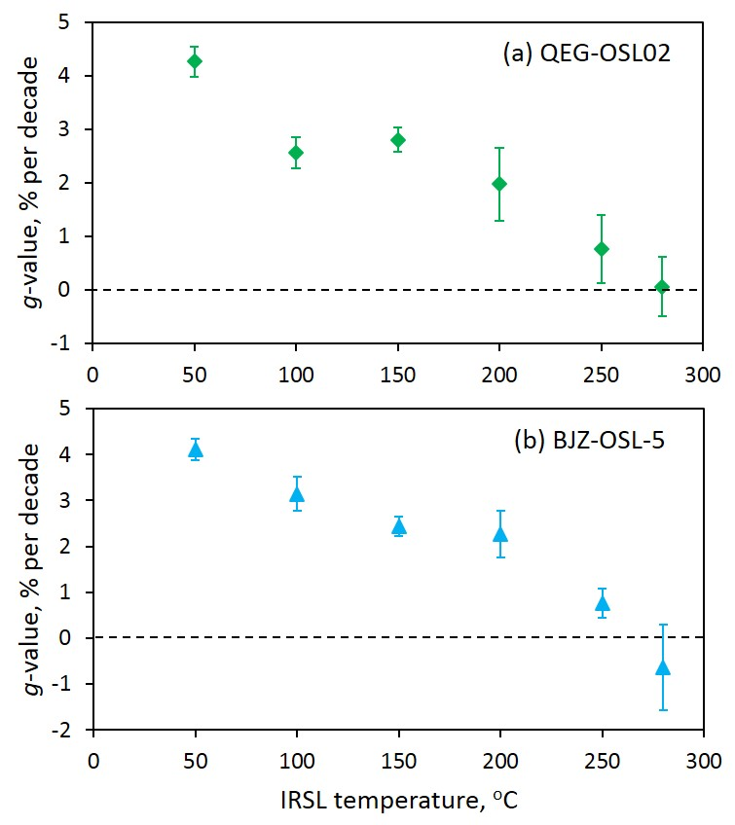
Supplementary Figure 9. Anomalous fading rates (g-values, expressed in % per decade) for the MET-pIRIR L_{x}/T_{x} signals of samples (a) QEG-OSL-2 and (b) BJZ-OSL-5 measured at IR stimulation temperatures of 50─280 °C.

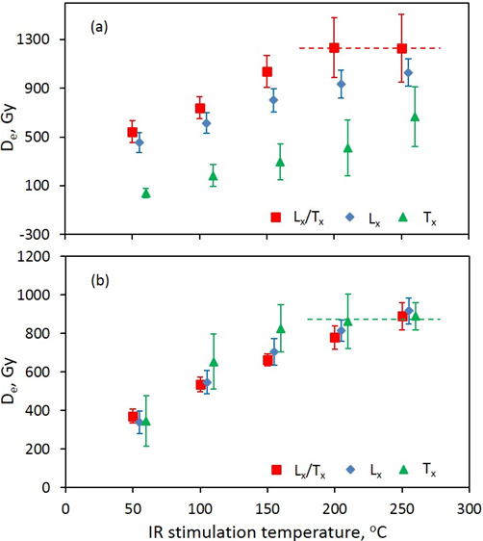
Supplementary Figure 10. D_{e} values obtained from the L_{x}/T_{x}, L_{x} and T_{x} signals of samples (a) MTL-OSL-05 and (b) QEG-OSL-02, plotted against IR stimulation temperature. For clarity, the L_{x} and T_{x} data points are offset laterally at each stimulation temperature.

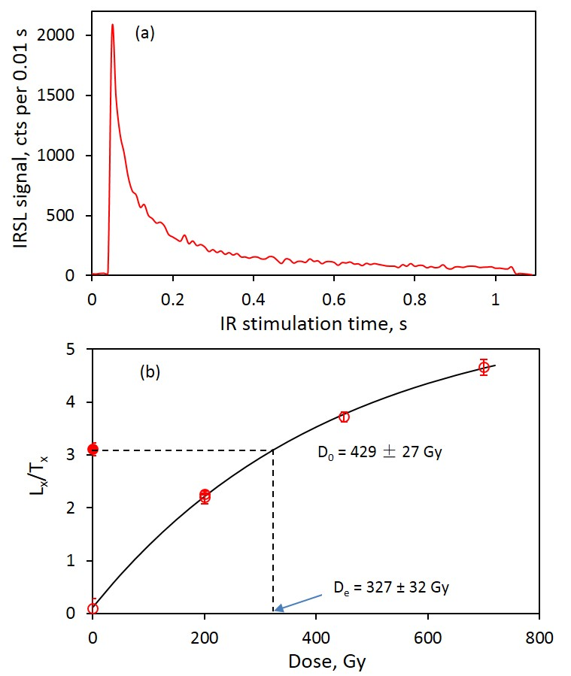
Supplementary Figure 11. (a) Typical 250 °C MET-pIRIR decay curve and (b) sensitivity-corrected dose response curve for a single K-feldspar grain from sample BJZ-OSL-3. The curve was fitted using a single saturating exponential function of the form , where I is the normalised IRSL intensity, D is the regenerative dose, D₀ is the characteristic saturation dose, and the sum of I₀ and c is the saturation value of the exponential curve. The natural dose signal is shown as a filled circle on the y-axis in (b).

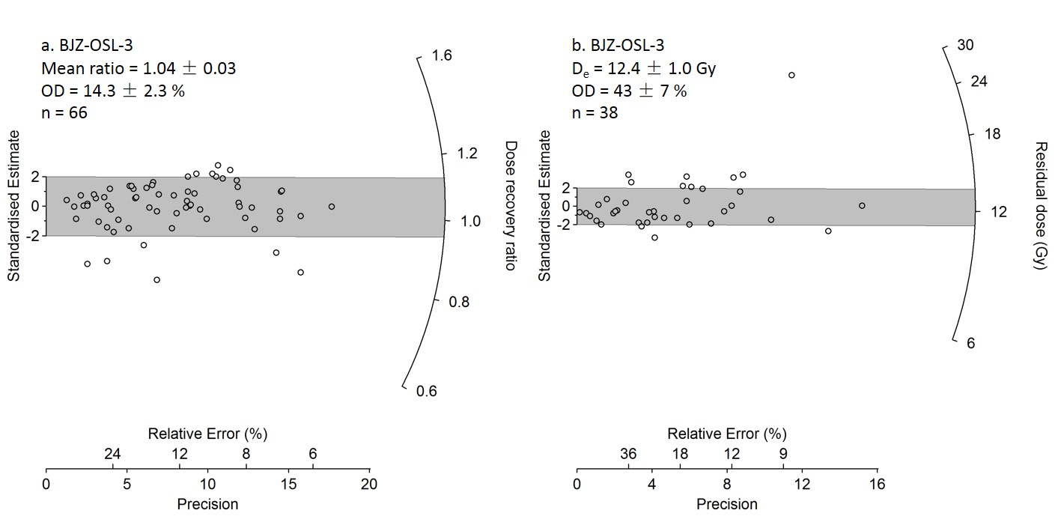
Supplementary Figure 12: (a) Distribution of dose recovery ratios (recovered dose/given dose) for all accepted K-feldspar grains of sample BJZ-OSL-3. (b) Distribution of residual dose values for all accepted K-feldspar grains of the same sample.

