SUPPLEMENTARY MATERIAL

1. Table of consensus hydrophobicities of the amino acids and nucleotides according to Eisenberg et al. (1982) and Boldina et al. (2009).

residue | consensus*
ILE | –0.73
PHE | –0.61
VAL | –0.54
LEU | –0.53
TRP | –0.37
MET | –0.26
ALA | –0.25
GLY | –0.16
CYS | –0.04
TYR | –0.02
PRO | 0.07
THR | 0.18
SER | 0.26
HIS | 0.40
GLU | 0.62
ASN | 0.64
GLN | 0.69
ASP | 0.72
LYS | 1.1
ARG | 1.8
base
T | –0.77
G | –1.36
C | –0.76
A | –1.07
(*) Posititive signs mean hydrophobic character. Negative signs mean negative hydrophobicity, that is hydrophilic character.

2. Description of the simulations of the relative rotations

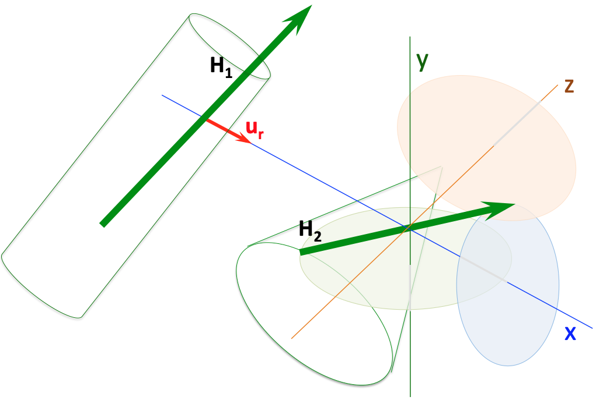
Figure S1. Two consecutive monomers with their H vectors (H₁ and H₂) and their D vectors (not drawn for simplicity) interact in order to form a dimer. Both energies enD and enH are computed by means of eqs. (11) – (12) (see main text) and then H₂ (or D₂) is rotated in three orthogonal directions, with respect to H₁ (or D₁) in steps of 10º. These directions of rotation are: rotation around the x–axis defined as the direction of the joining distance vector of H₁ and H₂ (u_{r}); rotation around the y–axis defined as the direction perpendicular to both the plane formed by the x–axis and vector H₂; rotation around the z–axis as the direction perpendicular to both x–axis and y–axis. For each simulated rotation angle, enH is computed. The same procedure is applied to electric dipole moments D₁ and D₂, and enD is computed. It should be noted that rotations performed for the H₂ vector over H₁ are independent of those performed for the D₂ vector over D₂.

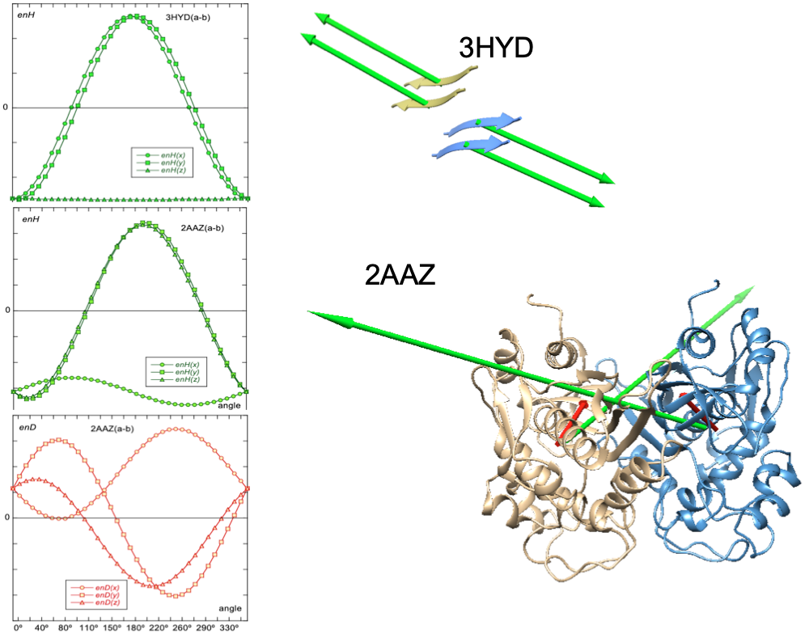
Figure S2. Examples of simulations of rotation of two contiguous monomers in systems PDBid: 3HYD and PDBid: 2AAZ. For both cases, rotations of one of the monomers over the other are simulated in the three directions of space in steps of 10º as described in Figure S1. Top plot: enH(x), circles; enH(y), squares; enH(z), triangles, are the angular variations of energies obtained from eq. (12) (see main text) for 3HYD. In this particular system the monomers are very small peptides, lacking substantial electric dipoles and are very well aligned in parallel, so the energy distributions appear very symmetrical. The native orientation between the monomers (0º) is that of minimum energy, that is, the orientation with the optimal energy value.
Systems like 2AAZ also show a hydrophobic attraction between adjancent monomers, as observed in the value of enH for 0º (middle plot), this value does not correspond to the optimal minimum energy. The interaction between the electric dipoles is repulsive for the native orientation (bottom plot, in red) and the angular distributions of enD has a marked asymmetry. This electrostatic repulsion, together with steric hindrances, prevent adequate relative orientation of the monomers for optimal hydrophobic attraction. This is the most common situations when studying macromolecular assemblies.

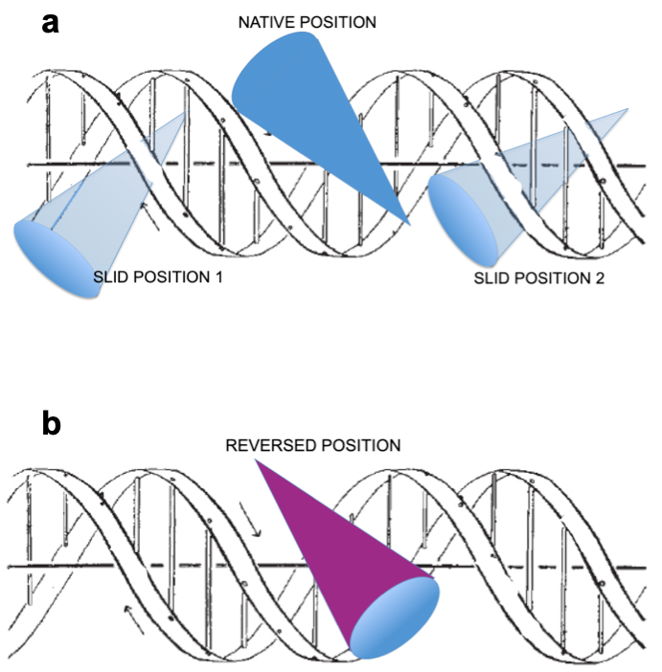
Figure S3. a) Schematic representation of the simulation of a protein (solid blue cone) sliding from its native position to both, backward (1) and forward (2) positions (pale blue cones). Energies enH and enD of interaction between the protein and the DNA may be computed either by taking the native position as reference or by taking the new slid position on the DNA as reference (see text). b) Simulation of reversing the sense of the position of (purple cone) from its native orientation

