DIFFERENTIAL REPAIR ENZYME SUBSTRATE SELECTION
WITHIN DYNAMIC DNA ENERGY LANDSCAPES

Jens Völker* and Kenneth J. Breslauer^{*&π}
* Department of Chemistry and Chemical Biology, Rutgers, The State University of New Jersey, 610 Taylor Rd, Piscataway, NJ 08854
& The Rutgers Cancer Institute of New Jersey, New Brunswick, NJ 08901

Supplementary material

Part1: Single Strand Melting:
Figure S1 shows the temperature dependent spectroscopic properties (UV, CD and 2Ap & pdC Fluorescence) of the [CAG]₈ and [CTG]₄ single stands measured simultaneously within the same experiment. The significant changes in spectral properties with temperature observed for all 4 spectroscopic observables indicate that the single strands are highly ordered/folded and undergo temperature induced gradual unfolding processes.
In an effort to gain better insight into the thermally induced unfolding process of the single strand we extracted conventional single wavelength denaturation curves for characteristic wavelength from each of the 3D spectra in Figure S1 and converted the resulting intensity versus temperature data into fraction melted (α) vs temperature curves to allow comparison between observables with very different signal intensities and opposing signs. The results are shown in Figure S2. Not unexpected for the thermal denaturation of repetitive single strands, we find that the unfolding process covers a wide temperature range and appears multiphasic, with different experimental observables showing different temperature dependencies, despite all denaturation curves being derived from the same measurement on the same sample. These observations suggest that the (CNG)_{n} oligonucleotides adopt an ensemble of multiple, near isoenergetic intra and intermolecular folded states each with their own temperature sensitivities that influence bulge loop formation upon 1:1 mixing of the strands. The important observation here is that, regardless of observable chosen, only a small fraction of either single strand has undergone a partial thermal unfolding process in the range of incubation temperatures used for testing the temperature dependence of bulge loop formation. As a consequence, bulge loop formation upon 1:1 mixing initiates from partially folded single strand states and depends on the incubation temperature. The existing single strand structure, especially within the repeat sequence, guides bulge loop formation during the initial fast association kinetics and biases the distribution of loop isomers initially formed. It is this single strand order that causes the kinetically trapped distribution of rollamers we observe by favoring those loop states where the preexisting repeat domain base pairing/fold back structure is least disrupted. In other words, the pre-existing order to the single strands, and in particular the repeat domain within these single strands, traps the rollamer ensemble initially formed in a metastable kinetically trapped state.

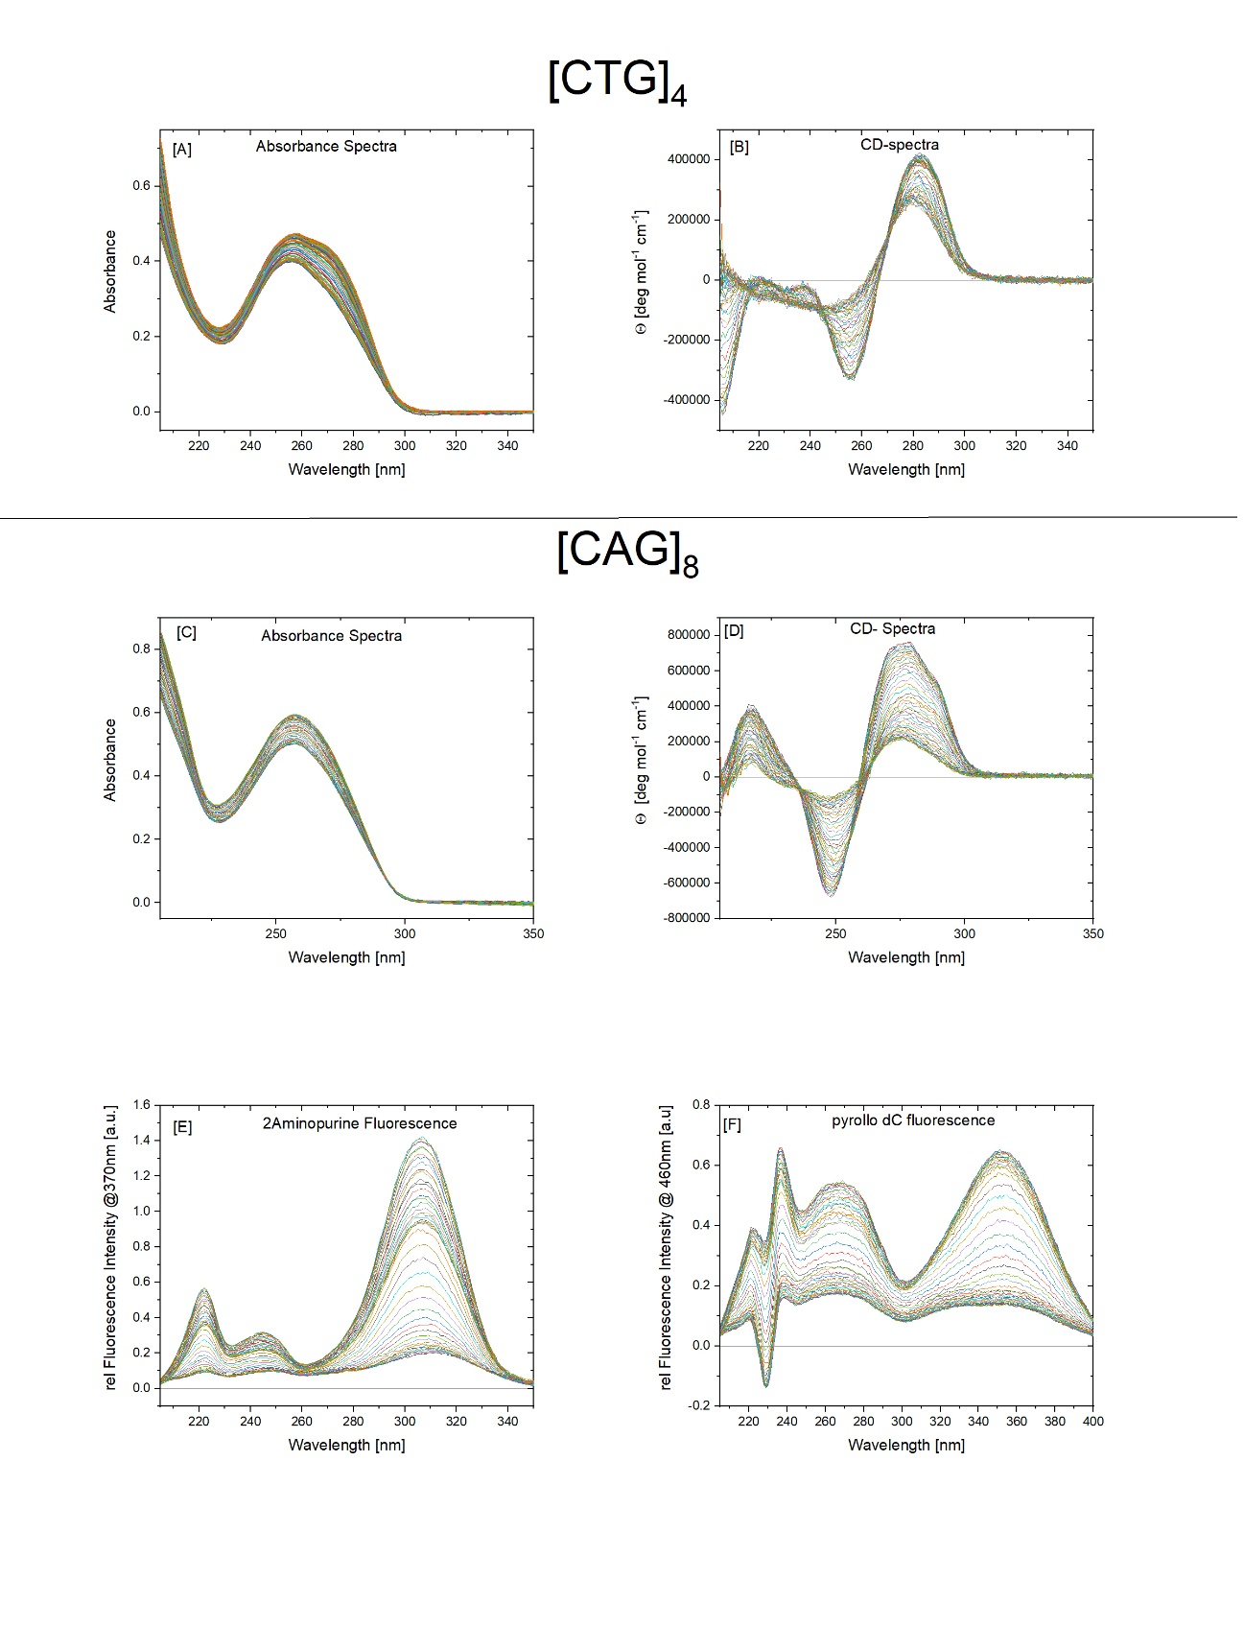
Figure S1: Temperature dependent changes in CD spectra, UV spectra, 2Ap fluorescence excitation spectra determined at the2Ap emission maximum of 370nm, pdC excitation spectra measured at the pdC excitation maximum of 460nm for the [CAG]₈ single strand. Similar spectral changes were recorded for the recorded for the parent single strand lacking an abasic site (not shown) , albeit shifted to lower temperature by a few degrees.
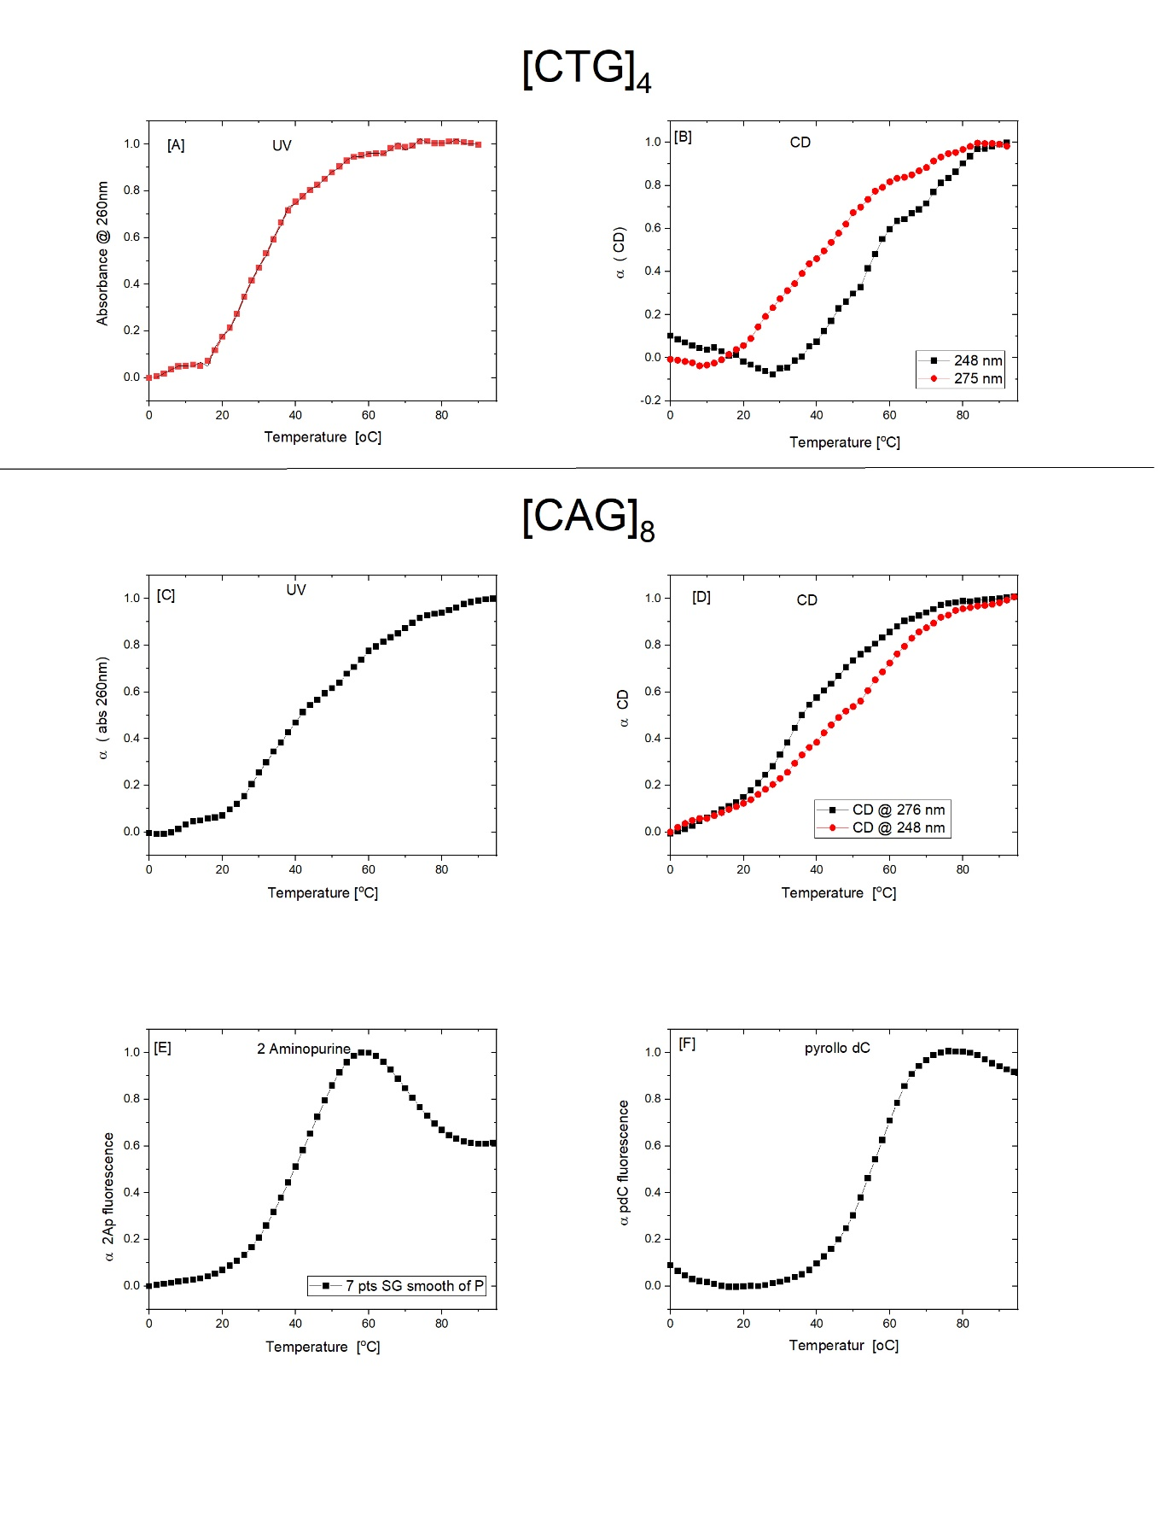

Figure S2 presents a comparison of the melting behavior of the single strand [CAG]₈ as detected by different observables. To allow comparisons between curves with significantly different signal intensities, the intensity data were converted into alpha (α)/ fraction melted data points for each observable. Note the differences in apparent Tm for the different observables indicating the differential sensitivities of the different observables to the melting behavior of the broad ensemble of folded structure adopted by the single strand. Note also some fraction of the single strand self-structure has been disrupted at temperatures below 40°C, providing an explanation for the temperature dependence of the rollamer loop distributions initially formed on mixing the [CAG]₈ strand with the [CTG]₄ described earlier.

Part 2: Kinetics of loop redistribution:
Figure S3 shows the time dependent changes in 2Ap fluorescence at 48°C detected for the kinetically trapped rollamer distributions obtained at variable incubation temperatures. 48°C was chosen for the experiments shown in Figure S3, as loop redistribution to the equilibrium state at temperature below 45°C proceeds too slowly to result in a meaningful kinetic curve. Even at 48° the redistribution kinetics is incomplete after 24000 sec as shown by the change in fluorescence after a temperature jump to 60 ˚C for 600 sec and back to 48°C. These two temperature jumps result in the two step changes in fluorescence intensity seen in Figure 3S after 24000 sec and 24600 sec, respectively. Figure S3 also reveals that regardless of the initial loop distribution, indicated by different initial 2Ap fluorescence intensities, the final fluorescence intensity recorded after heat annealing at 60°C is the same. Together, our observations suggest that rollamer formation is composed of two separate kinetic processes, a fast (on the timescale of our measurements) bimolecular reaction that leads to the formation of the global rollamer structure with a particular distribution of loop isomers, identified by its common CD spectrum and variable, condition depend, 2Ap fluorescence intensities. This fast kinetic process is followed by a slow intramolecular rearrangement of the distribution of loop isomers to the final equilibrium state, characterized by the same CD spectrum as seen initially and a gradual change in 2Ap fluorescence intensity to a common (equilibrium) intensity that does not undergo further changes with incubation times.
Figure S3: Time dependent changes in 2Ap fluorescence at 48°C after initial rollamer formation at the incubation temperature indicated.
