Supplementary Information

Anionic Food Color Tartrazine Enhances Antibacterial Efficacy of Histatin-derived Peptide DHVAR4 by Fine-Tuning its Membrane Activity
Maria Ricci, Kata Horváti, Tünde Juhász, Imola Szigyártó, György Török, Fanni Sebák, Andrea Bodor, László Homolya, Judit Henczkó, Bernadett Pályi, Tamás Mlinkó, Judith Mihály, Bilal Nizami, Zihuayuan Yang, Fengming Lin, Xiaolin Lu, Loránd Románszki, Attila Bóta, Zoltán Varga, Szilvia Bősze, Ferenc Zsila*, Tamás Beke-Somfai*

Table of contents
Materials 3
Supplementary Methods 4
Supplementary Results 8
Antibacterial tests – initial experiment 8
Comparative assays to analyze the synergistic effect of TZ on the antibacterial activity of DHVAR4. 11
Flow cytometry 12
Fig. S3 CD baseline spectra of tartrazine and amaranth. 13
NMR investigation 14
Infrared Spectroscopy 16
Molecular docking simulation 17
Supplementary Figures 19
Fig. S6. DLS investigation. 19
Fig. S7. UV absorbance spectra associated with the CD data displayed in Fig. 4a. 20
Fig. S8. Alfa-helicity of DHVAR4. 21
Fig. S9. a Infrared spectra in the acyl chain region of PC/PG and PC liposomes. 22
Fig. S10. Infrared spectra of PC/PG liposomes in the presence of TZ. 23
Fig. S11 IR spectra in the PC/PG phosphate stretching region in the presence of an excess of lipid. 24
Fig. S12 Morphology of PC/PG liposomes in the presence of DHVAR4 and the studied azo compounds 25
Fig. S13. Annexin V affinity assay. 26
Fig. S14. a Peptide localization in E. coli cells 27
Fig. S15. Analytical characterization of the peptides 28
References 29

Materials
1,2-dipalmitoyl-sn-glycero-3-phospho-(1'-rac-glycerol) (DOPC) and1,2-dioleoyl-sn-glycero-3-phospho-(1'-rac-glycerol) (DOPG) were purchased from Avanti Polar Lipids Inc and NOF Europe GmbH. Food colors were purchased from Sigma-Aldrich. All chemicals were used without further purification.
For peptide synthesis, amino acid derivatives were obtained from Reanal Laboratory Chemicals (Hungary) or from Iris Biotech (Germany). Reagents, such as N,N’-diisopropylcarbodiimide (DIC), triisopropylsilane (TIS), 1-hydroxybenzotriazole (HOBt), and 1,8-diazabicyclo[5.4.0]undec-7-ene (DBU), 5(6)-carboxyfluorescein (Cf) were purchased from Sigma-Aldrich (Hungary). Trifluoroacetic acid (TFA), N,N-dimethylformamide (DMF) and acetonitrile were from VWR. All chemicals were used without further purification.
For the in vitro assays, RPMI-1640 medium, fetal calf serum (FCS) and trypsin were obtained from Sigma-Aldrich. HPMI buffer (9 mM glucose, 10 mM NaHCO₃, 119 mM NaCl, 9 mM HEPES, 5 mM KCl, 0.85 mM MgCl₂, 0.053 mM CaCl₂, 5 mM Na₂HPO₄ × 2H₂O, pH 7.4 was prepared in our laboratory using components obtained from Sigma-Aldrich (Hungary).

Supplementary Methods
Synthesis, purification and characterization of DHVAR4 and Cf-DHVAR4 peptides
Peptides were produced on Rink Amide MBHA resin (capacity = 0.71 mmol/g, Novabiochem) in an automated peptide synthesizer (Syro-I, Biotage, Sweden) using standard Fmoc/tBu strategy with HOBt/DIC coupling reagents. To obtain a fluorescent derivative of DHVAR4 peptide, N-terminal amino group was conjugated with 5(6)-carboxyfluorescein (Cf) in the presence of DIC/HOBt reagents. Peptides were cleaved from the resin with TFA/H₂O/TIS (9.5 : 2.5 : 2.5 v/v) mixture (2 hrs, RT). After filtration compounds were precipitated in cold diethyl ether, centrifuged (4000 rpm, 5 min) and freeze-dried from water. Crude products were purified by using an UltiMate 3000 Semipreparative HPLC (Thermofisher, USA) on a semipreparative C-18 Phenomenex Jupiter column (10 mm × 250 mm, 5 µm) using gradient elution, consisted of 0.1% TFA in water (eluent A) and 0.1% TFA in acetonitrile/water = 80/20 (v/v) (eluent B). Purified peptides were analyzed by RP-HPLC on an analytical Waters Symmetry C-18 (4.6 mm × 150 mm, 5 µm) HPLC column using gradient elution with the above-mentioned eluent A and B (flow rate was 1 mL/min, UV detection at λ = 220 nm). Molecular mass of the peptides was determined by using a Bruker Esquire 3000+ ion trap mass spectrometer (Bruker, Germany) equipped with electrospray ionization (ESI) source (see also Figure S15). Peptide samples were dissolved in a mixture of acetonitrile/water = 1:1 (v/v) containing 0.1% acetic acid and introduced by a syringe pump with a flow rate of 10 µL/min. Peptide content of the final products was determined by amino acid analysis performed on a Sykam Amino Acid S433H analyzer (Eresing, Germany) equipped with an ion exchange separation column and post-column derivatization. Prior to analysis samples were hydrolyzed with 6 M HCl in sealed and evacuated tubes at 110°C for 24 hrs. For post-column derivatization the ninhydrin-method was used. Analytical characteristics of the peptides are indicated in Table S1 and Figure S15.
Table S1 Analytical characteristics of the investigated peptides
Peptide | Sequence | M_{av} calc/found | R_{t} (min) | Peptide content
DHVAR4 | KRLFKKLLFSLRKY | 1839.4/1839.2 | 11.0 | 48%
Cf-DHVAR4 | 5(6)-carboxyfluorescein-KRLFKKLLFSLRKY | 2197.6/2197.5 | 13.8 | 46%

Liposome preparation
Unilamellar DOPC/DOPG and DOPC liposomes were prepared with the lipid thin film hydration technique. An appropriate amount of lipids at the molar ratio DOPC:DOPG = 8:2 were firstly dissolved in chloroform. After evaporation of the solvent, the resulting lipid film was kept in vacuum overnight to remove the residual traces of the organic solvent. The dry lipid film was then hydrated using a 10 mM, pH = 7.4 phosphate buffered saline solution (PBS, Sigma-Aldrich, Hungary) made of ultrapure water (18.2 MΩcm) to achieve a final lipid concentration of 10 mg/ml. The sample was homogenized thorough ten freeze-thaw cycles, by using liquid nitrogen and warm water bath (~50 °C). In order to obtain unilamellar liposomes, the sample was extruded for ten times through polycarbonate filters (Nuclepore, Whatman Inc.) with 100 nm pore size using a LIPEX extruder (Northern Lipids Inc., Canada). For ATR-IR and CD measurements, liposomes were extruded through polycarbonate filters with 200 nm pore size.

Molecular docking simulation
In order to explore the localization of TZ on the helical DHVAR4, molecular docking simulation was performed using AutoDock Vina V1.1.2 (Trott and Olson, 2010). AutoDock Vina and its scoring function is one of the most widely used docking software suit(Huey et al., 2004) with significant improvement in the precision in prediction (Trott and Olson, 2010). The starting 3D coordinates of TZ was obtained from ChemSpider (10606981). Prior to docking simulation, counterions were removed from TZ. For accurate spatial representation of the ligand, structure of TZ was optimized with Gaussian 09 software package (M. J. Frisch, G. W. Trucks, H. B. Schlegel, G. E. Scuseria, et al., 2013) at the RHF/3-21G level of theory. Initial structure of DHVAR4 was modelled in a complete helical conformation as assumed to be present in the membrane bound state. Ligand and peptide were preprocessed in the following way using Autodock tool 4.2 (Morris et al., 2009): (a) non-polar hydrogens were merged; (b) Gasteiger charges were added to TZ and DHVAR4 molecule; (c) number of torsion was determined for ligand; (d) a sufficiently large search space of 25 X 25 X 25 Å centred on the peptide was defined, so as to cover the entire DHVAR4. While TZ was treated as flexible molecule, only the side chains of the DHVAR4 were kept flexible. A total of 20 TZ-DHVAR4 conformations were generated during the docking simulations. These showed no significant variation in energy, thus they were clusterized based on the relative orientation of DHVAR4 and TZ.

Dynamic Light Scattering (DLS)
The measurement of the average size and size distribution of liposomes was performed using a W130 apparatus (Avid Nano Ltd., High Wycombe, UK). 80 µL sample was dissolved in PBS and measured in a disposable low-volume cuvette (UVette, Eppendorf Austria GmbH). The data analysis was performed using the i-Size 3.0 software supplied with the device.

NMR spectroscopy
NMR spectra were recorded on a Bruker Avance III 700 spectrometer operating at 700.05 MHz using a Prodigy TCI H&F-C/N-D, 5 mm z-gradient probehead. Temperature was calibrated against the methanol standard sample; measurements were performed at 298 K. ¹H chemical shifts were referenced to the internal DSS standard. Resonance assignment and sequential connectivities for DHVAR were determined from 2D homonuclear TOCSY (mixing time 80 ms), NOESY (mixing times 100 ms, 300 ms) and COSY measurements. ¹⁵N fast HMQC and ¹³C HSQC measurements were performed on the natural abundance compounds. Translational diffusion coefficients were determined using the stimulated echo pulse sequence with bipolar pulses and water suppression. The diffusion time Δ and the diffusion gradient length δ were kept constant, and gradient strength was varied linearly in 16 steps, from 5 to 95 % of its value. All spectra were processed and translational diffusion coefficients were calculated within TopSpin. Peak assignment was done using Sparky (Goddard and Kneller, 2001). All samples were prepared in 10 mM phosphate buffer, 50 mM Na₂SO₄, 10% D₂O. The peptide and/or TZ concentration was 1 mM. For the titration experiment, the following peptide and TZ concentrations were used (relative TZ concentration to peptide DHVAR4 in bracket): 0.95 mM peptide and 0.38 mM TZ (40%), 0.93 mM peptide and 0.65 mM TZ (70%), 0.91 mM peptide and 0.91 mM TZ (100%).

Atomic Force Microscopy (AFM)
AFM images were recorded by a Dimension 3100 atomic force microscope (AFM) equipped with a Nanoscope IIIa controller (Digital Instruments/Veeco, Santa Barbara, California, USA), using silicon cantilevers in TappingModeTM oscillating at 293.1 kHz frequency, providing a 512×512 point resolution. Raw measurement files were processed using the Nanoscope software by applying a 3rd order flattening. The samples were prepared by placing 1 µL droplets of pure aqueous solution of the DHVAR4-TZ complex on a piece of (100) silicon wafer and letting to dry by evaporation.

Field Emission Scanning Electron Microscopy (FESEM)
E. coli cells were cultivated in LB medium at 37 °C shaken at 200 rpm overnight. Cells were centrifuged at 8000 rpm for 5 min and then resuspended in 0.9% NaCl. The optical density at 600 nm (OD600) of the bacterial suspension was measured using a UV-vis spectrophotometer (UV-2600, Shimadzu, Japan). Then, the bacterial suspension was diluted to OD₆₀₀ = 0.5 with 0.9% NaCl and mixed with DHVAR4 or DHVAR4-TZ dissolved in PBS. The final concentrations of DHVAR4 and TZ are 20 μM and 40 μM, respectively. The samples were incubated for 40 minutes at 37 ℃. All samples were collected by centrifugation at 8000 rpm for 5 min and then resuspended in 0.9% NaCl. After washing with 0.9% NaCl three times, the bacteria cells were mixed with 2.5% (v/v) glutaraldehyde for 12 hrs to fix the cell morphology, followed by dehydration using graded ethanol (30%, 50%, 70%, 90%, and 95%). Then the bacterial cells were resuspended in 100% ethanol and dripped in a silicon slide for SEM imaging using a scanning electron microscope (ULTRA Plus FESEM, Zeiss, Germany).

Supplementary Results

Antibacterial tests – initial experiment
The first set of experiments was performed in order to select a food color that showed the highest alteration effect on the antibacterial activity of DHVAR4 peptide on S. pneumoniae (ATCC 49619) (Table S2). In vitro antibacterial activity of the compounds was determined against by serial dilution method in Brain Heart Infusion (BHI) medium, which was prepared in-house. Compounds were added to the medium as 10 μL DMSO solutions in duplicates (range of final concentrations was between 0.01 and 50 μM). Each tube was inoculated with 0.5 Mcfarland bacteria and the minimal Inhibitory concentration (MIC) was determined after incubation at 37 ºC for 16-24 hrs. MIC was the lowest concentration of a compound at which no visible growth of the bacteria occurred and relative bacterial count was compared to untreated control tubes. The following food colors were measured: ponceau 4R, tartrazine, allura red AC, amaranth, azorubine and indigo carmine (Fig. S1a and Table S2).
First, the food colors were measured alone, without the addition of DHVAR4. Allura red AC showed antibacterial activity at 30 μM, therefore this food color was not investigated further. Remaining dyes were measured with DHVAR4 in a mixture of 1:1 molar ratio (Fig. S1b). Somewhat lower bacterial load was detected for DHVAR4 in the presence of amaranth, azorubine, Ponceau 4R and indigo carmine. The highest alteration effect on the antibacterial activity of DHVAR4 was measured for tartrazine, therefore this dye was studied further in more details.

Table S2 Basic properties of the investigated dyes
Compound | MW  (gmol⁻¹) | Empirical formula | Chemical name | n. anionic groups
Tartrazine (E102) | 534.37 | C₁₆H₉N₄Na₃O₉S₂ | Trisodium 5-hydroxy-1-(4-sulphonatophenyl)-4-(4-sulphonatophenylazo)-H-pyrazole-3-carboxylate | 3
Amaranth (E123) | 604.48 | C₂₀H₁₁N₂Na₃O₁₀S₃ | Trisodium 2-hydroxy-1-(4-sulphonato-1- napthylazo)naphthalene-3,6-disulphonate | 3
Indigo carmine  (E132) | 466.35 | C₁₆H₈N₂Na₂O₈S₂ | Disodium 3,3′-dioxo-2,2′-bi-indolylidene-5,5′-disulphonate. | 2
Ponceau 4R  (E124) | 604.46 | C₂₀H₁₁N₂Na₃O₁₀S₃ | Trisodium-2-hydroxy-1-(4-sulfonato-1-naphthylazo)  naphthalene-6, 8-Disulfonate | 3
Azorubin  (E122) | 502.42 | C₂₀H₁₂N₂Na₂O₇S₂ | Disodium 4-hydroxy-3-(4-sulfonato-1-naphthylazo)  naphtylene-1-sulfonate | 2
Allura red  (E129) | 496.42 | C₁₈H₁₄N₂Na₂O₈S₂ | Disodium 6-hydroxy-5-((2-methoxy-5-methyl-4-sulfophenyl)azo)-2-naphthalenesulfonate | 2

Fig. S1. a Chemical structure, name and color of the investigated food dyes. b Antibacterial activity of DHVAR4 in the absence and presence of food colors (1:1 molar ratio) measured on S. pneumoniae.

Comparative assays to analyze the synergistic effect of TZ on the antibacterial activity of DHVAR4.
The next set of experiments aimed to analyze the modifying effect of tartrazine (TZ) on the DHVAR4 antimicrobial activity. The antibacterial effect of the compounds was measured on E. coli (ATCC 35033) and on S. pneumoniae (ATCC 49619) strains using a 96-well plate-based assay. For the method description see main text (Methods 2.1. Section). A representative set of raw OD data are shown in Table S3. Relative bacterial count was calculated as follows: extracting the average medium control values from the OD values of the sample and divided by the average OD of the growth control (Harnack,K. et al., 1999; Janke, S. A. et al., 1999; Jorgensen and Ferraro, 2009; Marlon, L. Bayot and Bradley, N. Bragg, 2019; White Paper, 2015).

Relative bacterial count = (OD - ODmedium control) / (OD growth control - ODmedium control).

Table S3. Representative raw OD data of the antibacterial assay
medium control | growth control | TZ | DHVAR4 |  |  |  |  | DHVAR4 + 40 µM TZ
 |  | 40 µM | 5 µM | 10 µM | 20 µM | 40 µM |  | 5 µM | 10 µM | 20 µM | 40 µM
0,251 | 1,608 | 1,573 | 1,514 | 1,485 | 1,403 | 0,249 |  | 1,609 | 1,416 | 0,663 | 0,326
0,257 | 1,590 | 1,613 | 1,65 | 1,505 | 1,515 | 0,252 |  | 1,607 | 1,458 | 0,748 | 0,256
0,252 | 1,466 | 1,613 | 1,653 | 1,477 | 1,485 | 0,336 |  | 1,602 | 1,428 | 1,230* | 0,201
0,251 | 1,303
0,250 | 1,783 |  |  |  |  |  |  |  |  | *contamination
0,247 | 1,620
0,249 | 1,604
0,248 | 1,666
0,251 | 1,580 | =Avarage

Flow cytometry
We investigated the uptake of the peptide in mammalian cancer cells (HeLa; cervical adenocarcinoma cell line(Gey, G. O. Kubicek, M. T. and Coffman, W. D., 1952)) using flow cytometry in the absence and presence of TZ, to reveal a possible influence of the azo dye on the internalization efficiency. HeLa cells were treated with three peptide and peptide-TZ (molar ratio 1:1) concentrations, namely 5 µM, 10 µM and 25 µM. In order to reveal a time-dependent internalization, samples were incubated for 15 and 60 minutes. Results show that Cf-DHVAR4 is able to enter HeLa cells with high efficiency. In particular, mean fluorescence values show that the peptide uptake depends on the concentration and, to a lesser extent, on the incubation time (Fig. 2c). Indeed, higher internalization rate was measured after 60 minutes, compared to 15 minutes.
It is worth noting that even after 15 minutes of incubation 100% of the cells were FITC-positive (Fig. S2). However, the presence of TZ did not show alteration on the cellular uptake of HeLa cells.
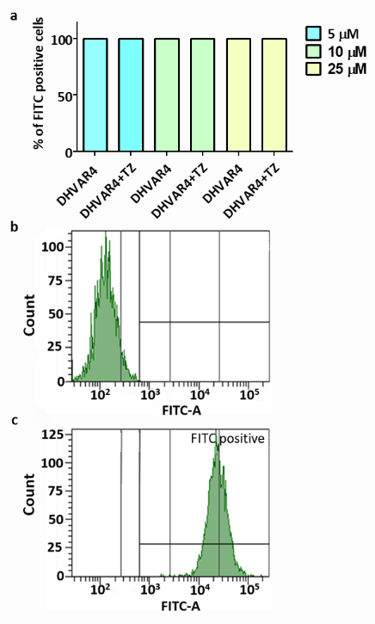
Fig. S2. a Percentage of FITC-positive cells quantified by flow cytometry after 15 min incubation of HeLa cells with 5 µM, 10 µM and 25 µM Cf-DHVAR4 and DHVAR4+TZ. The molar ratio DHVAR4:TZ is 1:1. b Autofluorescence of untreated HeLa cells. c Fluorescence of cells treated with 10 µM Cf-DHVAR4.

Fig. S3 CD baseline spectra of tartrazine and amaranth. CD spectra of the dyes in 10 mM, pH 7.3 potassium phosphate buffer (0.05 M Na₂SO₄).

NMR investigation
From 2D homo- and heteronuclear measurements (TOCSY, NOESY, ¹H,¹³C-HSQC, ¹H,¹⁵N-sofast HMQC at natural isotopic abundance) the full assignment for 13 residues (out of 14) of the DHVAR4 peptide is obtained. Structural elements can be assessed on the basis of secondary chemical shift (SCS) analysis, by following the SCS=δ(measured)-δ(random coil) trend along the amino acid sequence. Secondary chemical shifts calculated for Hα environments can report on existent structural motifs: SCS = δ_{measured} - δ_{RC} where reference random coil values were sequence-, temperature- and pH- corrected (Kjaergaard and Poulsen, 2011). SCS Hα values are close to 0.0 meaning the chemical shift environments are around random coil values and no tendencies are observed along the amino acid sequence (see Fig S3).
As shown in Fig. S3, there is no preferred tendency along the aminoacid sequence, the values deviate between -0.2 – 0.2 ppm being in full accordance with a highly mobile, disordered peptide fragment.
Fig. S4. Secondary chemical shifts of DHVAR4 for Hα
To study the DHVAR4 and TZ interaction, the peptide was titrated with TZ, and at each addition 1D ¹H NMR spectra and DOSY measurements were recorded. TZ has four aromatic peaks in the 7.6-8.0 ppm region, which do not overlap with any of the peptide resonances. The titration of DHVAR4 was done with increasing 0, 40, 70 and 100% relative TZ concentration in order to achieve a final 1:1 ratio (1mM of each partner). Above 40% relative concentration, a yellow precipitate was formed in increasing amounts with successive tartrazine addition.
To follow the possible complex formation, translational diffusion coefficients were determined (Table S4). For evaluation, the peptide aliphatic peaks and for TZ the aromatic peaks were used. The diffusion coefficients remained constant during the titration (both for peptide and TZ). This means that there is no significant amount of peptide-tartrazine complex in the solution.

Table S4 Diffusion coefficients for DHVAR4 and TZ measured by diffusion NMR
Sample | D / m²/s
 | DHVAR4 | TZ
TZ | - | (4.6 ± 0.1) ·10⁻¹⁰
DHVAR4 | (2.1 ± 0.1) ·10⁻¹⁰ | -
DHVAR4-TZ (40 %) | (2.0 ± 0.1) ·10⁻¹⁰ | (4.8 ± 0.1) ·10⁻¹⁰
DHVAR4-TZ (70 %) | (2.0 ± 0.1) ·10⁻¹⁰ | (4.7 ± 0.2) ·10⁻¹⁰
DHVAR4-TZ (100 %) | (2.1 ± 0.1) ·10⁻¹⁰ | (4.7 ± 0.1) ·10⁻¹⁰

Infrared Spectroscopy

Amide I band, Fig. 3e
The analysis of the infrared spectrum of DHVAR4 in the region of the amide I reveals the presence of different contributions (Fig.3e, second derivative), namely α-helices, disordered conformations (1657 cm⁻¹), turns (1675 cm⁻¹) and intermolecular β-sheets (1627 cm⁻¹ and 1695 cm⁻¹) (Barth, 2007; Dong et al., 1998; Ismail et al., 1992). The high local peptide concentration enhances intermolecular interactions, which might cause oligomerization.

Amide I band, Fig. 4b
The amide I band of DHVAR4 in the presence of PC/PG membranes is characterized by the prominent contribution at 1655 cm⁻¹, which is representative of α-helices (Fig. 4b, second derivative). The two less intense contribution (1676 and 1689 cm⁻¹) may be attributed to turns and β-sheets (Barth, 2007; Dong et al., 1998) or to peculiar conformations observed for membrane surface-bound peptides (Brauner et al., 1987).

Acyl chain region, Fig S9a
The acyl chains of the membrane lipids can be described by the CH₂ symmetric (~2850 cm⁻¹) and antisymmetric (~2920 cm⁻¹) stretching vibrations. The interaction of DHVAR4 and the complex DHVAR4-TZ with PC/PG, as well as PC liposomes does not alter the band position of the methylene vibrations (Fig. S9a), suggesting (Ricci et al., 2016) that the hydrophobic lipid tail region is involved in the interaction neither for the peptide alone nor for the DHVAR4-TZ complex.

Phosphate region, Fig. 4e
It is possible to find the phosphate stretching in two ranges, at 1050–1100 cm⁻¹ and around 1190–1265 cm⁻¹. The phosphate antisymmetric stretching ν_{asym}(PO₂⁻) shows a band at ~1240 cm⁻¹, with a shoulder at around 1180 cm⁻¹ deriving from the CO-O single bond vibrations of the carbonyl ester groups (Hübner and Blume, 1998). The symmetric stretching is constituted by a band at 1090 cm⁻¹ with a shoulder at ~1060 cm⁻¹, which results from R-O-P-O-R’ stretching of phosphate diester. It is suggestive of the internal packing in the lipid head-group region (Schibli et al., 2002). Indeed, changes of the transition vectors of the two P-O-C vibrations are related to alterations of the phosphate head-group conformation, which might affect the torsion angle of lipid molecules and the bilayer curvature (Bóta et al., 2018; Lőrincz et al., 2015).
In the case of neutral PC membranes (see also Fig. S9b) a red shift of ν_{asym}(PO₂⁻) can be detected only at higher TZ concentration, confirming the propensity of cationic AMPs to interact more strongly with partly negatively charged phospholipids (Chan et al., 2006; Schibli et al., 2002).

Molecular docking simulation
For estimating interactions between the peptide residues and tartrazine, flexible docking simulations were performed. Accordingly, TZ internal bonds and DHVAR4 side chains were allowed to be rotatable, whereas TZ molecule was allowed to explore the search space covering the peptide molecule completely. Based on the 20 docked structures, the cluster containing very similarly docked TZ with the highest number, Cluster 1, were considered for further visual investigation. Accordingly, here ARG-2 and LYS-5 make hydrogen bonds with TZ in the highest ranking cluster 1 (Fig. S5). Whereas PHE-9 makes a π-π stacking interaction and hydrocarbon chain of LYS-6 takes part in hydrophobic interactions involving benzene rings of TZ. The 3D model of Cluster 1 is shown in Fig. S5a and corresponding interaction plot in Fig. S5b. From these observations it could be concluded that besides the hydrogen bonds formed between charged regions of the two compounds, PHE-9 also plays a crucial role in stabilizing the peptide-TZ complex, indicating that a suitable spatial distribution of polar and apolar regions is required to make a stable interaction between a particular AMP and the employed TZ molecule.
Table S5 The 20 conformations of flexible docking
 | Model no. | Dock binding energies ΔG  (kcal/mol) | Cluster no #
1 | Model 1 | -7.9 | Cluster 2
2 | Model 2 | -7.9 | Cluster 1
3 | Model 3 | -7.7 | Cluster 2
4 | Model 4 | -7.6
5 | Model 5 | -7.6
6 | Model 6 | -7.5
7 | Model 7 | -7.4
8 | Model 8 | -7.4 | Cluster 1
9 | Model 9 | -7.3
10 | Model 10 | -7.3
11 | Model 11 | -7.1
12 | Model 12 | -7.1
13 | Model 13 | -7.1 | Cluster 1
14 | Model 14 | -7.0
15 | Model 15 | -7.0
16 | Model 16 | -6.9
17 | Model 17 | -6.8 | Cluster 1
18 | Model 18 | -6.8 | Cluster 1
19 | Model 19 | -6.7
20 | Model 20 | -6.6

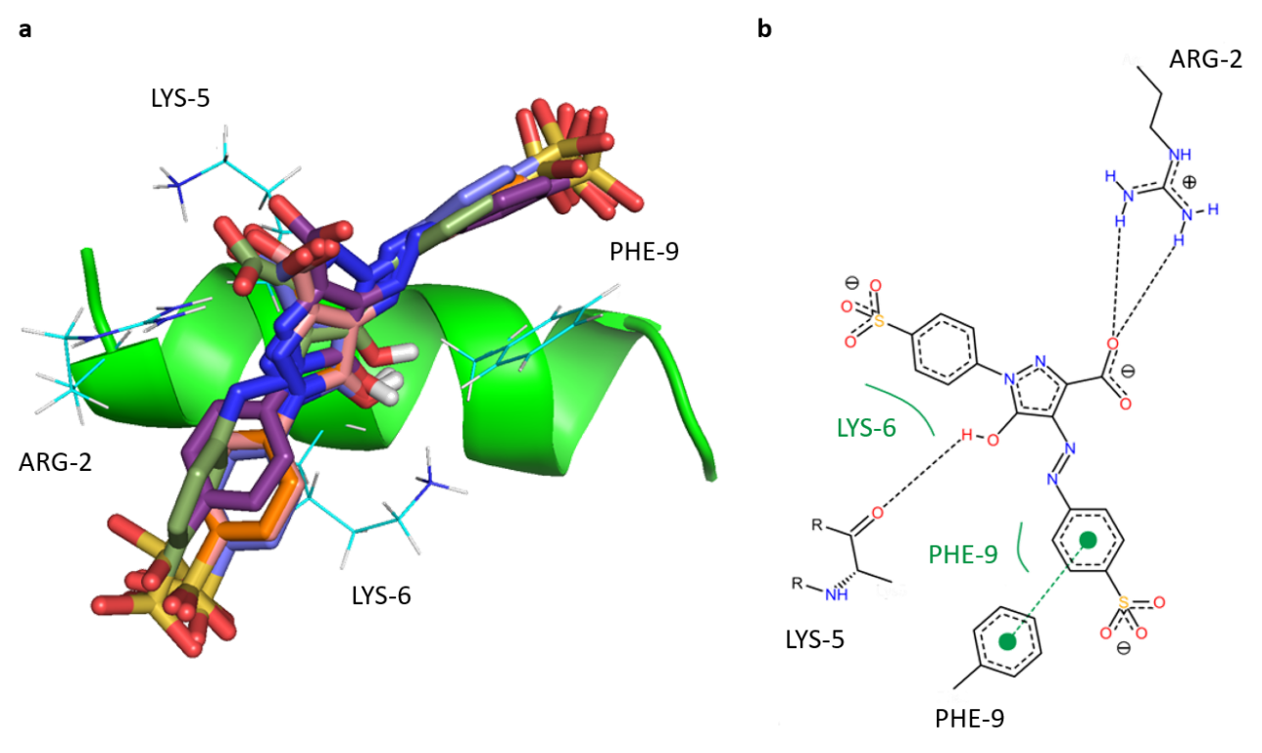
Fig. S5. Binding orientation of the complex DHVAR4-TZ. a The 5 models of TZ binding with DHVAR4 in the cluster 1. TZ molecule is shown in licorice. Peptide side chains which interact with TZ are shown with line representation. The hydrogens of TZ are removed for the sake of clarity. b The 2 D interaction plot of TZ and DHVAR4 from the cluster 1. Black dashed lines represent hydrogen bonds, while green spline sections depict the hydrophobic contact. The names of the residues are given in three letter code followed by the positions.

Supplementary Figures
Fig. S6. DLS investigation. Measurements were performed analyzing 29 µM DHVAR4 at increasing TZ concentration. a Count rate plot for DHVAR4 solutions as a function of TZ concentration obtained together with the curves showed in panel b. b Normalized intensity autocorrelation functions of DHVAR4 at different TZ concentration. The hydrodynamic diameter cannot be unequivocally ascertained due to the high polydispersity index (between 2 and 4.5) and signal-to-noise ratio.

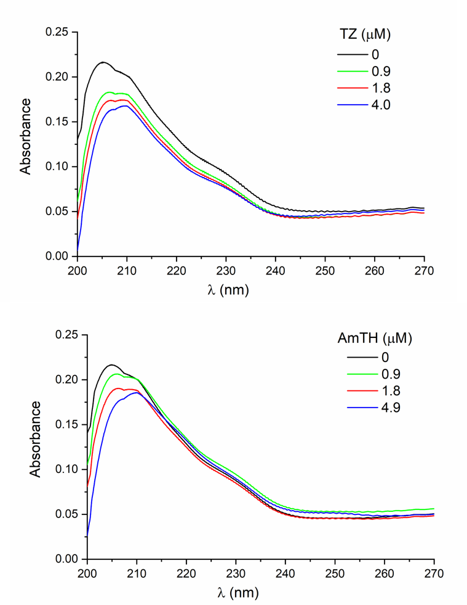

Fig. S7. UV absorbance spectra associated with the CD data displayed in Fig. 4a.

Fig. S8. Alfa-helicity of DHVAR4. DHVAR4 was measured in the helix promoting solvent trifluoroethanol (TFE). Since the peptide is fully helical in this solvent, the molar CD values of the n→π* band obtained in TFE and in liposome-peptide systems were used to calculate the dye induced helix content changes.

Fig. S9. a Infrared spectra in the acyl chain region of PC/PG and PC liposomes. Samples were analyzed in the presence of 74 µM DHVAR4 or DHVAR-TZ. The molar ratio DHVAR4-TZ is 1:1 in all spectra. No significant variation can be detected in the peak position of the antisymmetric (ν_{asym}(CH₂)) and symmetric (ν_{sym}(CH₂)) stretching of methylene groups in the presence of DHAVR4 and DHVAR4-TZ. Peptide to lipid ratio is 1:172. Peak picking was performed using a mathematical fitting analysis (Peak Analyzer, OriginLab software). b Infrared spectra of PC liposomes in the phosphate stretching region. Samples were analyzed in the presence of 75 µM DHVAR4 and at different peptide:TZ molar ratio (2:1 and 1:1). Spectra are normalized by the intensity of ν_{sym}(PO₂⁻) in order to highlight the shift of ν_{asym}(PO₂⁻) and the variation of the relative intensity 1091/1060 cm⁻¹. Left inset: shift of ν_{asym}(PO₂⁻) peak position of PC liposomes, in the presence of DHVAR4 and DHVAR4-TZ or DHVAR4-AmTH. Right inset: variation of the relative intensity between ν_{sym}(PO₂⁻) at 1091 cm⁻¹ and the shoulder at ~1060 cm⁻¹, belonging to the ν(R-O-P-O-R’). Peptide to lipid ratio is 1:172. Peak picking was performed using a mathematical fitting analysis (Peak Analyzer, OriginLab software).

Fig. S10. Infrared spectra of PC/PG liposomes in the presence of TZ. a Peak position of antisymmetric phosphate stretching (ν_{asym}(PO₂⁻)) of PC/PG liposomes in the presence of 30 µM and 75 µM TZ. Peak position of ν_{sym}(CH₂) and ν_{asym}(CH₂) is not affected by the presence of TZ, indicating that the dye does not interact with the acyl chains. b Variation of the relative intensity between ν_{sym}(PO₂⁻) at 1091 cm⁻¹ and ν(R-O-P-O-R’) at ~1060 cm⁻¹. c Infrared spectra of the acyl chain region of PC/PG and PC liposomes and in the presence of 30 µM and 75 µM TZ. Peptide to lipid ratio is 1:172. Peak picking was performed using a mathematical fitting analysis (Peak Analyzer, Origin-Lab software).
The analysis of PC/PG membranes only in the presence of the TZ shows that the azo dye does not considerably change ν_{asym}(PO₂⁻), while it decreases the intensity of the shoulder at 1060 cm⁻¹ (a and b). Therefore, TZ alters the surroundings of the polar heads inducing a change in the head-group orientation respect to the bilayer plane. This result can be related to the effect observed in the presence of the peptide (Fig. 4e), where the action of TZ drives the orientation of the head-group to the original state.

Fig. S11 IR spectra in the PC/PG phosphate stretching region in the presence of an excess of lipid.
ATR-IR spectra of PC/PG liposomes (L) and in the presence of DHVAR4 (P) at different peptide:TZ molar ratio (2:1 and 1:1). Spectra are normalized by the intensity of ν_{sym}(PO₂⁻). Left inset: shift of ν_{asym}(PO₂⁻) peak position in the presence of DHVAR4 and DHVAR4-TZ or DHVAR4-AmTH. Right inset: variation of the relative intensity at 1091 cm⁻¹ and ~1060 cm⁻¹. Peak picking was performed using a mathematical fitting analysis (Peak Analyzer, Origin-Lab software). Peptide to lipid ratio is 1:172. Error bars indicate the standard deviation.

Fig. S12 Morphology of PC/PG liposomes in the presence of DHVAR4 and the studied azo compounds. a FF-TEM picture of 100-nm PC/PG unilamellar liposomes. Scale bar: 200 nm. The pure lipid system exhibits the characteristic surface morphology of spherical-shaped unilamellar vesicles. b PC/PG liposomes in the presence of DHVAR4. Scale bar: 500 nm. c PC/PG liposomes in the presence of DHVAR4-TZ. Scale bar: 400 nm. d PC/PG liposomes in the presence of DHVAR4-AmTH. Scale bar: 500 nm. e DLS investigation of 100-nm PC/PG liposomes in PBS buffer solution (black line), and in the presence of DHVAR4 (blue line), DHVAR4-TZ (orange line) and DHVAR4-AmTH (red line). Right panel: mean hydrodynamic diameter (D) and polydispersity (Polydisp) values of the studied samples. The analysis of the correlation functions reveals a significant increase of the polydispersity and more than one D values can be detected for all samples. It is notably the case of AmTH that causes the most prominent shift of the correlation function, confirming the formation of larger vesicles as observed in the electron micrograph (d).

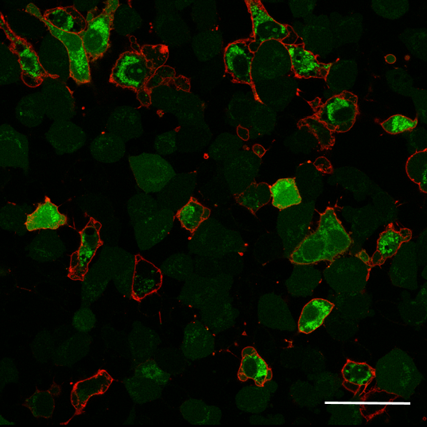
Fig. S13. Annexin V affinity assay. HeLa cells were incubated with 5 µM Cf-DHVAR4 for 12 minutes. Green color: Cf-DHVAR4 peptide; Red color: plasma membrane-bound annexin V. Bar: 10 µm.

Fig. S14. a Peptide localization in E. coli cells. Cells were treated for 40 minutes with Cf-DHVAR4 and Cf-DHVAR4-TZ, indicating in both cases the preferential localization of the peptide in the bacterial membrane. Scale bar: 5 µm. b Confocal microscopy images of solitary E. coli cells. Confocal microscopy images of solitary E. coli cells 10 minutes after the addition of Cf-DHVAR4 and Cf-DHVAR4-TZ. Left panel: phase contrast view; right panel: fluorescence channel. Scale bar: 10 µm. c Confocal microscopy images of agglutinated E. coli cells. Cells were treated for 10 minutes with Cf-DHVAR4. Left panel: phase contrast view; right panel: fluorescence channel. Cf-DHVAR4 accumulates mostly in cell clusters and in their proximity. Scale bar: 25 µm.

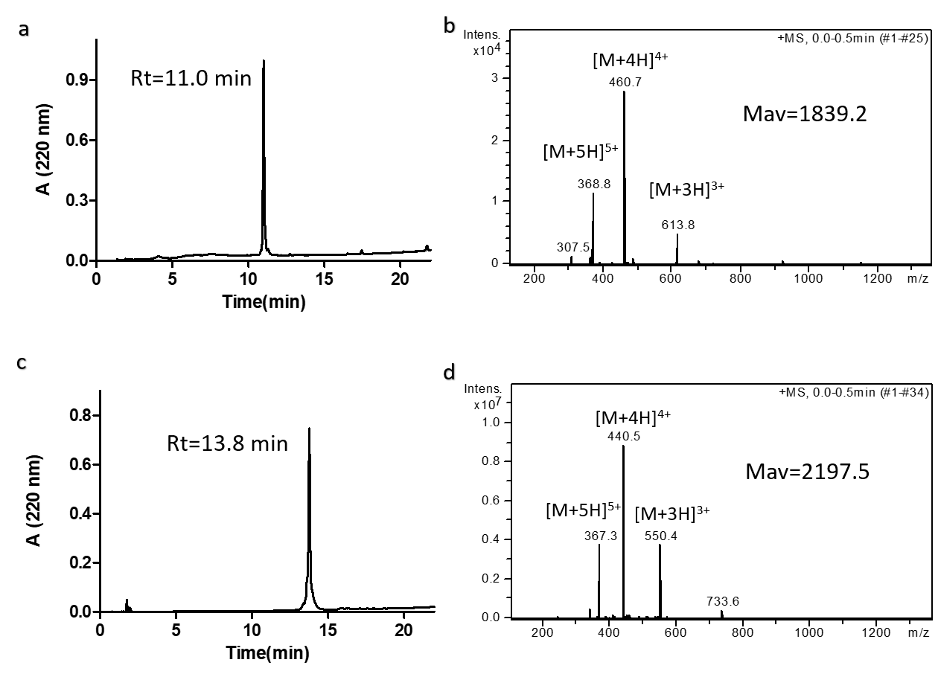

Fig. S15. Analytical characterization of the peptides. Purified peptides were analyzed by RP-HPLC on an analytical Waters Symmetry C-18 (4.6 mm × 150 mm, 5 µm) HPLC column. Molecular mass of the peptides was determined by using a Bruker Esquire 3000+ ion trap mass spectrometer (Bruker, Germany) equipped with electrospray ionization (ESI) source. a and b refer to DHVAR4, c and d to Cf-DHVAR4.

References
Barth, A. (2007). Infrared spectroscopy of proteins. Biochim. Biophys. Acta BBA - Bioenerg. 1767, 1073–1101.
Bóta, A., Wacha, A., Varga, Z., Szigyártó, I.C., Kristyán, S., Lőrincz, A., Szabó, P., Kálmán, M., Naszályi-Nagy, L., and Mihály, J. (2018). Role of oligo (malic acid) on the formation of unilamellar vesicles. J. Colloid Interface Sci. 532, 782–789.
Brauner, J.W., Mendelsohn, R., and Prendergast, F.G. (1987). Attenuated total reflectance Fourier transform infrared studies of the interaction of melittin, two fragments of melittin, and. delta.-hemolysin with phosphatidylcholines. Biochemistry 26, 8151–8158.
Chan, D.I., Prenner, E.J., and Vogel, H.J. (2006). Tryptophan- and arginine-rich antimicrobial peptides: Structures and mechanisms of action. Biochim. Biophys. Acta BBA - Biomembr. 1758, 1184–1202.
Dong, A., Matsuura, J., Manning, M.C., and Carpenter, J.F. (1998). Intermolecular β-Sheet Results from Trifluoroethanol-Induced Nonnative α-Helical Structure in β-Sheet Predominant Proteins: Infrared and Circular Dichroism Spectroscopic Study. Arch. Biochem. Biophys. 355, 275–281.
Gey, G. O. Kubicek, M. T., and Coffman, W. D. (1952). T. Tissue Culture Studies of the Proliferative Capacity of Cervical Carcinoma and Normal Epithelium. Cancer Res. 12, 264 265.
Goddard, T., and Kneller, D. (2001). Sparky 3 NMR software. Univ. Calif. San Franc.
Harnack,K., Spolaczyk, R., and Janke, S. A. (1999). Turbidity measurements (OD600) with absorption spectrometers. Biospektrum 6, 503–504.
Hübner, W., and Blume, A. (1998). Interactions at the lipid–water interface. Chem. Phys. Lipids 96, 99–123.
Ismail, A.A., Mantsch, H.H., and Wong, P.T.T. (1992). Aggregation of chymotrypsinogen: portrait by infrared spectroscopy. Biochim. Biophys. Acta BBA - Protein Struct. Mol. Enzymol. 1121, 183–188.
Janke, S. A., Fortnagel, P., and Bergmann R. (1999). Microbiological turbidimetry using standard photometers. Biospektrum 6, 501–502.
Jorgensen, J.H., and Ferraro, M.J. (2009). Antimicrobial Susceptibility Testing: A Review of General Principles and Contemporary Practices. Clin. Infect. Dis. 49, 1749–1755.
Kjaergaard, M., and Poulsen, F.M. (2011). Sequence correction of random coil chemical shifts: correlation between neighbor correction factors and changes in the Ramachandran distribution. J. Biomol. NMR 50, 157–165.
Lőrincz, A., Mihály, J., Németh, C., Wacha, A., and Bóta, A. (2015). Effects of ursolic acid on the structural and morphological behaviours of dipalmitoyl lecithin vesicles. Biochim. Biophys. Acta BBA-Biomembr. 1848, 1092–1098.
M. J. Frisch, G. W. Trucks, H. B. Schlegel, G. E. Scuseria, M. A. Robb, J. R. Cheeseman, G. Scalmani, V. Barone, B. Mennucci, G. A. Petersson, H. Nakatsuji, M. Caricato, X. Li, H. P. Hratchian, A. F. Izmaylov, J. Bloino, G. Zheng, J. L. Sonnenberg, M. Hada, M. Ehara, K. Toyota, R. Fukuda, J. Hasegawa, M. Ishida, T. Nakajima, Y. Honda, O. Kitao, H. Nakai, T. Vreven, J. A. Montgomery, Jr., J. E. Peralta, F. Ogliaro, M. Bearpark, J. J. Heyd, E. Brothers, K. N. Kudin, V. N. Staroverov, T. Keith, R. Kobayashi, J. Normand, K. Raghavachari, A. Rendell, J. C. Burant, S. S. Iyengar, J. Tomasi, M. Cossi, N. Rega, J. M. Millam, M. Klene, J. E. Knox, J. B. Cross, et al. (2013). Gaussian 09, Revision E.01. Gaussian Inc Wallingford CT.
Marlon, L. Bayot, and Bradley, N. Bragg (2019). Antimicrobial Susceptibility Testing - StatPearls - NCBI Bookshelf (Treasure Island (FL, USA): StatPearls Publishing).
Morris, G.M., Huey, R., Lindstrom, W., Sanner, M.F., Belew, R.K., Goodsell, D.S., and Olson, A.J. (2009). AutoDock4 and AutoDockTools4: Automated docking with selective receptor flexibility. J. Comput. Chem. 30, 2785–2791.
Ricci, M., Oliva, R., Del Vecchio, P., Paolantoni, M., Morresi, A., and Sassi, P. (2016). DMSO-induced perturbation of thermotropic properties of cholesterol-containing DPPC liposomes. Biochim. Biophys. Acta BBA-Biomembr. 1858, 3024–3031.
Schibli, D.J., Epand, R.F., Vogel, H.J., and Epand, R.M. (2002). Tryptophan-rich antimicrobial peptides: comparative properties and membrane interactions. Biochem. Cell Biol. 80, 667–677.
Trott, O., and Olson, A.J. (2010). AutoDock Vina: Improving the speed and accuracy of docking with a new scoring function, efficient optimization, and multithreading. J. Comput. Chem. 31, 455–461.
White Paper (2015). Factors Influencing OD600 Measurements – Which factors influence microbial growth and with this varying absorbance values of turbidity measurements using the same photometer? Eppendorf AG.

