Supporting Information

Secondary nucleation of monomers on fibril surface dominates α-synuclein aggregation and provides an autocatalytic amyloid amplification mechanism

Ricardo Gaspar^{1, 2}, Georg Meisl³, Alexander K. Buell^{3, 4}, Laurence Young⁵, Clemens F. Kaminski⁵, Tuomas P. J. Knowles³, Emma Sparr^{1, *} and Sara Linse^{2, *}

Departments of Physical-Chemistry¹ and Biochemistry and Structural Biology², Lund University, Sweden
Department of Chemistry³, University of Cambridge, United Kingdom
Institute of Physical Biology⁴, University of Düsseldorf, Germany
Department of Chemical Engineering and Biotechnology⁵, University of Cambridge, United Kingdom
*Corresponding Authors: emma.sparr@fkem1.lu.se and sara.linse@biochemistry.lu.se

S1) α-Syn protein expression and purification
Human α-syn was expressed in Escherichia coli from the aS-pT7-7 plasmid (received from H. Lashuel, EPFL Lausanne). The plasmid was transformed into E. Coli BL21 Star PLysS DE3 (Ca²⁺ competent cells) by heat shock and grown on LB/agar plates with 50 mg/l ampicillin and 30 mg/l chloramphenicol. Single colonies were used to inoculate 50 ml overnight cultures (LB with 50 mg ampicillin per l) and 5 ml was then transferred to each 500 ml day culture of the same medium. IPTG was added when OD600 reached 0.6 and the cells were harvested 4 h later and the cell pellet frozen.
α-syn was purified using heat treatment, ion exchange and gel filtration chromatography (1) as follows: Cell pellet from a total of 4 liter culture was disrupted by sonication after being diluted 1:1 in ice-cold 10 mM Tris/HCl, 1 mM EDTA, pH 7.5 (buffer A), followed by centrifugation at 15 000 g for 10 mins (spin 1). A boiling step was used in order to eliminate contaminating proteins from E. coli. The supernatant from spin 1 was poured 1:1 into boiling buffer A and heated to 85°C followed by rapid cooling and new centrifugation (spin 2). The supernatant from spin 2 was then loaded onto a 120 g DEAE cellulose column equilibrated in buffer A. The protein was eluted using a linear salt gradient from 0–0.5 M NaCl, with a total volume of 1.4 liters, and examined using agarose gel electrophoresis. Fractions containing α-syn were pooled, diluted 1:1 in buffer A, and loaded onto a 80 g DEAE sephacel column equilibrated in 10 mM Tris/HCl pH 7.5 and eluted using a 1.4 liter linear salt gradient from 0–0.5 M NaCl and were again examined using UV spectroscopy and agarose gel electrophoresis. Fractions containing pure α-syn were pooled and then stored as frozen aliquots (−20°C). Samples before and after the purification boiling step were analyzed using sodium dodecyl sulfate-polyacrylamide gel electrophoresis (SDS-PAGE) (Figure S1A).
A key procedure to achieving reproducible kinetics is to use pure monomeric α-syn as starting point. Before any kinetic experiment, a gel-filtration step is crucial to isolate monomeric α-syn in the desired degassed experimental buffer. Only protein sample corresponding to the central region of the peak is collected and used for the experiments (Figure S1B). As the reaction is very sensitive to the concentration and size of the seeds, it is vital to handle all seed solutions in the same manner. Seed fibrils of α-syn briefly sonicated in a water bath can be observed by Cryo-TEM (Figure S1C). From the Cryo-TEM images, the average size of the seed fibrils was assessed to be between 200-400 nm, in agreement with previous imaging using AFM (2). It is important to mention, that for lower seed concentrations (from ca. 30 nM) the ThT kinetic traces were not reproducible, presumably due to the difficulty to reliably titrate such low concentrations under conditions where the seed fibrils have been shown to flocculate (2).
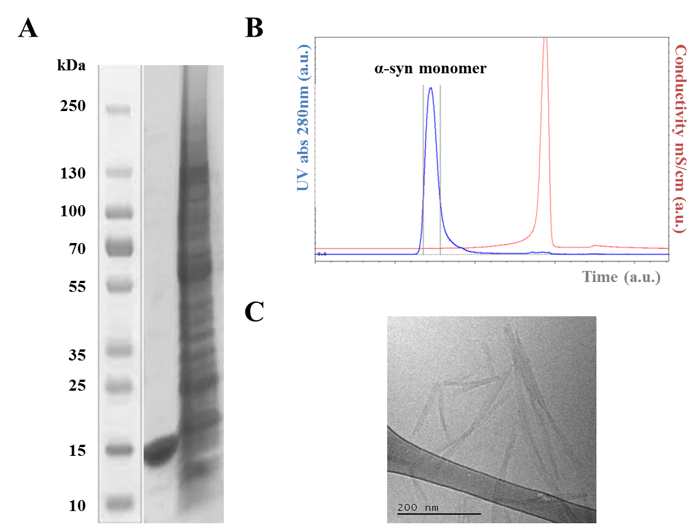

Figure S1. Recombinant α-syn protein expression and purification setup. A: 10 µL samples taken before and after the boiling step of the purification method were run on a 12% SDS-PAGE gel. The purification method employed leads to pure recombinant monomeric α-syn (~14,4kDa). B: Gel-filtration step in 10 mM MES buffer pH 5.5 used to freshly isolate pure monomeric α-syn which is done prior to any experiment. C: Example of 5 µL fibrils formed in 10 mM MES pH 5.5 imaged by Cryo-TEM on a glow-discharged carbon grid.

S2) ThT dye optimization setup for kinetic studies
The method used to monitor the aggregation process relies on the enhanced fluorescence intensity of ThT bound to fibrils (3). A conversion of the fluorescence signal to aggregate mass requires that the signal intensity is proportional to the amount of fibrils formed. The molecular origin of the binding of ThT to amyloid fibrils is still unclear and the ThT affinity and quantum yields are influenced by several factors (4). Therefore preliminary optimization studies were conducted specifically for our solution conditions. Initially, a set of solutions with 40, 60 and 100 µM preformed α-syn seeds were titrated with ThT to concentrations ranging from 10 µM up to 200 µM in PS plates. From figure S2, the first observation that can be made is that the fluorescence intensity from ThT dye bound to the fibril structure is proportional to the amount of fibrillar mass. From figure S2, it is also evident that the fluorescence of the dye decreases at higher dye concentrations. This is likely to be due to the so-called “inner filter effect” (5) and/or self-quenching. These studies indicated 20 µM as the ideal concentration of ThT to be used in our assays yielding reasonable fluorescence yield and a linear report on the concentration of fibrils.

Figure S2. ThT titration of different concentrations of α-syn preformed seed fibrils A: 100 µM B: 60 µM C: 40 µM in 10 mM MES pH 5.5 at 37ºC under quiescent conditions. The figures show averages of two traces that are shown in bold and are plotted as ThT intensity as a function of time. D: ThT fluorescence intensity at the plateau plotted as a function of the respective ThT concentration, for each concentration of preformed seed fibrils tested. Arrow and dotted line indicate the optimal concentration for ThT (20 µM) accessed to have a linear relationship between fluorescence intensity and aggregate concentration.

A second set of experiments based on monitoring α-syn aggregation per se from monomer to fibrils in PS plates in the presence of different concentrations of ThT was also performed. The decrease of fluorescence intensity at elevated dye concentrations was also observed here (see above). Although low concentrations of ThT seem ideal in terms of fluorescence yield, it is additionally crucial that the concentration of dye in the sample is sufficient, so that decreases in fluorescence do not occur as a result of complete depletion of ThT from the solution at high concentration of β-sheet enriched α-syn fibrils. Overall, both experiments pointed to 20 µM as the ideal ThT concentration for studies with α-syn and for our solution conditions.

S3) Non-seeded aggregation kinetic experiments: Role of surfaces
α-Syn aggregation is strongly influenced by intrinsic and extrinsic factors. To investigate the role of surfaces, reactions starting from monomeric α-syn were monitored in untreated polystyrene (PS) plates as well as non-binding PS plates coated with PEG. Interestingly, no aggregation of α-syn was detected during the time frame of the experiment (up to 100 h) in the PEGylated plates, whereas reproducible kinetic traces with typical sigmodal curves were observed in PS plates (Figure S3A). This highlights the importance of heterogeneous nucleation of α-syn on the PS surface. Another striking observation from the current experiments in PS plates is that α-syn aggregation kinetics appears independent of the peptide concentration at high monomer concentrations (above ca. 30 µM, Figure S3B). To characterize the aggregation mechanism of α-syn in the absence of catalyzing foreign surfaces, all further experiments were conducted in non-binding PEGylated PS plates in the presence of seeds.

Figure S3. Non-Seeded aggregation kinetics of α-syn. A: Aggregation kinetics for 30 µM α-syn in plain PS plates (black) and in non-binding PEGylated PS plates (blue). B: α-Syn aggregation kinetics for different monomer concentrations (10-50 µM) in plain PS plates. All experiments were performed in 10 mM MES pH 5.5 at 37ºC and under quiescent conditions. The figures show averages of three traces as solid lines with individual traces as dotted lines.

S4) QCM-D experiments: Sensor and fibril preparation
For QCM experiments, the preparation of the sensor surfaces closely followed the protocols described in (6) Pre-formed fibrils were diluted to 20 µM in PBS buffer, sonicated for 4 min using a probe sonicator (pulsed, 3s on, 3s off, 20% amplitude on a 500 W ultrasonic homogenizer, Cole Parmer, Hanwell, UK) and then 2-Iminothiolane (Traut's reagent) was added at a final concentration of 1 mg/ml. This compound covalently attaches to proteins by reacting with free amine groups, in particular, but not only, the N-terminus, and releases a free thiol group, which in turn enables covalent attachment to the gold-coated surface of the QCM sensor. After 5 min incubation, 80 µl of the fibril suspension was added onto each of the QCM sensors that had been cleaned prior to incubation using hot NH₃/H₂O₂ solution (80ºC, 30 min) and 20 min of UV/O3 treatment. After 1 h incubation at room temperature under an atmosphere of saturated humidity, the sensors were washed with PBS buffer and incubated for 15 min with a 1% volume solution of mPEG thiol in PBS buffer (Polypure, Norway). Then the sensors were washed with water and dried with nitrogen, immediately followed by insertion into the microbalance. The sensors were then incubated at 37ºC in PBS buffer until a stable baseline was achieved, and subsequently the experiment could be initiated.
In order to probe whether the surface density of fibrils was comparable on the different sensors, the sensors were incubated with 20 µM α-syn in PBS, and the very similar rate of change of frequency induced by the fibril elongation confirmed very similar surface concentration of fibrils on the sensors (data not shown).
For the main experiments, several overtones of the fundamental frequency, as well as the associated dissipation values were simultaneously monitored. For simplicity, we restrict our analysis to the frequency and dissipation of the overtone N = 3. The fundamental frequency is often found not to yield useful data, due to poor energy trapping, therefore it is mostly not considered in the analysis. For rough, viscoelastic layers, the amplitude of the frequency response decreases with increasing overtone number, leading to a decrease in the signal-to-noise ratio. Therefore the overtone with N = 3 is best suited for our analysis. The differential response of the different overtones in principle contains information about the structural and viscoelastic properties of the protein surface adsorbed layer. However, there are no analytical theories available to us that allow for modeling of the complex layer consisting of a random network of amyloid fibrils on a surface. We have recently shown through empirical calibration experiments, combined with solutions of the reaction-diffusion dynamics towards the surface, that the mass sensitivity of a QCM for the process of amyloid fibril growth is several times higher than expected for a smooth rigid adsorbed layer (7), highlighting the importance of trapped water for the frequency response.

S5) Integrated Rate Law
The global data analysis was performed using the AmyloFit platform for analysis and fitting of protein aggregation data (8).
Here we show that a positive curvature in the kinetic curves implies an increase in aggregate number. The differential equation for the mass concentration of aggregates, M(t), is given by (8):

$\begin{aligned}\frac{dM}{dt}=k_{+}+m\left(t\right)P\left(t\right) \left(1\right)\end{aligned}$
where $\begin{aligned}k_{+}\end{aligned}$ is the elongation rate constant, $m\left(t\right)$ is the monomer concentration and $P\left(t\right)$ is the number concentration of aggregates. Positive curvature means ${d^{2}M}/{{dt}^{2}}>0$, therefore:

$$\begin{aligned}\frac{d}{dt}k_{+}m\left(t\right)P\left(t\right)=k_{+}\left(\frac{dm}{dt}P\left(t\right)+m\left(t\right)\frac{dP}{dt}\right)>0 \left(2\right)\end{aligned}$$

As the monomer concentration will decrease during the aggregation reaction ${dm}/{dt}<0$, moreover both $m\left(t\right)$ and $P\left(t\right)$ are non-negative, it hence follows that ${dP}/{dt}>0$ which corresponds to an increase in the number concentration of fibrils. Therefore a positive curvature in the aggregate mass concentration implies an increase in the number of fibrils. Note that no specific assumption about the functional form $P\left(t\right)$ was necessary in this proof.

S6 and S7) Two-color dSTORM approach
For labeling α-syn cysteine variant (N122C), lyophilized peptide was dissolved in 6M GuHCl with 1mM DTT in order to reduce disulfide bonds. A gel filtration step was followed in order to isolate monomer in 20mM sodium phosphate pH 8 and remove DTT. The concentration of peptide was obtained measuring the UV absorbance at 280 nm. Added to the peptide sample, 1.5 equivalents of dye, either Alexa Fluor 647 (AF647) or Alexa Fluor 568 (AF568) and was left incubating for 2 h. Gel filtration was again performed to isolate the monomer in our experimental buffer, 10 mM MES pH 5.5 and remove excess free dye. The monomeric fraction collected was analyzed by SDS-PAGE (Figure S6 A and B).

Figure S6. α-Syn cysteine variant N122C labeling and purification setup. 10 µL samples taken after gel filtration were run on a 12% SDS-PAGE gel. In gel A, stained with coomasie, three bands are visible corresponding to (from left to right) a control α-syn WT sample, α-syn labeled with AF647 and α-syn labeled with AF568. In B, the same gel before coomasie staining, where only two bands are visible (from left to right), α-Syn labeled with AF568 (purple) and AF647 (green). A clear band around ~14,4kDa is visible for each sample.

Dye labels were evaluated in terms of interfering with the aggregation process using ThT kinetics studies (S6 A and B). dSTORM images were taken of seeds fibrils labeled with Alexa Fluor dyes with different labeling densities in order to optimize image quality. In parallel seeding aggregation kinetic studies (S7 A and B), were performed to evaluate the interference of these dyes in terms of aggregation kinetics. It was shown that a 1:20 ratio of labeled α-syn to unlabeled peptide was the optimal in terms of labeling density and unperturbed aggregation kinetics (S7 A and B).

Figure S7. Seeded α-syn aggregation kinetics to evaluate the interference of Alexa Fluor dyes. A fixed total monomer concentration of 30 µM was supplemented with a fixed 10% unlabeled seed concentration. Different labeling densities were tested for each labeling dye, A: Alexa Fluor 647 (AF647, red lines) and B: Alexa Fluor 568 (AF568, green lines), comparing in both cases to kinetic traces of unlabeled α-syn (black line). Averages of three traces are shown as solid lines. All figures show ThT intensity as a function of time (non-normalized data). All experiments were performed in 10 mM MES pH 5.5 in non-binding PEGylated plates at 37ºC and under quiescent conditions.

References
(1) Grey M, Linse S, Nilsson H, Brundin P and Sparr E (2011). Membrane interaction of α-synuclein in different aggregation states. Journal of Parkinson´s Disease I: 359-371.
(2) Buell AK, Galvagnion C, Gaspar R, Sparr E, Vendruscolo M, Knowles TPJ, Linse S and Dobson CM (2014). Solution conditions determine the relative importance of nucleation and growth processes in α-synuclein aggregation. Proc. Natl. Acad. Sci. USA 111(21): 7671-7676.
(3) Levine H (2008). Thioflavin-T interaction with synthetic Alzheimer´s Disease β-Amyloid peptides: detection of amyloid aggregation in solution. Protein Sci. 2: 404-410.
(4) Coelho-Cerqueira E, Pinheiro AS and Follmer C (2014). Pitfalls associated with the use of Thioflavin-T to monitor anti-fibrillogenic activity. Bioorg. Med. Chem. Lett. 24(14): 3194-8.
(5) Fonin AV, Sulatskaya AI, Kuznetsova IM and Turoverov KK (2014). Fluorescence of dyes in solutions with high absorbance. Inner filter effect correction. PLoS ONE 9(7): e103878.
(6) Buell AK, White DA, Meier C, Welland ME, Knowles TPJ and Dobson CM (2010). Surface attachment of protein fibrils via covalent modification strategies. J. Phys. Chem. B. 114(34): 10925-38.
(7) Michaels TCT, Buell AK, Terentjev EM and Knowles TPJ (2014). Quantitative analysis of diffusive reactions at the solid-liquid interface in finite systems. J. Phys. Chem. Lett. 5(4): 695-699.
(8) Meisl G, Kirkegaard JB, Arosio P, Michaels TC, Vendruscolo M, Dobson CM, Linse S and Knowles TPJ (2016). Molecular mechanisms of protein aggregation from global fitting of kinetic models. Nat. Protoc. 11(2): 252-72.

