Supplementary Information
Supplementary Methods
Supplementary Figures
Figure S1 Flow diagram of the selection of addiction iFC studies.
Figure S2 Comparisons in rs-FC findings of depressant user (Panel A), stimulant user (Panel B), and distinct alteration patterns in rs-FC network between depressant user and stimulant user (Panel C).
Supplementary Tables
Table S1 Alterations of intrinsic functional connectivity between depressant user, stimulant user, and their contrast results
Table S2 Summary of Seed-Networks and Seed ROIs of Studies Included in Meta-analysis
Table S3 Demographic and clinical characteristics of substance use disorder (SUD) included in the Meta-analysis
Table S4 Demographic and clinical characteristics of behavioral addictions (BA) included in the Meta-analysis
Table S5 Summary of Methods Implemented in Studies Included in Meta-analysis
Table S6 Results of Jackknife Sensitivity Analysis of Addiction-HC
Table S7 Results of Jackknife Sensitivity Analysis of BA-HC
Table S8 Results of Jackknife Sensitivity Analysis of SUD-HC
Table S9 Publication bias of the clusters in rs-FC meta-analysis
Included Datasets

Supplementary Methods
Details of literature search
Firstly, a comprehensive search strategy was combined by MeSH term and free text words described in the bellowing in the four electronic database, PubMed, OVID Embase, OVID Medline, and Web of Science:
(((fmri[MeSH Terms]) OR (Functional magnetic resonance imaging)) OR (functional MRI)) AND ("Behavior, Addictive"[MeSH] OR "Oncogene Addiction"[MeSH] OR "Addiction Medicine"[MeSH] OR "Substance-Related Disorders"[MeSH] OR "Opioid-Related Disorders"[MeSH] OR "Munchausen Syndrome"[MeSH] OR "Cocaine-Related Disorders"[MeSH] OR "Amphetamine-Related Disorders"[MeSH] OR "Tobacco Use Disorder"[MeSH] OR "Morphine Dependence"[MeSH] OR "Heroin Dependence"[MeSH] OR "Alcoholism"[MeSH] OR "Narcotic-Related Disorders"[MeSH] OR "Opium Dependence"[MeSH] OR "Internet Addiction Disorder"[MeSH]) AND resting state
After searching this comprehensive search strategy, search strategy about single type of addiction was conducted:
((((fmri[MeSH Terms]) OR (Functional magnetic resonance imaging)) OR (functional MRI)) AND ((((((((((((((Substance-Related Disorders[MeSH Terms]) OR (Substance Use)) OR (Substance Uses)) OR (Use, Substance)) OR (Drug Abuse)) OR (Abuse, Drug)) OR (Drug Dependence)) OR (Dependence, Drug)) OR (Drug Addiction)) OR (Addiction, Drug)) OR (Substance Use Disorders)) OR (Disorder, Substance Use)) OR (Organic Mental Disorders, Substance-Induced)) OR (Substance Abuse))) AND (resting state)
(((((("Cocaine"[MeSH]) OR (Cocaine Hydrochloride)) OR (Hydrochloride, Cocaine)) OR (Cocaine HCl)) OR (HCl, Cocaine)) AND (((fmri[MeSH Terms]) OR (Functional magnetic resonance imaging)) OR (functional MRI))) AND (resting state)
((((fmri[MeSH Terms]) OR (Functional magnetic resonance imaging)) OR (functional MRI)) AND ((((((Cannabis[MeSH Terms]) OR (Cannabi[MeSH Terms])) OR (Marijuana[MeSH Terms])) OR (Hemp[MeSH Terms])) OR (Bhang[MeSH Terms])) OR (Ganja[MeSH Terms]))) AND (resting state)
((((fmri[MeSH Terms]) OR (Functional magnetic resonance imaging)) OR (functional MRI)) AND (resting state)) AND ((((((((((Amphetamine[MeSH Terms]) OR (Amfetamine)) OR (Phenopromin)) OR (Desoxynorephedrin)) OR (Phenamine)) OR (Centramina)) OR (Fenamine)) OR (Mydrial)) OR (Amphetamine Sulfate)) OR (l-Amphetamine))
((((fmri[MeSH Terms]) OR (Functional magnetic resonance imaging)) OR (functional MRI)) AND ((((((Methamphetamine[MeSH Terms]) OR (Desoxyephedrine)) OR (Metamfetamine)) OR (Methylamphetamine)) OR (Deoxyephedrine)) OR (Methamphetamine Hydrochloride))) AND (resting state)
((((fmri[MeSH Terms]) OR (Functional magnetic resonance imaging)) OR (functional MRI)) AND (resting state)) AND (((((((Heroin[MeSH Terms]) OR (Diacetylmorphine)) OR (Diamorphine)) OR (Diagesil)) OR (Min-I-Jet Morphine Sulphate)) OR (Heroin Hydrochloride)) OR (Diacetylmorphine Hydrochloride))
((((fmri[MeSH Terms]) OR (Functional magnetic resonance imaging)) OR (functional MRI)) AND (resting state)) AND (((((((Analgesics, Opioid[MeSH Terms]) OR (Opioid Analgesics)) OR (Analgesic, Opioid)) OR (Opioids)) OR (Partial Opioid Agonists)) OR (Full Opioid Agonists)) OR (Opioid Mixed Agonist-Antagonists))
((((fmri[MeSH Terms]) OR (Functional magnetic resonance imaging)) OR (functional MRI)) AND (resting state)) AND (((((((abuse, alcohol[MeSH Terms]) OR (Alcohol Dependence)) OR (Alcohol Addiction)) OR (Alcoholic Intoxication, Chronic)) OR (Alcohol Use Disorder)) OR (Alcohol Abuse)) OR (Ethanol Abuse))
((((fmri[MeSH Terms]) OR (Functional magnetic resonance imaging)) OR (functional MRI)) AND (resting state)) AND (((((((Tobacco Use Disorder[MeSH Terms]) OR (Disorder, Tobacco Use)) OR (Tobacco Use Disorders)) OR (Nicotine Addiction)) OR (Tobacco Dependence)) OR (Nicotine Dependence)) OR (Nicotine Use Disorder))
((((fmri[MeSH Terms]) OR (Functional magnetic resonance imaging)) OR (functional MRI)) AND (resting state)) AND ((((Behavior, Addictive[MeSH Terms]) OR (Addictive Behavior)) OR (Addictive Behaviors)) OR (Behaviors, Addictive))
((((fmri[MeSH Terms]) OR (Functional magnetic resonance imaging)) OR (functional MRI)) AND (resting state)) AND ((((gambling[MeSH Terms]) OR (Gambling, Pathological)) OR (Pathological Gamblings)) OR (Gambling, Pathologic))
((((fmri[MeSH Terms]) OR (Functional magnetic resonance imaging)) OR (functional MRI)) AND (((((((Internet Addiction Disorder[MeSH Terms]) OR (Addiction Disorder, Internet)) OR (Disorder, Internet Addiction)) OR (Internet Addiction)) OR (Social Media Addiction)) OR (Social Media Addiction)) OR (Internet Gaming Disorder))) AND (resting state)
(((((((((((compulsive buying) OR (compulsive shopping)) OR (shopping addiction)) OR (pathological shopping)) OR (shopping disorder)) OR (Internet shopping disorder)) OR (buying disorder)) OR (buying addiction)) OR (pathological buying)) OR (compulsive buying)) AND (((fmri[MeSH Terms]) OR (Functional magnetic resonance imaging)) OR (functional MRI))) AND (resting state)
Literature searches was carried out without restrictions on time of publication or publication status. Filters was used to constrain database searches to studies of human participants written in English.

Supplementary Figures
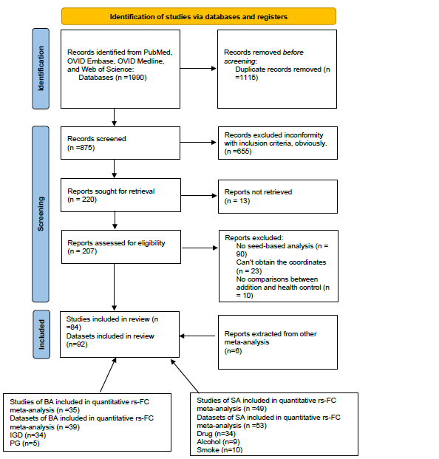
Figure S1 Flow diagram of the selection of addiction iFC studies.

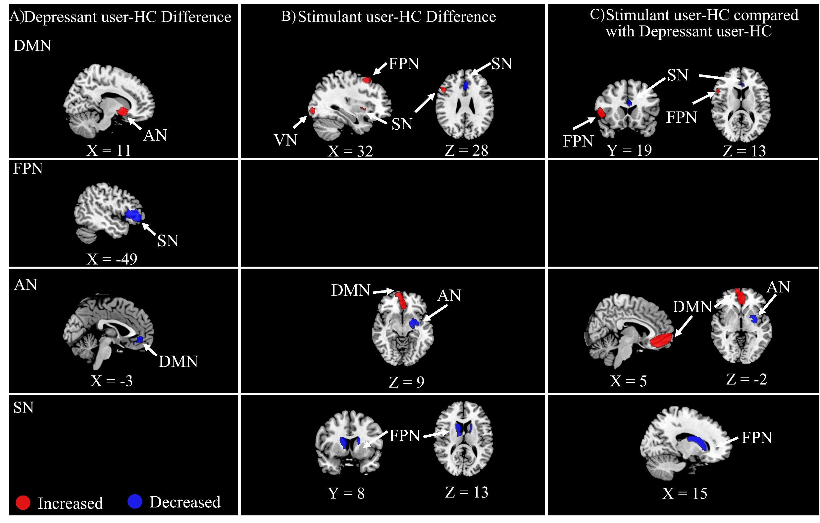
Figure S2 Comparisons in rs-FC findings of depressant user (Panel A), stimulant user (Panel B), and distinct alteration patterns in rs-FC network between depressant user and stimulant user (Panel C). The first column denotes the seed-belonging networks.
Abbreviations: AN, affective network; DMN, default mode network; FPN, frontal parietal network; SN, salience network; VN: visual network.

Supplementary Tables
Table S1 Alterations of intrinsic functional connectivity between depressant user, stimulant user, and their contrast results
Seed network | Effect anatomy | Effect network | MNI coordinate | Number of voxels | SDM Z value | p value | Breakdown (Main clusters)
Depressant user > HC
DMN | Right striatum | AN | 8, 8, -8 | 391 | -2.151 | 0.00018 | Right striatum (235)
Depressant user < HC
FPN | Left Insular | SN | -40, 16, -8 | 904 | -3.630 | 0.00004 | Left IFG (598)  Left Insular (190)
AN | Left SFG | DMN | -4, 44, -6 | 160 | -2.377 | 0.00022 | Left SFG (94)  Left ACC (33)
Stimulant user < HC
DMN | Left ACC | SN | 0, 26, 26 | 225 | -2.078 | 0.00018 | Left ACC (137)  Right ACC (33)
AN | Left striatum | AN | -28, -2, -6 | 790 | -2.826 | 0.00001 | Left Putamen (147)  Left amygdala (111)  Left striatum (83)
SN | Right ATP | FPN | 16, 2, 16 | 589 | -4.429 | <0.00001 | Right ATP (237)  Right Caudate (224)
 | Left ATP | FPN | -18, 8, 18 | 119 | -2.881 | 0.00008 | Right ATP (94)  Right Caudate (23)
Stimulant user > HC
DMN | Right IFG | SN, FPN | 50, 14, 2 | 1305 | 3.493 | <0.00001 | Right IFG (688)  Right Insular (269)  Right RO (106)
 | Right MFG | FPN | 32, 16, 56 | 164 | 2.322 | 0.00006 | Right MFG (136)
 | Right IOG | VN | 32, -90, -4 | 101 | 2.144 | 0.00018 | Right IOG (85)
AN | Right SFG | DMN | 10, 66, 0 | 908 | 2.013 | 0.00002 | Right SFG (563)  Left SFG (121)  Corpus callosum (100)
Stimulant user < Depressant user
DMN | Left ACC | SN | -2, 24, 20 | 316 | -1.855 | 0.000129 | Left ACC (212)  Right ACC (59)
AN | Left Putamen | AN | -28, 0, -6 | 642 | -2.449 | <0.00001 | Left Putamen (133)  Left Amygdala (97)  Left striatum (73)
SN | Right ATP | FPN | 16, 2, 16 | 584 | -3.883 | <0.00001 | Right ATP (244)  Right Caudate (223)
Stimulant user > Depressant user
DMN | Right IFG | FPN | 50, 14, 2 | 438 | 2.232 | <0.00001 | Right IFG (279)  Right Insular (81)
AN | Right SFG | DMN | 0, 42, -6 | 1803 | 2.568 | <0.00001 | Left ACC (280)  Right SFG (560)  Left SFG (378)  Corpus callosum (232)  Left gyrus rectus (139)

Abbreviations: ACC: anterior cingulate cortex; FG: fusiform gyrus; IFG: inferior frontal gyrus; MCC: median cingulate cortex; MFG: middle frontal gyrus; PCC: posterior cingulate cortex; SFG: superior frontal gyrus; AN, affective network; DAN, dorsal attention network; DMN, default mode network; FPN, frontal parietal network; SSN, somatosensory network; SN, salience network.

Table S2 Summary of Seed-Networks and Seed ROIs of Studies Included in Meta-analysis

Reference | Seed-Networks and Direction of Effects
 | DMN |  |  | FPN |  |  | AN |  |  | SN |  |  | SSN |  |  | DAN |  |  | Visual |  |  | Thalamus
 | Addiction  >TD | Addiction  <TD | No  Sig | Addiction  >TD | Addiction  <TD | No  Sig | Addiction  >TD | Addiction  <TD | No  Sig | Addiction  >TD | Addiction  <TD | No  Sig | Addiction  >TD | Addiction  <TD | No  Sig | Addiction  >TD | Addiction  <TD | No  Sig | Addiction  >TD | Addiction  <TD | No  Sig | Addiction  >TD | Addiction  <TD | No  Sig
Adinoff et al 2015 | Hippo
Bae et al., 2017 IGD | PCC |  |  | DLPFC |  |  | Amyg
Bae et al., 2017 ibGD | PCC |  |  |  | DLPFC |  | Amyg
Berlingeri et al, 2017 |  |  |  |  |  |  | NAcc | NAcc
Bi et al 2017 |  |  |  |  |  |  |  |  |  |  | Insula
Blanco et al., 2017 | Caud | Caud |  | Caud  Putam | Caud  Putam |  |  | ACC |  | Putam,  FG | Putam  ACC |  |  |  |  | FG
Camchong et al 2011 | ACC
Camchong et al 2013 | ACC |  |  |  |  |  | NAcc | NAcc |  | ACC
Chen, C et al 2016 |  |  |  |  |  |  | NAcc | NAcc |  | Insula | Insula
Chen, J et al 2020 |  |  |  |  | DLPFC
Chen, X et al 2014_NI | PCC | PCC
Chen, X et al 2014_SI
Contreras et al 2015 CD | Caud |  |  |  |  |  |  |  |  | Putam
Contreras et al 2016CD | OFC | OFC |  |  |  |  | Amyg | Amyg
Contreras et al 2015 PG | Caud
Contreras et al 2016PG | OFC |  |  |  |  |  | Amyg | Amyg
Denier et al 2015 |  |  |  |  |  |  |  |  |  |  |  |  |  |  |  |  |  |  |  |  |  |  | Thalam
Ding et al 2013 | PCC | PCC
Dong et al 2012 |  |  |  |  |  |  |  |  |  | IPL
Farre et al 2021 AUD | PCC
Farre et al 2021 AUD_ADHD | PCC |  |  |  |  |  |  |  |  |  |  |  |  |  |  |  | FEF
Ge et al 2017 IGD |  |  |  | DLPFC | DLPFC
Ge et al 2017 SND |  |  |  |  | DLPFC
Geng et al 2017 |  |  |  |  |  |  |  | TP |  |  | Insula
Gu et al 2010 |  | VTA  Hippo |  |  |  |  |  | ACC | NAcc | Amyg |  |  |  |  | PMA |  |  |  |  |  |  |  | Thalam
Halcomb et al 2019 |  |  |  |  |  |  |  |  |  | Insula | Insula
Han et al 2019 |  | MCG |  |  | MFG  MCG |  |  |  |  | Insula
Han et al 2018 |  |  |  | DLPFC | DLPFC
Han,X te al 2018 | OFC
Hong et al 2015 |  |  |  |  |  |  |  |  |  |  | Putam
Jung et al 2014 |  | PCC
Kang et al 2018 |  |  |  |  |  |  |  | Amyg
Kelly et al 2011 |  |  |  |  |  |  |  |  |  |  |  |  |  |  |  | IFS | IFS
Kim et al 2019 |  |  |  |  |  |  |  | OFC
Kim et al 2021 | mPFC |  |  |  |  | DLPFC | ANcc  Amyg
Ko et al 2015 |  |  |  |  |  |  | Amyg | Amyg
Koehler et al 2013 |  |  |  | MFG | MFG |  | VS
Kohno et al 2018 |  |  |  |  | DLPFC |  | VS
Kohno et al 2014 |  |  |  |  |  |  |  |  |  |  |  |  |  |  |  |  |  |  |  |  |  | Thalam
Lee et al 2017 IGD | PCC
Lee et al 2017 IGD+ADHD | PCC
Lee et al 2018 IGD | ACC |  |  |  |  |  | ACC |  |  | ACC
Lee et al 2018 IGD+DEP | ACC | ACC |  |  |  |  |  | ACC
Lee et al 2021 |  |  |  |  |  |  |  |  |  |  | Putam
Lee et al (a) 2020 |  | PCC |  |  |  |  |  |  |  | Insula
Lee et al (b) 2021 |  |  |  |  |  |  |  |  |  |  |  |  | FEF | IPS
Li,Q et al 2013 | PCC
Liao et al 2016 |  |  |  |  |  |  |  |  |  |  |  |  |  |  |  |  |  |  |  |  |  |  | Thalam
Lin et al 2018 |  |  |  |  | DLPFC
Lin et al 2015 |  | Caud |  |  | Caud  Putam |  |  | Caud |  | Putam | Putam  Caud
Liu et al 2021 | AG | AG |  |  |  |  | NAcc | NAcc
Liu et al 2018 |  |  |  |  |  |  | Amyg
Liu et al 2019 |  |  |  |  |  |  |  |  |  |  |  |  |  |  |  |  |  |  |  |  |  |  | Thalam
Ma et al 2010 |  |  |  |  |  |  | NAcc  Amyg  OFC | NAcc  OFC
McHugh et al 2013 |  |  |  |  |  |  |  | Putam
McConnel et al 2020 |  |  |  |  |  |  | NAcc
Motzkin et al 2014 |  |  |  |  |  |  |  | NAcc
Muller et al 2015 | PCC  ACC | PCC |  | SFG | SFG |  |  | NAcc |  |  |  |  | postcentral |  |  | SPL
Pujol et al 2014 | PCC | PCC  Hippo |  | PCC | PCC |  |  |  |  | Insula | Insula
Pitel et al 2013 |  |  |  |  | cerebell |  |  |  |  |  |  |  |  |  |  |  | cerebell
Qiu et al 2013 |  |  |  |  | DLPFC
Qiu et al 2016 | OFC
Seok et al 2018 | Caud
Shen et al 2017 |  |  |  |  |  |  | Amyg | Amyg
Shen et al 2018 |  |  |  |  |  |  |  |  |  |  | Cerebll
Sutherland et al 2013 |  |  |  |  |  |  |  |  |  |  | Insula ACC
Sun et al 2019 |  |  |  |  | SFG
Um et al 2020 |  |  |  |  |  |  | Amyg |  | NAcc
Verdejo et al 2014 |  | ACC |  |  | ACC |  |  |  |  |  |  | Insula |  |  |  |  |  |  |  | Cuneus
Wang et al 2017 |  |  |  |  |  |  |  |  |  |  |  |  |  |  |  |  |  |  |  |  |  |  | Thalam
Wang et al 2018 |  |  |  |  | DLPFC |  |  |  |  |  |  |  |  |  |  |  |  |  |  | Cuneus |  |  | Thalam
Wang,J et al 2016 |  | mPFC |  |  |  |  |  | OFC
Wang,L et al 2016 | Precu | Precu |  |  |  |  |  |  |  |  |  |  |  |  |  |  |  |  | Cuneus | cuneus
Wang,P et al 2016 |  |  |  |  |  |  |  |  |  | Insula | Insula
Wang et al 2019 |  |  |  |  |  |  | NAcc | NAcc
Wang et al 2013 | Caud  ACC  SFG | Caud  ACC  SFG |  | Caud | Caud |  | Cerebll | Cerebll |  | STG | STG |  |  |  |  |  |  |  | SOG | SOG
Wang et al 2017 |  |  |  |  |  |  |  |  |  |  |  |  |  |  |  |  |  |  |  |  |  |  | Thalam
Xie et al 2011 |  |  |  |  |  |  | Amyg | Amyg
Yuan et al 2017 |  |  |  |  |  |  | Stria
Zhai et al 2015 | mPFC | mPFC
Zhai et al 2014 | Hippo | Hippo
Zhang,M et al 2018 |  |  |  |  |  |  | VS
Zhang,M et al 2015 |  |  |  |  |  |  |  | NAcc
Zhang,Y_a et al 2016 |  |  |  |  |  |  |  |  |  | Insula
Zhang,Y_b et al 2016 | PCC
Zhang,H et al 2018 |  | MFG  SFG | Hippo  SFG
Zhang,S et al 2018 |  |  |  |  |  |  |  | VS
Zhang et al 2015 |  |  |  | ACC | ACC |  |  |  |  | ACC | ACC
Zhang et al 2016 |  |  |  |  |  |  |  |  |  |  | Insula
Zhou et al 2017 |  |  |  |  |  |  |  |  |  |  | Insula
Zimmermann et al 2018 | OFC
Zou et al 2015 |  |  |  |  |  |  | NAcc | NAcc
Total | 37 | 33 | 3 | 11 | 24 | 1 | 27 | 27 | 2 | 17 | 19 | 2 | 2 | 1 | 1 | 3 | 3 | 0 | 2 | 4 | 0 | 1 | 7 | 0
 | 57 |  |  | 27 |  |  | 41 |  |  | 29 |  |  | 4 |  |  | 5 |  |  | 4 |  |  | 8

Abbreviations: DMN: default mode network; FPN: frontoparietal network; AN: affective network; SN: salience network; DAN: dorsal attention network; SSN: sensorimotor network; ACC: anterior cingulate cortex; Amyg: Amygdala; AG: Angular gyrus; Caud: Caudata; DLPFC: dorsolateral prefrontal cortex; Hippo: Hippocampus; PMA: Primary motor cortex; OFC: orbitofrontal cortex; NAcc: nucleus accumbens; SFG: superior frontal gyrus; MFG: middle frontal gyrus; Thalam: Thalamus; Putam: Putamen; IPL: inferior parietal lobule; mPFC: medial prefrontal cortex; Precu: precuneus; VTA: ventral tegmental area; MFG: middle frontal gyrus; MCG: middle cingulate gyrus; cerebell: cerebellum; FG: fusiform gyri; IGD: internet gaming disorder; IbGD: internet-based gambling disorder; NI: internet gaming disorder without smoking; SI: internet gaming disorder with smoke; CD: cocaine dependence; PG: pathological gambling; AUD: alcohol use disorder; SND: smokers with nicotine dependence; FEF: Frontal Eye Field; TP: temporal pole; IFS: inferior frontal sulcus; SPL: superior parietal lobe; STG: Superior Temporal Gyrus; SOG: Superior Occiptal Gyrus; Stria: striatum; VS: ventral striatum; IPS: intraparietal sulcus; DEP: depression.

Table S3 Demographic and clinical characteristics of SA included in the Meta-analysis
Studies | Type | Sample |  | Mean Age (addiction / HC) | Gender(male) | Co-morbidity | Drug usage |  |  |  | Clinic scale
 |  | HC | Addiction |  |  |  | Age of onset use | Durations (year) | Substance use (gram/month) | Severity
Drug
Adinoff et al 2015 | Cocaine | 20 | 22 | 44.7/42.2 | 86.4%/65.0% | 68%smokers  36.4%Alochol  31.8% Mix drug | NA | NA | AN | CCQ-Brief  OCCS | NA
Berlingeri et al, 2017 | Cocaine | 19 | 18 | 33.1/39.3 | 100%/68.4% | 44.4% alcohol  22.2%smoker | NA | NA | NA | NA | BIS, BDI, BAI, GAF
Blanco et al., 2012 | Cannabis | 29 | 28 | 21/22 | NA | 7% alcohol | 14.9 | 6.0 | NA | NA | NA
Camchong et al 2011 | Cocaine | 24 | 27 | 39.7/39.8 | 81.5%//79.2% | 29.6%depression | 25.56 | 14.6 | NA | NA | NA
Contreras et al 2015 CD | Cocaine | 21 | 20 | 34.6/31 | 95% | NA | 22.4 | NA | 18.4 | NA | NA
Contreras et al 2016 CD | Cocaine | 21 | 20 | 34.6/31 | 95% | NA | 22.4 | NA | 10.6 | NA | NA
Denier et al 2015 | Heroin | 20 | 29 | 41.5/40.3 | 72.4%/70% | 51.7% mix drug | 18.3 | 20.6 | 9.705 | NA | BIS-11
Geng et al 2017 | Cocaine | 67 | 64 | 40.6/40.0 | 76.6%/68.7% | 75%smoke  10.9% mix drug  14.9% alcohol | NA | 13 | NA | NA | NA
Gu et al 2010 | Cocaine | 39 | 39 | 38/40 | 59.0%/74.4% | 79.5%smoke  51.3%THC  84.6% alcohol | NA | NA | NA | NA | WAIS
Kelly et al 2011 | Cocaine | 24 | 25 | 35.0/35.1 | 92%/83% | 24%smoke | 22 | 11.4 | NA | CSSA | CFQ
Kohno et al 2018 | Methamphetamine | 30 | 20 | 33.4/37.6 | 45%/86.7% | 52%smoker | NA | 12.0 | 31.8 | NA | NA
Kohno et al 2014 | Methamphetamine | 27 | 25 | 33.9/35.7 | 59%/48% | 80%smoker | NA | 8.59 | 14.9 | NA | NA
Li,Q et al 2013 | Heroin | 15 | 14 | 31.9/53.4 | NA | NA | NA | 7.44 | 18 | NA | NA
Liao et al 2016 | Ketamine | 88 | 40 | 27.1/26.8 | 79.5%/82% | 100%Smoker  30.4%alcohol  63% mix drug | 23.1 | 3.425 | 41.07 | NA | NA
Lin et al 2018 | Heroin | 30 | 30 | 30.1/29.8 | 100%/100% | NA | NA | NA | NA | NA | NA
Ma et al 2010 | Heroin | 13 | 14 | 29.8/30.1 | 100%/100% | 100%smoker | NA | 7.11 | NA | NA | NA
McHugh et al 2013 | Opioid | 22 | 45 | 43.5/42.05 | 86.7%/63.6% | 77.8%smoker  22.2%mix drug | 26.8 | 8.34 | NA | NA | BIS-11
McConnel et al 2020 | Cocaine | 30 | 31 | 36.9/51.5 | 47%/55% | 35% drug mix | NA | NA | NA | NA | NA
Motzkin et al 2014 | Substance | 18 | 22 | 31.7/32.0 | NA | 50%smoker  100% mix drug | 18.7 | 3.2 | NA | NA | NA
Pujol et al 2014 | Cannabis | 29 | 28 | 22/21 | NA | 6.9%smoke | <16 | >2 | NA | NA | STAI
Qiu et al 2013 | Heroin | 30 | 30 | 41.5/42.4 | 100%/100% | NA | NA | 7.66 | 1.56 | NA | NA
Qiu et al 2016 | Codeine | 14 | 14 | 24.1/24.9 | NA | NA | 19.79 | 4.96 | NA | NA | NA
Verdejo et al 2014 | Cocaine | 14 | 10 | 30.1/35.1 | 92.8%/80% | NA | NA | NA | NA | NA | NA
Wang,L et al 2016 | Heroin | 30 | 30 | 38.9/40.7 | 76.6%/80% | NA | NA | 14.4 | NA | NA | BIS-11
Wang,P et al 2016 | Heroin | 30 | 30 | 42.44/41.47 | 100%/100% | NA | NA | 7.66 | 1.56 | NA | NA
Wang et al 2019 | Amphetamine | 21 | 16 | 29.52/28 | 100%/100% | 52% mix drug | NA | NA | NA | NA | NA
Wang et al 2013 | Heroin | 17 | 15 | 33.9/34.3 | 100%/100% | 100%smoker | NA | 6.79 | 2.13 | NA | NA
Xie et al 2011 | Heroin | 22 | 15 | 33.05/28.91 | 100%/100% | NA | NA | 6.59 | 28.8 | NA | NA
Zhai et al 2015 | Heroin | 22 | 15 | 33.05/28.87 | 100%/100% | NA | NA | 6.59 | 28.8 | NA | NA
Zhai et al 2014 | Heroin | 22 | 15 | 33.05/28.87 | 100%/100% | NA | NA | 6.59 | 28.8 | NA | NA
Zhang et al 2018 | Methamphetamine | 18 | 17 | 23.8/21 | 43.7%/52.9% | 31.25%alcohol  31.25%smoker | NA | NA | NA | NA | NA
Zhang_SL et al 2018 | Cocaine | 66 | 66 | 39.3/41.4 | 54.5%/66.7% | NA | 17.1 | 20.2 | 31.4 | NA | NA
Zhang et al 2015 | Heroin | 15 | 21 | 27.79/33.07 | 100%/100% | NA | NA | 6.02 | 25.5 | NA | NA
Zimmermann et al 2018 | Marijuana | 18 | 19 | 24.11/23.79 | 10.5%/11.1% | 94.7%smoke  94.4%smoke  100%mix drug | NA | NA | NA | NA | NA
Zou et al 2015 | Heroin | 29 | 30 | 40.73/38.9 | 80%/66.7% | 86.67%smoke | NA | NA | NA | NA | NA
Alcohol
Camchong et al 2013 | Alcohol | 23 | 23 | 48.5/48.0 | 65.2% | 43.5% MDD  17.39%drug  30.43% smoke | NA | NA | 188.51 | NA | NA
Farre et al 2021 AUD | Alcohol | 18 | 17 | 48.29/40.7 | 88.2%/66.7% | 52.9%smokers | NA | NA | NA | AUDIT  AUQ, ADS | FTND
Farre et al 2021 AUD+ADHD | Alcohol | 18 | 10 | 41.10/40.7 | 70%/66.7% | 80%smokers  ADHD | NA | NA | NA | AUDIT, AUQ, ADS | FTND
Halcomb et al 2019 | Alcohol | 16 | 21 | 35.3/37.3 | 47.6%/68.8% | 19%smoke | NA | NA | 34.8 | NA | NA
Liu et al 2019 | Alcohol | 15 | 15 | 47.3/47.3 | 100% | NA | NA | NA | 63.2 | ADS,  AUDIT | BIS-11, SAS, SDS
Muller et al 2015 | Alcohol | 26 | 27 | 49/50 | 65%/66.7% | NA | 29 | NA | NA | AUDIT | BIS-11, BDI, STAI-T, STAI-S
Pitel et al 2013 | Alcohol | 12 | 12 | 38/43 | 100% | NA | NA | NA | NA | NA | NA
Wang et al 2018 | Alcohol | 33 | 56 | 43.4/42.9 | 100% | 91.1% smoke | 19.7 | NA | 49.1 | MAST | BIS-11, HAMD, HAMA
Wang,J et al 2016 | Alcohol | 20 | 20 | 40.5/43.95 | 100% | 82.5%Smoker | 18.7 | NA | 61.4 | MAST | BIS-11
Smoke
Bai et a 2017 | Smoke | 24 | 24 | 20.8/20.6 | 100% | NA | NA | 4.7 | 498 | FTND | NA
Bi et al 2017 | Smoke | 40 | 40 | 19.62/19.8 | NA | NA | 13.73 | 4.2 | 467.4 | FTND | NA
Ge et al 2017 SND | Smoke | 33 | 29 | 22.6/20.8 | 100%81.8% | NA | NA | 2-10 | NA | FTND | BIS-11, SAS, SDS
Shen et al 2017 | Smoke | 41 | 84 | 38.46/38.32 | 100% | NA | NA | 17.35 | 706.8 | FTND | HRSD, HRSA
Shen et al 2018 | Smoke | 14 | 85 | 38.46/28.24 | 100% | NA | 20.87 | 17.36 | 703.8 | FTND | NA
Zhou et al 2017 | Smoke | 37 | 37 | 32.81/33.11 | 100% | NA | 17.92 | 15.05 | 672.9 | FTND | NA
Wang et al 2017 | Smoke | 24 | 24 | 20.6/20.8 | 100% | NA | 14.2 | 4.7 | 498 | FTND | NA
Chen et al 2014 | Smoke | 30 | 29 | 22.1/20.8 | 100% | 100%IGD | NA | NA | NA | FTND | SAS, SDS, BIS-11
Sutherland et al 2013 | Smoke | 20 | 24 | 36/30 | 50%/50% | NA | NA | 18 | 540 | NA | NA
Um et al 2020 | Smoke | 34 | 62 | 34.15/35.31 | 41.17%/40.32% | 32% alcohol use | 15.13 | 16 | 270 | FTND | NA
Abbreviations: ADS: Alcohol Dependence Scale; AUDIT: Alcohol Use Disorder Identification Test; AUQ: Alcohol Urge Questionnaire; BAI :Beck Anxiety Inventory; BDI: Beck Depression Inventory; BIS-11: Barratt Impulsiveness Scale -11; GAF: Global Assessment of Functioning; FTND: Fagerstrom Test for Nicotine Dependence; CCQ-Brief: Cocaine Craving Questionnaire-Brief; CSSA: Cocaine Selective Severity Assessment; CFQ: Cognitive Failures Questionnaire; HAMA: Hamilton Anxiety Scale; HAMD: Hamilton Depressive Scale; HRSD: Hamilton Rating Scale for Depression; HRSA: Hamilton Rating Scale for Anxiety; MAST: Michigan Alcoholism Screening Test; OCCS: Obsessive-Compulsive Cocaine Scale; SAS: Self-Rating Anxiety Scale; SDS: Self-Rating Depression Scale; STAI: State Trait Anxiety Inventory; STAI-T: Trait Anxiety Inventory; STAI-S: State Anxiety Inventory;

Table S4 Demographic and clinical characteristics of BA included in the Meta-analysis
Studies | Sample |  | Mean Age (addiction / HC) | Gender(male) | Co-morbidity | Clinic Measurement |  |  |  | Severity
 | HC | Addiction |  |  |  | Anxiety | Depression | Impulsivity | Other
IGD
Bae et al., 2017 | 15 | 15 | 25.7/25.7 | 100% | 66.7%alcoho  53.3%Smoke | NA | BDI | BIS-11 | K-ARS | YIAS
Chen, C et al 2016 | 28 | 28 | 23.6/24.1 | 100% | NA | NA | NA | BIS-11 | NA | CIAS
Chen, J et al 2020 | 26 | 22 | 14.1/ 13.9 | 77.2%/73.1% | NA | NA | NA | BIS-11 | NA | IAT
Chen, X et al 2014 SI | 30 | 29 | 22.1/20.8 | 100% | 100%smoke | SAS | SDS | BIS-11 | FTND | CIAS
Chen, X et al 2014 NI | 30 | 22 | 21/20.8 | 100% | Na | SAS | SDS | BIS-11 | NA | CIAS
Ding et al 2013 | 24 | 17 | 16.9/15.9 | 76.5%/66.6% | NA | SAS | SDS | BIS | NA | CIAS
Dong et al 2012 | 14 | 15 | 24.2/24.6 | 100% | NA | NA | NA | NA | NA | IAT
Ge et al 2017 IGD | 33 | 27 | 20.78/20.8 | 70.4%/81.8% | NA | SAS | SDS | BIS-11 | NA | CIAS
Han et al 2019 | 38 | 49 | 14.6/14.8 | NA | 59.2%ADHD | BAI | CDI | BIS | NA | YIAS
Han,Wu et al 2018 | 30 | 30 | 21.2/20.83 | 40%/43.3% | NA | SAS | SDS | BIS-11 | NA | CIAS
Han,X te al 2018 | 30 | 26 | 16.81/17.0 | 100% | NA | SAS | SDS | BIS-11 | NA | CIAS
Hong et al 2015 | 11 | 12 | 13.41/14.8 | 100% | NA | NA | NA | NA | NA | YIAS
Kang et al 2018 | 15 | 15 | 15.6/15.7 | 100% | NA | NA | CDI | NA | K-ARS | YIAS
Kim et al 2019 | 24 | 22 | 28.27/28.17 | 100% | NA | NA | NA | DII | NA | IGD scale
Kim et al 2021 | 23 | 22 | 24.30/23.5 | 100% | NA | HADS | HADS | BIS-11 | NA | IAT
Ko et al 2015 | 30 | 30 | 23.57/24.3 | 100% | NA | NA | NA | BIS-11 | NA | CIAS
Lee et al 2017 IGD | 19 | 24 | 24.3/23.6 | 100% | NA | BAI | BDI | BIS-11 | WURS  AUDIT | IAT
Lee et al 2017 IGD+ADHD | 19 | 20 | 23.6/23.6 | 100% | 100%ADHD | BAI | BDI | BIS-11 | WURS  AUDIT | IAT
Lee et al 2018 IGD | 20 | 22 | 24.0/24.0 | 100% | NA | BAI | BDI | BIS-11 | AUDIT | IAT
Lee et al 2018 IGD+DEP | 20 | 22 | 24.0/24.0 | 100% | 100%Depression | BAI | BDI | BIS-11 | AUDIT | IAT
Lee et al 2021 | 18 | 18 | 23.8/23.9 | 100% | NA | BAI | BDI | BIS-11 | AUDIT | IAT
Lee et al 2020 | 18 | 17 | 13.7/13.4 | 100% | NA | BAI | BDI | BIS-11 | CASS | KS
Lin et al 2015 | 15 | 14 | 17.1/17.9 | 100% | NA | SCARED | NA | BIS-11 | NA | YIAS
Liu et al 2021 | 41 | 74 | 22.3/23.0 | 100% | NA | BAI | BDI | NA | NA | CIAS
Liu et al 2018 | 41 | 74 | 22.3/23.0 | 100% | 77.0% alcohol  10.8%smoke | BAI | BDI | NA | NA | CIAS
Seok et al 2018 | 20 | 20 | 21.7/22.4 | 100% | NA | NA | BDI | BIS-11 | AUDIT | IAT
Sun et al 2019 | 52 | 53 | 21.9/20.9 | 56.6%/57.7% | NA | NA |  | BIS-11 |  | CIAS
Yuan et al 2017 | 44 | 43 | 19.0/19.5 | 74.4%/77.3% | NA | NA | BDI |  |  | IAT
Zhang,M et al 2018 | 41 | 74 | 22.3/23.0 | 100% | 77.0% alcohol  10.8%smoke | BAI | BDI | BIS-11 | Craving | CIAS
Zhang,M et al 2015 | 24 | 35 | 22.5/23.1 | NA | 80.0% alcohol  14.3%smoke | BAI | BDI | NA | Craving | CIAS
Zhang,Y b et al 2016 | 41 | 74 | 22.3/23.0 | 100% | 77.0% alcohol  10.8%smoke | BAI | BDI | NA | FTND | CIAS
Zhang,JT et al 2016 | 19 | 36 | 22.1/22.9 | 100% | NA | BAI | BDI | NA | FTND  Craving  AUDIT | CIAS
Zhang, Y a et al 2016 | 19 | 19 | 20.8/21.5 | 89.5% | NA | NA | NA | NA |  | YIAS
Lee et al 2021 | 49 | 39 | 22.9/22.4 | 74.4%/65.3% | NA | BAI | BDI | BIS | AUDIT | IAT, SAPS
Gambling
Contreras et al 2015 PG | 21 | 19 | 33.8/31 | 89.5%/95% | NA | NA | NA | NA | NA | NA
Contreras 2016 PG | 21 | 19 | 33.8/31 | 89.5%/95% | NA | NA | NA | NA | NA | NA
Jung et al 2014 | 15 | 15 | 27.9/26.6 | 100% | NA | BAI | BDI | NA | NA | PG-YBOCS, SOGS
Koehler et al 2013 | 19 | 19 | 32.79/37 | 100% | NA | NA | NA | BIS-10 | NA | KFG, G-SAS
Bae et al 2017 | 15 | 14 | 26.0/25.7 | 100% | 64.3%smoke  78.6%alcohol | NA | NA | NA | NA | NA
Abbreviations: AUDIT: Alcohol Use Disorder Identification Test; BDI: Beck Depression Inventory; BIS-11: Barratt Impulsiveness Scale -11; CASS: Conners/Wells Adolescent Self-report Scale; CDI: Child Depression Inventory; CIAS: Chen Internet Addiction Scale; DII: Dickman Impulsivity Inventory; FTND: Fagerstrom Test for Nicotine Dependence; G-SAS: Gambling Symptom Assessment Scale; HADS: Hospital Anxiety and Depression Scale; IAT: Internet Addiction Test; IGD scale: Self-reported Internet Gaming Disorder Scale; K-ARS: Korean ADHD Rating Scale; KFG, “Kurzfragebogen zum Glücksspielverhalten” (gambling questionnaire); KS: Korean Internet Addiction Proneness Scale, SAS: Self-Rating Anxiety Scale; PG-YBOCS, Pathological Gambling Modification of Yale-Brown Obsessive Com pulsive Scale; SAPS, Smartphone Addiction Proneness Scale; SCARED: The Screen for Child Anxiety Related Emotional Disorders; SDS: Self-Rating Depression Scale; SOGS, South Oaks Gambling Screen; WURS: WURS: Wender Utah Rating Scale; YIAS: Young Internet Addiction Scale.

Table S5 Summary of Methods Implemented in Studies Included in Meta-analysis
TAL | Scanner | Duration (min) | TR/TE (ms) | EO/C | seed type | Software | Preprocessing  Nuisance Regressors | Coordinate  System | Motion Inclusion Criteria
Adinoff et al 2015 | Philips 3T | 6 | 1700/2 | O | Mask | SPM8 | 6MP, WM, CSF | TAL | AFN
Bae et al., 2017 | Philips 3T | 12 | 3000/40 |  | NA | SPM8, REST | NA | TAL | 2mm or 2°
Bai et a 2017l | Discovery 3T | 6.16 | 8.5/3.4 | C | Mask | DPARSF, SPM12, | 6MP, CSF | MNI | Wavelet despiking
Berlingeri et al, 2017 | GE 1.5T | 10 | 3000/60 | C | 5mm sphere | DPARSF, MRIcorn | 6MP, CSF, WM, GS | MNI | NA
Blanco et al., 2017 | GE 1.5T | 6 | 2000/50 | C | 3.5mm sphere | SPM8 | NA | MNI | NA
Camchong et al 2011 | Siemens 3T | 6 | 2000/30 | C | 3.5mm sphere | FEAT, | NA | MNI | NA
Camchong et al 2013 | Siemens 3T | 4.06 | 2000/30 | C | 3.5mm sphere | AFNI, FMRIB | CSF, WM | MNI | NA
Chen, C et al 2016 | GE 3T | 10 | 6.6/2.8-12 | C | 3.5mm sphere | SPM8 | 6MP, CSF, WM, GS | MNI | NA
Chen, J et al 2020 | Siemens 3T | 3 | 1650/27 | C | 6mm sphere | SPM12, DPABI, REST | NA | MNI | NA
Chen, X et al 2014 | GE 3T | 7.3 | 2000/30 | C | NA | DPARSF, SPM8, REST | 6MP, CSF, WM | MNI | 1mm or 1°
Contreras et al 2015 | Philips 3T | 6 | 2000/35 | C | 3.5mm sphere | SPM8 | CSF, WM | MNI | NA
Denier et al 2015 | Siemens 3T | 5 | 2000/28 | NA | Mask | SPM8, CONN toolbox, REST | CSF, WM | MNI | NA
Ding et al 2013 | GE 3T | 7.3 | 2000/30 | C | Mask | MRIcorn, REST, SPM5, Data Processing Assistant for  Resting-State fMRI V 2.0 | 6MP, CSF, WM, GS | MNI | 1mm or 1°
Dong et al 2012 | Siemens 3T | NA | 2000/30 | C | Mask | DPARSF | NA | MNI | 2mm or 1°
Farre et al 2021 | Siemens 3T | 6.06 | 1500/28 | C | NA | CONN | CSF, WM, gray matter | MNI | 3mm or 3°
Ge et al 2017 | GE 3T | 7.3 | 2000/30 | C | Mask | DPABI, SPM8 | 6MP, CSF, WM, GS | MNI | 1.5mm or 1.5°
Geng et al 2017 | Siemens 3T | 6 | 2000/27 | C | Mask | AFNI | 6MP, CSF, WM | TAL | NA
Gu et al 2010 | Siemens 3T | 6 | 2000/27 | C | Mask | AFNI，SPM5 | 6MP, CSF, WM | TAL | NA
Halcomb et al 2019 | Siemens 3T | NA | 1200/29 | C | Mask | FSL version，SPM12 | CSF, WM, gray matter | MNI | NA
Han et al 2019 | Philips 3T | 12 | 3000/40 | NA | NA | DPARSF, SPM12, REST, CONN-fMRI FC | CSF, WM, gray matter | MNI | 3mm or 2°
Han et al 2018 | GE 3T | 7.3 | 2000/30 | C | Mask | SPM12, DPABI | 24MP, CSF, WM | MNI | 1.5mm or 1.5°
Han,X te al 2018 | GE 3T | 7.3 | 2000/30 | C | Mask | SPM12, DPABI | 6MP, CSF, WM, GS | MNI | 1mm or 1°
Hong et al 2015 | Siemens 3T | 6.75 | 2700/30 | C | Mask | SPM8 | CSF, WM, GS | MNI | 2mm or 2°
Jung et al 2014 | Siemens 1.5T | 4.68 | 2340/52 | C | Mask | FMRIB, ANFI | NA | MNI | NA
Kang et al 2018 | Siemens 3T | NA | 3000/30 | C | Mask | REST | CSF, WM | TAL | 3mm or 3°
Kelly et al 2011 | Siemens 3T | 6 | 2000 | C/O | Mask | ANFI, FSL | MP, CSF, WM, GS | MNI | NA
Kim et al 2019 | Siemens 3T | NA | 2000/30 | O | NA | SPM8, DPARSF | NA | MNI | NA
Kim et al 2021 | Siemens 3T | 6 | 2000/30 | O | NA | CONN | CSF, WM, gray matter | MNI | 3mm
Ko et al 2015 | Siemens 3T | NA | 2000/35 | C | Mask | DARTEL, SPM8, REST | CSF, WM, gray matter | MNI | 2mm or 2°
Koehler et al 2013 | Siemens 3T | NA | 2500/35 | NA | NA | FMRIB, AFNI | CSF, WM | MNI | NA
Kohno et al 2018 | Siemens 3T | NA | 2000/40 | O | NA | FSL, | CSF, WM, two metrics of motion-related artifac | MNI | NA
Kohno et al 2014 | Siemens 3T | 5 | 2000/30 | O | 10mm sphere | FSL, FMRIB | CSF, GS, 2 metrics of motion-related artifact | MNI | 2mm or 1.5°
Lee et al 2017 | Siemens 3T | 6 | 2200/30 | O | 6mm sphere | SPM8, CONN-fMRI | NA | MNI | 3mm
Lee et al 2018 | Siemens 3T | 6 | 2200/30 | O | 5mm sphere | SPM8, CONN-fMRI | NA | MNI | 2mm
Lee et al 2021 |  |  |  |  | 4mm sphere | SPM12 | CSF, WM, gray matter | MNI | 3mm
Lee et al 2020 | Siemens 3T | 15 | 2200/30 | O | 5mm sphere | SPM12 ，CONN-fMRI | CSF, WM, gray matter | MNI | 3mm
Li,Q et al 2013 | GE 3T | NA | 2000/30 | NA | 6mm sphere | SPM5 | CSF, WM, GS | TAL | 1.5mm or 1.5°
Liao et al 2016 | Siemens 3T | 9 | 3000/30 | C | 6mm sphere | SPM8, AFNI | NA | MNI | NA
Lin et al 2018 | GE 3T | NA | 2000/35 | C | Mask | SPM8 | CSF, WM, gray matter | MNI | 3mm
Lin et al 2015 | Philips 3T | NA | 2000/30 | C | 6mm sphere | SPM8 | CSF, WM, GS | MNI | 2mm or 2°
Liu et al 2021 | Siemens 3T | NA | 2000/30 | NA | Mask | DPABI, SPM8 | CSF, WM, gray matter | MNI | 3mm or 3°
Liu et al 2018 | Siemens 3T |  | 2000/30 | O | Mask | DPABI, SPM8 | NA | MNI | 3mm or 3°
Liu et al 2019 | Philips 3T | NA | 2000/30 | NA | NA | Freesurfer，ANFI,FSL | NA | MNI | NA
Ma et al 2010 | Siemens 3T | 6 | 2000/30 | O | Mask | FSL，AFNI | CSF, WM, | TAL | 1mm
McHugh et al 2013 | Philips 3T | NA | 1700/25 | NA | NA | AFNI, Freesurfer | CSF, WM, | TAL | NA
McConnel et al 2020 | Philips 3T | 6 | 2000 | C | Mask | CAT12, SPM12, CONN | NA | MNI | NA
Motzkin et al 2014 | Siemens 1.5T | 5.5 | 2000/39 | NA | NA | AFNI, FSL | 6MP, WA, ventricular time series | MNI | NA
Muller et al 2015 | 3T GE | NA | 2200/30 | NA | Mask | SPM8, CONN | NA | MNI | NA
Pujol et al 2014 | 1.5T GE | 4 | 2000/50 | O | 3.5 mm sphere | SPM8 | NA | MNI | NA
Pitel et al 2013 | 3T GE | 5 | 2200/30 | C | NA | SPM8 | CSF, WM, GM | MNI | NA
Qiu et al 2013 | 3T GE | NA | 2000/35 | C | Mask | SPM8, REST | 6MP, CSF, WM | MNI | 3mm
Qiu et al 2016 | 1.5T Philips | NA | 2000/50 | C | NA | SPM8, REST | CSF, WM, gray matter | TAL | 1mm
Seok et al 2018 | 3T Philips | NA | 2000/28 | O | Mask | SPM8, VBM8, CONN | CSF, WM, | MNI | NA
Shen et al 2017 | 3T GE | 6.16 | 2000/30 | C | Mask | Freesurfer, DPARSFA, REST | 24MP, CSF, WM | MNI | 2mm
Shen et al 2018 | 3T GE | 6.16 | 2000/30 | C | 3 mm sphere | SUIT, SPM8 | 6MP, CSF, WM | MNI | 2mm
Sun et al 2019 | 3T GE | 7.3 | 2000/30 | C | Mask | SPM8, REST, DPABI, AFNI | 6MP, CSF, WM | MNI | 1.5mm or 1.5°
Verdejo et al 2014 | 1.5T GE | NA | 2000/50 | NA | Mask | SPM8 | CSF, WM, GS | MNI | NA
Wang et al 2017 | 3T GE | 6.16 | 8.5/3.4 | NA | NA | DPARSF, SPM12 | 6MP, CSF, WM | MNI | NA
Wang et al 2018 | Siemens 3T | NA | 2000/30 | C | 6 sphere | SPM8, REST | 6MP, CSF, WM, GS | MNI | 2mm or 2°
Wang,J et al 2016 | Siemens 3T | NA | 2000/30 | C | 10 mm sphere | SPM8 | 6MP, CSF, WM, GS | MNI | 2mm or 2°
Wang,L et al 2016 | Siemens 3T | 8 | 2000/30 | C | NA | SPM8, DARTEL | 6MP, CSF, WM, GS | MNI | 1mm or 1°
Wang,P et al 2016 | GE 3T | 8 | 2000/35 | C | Mask | SPM8, REST | CSF, WM, GS | MNI | NA
Wang et al 2019 | GE 1.5T | NA | 3000/40 | NA | NA | DPARSF, SPM12, REST | 6MP, CSF, WM | MNI | 3mm or 3°
Wang et al 2013 | GE 3T | 5.16 | 2000/30 | C | 6 sphere | SPM8 | NA | TAL | 1mm or 1°
Xie et al 2011 | GE 3T | 6 | 2000/25 | C | Mask | ANFI, SPM8, mathworks | 6MP, CSF, WM | TAL | NA
Yuan et al 2017 | GE 3T | 6.16 | 2000/30 | C | NA | Freesurfer, ANFI, FSL | NA | MNI | NA
Zhai et al 2015 | GE 3T | 6 | 2000/25 | C | 6 spher | SPM8, AFNI | 6MP, CSF, WM, GS | MNI | NA
Zhai et al 2014 | GE 3T | 6 | 2000/25 | C | Mask | SPM8, AFNI | 6MP, CSF, WM, GS | MNI | NA
Zhang,J et al 2018 | Siemens 3T | NA | 2000/30 | O | NA | DPARSF | 24MP, CSF, WM | MNI | 3mm or 3°
Zhang,J et al 2015 | Siemens 3T | NA | 2000/30 | O | NA | DPARSF, REST | 6MP, CSF, WM, GS | MNI | 3mm or 3°
Zhang,J et al 2016 | Siemens 3T | NA | 2000/30 | O | 6 sphere | DPARSF, REST, SPM8 | CSF, WM | MNI | 3mm or 3°
Zhang,JT et al 2016 | Siemens 3T | NA | 2000/30 | O | 6 sphere | DPARSF, SPM8 | CSF, WM | MNI | 3mm or 3°
Zhang et al 2018 | GE 3T | 6 | 2000/30 | C | 6 mm sphere | SPM8, DPARSF | 6MP, CSF, WM, GS | MNI | 3mm or 3°
Zhang et al 2018 | Siemens 3T | 10 | 2000/25 | C | Mask | SPM8 | 6MP, CSF, WM, GS | MNI | 1mm
Zhang et al 2015 | GE 3T | NA | 2000/25 | NA | mask | SPM8, AFNI | 6MP, CSF, WM, GS | TAL | NA
Zhang et al 2016 | Siemens 3T | NA | 2000/35 | C | Mask | SPM8, DPARSF, REST | 6MP, CSF, WM, GS | MNI | 3mm or 3°
Zhou et al 2017 | Siemens 3T | NA | 3000/30 | C | NA | SPM12, DPARSF | 6MP, CSF, WM, | MNI | 3mm or 3°
Zimmermann et al 2018 | Siemens 3T | NA | 2500/30 | C | 10 mm sphere | SPM8, FSL | CSF, WM, | MNI | 3mm or 3°
Zou et al 2015 | Siemens 3T | 8 | 2000/30 | C | Mask | SPM8 | CSF, WM, GM | MNI | 1 mm
Sutherland et al 2013 | Siemens 3T | 8 | 2000/27 | C | NA | AFNI, SPM5 | CSF, WM, GM | MNI | NA
Um et al 2020 | Siemens 3T | 5 | 2500/30 | NA | NA | AFNI, SPM5 | CSF, WM, GM | MNI | NA
Contreras et al 2016 | Philips 3T | 6 | 2000/35 | C | 3.5mm sphere | SPM8 | CSF, WM | MNI | NA

Abbreviations: TR=repetition time; TE=echo time; MP= motion parameters; CSF=cerebrospinal fluid; WM= white matter; GS= global signal; RMS=root mean square; FD=framewise displacement; SPM=Statistical Parametric Mapping; AFNI=Analysis of Functional NeuroImages; CONN=Functional Connectivity Toolbox; DPARFS=Data Processing Assistant for Resting-State fMRI; DPABI: Data Processing & Analysis for Brain Imaging; fMRISTAT=a MATLAB toolbox for the statistical analysis of fMRI data; FSL=FMRIB Software Library; GIFT: Group ICA of fMRI Toolbox; REST=Resting-State fMRI Data Analysis Toolkit.

Table S6 Results of Jackknife Sensitivity Analysis of Addiction-HC
Discarded datasets | Seed Networks and effect anatomy
 | DMN |  |  |  | FPN |  | AN |  | SN
 | Right IFG | Right LN | Left FAT | Left ATP | Left insula | Left ATP | Left IFG | Right IFG | Left RO | Right MCC
Adinoff et al 2015 | Yes | Yes | Yes | Yes
Bae et al., 2017 IGD | Yes | Yes | Yes | Yes | Yes | Yes | Yes | Yes
Bae et al., 2017 ibGD | Yes | Yes | Yes | Yes | Yes | Yes | Yes | Yes
Berlingeri et al, 2017 |  |  |  |  |  |  | Yes | Yes
Blanco et al., 2017 | Yes | Yes | Yes | Yes | Yes | Yes | Yes | Yes | Yes | Yes
Camchong et al 2011 | Yes | Yes | Yes | Yes
Camchong et al 2013 | Yes | Yes | Yes | No |  |  | Yes | Yes | Yes | Yes
Chen, C et al 2016 |  |  |  |  |  |  | Yes | Yes | No | Yes
Chen, J et al 2020 |  |  |  |  | Yes | Yes
Chen, X et al 2014_NI | Yes | Yes | Yes | Yes
Chen, X et al 2014_SI | Yes | Yes | Yes | Yes
Contreras et al 2015 CD | Yes | Yes | Yes | Yes |  |  |  |  | Yes | Yes
Contreras et al 2015 PG | Yes | Yes | Yes | Yes
Denier et al 2015
Ding et al 2013 | Yes | Yes | Yes | Yes
Dong et al 2012 |  |  |  |  |  |  |  |  | Yes | Yes
Farre et al 2021 AUD | Yes | Yes | Yes | Yes
Farre et al 2021 AUD+ADHD | Yes | Yes | Yes | Yes
Ge et al 2017 IGD |  |  |  |  | Yes | Yes
Ge et al 2017 SND |  |  |  |  | Yes | Yes
Geng et al 2017 |  |  |  |  |  |  | Yes | Yes | Yes | Yes
Gu et al 2010 | Yes | Yes | Yes | Yes |  |  | Yes | Yes | Yes | Yes
Halcomb et al 2019 |  |  |  |  |  |  |  |  | Yes | Yes
Han et al 2019 | Yes | Yes | Yes | Yes | Yes | Yes |  |  | Yes | Yes
Han et al 2018 |  |  |  |  | Yes | Yes
Han,X te al 2018 | Yes | Yes | Yes | Yes
Hong et al 2015 |  |  |  |  |  |  |  |  | Yes | Yes
Jung et al 2014 | Yes | Yes | Yes | Yes
Kang et al 2018 |  |  |  |  |  |  | Yes | Yes
Kelly et al 2011
Kim et al 2019 |  |  |  |  |  |  | Yes | Yes
Kim et al 2021 | Yes | Yes | Yes | Yes |  |  | Yes | Yes
Ko et al 2015 |  |  |  |  |  |  | Yes | Yes
Koehler et al 2013 |  |  |  |  | Yes | Yes | Yes | Yes
Kohno et al 2018 |  |  |  |  | Yes | Yes | Yes | Yes
Kohno et al 2014
Lee et al 2017 IGD | Yes | Yes | Yes | Yes
Lee et al 2017 IGD+ADHD | Yes | Yes | Yes | Yes
Lee et al 2018 IGD | Yes | Yes | No | Yes |  |  | Yes | Yes | Yes | Yes
Lee et al 2018 IGD+DEP | Yes | Yes | No | Yes |  |  | Yes | Yes
Lee et al 2021 |  |  |  |  |  |  |  |  | Yes | Yes
Lee et al 2020 | Yes | Yes | Yes | Yes |  |  |  |  | Yes | Yes
Li,Q et al 2013 | Yes | Yes | Yes | Yes
Lin et al 2018 |  |  |  |  | Yes | Yes
Lin et al 2015 | Yes | Yes | Yes | Yes | Yes | Yes | Yes | Yes | Yes | Yes
Liu et al 2021 |  |  |  |  |  |  | Yes | No
Liu et al 2018 |  |  |  |  |  |  | Yes | No
Ma et al 2010 |  |  |  |  |  |  | Yes | Yes
McHugh et al 2013
McConnel et al 2020 |  |  |  |  |  |  | Yes | Yes
Motzkin et al 2014 |  |  |  |  |  |  | Yes | Yes
Muller et al 2015 | Yes | Yes | Yes | Yes | Yes | Yes | Yes | Yes
Oliva et al 2020 |  |  |  |  | Yes | Yes
Pujol et al 2014 | Yes | Yes | Yes | Yes | Yes | Yes |  |  | Yes | Yes
Pitel et al 2013 |  |  |  |  | Yes | Yes
Qiu et al 2013 |  |  |  |  | Yes | Yes
Qiu et al 2016 | Yes | Yes | Yes | Yes
Seok et al 2018 | Yes | Yes | Yes | Yes
Shen et al 2017 |  |  |  |  |  |  | Yes | Yes
Shen et al 2018 |  |  |  |  |  |  |  |  | Yes | Yes
Sousa et al 2019 | Yes | Yes | Yes | Yes
Sun et al 2019 |  |  |  |  | Yes | Yes
Verdejo et al 2014 | Yes | Yes | Yes | Yes | Yes | Yes
Wang et al 2018 |  |  |  |  | Yes | No
Wang,J et al 2016 | Yes | Yes | Yes | Yes |  |  | Yes | Yes
Wang,L et al 2016 | Yes | Yes | Yes | Yes
Wang,P et al 2016 |  |  |  |  |  |  |  |  | Yes | Yes
Wang et al 2019 |  |  |  |  |  |  | Yes | Yes
Wang et al 2013 | Yes | Yes | Yes | Yes | Yes | Yes | Yes | Yes | Yes | Yes
Xie et al 2011 |  |  |  |  |  |  | Yes | Yes
Yuan et al 2017 |  |  |  |  |  |  | Yes | Yes
Zhai et al 2015 | Yes | No | Yes | Yes
Zhai et al 2014 | Yes | Yes | Yes | Yes
Zhang,M et al 2018 |  |  |  |  |  |  | No | Yes
Zhang,M et al 2015 |  |  |  |  |  |  | Yes | Yes
Zhang,Y_a et al 2016 | Yes | Yes | Yes | Yes | Yes | Yes |  |  | No | Yes
Zhang,Y_b et al 2016 | Yes | Yes | Yes | Yes
Zhang,H et al 2018 | Yes | Yes | No | Yes
Zhang,S et al 2018 |  |  |  |  |  |  | Yes | Yes
Zhang et al 2015 |  |  |  |  | Yes | Yes |  |  | No | Yes
Zhang et al 2016 |  |  |  |  |  |  |  |  | Yes | Yes
Zhang et al 2016
Zhou et al 2017 | Yes | Yes | Yes | Yes |  |  |  |  | Yes | Yes
Zimmermann et al 2018 | Yes | Yes | Yes | Yes
Zou et al 2015 |  |  |  |  |  |  | Yes | Yes
Sutherland et al 2013 |  |  |  |  |  |  | Yes | Yes
Sutherland et al 2013 |  |  |  |  |  |  |  |  | Yes | Yes
Contreras et al 2016CD | Yes | Yes | Yes | Yes |  |  | Yes | No
Contreras et al 2016PG | Yes | Yes | Yes | Yes |  |  | Yes | Yes
Overall | 43/43 | 42/43 | 40/43 | 42/43 | 24/24 | 23/24 | 35/36 | 32/36 | 20/23 | 23/23
Abbreviations: ATP: anterior thalamic projections; FAT: frontal aslant tract; IFG: inferior frontal gyrus; LN: lenticular nucleus; MCC: median cingulate cortex; RO: rolandic operculum; AN, affective network; DAN, dorsal attention network; DMN, default mode network; FPN, frontal parietal network; SSN, somatosensory network; SN, salience network.

Table S7 Results of Jackknife Sensitivity Analysis of BA-HC
Discarded datasets | Seed Networks and effect anatomy
 | FPN |  | AN |  | SN
 | Right SFG | Left PCC | Right IFG | Corpus callosum | Left MCC | Right RO | Left SMA
Bae et al., 2017 IGD | Yes | Yes | Yes | Yes
Bae et al., 2017 ibGD | Yes | Yes | Yes | Yes
Chen, C et al 2016 |  |  | Yes | Yes | Yes | Yes | Yes
Chen, J et al 2020 | Yes | Yes
Dong et al 2012 |  |  |  |  | Yes | Yes | Yes
Ge et al 2017 IGD | Yes | Yes
Han et al 2019 | Yes | Yes |  |  | Yes | Yes | Yes
Han et al 2018 | Yes | Yes
Haynos et al 2021 | Yes | Yes
Hong et al 2015 |  |  |  |  | Yes | Yes | Yes
Kang et al 2018 |  |  | Yes | Yes
Kim et al 2019 |  |  | Yes | Yes
Kim et al 2021 | Yes | Yes | Yes | Yes
Ko et al 2015 |  |  | Yes | Yes
Koehler et al 2013 | Yes | Yes | Yes | Yes
Lee et al 2018 IGD |  |  | Yes | Yes | Yes | Yes | Yes
Lee et al 2018 IGD+DEP |  |  | Yes | Yes
Lee et al 2021 |  |  |  |  | Yes | Yes | Yes
Lee et al 2020 |  |  |  |  | Yes | Yes | Yes
Lin et al 2015 | Yes | Yes | Yes | Yes | Yes | Yes | Yes
Liu et al 2021 |  |  | Yes | Yes
Liu et al 2018 |  |  | Yes | Yes
Oliva et al 2020 | Yes | Yes
Sun et al 2019 | Yes | Yes
Yuan et al 2017 |  |  | Yes | Yes
Zhang,M et al 2018 |  |  | Yes | No
Zhang,M et al 2015 |  |  | Yes | Yes
Zhang,Y_a et al 2016 |  |  |  |  | Yes | Yes | Yes
Zhang et al 2016 | Yes | Yes |  |  | Yes | No | Yes
Contreras et al 2016PG |  |  | Yes | Yes
Overall | 12/12 | 12/12 | 17/17 | 16/17 | 10/10 | 9/10 | 10/10
Abbreviations: ACC: anterior cingulate cortex; IFG: inferior frontal gyrus; MCC: median cingulate cortex; PCC: posterior cingulate cortex; RO: rolandic operculum; SFG: superior frontal gyrus; SMA: supplementary motor area.

Table S8 Results of Jackknife Sensitivity Analysis of SA-HC
Discarded datasets | Seed Networks and effect anatomy
 | DMN |  |  |  | FPN | AN | SN | Thalamus
 | Right IFG | Right ATP | Left striatum | Right ACC | Left IFG | Right SFG | Left fusiform gyrus | Right ACC | Left thalamus | Right SFG | Right MFG
Adinoff et al 2015 | Yes | Yes | Yes | Yes
Bai et a 2017 |  |  |  |  |  |  |  | Yes | Yes | No | No
Berlingeri et al, 2017 |  |  |  |  |  | Yes
Blanco et al., 2017 | Yes | Yes | Yes | Yes | Yes | Yes | Yes
Camchong et al 2011 | Yes | Yes | Yes | Yes
Camchong et al 2013 | Yes | Yes | Yes | Yes |  | Yes | Yes
Contreras et al 2015 CD | Yes | No | Yes | Yes |  |  | Yes
Denier et al 2015 |  |  |  |  |  |  |  | Yes | Yes | Yes | Yes
Farre et al 2021 AUD | Yes | Yes | Yes | Yes
Farre et al 2021 AUD+ADHD | Yes | Yes | Yes | Yes
Ge et al 2017 SND |  |  |  |  | No
Geng et al 2017 |  |  |  |  |  | Yes | Yes
Gu et al 2010 | Yes | Yes | Yes | Yes |  | Yes | Yes | Yes | Yes | Yes | Yes
Halcomb et al 2019 |  |  |  |  |  |  | Yes
Kohno et al 2018 |  |  |  |  | Yes | Yes
Kohno et al 2014 |  |  |  |  |  |  |  | Yes | Yes | Yes | Yes
Li,Q et al 2013 | Yes | Yes | No | Yes
Liao et al 2016 |  |  |  |  |  |  |  | Yes | Yes | Yes | Yes
Lin et al 2018 |  |  |  |  | Yes
Liu et al 2019 |  |  |  |  |  |  |  | Yes | Yes | Yes | No
Ma et al 2010 |  |  |  |  |  | Yes
McHugh et al 2013 |  |  |  |  |  | Yes
McConnel et al 2020 |  |  |  |  |  | Yes
Motzkin et al 2014 |  |  |  |  |  | Yes
Muller et al 2015 | Yes | Yes | Yes | Yes | Yes | Yes
Pujol et al 2014 | Yes | Yes | Yes | Yes | Yes |  | Yes
Pitel et al 2013 |  |  |  |  | Yes
Qiu et al 2013 |  |  |  |  | Yes
Qiu et al 2016 | Yes | Yes | Yes | Yes
Shen et al 2017 |  |  |  |  |  | Yes
Shen et al 2018 |  |  |  |  |  |  | Yes
Verdejo et al 2014 | Yes | Yes | Yes | Yes | Yes
Wang et al 2017 |  |  |  |  |  |  |  | Yes | Yes | No | No
Wang et al 2018 |  |  |  |  | Yes |  |  | Yes | Yes | Yes | Yes
Wang,J et al 2016 | Yes | Yes | Yes | Yes |  | Yes
Wang,L et al 2016 | Yes | Yes | Yes | Yes
Wang,P et al 2016 |  |  |  |  |  |  | No
Wang et al 2019 |  |  |  |  |  | Yes
Wang et al 2013 | Yes | Yes | Yes | Yes | Yes | Yes | Yes
Xie et al 2011 |  |  |  |  |  | Yes
Zhai et al 2015 | Yes | Yes | Yes | Yes
Zhai et al 2014 | Yes | Yes | Yes | Yes
Zhang,H et al 2018 | Yes | Yes | Yes | Yes
Zhang,S et al 2018 |  |  |  |  |  | No
Zhang et al 2015 | Yes | Yes | Yes | Yes | Yes |  | Yes
Zhou et al 2017 | Yes | Yes | Yes | Yes |  |  | Yes
Zimmermann et al 2018 | Yes | Yes | Yes | Yes
Zou et al 2015 |  |  |  |  |  | No
Sutherland et al 2013 |  |  |  |  |  | Yes
Sutherland et al 2013 |  |  |  |  |  |  | Yes
Contreras et al 2016CD | Yes | Yes | Yes | Yes |  | Yes
Overall | 23/23 | 22/23 | 22/23 | 23/23 | 11/12 | 17/19 | 12/13 | 8/8 | 8/8 | 6/8 | 5/8
Abbreviations: ACC: anterior cingulate cortex; ATP: anterior thalamic projections; FAT: frontal aslant tract; IFG: inferior frontal gyrus; MFG: middle frontal gyrus; SFG: superior frontal gyrus.
Table S9 Publication bias of the clusters in rs-FC meta-analysis
The cluster in Addiction-HC | Publication bias (funnel plot) | The cluster in BA-HC | Publication bias (funnel plot) | The cluster in BA-HC | Publication bias (funnel plot)
Right IFG (DMN seeds)  Bias: -1.41, t: -3.01, df: 40, p: 0.005 | 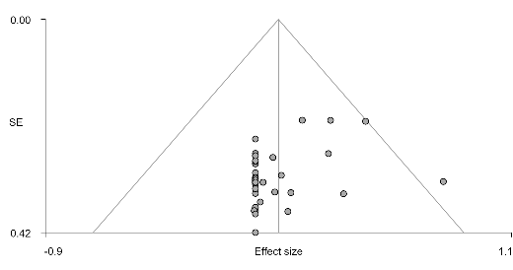 | Right SFG (FPN seeds)  Bias: 1.49, t: 1.13, df: 11, p: 0.283 | 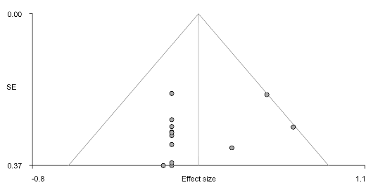 | Right IFG (DMN seeds)  Bias: 0.86, t: 0.78, df: 20, p: 0.445 | 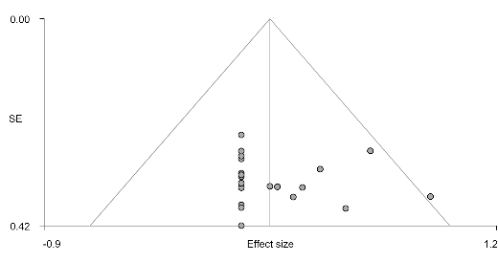
Right LN (DMN seeds)  Bias: -0.55, t: -0.73, df: 40, p: 0.470 | 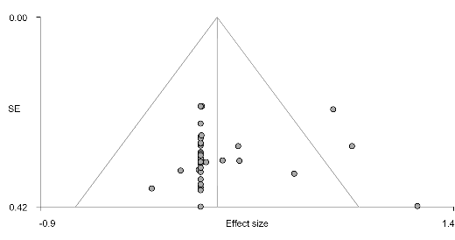 | Right PCC (FPN seeds)  Bias: 1.49, t: 1.13, df: 11, p: 0.283 | 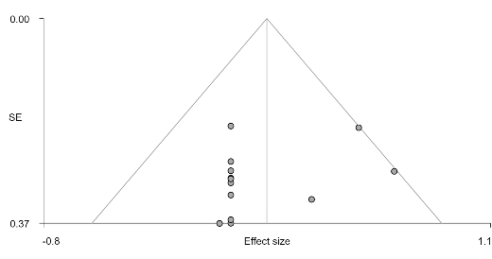 | Right ATP (DMN seeds)  Bias: 1.65, t: 1.39, df: 20, p: 0.179 | 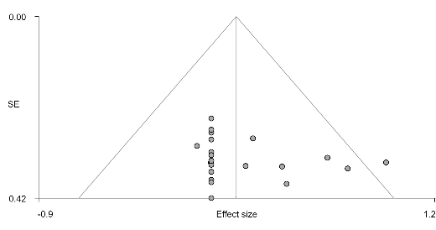
Left FAT (DMN seeds)  Bias: -1.82, t: -3.67, df: 40, p: 0.001 | 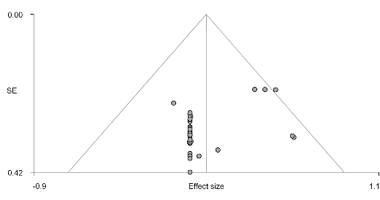 | Right IFG (AN seeds)  Bias: -2.40, t: -2.58, df: 15, p: 0.021 | 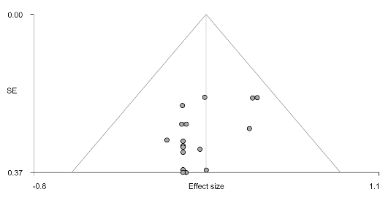 | Left striatum (DMN seeds)  Bias: 1.68, t: 1.49, df: 20, p: 0.153 | 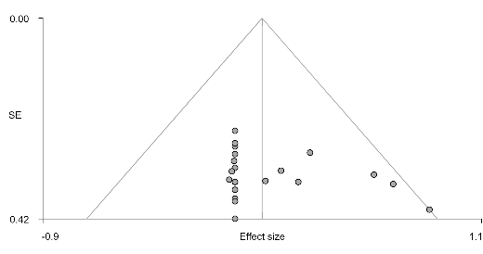
Left ATP (DMN seeds)  Bias: 0.73, t: 2.36, df: 40, p: 0.023 | 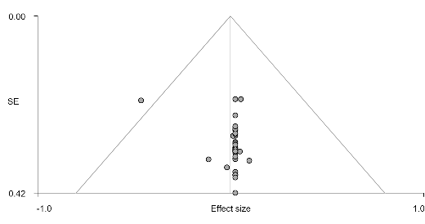 | Corpus callosum (AN seeds)  Bias: -0.06, t: -0.06, df: 15, p: 0.952 | 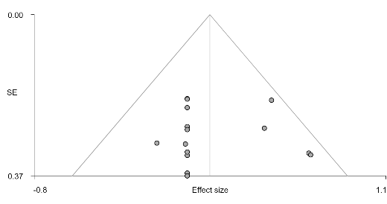 | Right ACC (DMN seeds)  Bias: 0.07, t: 0.05, df: 20, p: 0.959 | 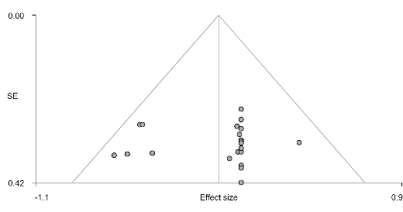
Left insula (FPN seeds)  Bias: -0.95, t: -1.21, df: 22, p: 0.238 | 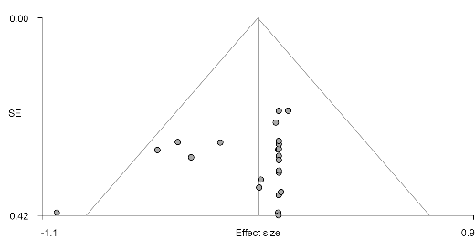 | Right MCC (SN seeds)  Bias: -0.25, t: -0.16, df: 8, p: 0.879 | 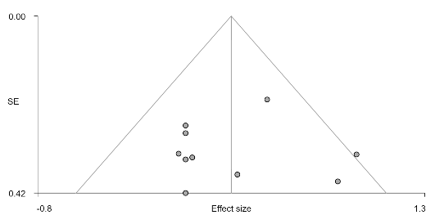 | Left IFG (FPN seeds)  Bias: -0.37, t: -0.53, df: 11, p: 0.609 | 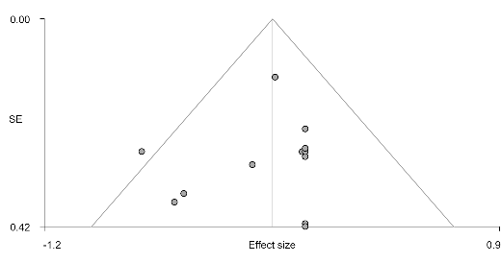
Left ATP (FPN seeds)  Bias: -0.65, t: -0.60, df: 22, p: 0.557 | 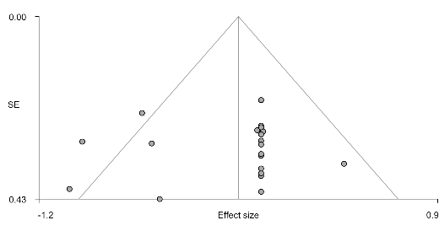 | Left MCC (SN seeds)  Bias: -1.41, t: -1.03, df: 8, p: 0.333 | 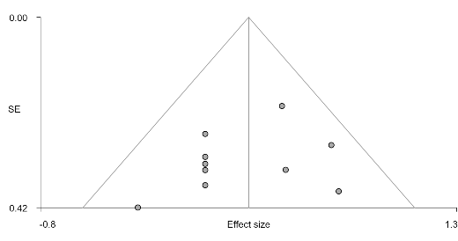 | Right SFG (AN seeds)  Bias: -1.05, t: -1.45, df: 17, p: 0.166 | 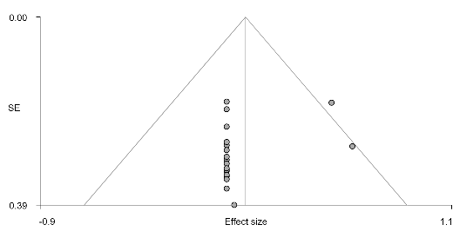
Left IFG (AN seeds)  Bias: -0.71, t: -1.56, df: 34, p: 0.127 | 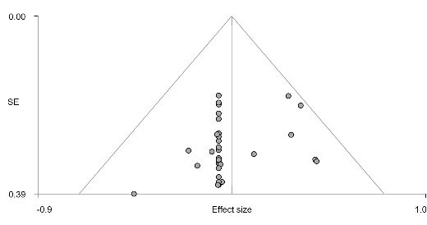 | Right RO (SN seeds)  Bias: -2.38, t: -1.67, df: 8, p: 0.133 | 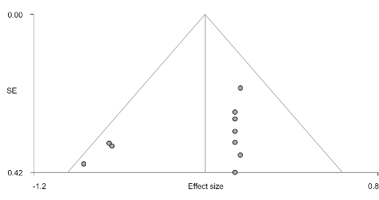 | Left fusiform gyrus (SN seeds)  Bias: 0.34, t: 0.49, df: 12, p: 0.636 | 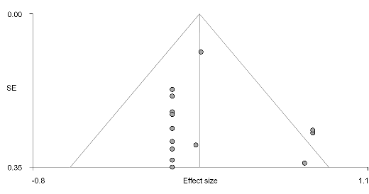
Right IFG (AN seeds)  Bias: -1.00, t: -1.92, df: 34, p: 0.063 | 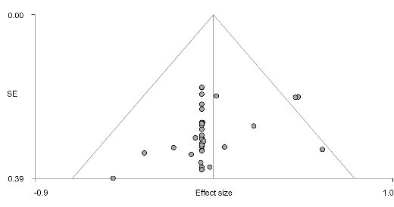
Left RO (SN seeds)  Bias: -0.07, t: -0.08, df: 21, p: 0.935 | 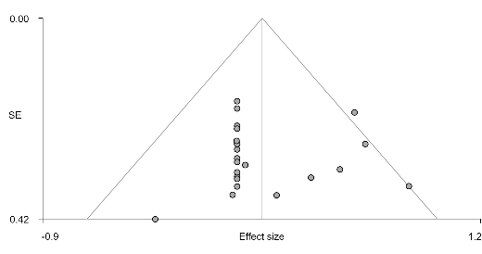
Right MCC (SN seeds)  Bias: 0.29, t: 0.33, df: 21, p: 0.742 | 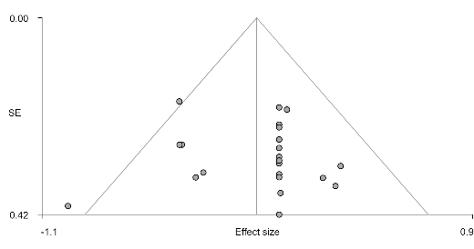
Abbreviations: ATP: anterior thalamic projections; FAT: frontal aslant tract; IFG: inferior frontal gyrus; LN: lenticular nucleus; MCC: median cingulate cortex; MFG: middle frontal gyrus; RO: rolandic operculum; SFG: superior frontal gyrus; SLF: superior longitudinal fasciculus; STG: superior temporal gyrus; AN, affective network; DAN, dorsal attention network; DMN, default mode network; FPN, frontal parietal network; SSN, somatosensory network; SN, salience network.

Included datasets
- Adinoff, B., Gu, H., Merrick, C., McHugh, M., Jeon-Slaughter, H., Lu, H., . . . Stein, E. A. (2015). Basal Hippocampal Activity and Its Functional Connectivity Predicts Cocaine Relapse. Biol Psychiatry, 78(7), 496-504. doi:10.1016/j.biopsych.2014.12.027
- Bae, S., Han, D. H., Jung, J., Nam, K. C., & Renshaw, P. F. (2017). Comparison of brain connectivity between Internet gambling disorder and Internet gaming disorder: A preliminary study. J Behav Addict, 6(4), 505-515. doi:10.1556/2006.6.2017.061
- Bai, J., Wang, C., von Deneen, K. M., Yuan, K., & Cheng, J. (2017). Altered thalamo-cortical resting state functional connectivity in smokers. Neurosci Lett, 653, 120-125.
- Berlingeri, M., Losasso, D., Girolo, A., Cozzolino, E., Masullo, T., Scotto, M., . . . Paulesu, E. (2017). Resting state brain connectivity patterns before eventual relapse into cocaine abuse. Behav Brain Res, 327, 121-132. doi:10.1016/j.bbr.2017.01.002
- Blanco-Hinojo, L., Pujol, J., Harrison, B. J., Macià, D., Batalla, A., Nogué, S., . . . Martín-Santos, R. (2017). Attenuated frontal and sensory inputs to the basal ganglia in cannabis users. Addict Biol, 22(4), 1036-1047. doi:10.1111/adb.12370
- Camchong, J., MacDonald, A. W., 3rd, Nelson, B., Bell, C., Mueller, B. A., Specker, S., & Lim, K. O. (2011). Frontal hyperconnectivity related to discounting and reversal learning in cocaine subjects. Biol Psychiatry, 69(11), 1117-1123. doi:10.1016/j.biopsych.2011.01.008
- Camchong, J., Stenger, A., & Fein, G. (2013). Resting-state synchrony in long-term abstinent alcoholics. Alcohol Clin Exp Res, 37(1), 75-85. doi:10.1111/j.1530-0277.2012.01859.x
- Chen, C. Y., Yen, J. Y., Wang, P. W., Liu, G. C., Yen, C. F., & Ko, C. H. (2016). Altered Functional Connectivity of the Insula and Nucleus Accumbens in Internet Gaming Disorder: A Resting State fMRI Study. Eur Addict Res, 22(4), 192-200. doi:10.1159/000440716
- Chen, J., Li, X., Zhang, Q., Zhou, Y., Wang, R., Tian, C., & Xiang, H. (2020). Impulsivity and Response Inhibition Related Brain Networks in Adolescents With Internet Gaming Disorder: A Preliminary Study Utilizing Resting-State fMRI. Frontiers in psychiatry Frontiers Research Foundation, 11, 618319.
- Chen, X., Wang, Y., Zhou, Y., Sun, Y., Ding, W., Zhuang, Z., . . . Du, Y. (2014). Different resting-state functional connectivity alterations in smokers and nonsmokers with Internet gaming addiction. Biomed Res Int, 2014, 825787. doi:10.1155/2014/825787
- Contreras-Rodríguez, O., Albein-Urios, N., Perales, J. C., Martínez-Gonzalez, J. M., Vilar-López, R., Fernández-Serrano, M. J., . . . Verdejo-García, A. (2015). Cocaine-specific neuroplasticity in the ventral striatum network is linked to delay discounting and drug relapse. Addiction, 110(12), 1953-1962. doi:10.1111/add.13076
- Contreras-Rodriguez, O., Albein-Urios, N., Vilar-Lopez, R., Perales, J. C., Martinez-Gonzalez, J. M., Fernandez-Serrano, M. J., . . . Verdejo-Garcia, A. (2016). Increased corticolimbic connectivity in cocaine dependence versus pathological gambling is associated with drug severity and emotion-related impulsivity. Addict Biol, 21(3), 709-718. doi:10.1111/adb.12242
- Denier, N., Schmidt, A., Gerber, H., Vogel, M., Huber, C. G., Lang, U. E., . . . Borgwardt, S. (2015). Abnormal functional integration of thalamic low frequency oscillation in the BOLD signal after acute heroin treatment. Hum Brain Mapp, 36(12), 5287-5300. doi:10.1002/hbm.23011
- Ding, W. N., Sun, J. H., Sun, Y. W., Zhou, Y., Li, L., Xu, J. R., & Du, Y. S. (2013). Altered default network resting-state functional connectivity in adolescents with Internet gaming addiction. PLoS One, 8(3), e59902. doi:10.1371/journal.pone.0059902
- Dong, G., Huang, J., & Du, X. (2012). Alterations in regional homogeneity of resting-state brain activity in internet gaming addicts. Behav Brain Funct, 8, 41. doi:10.1186/1744-9081-8-41
- Farre-Colomes, A., Gerhardt, S., Luderer, M., Sobanski, E., Kiefer, F., & Vollstadt-Klein, S. (2021). Common and distinct neural connectivity in attention-deficit/hyperactivity disorder and alcohol use disorder studied using resting-state functional magnetic resonance imaging. Alcoholism: Clinical & Experimental Research, 09, 09.
- Ge, X., Sun, Y., Han, X., Wang, Y., Ding, W., Cao, M., . . . Zhou, Y. (2017). Difference in the functional connectivity of the dorsolateral prefrontal cortex between smokers with nicotine dependence and individuals with internet gaming disorder. BMC Neurosci, 18(1), 54. doi:10.1186/s12868-017-0375-y
- Geng, X., Hu, Y., Gu, H., Salmeron, B. J., Adinoff, B., Stein, E. A., & Yang, Y. (2017). Salience and default mode network dysregulation in chronic cocaine users predict treatment outcome. Brain, 140(5), 1513-1524. doi:10.1093/brain/awx036
- Gu, H., Salmeron, B. J., Ross, T. J., Geng, X., Zhan, W., Stein, E. A., & Yang, Y. (2010). Mesocorticolimbic circuits are impaired in chronic cocaine users as demonstrated by resting-state functional connectivity. Neuroimage, 53(2), 593-601. doi:10.1016/j.neuroimage.2010.06.066
- Halcomb, M. E., Chumin, E. J., Goñi, J., Dzemidzic, M., & Yoder, K. K. (2019). Aberrations of anterior insular cortex functional connectivity in nontreatment-seeking alcoholics. Psychiatry Res Neuroimaging, 284, 21-28. doi:10.1016/j.pscychresns.2018.12.016
- Han, D. H., Bae, S., Hong, J., Kim, S. M., Son, Y. D., & Renshaw, P. (2019). Resting-State fMRI Study of ADHD and Internet Gaming Disorder. J Atten Disord, 1087054719883022. doi:10.1177/1087054719883022
- Han, X., Wang, Y., Jiang, W., Bao, X., Sun, Y., Ding, W., . . . Zhou, Y. (2018). Resting-State Activity of Prefrontal-Striatal Circuits in Internet Gaming Disorder: Changes With Cognitive Behavior Therapy and Predictors of Treatment Response. Front Psychiatry, 9, 341. doi:10.3389/fpsyt.2018.00341
- Han, X., Wu, X., Wang, Y., Sun, Y., Ding, W., Cao, M., . . . Zhou, Y. (2018). Alterations of resting-state static and dynamic functional connectivity of the dorsolateral prefrontal cortex in subjects with internet gaming disorder. Frontiers in Human Neuroscience, 12 (no pagination)(41).
- Hong, S. B., Harrison, B. J., Dandash, O., Choi, E. J., Kim, S. C., Kim, H. H., . . . Yi, S. H. (2015). A selective involvement of putamen functional connectivity in youth with internet gaming disorder. Brain Res, 1602, 85-95. doi:10.1016/j.brainres.2014.12.042
- Jung, M. H., Kim, J. H., Shin, Y. C., Jung, W. H., Jang, J. H., Choi, J. S., . . . Kwon, J. S. (2014). Decreased connectivity of the default mode network in pathological gambling: a resting state functional MRI study. Neurosci Lett, 583, 120-125. doi:10.1016/j.neulet.2014.09.025
- Kang, K. D., Jung, T. W., Park, I. H., & Han, D. H. (2018). Effects of Equine-Assisted Activities and Therapies on the Affective Network of Adolescents with Internet Gaming Disorder. J Altern Complement Med, 24(8), 841-849. doi:10.1089/acm.2017.0416
- Kelly, C., Zuo, X. N., Gotimer, K., Cox, C. L., Lynch, L., Brock, D., . . . Milham, M. P. (2011). Reduced interhemispheric resting state functional connectivity in cocaine addiction. Biol Psychiatry, 69(7), 684-692. doi:10.1016/j.biopsych.2010.11.022
- Kim, J. Y., Chun, J. W., Park, C. H., Cho, H., Choi, J., Yang, S., . . . Kim, D. J. (2019). The Correlation between the Frontostriatal Network and Impulsivity in Internet Gaming Disorder. Sci Rep, 9(1), 1191. doi:10.1038/s41598-018-37702-4
- Kim, S. J., Kim, M. K., Shin, Y. B., Kim, H. E., Kwon, J. H., & Kim, J. J. (2021). Differences in resting-state functional connectivity according to the level of impulsiveness in patients with internet gaming disorder. J Behav Addict, 24, 24.
- Ko, C. H., Hsieh, T. J., Wang, P. W., Lin, W. C., Yen, C. F., Chen, C. S., & Yen, J. Y. (2015). Altered gray matter density and disrupted functional connectivity of the amygdala in adults with Internet gaming disorder. Prog Neuropsychopharmacol Biol Psychiatry, 57, 185-192. doi:10.1016/j.pnpbp.2014.11.003
- Koehler, S., Ovadia-Caro, S., van der Meer, E., Villringer, A., Heinz, A., Romanczuk-Seiferth, N., & Margulies, D. S. (2013). Increased functional connectivity between prefrontal cortex and reward system in pathological gambling. PLoS One, 8(12), e84565. doi:10.1371/journal.pone.0084565
- Kohno, M., Loftis, J. M., Huckans, M., Dennis, L. E., McCready, H., & Hoffman, W. F. (2018). The relationship between interleukin-6 and functional connectivity in methamphetamine users. Neurosci Lett, 677, 49-54. doi:10.1016/j.neulet.2018.04.037
- Kohno, M., Morales, A. M., Ghahremani, D. G., Hellemann, G., & London, E. D. (2014). Risky decision making, prefrontal cortex, and mesocorticolimbic functional connectivity in methamphetamine dependence. JAMA Psychiatry, 71(7), 812-820. doi:10.1001/jamapsychiatry.2014.399
- Lee, D., Lee, J., Lee, J. E., & Jung, Y. C. (2017). Altered functional connectivity in default mode network in Internet gaming disorder: Influence of childhood ADHD. Prog Neuropsychopharmacol Biol Psychiatry, 75, 135-141. doi:10.1016/j.pnpbp.2017.02.005
- Lee, D., Lee, J., Namkoong, K., & Jung, Y. C. (2018). Subregions of the Anterior Cingulate Cortex Form Distinct Functional Connectivity Patterns in Young Males With Internet Gaming Disorder With Comorbid Depression. Front Psychiatry, 9, 380. doi:10.3389/fpsyt.2018.00380
- Lee, D., Lee, J., Namkoong, K., & Jung, Y. C. (2021). Altered functional connectivity of the dorsal attention network among problematic social network users. Addict Behav, 116, 106823. doi:10.1016/j.addbeh.2021.106823
- Lee, D., Namkoong, K., Lee, J., & Jung, Y. C. (2021). Dorsal striatal functional connectivity changes in Internet gaming disorder: A longitudinal magnetic resonance imaging study. Addict Biol, 26(1), e12868. doi:10.1111/adb.12868
- Lee, J., Lee, D., Namkoong, K., & Jung, Y. C. (2020). Aberrant posterior superior temporal sulcus functional connectivity and executive dysfunction in adolescents with internet gaming disorder. J Behav Addict, 9(3), 589-597.
- LI Qiang, YANGWei-chuan, WANGYa-rong, & HUANGYu-fang. (2013). Abnormal function of the posterior cingulate cortex in heroin addicted users during resting-state and drug-cue stimulation task. doi:10.3760/cma.j.issn.0366-6999.20120960
- Liao, Y., Tang, J., Liu, J., Xie, A., Yang, M., Johnson, M., . . . Hao, W. (2016). Decreased Thalamocortical Connectivity in Chronic Ketamine Users. PLoS One, 11(12), e0167381. doi:10.1371/journal.pone.0167381
- Lin, F., Zhou, Y., Du, Y., Zhao, Z., Qin, L., Xu, J., & Lei, H. (2015). Aberrant corticostriatal functional circuits in adolescents with Internet addiction disorder. Front Hum Neurosci, 9, 356. doi:10.3389/fnhum.2015.00356
- Lin, H. C., Wang, P. W., Wu, H. C., Ko, C. H., Yang, Y. H., & Yen, C. F. (2018). Altered gray matter volume and disrupted functional connectivity of dorsolateral prefrontal cortex in men with heroin dependence. Psychiatry Clin Neurosci, 72(6), 435-444. doi:10.1111/pcn.12655
- Liu, J., Cai, W., Zhao, M., Cai, W., Sui, F., Hou, W., . . . Yuan, K. (2019). Reduced resting-state functional connectivity and sleep impairment in abstinent male alcohol-dependent patients. Hum Brain Mapp, 40(17), 4941-4951. doi:10.1002/hbm.24749
- Liu, L., Potenza, M. N., Lacadie, C. M., Zhang, J. T., Yip, S. W., Xia, C. C., . . . Fang, X. Y. (2021). Altered intrinsic connectivity distribution in internet gaming disorder and its associations with psychotherapy treatment outcomes. Addict Biol, 26(2), e12917. doi:10.1111/adb.12917
- Liu, L., Xu, R., Li, L., Li, B., Zhang, X., Zhang, X., & Xu, Z. (2018). Correlation and in vitro mechanism of bactericidal activity on E. coli with whey protein isolate during ultrasonic treatment. Microb Pathog, 115, 154-158. doi:10.1016/j.micpath.2017.12.062
- Ma, N., Liu, Y., Li, N., Wang, C. X., Zhang, H., Jiang, X. F., . . . Zhang, D. R. (2010). Addiction related alteration in resting-state brain connectivity. Neuroimage, 49(1), 738-744. doi:10.1016/j.neuroimage.2009.08.037
- McConnell, P. A., Garland, E. L., Zubieta, J. K., Newman-Norlund, R., Powers, S., & Froeliger, B. (2020). Impaired frontostriatal functional connectivity among chronic opioid using pain patients is associated with dysregulated affect. Addict Biol, 25(2), e12743.
- McHugh, M. J., Demers, C. H., Braud, J., Briggs, R., Adinoff, B., & Stein, E. A. (2013). Striatal-insula circuits in cocaine addiction: implications for impulsivity and relapse risk. Am J Drug Alcohol Abuse, 39(6), 424-432. doi:10.3109/00952990.2013.847446
- Motzkin, J. C., Baskin-Sommers, A., Newman, J. P., Kiehl, K. A., & Koenigs, M. (2014). Neural correlates of substance abuse: reduced functional connectivity between areas underlying reward and cognitive control. Hum Brain Mapp, 35(9), 4282-4292. doi:10.1002/hbm.22474
- Müller-Oehring, E. M., Jung, Y. C., Pfefferbaum, A., Sullivan, E. V., & Schulte, T. (2015). The Resting Brain of Alcoholics. Cereb Cortex, 25(11), 4155-4168. doi:10.1093/cercor/bhu134
- Pujol, J., Blanco-Hinojo, L., Batalla, A., López-Solà, M., Harrison, B. J., Soriano-Mas, C., . . . Martín-Santos, R. (2014). Functional connectivity alterations in brain networks relevant to self-awareness in chronic cannabis users. J Psychiatr Res, 51, 68-78. doi:10.1016/j.jpsychires.2013.12.008
- Qiu, Y., Jiang, G., Su, H., Ma, X., Li, L., Tian, J., & Zhang, X. (2013). [Alterations in orbitofrontal cortex functional connectivity and decision making deficits in heroin-dependent individuals]. Nan Fang Yi Ke Da Xue Xue Bao, 33(8), 1117-1121.
- Qiu, Y. W., Jiang, G. H., Su, H. H., Lv, X. F., Ma, X. F., Tian, J. Z., & Zhuo, F. Z. (2016). Short-term UROD treatment on cerebral function in codeine-containing cough syrups dependent male individuals. Eur Radiol, 26(9), 2964-2973. doi:10.1007/s00330-015-4139-8
- Seok, J. W., & Sohn, J. H. (2018). Altered Gray Matter Volume and Resting-State Connectivity in Individuals With Internet Gaming Disorder: A Voxel-Based Morphometry and Resting-State Functional Magnetic Resonance Imaging Study. Front Psychiatry, 9, 77. doi:10.3389/fpsyt.2018.00077
- Shen, Z., Huang, P., Wang, C., Qian, W., Luo, X., Guan, X., . . . Zhang, M. (2017). Altered function but not structure of the amygdala in nicotine-dependent individuals. Neuropsychologia, 107, 102-107. doi:10.1016/j.neuropsychologia.2017.11.003
- Shen, Z., Huang, P., Wang, C., Qian, W., Yang, Y., & Zhang, M. (2018). Cerebellar Gray Matter Reductions Associate With Decreased Functional Connectivity in Nicotine-Dependent Individuals. Nicotine Tob Res, 20(4), 440-447. doi:10.1093/ntr/ntx168
- Stopyra, M. A., Simon, J. J., Skunde, M., Walther, S., Bendszus, M., Herzog, W., & Friederich, H. C. (2019). Altered functional connectivity in binge eating disorder and bulimia nervosa: A resting-state fMRI study. Brain Behav, 9(2), e01207. doi:10.1002/brb3.1207
- Sun, Y., Wang, Y., Han, X., Jiang, W., Ding, W., Cao, M., . . . Zhou, Y. (2019). Sex differences in resting-state cerebral activity alterations in internet gaming disorder. Brain Imaging Behav, 13(5), 1406-1417. doi:10.1007/s11682-018-9955-4
- Sutherland, M. T., Carroll, A. J., Salmeron, B. J., Ross, T. J., Hong, L. E., & Stein, E. A. (2013). Down-regulation of amygdala and insula functional circuits by varenicline and nicotine in abstinent cigarette smokers. Biol Psychiatry, 74(7), 538-546. doi:10.1016/j.biopsych.2013.01.035
- Sutherland, M. T., Carroll, A. J., Salmeron, B. J., Ross, T. J., & Stein, E. A. (2013). Insula's functional connectivity with ventromedial prefrontal cortex mediates the impact of trait alexithymia on state tobacco craving. Psychopharmacology (Berl), 228(1), 143-155. doi:10.1007/s00213-013-3018-8
- Verdejo-Garcia, A., Contreras-Rodríguez, O., Fonseca, F., Cuenca, A., Soriano-Mas, C., Rodriguez, J., . . . de la Torre, R. (2014). Functional alteration in frontolimbic systems relevant to moral judgment in cocaine-dependent subjects. Addict Biol, 19(2), 272-281. doi:10.1111/j.1369-1600.2012.00472.x
- Wang, C., Bai, J., Wang, C., von Deneen, K. M., Yuan, K., & Cheng, J. (2017). Altered thalamo-cortical resting state functional connectivity in smokers. Neurosci Lett, 653, 120-125. doi:10.1016/j.neulet.2017.05.038
- Wang, J., Fan, Y., Dong, Y., Ma, M., Dong, Y., Niu, Y., . . . Cui, C. (2018). Combining gray matter volume in the cuneus and the cuneus-prefrontal connectivity may predict early relapse in abstinent alcohol-dependent patients. PLoS One, 13(5), e0196860. doi:10.1371/journal.pone.0196860
- Wang, J., Fan, Y., Dong, Y., Ma, M., Ma, Y., Dong, Y., . . . Cui, C. (2016). Alterations in Brain Structure and Functional Connectivity in Alcohol Dependent Patients and Possible Association with Impulsivity. PLoS One, 11(8), e0161956. doi:10.1371/journal.pone.0161956
- Wang, L., Zou, F., Zhai, T., Lei, Y., Tan, S., Jin, X., . . . Yang, Z. (2016). Abnormal gray matter volume and resting-state functional connectivity in former heroin-dependent individuals abstinent for multiple years. Addict Biol, 21(3), 646-656. doi:10.1111/adb.12228
- Wang, P. W., Lin, H. C., Liu, G. C., Yang, Y. H., Ko, C. H., & Yen, C. F. (2016). Abnormal interhemispheric resting state functional connectivity of the insula in heroin users under methadone maintenance treatment. Psychiatry Res Neuroimaging, 255, 9-14. doi:10.1016/j.pscychresns.2016.07.009
- Wang, Y., Yan, K. J., Fan, C. X., Luo, X. N., & Zhou, Y. (2019). Altered functional connectivity of the nucleus accumbens subdivisions in amphetamine-type stimulant abusers: a resting-state fMRI study. BMC Neurosci, 20(1), 66. doi:10.1186/s12868-019-0548-y
- Wang, Y., Zhu, J., Li, Q., Li, W., Wu, N., Zheng, Y., . . . Wang, W. (2013). Altered fronto-striatal and fronto-cerebellar circuits in heroin-dependent individuals: a resting-state FMRI study. PLoS One, 8(3), e58098. doi:10.1371/journal.pone.0058098
- Xie, C., Shao, Y., Fu, L., Goveas, J., Ye, E., Li, W., . . . Yang, Z. (2011). Identification of hyperactive intrinsic amygdala network connectivity associated with impulsivity in abstinent heroin addicts. Behav Brain Res, 216(2), 639-646. doi:10.1016/j.bbr.2010.09.004
- Yuan, K., Yu, D., Cai, C., Feng, D., Li, Y., Bi, Y., . . . Tian, J. (2017). Frontostriatal circuits, resting state functional connectivity and cognitive control in internet gaming disorder. Addict Biol, 22(3), 813-822. doi:10.1111/adb.12348
- Zhai, T., Shao, Y., Chen, G., Ye, E., Ma, L., Wang, L., . . . Yang, Z. (2015). Nature of functional links in valuation networks differentiates impulsive behaviors between abstinent heroin-dependent subjects and nondrug-using subjects. Neuroimage, 115, 76-84. doi:10.1016/j.neuroimage.2015.04.060
- Zhai, T. Y., Shao, Y. C., Xie, C. M., Ye, E. M., Zou, F., Fu, L. P., . . . Yang, Z. (2014). Altered intrinsic hippocmapus declarative memory network and its association with impulsivity in abstinent heroin dependent subjects. Behav Brain Res, 272, 209-217. doi:10.1016/j.bbr.2014.06.054
- Zhang, J. T., Ma, S. S., Li, C. R., Liu, L., Xia, C. C., Lan, J., . . . Fang, X. Y. (2018). Craving behavioral intervention for internet gaming disorder: remediation of functional connectivity of the ventral striatum. Addict Biol, 23(1), 337-346. doi:10.1111/adb.12474
- Zhang, J. T., Ma, S. S., Yip, S. W., Wang, L. J., Chen, C., Yan, C. G., . . . Fang, X. Y. (2015). Decreased functional connectivity between ventral tegmental area and nucleus accumbens in Internet gaming disorder: evidence from resting state functional magnetic resonance imaging. Behav Brain Funct, 11(1), 37. doi:10.1186/s12993-015-0082-8
- Zhang, J. T., Yao, Y. W., Li, C. S., Zang, Y. F., Shen, Z. J., Liu, L., . . . Fang, X. Y. (2016). Altered resting-state functional connectivity of the insula in young adults with Internet gaming disorder. Addict Biol, 21(3), 743-751. doi:10.1111/adb.12247
- Zhang, J. T., Yao, Y. W., Potenza, M. N., Xia, C. C., Lan, J., Liu, L., . . . Fang, X. Y. (2016). Altered resting-state neural activity and changes following a craving behavioral intervention for Internet gaming disorder. Sci Rep, 6, 28109. doi:10.1038/srep28109
- Zhang, S., Hu, Q., Tang, T., Liu, C., Li, C., Zang, Y. Y., & Cai, W. X. (2018). Changes in Gray Matter Density, Regional Homogeneity, and Functional Connectivity in Methamphetamine-Associated Psychosis: A Resting-State Functional Magnetic Resonance Imaging (fMRI) Study. Med Sci Monit, 24, 4020-4030. doi:10.12659/msm.905354
- Zhang, S., & Li, C. R. (2018). Ventral striatal dysfunction in cocaine dependence - difference mapping for subregional resting state functional connectivity. Transl Psychiatry, 8(1), 119. doi:10.1038/s41398-018-0164-0
- Zhang, Y., Gong, J., Xie, C., Ye, E. M., Jin, X., Song, H., . . . Shao, Y. (2015). Alterations in brain connectivity in three sub-regions of the anterior cingulate cortex in heroin-dependent individuals: Evidence from resting state fMRI. Neuroscience, 284, 998-1010. doi:10.1016/j.neuroscience.2014.11.007
- Zhang, Y., Mei, W., Zhang, J. X., Wu, Q., & Zhang, W. (2016). Decreased functional connectivity of insula-based network in young adults with internet gaming disorder. Exp Brain Res, 234(9), 2553-2560. doi:10.1007/s00221-016-4659-8
- Zhou, S., Xiao, D., Peng, P., Wang, S. K., Liu, Z., Qin, H. Y., . . . Wang, C. (2017). Effect of smoking on resting-state functional connectivity in smokers: An fMRI study. Respirology, 22(6), 1118-1124. doi:10.1111/resp.13048
- Zimmermann, K., Yao, S., Heinz, M., Zhou, F., Dau, W., Banger, M., . . . Becker, B. (2018). Altered orbitofrontal activity and dorsal striatal connectivity during emotion processing in dependent marijuana users after 28 days of abstinence. Psychopharmacology (Berl), 235(3), 849-859. doi:10.1007/s00213-017-4803-6
- Zou, F., Wu, X., Zhai, T., Lei, Y., Shao, Y., Jin, X., . . . Yang, Z. (2015). Abnormal resting-state functional connectivity of the nucleus accumbens in multi-year abstinent heroin addicts. J Neurosci Res, 93(11), 1693-1702. doi:10.1002/jnr.23608

