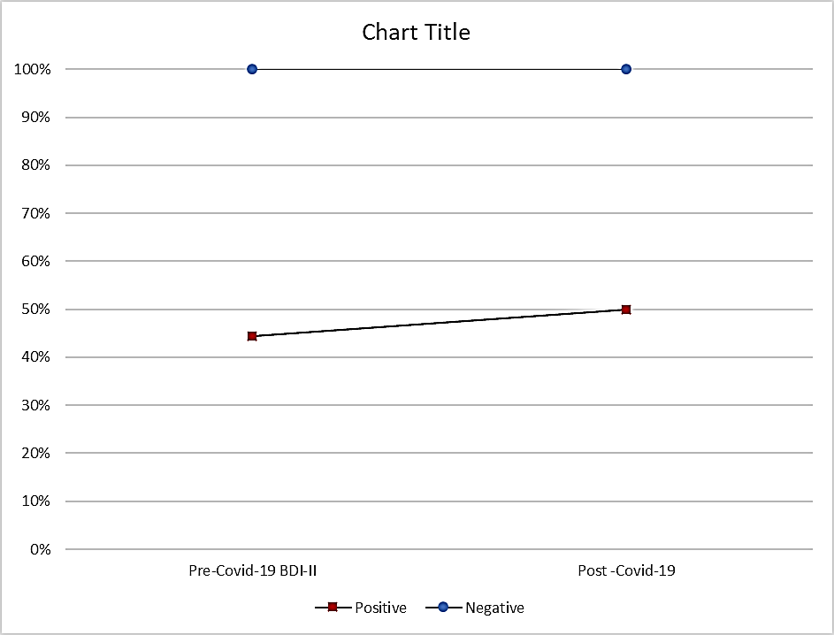

**Supplementary Figure S4.** Predicted post-COVID-19 BDI-II scores and probabilities of elevated depression risk post-COVID-19 in stratified regression analysis using fully adjusted models

|  |
| --- |
| *Legend:* *BDI-II, Beck Depression Inventory-II, COVID-19, coronavirus disease 2019. Predicted post-COVID-19 BDI-II was calculated using linear regression; predicted probabilities for depressive symptomatology post-COVID-19 were calculated using logistic regression. Both analyses show the fully adjusted models (Adjusted for age, sex, education, marital status, intervention group, cluster randomisation, recruitment centre, pre-COVID-19 BDI-II scores, time since infection for post-COVID-19 depression assessments, presence of obesity, diabetes mellitus, hypertension, hypercholesterolemia, and baseline cognition, adherence to Mediterranean diet scores, smoking status, physical activity, and alcohol consumption. Red square markers indicate COVID-19-positive status and blue dots indicate COVID-19-negative status within the strata. Error bars indicate 95% CI. BDI-II scores have a potential range between 0 and 63 and predicted probabilities between 0 and 1.* |