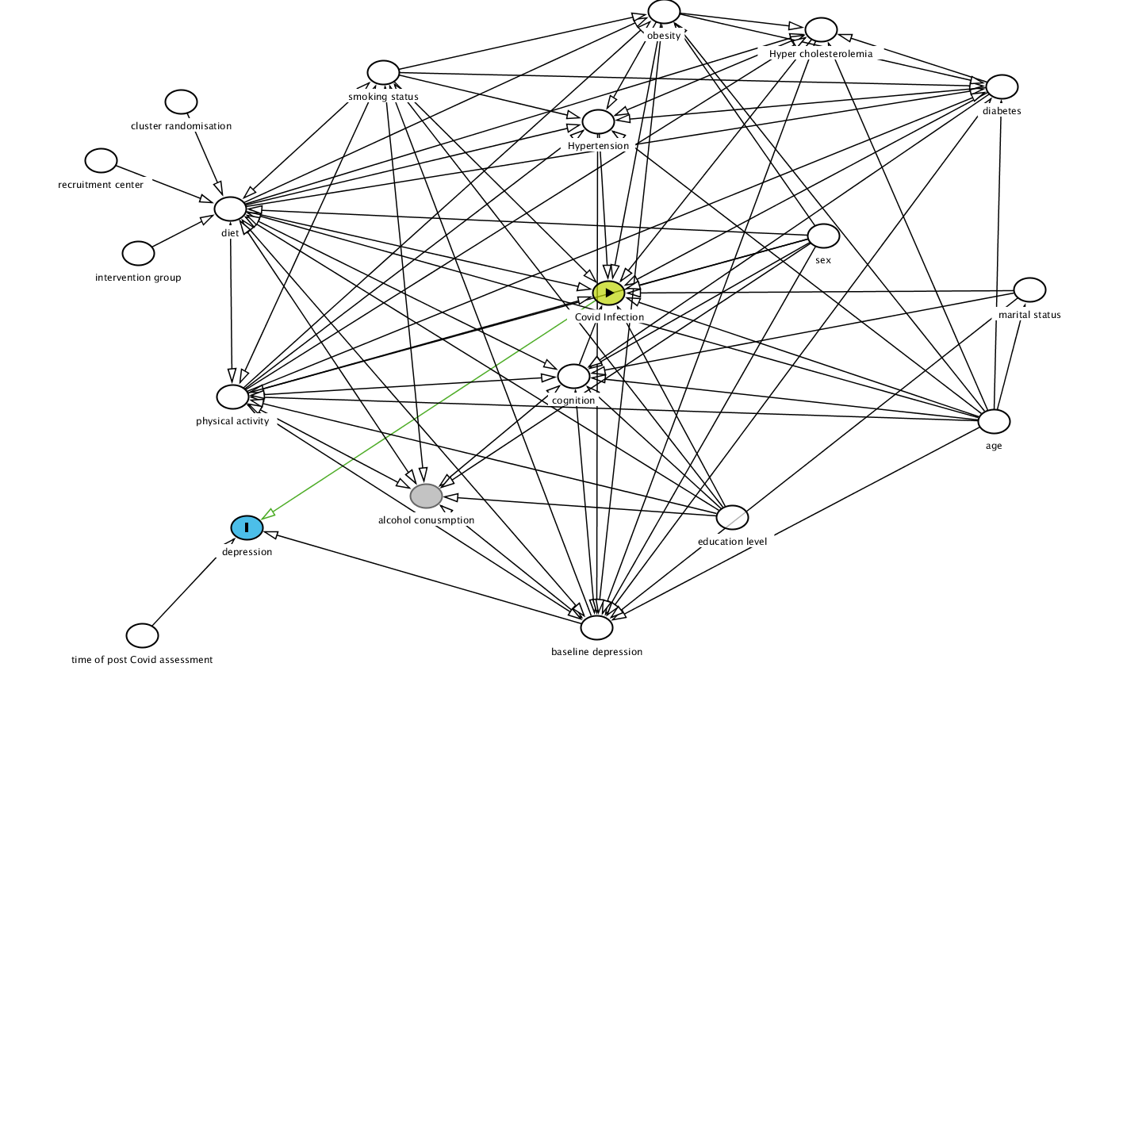
Supplementary Figure S2: Directed acyclic graph to identify minimal adjustments to evaluate the impact of COVID-19 on depression measures in PREDIMED-Plus participants

